Professional placement
Nathan Barlow
2318300

Component 1: Professional Experience Report

Introduction
This report details my placement experience as an Assistant Account Analyst at Loadlok, a small to medium size manufacturing company in South Wales specialising in lorry parts and cargo control solutions. The Loadlok business is a part of the Cargo Control Company, which itself operates under the global umbrella of the Heico Companies.
Over the course of my placement, through the support and guidance of my Mentor, I had the opportunity to engage with the financial operations of three associated companies. Although I worked remotely and did not visit the factory premises, I gained valuable insights into accounting practices, business processes, and the real-world application of financial theories through the mentorship of experienced professionals and hands-on exposure to company-specific software systems.
This report provides a critical overview and review of my experience within broader business and academic frameworks.

Organisational Context and Role Description
Loadlok is a leading UK manufacturer of cargo restraint systems used in logistics and transportation, particularly focusing on refrigerated units and heavy-duty strapping systems. The company is part of a vertically integrated group. The accounts team at Loadlok ensures control over quality and supply chain efficiency. As part of my placement, I supported accounting staff in the accounting practices of Loadlok and two other affiliated companies under the same parent organisation with supervision.

My primary role was as an Assistant Account Analyst, where I contributed to monthly financial reporting, reconciliations, accrual calculations, and the preparation of management accounts. I experienced data validation techniques, ledger analysis, and the identification of financial discrepancies. My mentor provided structured learning on how real-world companies utilise proprietary software to manage their accounts, offering practical insights not covered in traditional university modules.

Key Responsibilities and Tasks
One of my core responsibilities involved assisting in the creation and analysis of monthly financial packs. These packs included income statements, cash flow summaries, and balance sheet reconciliations. I became proficient in identifying accounting errors, flagging variances, and ensuring data integrity across different reporting periods. I also engaged in routine reconciliation tasks, where I compared ledger entries to bank statements and supplier invoices, a process essential for maintaining financial accuracy.
Additionally, I was tasked with inputting and validating accruals and prepayments, aligning with the Matching Principle of accounting (Horngren et al., 2019). This experience provided a solid understanding of how theoretical concepts such as accruals-based accounting apply in real-time business settings. I also assisted in validating intercompany transactions and tracking group-level consolidations—a critical activity within vertically integrated organisations like Heico.

Use of Technology and Systems
My placement introduced me to bespoke accounting software, designed specifically for the internal processes of the companies. The proprietary nature of the system meant that my knowledge and learning to date were not entirely relevant.
My mentor guided me through the logic of the system, including navigation of modules for accounts receivable, accounts payable, and general ledger reporting. The experience highlighted the significance of internal digital infrastructures in streamlining financial workflows (Romney & Steinbart, 2020).
Working with spreadsheets was also a key part of my role. I utilised Microsoft Excel to assist in month-end pack formatting, using pivot tables, formulas, and conditional formatting to highlight anomalies. This was particularly valuable in analysing patterns across the 2022, 2023, and 2024 financial packs, helping identify trends and flagging errors for senior management. The analytical and technological skills I developed align with the Institute of Management Accountants' core competencies for accounting professionals (IMA, 2022).

Business Concepts and Theoretical Application
Several key business management concepts were experienced and applied during my placement.

Firstly, the principle of Internal Control which was evident in the routine segregation of duties and oversight mechanisms. As an Assistant Account Analyst, my reconciliations and inputs were reviewed by my mentor, ensuring accuracy and reducing the risk of fraud (COSO, 2013).
Cost allocation and variance analysis were embedded into monthly processes. For example, when discrepancies arose in material costs or transportation expenses, I was guided to identify the source of the variance, whether due to supplier pricing changes or currency fluctuation. These practices reflect core management accounting techniques (Drury, 2018) and support strategic decision-making.

The concept of the Value Chain (Porter, 1985) also became evident to me during my placement. Loadlok’s manufacturing and distribution processes are tightly integrated, and the finance function supports this by allocating costs efficiently, tracking ROI (Return on Investment) on capital expenditures, and ensuring compliance with financial regulations. By participating in these activities, I recognised the interplay between finance and other operational departments.

Professional Development and Learning
Beyond technical skills, I developed a deeper understanding of workplace professionalism, communication, collaboration and accountability.
Working under the mentorship of a knowledgeable and experienced professional, I learned the importance of asking precise questions, documenting processes, and adhering to internal timelines and deadlines. These soft skills are often under-emphasised in academic settings but are crucial for workplace success (Robles, 2012).
One particularly valuable aspect of my development was understanding how financial data supports strategic planning. For example, the accounts month-end packs have value above simple reporting tools; the packs also inform quarterly reviews, investment decisions, and budget adjustments. This practice helps bridge the gap between operational data and executive decision-making.
Through feedback and observation, I learned the importance of accuracy and consistency. A small error in a reconciliation sheet could cause delays or misinformation to management. Attention to detail, a key transferable skill, was something I improved substantially during this placement.

Limitations and Challenges

My placement gave me many valuable experiences, but I recognise it had limitations. The most significant being unable to visit the factory or engage directly with other departments and staff. This restricted my understanding of how finance interacts with operations in a physical environment. Also, because the software was proprietary, I was unable to gain transferable certifications or practice outside the company’s context. Another challenge was managing data complexity. Early in the placement, I struggled to reconcile conflicting figures across documents. With time and guidance, I improved, but this highlighted the importance of ongoing training and mentorship when transitioning from academic learning to real-world application.

Industry Relevance and Broader Context
The logistics and cargo manufacturing industry is undergoing digital transformation. Companies like Loadlok are investing in automation and data analytics to optimise supply chains and financial reporting, bringing business efficiencies and controlling costs in a competitive business sector. According to PwC (2022), integrating digital technologies in finance functions improves decision-making and operational efficiency.
My exposure to digital finance systems and data validation practices is highly relevant. The skills I developed are relevant to industry trends towards integrated financial planning and performance analysis (CIMA, 2021). Additionally, the global nature of Heico Companies provided insight into multi-currency transactions and the complexities of international financial management.

Conclusion
In conclusion, my placement at Loadlok, within the Heico Group has been a very valuable experience in developing my practical accounting and business analysis knowledge and skills. From contributing to month-end financial packs to learning the intricacies of bespoke software systems, I gained valuable hands-on experience that complimented my academic learning. The role reinforced to me the importance of key theoretical principles such as Accrual Accounting, Variance Analysis, and Internal Control Mechanisms, while also building my soft skills like communication, accuracy, and professional accountability and collaboration. Although the placement had limitations, particularly regarding physical interaction with the operational side of the business, the mentorship and tasks I engaged in have provided me with a good understanding of how accounting supports strategic goals in an operating business. I extend my thanks and appreciation to Loadlok and to my Mentor for the time, expertise and knowledge shared with me and patience with my many questions.
Component 2: Reflective Analysis

Introduction
My placement as an Assistant Account Analyst at Loadlok provided me with the opportunity to develop both professionally and personally in a supported, supervised and structured way in a small/medium size local business setting. Although I was not physically present at Loadlok’s manufacturing site, my remote accounts analytical role gave me experience and insight over the financial processes of the business, giving me first-hand knowledge and understanding of how accounts teams process all the relevant data to keep a business running smoothly and profitably. This reflective analysis reviews my expectations, experience, performance, skill development, challenges, and how the experience influenced my long-term career goals.

Initial Expectations versus Reality
Before beginning my placement, I was apprehensive and anticipated a fairly hands-off and technical role focused purely on spreadsheets and routine data entry. I expected to experience and perhaps be able to apply the financial principles I had studied at University, such as double-entry bookkeeping, balance sheet analysis, and cash flow management. I did not expect to be able to work with company-specific software systems or to critically evaluate financial data or do more than experiencing the most basic account reporting.
However, the reality of the role was significantly more than I expected or could have hoped for. I was introduced to financial processes tailored to Loadlok, Cargo Control Company, and Heico Companies. Each entity used bespoke systems for month-end reconciliation, forecasting, and reporting. This unexpected complexity helped build my understanding of business accounting and provided an opportunity to learn from professionals I respect in the business. Through my mentor, I was shown the rationale behind different reporting methods and how these adapt based on organisational structure and operational needs.
This difference between my expectations and reality aligns with Schön’s (1983) concept of reflective practice, where learning occurs through adapting to lived experiences and challenges rather than relying on preconceived knowledge.

Personal Performance and Skill Development
Throughout the placement, my awareness, knowledge, understanding and skills developed enabling me to move from only being able to observe to active contribution. This I found very rewarding. One of the most significant improvements was in my technical proficiency. University accounting modules taught me generic software like Excel and Sage, but my mentor introduced me to Loadlok’s internal reporting formats and month-end pack processes. These were significantly more detailed, incorporating aspects like cost center mapping, variance analysis, and forecasting adjustments. My self belief and confidence improved as my understanding and knowledge grew. This reflects Kolb’s (1984) Experiential Learning Theory, which informs that learning is most effective when it comes from active engagement.
In addition, I developed critical thinking and problem-solving skills by comparing financial data across years (as seen in the 2022–2024 Month-End Pack files) and understanding anomalies through discussions with my mentor. I also improved my attention to detail, since minor discrepancies in reporting had significant implications. According to Mintzberg’s (1994) managerial roles theory, my role reflected the "monitor" and "disseminator" roles—where information is not just collected but interpreted for decision-making.
I also enhanced my communication skills, particularly when reporting my findings or requesting clarifications. Explaining financial discrepancies required clarity and accuracy—skills that are highly transferable. As Goleman (1998) outlines in emotional intelligence theory, this reflects strong self-regulation and social awareness.

Feedback and Adaptability
One of the most valuable aspects to me of my placement was receiving feedback. My mentor used a developmental approach, allowing me to attempt tasks independently and then guiding me through any errors or inefficiencies. For example, I initially misclassified a set of expenditures under the wrong account code. Instead of simply correcting me, my mentor walked me through the implications of misreporting and demonstrated how to trace the error back through the reporting structure. This feedback loop significantly accelerated my learning and reinforced the value of constructive criticism (Brookfield, 1995).
I also had to adapt to a remote working environment, which required me to be disciplined, independent and show initiative. Without physical supervision, I learned to manage my time, set internal deadlines, and seek clarification when needed. This ties into Bandura’s (1986) concept of self-efficacy, where belief in one’s own ability to manage and succeed influences actual performance.

Challenges Faced and Solutions Employed
a. Technical Learning Curve
My biggest challenge was understanding company-specific financial software and reporting tools. This was not something covered in academic study. Initially, I felt overwhelmed by the complex structure of the month-end packs and the unfamiliar terminology used in Loadlok’s financial reporting. I overcame this by documenting every learning session with my mentor and creating a personal reference guide.
b. Contextual Limitations
Another challenge was my lack of exposure to the physical operations of Loadlok. As a manufacturing company, many financial decisions are closely tied to operational logistics—something I had to understand through secondary information and mentor explanations. To overcome this, I conducted independent research into Loadlok’s product range and market environment using their official site and industry publications.
c. Managing Repetition and Engagement
Financial roles can involve repetitive tasks, such as monthly reconciliation and forecasting updates. At times, this led to dips in motivation. To address this, I began setting micro-goals for each task and tracked my own improvements over time. By measuring personal progress, I maintained engagement and purpose—supporting Deci and Ryan’s (1985) Self-Determination Theory, which emphasises autonomy and competence as drivers of motivation.

6. Professional Growth and Career Development
This placement has started to shape my professional identity. Initially, I was uncertain whether I would pursue a technical accounting role or a broader business strategy position. However, this experience highlighted the strategic value of accounting in business decision-making. Understanding how financial reports influence planning, budgeting, and investment has motivated me to pursue further qualifications in management accounting (e.g., CIMA).
I have also developed a greater appreciation for mentorship and knowledge-sharing. The patience with which my mentor taught me, her willingness to give time and walk me through the accounts analyst role has made a lasting impression. My Mentor showed me the importance of professional skills and standards and of cultivating professional relationships. As I enter the workforce, I intend to both seek and eventually offer similar mentorship opportunities.

7. Impact on the Organisation
Although I was not responsible for major decision-making, my role did contribute to data accuracy and financial insight. By supporting the month-end pack process, verifying figures, and identifying discrepancies, I helped maintain data integrity—a crucial foundation for strategic planning.
I also documented standard operating procedures for some of the recurring reporting processes. These internal documents will remain in use, streamlining future onboarding and ensuring consistency—representing a tangible contribution to the organisation’s knowledge base.

8. Theoretical Integration and Application
Reflecting on this placement has enabled me to better appreciate business principles and intricacies. For example:
- Lewin’s Change Model (1951) helped me understand how Loadlok adapts financial practices year-to-year based on shifting market and internal conditions (e.g., cost increases or logistics constraints).
- Strength, Weakness, Opportunity and Threat (SWOT) analysis was implicitly applied during forecasting reviews, where we examined internal strengths/weaknesses (e.g., rising costs, new clients) and external threats (e.g., inflation).
- Porter’s Value Chain (1985) helped contextualise financial reporting in manufacturing by showing how each function (procurement, production, logistics) affects the financial outcomes I analysed.
This alignment of theory with practice strengthens my confidence in applying academic knowledge to real business settings.

Conclusion
My Placement was an extremely rewarding and informative learning experience. Learning from the skills, knowledge and expertise of an experienced accounts professional helped me understand and appreciate the qualities and technical skills of that role as well as learning about hands-on complex finance processes of the different companies in the Heico Group. Most surprising to me was learning that each firm, even from the same group, has different methods of tracking and reporting finances—right from valuations of raw materials to monthly report formats!
In summary, this placement has helped me appreciate the differences between academic theory and practice in the workplace. It has left me more aware of the role of accounting as being strategic, more confident in applying financial tools, and surer in stating long-term career goals. I feel better prepared and more confident both personally and professionally to apply for future finance roles, and I intend to continue to expand my skills in management accounting and beyond.

Component 3: Supporting Visual Content (Poster)

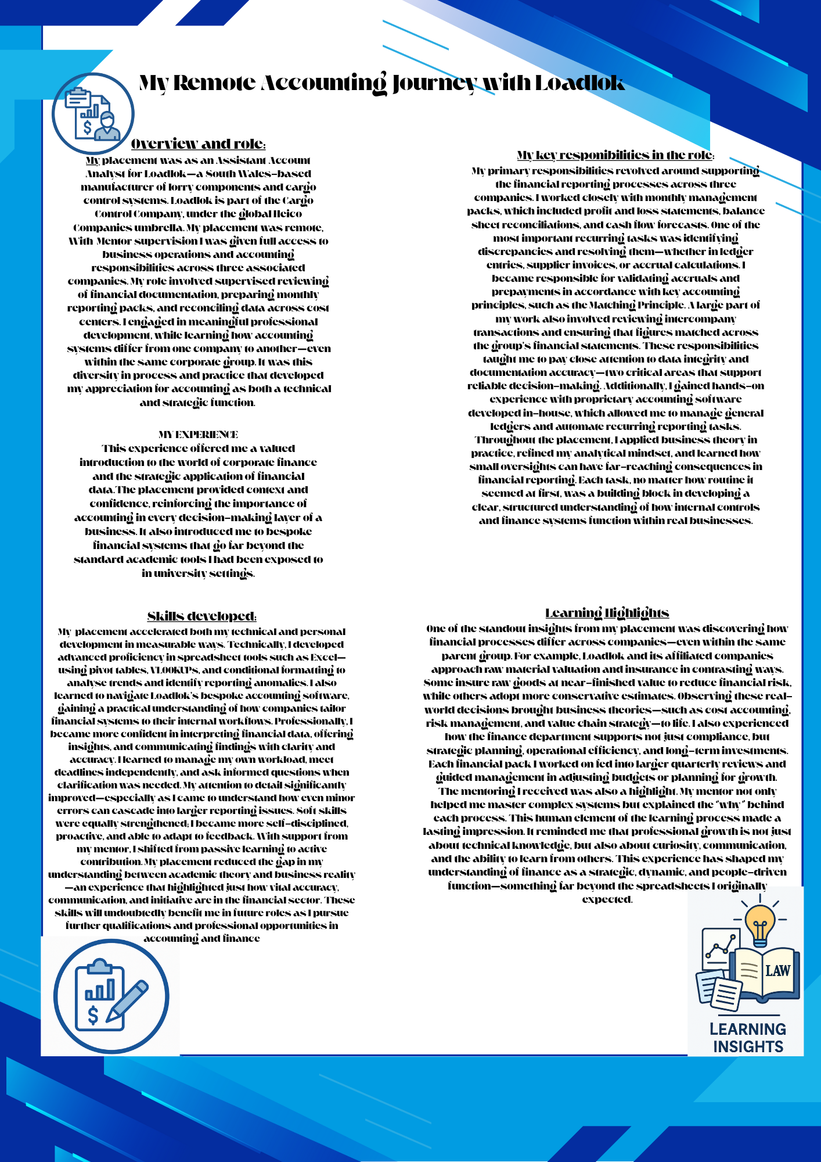

Reference List
Bandura, A. (1986) Social Foundations of Thought and Action: A Social Cognitive Theory. Englewood Cliffs, NJ: Prentice-Hall.
Brookfield, S.D. (1995) Becoming a Critically Reflective Teacher. San Francisco: Jossey-Bass.
CIMA. (2021) The role of the finance function in the digital age. Chartered Institute of Management Accountants.
Committee of Sponsoring Organizations of the Treadway Commission (COSO). (2013) Internal Control—Integrated Framework.
Deci, E.L. and Ryan, R.M. (1985) Intrinsic Motivation and Self-Determination in Human Behavior. New York: Plenum.
Drury, C. (2018) Management and Cost Accounting (10th ed.). Andover: Cengage Learning.
Goleman, D. (1998) Working with Emotional Intelligence. London: Bloomsbury Publishing.
Horngren, C.T., Sundem, G.L., Elliott, J.A. and Philbrick, D. (2019) Introduction to Financial Accounting (12th ed.). Harlow: Pearson.
IMA. (2022) Management Accounting Competency Framework. Institute of Management Accountants.
Kolb, D.A. (1984) Experiential Learning: Experience as the Source of Learning and Development. Englewood Cliffs, NJ: Prentice-Hall.
Lewin, K. (1951) Field Theory in Social Science. New York: Harper & Row.
Mintzberg, H. (1994) The Rise and Fall of Strategic Planning. New York: Free Press.
Porter, M.E. (1985) Competitive Advantage: Creating and Sustaining Superior Performance. New York: Free Press.
PricewaterhouseCoopers (PwC). (2022) Finance transformation in the digital age. PwC.
Robles, M.M. (2012) ‘Executive Perceptions of the Top 10 Soft Skills Needed in Today’s Workplace’, Business Communication Quarterly, 75(4), pp. 453–465.
Romney, M.B. and Steinbart, P.J. (2020) Accounting Information Systems (15th ed.). Harlow: Pearson.
Schön, D.A. (1983) The Reflective Practitioner: How Professionals Think in Action. London: Temple Smith.

