
Module: Problem Solving and Innovation
Module Code: BMSW4014
Title: The Decline of the retailer Wilko.

Student Name : Kamila Boldezerska
Student ID : 2309832
Word Count : 1803

Table of Contents
Introduction 3
Nature, Impact and Problems faced by the Wilko. 4
SWOT Analysis 5
Strengths 5
Weaknesses: 6
Opportunities: 6
Threats: 6
Identified Problem 6
Analyzing the Problem: 7
Solutions that might work: 7
PESTEL Analysis 7
Conclusion 10
References 11

Title: The Decline of the retailer Wilko.

Introduction
In recent years, the retail sector has experienced substantial changes, and the degree of success or absence thereof has been determined by an assortment of factors. This report provides an extensive analysis of the circumstances surrounding the closure of Wilko, a formerly prosperous store that was compelled to close due to financial difficulties. This study implements problem-solving techniques in an effort to identify and dissect the primary factors that contributed to Wilko's downfall. In addition, the study looks at past comments that could have changed how things turned out.

Nature, Impact and Problems faced by the Wilko.
The business and its money were badly affected by many inside and outside forces, which caused Wilko to shut down. The store business was undergoing rapid change, which presented a challenge for Wilko. Purchasing products online became increasingly convenient, and both brick-and-mortar and online retailers experienced growth. Stores of the company lost customers because they couldn't change with the times and meet customers' changing needs. Like changes in the market, things were not that easy. Because of problems with how it did business and managed its supply chain, Wilko was having trouble running its business. It cost more to run and made less in output because of these problems (Ellitan, 2020).
What buyers wanted changed over time, so the shop had trouble with its old business plan. The company couldn't keep up with the competition because Wilko didn't invest in new technology and ideas. this made the problems worse. Willko's life was really tough because of these issues. Due to revenue and sales losses, the company made the strategic decision to enter administration as a means to restore financial stability (Rahman, 2019). Unfavourable events transpired at the establishment, causing distress among the employees and other key personnel. More than that, they were bad for stores in general. Many stores learned how important it is to change quickly after a big name like Wilko closed.
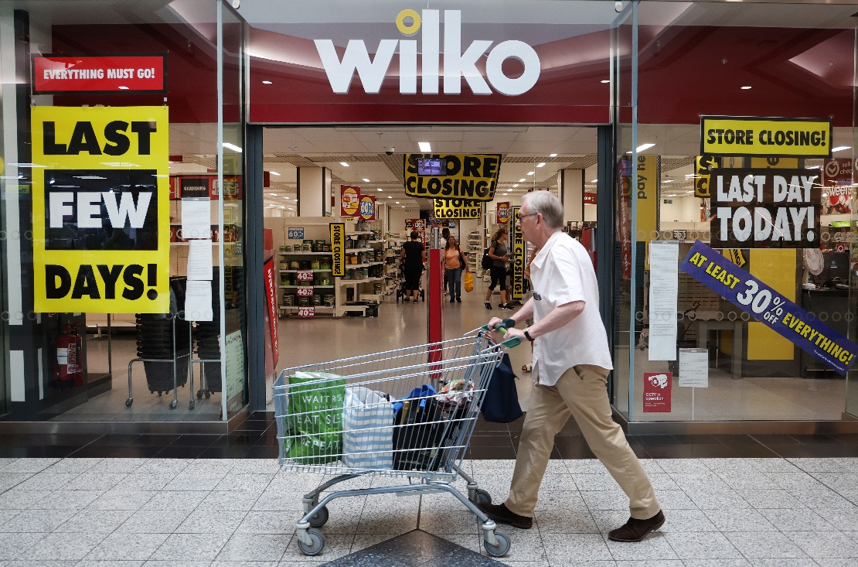
Image: Store Closing of Wilko.
Source: Internet.
There were many smart things Wilko could have done to slow down the fall. Things could run more smoothly and customers would be pleased if you used new technologies, bought a dependable online platform, and got better at controlling the supply chain. If the business had followed the rules and started running itself in more environmentally friendly ways, for example, it might have improved its image and attracted people who care about the environment.

SWOT Analysis

Strengths
In the past, the renowned store Wilko performed exceptionally well due to a multitude of positive attributes. That name was on a lot of shops all over the UK. These shops had a lot of different items for reasonable prices (Brem, Bilgram, and Marchuk, 2019). Because Wilko carried a vast selection of premium labels, customers were confident that they could find everything they required for their residences there.

Weaknesses:
Unfortunately, Wilko ran into some problems that led to its end, even though it had some good points. One big weakness was that they didn't have an online footprint or an e-commerce plan (Ning, and Li, 2018). As stores changed, more and more people bought things online. Due to its inability to adapt rapidly, Wilko lagged behind its competitors. They didn't put enough money into technology and online ads, which made this weakness worse and made it harder for them to reach more people.

Opportunities:
While Wilko had many chances to do well, he didn't fully take advantage of them. By meeting the growing market demand for safe and environmentally friendly goods, Wilko may be able to improve its product line and adapt to changing customer tastes. Furthermore, the business could have taken advantage of the growing trend of shopping online by making its online store bigger (Verganti, Vendraminelli, and Iansiti, 2020). This would have allowed it to reach new markets and make things easier for customers.

Threats:
Wilko was forced to cease as a result of numerous external hazards it encountered. It was challenging because both traditional stores and large online retailers faced intense competition. Wilko failed to attract customers due to its inability to differentiate itself in the market and effectively adapt to competitive strategies. Unpredictable economic events, like Brexit and the global economic slump, made the problems worse by lowering customer trust and making them less likely to buy.

Identified Problem
The primary reason Wilko ceased operations was its inability to adjust to shifts in the retail industry. While other retailers capitalised on the expanding e-commerce industry, Wilko lagged behind due to its inadequate online infrastructure. The business incurred financial losses and lost sales as a result of failing to identify and respond to the alteration in consumer behaviour.

Analyzing the Problem:
It wasn't a surprise that stores had to change how they run their businesses as online shopping became more popular. E-commerce and internet marketing were not used by Wilko right away or at all for some reason. This gave them a quick chance to catch up. Because Wilko wasn't online, they couldn't meet their customers' new needs, which were to be simple and quick.

Solutions that might work:
Because of this, Wilko could have fixed the problem by making a detailed plan for getting digital. Wilko could have reached more people with smart online ads and an online store that was well-designed and easy to use (Wanzenböck et al., 2021). The integration of cutting-edge technologies, including personalised online experiences and mobile payments, could have significantly improved the overall consumer experience.

PESTEL Analysis
- Political Factors: There are a lot of things that affect the business world that are connected to politics. It's worth thinking about what might happen to Wilko if the government changes its rules and laws in the retail industry. For instance, changes in tax laws, wage laws, and trade policies could have had an effect on Wilko's costs and how well it ran its business (Kinicki, and Fugate, 2018).
- Economic Factors: The economic environment has a big effect on how people act and how much money they spend. Wilko would have gone through the same changes as any other store. During bad economic times, people might not have spent as much, which lowered Wilko's sales and profits (Treffinger, Isaksen, and Stead-Dorval, 2023). Inflation and changes in the value of different currencies may have had an effect on Wilko's prices.
- Social Factors: Changes in society and customer tastes have a big effect on the retail business. The way people think, what they do, and the groups they're a part of may have had an effect on Wilko's sales. People may not have gone to traditional shops as much because of the rise of online shopping and changes in customer tastes, which has hurt Wilko's sales and foot traffic.
- Technological Factors: The operational procedures of retail establishments have undergone transformation due to ground-breaking technologies. Stores need to change with the times in order to stay in business. It's possible that Wilko couldn't compete or run its business smoothly because it didn't use or adopt new technologies. If Wilko's website was out of date or its tools for managing its supply chain didn't work right, for example, the company might not have been able to meet customer standards.
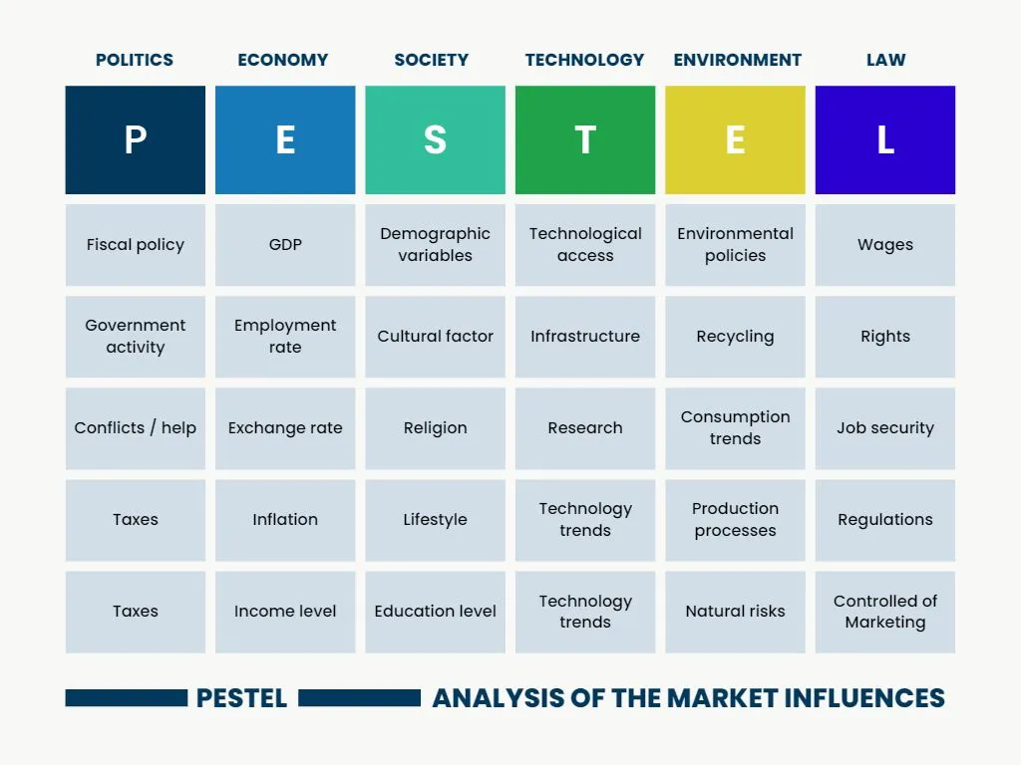
Table: PESTEL Analysis.
Source: (Kinicki, and Fugate, 2018)
- Legal Factors: It is important for any company to follow the rules and laws when it comes to legal issues. Wilko might have had legal problems because of wage laws, health and safety rules, or other rules that were important to the business's activities. If the company doesn't follow the rules, it might lose all of its money. It may incur financial penalties, encounter legal complications, or suffer damage to its reputation (Tan, 2021).
- Environmental Factors: People are making choices that are better for the environment as they learn more about it and how to be more eco-friendly. Wilko could have been advised by tree huggers to address its issues if it had not implemented environmentally favourable practices or demonstrated a lack of concern for the environment (Kim et al., 2018). Additionally, the business might have had to spend extra cash to follow environmental rules.

Conclusion
Wilko ultimately suffered defeat at the hands of a multitude of internal and external factors. A lot of problems happened inside because it didn't change to meet the needs of new customers, use e-commerce, or keep costs low. The situation got even worse when more people began to shop online and markets in other countries started to shake. Both the SWOT and PESTLE analyses emphasise the criticality of proactive planning, adaptability, and strategic decision-making in the contemporary, fast-paced business environment. Numerous retailers would do well to observe Wilko's demise. As this example shows, it is crucial to consistently try new things, make use of technology, and prioritise customer happiness. To stay in business, retailers need to know about the newest market trends, figure out how to use new technology to their advantage, and make solid business plans.

References
Brem, A., Bilgram, V. and Marchuk, A., 2019. How crowdfunding platforms change the nature of user innovation–from problem solving to entrepreneurship. Technological Forecasting and Social Change, 144, pp.348-360.
Ellitan, L., 2020. Competing in the era of industrial revolution 4.0 and society 5.0. Jurnal Maksipreneur: Manajemen, Koperasi, dan Entrepreneurship, 10(1), pp.1-12.
Kim, J.Y., Choi, D.S., Sung, C.S. and Park, J.Y., 2018. The role of problem solving ability on innovative behavior and opportunity recognition in university students. Journal of Open Innovation: Technology, Market, and Complexity, 4(1), p.4.
Kinicki, A. and Fugate, M., 2018. Organizational behavior: A practical, problem-solving approach. McGraw-Hill.
Ning, L. and Li, J., 2018. Joint problem solving and organizational learning capacity in new product innovation. R&D Management, 48(5), pp.519-533.
Rahman, M.M., 2019. 21st century skill'problem solving': Defining the concept. Rahman, MM (2019). 21st Century Skill “Problem Solving”: Defining the Concept. Asian Journal of Interdisciplinary Research, 2(1), pp.64-74.
Tan, O.S., 2021. Problem-based learning innovation: Using problems to power learning in the 21st century. Gale Cengage Learning.
Treffinger, D.J., Isaksen, S.G. and Stead-Dorval, K.B., 2023. Creative problem solving: An introduction. Routledge.
Verganti, R., Vendraminelli, L. and Iansiti, M., 2020. Innovation and design in the age of artificial intelligence. Journal of Product Innovation Management, 37(3), pp.212-227.
Wanzenböck, I., Wesseling, J.H., Frenken, K., Hekkert, M.P. and Weber, K.M., 2021. A framework for mission-oriented innovation policy: Alternative pathways through the problem–solution space. Science and public policy, 47(4), pp.474-489.

