Portfolio of evidence
And 1000-word reflective log.

Table of Contents

Reflective Commentary

References

Portfolio of Evidence

Evidence 1 Background information

Section A: Information sheet

Section B: Placement tasks and activities

Section C: Progress document

Evidence 2 Reflective logs

Evidence 3 Research Development Process

Section A: Literature search

Section B: Development of research question

Section C: Development of interview schedule

Section D: Possible IAT words and phrases

Evidence 4 Reports

BACP code of ethics (Safeguarding and confidentiality)

Appendices

References

Reflective Log

The following contains a reflection on my experiences while carrying out research on menstrual leave as part of my counselling skills placement, and how I, as a future counsellor, will be influenced by these experiences. The reflection will follow Gibbs’ reflective cycle (1998), and as previously mentioned, will focus on the development of my counselling skills and knowledge of psychology through the research I have taken part in (Midwinter and Dickson, 2015).
As part of my counselling skills module, I was required to find and apply for a placement opportunity at a local institution, who’s aim and purpose would be to work closely with disadvantaged individuals, with the intention of adapting and developing my counselling skills and knowledge of psychology. However, as I was late joining the course (having transferred from another university), I was unaware of this part of the module, and therefore made no arrangements to volunteer at a local institution. Because of this, one of my lecturers offered me and another student the opportunity to instead take part in research, looking into the debate and opinions surrounding paid menstrual leave. Having previously worked in the care sector, it was my initial plan to reapply to either work or volunteer at my old place of employment had I not been given the opportunity to take part in this research. I was previously employed at a nursing home in the Gower, and I thoroughly enjoyed the work. While it is young people I would like to work with in the future, I felt like it could be a safe and wise option since I knew what I would be getting myself into. Though, taking the research placement sounded interesting, so I was excited and eager to give it a go. I love new experiences.
Before taking part in this research, I had not heard of menstrual leave. Taking the time to research and learn about the topic was exciting, as there was such a rich and lively debate surrounding it. I came across a variety of opinions and struggled to make up my mind about what I thought about menstrual leave, whether I agreed with the idea and whether I thought it was fair. Of course, these ethical/moral questions and internal battles are something I am going to encounter a lot as a counsellor, so trying to figure out where I initially stood on the topic was a fun mental exercise before getting stuck in to developing the research structure and methodology. Through figuring out my stance on menstrual leave, I was also surprised to discover that most men were clueless about menstruation in general, let alone the idea menstrual leave. This was a common theme among many of the studies my partner and I had investigated. I was immediately aware of the fact that an individual’s views on menstruation in general would act the foundation for their views on menstrual leave as a social policy. Knowing, then, that a most men were so apparently misinformed about menstruation, it was clear that we were going to get some interesting results. I also came to the realisation that one of the methods of analysing data for the study could be likened to counselling. Like counselling, thematic analysis is a way of drawing themes from an individual’s speech, normally in an interview setting. Counselling, then, is essentially thematic analysis in real time. While not significant, I found this similarity interesting.
At first, it was difficult for me to understand why a lot of men were so clueless about menstruation. With myself being raised by mostly, if not all women, menstruation was neither a new nor uncomfortable topic for me. I quickly made judgments about those put off by the idea of menstruation, allowing my self to make sly comments and jokes about how I found it childish. Then, after some thought, I concluded that it was not only internal ethical/moral questions and battles I would have to become accustomed to, but it was also other people’s differing opinions, as well as their own ethical and moral struggles. I had to remind myself that as a counsellor, I must be free of judgment, completely impartial.
Having come to this conclusion, I decided to analyse my own values and virtues. In general, I try my best to stick to these rules/values and dictate how I live my life through this lens. While I understand that it would be impossible (especially today with so many distractions and temptations) to live by such a strict ‘code’ without slipping up every now and then, I believe it is in trying my best to live in accordance with these values and rules that real virtue is to be found. The fact that I was so quick to judge, even as a student taking part in a counselling degree, indicated to me that I needed to reassess myself. Though, not with the intention of scolding myself, rather, to gently remind myself of how best to approach similar situations in the future, given that I am planning on graduating and embarking on a career as a counsellor, after all.

References

Midwinter, & Dickson, J. (2015). Embedding counselling and communication skills : a relational skills model. Routledge.

Evidence 1

Section A:
Information Sheet
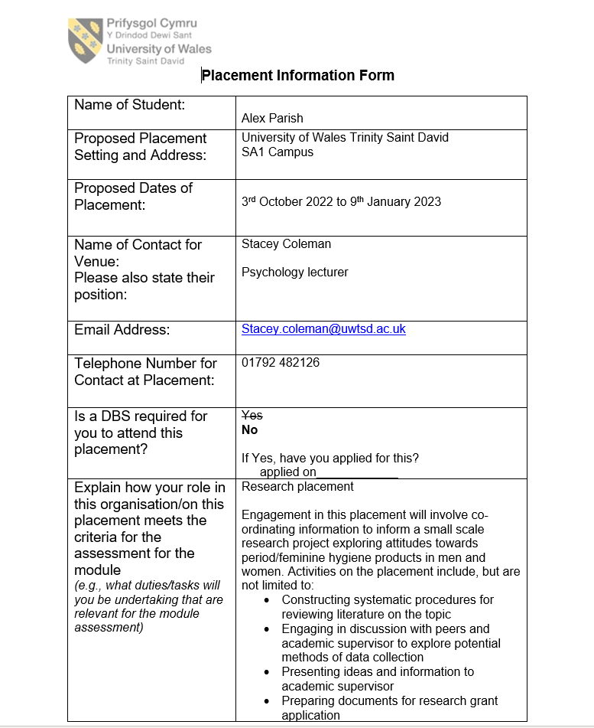

Section B:
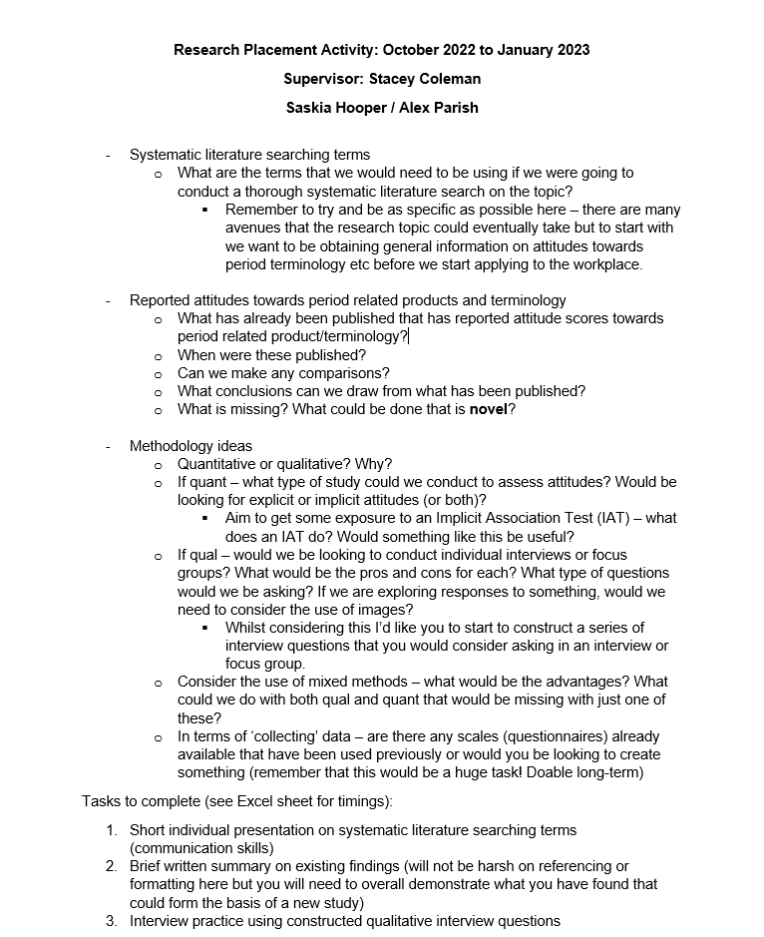
Placement tasks and activities

Section C:
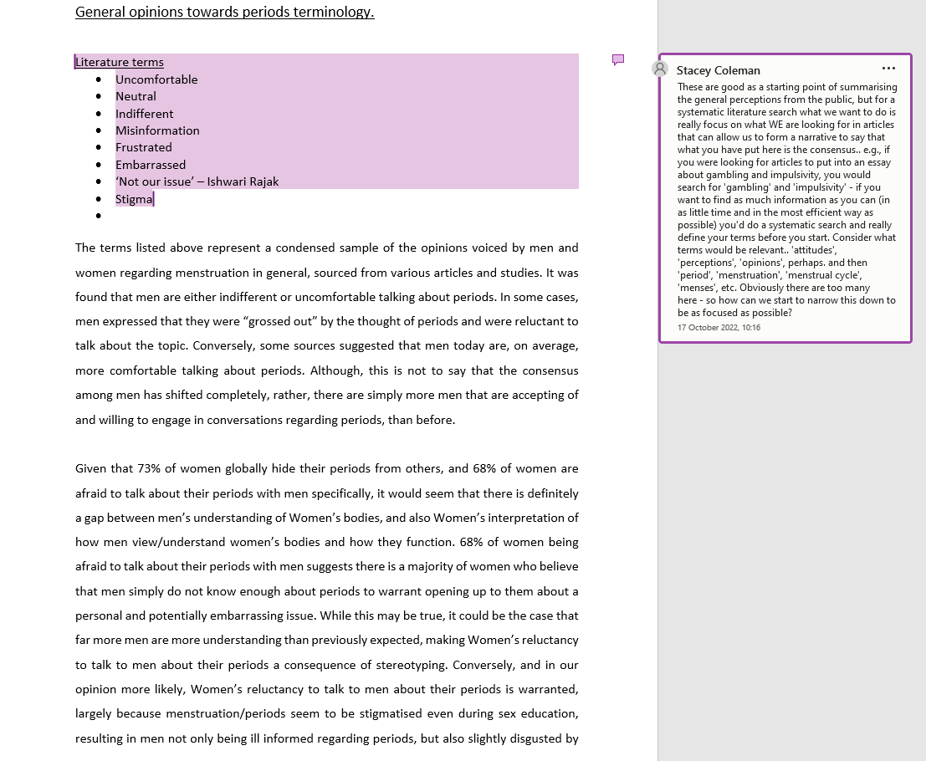
Progress Document

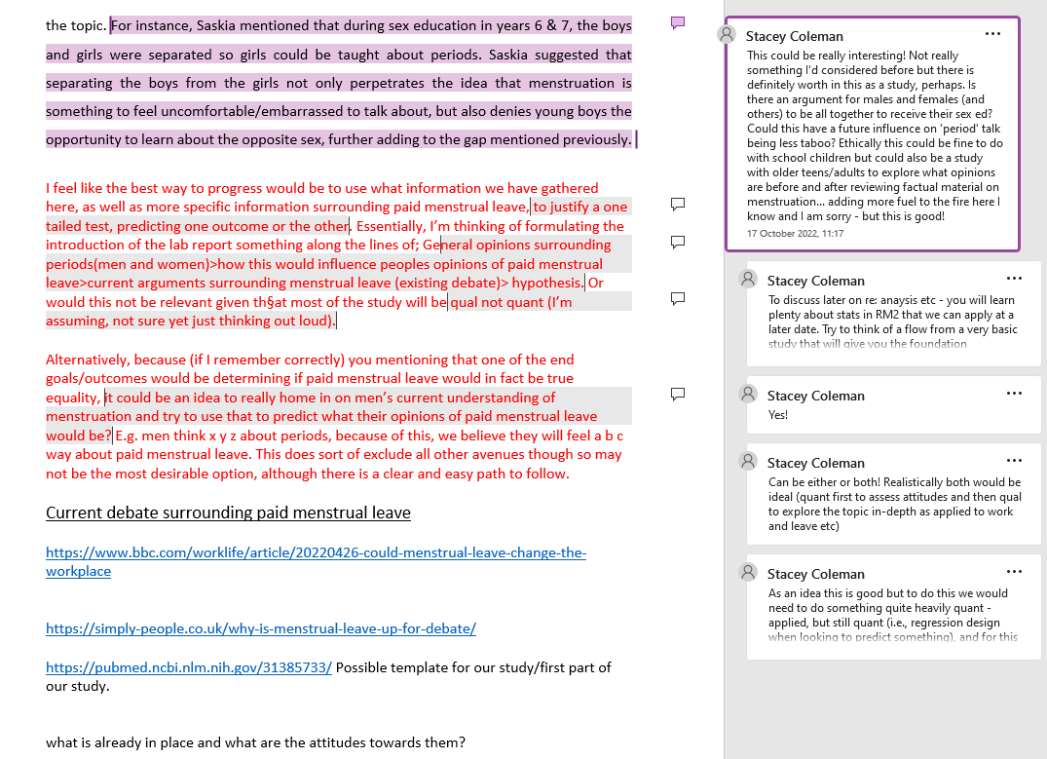
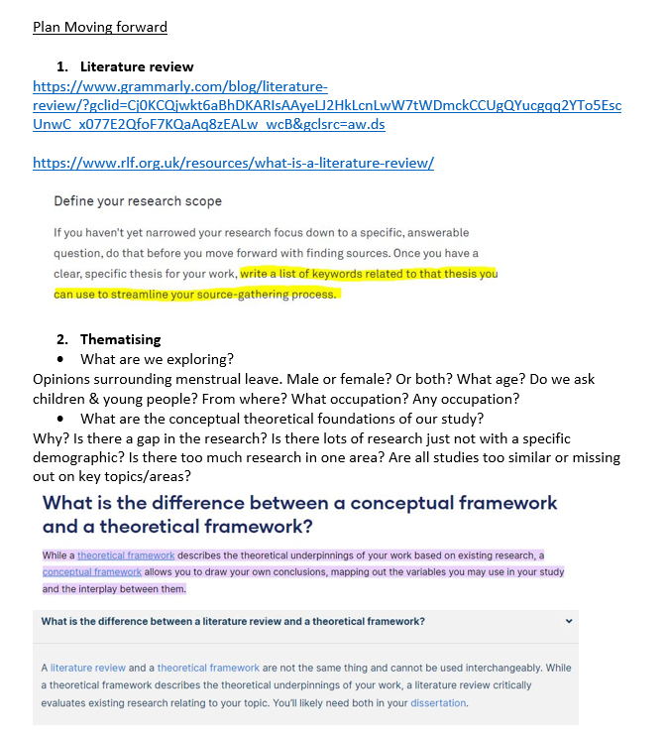

Evidence 2

Reflective log
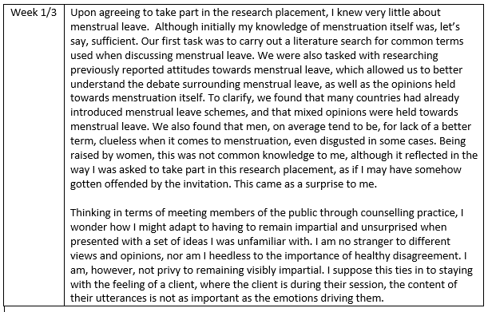
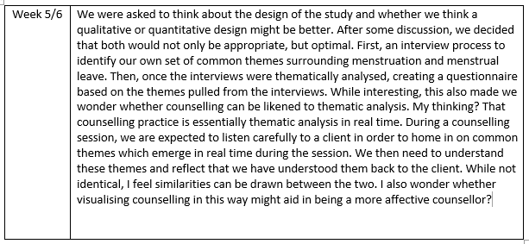

Evidence 3
Section A:
Literature search
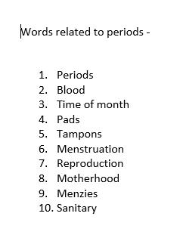
Section B:
Development of research questions
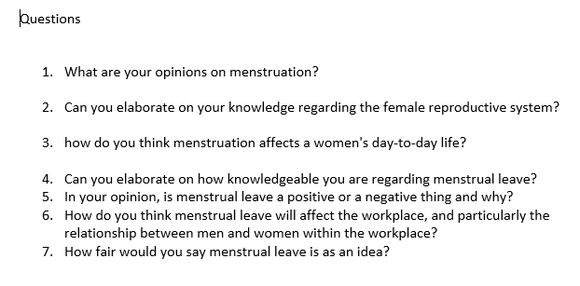

Section C:
Interview schedule and research questions
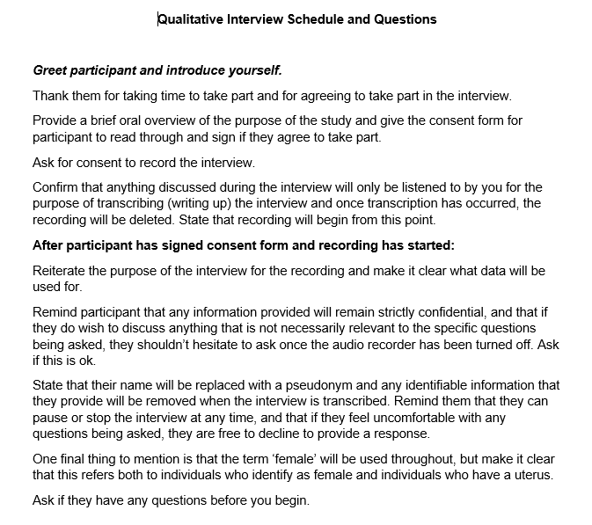
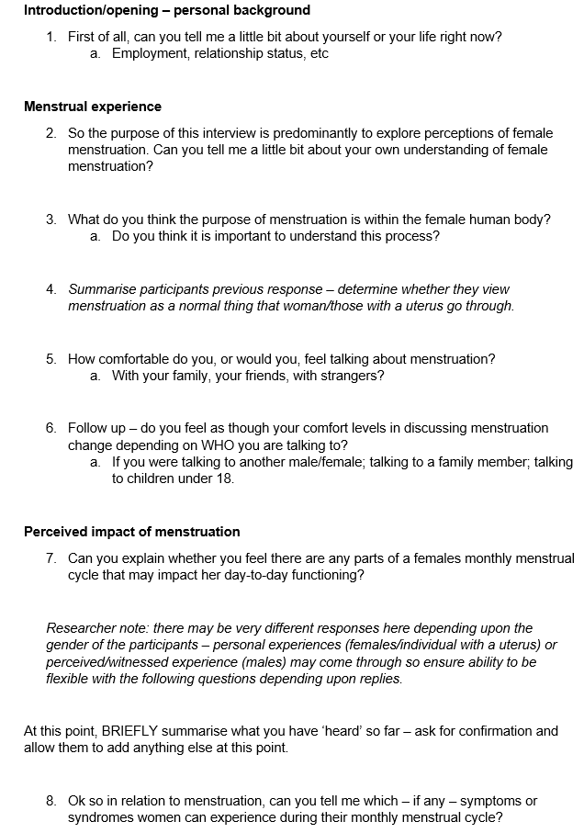
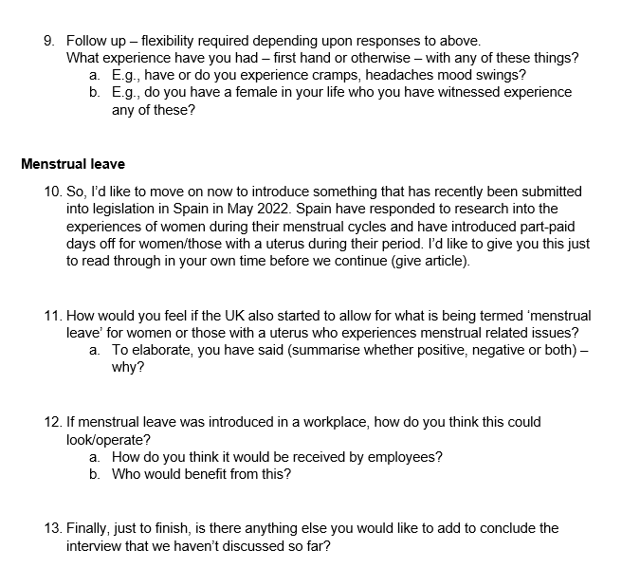

Section D:
Possible IAT words and phrases
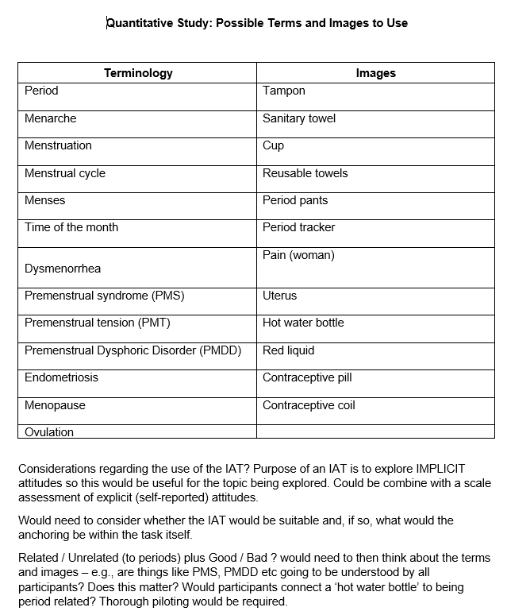

Evidence 4

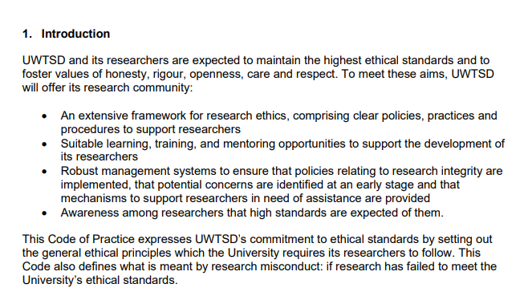
Section A: Confidentiality and safeguarding

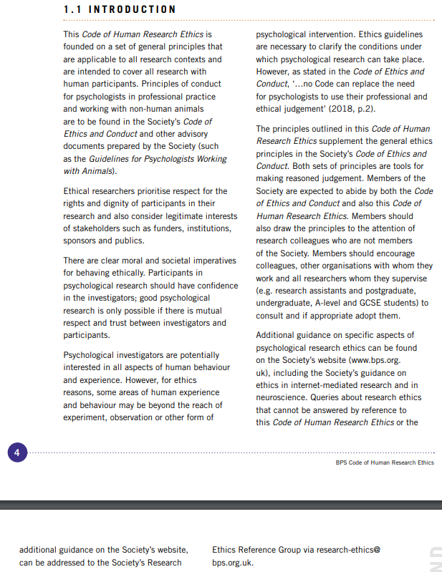
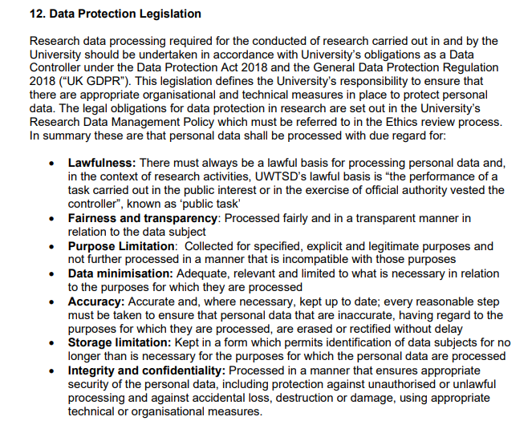

Section B: Counselling ethics

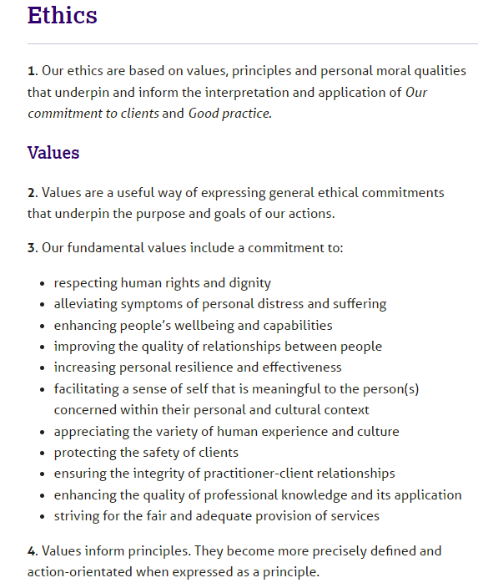

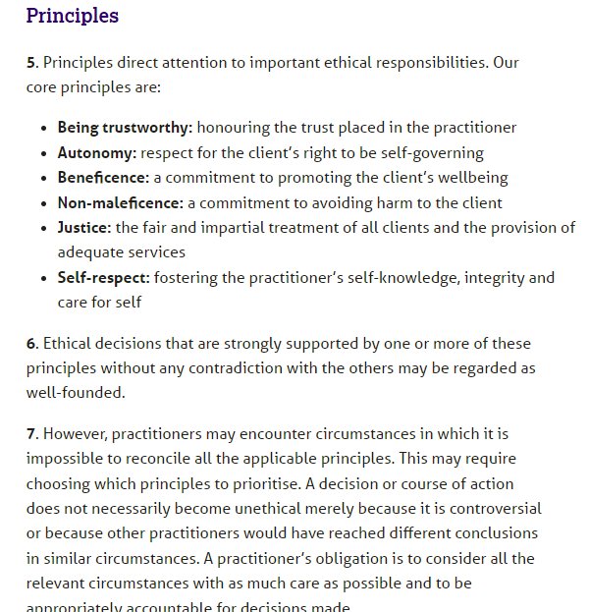

Appendices

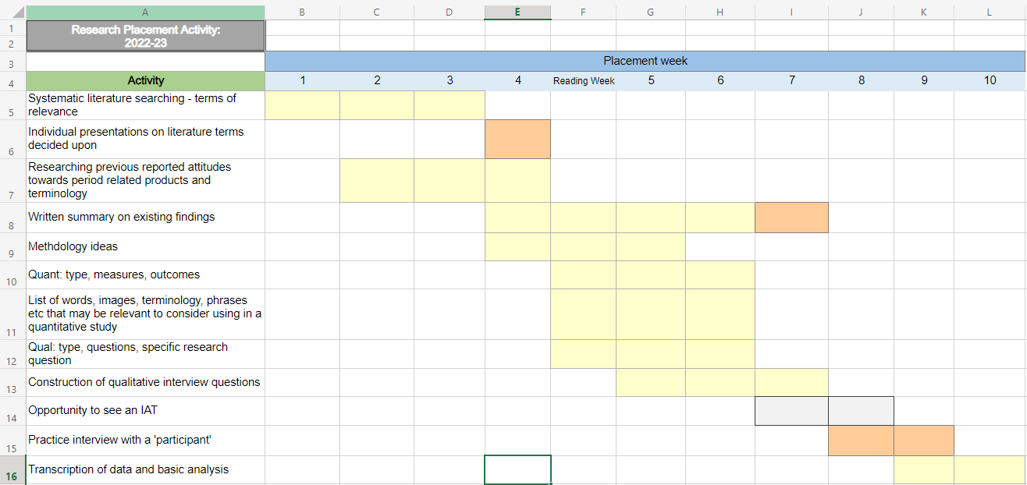
Time allocated to placement

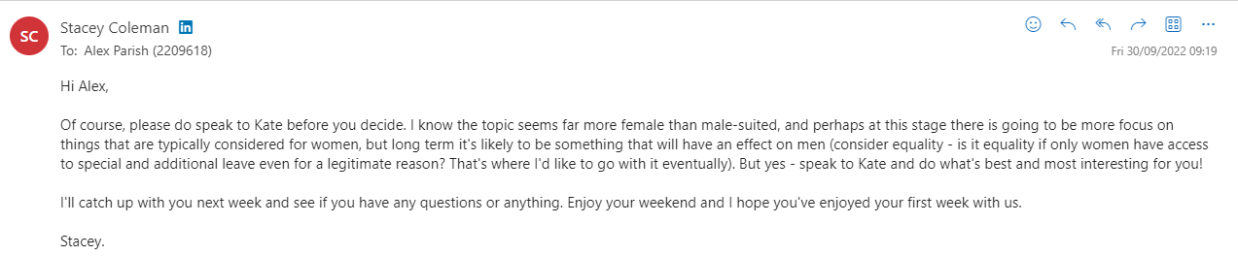
Correspondence with placement Lead

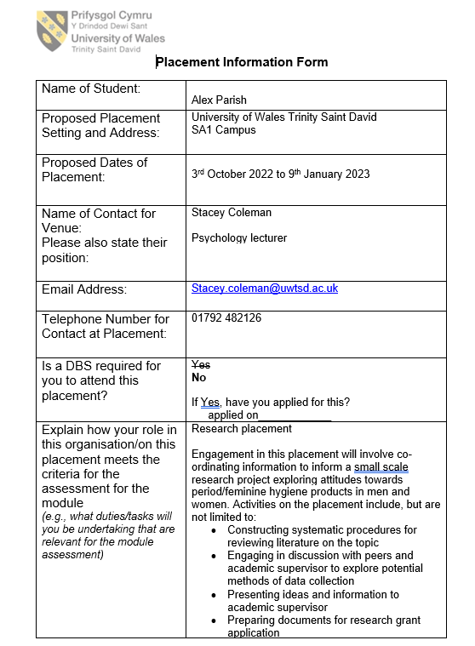
Information Sheet

References

Ethical framework for the counselling professions formally adopted 1 July 2018 (no date) BACP Ethical Framework for the Counselling Professions. Available at: https://www.bacp.co.uk/events-and-resources/ethics-and-standards/ethical-framework-for-the-counselling-professions/ (Accessed: January 8, 2023).

