
Student Name: Ioan Saibel
Student ID: 2420427
Professor Name: Ihsan Ul Haq

Business Intelligence and Its Role in Modern Organisations
LCBB5014 – Data Handling & Business Intelligence

Contents
1. Introduction 1
2. Understanding Business Intelligence Concepts 2
3. Business Intelligence Applications 3
4. Real-World Examples of Business Intelligence 3
5. Benefits and Challenges of Business Intelligence 3
6. Conclusion 4
References 4

1. Introduction
Business Intelligence (BI) refers to the technologies, processes, and practices used by organisations to collect, integrate, analyse, and present data in order to support effective decision-making (Sharda, Delen and Turban, 2020). In contemporary organisations, data is generated continuously through digital transactions, online platforms, and internal business systems. Without structured analysis, this data provides little strategic value. BI enables organisations to transform raw data into meaningful insights that can be used to improve performance and competitiveness (Laudon and Laudon, 2022).
The importance of Business Intelligence has increased significantly due to rapid digitalisation, global competition, and changing customer expectations. Organisations are required to make timely and accurate decisions, often based on large volumes of complex data (McAfee and Brynjolfsson, 2012). BI systems support these requirements by providing managers with dashboards, reports, and analytical tools that enhance visibility across business operations.
The purpose of this report is to explore the role of Business Intelligence in modern organisations. The report will explain key BI concepts and components, examine BI applications across various industries, analyse real-world case studies, and evaluate the benefits and challenges associated with BI implementation. Finally, the report will consider future BI trends and provide recommendations for maximising BI value.

2. Understanding Business Intelligence Concepts
Business Intelligence is a broad concept that encompasses data management, analytics, and information delivery to support business decision-making (Sharda, Delen and Turban, 2020). BI integrates data from multiple sources and transforms it into structured information that can be analysed by decision-makers at different organisational levels.
One of the core components of BI is data collection, which involves gathering data from internal systems such as Enterprise Resource Planning (ERP) and Customer Relationship Management (CRM), as well as external sources such as market data and social media (Laudon and Laudon, 2022). This data is subsequently stored in a data warehouse, which provides a centralised repository optimised for analytical processing rather than daily transactions (Kimball and Ross, 2013).
Another critical BI component is data mining, which focuses on identifying patterns, trends, and relationships within large datasets. Techniques such as classification, clustering, and association analysis enable organisations to discover insights that are not immediately visible through traditional reporting methods (Provost and Fawcett, 2013). These techniques form the foundation for advanced analytics.
Analytics and reporting further enhance BI capabilities by applying statistical and computational models to interpret data. Descriptive analytics explains past performance, diagnostic analytics identifies causes of outcomes, predictive analytics forecasts future trends, and prescriptive analytics recommends actions (Davenport and Harris, 2017). Data visualisation, through dashboards and interactive reports, allows users to interpret complex data quickly and effectively (Few, 2013).
The evolution of BI has been significant. Traditional BI systems focused primarily on historical reporting and static dashboards. Modern BI systems incorporate artificial intelligence (AI), machine learning, and real-time analytics, enabling organisations to generate predictive and prescriptive insights (Chen, Chiang and Storey, 2012). Self-service BI tools now allow non-technical users to analyse data independently, reflecting BI’s transformation into a strategic organisational asset (Marr, 2021).
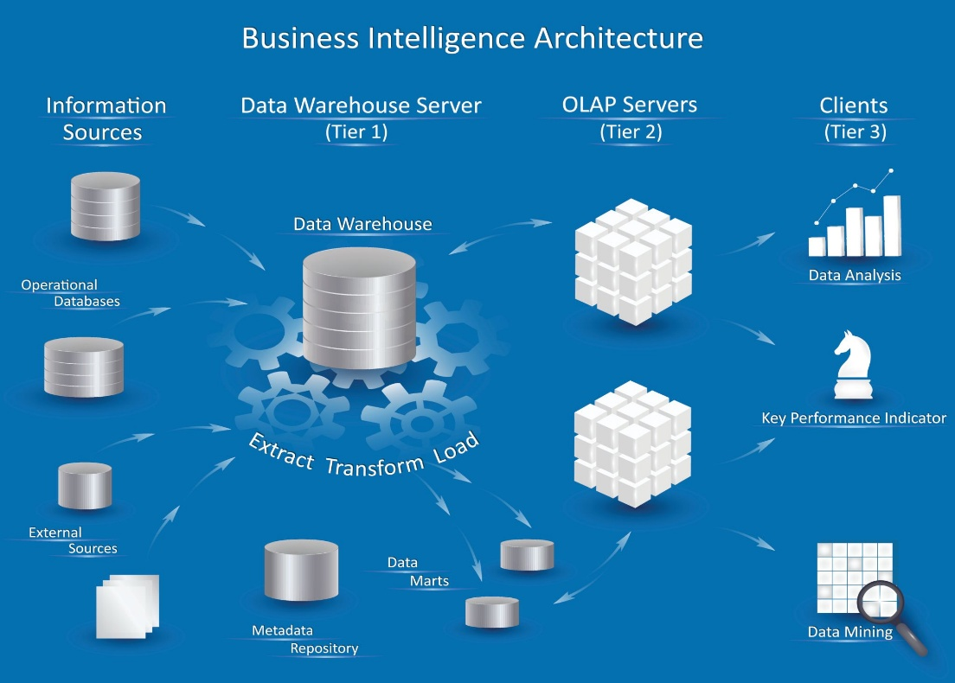
Figure 1: Business Intelligence Architecture
Source: Adapted from Sharda, Delen and Turban (2020).
As illustrated in Figure 1, Business Intelligence integrates data from multiple sources into a data warehouse, where analytics and reporting tools support managerial decision-making (Sharda, Delen and Turban, 2020).

3. Business Intelligence Applications
Business Intelligence applications are widely used across industries to support operational efficiency and strategic decision-making. Common BI tools include dashboards, reporting systems, data mining software, and predictive analytics platforms, all of which help organisations analyse large datasets efficiently (Power, 2019).
In the finance industry, BI is used for fraud detection, risk assessment, and financial forecasting. Financial institutions analyse transaction data to identify anomalies and prevent fraudulent activities (Sharda, Delen and Turban, 2020). BI dashboards also support regulatory compliance by providing accurate and timely financial reports (Laudon and Laudon, 2022).
In the retail sector, BI plays a crucial role in analysing customer behaviour, optimising inventory management, and supporting personalised marketing strategies. Retailers use BI to forecast demand, reduce stockouts, and improve pricing strategies (McAfee and Brynjolfsson, 2012). Data-driven insights enable retailers to enhance customer satisfaction and improve operational performance (Davenport and Harris, 2017).
The healthcare industry relies on BI to improve patient outcomes and operational efficiency. BI systems analyse patient records, treatment outcomes, and resource utilisation to support clinical and administrative decisions (Raghupathi and Raghupathi, 2014). Dashboards help hospitals monitor performance indicators such as waiting times and bed occupancy.
In manufacturing, BI supports supply chain optimisation, quality control, and predictive maintenance. Manufacturers analyse production and sensor data to reduce downtime and improve efficiency (Marr, 2021). Predictive analytics enables proactive maintenance planning, reducing operational costs and increasing productivity.
Popular BI platforms such as Power BI, Tableau, and SAP Business Intelligence provide interactive dashboards, advanced visualisation, and enterprise-level analytics. These tools enhance data accessibility, collaboration, and decision-making across organisations (Sharda, Delen and Turban, 2020).

4. Real-World Examples of Business Intelligence
A well-known example of BI application is Amazon, which uses BI and analytics extensively to personalise customer experiences and optimise operations. Amazon analyses customer browsing behaviour, purchase history, and feedback to generate personalised recommendations, increasing sales and customer engagement (Marr, 2021). BI also supports supply chain optimisation by forecasting demand and managing inventory efficiently (Davenport and Harris, 2017).
Another strong example is Netflix, which relies on BI to guide strategic decisions related to content creation and customer retention. Netflix analyses user viewing patterns and engagement metrics to recommend content and decide which original productions to invest in (Seddon et al., 2017). Predictive analytics reduces uncertainty in content investment decisions and enhances customer satisfaction.
In the retail sector, Walmart uses BI to optimise inventory management and pricing strategies. By analysing point-of-sale and supply chain data, Walmart can respond quickly to changes in customer demand and market conditions (McAfee and Brynjolfsson, 2012). These BI-driven practices have contributed to reduced operational costs and improved profitability.
These case studies demonstrate that BI can deliver measurable benefits such as increased revenue, improved decision-making speed, enhanced customer experience, and greater operational efficiency (Marr, 2021).

5. Benefits and Challenges of Business Intelligence
One of the primary benefits of Business Intelligence is improved decision-making, as BI provides timely, accurate, and relevant information to managers (Power, 2019). BI also enhances operational efficiency by identifying inefficiencies and performance gaps across business processes (Davenport and Harris, 2017). Furthermore, BI enables organisations to gain deeper customer insights, supporting personalised products and services (McAfee and Brynjolfsson, 2012).
Another key benefit is the achievement of competitive advantage. Organisations that effectively use BI can respond more quickly to market changes and make informed strategic decisions (Sharda, Delen and Turban, 2020).
Despite these advantages, BI implementation presents several challenges. Data quality issues, such as incomplete or inaccurate data, can undermine BI effectiveness (Kimball and Ross, 2013). High implementation costs and system complexity may limit adoption, particularly for small organisations (Laudon and Laudon, 2022). Additionally, a skills gap exists due to the shortage of data analytics expertise, while data privacy and security concerns have become increasingly important (Marr, 2021).
To overcome these challenges, organisations should establish strong data governance practices, invest in employee training, and adopt scalable, cloud-based BI solutions (Sharda, Delen and Turban, 2020).

6. Conclusion
This report has explored Business Intelligence and its role in modern organisations. It has examined key BI concepts, applications across industries, real-world case studies, and the benefits and challenges associated with BI implementation. The analysis demonstrates that BI is a critical tool for improving decision-making, operational efficiency, and competitive advantage.
Looking to the future, BI will continue to evolve through advancements in artificial intelligence, real-time analytics, and self-service platforms (Chen, Chiang and Storey, 2012). Organisations that invest in data quality, analytical capabilities, and a data-driven culture will be best positioned to maximise BI’s potential and maintain competitiveness in an increasingly data-driven business
environment (Marr, 2021).

References
Chen, H., Chiang, R.H.L. and Storey, V.C. (2012) ‘Business intelligence and analytics’, MIS Quarterly, 36(4), pp. 1165–1188.
Davenport, T.H. and Harris, J.G. (2017) Competing on Analytics. Boston: Harvard Business School Press.
Few, S. (2013) Information Dashboard Design. 2nd edn. Burlingame: Analytics Press.
Kimball, R. and Ross, M. (2013) The Data Warehouse Toolkit. 3rd edn. Hoboken: Wiley.
Laudon, K.C. and Laudon, J.P. (2022) Management Information Systems. 17th edn. Harlow: Pearson.
Marr, B. (2021) Data Strategy. London: Kogan Page.
McAfee, A. and Brynjolfsson, E. (2012) ‘Big data: the management revolution’, Harvard Business Review, 90(10), pp. 60–68.
Power, D.J. (2019) ‘Decision support, analytics, and business intelligence’, Journal of Decision Systems, 28(1), pp. 1–3.
Provost, F. and Fawcett, T. (2013) Data Science for Business. Sebastopol: O’Reilly.
Raghupathi, W. and Raghupathi, V. (2014) ‘Big data analytics in healthcare’, Health Information Science and Systems, 2(1), pp. 1–10.
Seddon, P.B. et al. (2017) ‘How does business analytics contribute to business value?’, Information Systems Journal, 27(3), pp. 237–269.
Sharda, R., Delen, D. and Turban, E. (2020) Business Intelligence, Analytics, and Data Science. 4th edn. Harlow: Pearson.

