

Problem Solving and Decision
Making

Student Name: Alexandru Cardei Pantiru
Student ID: 2009433
Lecturer Name: Balendran Kandasamy

Table of Contents
Task 1- Role Play 3
Task 2- Report-Complex Problem’s Scope and Impact 4
Cause-and-Effect Analysis of the Problem 7
PESTLE analysis 9
Evaluation of Alternative Solution 11
Planning Implementation and Evaluating Outcome 12
Conclusion 13
References 14

Task 1
The following role play I will talk about is an unsatisfied employee working for a Security Company. I will try to find any problems that lead to employee dissatisfaction and of course find solutions in solving this case.
I mention this is a real life case scenario.

Alex: Hello. My name is Alexandru Cardei, I’m the Consultant Manager at Next Bodyguard Protection Ltd

Mina: Hello Sir, my name is Mina, I’m an employee working with the company for about 4 months. I would like to talk to you regarding job queries.

Alex: Hi Mina, yes of course, how can I help you today?

Mina: I would like to discuss a few work related issues. I’m facing difficulties with the job schedule and pay rate.

Alex: Yes, of course. Can you describe your job issues you’re facing in your workplace?

Mina: First of all, job dissatisfaction has become the source of many problems and difficulties in my life. For instance, I do not enjoy the work, which hampers our efficiency and productivity very much (NASIM, 2021). Also, the pay rate no longer satisfies me because I'm overqualified and the payment and the qualifications I have do not match. In addition to this, working hours affect my family life due to long night shifts. In addition, I have worked so hard to build the experience I have and I feel that I'm not rewarded accordingly. I get home late, I have family and I can't stay to work late anymore. I know it is very busy, but I would like it if my shifts can be changed, to work during the day, maybe, less hours if that would be possible.

Alex: I understand your concern about the job you are doing and I would like to help you. We see that in the last couple of months since you became an employee in our Company your performance has increased very well within the role. I looked into your CV and I’m really impressed with your qualifications and skills. I know this is a challenging time for all of us and I would take all aspects into consideration. Due to our company policy agreement, you will be qualified for the possible pay rise once you will pass your probation period — which is 6 months within the company. Regarding your second matter, long working hours, I am sure that we can look into it and find the best solution for you. Could you please tell me what solution would be the best for the shifts you've been working?

Mina: Yes. I am happy with the company I work with and I would be glad to wait until the probation period has passed. Regarding the shift pattern I'm working now, in my situation it would be best for me to do morning or day shifts without any late shifts/nights. Is it possible to make an arrangement regarding this?

Alex: Yes. I will consult my area manager and we will discuss further to find the best solution for you. I will give you a written confirmation of the decision via email within 5 working days. We can discuss this matter further to see if this will match your requirements regarding your job role and what decision we are taking.

Mina: That will be great! I am looking forward to hearing from you as soon as possible Mr Alex
Thank you!

Alex: I want you to understand that we are here to help you and offer you the necessary support, we are with you and only together we will succeed. Thank you for having the courage to pass on these work-related issues to me. I'm sure that our desire will be a favourable one and that we will work together in the future.

Task 2
Individual Report

Introduction
In this report, the focus is on employee dissatisfaction because of the pandemic. It’s scope and impact will be analysed. Solutions will be evaluated and examined to find the most optimal one. The plan implementation procedure will also be discussed, and suitable monitoring and review techniques will be assessed.

Complex Problem’s Scope and Impact
The pandemic has taken a toll on all of us both mentally and financially. Because of Continuous lockdown businesses were not allowed to open and many people had to work from home. It created new challenges, and many struggled to maintain a work-life balance (Sargeant, 2018). So, the problem is that the Covid-19 has caused employee dissatisfaction because of stress, domestic challenges and financial insecurity. Because of the high employee dissatisfaction, people are quitting and leaving jobs. This has led to a high turnover rate and low retention rate which is not beneficial for the company as the cost of hiring a new employee is significantly higher than retaining the old employee (Sargeant, 2018). In the UK, it is at least £12,000 and may vary. Because when a new employee is hired there are some costs associated with the hiring process and the company also has to spend extra money for the training and development of employees further increasing the cost. Employee dissatisfaction also makes employees demotivated and become reluctant to work which leads to low productivity and poor customer service (Sumra and Haseeb, 2019). Ultimately, the overall organisation productivity is decreased. Employee dissatisfaction creates a bad working experience with the employers. It creates animosity and hostility towards the employers. Employees feel they are not being properly taken care of which destroys the amicable relationship between the employee and employers. The low productivity causes the business enterprise to get low outputs from higher inputs which increases the costs. Also, because of the poor customer service, customers get upset and angry. Because of the horrible experience the customers do not buy again (Sumra and Haseeb, 2019). So, the organisation not only fails to create customer loyalty and repeat customer base but also increase the consumer acquisition cost as the cost of getting a new customer is five times higher than an old repeat customer. Employee dissatisfaction can create a bad reputation for the company. disgruntled employees can make negative comments about the company with their family and friends and with the aid of the grapevine, the organisation can get a bad name. For this reason, the company can lose potential employees and customers and the company is also unable to create a talented workforce that will give competitor’s the edge and the company will have to fold out (Sumra and Haseeb, 2019).

Cause-and-Effect Analysis of the Problem

The cause and effect refer to examining and analysing two of the key steps of the issue under consideration which looks backwards and forward. By retracing the backward steps, it gives the opportunity to identify the mistakes and how these mistakes have cost money to the business. it provides a reflection on the past processes. The cause-and-effect analysing is discussed in the context of employee dissatisfaction is given below:
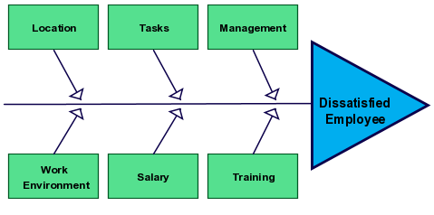
Figure 1: Cause and Effect Analysis
Source: (creately.com, 2021)
The Covid-19 has caused stress and uncertainty for the employees. The mental wellbeing of the workforce is vital. It leads to absenteeism, low productivity and quitting the job. Job satisfaction has been down by 35% in the pandemic crisis (Rafferty, 2019). There are six factors on which employee satisfaction depends. Employers have control over these factors. The Covid-19 is also one of the reasons for job dissatisfaction, but it is something the organisation has no control over and neither has the solution. However, by influencing other factors employee dissatisfaction might be reduced (Rafferty, 2019).
Location: The lockdowns and the protocols of social distancing have prevented employees from working in the office. Almost all the employees in the UK except essential services have worked from home. By working at home many people can now waste time talking to friends and family, many have to juggle between work and caring for a baby or family member. So, the location may not be changed (Whittaker, 2018). However, by providing flexible work hours and mental wellbeing support. It lacked a work-life balance. The stress effect can be curtailed.
Tasks: The procedure of doing tasks has also shifted slightly from the traditional method. Many meetings, work reports, performance reports etc. have been done online. The payments have also been contactless. Many had to work more hours. The new way of doing things has made it tough for employees to do their jobs. The harder the job, the more dissatisfaction (Whittaker, 2018).
Management: The HR department of any company has the reasonability of motivating the employees. nonetheless, only 31% felt very supported by their manager and only 16% felt the same about HR policies (Whittaker, 2018). The pandemic has made it challenging to manage employees. Without proper management and direction, the employees may not understand the job tasks which further reduces their motivation and organisational productivity gets low. The management has to be more communicative and HR policies should target assisting the employees (Brömmelmeyer, 2019).
Work Environment: The Covid-19 has forced business enterprises towards remote working and co-working. People cannot go to the office and do their tasks from home. 64% of the employees in the UK are based in the home. The home of an employee does not have a rich and stimulating atmosphere as the office, but a dynamic workspace can be created (Brömmelmeyer, 2019). As the work environment at home is very much unsuitable, employees are struggling to complete daily tasks which are mentally exhausting. However, remote working space can save employer’s money in rent or office costs and also reduces carbon emissions. These can be used to ensure employee mental wellness (Brömmelmeyer, 2019).
Salary: The employees have also taken a hit in their salaries. The government initiative that was taken paid only 80% of the salary. The government pays 60% for the hours' employee is on furlough and 70% of the wages (Darmawan, 2021). It has definitely impacted the employee lifestyle because now they have less disposable income. Also, one of the best motivating factors for employees is an attractive salary which has not been possible in the Covid-19. 29% are worried about the job and 16% have insecurity about their wages. This has caused employees to feel demotivated and to lose their interest in work (Darmawan, 2021).
Training: Training materials and continual development programs for employees is a good motivating factor. It allows the employee to learn and allows them to focus on future prospects. Because of the pandemic, physical training workshops and hands-on experience have not been available (Aulia Safitri, 2019). Also, there is an increasing unemployment issue. The employer could not give the workforce the facilities to train. However, there are online workshops, courses and virtual sessions available. Without the proper training, the workforce was not very much skilled leading to low performance (Aulia Safitri, 2019).

PESTLE analysis
The pestle analysis has six factors. They are political, economic, social, technological, legal, and environmental. These are discussed below:

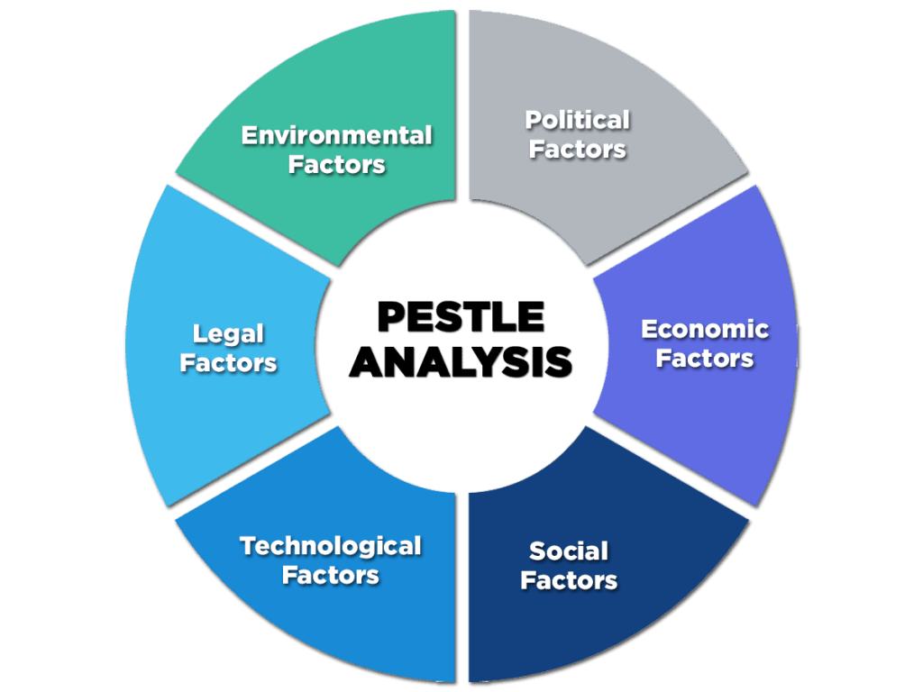

Figure 2: Pestle Analysis
Source: (enterslice.com, 2021)

Political: The political factor has both advantages and disadvantages. Because of lockdown, employee stress is higher leading to unemployment. However, the UK government has created schemes for the public to pay their salaries. It may not be the full amount but has been quite instrumental in stopping the economic crash. Also, it has given many people job security as businesses were closed, it was impossible to pay the salaries. still, 25% of people felt that they might lose their jobs (Achinas and Horjus, 2019). Nonetheless, without the government scheme, the situation would have been more drastic.
Economic: The Covid-19 had a negative impact on the economy. There has been a lot of fluctuation in prices and people’s quality of life also has been affected. Employee stress levels and unemployment is on the rise. People’s disposable income has also decreased. The slow pace of the economy and lower salaries has further posed a challenge on the employees to maintain their motivation. As salaries, benefits and promotion are the best way to incentivize (Walsh and Roma, 2019).
Social: The continuous lockdowns and health protocols prevented people from having a social life. People could not meet with family and friends for months. This isolation has caused stress in people. People could not get to school, university, office, parties and holidays etc. (Walsh and Roma, 2019). Also, people had too much time to work that created overthinking, mental loneliness, anxiety, eating disorders etc. so, the anxiety and stress caused employee dissatisfaction and fogged the ability of the workforce to do their tasks properly (Walsh and Roma, 2019).
Technological: Technological advancements have helped in these difficult times. People were able to buy groceries and other essential commodities and services through online and contactless payment. Completely avoiding human contact (Bella, 2018). Except, essential workers, most people conducted their jobs tasks by working online which may have helped in taking some of the monotony out of life. People could talk and connect with their friends via zoom or google meet and business meetings were also done in the same way. So, technology had an indirect impact of giving the employee the strength to go on (Bella, 2018).
Legal: In the Covid-19, the government imposed lockdowns. There was a restriction in travel and people had to follow safety protocols. People were fined and jailed for breaking the rules. The disconnection from people and quarantine made the process stressful which had a hand in making employees somewhat dissatisfied (Bella, 2018).
Environmental: The working environment plays a role in making employees satisfied. By creating a friendly and innovative culture, the working environment should be toxic-free. Constructive discussions and conflict resolution should be taken. There is no direct relationship between employee dissatisfaction and the natural environment. However, natural elements can influence mood and the absence of natural components can lead to depressed mood and job satisfaction may decrease (Sell and Cleal, 2016).

Evaluation of Alternative Solution
The solutions are virtual therapy sessions, technological sessions, virtual workshops and training programs and HR policies. These are discussed below:
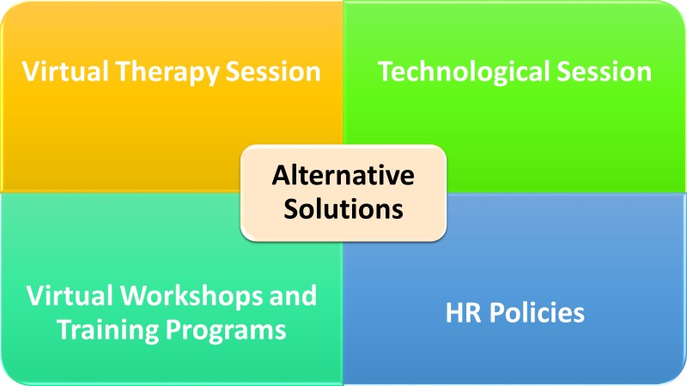
Figure 3: Alternative Solution
Source: Author’s Design
Virtual Therapy Session: The pandemic has been nerve-wracking and exhausting for people’s mental health. it has been quite taxing, and people have suffered from major depression and some even committing suicide. However, virtual therapy sessions can help. The employers can provide free mandatory therapy sessions for the employees to sort out the issues. With proper support and reaffirmations, the employees can be incentivized (Park, 2019).
Technological Session: The abrupt change in doing tasks has shifted from the traditional methods technological side. People are doing remote work (Park, 2019). But as it is now, many people are facing difficulties in properly operating them. The company can organise technical know-how sessions so that people are more efficient in using the technology and are familiar with space. This will aid them in doing their job properly and in less time. So, the discontent will be reduced (Park, 2019).
Virtual Workshops and Training Programs: Employees also need proper training to enhance their productivity thus improving the overall organisational performance. In the pandemic physical workshops has not been possible. However, the business enterprise can provide virtual workshops and online training programs to develop employee skills. As employees become more confident in their job tasks and skills, dissatisfaction will decrease (Chen and Kong, 2021).
HR Policies: The HR policies in the UK have not been quite successful. Only 16% of the employees felt supported by the HR policy. The HR policy should be properly created and strategized to provide employee service that reduces dissatisfaction (Ali, 2019). However, the employees are getting mental wellbeing support. The organisation’s HR should focus on providing monetary compensation rather than non-monetary benefits. Providing financial support and an attractive salary is the best way to eliminate employee dissatisfaction (Ali, 2019).
So, the most appropriate solution is to create an HR policy for providing employee’s monetary support.

Planning Implementation and Evaluating Outcome
The organisation’s planning and implementation of the process can be described with the aid of change management. It is discussed below:
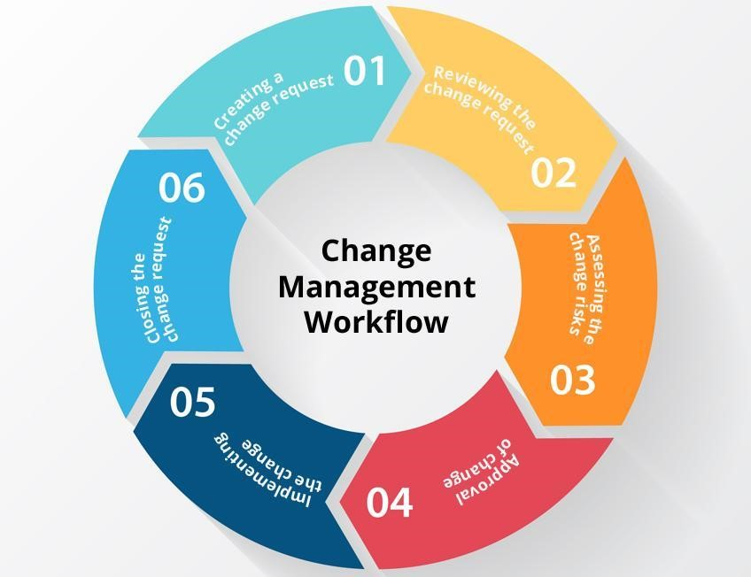
Figure 4: Change Management
Source: (Jahan, 2021)
Creating a change request: The HR of the organisation can take the charge of lifting the issue of employee dissatisfaction. HR should be clear about the importance of workforce’s satisfaction and how providing monetary benefits can boost the employee’s motivation and enhance employee performance. Benefits, promotions, salary and salary increments are the most crucial factor for incentivizing employees (Gupta, 2017).
Reviewing the change request: The corporate management will evaluate and examine the change request to determine whether it is the optimal process and if there is any need for correction and revising. It must be beneficial for both the company and the employee otherwise the request will be rejected (Gupta, 2017).
Assessing the changing risk: The organisation has to assess the risk level that is intertwined with the change. This will aid in achieving greater productivity as qualitative and quantitative criteria will be combined for the evaluation. Also, by identifying risk, they can look for ways to reduce it. However, if it is too risky, the organisation will drop the project (Abicho, 2017).
Approval of Change: After reviewing and assessing the risk, the organisation has to determine if it is the right way to go. Corrections and modifications can be made necessary. The organisation may increase the benefits but not as much as HR requested. If everything is alright, the change will be approved (Abicho, 2017).
Implementing the change: After approval, the accounting and finance department will figure out the way to source the funds without hurting company operation and performance. Then the HR will oversee to ensure that employee’s get properly motivated, and productivity has increased (Nilsen and Seing, 2019).
Closing the change request: When the implementation process is complete. It should be analysed and evaluated to identify the benefits and the costs. Then the close request should be closed (Abicho, 2017).

Conclusion
The coronavirus crisis has made achieving employee satisfaction more challenging than ever. Employers are looking for ways to motivate the workforce in these crucial times. Because by getting a talented workforce and keeping employees satisfied is the way of getting an edge over the rivals. Also, the future may lead to a remote working system. So, employers should place strategies to stay competitive in the future.

References
Abicho, T., 2017. Perceptions toward Leadership, and Change Management. Prehospital and Disaster Medicine, 32(S1), p.S98.
Achinas, S. and Horjus, J., 2019. A PESTLE Analysis of Industries in Europe. Sustainability, 11(21), p.5981.
Ali, A., 2019. Impact of HR Policies and Practices on Employee Job Satisfaction. SEISENSE Journal of Management, 2(2), pp.48-57.
Aulia Safitri, F., 2019. The Effect of Training, Discipline, Motivation, and Satisfaction on Employee Achievement. SSRN Electronic Journal,.
Bateman, C., 2018. Role-taking, role-play, and story-play with Tolkien's legendarium. International Journal of Play, 3(2), pp.107-118.
Bella, D., 2018. Technological forecasting and social change. Technological Forecasting and Social Change, 34(4), p.iv-v.
Brömmelmeyer, C., 2019. Typical areas of employee dissatisfaction. Management Report for Nonunion Organizations, 20(4), pp.4-5.
Chen, P. and Kong, Y., 2021. Development of a Virtual Training Program Amidst the Covid-19
Era. Journal of Education and Training Studies, 9(2), p.45.
Darmawan, K., 2021. SALARY: DOES AFFECT EMPLOYEE MOTIVATION AND
PERFORMANCE?. International Journal of Accounting and Management Research, 1(2), pp.46-51.
Gupta, P., 2017. Change Management at the heart of Strategy. NHRD Network Journal, 5(3), pp.80-87.
NASIM, S., 2021. HR Practices and Organizational Performance: What Role Does Employee Satisfaction Play?. International Review of Management and Business Research, 10(1), pp.375-386.
Nilsen, P. and Seing, I., 2019. Implementation of change in business enterprise. Implementation Science, 14(1).
Park, D., 2019. Employee Satisfaction Evaluation. Employee Assistance Quarterly, 8(2), pp.15-34.
Rafferty, D., 2019. Overview of cause-and-effect analysis of employee job dissatisfaction. European Journal of Business and Management,.
Sargeant, M., 2018. Employee satisfaction and dissatisfaction. Employee Relations, 23(5), pp.483-497.
Sell, L. and Cleal, B., 2016. Job Satisfaction and Work Environment. LABOUR, 25(1), pp.1-23.
Sumra, S. and Haseeb, S., 2019. The Impact of Employee Dissatisfaction on Employee and Organizational Performance. International Journal of Scientific and Research Publications (IJSRP), 9(6), p.p9003.
Walsh, K. and Roma, E., 2019. An analysis of political, economic, social, technological, legal and environmental (PESTLE) factors. MedEdPublish, 8(2).
Whittaker, S., 2018. Who is responsible for employee dissatisfaction?. Leader to Leader, 2008(50), pp.53-54.
creately.com, 2021. [online] Available at:
<https://creately.com/blog/diagrams/how-to-use-cause-and-effect-analysis/#:~:text=The%2 0cause%20and%20effect%20analysis%20basically%20involves%20two,you%20are%20ab le%20to%20work%20towards%20avoiding%20> [Accessed 8 August 2021].
enterslice.com, 2021. [online] Available at:
https://enterslice.com/learning/pestle-analysis-a-mechanism-for-analysis-of-businesses/?__ cf_chl_managed_tk__=pmd_33207c68b2edd7d67cac4f4579e6d43250eea13f-1628440600 -0-gqNtZGzNAvijcnBszQZ6.
Jahan, S., 2021. Change management | Human Resource Management. [online] Human Resource Management | A School of Human Resource Management. Available at: <http://hrmpractice.com/change-management/>.

