

BA (Hons) Leadership and Management Skills for the Workplace

Module: Leading and Implementing Workplace Change
Module code: BMSW6103

Student: Rupia Hussain-ID: 2010133
Lecturer: Nadeem Mirza

Assignment Title: Individual Report on:
Change Management Plan

Executive summary

In this report, we will analyse McDonald's, one of the world's leading fast-food restaurant chains. Using various business analytical tools and change management theories/models scrutinize present position, strengths, weakness and the impact of the Covid-19 pandemic influence and how the organisation managed change and stayed ahead of the market even in the volatile unstable times.

The primary business analytical tools and change management theories/models that will underpin this report are as follows: SWOT, Pestle. Change Management Theory: Kotter’s, ADKAR and Lewin's Change Management Model.
Impact of New Change Implementations Expected Outcome and Suggestions for McDonald's short- and long-term goals and recommendation.

The organisation's recent history, along with an analysis of how external factors such as the COVID-19 pandemic and ongoing economic uncertainty, have influenced the company. This includes an examination of strategic changes within the organisation and how they were effectively managed. A change management plan with recommended actions for new leadership approaches. Also, the report will explore the potential ramifications of not adhering to McDonald's recommendations and highlight the importance of their implementation.

Table of Content

Page Number
1. Introduction…………………………………………………………………………………..…………...4
Justification of choice of organisation…………………………………………..4
Impact of external factors……………………………………………………………..5
2. Impact of Covid-19 Pandemic…………………………………………………………………….5
Pestle analyses…………………………………………………………….…………………6
Swot analyses……………………………………………………………….………………..7
3. Types of Leadership………………………………………………………….……………….............10
4. Impact of McDonald’s Culture…………………………………………………………………….11
Areas of improvement………………..…………………………………………………12
5. Present Volatile business Environment……………………………………………..…………13
for short, mid and long-term goals…….………………………………..............13
6. Evaluation of Change Management Models…………………………………….………….14
Kotter’s…………………………………………………………………………….……………..15
ADKAR…………………………………………………………………….………………………16
Lewin’s………………………………………………………………….…………………………17
7. Suitable Change Management Model for McDonald……………………………………17
Smart Goals…………………………………….……………………………………………..19
8. Suggestion to improve Strategic Structure…………………….…………………...............19
New Leadership Style Plan………………………………….……………...………….19
9. Recommendation…………………………………………………………………………………………..21
10. Consequences of not following Recommendations…………………………………….22
11. Conclusion……………………………………………………………………………………………………24
12. Reference………………………………………………………………………………………...................25

1. Introduction

The report will be divided into several sections, each covering various aspects of the company's operations, performance and potential for improvement. This analysis aims to provide valuable insights and recommendations to enhance McDonald's overall performance and competitiveness in the fast-food industry.
McDonald's is an iconic multinational fast-food restaurant chain that has become synonymous with the fast-food industry in the UK. This report provides an overview of McDonald's history, its global presence, business strategy, the impact of implementing change and new challenges.
1.1. Justification of Choice of the Organisation.
As the sales assistant for the company, I had firsthand experience in handling customers and dealing with daily challenges. It was a clear and natural choice for me because most of the changes directly affected both my personal and professional life. Numerous rapid changes were implemented overnight for shop floor employees without any prior direction or indications. Some of these changes were necessitated by unpredictable external circumstances, while others were planned. While many changes had a positive impact and were easier to adapt to, some brought negative consequences and proved to be more challenging to adjust to.
1.2. McDonald's: A Global Fast-Food Giant 
McDonald's started as a single restaurant in San Bernardino, California, USA. The company's revolutionary approach to fast-food service and the implementation of the "Speedee Service System" set it apart from competitors. Established in 1940 by Richard and Maurice McDonald, the company has grown into one of the world's most recognised and successful brands (Mcdonalds.com, 2017). UK’s first McDonald’s opened on 13th October 1974 in Powis Street, Woolwich, south-east London (McDonald's, 2022)
In 1955, Ray Kroc, a franchise salesperson, acquired the chain's rights from the McDonald brothers and began expanding the brand through franchising. This move accelerated the growth of McDonald's into a global phenomenon. McDonald’s Corporation is one of the world's leading fast-food chains, with over 39,000 locations in more than one hundred countries (Galloway, 2023).
1.3. The Impact of External Factors
The company has experienced significant changes in its recent history, particularly in response to external environmental factors such as the COVID-19 pandemic and ongoing economic uncertainty. In the past decade, McDonald's has undergone several strategic shifts to adapt to changing consumer preferences and market dynamics. The company has focused on digital innovation, menu diversification and sustainability initiatives. The introduction of the "Experience of the Future" concept, which includes digital ordering kiosks and table service, and the expansion of the McCafé brand, are examples of these changes (McDonald's, 2022).

2. The Impact of the COVID-19 Pandemic

The COVID-19 pandemic has had a profound impact on McDonald's. With UK strict lockdowns and social distancing measures implemented. McDonald's was able to leverage its existing drive-thru, delivery and takeaway services to mitigate some of the impacts. The pandemic accelerated the company's digital transformation, with a significant increase in mobile ordering, delivery and curb side pickup (The One Brief, 2021). Despite these adaptations, McDonald's reported a 22% decrease in global revenue and a 68% decrease in net income in Q2 2020 compared to the previous year (Team, 2021). However, the company showed resilience and began to recover in the second half of 2020, with a significant rebound in 2021. According to Umeshell (2023) for the period ending 30 June 2023, the company’s revenues rose by 14% to $6.49bn from $5.71bn last year.
2.1. The Ongoing Economic Uncertainty

The company has also faced supply chain disruptions due to trade restrictions and geopolitical tensions caused by Brexit. To mitigate these risks, McDonald's has diversified its supply chain and increased local sourcing. McDonald's recent history is marked by its ability to adapt to external environmental changes. The COVID-19 pandemic and ongoing economic uncertainty have posed significant challenges, but they have also presented opportunities for innovation and transformation (The One Brief, 2021). The company's focus on digitalisation, diversification and sustainability has positioned it well to navigate these challenges and continue its success in the UK market.

2.2. To find out the external present position of the company a PESTLE analysis can give an overview of the external macro-environmental factors that can impact a business or organisation. It stands for Political, Economic, Social, Technological, Legal and Environmental factors.

3. Internal Analysis with SWOT
SWOT analysis is a strategic planning tool that helps identify a company's internal strengths and weaknesses as well as external opportunities and threats.

3. Types of Leadership

As
this report concentrated on the change implementation and its impact, it is important to find out what sort of leadership approaches and management styles McDonald's uses. The big organisation is likely to use a mix of leadership styles to manage change, depending on the specific situation (Thompson, 2022). Some of the key styles they may employ include:

- Transformational leadership: This involves inspiring and motivating employees through vision, inspiration and intellectual stimulation. They articulate a compelling vision for the change and inspire employees to buy into it.
- Participative leadership: This involves including employees in the decision-making process and change implementation. Soliciting input and feedback from employees on proposed changes. This can help gain buy-in and support for the changes.
- Situational leadership: This involves adapting the leadership style to fit the situation and needs of the employees. An approach is based on factors like the type of change, the readiness of employees and the resources available. They match their style to what works best in each situation.
3.1. McDonald’s Leadership Style: Autocratic Leadership

According to research by Dudovskiy, (2022). McDonald's has more of an Autocratic leadership management approach in practice. This involves centralizing power and authority with little employee input. While not ideal, McDonald's leaders may occasionally need to use this directive style when implementing urgent or unpopular changes. They make top-down decisions and communicate what employees need to do (Thompson, 2022).

Nevertheless, McDonald's employs a mix of leadership styles depending on the change situation, but with an emphasis on transformational, participative and situational approaches to gain buy-in, input and adaptability. A combination of styles is often most effective for managing large organizational change.

4. Impact of McDonald's Culture on the Change Management

The development and implementation of change can have significant impacts on any organisation's culture. Here are some ways in which McDonald's culture may have an impact:

- Innovation and Adaptability: McDonald's has been known for its ability to innovate and adapt to changing market conditions. The company has introduced various menu items, store designs and technology improvements over the years to stay relevant and meet customer demands. Embracing these changes can promote a culture of innovation and adaptability within the organisation (Thompson, 2023).

- Employee Training and Development: As modern technologies and operational practices are introduced; McDonald's invested in training programs to ensure its employees are well-equipped to handle these changes. This focus on continuous learning can foster a culture of employee development and engagement (Thompson, 2023).

- Customer-Centric Approach: McDonald's has at times, made changes based on customer feedback and preferences. This customer-centric approach can reinforce a culture of putting customers first and continuously seeking ways to improve their experience (Thompson, 2023).
- Sustainability and Social Responsibility: Changes in the industry and growing public awareness of sustainability and social responsibility have influenced McDonald's to implement initiatives in these areas. Which impacted the company's culture, aligning it more closely with sustainable and socially responsible values.
- Digital Transformation: Like many businesses, McDonald's has been undergoing a digital transformation, embracing mobile ordering, delivery services and digital marketing. This approach reshapes the organization's culture, emphasising digital skills and innovation (Thompson, 2023).
4.1. Culture Influence Due to COVID-19 Pandemic
- Increased health and safety measures like masks, sanitizing and social distancing disrupted the usual fast-paced, customer-focused culture. Employees had to adjust to new procedures and restrictions.

- Shifts to drive-thru, delivery and takeaway disrupted the in-store dining experience that was central to McDonald's culture. Employees had to adapt their job roles and responsibilities.
- Remote work for some employees changed the traditional collaborative culture and required new communication tools and processes. This could create an "in-office vs. remote" divide.
- Furloughs and layoffs during store closures damaged employee morale and trust in leadership. This took a toll on the overall company culture.

4.2. Areas for Improvement
The impact of change on culture was not universally positive. Challenges in managing change effectively and resistance to change are raised among employees affecting them mentally and practically. Therefore, McDonald's needed to communicate effectively, involve employees in the change process and address concerns to ensure a successful transformation: -

- Better communication from leadership during the initial changes and ongoing updates.
- More transparency about decisions and the "new normal".
- Increased employee input and involvement in developing new health and safety protocols.
- Making employees part of the solution can boost morale.
- More training and support for employees adapting to new job roles and responsibilities. Ensuring they have the skills, tools and resources to succeed.
- Abet a remote and in-office culture that is inclusive and collaborative. Using technology to connect employees, celebrate successes and maintain team spirit.
- Rebuilding trust with employees through transparency, clear expectations, recognition of efforts and career development opportunities. Investing in the people.
- Continued emphasis on McDonald's values and purpose to anchor the culture amidst disruption. Providing stability and direction during times of change.

The COVID-19 pandemic disrupted McDonald's culture in many ways, but the company could have improved the change management process with better communication, employee input, training, support and trust-building measures. An emphasis on values and purpose can also help guide cultural transformation.

5. Present Volatile Business Environment

- Leadership Styles - McDonald's may need to shift from more traditional, hierarchical leadership styles to those that are more collaborative, empowering and agile. As the pace of change accelerates, McDonald's will require leaders who can quickly adapt strategies, motivate employees and make fast decisions (McDonald's, 2018).

- Organisational Structure - McDonald's current centralized, functional structure may need to become more decentralized, cross-functional and networked. This would allow the organisation to be more responsive, adaptive and innovative as customer needs and the market evolve rapidly. Teams with end-to-end accountability may replace rigid departments (Thompson, 2015).

- Organisational Culture - McDonald's culture of stability, predictability and efficiency may need to shift towards one that is more flexible, entrepreneurial and risk-taking. Employees will require more autonomy, empowerment and an environment that embraces experimentation, creativity and failure. Collaboration and diversity of perspectives will become more important (Thompson, 2015).

- Technology - This includes things like artificial intelligence, automation, advanced data analytics, cloud computing and mobile solutions. Technology will be key to enabling changes in areas like the customer experience, supply chain and workforce management.

- Business Model - McDonald's traditional franchise-based business model may need to evolve to incorporate new revenue streams and partnerships. This could include things like delivery services, e-commerce, subscription offerings and strategic alliances that leverage complementary capabilities. Diversification will be important for future growth (Thompson, 2015).
5.1. Proposition for Short-term, Mid-term, and Long-term goals:
Short-term (0-12 months):
- Focus on effective communication to ensure that all employees and stakeholders are aware of the new leadership's vision and strategies.
- Conduct employee workshops and training sessions to address concerns and foster a positive organisational culture.
- Initiate small-scale pilot projects to test innovative ideas before implementing them on a broader scale.
Mid-term (1-3 years):
- Implement technology-driven solutions to streamline operations and enhance customer engagement.
- Invest in leadership development programs to groom potential leaders within the organisation and ensure a smooth succession plan.
Long-term (3+ years):
- Continue to innovate and diversify the menu to cater to changing consumer preferences and stay ahead of competitors.
- Establish a strong online presence and explore delivery services to adapt to the evolving market landscape.

Due to the rapidly changing external environment, McDonald's will need to transform key areas like leadership, structure, culture and technology to remain agile and adaptive. A diversified business model will position McDonald's for sustained success in the future (Brunsson, 2017).

6. Evaluation of Change Management Models

Change management models provide structured approaches to managing organisational change effectively. Critically evaluating three popular change management models: Kotter's, ADKAR and Lewin's change management model, while highlighting their positive and negative aspects.
Kotter's is a well-known, straightforward model that would help McDonald's build momentum and anchor a new leadership style in the culture. The eight steps provide a clear framework and checklist for implementation (Kotter, 2012).
6.1. Kotter's 8-Step Change Management Theory: -
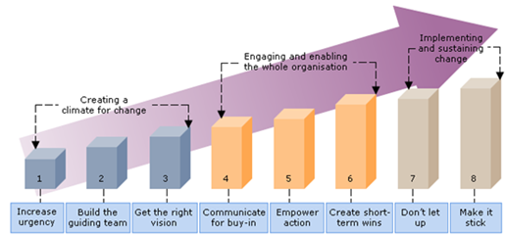
(Image: Staffnet n.d.)
Analysis – Positive:
Simplicity: Kotter's model is easy to understand, making it accessible to employees at all levels of the organisation.
- Comprehensive: It consists of eight stages, providing a comprehensive roadmap for managing change from start to finish.
- Emphasis on Leadership: The model underscores the importance of strong leadership and the role of leaders in driving and sustaining change initiatives.
- Continuous Improvement: The model encourages a continuous improvement mindset, which is essential for organisations in a rapidly evolving environment.
Negative:
- Linear Approach: Kotter's model follows a linear approach if the change occurs in sequential stages. However, change can be more iterative and unpredictable.
- Lack of Flexibility: The rigid structure of the model might not accommodate unique organizational contexts, leading to potential implementation challenges.
- Limited Employee Involvement: The model places significant emphasis on top-down decision-making, which may overlook valuable insights from employees on the ground.
6.2. ADKAR Change Management Model: -
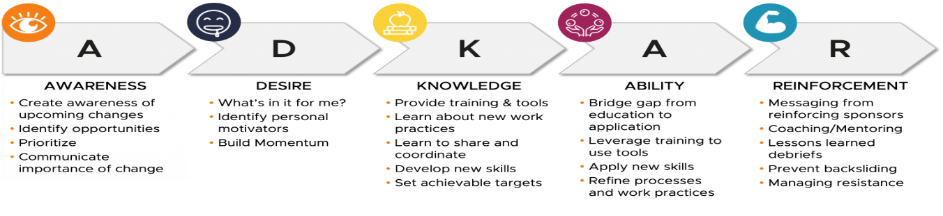
(Image: Jones, 2021)
Analyses: Positive
Individual Focus: ADKAR concentrates on the individual's journey through change, emphasizing the importance of addressing employees concerns and needs.
- Goal-Oriented: The model sets clear objectives for change, making it easier to measure progress and success.
- Applicability: ADKAR applies to several types of organisational changes, making it versatile for different situations.

Negative:
- Oversimplification: Critics argue that the model oversimplifies the complexities of organisational change, as it primarily focuses on individual change rather than the broader systemic aspects.
- Limited Organisational Context: The ADKAR model doesn't delve deep into the organisational dynamics and culture, which can be crucial factors in successful change management.
- Inadequate Integration: While the model addresses individual change, it might not sufficiently integrate with other aspects of change management, such as communication and stakeholder engagement.
This goal-oriented model focuses on building the capabilities needed for change at the individual level. It would help the organisation ensure employees are properly prepared and supported to adapt and perform under the new change (Malhotra, 2019).
6.3. Lewin's 3-Step Model:
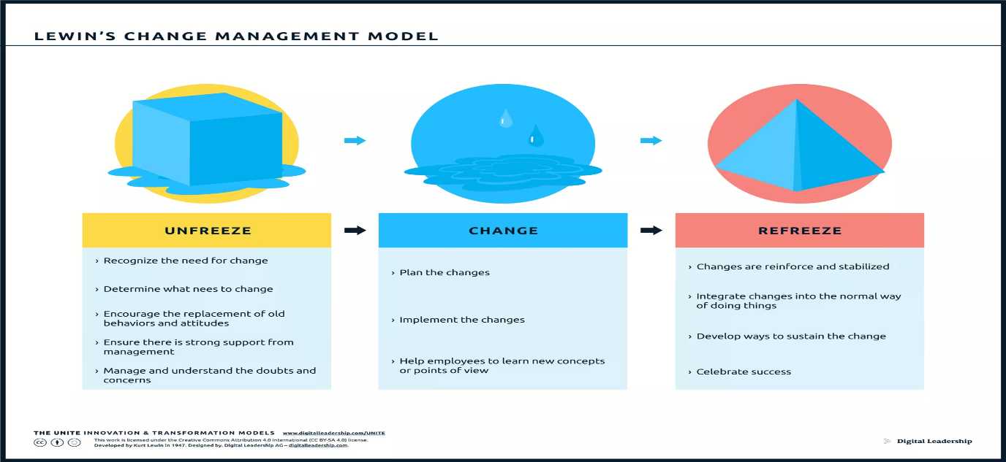
(Image: Digital Leadership, 2023)
Analyses: Positive
- Three-Step Process: Lewin's model is simple and practical, consisting of three stages: unfreeze, change and refreeze. This straightforward approach is valuable for initiating and stabilizing change (Mind Tools, 2022).
- Focus on Mindset: The model emphasizes the importance of addressing people's mindsets and attitudes during the change process, recognising the psychological aspect of change.
- Change as a Process: Lewin's model sees change as an ongoing process, which aligns with the idea that change is not a one-time event but a continuous journey.
Negative:
- Lack of Detailed Guidance: The model provides a broad framework but lacks specific guidance on how to execute each stage effectively.
- Overemphasis on Stability: The "refreeze" stage might prioritize stability over adaptability, which can hinder the organisation's ability to respond to future changes.
- Limited Focus on Resistance: While Lewin acknowledges the importance of addressing resistance, the model doesn't offer extensive strategies to handle resistance effectively.
This model would help organisations transition through the phases of change in a structured way. The "unfreeze" and "refreeze" steps would be key to letting go of old leadership habits and adopting the modern style permanently (Mind Tools, 2022).
Each change management model has its strengths and weaknesses. The choice of model should depend on the specific needs and characteristics of the organisation changing. Combining elements from different models or customising them to suit the organisational context may result in a more effective change management approach. Successful change management often requires strong leadership, clear communication, employee engagement, and a focus on the human aspect of change (Kotter, 1997).

7. Suitable Change Management Model for McDonald

The ADKAR model is more suitable for McDonald's as it provides a structured and individual-centric approach to managing strategic change. By addressing the specific needs of employees, measuring progress and provoking a culture of continuous improvement. The ADKAR model is suitable to implement suitable strategic change for McDonald's for two reasons.
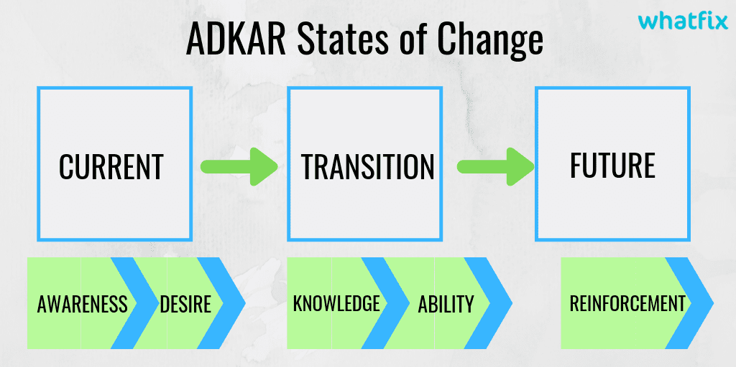
  - (Image: Malhotra, 2019)
7.1. Verification One: -
a) The ADKAR model is centred around individual employees and stakeholders, focusing on the specific needs and challenges they may face during the change process. This is particularly important for a large organisation like McDonald's, where a considerable number of employees are involved in the day-to-day operations.
b) Step-by-step Approach: The ADKAR model follows a clear step-by-step approach, which helps break down the change process into manageable stages. These stages are Awareness, Desire, Knowledge, Ability and Reinforcement. This sequential progression allows for a structured and organized change implementation, reducing confusion and resistance (Malhotra, 2019).
c) Addressing Resistance: McDonald's, being a well-established and global brand, may encounter resistance from employees who have grown accustomed to existing processes and systems. Fostering a more receptive environment for change.
d) Measurable Outcomes: Offers a tangible way to measure the success of the change initiative. By tracking progress through the five stages, McDonald's management can assess whether employees have achieved awareness, desire, knowledge, ability and reinforcement related to the strategic change.
e) Flexibility: Adaptable and can be integrated with other change management frameworks. This flexibility allows McDonald's to customise the change implementation to suit its specific organisational structure, culture and strategic objectives.
f) Employee Engagement: The model encourages active employee involvement throughout the change process. Involving employees early on and helping them understand the benefits of the change increases their engagement and ownership of the new strategies, leading to a smoother transition (Malhotra, 2019).
g) Continuous Improvement: McDonald's is a company that constantly evolves and innovates its products and services. The ADKAR model supports the idea of continuous improvement by reinforcing the change and ensuring that the new strategies become embedded in the organisation's culture.

7.2. Verification Two- SMART Goals: -
SMART goals are a framework used to set specific, measurable, achievable, relevant and time-bound objectives. By incorporating all the SMART components into the objective, the organisation increases the likelihood of accomplishing it within a reasonable time limit (Caroline, 2022). Moreover, it allows management to eliminate ambiguity and monitor progress with greater ease, thus reducing potential challenges on the path to success. The ADKAR change model aligns with smart goals and objectives.
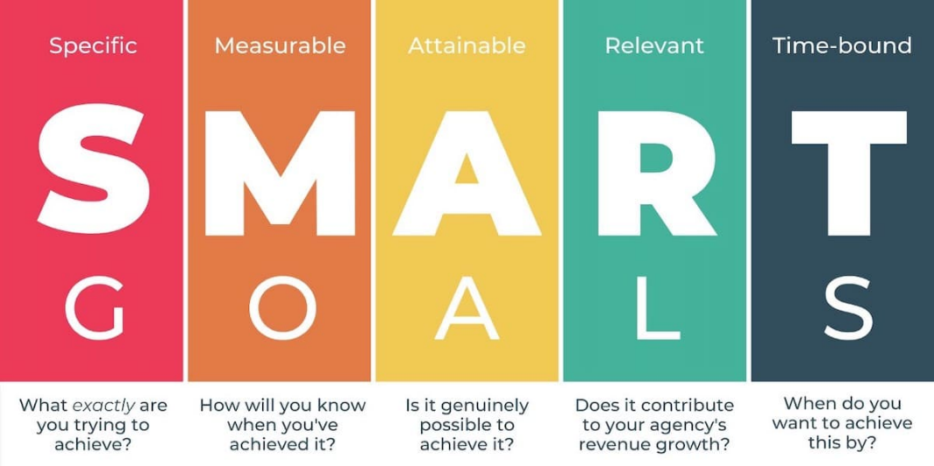
(Image: Caroline, 2022)
By applying The ADKAR and SMART goals, McDonald's can clearly define what it wants to achieve, measure its progress, ensure its objectives are realistic and relevant, and create a sense of urgency to drive positive change within the organisation (Kotter, 1997). The SMART goals theory can be communicated across various levels of the company, helping employees understand their roles in contributing to the overall improvement or specifically required change. Regular assessment and adjustments to these goals would be essential for continuous improvement and success.

8. Approbations to Improve the Strategic Structure

As the world had to adapt to the global unprecedented Covid 19 pandemic, it is evident to suggest using a Situational Leadership Approach for Initiating and Implementing Change. The Situational Leadership approach suggests that leaders should adapt their leadership style based on the readiness and capabilities of their team members. For the new leadership style implementation at McDonald's, the leaders can assess the competence and commitment of their employees and adjust their approach accordingly. As employees become more capable and confident in their roles, the leaders can gradually delegate more responsibilities, fostering a sense of empowerment and ownership (Kotter, 1997)
8.1. New Leadership Style Plan
The ADKAR change management model is a goal-oriented framework that can help McDonald's successfully manage change at an individual level. Let's use this model to propose a change management plan for the new leadership style.
Step-by-Step Process to Implement the Change Strategy:
Step 1: Assess Current Leadership Style and Organisational Readiness
- Assess the current leadership practices at McDonald's.
- Evaluate the readiness and capabilities of employees to adapt to the new leadership style.
Step 2: Define the New Leadership Style
- Clearly define the objectives and principles of the new leadership approach to staff.
- Identify specific behaviours and actions that exemplify the Situational Leadership style.
Step 3: Communicate the Change
- Develop a comprehensive communication plan to share the vision of the new leadership style (Kotter, 1997)
- Address potential concerns and provide opportunities for employees to ask questions and seek clarifications.
Step 4: Training and Development
- Provide training programs for leaders on Situational Leadership concepts and techniques.
- Offer workshops and simulations to help leaders apply the principles in real-life scenarios.
Step 5: Employee Engagement and Involvement
- Involve employees in the change process by seeking their input and feedback.
- Encourage leaders to listen to employees and take their perspectives into account.
Step 6: Pilot Implementation
- Begin the implementation of the new leadership style in selected teams or departments as a pilot.
- Monitor and assess the effectiveness of the approach in the pilot phase.
Step 7: Adjust and Scale
- Based on feedback and results from the pilot, make necessary adjustments to the implementation plan.
- Scale up the new leadership style across the organisation, gradually introducing it to different teams.
Step 8: Support and Coaching
- Provide ongoing support and coaching to leaders as they apply the Situational Leadership approach.
- Encourage leaders to share their experiences and best practices.
Step 9: Recognise and Celebrate Success
- Acknowledge and celebrate instances where the new leadership style positively impacts employee engagement and performance.
- Recognise and reward leaders who effectively apply Situational Leadership principles.

8.2. Probable Impact on McDonald's Culture
The implementation of the Situational Leadership approach can have several impacts on McDonald's culture: -
- Increased Flexibility: The Situational Leadership style promotes flexibility and adaptability, encouraging leaders to adjust their approach based on the unique needs of their team members.
- Empowerment and Accountability: As leaders gradually delegate responsibility to employees, harbour empowerment and ownership among the workforces.
- Improved Communication: Leaders actively listening to employees needs and adjusting their leadership style accordingly can enhance communication and create an open and collaborative culture (Kotter, 1997).
- Employee Development: With a focus on individualized coaching and support, the new leadership style can promote employee development and skill enhancement (Rogers, 2020).
- Trust and Respect: Employees are more likely to trust and respect leaders who consider their readiness and capabilities when assigning tasks and responsibilities.

9. Recommendations

To ensure long-term success, McDonald's should:
- Regularly assess the effectiveness of the new leadership style and make necessary adjustments based on feedback and results.
- Encourage a culture of continuous learning and development for leaders to effectively apply Situational Leadership principles.
- Celebrate and reward leaders who demonstrate flexibility, adaptability and a focus on employee development.
By adopting a Situational Leadership approach and incorporating it into the organisation's change management plan, McDonald's can navigate the transition to the new leadership style more effectively and cultivate a positive and thriving organisational culture. Implementing a Situational Leadership approach for the new leadership style at McDonald's can bring positive changes to the organisation's culture, employee engagement and performance (Rogers, 2020). However, successful implementation requires effective communication, training and ongoing support for leaders.

10. Consequences of Not Following Recommendations

While these recommendations aim to bring positive changes and foster a conducive work environment, failing to follow them could have significant consequences for the company's culture, employee engagement and overall performance.

Consequences:
- Stagnant Organisational Culture:
Without regular assessment and adjustments to the new leadership style, McDonald's may experience a stagnant organisational culture. Situational Leadership relies on tailoring leadership approaches based on employee readiness and competence levels. If leaders do not adapt their leadership style to meet the needs of their team members, it can lead to a rigid, one-size-fits-all approach that impedes growth and employee satisfaction (Rogers, 2020). This could result in a lack of innovation, decreased employee motivation and a failure to keep pace with competitors.
- Inefficient Leadership:
A lack of continuous learning and development for leaders can lead to inefficient leadership practices. Situational Leadership requires leaders to be well-versed in assessing their team members' capabilities and applying appropriate leadership behaviours accordingly. Without ongoing training and development opportunities, leaders may struggle to effectively apply Situational Leadership principles, leading to misguided decision-making and poor employee outcomes.
- Reduced Employee Engagement: Neglecting to celebrate and reward leaders who demonstrate flexibility, adaptability and a focus on employee development can lead to reduced employee engagement. Recognition and rewards play a vital role in motivating leaders to excel and display desired behaviours. When leaders feel undervalued or overlooked for their efforts, they may become disengaged and disheartened (Rogers, 2020). Consequently, this could lead to a decline in employee morale, productivity and loyalty to the company.
- High Employee Turnover:
A failure to implement the recommended leadership approach could potentially result in high employee turnover rates. Situational Leadership emphasizes the importance of adapting leadership styles to individual employee needs, which flourishes a supportive and nurturing work environment. If leaders are not professionally trained or encouraged to apply this approach, employees may feel undervalued and unsupported and seek opportunities elsewhere. High turnover rates can be costly in terms of recruitment, training and lost productivity.

- Negative Brand Image:
An organisation that does not follow its recommended leadership principles may suffer from a negative brand image. In today's era of increased transparency and social media, disgruntled employees can easily share their negative experiences, affecting the perception of potential customers, investors and partners (Rogers, 2020). A poor brand image can have lasting consequences, leading to decreased customer loyalty and declining revenues.

11. Conclusion

According to research by Gleeson, (2017). The causes behind the failure of change initiatives differ, with a compilation of factors contributing to the lack of success. Among these factors, 'inadequate budget' was mentioned by 23%, whereas 'limited time' was only cited by 17%. However, the participants' prioritization highlighted those primary challenges including human-centric issues. Notably, poor communication (62%), inadequate leadership and support (54%), organisational power dynamics (50%), a deficiency in comprehending the change's purpose (50%), insufficient user endorsement (42%) and a dearth of collaboration (40%) emerged as the most crucial concerns. All these hurdles fundamentally stem from human factors.
To sum up, the ADKAR framework proves to be a better fit for McDonald's due to its organised and person-centred method of overseeing strategic change. By catering to the distinct requirements of staff, gauging advancement and nurturing a culture of ongoing enhancement, McDonald's can enhance the prospects of effectively executing changes.
The consequences of not following McDonald's recommendations for implementing a Situational Leadership approach are far-reaching and impactful. To maintain a thriving organisational culture, engaged employees and sustainable performances (Henderson, Gulati and Tuchman, (2015). It is imperative for McDonald's to regularly assess and adjust its leadership style, prioritizes continuous learning and development for leaders and celebrate and reward those who embody the desired leadership behaviours. By embracing these recommendations, McDonald's can uphold a workplace that encourages growth, empowers employees and achieves long-term success.

12. References

Andrew Thompson (2023). McDonald’s Organizational Culture Analysis. [online] Panmore Institute. Available at: https://panmore.com/mcdonalds-organizational-culture-analysis [Accessed 29 Jul. 2023].
Baker, C. (2023). Obesity Statistics. commonslibrary.parliament.uk, [online] (03336). Available at: https://commonslibrary.parliament.uk/research-briefings/sn03336/#:~:text=Adult%20obesity%20in%20England [Accessed 8 Aug. 2023].
Brunsson, N. (2017). Reform and Power. Oxford Scholarship Online. Oxford University Press. doi:https://doi.org/10.1093/oso/9780198296706.003.0007.
Caroline (2022). How to write effective SMART goals. [online] Breeze Blog. Available at: https://www.breeze.pm/blog/how-to-write-effective-smart-goals [Accessed 31 Jul. 2023].
Digital Leadership. (2023). Lewin’s Change Model. [online] Available at: https://digitalleadership.com/unite/lewins-change-model/ [Accessed 6 Aug. 2023].
Dudovskiy, J. (2022). McDonald’s Leadership: a brief overview. [online] Research-Methodology. Available at: https://research-methodology.net/mcdonalds-leadership/ [Accessed 27 Jul. 2023].
Galloway, S. (2023). Brand (marketing) | Description, Examples, History, Risks, & Rewards | Britannica Money. [online] www.britannica.com. Available at: https://www.britannica.com/money/topic/brand [Accessed 1 Aug. 2023].
Gleeson, B. (2017). 1 Reason Why Most Change Management Efforts Fail. Forbes. [online] 25 Jul. Available at: https://www.forbes.com/sites/brentgleeson/2017/07/25/1-reason-why-most-change-management-efforts-fail/ [Accessed 12 Aug. 2023].
Greenspan, R. (2022a). McDonald’s PESTEL/PESTLE Analysis & Recommendations. [online] Panmore Institute. Available at: https://panmore.com/mcdonalds-pestel-pestle-analysis-recommendations [Accessed 1 Aug. 2023].
Greenspan, R. (2022b). McDonald’s SWOT Analysis & Recommendations. [online] Panmore Institute. Available at: https://panmore.com/mcdonalds-swot-analysis-recommendations [Accessed 29 Jul. 2023].
Henderson, R., Gulati, R. and Tushman, M. (2015). Leading Sustainable Change. Leading Sustainable Change, pp.2–21. doi:https://doi.org/10.1093/acprof:oso/9780198704072.003.0001.
Kotter, JP (2012) Leading Change, With a New Preface by the Author, Harvard Business Review Press, Boston. [online] ProQuest Ebook Central. [2 August 2023].
Kotter JP, (1997). Action plan for change: Strategy & Leadership, 25(1), pp. 21.
Jones, K. (2021). The ABCs of ADKAR: A Method to Support Organizational Change Management. [online] Available at: https://www.beyond20.com/blog/adkar-organizational-change-management-ocm/ [Accessed 6 Aug. 2023].
Malhotra, G. (2019). ADKAR model of change management: What is it and how to use? [online] Whatfix. Available at: https://whatfix.com/blog/adkar-model-what-is-it-and-how-to-use-it/ [Accessed 4 Aug. 2023].
McDonald's (2018). What’s the structure of McDonald’s and how each department in the organisation interacts / works together? [online] www.mcdonalds.com. Available at: https://www.mcdonalds.com/gb/en-gb/help/faq/whats-the-structure-of-mcdonalds-and-how-each-department-in-the-organisation-interacts-works-together.html [Accessed 27 Jul. 2023].
McDonald's (2022). History | McDonald’s UK. [online] Mcdonalds.com. Available at: https://www.mcdonalds.com/gb/en-gb/newsroom/history.html [Accessed 8 Aug. 2023].
Mcdonalds.com. (2017). McDonald’s U.S. Leadership Team: CEO & Executives | McDonald’s. [online] Available at: https://www.mcdonalds.com/us/en-us/about-us/leadership-team.html [Accessed 1 Aug. 2023].
Mind Tools (2022). Lewin’s Change Management Model. [online] www.mindtools.com. Available at: https://www.mindtools.com/ajm9l1e/lewins-change-management-model [Accessed 4 Aug. 2023].
Office For National Statistics and Leaker, D. (2023). Labour Market overview, UK - Office for National Statistics. [online] Ons.gov.uk. Available at: https://www.ons.gov.uk/employmentandlabourmarket/peopleinwork/employmentandemployeetypes/bulletins/uklabourmarket/latest [Accessed 8 Aug. 2023].
Rogers, A.L. (2020). McDonald’s new CEO takes aim at the company’s ‘party’ culture. [online] CNBC. Available at: https://www.cnbc.com/2020/01/06/mcdonalds-new-ceo-takes-aim-at-the-companys-party-culture.html [Accessed 4 Aug. 2023].
Team, T. (2021). Will Easing Of Restrictions Continue To Drive McDonald’s Growth? [online] Forbes. Available at: https://www.forbes.com/sites/greatspeculations/2021/06/02/will-easing-of-restrictions-continue-to-drive-mcdonalds-growth/ [Accessed 1 Aug. 2023].
The One Brief (2021). Case study: McDonalds responds to the COVID-19 crisis. [online] The One Brief. Available at: https://theonebrief.com/case-study-mcdonalds-responds-to-the-covid-19-crisis-nb/ [Accessed 1 Aug. 2023].
Thompson, A. (2015). McDonald’s Organizational Culture Analysis. [online] Panmore Institute. Available at: https://panmore.com/mcdonalds-organizational-culture-analysis#:~:text=McDonald [Accessed 4 Aug. 2023].
Thompson, A. (2022). McDonald’s Organizational Structure & Its Characteristics - An Analysis. [online] Panmore Institute. Available at: https://panmore.com/mcdonalds-organizational-structure-analysis [Accessed 1 Aug. 2023].
Umeshell (2023). McDonald’s net income soars 94% to $2.31bn in Q2. [online] Verdict Food Service. Available at: https://www.verdictfoodservice.com/news/mcdonalds-net-income-soars-q2/ [Accessed 1 Aug. 2023].
www.staffnet.manchester.ac.uk. (n.d.). Why use Kotter | Staff Learning and Development | StaffNet | The University of Manchester. [online] Available at: https://www.staffnet.manchester.ac.uk/staff-learning-and-development/learning-pathways/professional-and-technical-development/change-management/leading-change/introduction-to-leading-change/why-use-kotter/ [Accessed 1 Aug. 2023].

