Strategic Management for smes
Herbak

Contents
Introduction 2
A Brief Follow up of SME 2
Appraisal and Strategic direction of the organization 3
External Environment 4
Internal Environment of Herbak 7
Stakeholder Analysis 9
Discussion of Strategic Choices in Markets and Propose a New Strategy 11
Evaluating a Sustainable Strategy for the future of the venture 13
Recommendation for the Company 14
Conclusion 15

Introduction
SME being one of the highlighted topics on the current assignment is going to be the central focus in this research paper, starting with the factual description of what exactly is a Small and Mid-size Enterprise (SME). Basically, Small and Mid-size Enterprises are corporations that intend follow through a balance; For instance, their revenues, their production procedures, manufactured goods and even the number of the hired employees are all kept under a check. (SMEs) or Small and Mid-size Enterprises have their own radar under which they operate. The procedure and construction of SMEs varies from country to country, in short, every country has their own concept of SME and their ideologies is sure to have a stark contrast in regard to the building of guidelines across different industrial sectors. Now indulging in the main topic of assessing and analysing the future established corporation Herbak which is categorised under the section of Small and Mid-size Enterprise is processed to be a new found build up, that intends to focus on not only making profit and servicing the consumer base but is also objected to be a Social Enterprise whose sole motive will be to mind the environmental challenges and make the best out of the raw natural products initiated and procedured through an absolute organic method. The motive is clearly to generate fresh out food commodities and goods that will focus on mainly the advancement and health beneficiaries of the individual as well keeping in mind the condition of the resources. In short as reflected a Social Enterprise whose main objective is to uplift the community by socially looking after its natural phenomenon and making sure that the resources are not damaged while using the end results as a mean to run the business. The primary goal is to reach out to the clients but while following through a socio-friendly notion. (Kim, et al., 2008)

A Brief Follow up of SME
Herbak being a Small and Mid-size Enterprise (SME) is particularly oriented around specifically the country UK, and that's what the notion of SME is all about; the said enterprise articulates under a particular country and are nominated as independent firms, whose asset and number of employees differs from nation to nation. The objective and prime goal of SME is to keep it under control and be limited instead of exaggerating and franchising under different area groups and arenas. From research it can be seen that there are a lot of positive influence and factors under the notion of SME; For instance, this individual Enterprise section plays a huge crucial role in uplifting the economy of the said country by Employing and mainly advancing in the section of Technology. Since SME tends to keep towards limit, thus the said organised group focuses and reflects on introducing and analysing new technological methods; For example, producing new products or services that is going to stand out. In case of Herbak it is the natural food products that concerns itself with the heath condition of the individuals. The initiation of SME also creates a competitive edge in the arena of market and industrial sector by challenging the Large Enterprises with all together contradictory prices, products, designs and efficiency. So, in brief, though SME aims to be small in nature it has in itself an individual role in elevating the economic structure of a country, in a very obvious way; By out numbering the large corporations, employing a vast group of people and giving better job opportunities, and last but not the least focusing on the image of innovation and technology - giving it a new face and making it as distinctive as possible in order to benefit the client base. (Naradda Gamage, S.K., et al., 2018)
It's technically a start-up plan or method for an establishment in order to make a certain place in the individualised industrial sector. In case of Herbak, it is the natural food supermarket and store. (Wang, et al., 2020)

Appraisal and Strategic direction of the organization
Herbak for its future development and establishment has chosen the path towards social upliftment via introducing food products that are not only organic but relatively healthy. In the present day it is not unusual for an establishment to come up with products that though are easy to cook and less time consuming has contradictory negative effects such as more than required fat, carbs and no valued Protein, whereas Herbak in its case implemented and made the necessitated effort to reach out for food supplements that are well harvested and as refreshing as it can be without adding any extra artificial mix ups, which from contemporary reports has proved to be the major issue behind the arena of health problems. (Anggadwita, et al., 2014)
Mission: - Herbak has well stated and made its mission clear in organising and reflecting on the environmental resources making it the underlining, that the resources should absolutely be appreciated and never be destroyed in the aim for providing and profiting the society. Of course, profit and advancements must well be obviously considered but the prime motive here would be to find resolute solutions in accordance to the environmental problems that initially rises while setting up a future venture. The concept of profit is no doubt important to Herbak but, the yet so established venture believes in accumulating the interest and instead of sharing it amongst shareholders or initiating an altogether different franchise, the future venture intends to use the said section in achieving and bettering it's social mission by reinvesting on producing food sections that will be 100% original and pure veg. (Wry, et al., 2017)
Strategies that Herbak proposes to follow through
The commitment to Organic Products: - Many well-known market and establishment seem to present the concept of organic products in a very misleading way, till to the date it is believed that organic is something that only the elitist and expensive social class are expected to use, this happens for the sole reason that those implemented products are way more costly and out of a budget friendly list, Herbak intends to correct the situation by first missioning on reducing the expenses of the targeted products secondly by fully supporting the concept and notion of greater biodiversity and highlighting on an well and healthy outcome for everybody out there. (Defourny, et al., 2017)
Encouraging the Right Business: - Herbak here intends and has the motivation to support all the Social Enterprises, SMEs & Cooperatives and in result influence them on acting not only independently but also helping them to truly operate in a sustainable manner. To initially make them understand the concept and benefit of sustainable progression. The idea Herbak here advocates are to endorse and promote the concept of Progressive Business models as much as possible. (de Souza, et al., 2020)
A Shift towards the Local Market: - Herbak believes that it is important to shift and develop an arena of local market not just for the sake of tourist attractions but so that the business of organically produced food can initially expand and as well give easy access to the customers out there who tends to go for 100% natural products (Yunus, M., et al., 2017).

External Environment
PESTLE Analysis
PESTLE analysis is a combination of six factors that, collectively, helps a company to understand various aspects of the market like the state of the market, and the risks, and gives time to prepare for the situation. The six factors are discussed in detail below: -
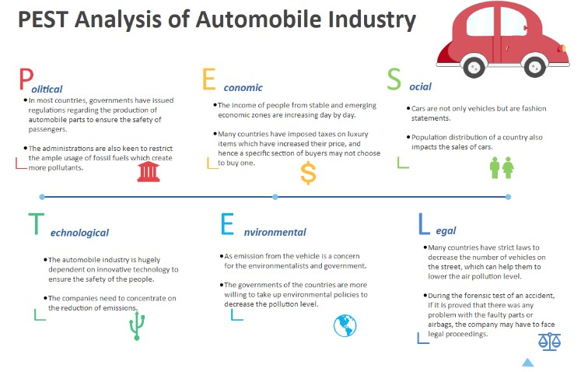
Fig: PESTLE Analysis (Source: Peteva, 2021)
The first factor is the Political factor. It is present in the whole world. Many governments in the world have strict rules for the companies in the food industry including the cleanliness of the kitchen to the requirements for the workers in the company. It is one of the industries in which the level of government regulation is very high (Frederick, et al. 2021). There are justifications for this because it is such an industry, manhandling of which can cause harm to common people directly.
The next factor is the Economic factor. A change that came in recent years is the increasing income of people and the increase, in turn, allows them to spend more money. This has changed the concept of eating. People nowadays, like to eat outside more rather than cook at home. It is a positive thing for the companies. But as people are earning more money, the same applies to labourers (Capobianco, et al. 2021). They are also earning more due to various reasons like government wage rules.
Social factor comes next, and there are many social factors that affect the industry. Health consciousness is one of them, as it is increasing in people. The health of a person is very much related to the food that is eaten, and the changing food habit of people is a worry for food joints. Although, for Herbak, it is not so worrying, because it only works with organic food. But the fast-food sellers have to change their strategy in order to cope. Another concern is the diet restrictions on people. This is also not so bad for the industry, but it has to understand the needs of people and change according to them, it is the only way for surviving.
The fourth factor is Technological. In this sector, automation is the current talking point. There are various types of automation, and some examples are currently used in some restaurants (Semos, et al. 2021). There are digital checkout systems in some restaurants, and there is the use of robots in experimental mode in some places.
Legal factor is next in line, and one of the main points here is the safety standards used in the industry. There are stringent rules for this in almost all countries. Though it does not happen frequently, but if the rules are breached, and a complaint is lodged, then it will have legal consequences. So, businesses should be more careful to abide by the rules to avoid the consequences.
The last on the list is the Environmental factor, and the greatest issue at present time is the impact of meat. There are some problems with meat and with the process of farming it (Devina, et al. 2021). And because of these problems, some people are shifting towards vegetarian options, and others tend to have a plant-based diet. At present, it is not a problem, but it can be in long term.
Porter’s Five Forces
It is a model by which a firm can analyse the level of competition in the market, and the state of other companies with respect to them so that they can use the outcomes in their favour to progress. The details of the five forces are given below: -
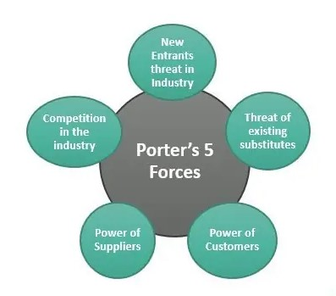
Fig: Porter’s Five Forces (Source: Setiawan, et al. 2021)
Competition among companies is relentless in this sector, and there are many scopes for going ahead of others in this industry. The best way for going ahead is the reduction in the price. Though there are other methods of doing so, but it is the most popular because it is the easiest (Kumar, et al. 2021). Other methods include creating innovative products, making good relationships with partners, and so on.
The bargaining power of the customers is the most powerful here. The companies are well aware that the customers are the one who decides the price here. Incidents happened when restaurants sold their products at a price they would never want to. Customers want good quality food at a reasonable price, otherwise, the company will incur losses.
The bargaining power of the suppliers is just the opposite of the customers. The suppliers have no such power over the companies. Restaurants get the raw material from different sources like butchers, dairies, and other companies. As there are a large number of suppliers, the restaurants will give the order to the one who will give the lowest rate. But advantages can be taken by creating innovative ways (Bendtsen, et al. 2021).
There are also threats of new entrants who will enter the market. In the food industry, the possibility is very high, because the starting finance is not so high. Also, experience plays a role here, rather than the food. So, it is important to check the progress of any new entrants so that the potentiality of future rivalry can be addressed much before.
The threat of substitutes is another type of threat here. It is mainly related to the change in the price within the industry and the substitutes. If the price of the substitute rises, that is no problem for the industry, but when it is the other way around, it brings great significance. Here, if the price of eating in a restaurant arises, customers can opt to eat at home. Therefore, it is a thing to keep an eye on.

Internal Environment of Herbak
At present every organisation is facing competition in the business market. There are very few companies that are still growing and making profit in this environment of competition where a small mistake or a wrong strategy can plunge the company into the sea of loss. However, by maintaining certain strategies, Herbak can have a good reputation in the business market. This company will be very much aware of the needs of the customers that have helped this organisation in creating the exact environment which is helpful foe the customers. Herbak tries to adopt to the needs of those who like freshly produced organic food items. By following the rules of SWOT and VRIO this company can have a more adoptive nature. These strategies are discussed below-
SWOT of Herbak: Through the process of following the SWOT, Herbak company can have the basic understanding of its strengths, opportunities, weaknesses and threats. This examination is based on the facts and ideas which are observed in the practical world of business. With the help of this method, Herbak can concentrate on the real problems instead of following the existing wrong beliefs that surround a new venture. As this examination is more like the structuring of a plan that is consisted of new tools of assessment, Herbak can conduct real life surveys and customer feedback programmes which would be helpful for a new venture. This method also encourages the advancement of new knowledge and ideas along with perspectives that are new in nature. For example, Herbak shall have a management team that encourages the progress of new ideas that can be used by the company. As the company would be a new venture, it can hire both experienced and freshers as its employees so there could be an amalgamation of old and experienced ideas along with the freshly brewed thoughts. To encourage this process the company can also reward the employees so that the employees can have a sense of purpose and usefulness. Through the SWOT examination Herbak will be able to detect the main aspects of strength and weakness. For example, as this company will be a producer of freshly produced organic products, it will have a growing market, but along with that comes the problems like carbon emission and food wastage. In the present, carbon emission is a growing problem so the company would have to think of strategies to curb the emission. Along with its benefits SWOT strategy has some problems also as this examination process does not deal with issues that can be faced by a new organisation like Herbak. It also doesn’t include any effective solution. For example, If Herbak faces some managerial crisis in the future, SWOT would not provide any effective solution to it.
VRIO analysis of Herbak
The VRIO is about value, rarity, imitability and organisation. As Herbak will be a company of freshly produced organic items, it would be different from the other packaged food industry. It would be of a rare kind as this industry is relatively new in India in comparison to other countries. Through following the VRIO, Herbak will be able to pinpoint the strategies of a new venture. The main goal of this strategy is to find the aspects of this new business model so that a new company like Herbak can follow the signs of upcoming problems and proceed according to it. Value is of great importance in this system as it gives the power to the company and how the company can assure the value of its products to its customers. Rarity is about finding the resources that a company has at its disposal and the capabilities that are unique to the company. For example, Herbak can have a wholly different customer feedback that can assure the customers about the company’s quality of products. Another aspect of this system is imitability that is what is the company’s policy about duplications and whether something akin to that which can cost the company a bad reputation. For example, if another company tries to imitate the products of Herbak, what would be the steps of the company to prevent it. The last step is about the organisation whether the workforce is reliable or not and if the system is on point which could be used as capital force. There are some problems of following the VRIO method is that sometimes it takes a lot of time to go according to it and as a new venture Herbak would have to use time in a very methodical way. Along with that it also depends on judgements that are very subjective in nature which is not appreciated by a new company. It also depends on analysis that is internal in nature and does not focus on external aspects. For example, a company that is connected to selling would have to understand the external forces of which customer is of great importance.

Stakeholder Analysis
There are different types of stakeholders in a company with different levels of engagement and interest. The stakeholder analysis is done to differentiate them in a process, according to their influence over the company. it is done with the help of a power-interest grid. There are four parts in the grid, high power high interest, high power low interest, low power high interest, and low power low interest. The details of them are discussed below: -
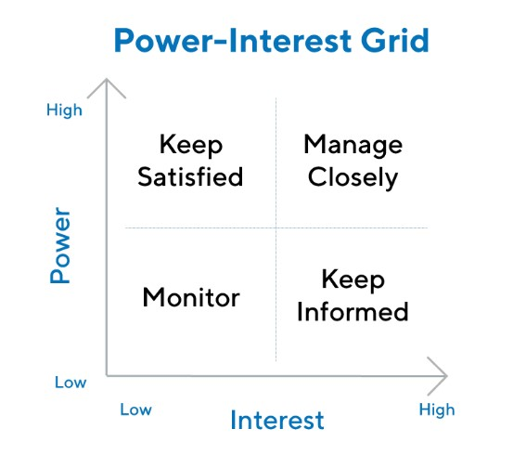
Fig: Stakeholder Analysis (Source: Karim, et al. 2021)
There are different types of stakeholders in a company operating in the food and flower industries both. There are four parts in the grid, and the most important one is the stakeholders with both high power and high interest. They are the pillar of the company. without them, the company will not be able to continue its operations (Wood, et al. 2021). The owner of the company and the management fall into this category. It is natural that the owner has a great interest in the company, and the management is also aware because their job is dependent on the performance of the company. they will be benefitted if the company makes a profit, but if the opposite happens, then there is a chance they will lose their job. So, they have to do their best all the time. The shareholders of the company are another example. They are interested because they invested a lot of money in the company, and have high power because the company has to think of the shareholders before coming to a decision. The next part deals with the stakeholders who have high power over the company, but a low interest in it. The customers are the main example of this category (Matzembacher, et al. 2021). They have huge power over the decisions made by the company because the company is nothing without its customer, but the customer is least bothered by the company they have nothing to do with the management of the company. the government can be another example too because it has enough power, but the government does not have an interest in a certain company. The third one is the group that has low power over the company, but high interest in it. The general employees of the company are the perfect example of it. They do not have power over the decisions made by the company but are responsible to execute the decisions. Competitors of the company are examples too because they have a high interest in the daily operations and the decisions of the company because they also have to counter them in a constant manner. But they do not have much power over the company. media is also an example. Although they do not possess any considerable amount of power over a company, they are interested in the company if they can get any type of news from it. The last part consists of those who neither possess the required power nor the interest in the company. the suppliers of the company are in this part. There are many companies in an industry, so the supplier has many companies that will be ready for supply (Pererva, et al. 2021). If the company is unable to get the supply from the supplier, the supplier will turn to other companies operating in the market. Clients can belong to this group too. There are many companies that provide the same type of service in the market, so the client will have no worries about a particular company. in no time, the client will find a replacement. This is a detailed discussion of the different parts of the stakeholder analysis which helps a company to segregate the stakeholders into different levels, to manage the company with more efficiency.

Discussion of Strategic Choices in Markets and Propose a New Strategy
Marketing Mix
It is a part of a greater marketing plan. This includes the four ‘P’s, which stand for Product, Price, Placement, and Promotion. They are the finer classification of the mix. They are as follows: -
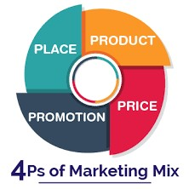
Fig: Marketing Mix (Source: Idris, 2021)
Product is the base of any company, as it is the thing by which the customers will know the company. the product is what is created by measuring the needs of the customer. For the successful launch of a product, it needs to be made sure that the product is unique in one or more ways from the competitors (Kakadellis, et al. 2021). The probability of marketing-related products also holds great significance. Price is the thing that a customer pays for using the product. Many things need to be assessed while considering costs. They are Research and development, Marketing, and many more. The price is generally fixed based on the research done on consumers. To sell a product successfully, the placement of the product plays a great role. If the product is a type of household product, then it is generally available in many stores, but given the product is premium, the number of stores will be limited (Naim, 2021). Promotion is another thing behind the success of any product. Without it, a very good product can be a failure.
Ansoff Matrix
This matrix is used to measure the potential growth of a company. it also states the level of risk associated with the growth. It is divided into four parts, which are discussed below: -
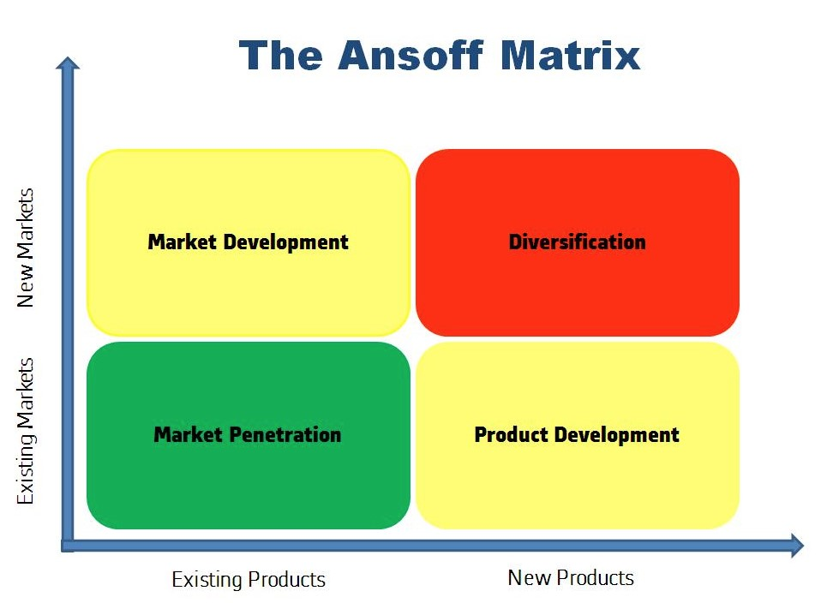
Fig: Ansoff Matrix (Source: Tang, 2021)
The four parts of the Ansoff matrix include Market penetration, Market development, Product development, and Diversification. The first one, market penetration is the easiest of the four options. In this, the company will introduce products that are familiar to the consumers in the market. In this process, the company has to keep the price low to attract customers. The next level is market development. In this method, the company enters the market with the existing products they manufacture so that they can retain the consumers while moving to the market. The third level is product development. In this method, research and development play a huge role. The company expands its operation by inventing new products or acquiring the right of selling a product from another firm. The last one, diversification is the most difficult one. It combines the processes of both product development and market development. Being the riskiest, this method can be the most beneficial if applied in the right way (Serrat Marín, 2021). These are the details of the four parts of the Ansoff matrix. The taken company of the report, Herbak, should take the two between these four, which are product development and diversification. While product development gives a company a competitive edge over others because of the uniqueness of the product, diversification takes the company to a new level where only a few companies operate. After giving a reasonable time to product development, and making sure that the diversification is done successfully, the company then needs to move to the method of market penetration, which helps in increasing the market share of the company.

Evaluating a Sustainable Strategy for the future of the venture
Herbak being a future venture has intended to go with the strategy of Triple Bottom Line. A theory that reflects on intermingling the non-financial aspects with that of the followed business practices in order to create extreme benefit and advancements for people, planet and prosperity. Through this strategy Herbak will have the advantage to consciously involve its employee on a frame of sustainability that will lead them towards the notion of optimization, improvement and innovation. (Yun, et al., 2017)
The concept triple bottom line was first coined in the year of 1997 by John Elkington. It brings in a new phase and approach that helped in comprehending and uplifting the already existing financial accounting-focused business system by giving into a structure that theorized-that only focusing on profit and loss is never going to make a statement or name of the organisation in the market, the essence of success goes beyond that and triple bottom line helped the industry in understanding that. It highlighted on the notion that in order to expand and franchise more a business establishment has to have contribute towards the environment by making sure of the well-being of the society and leaning on more towards a just economy. John Elkington stated “The triple bottom line wasn't designed to be just an accounting tool. It was supposed to provoke deeper thinking about capitalism and its future”
Looking into the 3Ps
The 3Ps of the Triple Bottom Line also known as People, Planet and Prosperity (that is also considered to be profit) are intersections of the strategy that are interconnected with each other in the aim to obtain success through the route of optimal sustainability.
People: - The people in this theory analyses and reflects on the stakeholders and shareholders, who as per consists of individuals that play a part in the supply chain reflecting on employees also it looks over the notion about how a community is being impacted about the outcome and result of the future generation and where definitely should the organisation and supply chain must operate.
Basically, an establishment that takes on the strategy of triple bottom line initially for obvious reasons looks after the business activities by aligning and advancing itself with the modernised effort of supporting human rights addressing the prospect of hunger poverty gender equity diversity and zoning on a healthy and secure work environment.
Planet: - The concept here is to attract and impress the consumers; that an organisation in this modern era can only achieve if the said industry supports well and have a positive influence on the community, economy and environment, if the consumers find the organisation distasteful because of their minimal efforts then surely the corporation will be boycotted by the clients themselves.
Prosperity: - Basically the idea here is to uplift the profit of an organisation by generating well amount of employment offers, advanced towards innovations as much as possible and creating wealth and asset of the said corporation without hesitation (Gimenez, et al., 2012).

Recommendation for the Company
A new organisation or company always faces certain difficulties in the field of business when it enters the field of the competitive market of today. When a company first enters the market, it does not have much experience so it learns constantly by experiencing new situations. To overcome these issues, a company should take steps beforehand. To achieve success, a new organization like Herbak should never ignore an opportunity that can assure the success of the company, even if there are obstacles. For example, if the company can get good advices and new ideas from its employees it should never ignore them as these will be the key to success for the company. Another important force that determines the success of the future of a company is selecting people who have great vision and skills. It would be more helpful if the person has great knowledge of the industry in which he is working. For example, as Herbak would be a company of food processing and freshly produced organic items, it would be of great value if the employees have knowledge about the recent progression in the field of food technology. As SMEs have difficulties in this competitive market, it needs to achieve certain goals to overcome these shortcomings. Customers are of the biggest value in this business world of food items. As a result of that a company like Herbak should conduct customer surveys in the market along with establishing a very strong customer care support that will greatly satisfy the buyers. By establishing this service, the buyers can let the company know about the problems that they are facing and the company would get the benefit of knowing the mistakes that they are making and the organisation would get to rectify these mistakes which can ensure the growth and success of the company in the future. Another way of success for a newly found company is to understand the market of it. As this company will be a company that serves food items, it will be great if the company can get the idea of the customer’s likings. To explain it further, the company should know about the culture of the community that they are serving as culture is related to the food habit of a community. This assumption would give the company an idea about how much items they should produce. It will lead to the growth of the profit and the loss would be minimalistic which in turn make the company more successful which will be very important for a new organisation. Another way to success is the successful and effective implementation of the strategies that the company is adopting. For example, if the company Herbak tries to adopt to the ideas of its employees, it should also take care of the successful implementation of the ideas. If the management of the company does not take care of the implementation it can turn into a disaster that can lead to the loss of profit which would make the company a failure.

Conclusion
To achieve success a company should always look forward to new ideas and new strategies that would make it a success in this competitive market of the business world that is brutal in nature. A company faces many rivalries in this age. As a result of that, the company should adopt the best business strategies such as good customer support, employee support, implementation of ideas in a successful way along with other strategies that would ensure the success of the company in this competitive future. They should also have good stakeholders and a board of directors who can take decisions that can ensure the success of the company. The company should also go global and adopt to the ideas that are related to it such as franchising and opening outlets in other countries. To open outlets in other countries the organisation should have a good idea of the market of the country. However, as this company is related to the industry of food, it would get success if it can produce good quality food items. By going global the company can also increase the share of profit. SMEs are facing many issues as the global economic condition is not in a great shape. As a result of that, the company can take suggestion from experts of that field or they can adopt to new ideas which would save resources.

References
Anggadwita, G. and Mustafid, Q.Y., 2014. Identification of factors influencing the performance of small medium enterprises (SMEs). Procedia-Social and Behavioral Sciences, 115, pp.415-423.
Bendtsen, E.B., Clausen, L.P.W. and Hansen, S.F., 2021. A review of the state-of-the-art for stakeholder analysis with regard to environmental management and regulation. Journal of environmental management, 279, p.111773.
Capobianco, N., Basile, V., Loia, F. and Vona, R., 2021. Toward a Sustainable Decommissioning of Offshore Platforms in the Oil and Gas Industry: A PESTLE Analysis. Sustainability 2021, 13, 6266.
de Souza João-Roland, I. and Granados, M.L., 2020. Social innovation drivers in social enterprises: Systematic review. Journal of Small Business and Enterprise Development, 27(5), pp.775-795.
Defourny, J. and Nyssens, M., 2017. Fundamentals for an international typology of social enterprise models. VOLUNTAS: International Journal of Voluntary and nonprofit organizations, 28(6), pp.2469-2497.
Devina, M.A. and Sunitiyoso, Y., 2021, December. Business Model Enhancement to Belibu Freshmart’Sustainability in Organic Industry. In Journal of International Conference Proceedings (JICP) (Vol. 4, No. 3, pp. 95-107).
Frederick, D.P. and Parappagoudar, S.K., 2021. A Descriptive Analysis on Sustainable Business Strategy of Online Food Service Industry.
Gimenez, C., Sierra, V. and Rodon, J., 2012. Sustainable operations: Their impact on the triple bottom line. International journal of production economics, 140(1), pp.149-159.
Idris, J.U.N.A.I.N.A.H., 2021. Marketing Mix 4Cs: Impact on Small and Medium Entrepreneurs (SMEs) Marketing Performance. In Proceeding of the 8th International Conference on Management and Muamalah (pp. 221-226).
Kakadellis, S., Woods, J. and Harris, Z.M., 2021. Friend or foe: Stakeholder attitudes towards biodegradable plastic packaging in food waste anaerobic digestion. Resources, Conservation and Recycling, 169, p.105529.
Karim, R., Latip, N.A., Marzuki, A., Haider, S., Nelofar, M. and Muhammad, F., 2021. The impact of 4ps marketing mix in tourism development in the mountain areas: A case study. Int. J. Econ. Bus. Adm. IJEBA, 9, pp.231-245.
Kim, K.S., Knotts, T.L. and Jones, S.C., 2008. Characterizing viability of small manufacturing enterprises (SME) in the market. Expert Systems with Applications, 34(1), pp.128-134.
Kumar, S.P., Chintagunta, A.D., Reddy, Y.M., Kumar, A., Agarwal, D.K., Pal, G. and Simal-Gandara, J., 2021. Application of phenolic extraction strategies and evaluation of the antioxidant activity of peanut skins as an agricultural by-product for food industry. Food Analytical Methods, 14(10), pp.2051-2062.
Matzembacher, D.E., Vieira, L.M. and de Barcellos, M.D., 2021. An analysis of multi-stakeholder initiatives to reduce food loss and waste in an emerging country–Brazil. Industrial Marketing Management, 93, pp.591-604.
Naim, A., 2021. Applications of Marketing Framework in Business Practices. Journal of Marketing and Emerging Economics, 1(6), pp.55-70.
Naradda Gamage, S.K., Ekanayake, E.M.S., Abeyrathne, G.A.K.N.J., Prasanna, R.P.I.R., Jayasundara, J.M.S.B. and Rajapakshe, P.S.K., 2020. A review of global challenges and survival strategies of small and medium enterprises (SMEs). Economies, 8(4), p.79.
Pererva, P.G., Kobielieva, T.O., Tkachov, M.M. and Diachenko, T.A., 2021. Management of relations with enterprise stakeholders based on value approach.
Peteva, V., 2021. Transformations of the Marketing mix in Conditions of the New Digital Reality. Izvestia Journal of the Union of Scientists-Varna. Economic Sciences Series, 10(3), pp.145-156.
Semos, N., Vasilios, D. and Vasilios, B., 2021. Development Strategies for the Fur Farming Industry in Greece. Open Journal of Business and Management, 9(6), pp.2683-2696.
Serrat Marín, J., 2021. Study of the market opportunity in Saudi Arabia for Spanish companies specialized in agricultural facilities.
Setiawan, E. and Dhewanto, W., 2021, December. Business Development Strategy to Develop and Sustain Small Family Business (Case Study: Huanghun Bird’s Nest). In Journal of International Conference Proceedings (JICP) (Vol. 4, No. 3, pp. 426-435).
Tang, Z., 2021. Potential demand for Itsudemo sushi factory in Uusimaa region.
Wang, S. and Wang, H., 2020. Big data for small and medium-sized enterprises (SME): A knowledge management model. Journal of Knowledge Management, 24(4), pp.881-897.
Wood, D.J., Mitchell, R.K., Agle, B.R. and Bryan, L.M., 2021. Stakeholder identification and salience after 20 years: Progress, problems, and prospects. Business & Society, 60(1), pp.196-245.
Wry, T. and York, J.G., 2017. An identity-based approach to social enterprise. Academy of Management Review, 42(3), pp.437-460.
Yun, J.J., Park, K., Im, C., Shin, C. and Zhao, X., 2017. Dynamics of social enterprises—Shift from social innovation to open innovation. Science, Technology and Society, 22(3), pp.425-439.
Yunus, M., 2017. Social business entrepreneurs are the solution. In The future makers (pp. 219-225). Routledge.

