UNIT 3 BOOKLET – PHILOSOPHY, BUDDHISM AND THE GREEK WORLD

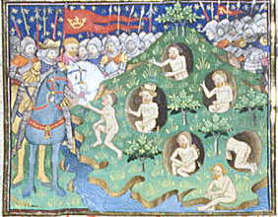
Alexander meeting the Gymnosophists, from a fifteenth century manuscript (reference: Royal 15 E VI f. 17v – image from British Library Catalogue of illuminated manuscripts)

In this session we will explore the manner in which Indian philosophers are presented in the Graeco-Roman literature and whether this reflects some genuine knowledge about India. We will also look at whether any Indian religious and philosophical ideas influenced Graeco-Roman philosophy, specifically in relation to Buddhism and ideas associated with Pyrrho. A number of extracts from ancient sources are given below which you should read in conjunction with the modern scholarship while considering the following questions:

Questions:

1) What features of these Indian philosophers/ascetics stand out most? Why do you think the Graeco-Roman sources were so keen to discuss them?

2) Do the ancient sources offer sufficient information to allow us to identify these Sramanas/Garmanes, Brachmanes, and Gymnosophistoi? Do they impart genuine information?

3) What aspects of “Pyrrhonism” seem quite “Buddhist” and is it possible to judge the extent to which the latter influenced the former?

Modern Scholarship:
Beckwith, C. I. (2015) Greek Buddha: Pyrrho’s Encounter with Early Buddhism in Central Asia. Princeton: Princeton University Press. (chapter 2 is available on Moodle).
Stoneman, R. (1995) ‘Naked Philosophers: The Brahmans in the Alexander Historians and the Alexander Romance’, Journal of Hellenic Studies. 115: 99-114 (article available on Moodle).

Indian Philosophers as described by Megasthenes
Megasthenes FRAGMENT XLI = Strabo Geog. 15.1.58-60
“Speaking of the philosophers, Megasthenes says that those who inhabit the mountains hymn the praises of Dionysus and point out as evidences the wild grape-vine, which grows in their country alone, and the ivy... but the philosophers in the plains worship Heracles. Now these statements of Megasthenes are mythical and refuted by many writers...
Megasthenes makes another division in his discussion of the philosophers, asserting that there are two kinds of them, one kind called Brachmanes and the other Garmanes; that the Brachmanes, however, enjoy fairer repute, for they are more in agreement in their dogmas; and that from conception, while in the womb, the children are under the care of learned men, who are reputed to go to the mother and the unborn child, and, ostensibly, to enchant them to a happy birth, but in truth to give prudent suggestions and advice; and that the women who hear them with the greatest pleasure are believed to be the most fortunate in their offspring; and that after the birth of children different persons, one after another, succeed to the care of them, the children always getting more accomplished teachers as they advance in years; and that the philosophers tarry in a grove in front of the city in an enclosure merely commensurate with their needs, leading a frugal life, lying on straw mattresses and skins, abstaining from animal food and the delights of love, and hearkening only to earnest words, and communicating also with anyone who wishes to hear them; and that the hearer is forbidden either to talk or to cough or even to spit; and if he does, he is banished from association with them for that day as a man who has no control over himself; and that, after having lived in this way for thirty-seven years, they retire, each man to his own possessions, where they live more freely and under less restraint, wearing linen garments, ornaments of gold in moderation in their ears and on their hands, and partake of meats of animals that are of no help to man in his work, but abstain from pungent and seasoned food; and that they marry as many wives as possible, in order to have numerous children, for from many wives the number of earnest children would be greater; and, since they have no servants, it is necessary for them to provide for more service from children — the service that is nearest at hand; but that the Brachmanes do not share their philosophy with their wedded wives, for fear, in the first place, that they might tell some forbidden secret to the profane if they become corrupt, and, secondly, that they might desert them if they became earnest, for no person who has contempt for pleasure and toil, and likewise for life and death, is willing to be subject to another; and that the earnest man and the earnest woman are such persons; and that they converse more about death than anything else, for they believe that the life here is, as it were, that of a babe still in the womb, and that death, to those who have devoted themselves to philosophy, is birth into the true life, that is, the happy life; and that they therefore discipline themselves most of all to be ready for death; and that they believe that nothing that happens to mankind is good or bad, for otherwise some would not be grieved and others delighted by the same things, both having dream-like notions, and that the same persons cannot at one time be grieved and then in turn change and be delighted by the same things. As for the opinions of the Brachmanes about the natural world, Megasthenes says that some of their opinions indicate mental simplicity, for the Brachmanes are better in deeds than in words, since they confirm most of their beliefs through the use of myths; and that they are of the same opinion as the Greeks about many things; for example, their opinion that the universe was created and is destructible, as also the Greeks assert, and that it is spherical in shape, and that the god who made it and regulates it pervades the whole of it; and that the primal elements of all things else are different, but that water was the primal element of all creation; and that, in addition to the four elements, there is a fifth natural element of which the heavens and the heavenly bodies are composed; and that the earth is situated in the centre of the universe. And writers mention similar opinions of the Brachmanes about the seed and the soul, as also several other opinions of theirs. And they also weave in myths, like Plato, about the immortality of the soul and the judgments in Hades and other things of this kind. So much for his account of the Brachmanes.
As for the Garmanes, he says that the most honourable of them are named Hylobii and that they live in forests, subsisting on leaves and wild fruits, clothed with the bark of trees, and abstaining from wine and the delights of love; and that they communicate with the kings, who through messengers inquire about the causes of things and through the Hylobii worship and supplicate the Divinity; and that, after the Hylobii, the physicians are second in honour, and that they are, as it were, humanitarian philosophers, men who are of frugal habits but do not live out of doors, and subsist upon rice and barley-groats, which are given to them by everyone of whom they beg or who offers them hospitality; and that through sorcery they can cause people to have numerous offspring, and to have either male or female children; and that they cure diseases mostly through means of cereals, and not through means of medicaments; and that, among their medicaments, their ointments and their poultices are most esteemed, but that the rest of their remedies have much in them that is bad; and that both this class and the other practise such endurance, both in toils and in perseverance, that they stay in one posture all day long without moving; and that there are also diviners and enchanters, who are skilled both in the rites and in the customs pertaining to the deceased, and go about begging alms from village to village and from city to city; and that there are others more accomplished and refined than these, but that even these themselves do not abstain from the common talk about Hades, insofar as it is thought to be conducive to piety and holiness; and that women, as well as men, study philosophy with some of them, and that the women likewise abstain from the delights of love. (Trans. H. L. Jones 1932).

The Philosopher Pyrrho
Diogenes Laertius Lives of Eminent Philosophers 9.11.61-63, 66, 68
“Pyrrho of Elis was the son of Pleistarchus, as Diocles relates. According to Apollodorus in his Chronology, he was first a painter... Afterwards he joined Anaxarchus, whom he accompanied on his travels everywhere so that he even associated with the Indian Gymnosophists and with the Magi. This led him to adopt a most noble philosophy, to quote Ascanius of Abdera, taking the form of agnosticism and suspension of judgement. He denied that anything was honourable or dishonourable, just or unjust. And so, universally, he held that there is nothing really existent, but custom and convention govern human action; for no single thing is in itself any more this than that.
He led a life consistent with this doctrine, going out of his way for nothing, taking no precaution, but facing all risks as they came, whether carts, precipices, dogs or what not, and, generally, leaving nothing to the subjective-ness of the senses... But Aenesidemus says that it was only his philosophy that was based upon suspension of judgement, and that he did not lack foresight in his everyday acts. He lived to be nearly ninety.
He would withdraw from the world and live in solitude, rarely showing himself to his relatives; this he did because he had heard an Indian reproach Anaxarchus, telling him that he would never be able to teach others what is good while he himself danced attendance on kings in their courts. He would maintain the same composure at all times, so that, even if you left him when he was in the middle of a speech, he would finish what he had to say with no audience but himself, although in his youth he had been hasty. Often, our informant adds, he would leave his home and, telling no one, would go roaming about with whomsoever he chanced to meet. And once, when Anaxarchus fell into a swamp, he passed by without giving him any help, and, while others blamed him, Anaxarchus himself praised his indifference and composure.
... When a dog rushed at him and terrified him, he answered his critic that it was not easy entirely to strip oneself of human weakness; but one should strive with all one's might against (conflicting ethical) matters, by deeds if possible, and if not, by reason....
... Posidonius, too, relates of him a story of this sort. When his fellow-passengers on board a ship were all unnerved by a storm, he kept calm and confident, pointing to a little pig in the ship that went on eating, and telling them that such was the unperturbed state in which the wise man should keep himself...” (lightly adapted from R. D. Hicks 1925).

Fragments of Aristobulos and Onesicritus in Strabo Geog. 15.1.61, 63-65
“Aristobulus says that he saw two of the sophists at Taxila, both Brachmanes; and that the elder had had his head shaved but that the younger had long hair, and that both were followed by disciples; and that when not otherwise engaged they spent their time in the market-place, being honoured as counsellors and being authorized to take as a gift any merchandise they wished; and that anyone whom they accosted poured over them sesame oil, in such profusion that it flowed down over their eyes; and that since quantities of honey and sesame were put out for sale, they made cakes of it and subsisted free of charge; and that they came up to the table of Alexander, ate dinner standing, and taught him a lesson in endurance by retiring to a place nearby, where the elder fell to the ground on his back and endured the sun's rays and the rains (for it was now raining, since the spring of the year had begun); and that the younger stood on one leg holding aloft in both hands a log about three cubits in length, and when one leg tired he changed the support to the other and kept this up all day long; and that the younger showed a far greater self-mastery than the elder; for although the younger followed the king a short distance, he soon turned back again towards home, and when the king went after him, the man bade him to come himself if he wanted anything of him; but that the elder accompanied the king to the end, and when he was with him changed his dress and mode of life; and that he said, when reproached by some, that he had completed the forty years of discipline which he had promised to observe; and that Alexander gave his children a present.
Onesicritus says that he himself was sent to converse with these sophists; for Alexander had heard that the people always went naked and devoted themselves to endurance, and that they were held in very great honour, and that they did not visit other people when invited, but bade them to visit them if they wished to participate in anything they did or said; and that therefore, such being the case, since to Alexander it did not seem fitting either to visit them or to force them against their will to do anything contrary to their ancestral customs, he himself was sent; and that he found fifteen men at a distance of twenty stadia from the city, who were in different postures, standing or sitting or lying naked and motionless till evening, and that they then returned to the city; and that it was very hard to endure the sun, which was so hot that at midday no one else could easily endure walking on the ground with bare feet.
Onesicritus says that he conversed with one of these sophists, Calanus, who accompanied the king as far as Persis and died in accordance with the ancestral custom, being placed upon a pyre and burned up. He says that Calanus happened to be lying on stones when he first saw him; that he therefore approached him and greeted him; and told him that he had been sent by the king to learn the wisdom of the sophists and report it to him, and that if there was no objection he was ready to hear his teachings; and that when Calanus saw the mantle and broad-brimmed hat and boots he wore, he laughed at him and said: "In olden times the world was full of barley-meal and wheaten-meal, as now of dust; and fountains then flowed, some with water, others with milk and likewise with honey, and others with wine, and some with olive oil; but, by reason of his gluttony and luxury, man fell into arrogance beyond bounds. But Zeus, hating this state of things, destroyed everything and appointed for man a life of toil. And when self-control and the other virtues in general reappeared, there came again an abundance of blessings. But the condition of man is already close to satiety and arrogance, and there is danger of destruction of everything in existence." And Onesicritus adds that Calanus, after saying this, bade him, if he wished to learn, to take off his clothes, to lie down naked on the same stones, and thus to hear his teachings; and that while he was hesitating what to do, Mandanis, who was the oldest and wisest of the sophists, rebuked Calanus as a man of arrogance, and that too after censuring arrogance himself; and that Mandanis called him and said that he commended the king because, although busied with the government of so great an empire, he was desirous of wisdom; for the king was the only philosopher in arms that he ever saw, and that it was the most useful thing in the world if those men were wise who have the power of persuading the willing, and forcing the unwilling, to learn self-control; but that he might be pardoned if, conversing through three interpreters, who, with the exception of language, knew no more than the masses, he should be unable to set forth anything in his philosophy that would be useful; for that, he added, would be like expecting water to flow pure through mud!
At all events, all he said, according to Onesicritus, tended to this, that the best teaching is that which removes pleasure and pain from the soul; and that pain and toil differ, for the former is inimical to man and the latter friendly, since man trains the body for toil in order that his opinions may be strengthened, whereby he may put a stop to dissensions and be ready to give good advice to all, both in public and in private; and that, furthermore, he had now advised Taxiles to receive Alexander, for if he received a man better than himself he would be well treated, but if inferior, he would improve him. Onesicritus says that, after saying this, Mandanis inquired whether such doctrines were taught among the Greeks; and that when he answered that Pythagoras taught such doctrines, and also bade people to abstain from meat, as did also Socrates and Diogenes, and that he himself had been a pupil of Diogenes, Mandanis replied that he regarded the Greeks as sound-minded if, but that they were wrong in one respect, in that they preferred custom to nature; for otherwise, Mandanis said, they would not be ashamed to go naked, like himself, and live on frugal fare; for, he added, the best house is that which requires the least repairs. And Onesicritus goes on to say that they inquire into numerous natural phenomena, including prognostics, rains, droughts, and diseases; and that when they depart for the city they scatter to the different market-places; and whatever they chance upon anyone carrying figs or bunches of grapes, they get fruit from that person as a free offering; but that if it is oil, it is poured down over them and they are anointed with it; and that the whole of a wealthy home is open to them, even to the women's apartments, and that they enter and share in meals and conversation; and that they regard disease of the body as a most disgraceful thing; and that he who suspects disease in his own body commits suicide through means of fire, piling a funeral pyre; and that he anoints himself, sits down on the pyre, orders it to be lighted, and burns without a motion.” (Trans. from H. L. Jones 1932).

Alexander and the Gymnosophists
Plutarch Alexander 64-65.
“He captured ten of the Gymnosophists who had done most to get Sabbas to revolt, and had made the most trouble for the Macedonians. These philosophers were reputed to be clever and concise in answering questions, and Alexander therefore put difficult questions to them, declaring that he would put to death him who first made an incorrect answer, and then the rest, in an order determined in like manner; and he commanded one of them, the oldest, to be the judge in the contest. The first one, accordingly, being asked which, in his opinion, were more numerous, the living or the dead, said that the living were, since the dead no longer existed. The second, being asked whether the earth or the sea produced larger animals, said the earth did, since the sea was but a part of the earth. The third, being asked what animal was the most cunning, said: "That which up to this time man has not discovered." The fourth, when asked why he had induced Sabbas to revolt, replied: "Because I wished him either to live nobly or to die nobly." The fifth, being asked which, in his opinion, was older, day or night, replied: "Day, by one day"; and he added, upon the king expressing amazement, that hard questions must have hard answers. Passing on, then, to the sixth, Alexander asked how a man could be most loved; "If," said the philosopher, "he is most powerful, and yet does not inspire fear." Of the three remaining, he who was asked how one might become a god instead of man, replied: "By doing something which a man cannot do"; the one who was asked which was the stronger, life or death, answered: "Life, since it supports so many ills." And the last, asked how long it were well for a man to live, answered: "Until he does not regard death as better than life." So, then, turning to the judge, Alexander bade him give his opinion. The judge declared that they had answered one worse than another. "Well, then," said Alexander, "thou shalt die first for giving such a verdict." "That cannot be, O King," said the judge, "unless thou falsely saidst that thou wouldst put to death first him who answered worst."
These philosophers, then, he dismissed with gifts; but to those who were in the highest repute and lived quietly by themselves he sent Onesicritus, asking them to pay him a visit. Now, Onesicritus was a philosopher of the school of Diogenes the Cynic. And he tells us that Calanus very harshly and insolently bade him strip off his tunic and listen naked to what he had to say, otherwise he would not converse with him, not even if he came from Zeus; but he says that Dandamis was gentler, and that after hearing fully about Socrates, Pythagoras, and Diogenes, he remarked that the men appeared to him to have been of good natural parts but to have passed their lives in too much awe of the laws. Others, however, say that the only words uttered by Dandamis were these "Why did Alexander make such a long journey hither?" Calanus, nevertheless, was persuaded by Taxiles to pay a visit to Alexander. His real name was Sphines, but because he greeted those whom he met with "Cale," the Indian word of salutation, the Greeks called him Calanus. It was Calanus, as we are told, who laid before Alexander the famous illustration of government. It was this. He threw down upon the ground a dry and shrivelled hide, and set his foot upon the outer edge of it; the hide was pressed down in one place, but rose up in others. He went all round the hide and showed that this was the result wherever he pressed the edge down, and then at last he stood in the middle of it, and lo! it was all held down firm and still. The similitude was designed to show that Alexander ought to put most constraint upon the middle of his empire and not wander far away from it.” (Trans. from B. Perrin 1919).

Appendix I: Key Maps and Locations

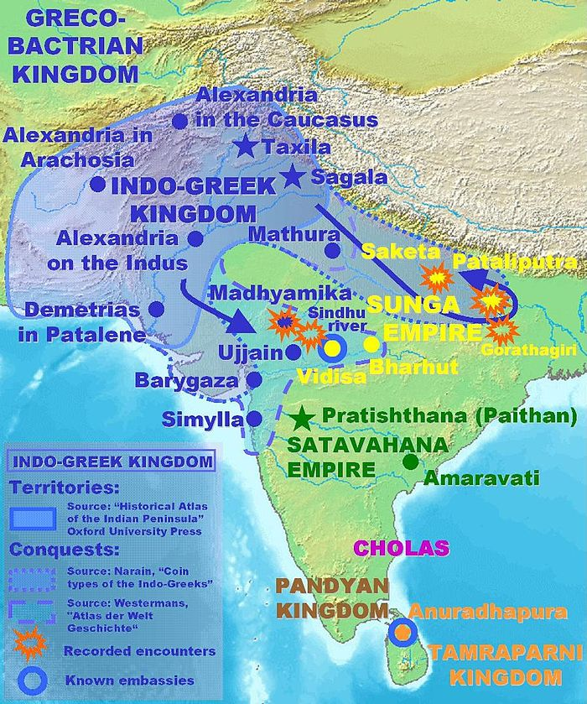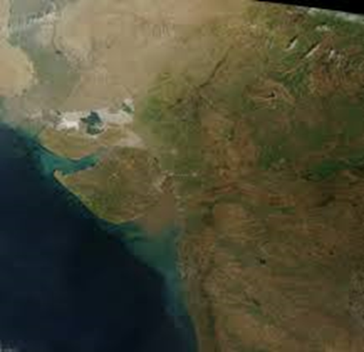
Cutch
Gulf of Cutch
Surasthra
Patalene, Saraostos and Sigerdis
Patalene equates with the Indus Delta region (part of modern southern Pakistan) and was conquered by Demetrius the son of Euthydemus according to Strabo (Geography 11.11.1; see also Claudius Ptolemy Geography 7.1.55); this ruler evidentially also set up a city named Demetrias-in-Patalene. The Saraostos and Sigerdis mentioned by Strabo are also thought to possibly equate with Surashtra and Cutch in the modern Indian state of Gujarat.

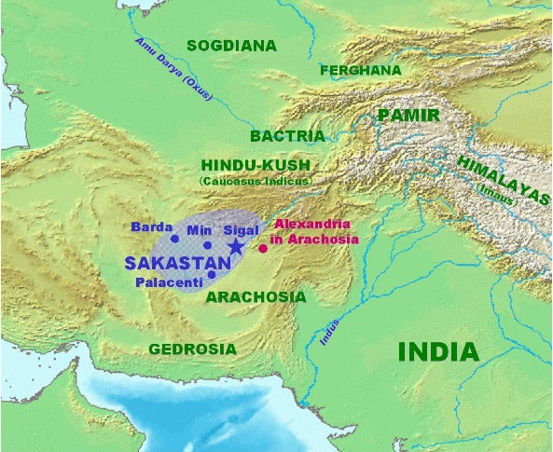
Ferghana
The Ferghana valley lies north of the Pamir Mountains and is located within the territories of modern northern Tajikistan, southern Kyrgyzstan and eastern Uzbekistan. The Yuezhi after suffering a major defeat at the hands of the Xiongnu moved westwards crossing into the Ferghana valley region before coming to the banks of the Oxus and subsequently entering into Bactria. The Sakas had previously entered into the region of Bactria by the mid-late second century BC and themselves had come under pressure from the Yuezhi (Sima Qian Shiji = Book of History). The Graeco-Bactrians had probably lost control of Bactria by c.130 BC.

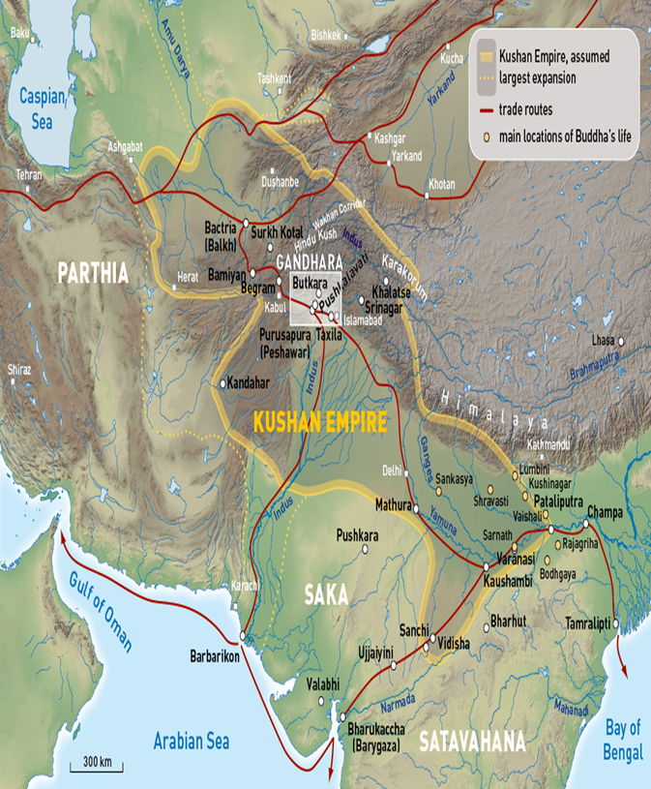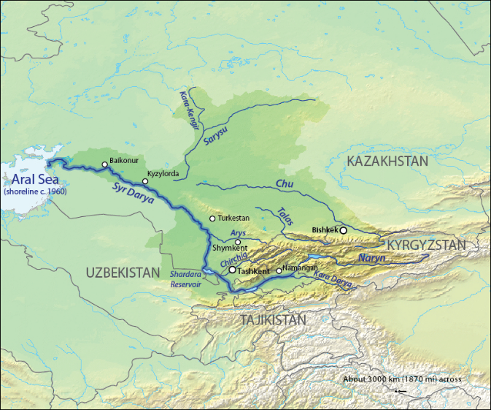
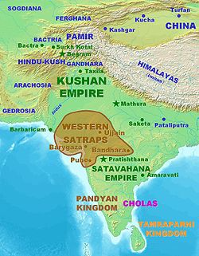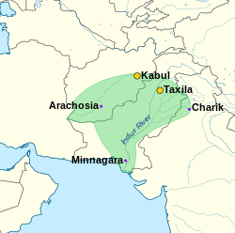
Indo -Parthians
The Sakas, Indo-Parthians and the Kushan Empire
Pliny the Elder (NH 6.19.50) claims that the Persians call the group of Scythians living nearest to them the Sacae (in Greek Sakai). Chinese historical records seem to place these Sakas (known the to the Chinese as Sai) in the territory around the Ili River and Chu River valleys before they were forced out by the migration of the Yuezhi, and during the mid-second century BC invaded into Bactria (where they would also later come under pressure from the Yuezhi). By the first century AD Saka rule had been established in northwest India, with a kingdom known as the Western Kshatrapas (or Western Satraps).
The Indo-Parthian kingdom which encompassed parts of modern southern Afghanistan and large swaths of Pakistan, appears to have arisen at the end of the first century BC and continued into the first century AD under the Gondopharid dynasts. Most knowledge about this kingdom comes from coinage and brief references in textual sources such as in the Periplus Maris Erythraei (38) which refers to various Parthian princes of the Indus Delta region who were constantly chasing each other off the throne.
The Kushan or Kushana appear to have been one of the tribes of the Yuezhi confederation who would establish a major Empire in Bactria, Gandhara, the Indus Valley area and parts of northern India during the course of the first to third centuries AD.

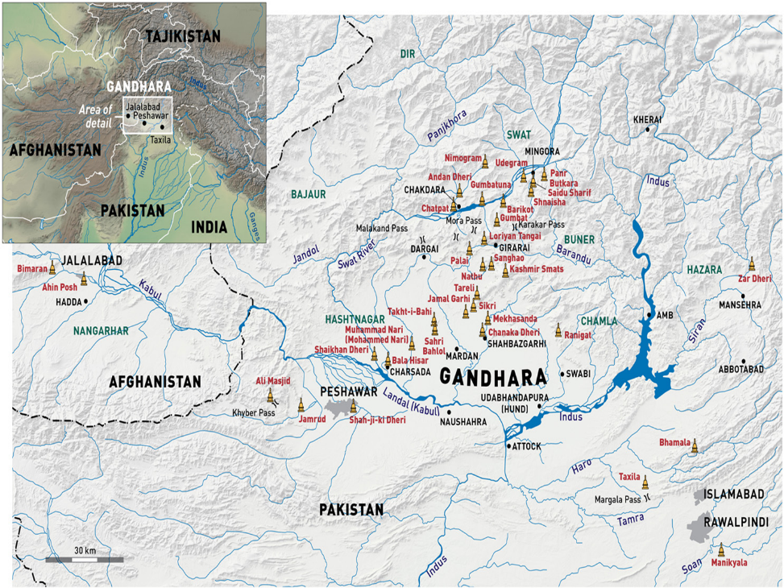
Gandhara
The ancient region of Gandhara lay in the north of modern Pakistan and partially in north-eastern Afghanistan. It was one of the regions annexed by the invading Indo-Greeks at the beginning of the second century BC. They would continue to rule in this region until the early first century BC when the territory fell to the Sakas, then the Indo-Parthians and eventually the Kushan Empire. During the Indo-Greek period aspects of Hellenic culture was adapted and modified and would continue to have an impact even after the fall of the Indo-Greeks. This legacy is particularly noticeable in artistic representations. Indeed, in the Kushan period a great many representations of the Buddha, scenes from the Buddha’s life, and wider stories connected to him were represented in a distinct style of art that, in part, was informed by earlier Hellenic influences (and possibly by contemporary contact with the Mediterranean world).

Appendix II: Graeco-Bactrians and Indo-Greeks – Key Dates

311-305 BC - Seleucus I campaigns in the Upper or Eastern Satrapies
305/04 BC – ceding of border territories by Seleucus I to the Maurya.
294-281 BC – major phase of Seleucid activity in Central Asia; Antiochus I sent to manage Upper Satrapies by his father (Seleucus); substantial foundation of new settlements and re-founding of settlements originally established by Alexander.
mid-late third century BC – Diodotus I and Diodotus II loosen their association with the Seleucid Empire; Diodotus II adopts title of basileus (king) for himself posthumously applies it to his father (Diodotus I).
c.220s BC - Euthydemus I seizes power from Diodotus II.
c.209-206 BC – Antiochus III marches east to deal with problems in the Upper Satrapies including revolts Hyrcania and Parthia, as well as attempting to bring the breakaway Graeco-Bactrians to heel; Antiochus initially defeats Euthydemus on the open field but fails to capture Bactra (chief city of Bactria) after a prolonged siege.
206 BC – Euthydemus recognised as king; marriage alliance formed, Demetrius (son of Euthydemus) married to one of Antiochus’ daughters; Euthydemus surrenders his elephant corps to Antiochus.
206-205 BC – Antiochus III marches to border territory of Indian (probably Mauryan king) Sophagasenus (as he is referred to in Greek sources); treaty of friendship renewed, Antiochus receives a gift (quite likely extorted) of war-elephants (precise number not specified, but Antiochus’ total elephant corps now reach 150).
end of third to early second century BC – the Graeco-Bactrians appear to lose control of Sogdia.
c.200 BC – Demetrius the “invincible” takes power.
early decades of second century BC – Graeco-Bactrians cross over the Parapamisadae (Hindu Kush) and take advantage of declining Mauryan power; last Mauryan king Bṛhadratha overthrown by one of his own generals Puṣyamitra (who established the Sunga dynasty).
c.190-180s BC - Agathocles and Pantaleon issue bilingual currency.
mid-second century BC - Eucratides the Great (contemporary of Mithradates of Parthia who ruled c. 175-160 BC) is probably last significant king with territories in Bactria; seems to have lost territories to the Parthians and “Scythians”, i.e. Sakas according to Strabo and Justin.
c.155-130 BC – Menander “the Saviour” rules; perhaps the most successful of the Indo-Greek kings who may even have marched an army (in a wider alliance) as far east as Pataliputra; seems to favour Buddhism (see coin issues) and even appears in Buddhist tradition as a convert (see the Milindapanha - The Questions of Milinda).
c.145-130 BC – sacking of Samarkand.
c.145 BC – initial sacking of Aï Khanum by the Sakas and subsequently by Yuehzi (Yueh-Chih) c.130 BC.
129/128 BC - Zhang Qian during his travels in Central Asia mentions seeing the Yuezhi on the northern banks of the Oxus River.
late second century BC – Heliodorus is sent as ambassador by the Indo-Greek Antialcidas to the court of King Kasiputra Bhagabhadra, and while at Vidisha (Besngar) sets up a pillar declaring himself a devotee of Vishnu.
c.90-80 BC – around this time the Indo-Scythian/Saka king Maues has probably taken over control of the city of Taxila.
c.70 BC – Indo-Greek rule in the region which is now modern Kabul probably falls to Yuezhi at this time.
mid-first century BC – Indo-Greek rule in Gandhara probably lost to the Indo-Scythians/Sakas by this point.
beginning of the first century AD – last vestiges of Indo-Greek rule in what is now the modern eastern Punjab seems to be swept away by the Sakas; Strato II possibly last Indo-Greek ruler (or at least vassal of one of the invading groups).

Appendix III: Potential reconstruction of Indo-Greek chronology

This table represents a reconstruction of the possible chronological order of the Indo-Greek kings by Bopearachchi (1991). Beware that this is very much a hypothetical reconstruction which relies on a very limited evidential basis (largely numismatic evidence). Consequently do not treat these dates as absolute, but rather as a plausible approximations which are potentially subject to revision (and which are not universally accepted).

Territories/  Dates | PAROPAMISADAE | ARACHOSIA | GANDHARA | W. PUNJAB | E. PUNJAB
200-190 BCE | Demetrius I
190-180 BCE | Agathocles | Pantaleon
185-170 BCE | Antimachus I
180-160 BCE | Apollodotus I
175-170 BCE | Demetrius II
160-155 BCE | Antimachus II
170-145 BCE | Eucratides
155-130 BCE | Menander I
130-120 BCE | Zoilos I |  | Agathokleia
120-110 BCE | Lysias |  | Strato I
110-100 BCE | Antialcidas |  | Heliokles II
100 BCE | Polyxenios |  | Demetrius III
100-95 BCE | Philoxenus
95-90 BCE | Diomedes | Amyntas |  | Epander
90 BCE | Theophilos | Peukolaos |  | Thraso
90-85 BCE | Nicias | Menander II |  | Artemidoros
90-70 BCE | Hermaeus | Archebios
 | Yuezhi tribes |  | Maues (Indo-Scythian)
75-70 BCE |  |  | Telephos | Apollodotus II
65-55 BCE |  |  |  | Hippostratos | Dionysios
55-35 BCE |  |  |  | Azes I (Indo-Scythian) | Zoilos II
55-35 BCE |  |  |  |  | Apollophanes
25 BCE- 10 CE |  |  |  |  | Strato II
 |  |  |  |  | Rajuvula (Indo-Scythian)

Bopearachchi, O. (1991) Monnaies gréco-bactriennes et indo-grecques, Catalogue raisonné. Paris: Bibliothèque Nationale.

