

Student name: Krishna Samirkumar Shah
Student ID: 2107627

Module name: Marketing Management [Assignment-2]
Module code: LCMB7001
Lecturer name: Tushara Balendran

Table of Contents
Introduction 3
Background of Burberry 3
key external influencing drivers within the organisation 3
Pestle analysis 3
Internal environment analysis 6
Porter’s five forces analysis 6
The role that marketing plays with the organisation 7
Conclusion 10
Recommendation 10
References 11

Introduction
Marketing management is known as the process of controlling the marketing aspects that being including setting out the company goals, organising the plans along taking decisions for the firm. This report is based upon Burberry organisation where environmental marketing analysis regarding the organisation will be examined that will be contributing towards the overall growth of the business establishment. PESTLE and Porter’s five forces analysis will be carried out in terms of examining the external and internal business environment for the business establishment. Furthermore, the role of marketing regarding Burberry organisation will also be examined within the report.

Background of Burberry
Burberry is a UK based luxury style brand that has its headquarter located in London, England. The organisation designs and allots ready attire fashion wear clothing such as trench coats, footwearand cosmetics. Burberry was established in the year 1856 and currently operates through its 421 stores across the global platform(Burberryplc, 2020). During the year 2021, Burberry announced that it had taken up the opportunity of becoming climate positive company by the end of the year 2040. A new target has been undertaken by Burberry to reduce supply chain emissions by 46% by the end of the year 2030.

key external influencing drivers within the organisation

Pestle analysis
Political
Examining the current political situation of the UK it has been noticed that the current situation of the global pandemic has put on trade restrictions, guidelines and new SOPs from the government. Besides, the tax rate of the UK has also increased by 19% that also makes it difficult for Burberry in functioningcommercial within the competitive business environment(Gov, 2021). The challenging political condition restricts the growth of Burberry in the UK.
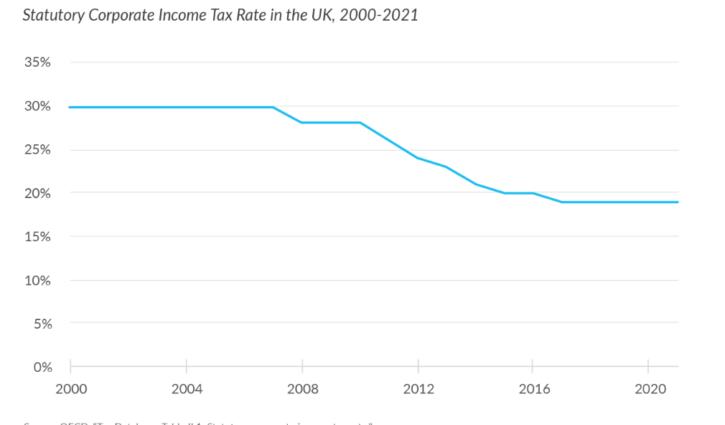
Figure 1: Corporate tax rate in the year 2020-2021
Source: (Gov, 2021)

Economic
Post the global pandemic condition of Covid-19, the current GDP of the UK is increasing by 5.34% making it easier for UK based fashion wear brand Burberry to operate their business within the country(Statista, 2021). The FDI investment within the UK has also increased which has opened up the door of opportunities for Burberry organisation in operating their business within the country. FDI investment help Burberry in arranging sources of funds to invest within the organisation to grow its business.
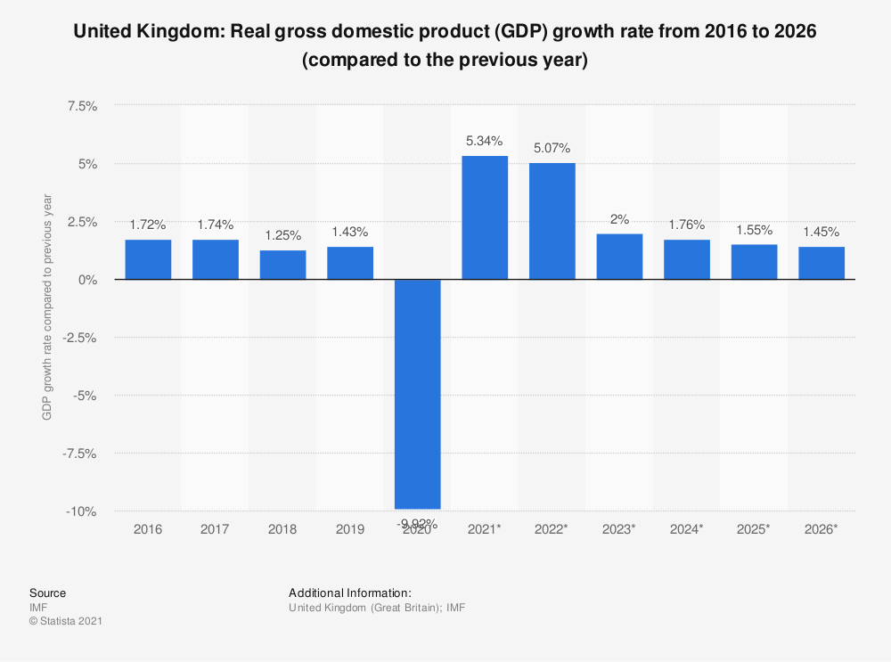
Figure 2: UK’s GDP growth
Source: (Statista, 2021)

Social
The UK comprises a multicultural society where people from different backgrounds and cultures coexist together. The multicultural society of the UK makes it easier for the organisation in introducing new products and services that match the expectations of the customers. Furthermore, the growth in UK people purchasing capability due to the growth of Average Annual Income of GBP 30,800 is contributing towards the growth of Burberry within the geographical location(Gov, 2021).
Technological
UK's technology is recognised as one of the most advanced in the world as it provides the great technological infrastructure for Burberry to operate its business. Moreover, UK’s technological department has financed GBP 10 billion to the development of the IT industry that immensely contributing towards the overall growth and productivity of the business establishment(Gov, 2020). Technological growth for Burberry helps them in increasing their manufacturing process while reducing the concern of wastages.
Legal
Burberry while functioning its business in the UK needs to obey the Health and Safety Act 1974 to protect the employees' rights while working in a hazardous situation. Moreover, Burberry also needs to comply with the Consumer Protection Act 2010, as it will be benefiting the organisation in keeping the trust and loyalty of the firm towards the organisation.
Environmental
Burberry is focused on eliminating the environmental concern and risk that negatively impacts the overall business operations of the organisation. The risk of resource wastages and poor packaging issues needs to be resolved by the organisation to maintain better business activities. Environmental Protection Act 1990 will be maintained by Burberry to eliminate the concern of environmental issues. Eliminating the environmental issues grows the business sustainability for the organisation.

Internal environment analysis

Porter’s five forces analysis
The threat of new entrant
The threat of new entrants is comparatively low for Burberry as it requires high capital to invest towards purchasing machinery and resources. Moreover, the new entrants also face challenges due to their lack of experience that increases the difficulty for them in performing the activities in an organised manner to achieve desired results(Hbs, 2020). Furthermore, the power of new business entrants is also low because Burberry has put up barriers in form of innovation that limits the growth of new business entrants in the UK.
Threat of suppliers
Suppliers hold moderate power while operating in the UK because there is a large number of suppliers present within the UK that offers resources to the organisation to manufacture and produce goods and services. Supplier’s threat is also moderate due to the presence of SMEs and international suppliers that decreases the power of suppliers. Burberry also has its backward integration process that lets them manufacture their resources as a result of which the power of suppliers decreases(Burberryplc, 2020). Hence, Burberry holds the opportunities to grow its overall business operations.

Threat of buyers
Buyers hold high bargaining power within the UK due to their changing tastes and preferences as a result of which makes it difficult for Burberry in attracting customers to the organisation. The bargaining power of customers is also high due to their low switching cost as a result of which it becomes difficult for Burberry in performing their business within the competitive environment of the UK(Burberryplc, 2020). The high bargaining power of buyers also makes it difficult for Burberry in keeping the loyalty of the customers towards the organisation.
Threat of substitutes
The threat of substitutes is considered to be high for Burberry as there is a large number of high street retail firms that offer different types of fashionwear clothing to the people that shift the loyalty of the customers towards another organisation. The similar value proposition with unique differences from present offerings that are being offered by the substitute products also decreases the overall potentiality of Burberry in achieving growth and productivity. The threat of substitutes for Burberry also decreases their overall brand status.
Competitive rivalry
The competitive rivalry for the organisation is high due to growing competition from Hermes, Zara and H&M that limits the growth opportunities for the organisation(Owler, 2020). Moreover, the competitive rivalry is also high because they offer similar product variety in different price points along with a value proposition that makes Burberry in differentiating their brand from that of their competitors. Furthermore, the growing competition for Burberry has also decreased the product life cycle as the new product are being launched to keep themselves within the competition. Therefore, the competitive rivalry is high for Burberry organisation.

The role that marketing plays with the organisation
SWOT analysis
Strength
The large product portfolio of Burberry enables them in attracting customers and make them loyal to the organisation. Burberry also has its presence in more than 50 countries and operates through more than 400 stores that benefit them in earning high revenue and extending their presence in different geographical locations(Burberryplc, 2020).

Weakness
The weakness that Burberry faces while operating their business is a cheap imitation from different high street brands that decreases the brand status of the organisation in the competitive business environment(Theguardian, 2020). The weakness of Burberry is their high pricing of the products that make it challenging for them in tapping into a large customer segment.
Opportunities
Growth opportunities that lie in front of Burberry include expanding their business in South-Asia Pacific regions that will increase their revenue and success. Effective use of e-commerce business for Burberry also makes it easier for them in operating in different geographical locations to tap into the local market(Luxurydaily, 2020).
Threat
Growing competition from Zara, H&M and Hermes makes it challenging for the organisation in operating their business in the competitive environment of the UK. High bargaining power and low switching costs for Burberry also increase the threat level for the organisation(Owler, 2020). Moreover, high taxation and economic recession are also considered as a threat for Burberry.
Segmentation, Targeting and Positioning
Segmentation
Segmentation is the process of dividing the customers on basis of their similar characteristics and traits. Segmentation helps the organisation in identifying their target customers for their products and services. Burberry uses demographic and psychographic segmentationsuch as customers of Burberry fall in the age group of 25 years to 45 years, people earning more than GBP 1000 per month is also their target customers(Camilleri, 2018).Psychographic segmentation for Burberry includes of personality and lifestyle of customers that help Burberry in designing the fashion wear based on the specific needs of the customers.
Targeting
The target customers for Burberry includes people falling in the age category of 25 years to 45 years. Burberry manufactures its fashionwear clothing based on the latest trend and fashion in the UK market. Targeting the right set of customers benefits the organisation in increasing their profitability along with growing competitive advantages for the organisation contributing towards their overall growth(Andaleeb, 2016).
Positioning
Examining the Bowman’s strategic clock, it has been seen that Burberry has undertaken a differentiation positioning strategy. Differentiation strategy for Burberry helps them in reducing the competition along with providing unique products to the customers as a result of which it grows the trust of them towards the organisation.
4Ps of Burberry
Product
Burberry specializes in fashionable clothes that are being appreciated worldwide because of their distinctive designs and exquisite materials. All of the Burberry products are made out of Tartan pattern that is a special type of fabric helping the brand in maintaining sustainability(Burberryplc, 2020). The quality and durability of Burberry also set them apart from the competitors.
Place
Burberry is a world rewound retail organisation that has its operations in more than 50 countries and operates through its 400 stores located in different geographical locations (Statista, 2020). Moreover, Burberry also operates its business through an online platform that makes it easier for them in building a positive relationship with the customers along with grow their operations.
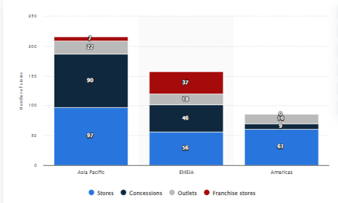
Figure 3:Burberry stores worldwide
Source: (Statista, 2020)
Price
Burberry follows a premium pricing strategy, where the prices of the products are being set based upon their product size, categories and specifications. The premium pricing strategy for Burberry also helps them in making their brand different from that of their competitors. Product quality and sustainable designing of the product also help Burberry in pricing its product premium.
Promotion
Burberry uses ATL and BTL promotional activities that being including of TV ads, Newspaper and magazine ads(Burberryplc, 2020). Whereas, the BTL promotional activities for Burberry also includes event promotions and trade shows in different locations of the UK to attract customers towards the organisation and grow their business operations.

Conclusion
The overall report is based upon Burberry organisation that operates their business through the UK and worldwide, Burberry specializes in premium fashionwear products. As the report progress key, external drivers impacting the business of Burberry has also been identified in terms of PESTLE analysis, whereas internal environmental analysis of Burberry has been examined through the help of porter's five forces analysis. Marketing analysis of Burberry in terms of SWOT, STP and 4Ps of the organisation has also been examined. Differentiated positioning strategy has been undertaken by Burberry as it helps them in differentiating their business from that of their competitors.

Recommendation
Recommendations for Burberry is based upon the analysis of the overall study.
- Based on SWOT analysis it has been seen that Burberry has a limited global presence, therefore, to grow their business in global business platform Burberry can decide on building a strategic alliance with MNCs retail firms so that it becomes easier for them in operating in the global business platform and earn high growth.
- The premium pricing strategy of Burberry limits its customer base;therefore, the organisation can look forward to developing mid-range fashionwear clothing that will be helping the organisation in growing its customer base and revenue generation capability.

References
Andaleeb, S., 2016. Market segmentation, targeting, and positioning. In Strategic Marketing Management in Asia. London: Emerald Group Publishing Limited.
Burberryplc, 2020. 2020/21 BURBERRY GROUP PLC STATEMENT. [Online]
Available at: https://www.burberryplc.com/content/dam/burberry/corporate/Responsibility/Responsibility_docs/Burberry%20Transparency%20in%20the%20Supply%20Chain%20and%20Modern%20Slavery%20Statement.pdf
[Accessed 14 December 2021].
Burberryplc, 2020. Burberry-launches-new-campaign-as-part-of-its-initiative-to-supp. [Online]
Available at: https://www.burberryplc.com/en/news/corporate/2020/burberry-launches-new-campaign-as-part-of-its-initiative-to-supp.html
[Accessed 18 December 2021].
Burberryplc, 2020. Home. [Online]
Available at: https://www.burberryplc.com/en/index.html
[Accessed 14 December 2021].
Burberryplc, 2020. Strategy. [Online]
Available at: https://www.burberryplc.com/en/company/strategy.html
[Accessed 14 December 2021].
Camilleri, M., 2018. In Travel marketing, tourism economics and the airline product. In: Market segmentation, targeting and positioning. London: Springer, Cham, pp. 69-83.
Gov, 2020. Technology. [Online]
Available at: https://www.great.gov.uk/international/content/about-uk/industries/technology/
[Accessed 14 December 2021].
Gov, 2021. Householddisposableincomeandinequality. [Online]
Available at: https://www.ons.gov.uk/peoplepopulationandcommunity/personalandhouseholdfinances/incomeandwealth/bulletins/householddisposableincomeandinequality/financialyear2020
[Accessed 14 December 2021].
Gov, 2021. Rates-and-allowances-corporation-tax. [Online]
Available at: https://www.gov.uk/government/publications/rates-and-allowances-corporation-tax/rates-and-allowances-corporation-tax#:~:text=At%20Budget%202020%2C%20the%20government,2021%20would%20remain%20at%2019%25.
[Accessed 14 December 2021].
Hbs, 2020. Burberry-using-digital-to-revitalize-a-brand. [Online]
Available at: https://digital.hbs.edu/platform-digit/submission/burberry-using-digital-to-revitalize-a-brand/
[Accessed 14 December 2021].
Luxury daily, 2020. Burberry-transforms-customer-experiences-through-digital-innovation. [Online]
Available at: https://www.luxurydaily.com/burberry-transforms-customer-experiences-through-digital-innovation/
[Accessed 18 December 2021].
Owler, 2020. Burberryplc. [Online]
Available at: https://www.owler.com/company/burberryplc
[Accessed 14 December 2021].
Owler, 2020. Burberryplc. [Online]
Available at: https://www.owler.com/company/burberryplc
[Accessed 18 December 2021].
Statista, 2020. Burberry-s-number-of-stores-worldwide-by-outlet-type-and-region. [Online]
Available at: https://www.statista.com/statistics/439354/burberry-s-number-of-stores-worldwide-by-outlet-type-and-region/
[Accessed 18 December 2021].
Statista, 2021. Gross-domestic-product-gdp-growth-rate-in-the-united-kingdom. [Online]
Available at: https://www.statista.com/statistics/263613/gross-domestic-product-gdp-growth-rate-in-the-united-kingdom/
[Accessed 14 December 2021].
Theguardian, 2020. Why-does-Burberry-destroy-its-products-q-and-a. [Online]
Available at: https://www.theguardian.com/fashion/2018/jul/20/why-does-burberry-destroy-its-products-q-and-a
[Accessed 18 December 2021].

