Digital Skills and Research Methods
PRESENTATION

STUDENT NAME – IULIAN RENTEA
STUDENT ID – 2123030

Table of Contents
Introduction 4
Background of the Revolut Ltd 5
The challenges before Revolut Ltd in the introduction of artificial intelligence 6
Insights into the modern technology introduced 8
Impact of technology introduced on Revolut Ltd 11
Lessons that can be drawn from the case study 13
Conclusion 14
References 15

Introduction
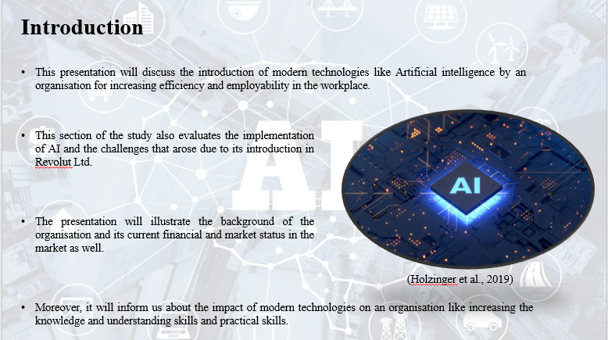

Background of the Revolut Ltd
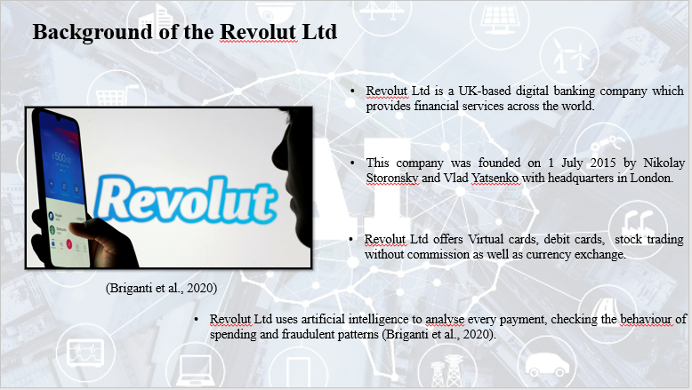

The challenges before Revolut Ltd in the introduction of artificial intelligence
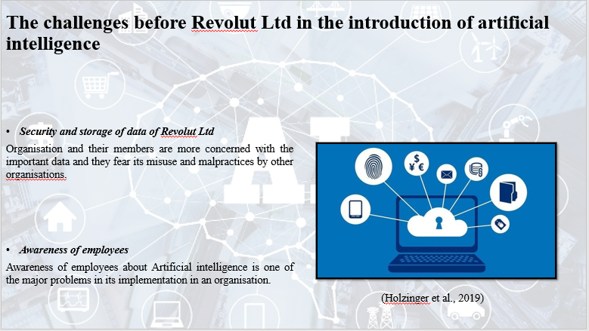
Security and storage of data of Revolut Ltd
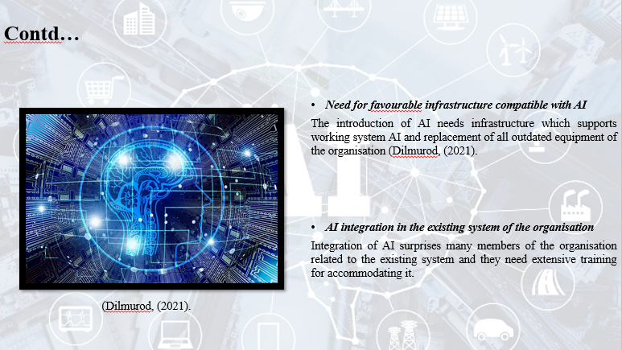

Insights into the modern technology introduced
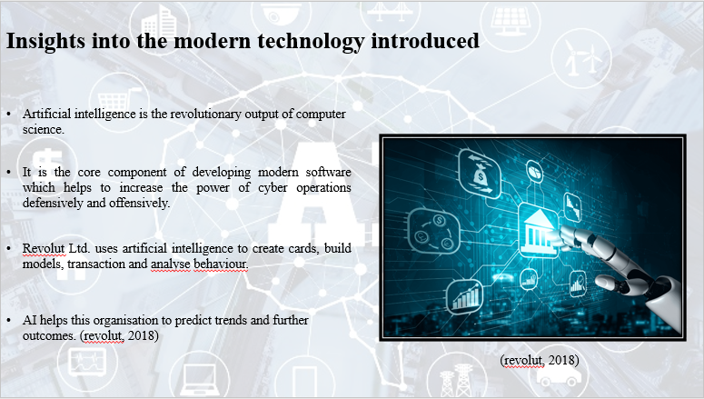
Benefits of AI
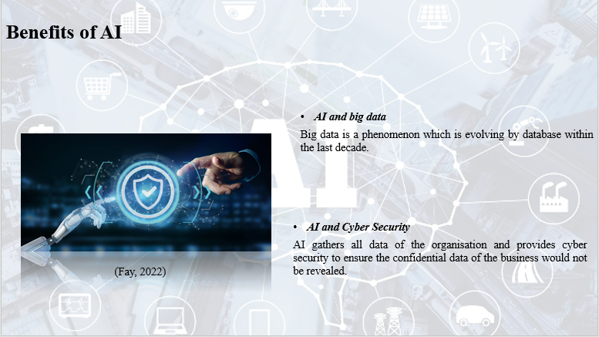

AI and Cyber Security
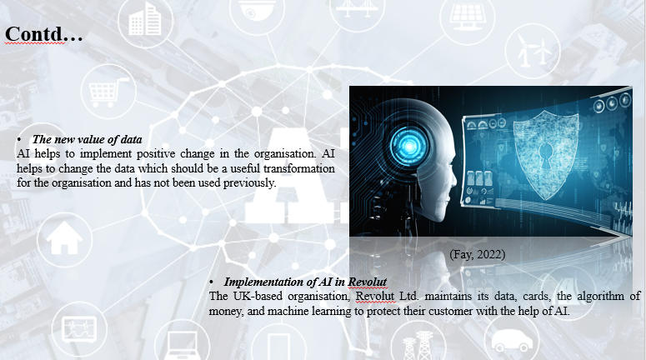

Impact of technology introduced on Revolut Ltd
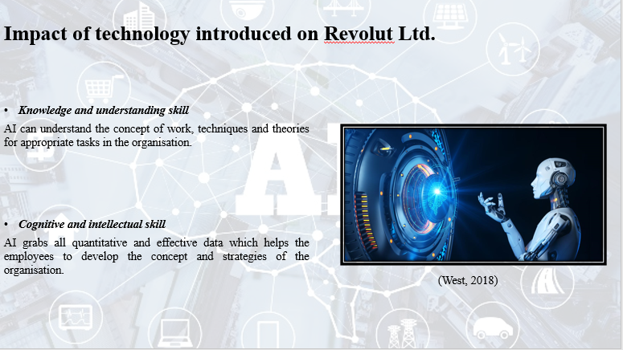

Cognitive and intellectual skill
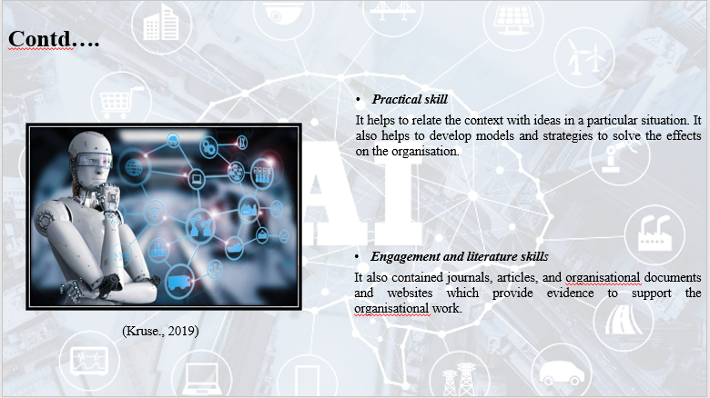

Lessons that can be drawn from the case study
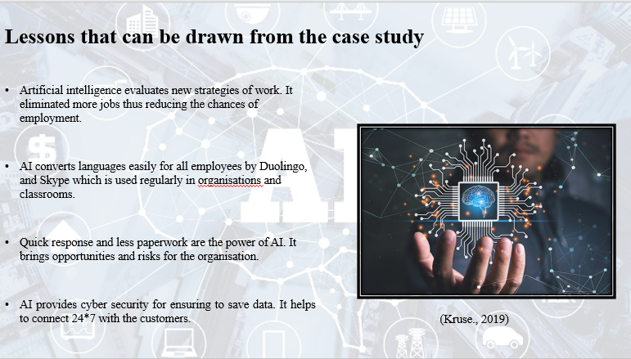

Conclusion
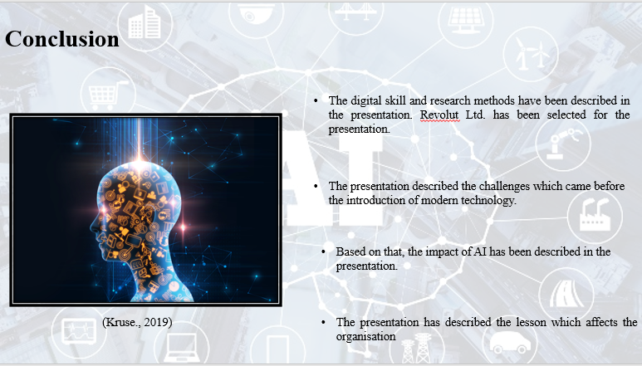

References


