Sabrina Malek

BIS ASSIGNMENT 2 PART 1

Contents
Part 1 (a) 2
1.0 Source Data 2
2.0 Star schema 2
3.0 Relationship diagram 3
4.0 ETL 3
4.1 What is ETL 3
4.2 ETL Process 3
Part 1 (b) 6
Part 1 (c) 7
Reference 9
Appendices 10

Table of Figures
Figure 1: Schema diagram 3
Figure 2: Relationship diagram 4
Figure 3 5
Figure 4 6
Figure 5 7
Figure 6 7
Figure 7 8
Figure 8: Dashboard 9

Part 1 (a)

Source Data
Data was extracted from 3 different Excel spreadsheets. These data were then combined into a single spreadsheet. Empty columns were deleted. Blank spaces were substituted with “Unknown”. A few rows only contain Department data. These rows were deleted because it is irrelevant. Under ‘Net Amount’ column, the data was written in currency form. The Pound Sterling (£) sign is included in the spaces.
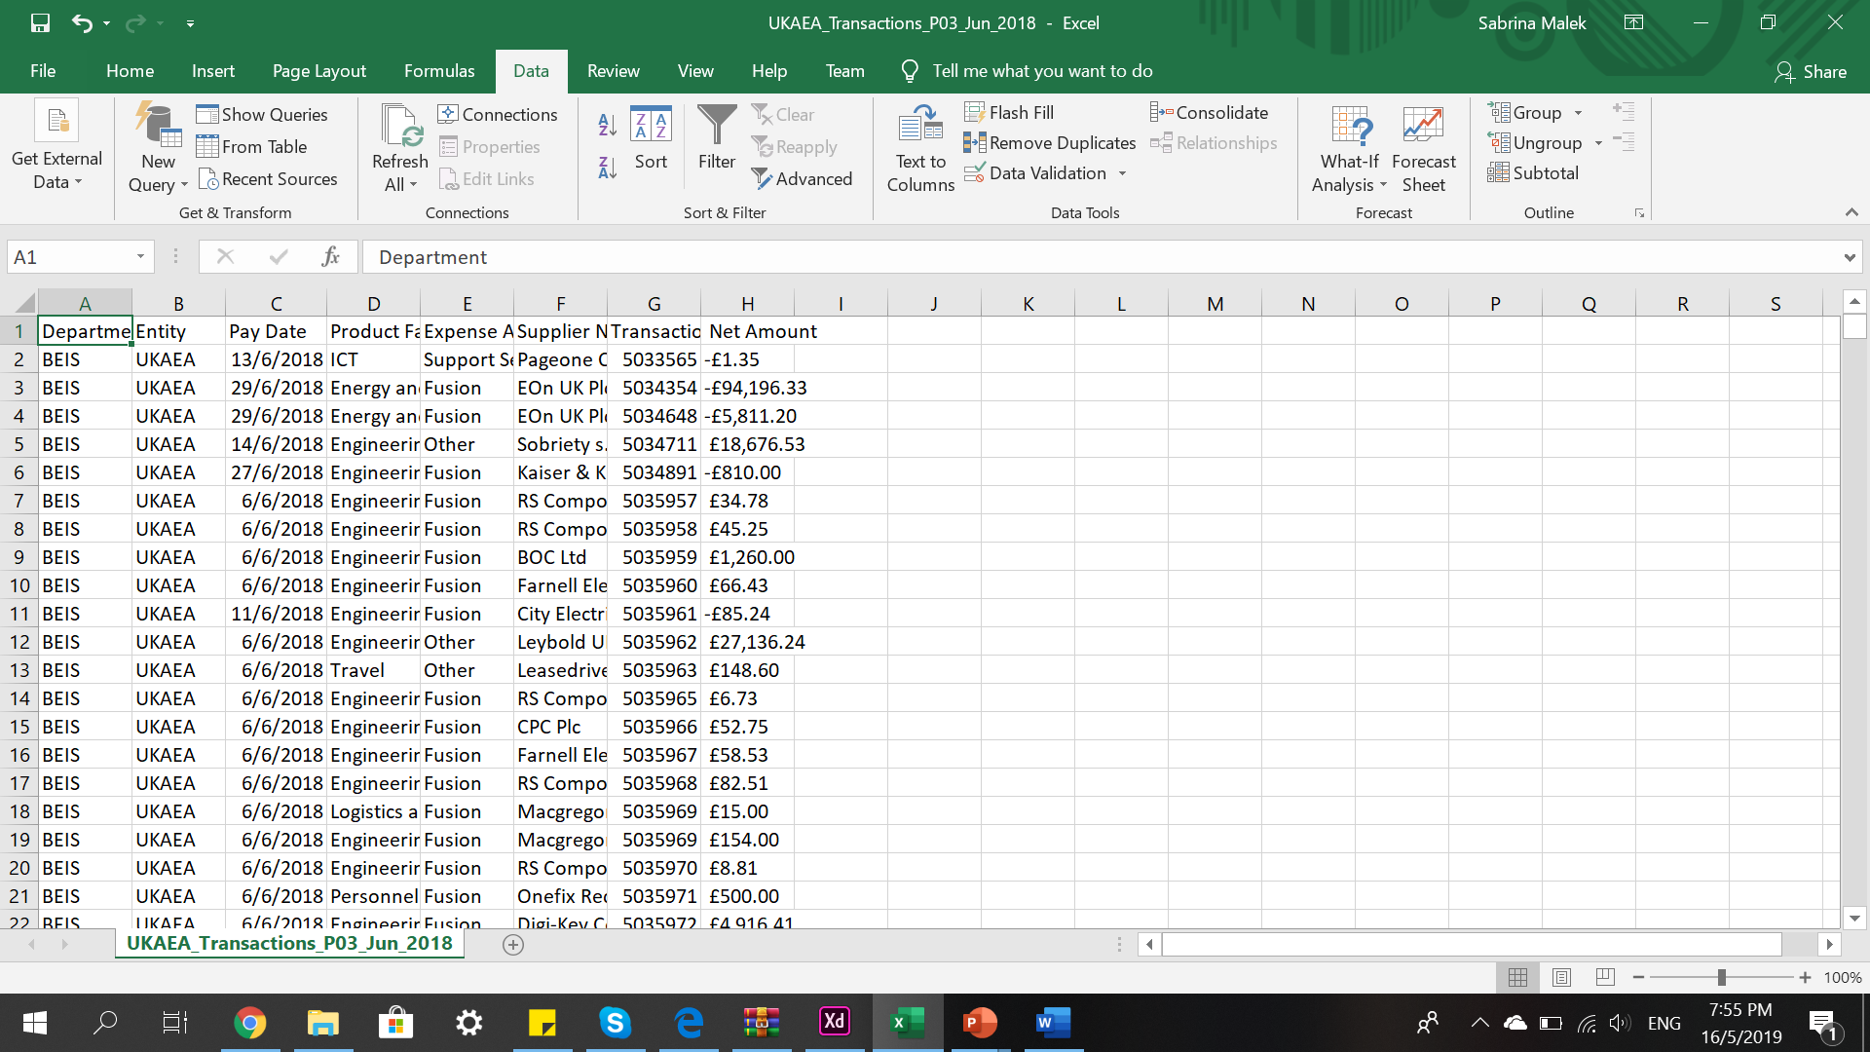
Figure 1
Figure 1 shows the data source. As illustrated, rows under ‘Net Amount’ contain a currency sign. These signs were removed as part of the data cleaning process. Duplicates that occur in the data source were also removed.
Each column is then transferred into different spreadsheet and duplicates are removed for each column. Figure 2 shows the result of duplicates removal. Only unique data remain.

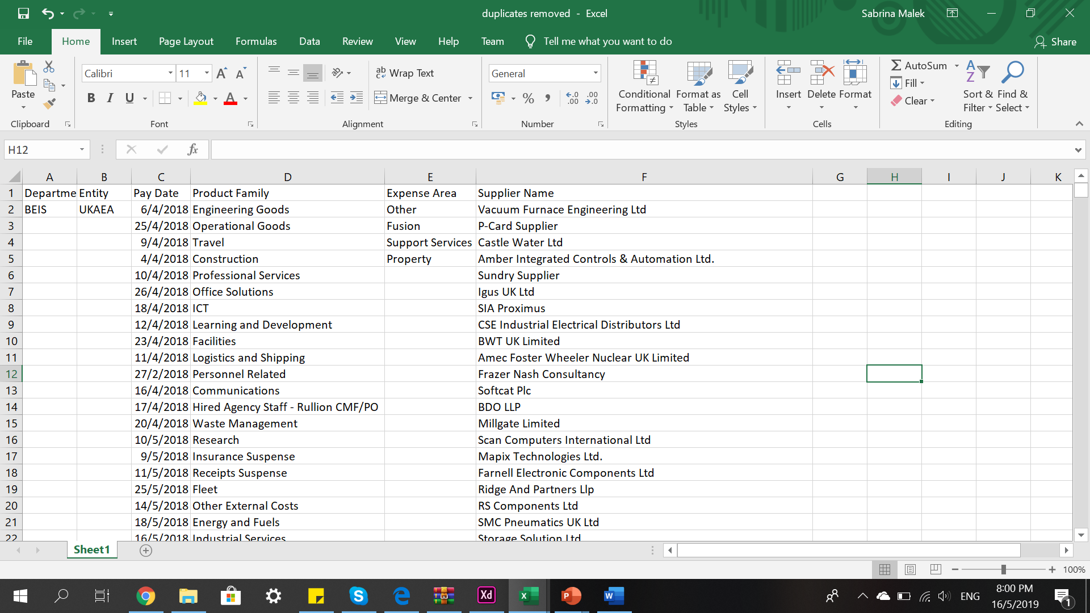
Figure 2

Star schema
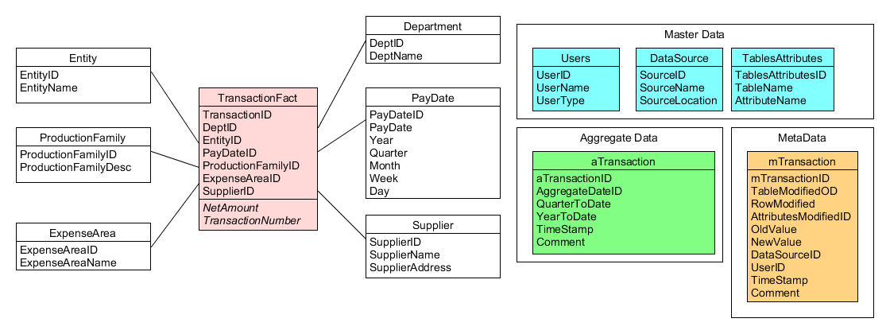
Figure 3: Schema diagram
Figure above shows star schema diagram produced. A fact table called ‘TransactionFact’ is placed in the middle to show connection between other dimensions. TransactionFact, contains attributes such as TransactionID, DeptID, EntityID, PayDateID, ProductionFamilyID, ExpenseAreaID, and SupplierID. These attributes are foreign keys, as they relate to primary keys in dimension tables. NetAmount and TransactionNumber are facts, therefore, they do not have any relationship with other dimension tables. Master Data, Aggregate Data and MetaData tables are included in the schema diagram. MetaData stores information about a table. It records the row and attribute modified, the table accessed, the time when it was modified, and more.

Relationship diagram
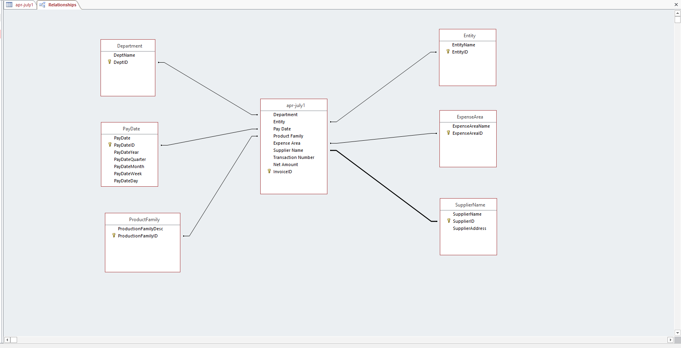
Figure 4: Relationship diagram
Figure 2 shows relationship diagram between fact table and dimension tables. All primary keys of dimensions are connected to foreign keys in fact table.

ETL

4.1 What is ETL
In Data Warehousing, it is important to load your data regularly. In order to load data, extraction of data is needed. The process of extracting data, integrating, rearranging it and loading it into data warehouses is called Extraction, Transformation, and Loading (ETL). Extraction is the process of retrieving data from a database. Collection of data is usually from different type of sources. Transformation is the process of converting data that was extracted into a form that can be placed in the data warehouse. Load is the process of bringing the data into data warehouse [1]. ETL process starts with extracting data from one or more sources and copied into the data warehouse.

4.2 ETL Process
During extraction, data was extracted from an Excel spreadsheet. Data quality was checked for dimensions and facts. It is important for source data to be archived. First step of creating the ETL plan is by creating a map of the data sources to the target tables. is important that a default strategy is developed for each section of the ETL plan. There are 3 different spreadsheets for the first quarter of financial year 2018-2019 that was downloaded from data.gov.uk. All 3 spreadsheets were combined into 1 spreadsheet to build the data warehouse. Raw data was gathered from the source systems to the ETL. In the cleaning and conforming data process, empty spaces were removed. Data error did not occur during the development of ETL process for UKAEA. The data was then scanned for deduplication, which is a process of removing multiple similar data. Data quality for all facts and dimensions were regulated. Then, each table needs to be identified. Dimension tables were generated based on columns from the database that has been identified. Primary key and description fields were added for its attributes. Its datatype should also be taken into consideration in this stage. Dimension tables that were created are; Department, Entity, PayDate, ProductionFamily, ExpenseArea, and Supplier. Fact table that was created is InvoiceFact table. Foreign keys such as DeptID, EntityID, PayDateID, ProdFamID, ExpenseAreaID, and SupplierID are its attributes. Each dimension was copied into another spreadsheet to remove duplicates in order to place a surrogate key. The database was then imported into a database management system, Microsoft Access. All dimensions were also imported into Access. Then, attributes and datatypes of these tables are transformed if there are any changes. All primary keys are defined in this stage. Update queries were created in order to update the fact table.
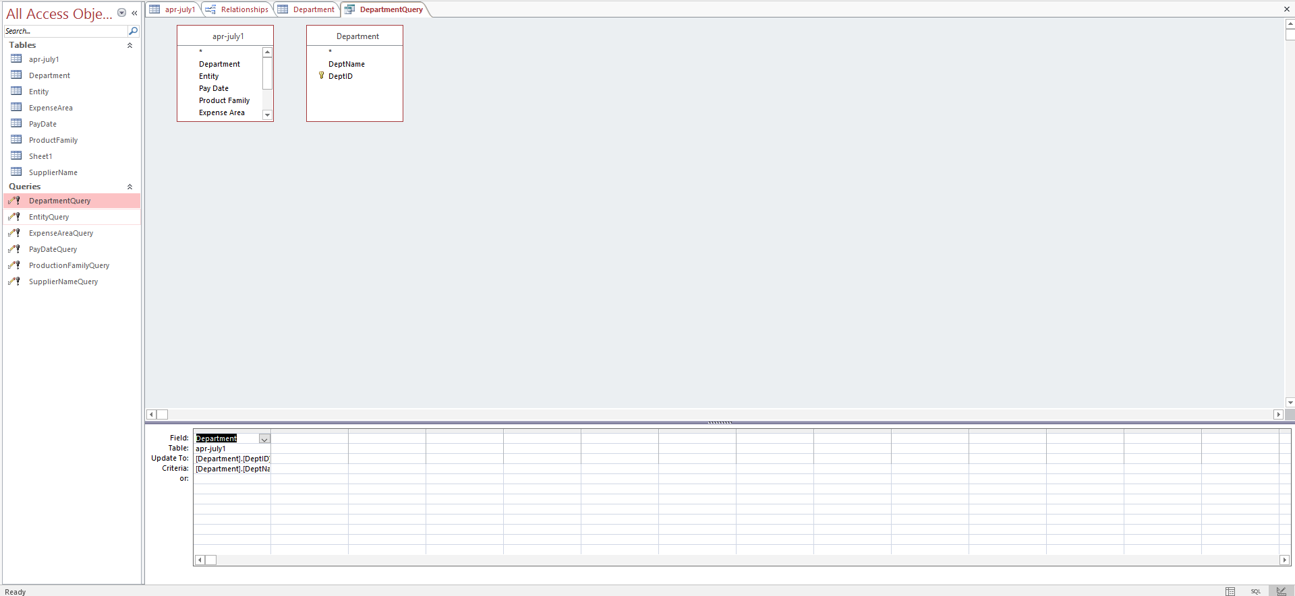
Figure 5
Figure 3 shows the process of updating ‘DepartmentQuery’. New fact rows are processed after running the query.
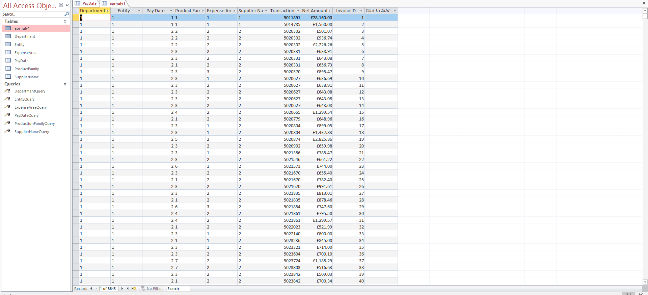
Figure 6
Figure 4 shows the updated database table after creating the queries.

Part 1 (b)

Tableau is used to generate reports on the data warehouse. Tableau’s features allow making reports easier. It also allows the results to communication effectively due to its visualization features. In the world of reporting, it is crucial for the reports to be displayed visually. Charts or graphs convey more information in a compact space. It also helps to speed up the decision-making process.
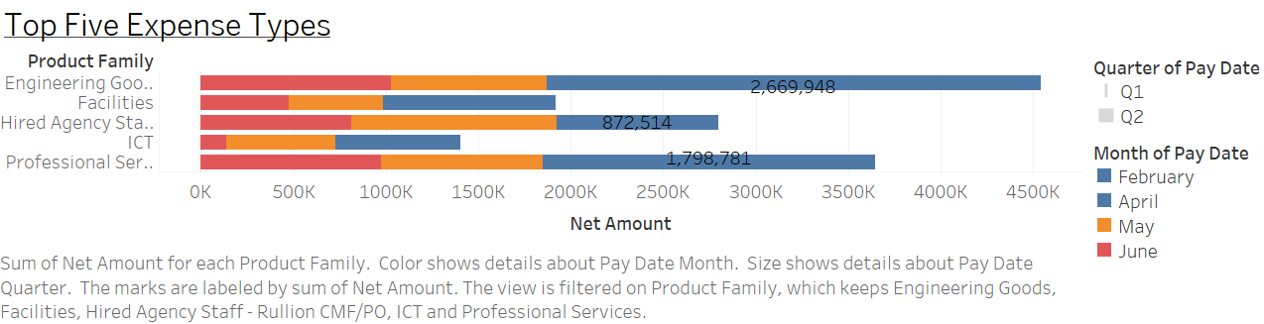
Figure 7
Figure 7 is a line bar graph showing five top expense types in UKAEA generated in Tableau. From the report, we can see that Engineering Goods has the high amount of expense compared to other products. Most money were spent on Engineering Goods in April, totalling £2,669,948 that month. Second highest product family expense is Professional Services. In total, over £3,500,000 was spent on this product from April to June. In April, UKAEA has spent £1,798,781 on Professional Services. UKAEA had also hired agency staff, which contributes to over £2,500,000 expenses over the span of 3 months. Both facilities and ICT record expenses less than £2,000,000. However, they are still significant as they are part of the top 5 expense types of UKAEA.

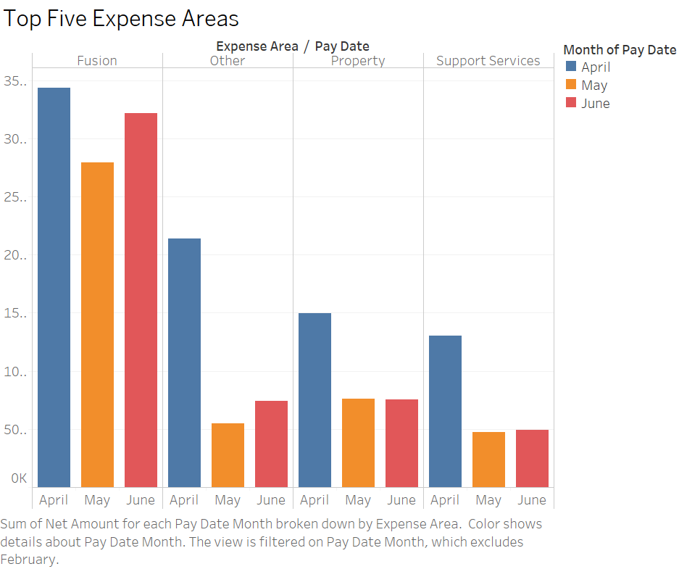
Figure 8
Figure 8 shows a bar graph showing five top expense areas of UKAEA as generated in Tableau. From the figure, it can be seen that Fusion costs UKAEA the most. The highest expense area record for Fusion is in April. It records at almost £3,500,000, which is the highest cost. Other expense areas such as Property, Support Services, and Others have significantly lower amount compared to Fusion. Total expenses for all areas are the highest in April.
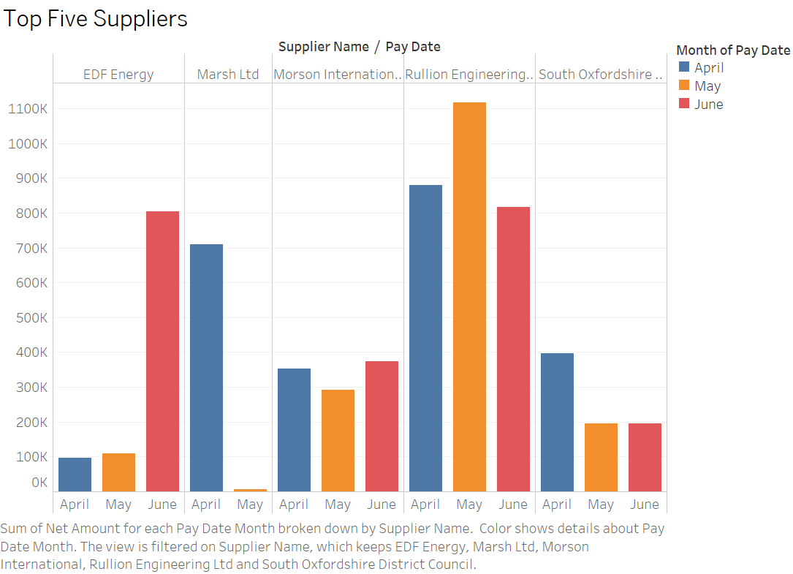
Figure 9
Figure 9 shows top 5 suppliers of UKAEA from April to June 2018, EDF Energy, Marsh Ltd, Morson International, Rullion Engineering Ltd, and South Oxfordshire District Council. Most supplies come from Rullion Engineering, totalling around £1,100,000 in May, £900,000 in April, and £800,000 in June. UKAEA also receives supplies from EDF Energy, totalling around £800,000 in June which is a significant increase from previous months, April and May. In April and May, EDF Energy supplies around £100,000 worth of supplies. One thing noticeable from the figure is that UKAEA has stopped getting supplies from Marsh Ltd in June. Initially, over £700,000 worth of supplies were from Marsh Ltd in April. However, in May it rapidly decreased to almost £0.

Part 1 (c)

A dashboard is a visual representation of important information that needs to be focused on to achieve its objectives and are arranged on a single screen [2]. In order for the information to be reach its audience, it needs to be clear and focused. It should not be too crowded, and all figures should be placed accordingly. It needs to convey information effectively. Hence, the dashboard that has designed for the data warehouse shows the information needed in graph or chart forms. Tables or texts do not reveal patterns or trends in data [3]. Data consistency is taken into consideration while designing the dashboard. Positions of every graph or chart make a big difference when making decisions. Top left corner of the screen usually gets the most attention, so important chart such as top 5 expense types is located there. The attention will then go to the chart below it, which is the location of top 5 expense areas. In the dashboard created, 3 different blocks are placed in consistent structure. To avoid complexity and keep it simple, it is important for a dashboard to not look crowded.
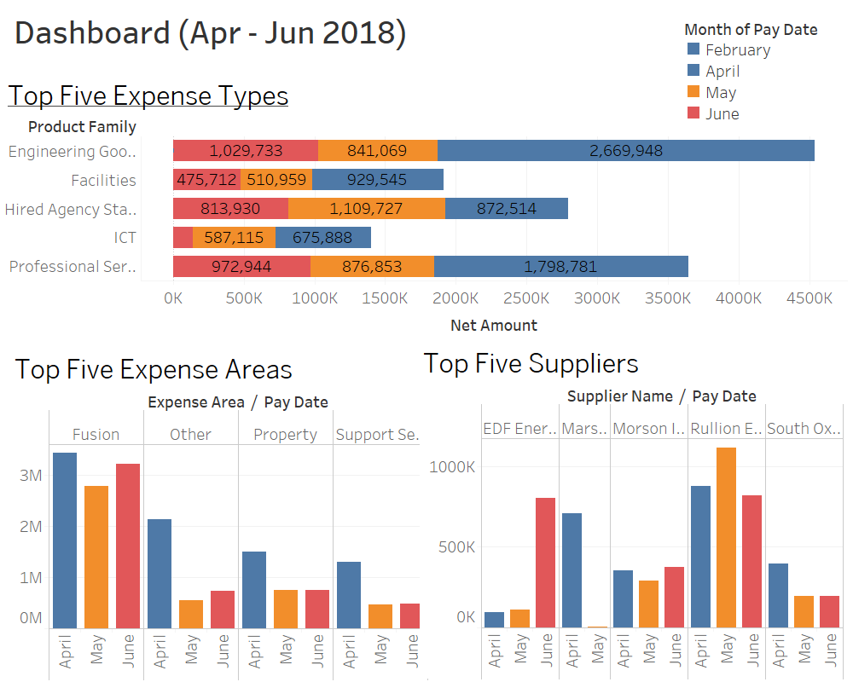
Figure 10: Dashboard

Reference
- V. Beal, “ETL - Extract, Transform, Load,” What is ETL (Extract, Transform, Load)? Webopedia Definition. [Online]. Available: https://www.webopedia.com/TERM/E/ETL.html. [Accessed: 15-May-2019].
- S. Few, “Dashboard Confusion,” Perceptual Edge, pp. 1–4, 20-Mar-2004.
- S. Few, “Dashboard Design for at-a-glance monitoring,” Perceptual Edge, 2010.

Appendices
ETL Plan – National Archive Case Study
Analyst(s): Sabrina

The existing data source is an Excel spreadsheet. The new data warehouse star schema is given below:

Database to data warehouse table mapping:

DATABASE TABLES | DATA WAREHOUSE TABLE
Spreadsheet | TransactionFact
Spreadsheet | Department
Spreadsheet | ExpenseArea
Spreadsheet | Entity
Spreadsheet | Supplier
Spreadsheet | ProductionFamily
Spreadsheet | PayDate
Not Applicable – This table needs to be generated from scratch | Users
Not Applicable – This table needs to be generated from scratch | Data_Sources

Database to data warehouse attribute mapping

TRANSACTIONFACT
TARGET ATTRIBUTE | SOURCE(S) | PROCESSING REQUIRED | MISSING VALUE? | INCORRECT VALUE?
TransactionID | PK | Automatically generated | Shouldn’t happen | Refer to staff
DeptID | Spreadsheet.Department | Linked to Department dimension PK | 1 (=Unknown) | Refer to staff
EntityID | Spreadsheet.Entity | Linked to Entity dimension PK | 1 (=Unknown) | Refer to staff
ExpenseAreaID | Spreadsheet.ExpenseArea | Linked to ExpenseArea dimension PK | 1 (=Unknown) | Refer to staff
PayDateID | Spreadsheet.PayDate | Linked to PayDate dimension PK | Shouldn’t happen | Refer to staff
ProductionFamilyID | Spreadsheet.ProductionFamily | Linked to ProductionFamily dimension PK | Shouldn’t happen | Refer to staff
SupplierID | Spreadsheet.Supplier | Linked to Supplier dimension PK | 1 (=Unknown) | Refer to staff
NetAmount | Spreadsheet.NetAmount | None | Shouldn’t happen | Refer to staff
TransactionNumber | Spreadsheet.TransactionNumber | None | Shouldn’t happen | Refer to staff

PRODUCTIONFAMILY
TARGET ATTRIBUTE | SOURCE(S) | PROCESSING REQUIRED | MISSING VALUE? | INCORRECT VALUE?
ProductionFamilyID | PK | Automatically generated | Shouldn’t happen | Refer to staff
ProductionFamilyDesc | Spreadsheet. ProductionFamily | None | “Unknown” | Refer to staff

ENTITY
TARGET ATTRIBUTE | SOURCE(S) | PROCESSING REQUIRED | MISSING VALUE? | INCORRECT VALUE?
EntityID | PK | Automatically generated | Shouldn’t happen | Refer to staff
EntityName | Spreadsheet.Entity | None | “Unknown” | Refer to staff

EXPENSEAREA
TARGET ATTRIBUTE | SOURCE(S) | PROCESSING REQUIRED | MISSING VALUE? | INCORRECT VALUE?
ExpenseAreaID | PK | Automatically generated | Shouldn’t happen | Refer to staff
ExpenseAreaName | Spreadsheet.ExpenseArea | None | “Unknown” | Refer to staff

PAYDATE
TARGET ATTRIBUTE | SOURCE(S) | PROCESSING REQUIRED | MISSING VALUE? | INCORRECT VALUE?
PayDateID | Spreadsheet.PayDate | None – Primary key | Shouldn’t happen | Refer to backup
PayDate | Spreadsheet.PayDate | None | Set to “Unknown” value | Set to “Unknown” value
Year | Spreadsheet.PayDate | None | Set to “Unknown” value | Set to “Unknown” value
Quarter | Spreadsheet.PayDate | None | Set to “Unknown” value | Set to “Unknown” value
Month | Spreadsheet.PayDate | None | Set to “Unknown” value | Set to “Unknown” value
Week | Spreadsheet.PayDate | None | Set to “Unknown” value | Set to “Unknown” value

SUPPLIER
TARGET ATTRIBUTE | SOURCE(S) | PROCESSING REQUIRED | MISSING VALUE? | INCORRECT VALUE?
SupplierID | Spreadsheet Supplier | None – Primary key | Shouldn’t happen | Refer to staff
SupplierName | Spreadsheet Supplier | None | Refer to staff | Refer to staff
SuppplierAddress | Spreadsheet Supplier | None | Refer to staff | Refer to staff

DEPARTMENT
TARGET ATTRIBUTE | SOURCE(S) | PROCESSING REQUIRED | MISSING VALUE? | INCORRECT VALUE?
DeptID | Spreadsheet Contract Number | None – Primary key | Shouldn’t happen | Refer to staff
DeptName | Spreadsheet Contract Number | None | Refer to staff | Refer to staff

This file created by Dr Nik Whitehead as part of the Wales Office example.
Comments
In general, the fact table is where most of the problems will occur as this is going to be by far the largest table in the schema. The foreign keys should be extractable from the other tables, and if these are not present then the only thing for it is to have a member of staff check what’s missing. If this is happening a lot then the organisation has some serious data quality/data governance issues that need to be addressed at source system level.

Problems with the dimension tables tend to be less drastic. Always ensure that there is a record in each dimension to represent an “Unknown” value (or, in a date dimension, a date that is an identifiable date in the past that only has problem records attached to it).

Master Data, Metadata and Aggregate Data tables

Users
TARGET ATTRIBUTE | SOURCE(S) | PROCESSING REQUIRED | MISSING VALUE? | INCORRECT VALUE?
UserID | Generated from user list | None – Primary key | Shouldn’t happen | Refer to staff
UserName | Generated from user list | None | Refer to staff | Refer to staff
UserType | Generated from user list | None | Refer to staff | Refer to staff

Data_Sources
TARGET ATTRIBUTE | SOURCE(S) | PROCESSING REQUIRED | MISSING VALUE? | INCORRECT VALUE?
SourceID | Generated from source list | None – Primary key | Shouldn’t happen | Refer to staff
SourceName | Generated from source list | None | Refer to staff | Refer to staff
SourceLocation | Generated from source list | None | Refer to staff | Refer to staff

TablesAttributes
TARGET ATTRIBUTE | SOURCE(S) | PROCESSING REQUIRED | MISSING VALUE? | INCORRECT VALUE?
TablesAttributesID | Generated from schema | None – Primary key | Shouldn’t happen | Refer to staff
TableName | Generated from schema | None | Refer to staff | Refer to staff
AttributeName | Generated from schema | None | Refer to staff | Refer to staff

Comments
These tables are set up at design time and will change very rarely thereafter. Data sources will change only as the organisation changes its upstream data collection process. Table and attribute changes will occur as the data warehouse is expanded to include new stars. Users will change as staff change, but the user table should also include records for the ETL system and for the operational system so that automated tasks can be logged in any metadata tables.
mTransaction
TARGET ATTRIBUTE | SOURCE(S) | PROCESSING REQUIRED | MISSING VALUE? | INCORRECT VALUE?
mTransactionID | Generated | None – Primary key | Shouldn’t happen | Refer to staff
TableModifiedID | Updated table | Link to TablesAttributes | Reject and rollback transaction | Reject and rollback transaction
RowModified | Updated table | Get RowID from updated table | Reject and rollback transaction | Reject and rollback transaction
AttributeModifiedID | Updated table | Link to TablesAttribtes | Reject and rollback transaction | Reject and rollback transaction
OldValue | Updated table | Original data value | Set to NULL | Reject and rollback transaction
NewValue | User/ETL Process | New data value | Reject and rollback transaction | Reject and rollback transaction
DataSourceID | Source system | Link to Data_Source | Reject and rollback transaction | Reject and rollback transaction
UserID | Login/ETL Process | Link to Users | Reject and rollback transaction | Reject and rollback transaction
Timestamp | DBMS | Generated | Reject and rollback transaction | Reject and rollback transaction
Comment | User/ETL Process | None | Reject and rollback transaction | Reject and rollback transaction

Comments
This table records who did what and when to the data warehouse and MUST be updated every time a change is made to the fact or dimensions in order to maintain an audit trail through the data. As a result, if any data is missing or incorrect then not only is the mTransaction row insert rejected but the transaction that caused the insert must also be rejected and rolled back.

aTransaction
TARGET ATTRIBUTE | SOURCE(S) | PROCESSING REQUIRED | MISSING VALUE? | INCORRECT VALUE?
aTransactionID | Generated | None – Primary key | Shouldn’t happen | Refer to staff
AggregateDateID | Generated | Link to Date_Dim | Rollback and write to log | Rollback and write to log
QuarterToDate | Orders_Fact | Sum TotalCost over time | Rollback and write to log | Rollback and write to log
YearToDate | Orders_Fact | Sum TotalCost over time | Rollback and write to log | Rollback and write to log
Timestamp | Generated | None | Rollback and write to log | Rollback and write to log
Comment | ETL Process | None | Doesn’t matter | Doesn’t matter

Comment
The aggregate table is generally updated monthly once the main body of the ETL process has completed for the month. As this is an automated process that does not tend to have a significant impact on the operation of the data warehouse any problems in the aggregation process are generally written to an error log file for investigation by a staff member.

