
Master of Business Administration

Module: Strategic Management
Module Code: LCMB7003
Tesla’s Market Expansion Strategy: Entering India’s Electric Vehicle Industry

Lecturer: Amare Desta
Student Name: Md Kausar Hosen
Student ID: 2406152

Word Count: 5072
Submission Date: 22nd December 2025

Table of Contents
1. Introduction 1
2. Selection of Organisation & Target Market 1
2.1 Tesla, Inc. Overview 1
2.2 Indian Market Overview & Justification 2
3. Comprehensive Strategic Analysis 4
3.1 PESTLE Analysis 4
3.2 Porter's Five Forces 6
3.3 Porter's Diamond Model 9
4. Strategy Development & Formulation 11
4.1 Market Entry Strategy 11
4.2 Growth Strategy (Ansoff Matrix) 13
4.3 Competitive Strategy (Porter’s Generic Strategies) 14
4.4 Internal Analysis (VRIO) 15
5. Performance Evaluation Framework 16
6. Conclusion 19
7. References 21
8. Appendix 26

1. Introduction
Tesla, Inc. is an electric vehicle (EV) manufacturer with global leadership, which is known to have innovative battery technology, software-based innovation, and brand positioning. The period of 2021-2023 witnessed a fast expansion of Tesla across the world, but the accelerating competition, price wars, and saturation in the mature markets of North America, Europe, and China have decelerated the growth (Tesla, 2024; Reuters, 2024). Consequently, long term growth has been made strategic through internationalization into emerging markets. India is a rather promising opportunity with a large automotive market, a lack of EVs, an expanding urban middle income, and a rising governmental interest in electric mobility (IBEF, 2024). Even though the Indian EV market has challenges such as price sensitivity and lack of adequate infrastructure, the long-term potential is what meets the Tesla growth ambitions. This report will analyze the Tesla expansion plan in India through strategic management theories and practical information in 2021 to 2025. The report evaluates the external and competitive environment, suggests appropriate entry and growth strategies, and develops a performance evaluation framework to evaluate the success of expansion.

2. Selection of Organisation & Target Market

2.1 Tesla, Inc. Overview
Tesla, Inc. is a worldwide market leader in the electric vehicle (EV) sector with a vertically integrated business model, which includes vehicle production, battery technology, proprietary software, and direct-to-consumer sales. Unlike the traditional automotive companies, Tesla does not have to rely on dealerships, which allows it to have a stronger control over prices, margins, and customer experiences, which have served as an essential competitive edge since 2021 (Tesla, 2023).
Three years of operational and financial development (2021-2023) showed impressive results in Tesla. The number of vehicles that are delivered rose by 936,222 in 2021 to 1.81 million vehicles in 2023, which is a compound annual growth rate of about 39% (Tesla, 2022; Tesla, 2024). During the same year, Tesla increased its revenue by USD 53.8 billion in 2021 and USD 96.8 billion in 2023, as a result of the scale-up of production and high demand of EVs in the world (Tesla, 2024). These numbers put Tesla as the largest volume and valued EV maker in the world at this time.
Nevertheless, 2024 was the first year in a decade when Tesla saw a reduction in vehicle deliveries around the globe, as the company received about 1.79 million vehicles, which indicates the level of competition, price cuts, and market saturation in major markets, such as China, the United States, and Europe (Reuters, 2024). The operating margins were also reduced because Tesla was involved in fierce price reductions in order to protect market share, indicating that it is putting more pressure on profitability (Tesla, 2024).
This stagnation highlights the strategic importance of Tesla to find other growth markets outside of developed EV economies. Investor briefings of 2025 emphasised the geographic diversification approach of management to continue long-term expansion and prevent overdependence on a small number of markets (Tesla, 2025). Countries that have a high population, low EV penetration, and supportive policy systems are thus key in the future international strategy of Tesla and India is a key target market.

2.2 Indian Market Overview & Justification
The third-largest automobile market in the world is India, which manufactures more than 25 million vehicles each year, but the EV adoption is at its infancy, especially in the segment of passenger cars (IBEF, 2024). Electric vehicles are estimated to constitute about 7-8 percent of the total vehicle sales as of 2024, however, electric passenger cars constituted less than 5 percent of the total car sales, and there is a lot of untapped potential (Statista, 2024).
The market momentum of EVs in India is high between 2021 and 2025. In 2024, the sale of TEVs was more than 2 million units, which is over 2 times more than in 2021, and the annual growth is steadily increasing with the popularity of urban demand and increasing fuel prices (Economic Times, 2024). It is projected that passenger EV sales will increase by over 35-40 percent in compound annual growth up to 2030 due to better infrastructure, reduction in battery prices, and rise in consumer awareness (Statista, 2025).
The intervention of the government has been a major factor in the development of the EV ecosystem in India. FAME-II scheme provided subsidies on the purchase and charging of EVs and the infrastructure between 2021 and 2024 allocating over INR 100 billion, and the Production Linked Incentive (PLI) scheme allocated over USD 3 billion to support the production of EVs and advanced batteries in the country (Government of India, 2022; IBEF, 2024). The policies are meant to lower the cost of long-term production and enhance the resilience of the supply chain though high import tariffs of up to 100 percent on fully assembled EVs are a short-term barrier to foreign producers entering the market (Reuters, 2025).
These obstacles notwithstanding, strategic fit between Tesla and India is strong. India provides Tesla with a huge, under penetrated, long-term demand base, and Tesla provides high-tech EV, high brand equity, and leadership in sustainability that can be in line with the decarbonisation goals of India. The opportunity to enter the Indian market at this stage of transition will help Tesla to develop brand awareness and control consumer tastes prior to the EV adoption maturity, which will place the company in a good position to expand the scale later in life (Statista, 2025).

3. Comprehensive Strategic Analysis

3.1 PESTLE Analysis
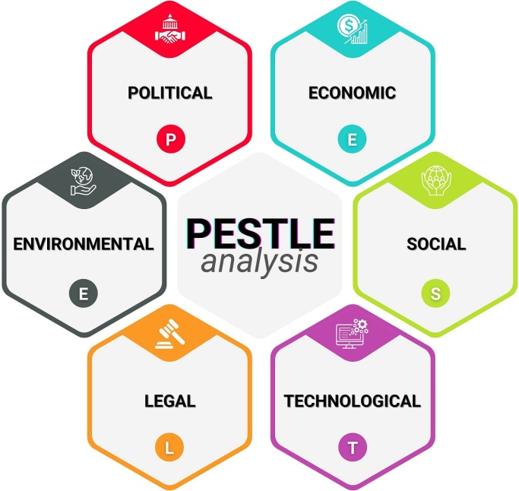
Figure 1: PESTLE Analysis
Source: (Iqbal, 2025).
Political factors
The political landscape in India is highly favorable to the adoption of electric vehicles (EVs), but there is a lack of consistency in the policies. FAME-II scheme provided over INR 100 billion of EV subsidies and charging infrastructure in 2021-2024 and the Production Linked Incentive (PLI) scheme will provide more than USD 3 billion of incentives to local EV and battery production (Government of India, 2022; IBEF, 2024). Such efforts have helped EV to sell more than two million units in 2024-25. Nonetheless, the impacts of high importation tariffs on fully assembled EVs of 100 percent considerably increase the entry-cost of foreign companies like Tesla (Reuters, 2025). This provides a strategic trade-off between the short term barriers to market entry and the long term incentives to localisation.

Economic factors
The average GDP growth in India of over 6% per annum (2021-24) has been good in supporting the increasing mobility demand (World Bank, 2024). This growth could not overcome the price sensitivity of the passenger car market, whose average car price is less than USD 15,000, which is much lower than the global prices of Tesla (Statista, 2024). Despite the fact that the total number of EV sales was more than two million units in 2024-25, the electric passenger cars occupied less than 3% of the total car sales, indicating financial limitations (EVreporter, 2025). These economic factors show that Tesla only survives on costs reduction by gradual localisation.
Social factors
The growing fuel prices, air pollution in cities as well as environmental awareness in the society have boosted social acceptance of EVs. The sales of luxury EV have increased by around 66 percent in early 2025, which means that high-income urban consumers are showing increased demand (Business Standard, 2025). Nevertheless, mass adoption cannot be achieved due to range anxiety, the lack of charging infrastructure, and cultural attachment to low-cost vehicles. There is thus an uneven distribution of social acceptance that is mainly in metropolitan regions.
Technological factors
The charging infrastructure of India grew at a high rate, and the number of public chargers grew over five times during the period between 2021 and 2025 (IBEF, 2025). However, the infrastructure is still centred in big cities. It continues to rely on imported battery cells and semiconductors and manufacturers are vulnerable to supply chain risks (IEA, 2023). Tesla has high-technology battery and software which can be differentiated but must be compatible with infrastructure.

Legal factors
The EV regulatory system is in transition, where there is positive national policy, but mixed state policy enforcement. The uncertainty in the import duty and localisation conditions enhances the operational risk of international entrants (Reuters, 2025).
Environmental factors
The long-term goals of the net-zero emissions in India by 2070 make EVs the focus of decarbonisation (Government of India, 2023). Nevertheless, the use of fossil-fuel-generated electricity restricts the short-term environmental gains but the sustainability positioning of Tesla is in line with the long-term objectives.

3.2 Porter's Five Forces
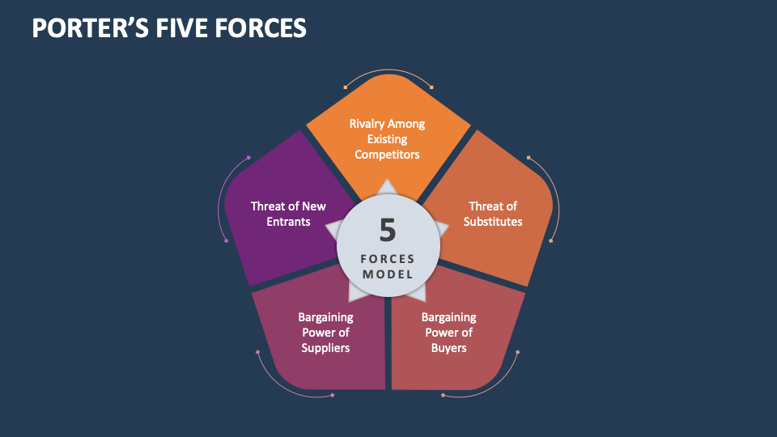
Figure 2: Porter’s Five Forces Analysis
Source: (Collidu, 2024)
Competitive rivalry
India has a competitive rivalry in the EV market, which is segmented. Tata Motors has been a leader in the electric passenger car market, which is backed by competitive prices and large local networks (Statista, 2024). Mahindra and MG motor are increasing their offerings, as global brands have moved to the high end EV market. In the first half of 2025, the sales of luxury EVs increased 66 percent, indicating the increasing competition in the high-end segments (Business Standard, 2025). Differentiation provided by Tesla technology will be challenged since competition is likely to rise with the growth in localisation.
Threat of new entrants
New entrants have a moderate threat level. There are high capital requirements, complicated regulations, and import tariffs of over 100% that will not facilitate quick entry (Reuters, 2025). Nevertheless, the incentives of PLI bring down the barriers to firms that commit themselves to local production, indicating more competition in the medium term (IBEF, 2024).
Buyer power
Buyer power is strong as the prices are sensitive and switching cost is low. In 2024-25, the penetration of passenger EV was still less than 3%, which suggests a reserved attitude of consumers (EVreporter, 2025). Premium pricing strategies are limited by buyers who want to receive low prices and reliability in infrastructures.
Supplier power
The power of suppliers is moderate/high, as the company relies on imported battery cells and vital components. The low local production makes the country vulnerable to international fluctuations in prices (IEA, 2023). The size of Tesla also partially reduces the risk, but does not exclude the power of suppliers.
Threat of substitutes
Threat of substitutes is high. More than 90% of passenger car sales are made by internal combustion engine vehicles, which are supported by reduced initial costs and the extensive refuelling network (S&P Global, 2025). EVs are also restricted by hybrid cars and transportation. EVs are favoured by long-term trends, whereas substitutes are not that far behind in the short- to medium-term perspective.
Generally, India has a fair to average long-term appeal to Tesla, where the growth potential is high but is weighed down by intense competition in the short-term.
Table 1: Porter’s Five Forces Analysis – Tesla in India
Force | Intensity | Key Evidence (2021–2025) | Implication for Tesla
Competitive rivalry | Moderate–High | Tata Motors holds ~70%+ share of India’s electric passenger car market; luxury EV sales grew ~66% in 2025 | Limited rivalry in premium EVs now, but competition will intensify as global firms localise
Threat of new entrants | Moderate | Import tariffs up to 100%; PLI incentives > USD 3bn encourage local manufacturing | High entry barriers short term; lower barriers long term if localisation increases
Buyer power | High | Passenger EV penetration <3%; average car price < USD 15,000 | Strong price sensitivity constrains premium pricing without localisation
Supplier power | Moderate–High | >70% of lithium-ion battery cells imported; limited domestic cell production | Cost volatility and supply risk until local battery ecosystem matures
Threat of substitutes | High | ICE vehicles >90% of passenger car sales; hybrids and public transport widespread | Substitutes limit short-term EV adoption despite long-term EV growth trend
Source: Statista (2024), IBEF (2024; 2025), IEA (2023), Reuters (2025), EVreporter (2025) and Business Standard (2025).

3.3 Porter's Diamond Model

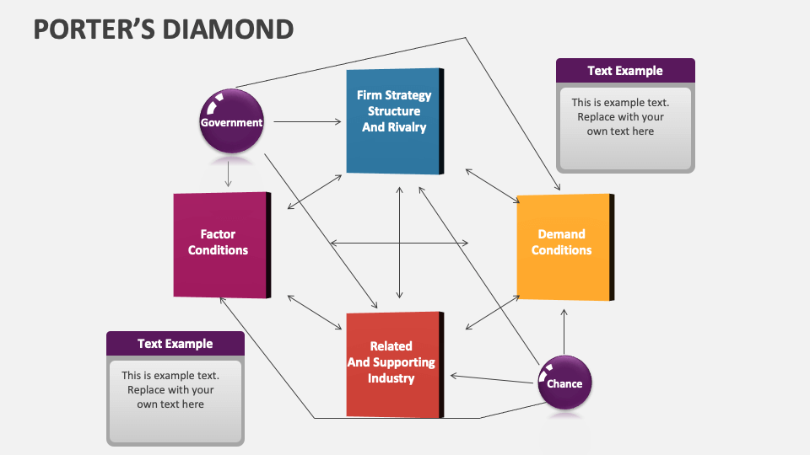
Figure 3: Porter’s Diamond Model
Source: (Collidu, 2024)
Factor conditions
India has good factor conditions of availability of labour, manufacturing capacity and experience in automobile. There are high-quality workforce in the country and already established automotive hubs in Tamil Nadu, Maharashtra, and Karnataka states, which facilitates scalable production (IBEF, 2025). The auto component industry in India exports more than 25 percent of the production indicating globalization. Nevertheless, high-tech production of EV battery cells is still scarce and more than 70 percent of the lithium-ion cells are imported, most of them originating in East Asia (IEA, 2023). Such reliance adds to the cost volatility and supply risk. The number of charging infrastructure increased to more than 29,000 in 2025, up since 2021, before the 5,000 stations, which is now distributed unevenly. It is necessary to strengthen the domestic battery production and grid capacity, which will improve the conditions of factors.

Demand conditions
India is showing emerging demand conditions of EVs but improving. By 2024-25, the total EV penetration is expected to be about 7-8% of the total vehicle sales, with the two- and three-wheelers having the largest influence (EVreporter, 2025). The uptake of passenger EVs is low, but the number of premium EVs is on the rise, and luxury EVs are gaining sales by 66 percent in the first part of 2025 (Business Standard, 2025). Consumer preferences are being influenced by rising fuel prices, environmental consciousness and congestion in urban areas. The demand in the mass-market is limited, however, by price sensitivity and range anxiety. Demand conditions thus show long term potential and not scale in the short run.
Related and supporting industries
The related and supporting industries of India are growing at a very fast rate. The auto components industry is also spending much on EV-related components like power electronics, and drive trains, and renewable energy capacity expansion is facilitating cleaner charging solutions (IBEF, 2025). Energy companies and infrastructure providers are partnering to increase the networks. Nonetheless, there are still loopholes in semiconductor manufacturing and high volumes battery cell manufacturing, which pose bottlenecks. The OEMs, suppliers, and technology companies need to work more closely to make the ecosystem more competitive.
Firm strategy, structure and rivalry
The domestic companies like Tata motors and Mahindra have embraced the aggressive EV strategies, diversifying their portfolios and investing in infrastructure collaborations. The fact that Tata Motors is leading in the field of affordable EVs and Mahindra is concentrating on the production of electric SUVs depicts a strategic alignment with the needs of the domestic market (Reuters, 2025). Competition encourages innovation and localisation that boosts national competitiveness. In the case of Tesla, global strategies should be localised using three strategies; phased entry, localisation and price alignment. The competitive landscape in India is favorable to those companies that combine technology and local market understanding and this implies that long term competitive edge can be created by strategic adaption and not standardisation.

4. Strategy Development & Formulation

4.1 Market Entry Strategy
The entry of Tesla into India market necessitates a risk-sensitive and gradual approach because of its complexity, cost-based pressures, and uncertainty in demand. Despite India being the third-largest automobile market in the world, in 2024, the penetration of passenger electric vehicles (EV) was less than 3% and this aspect indicates the potential to grow and the hindrances to adoption (Statista, 2024). Therefore, the entry strategy of Tesla is more concerned with flexibility, slow commitment, and alignment with the policies.
Phase 1: Imports (CBU)
The initial stage is the importation of Completely Built Units (CBUs) in order to gain market share with a minimum capital outlay. In the past, India levied up to 100-110% of duties on imported fully assembled EVs, which made luxury vehicles unaffordable (Reuters, 2024). Nevertheless, policy changes that occurred between 2024 and 2025 enable lower import taxation to manufacturers who undertake local investment and subsequent localisation (Government of India, 2024). Such a regulatory change allows Tesla to import small amounts of vehicles to gauge demand in the market, establish brand name, and gather consumer-level data without needing to commit to large-scale manufacturing.
Tesla can focus on affluent urban consumers in major cities like Delhi, Mumbai, and Bengaluru where EV awareness is more developed, and its charging networks are comparatively high to attract CBU imports. As per academic literature, the staged entry can be achieved by export or import to facilitate entry of firms in institutionally complex emerging markets (Meyer and Peng, 2016). Nonetheless, vehicles are priced high as part of CBU paradigm, which limits the volumes, which supports the necessity of the subsequent localisation.
Phase 2: Local Assembly (CKD)
As the demand is validated, the approach of Tesla changes to Completely Knocked Down (CKD) assembly. By greatly decreasing importation tariffs and transportation expenses, as well as allowing partial localisation of parts, CKD assembly will save many expenses (Aranca, 2025). The change enhances the competitiveness of prices and it is an indication of long-term commitment to the host country, which is in line with the India Make in India industrial goals (IBEF, 2024).
Local assembly also allows Tesla to localize vehicles to the Indian road conditions and climate and regulatory standards. The study of international manufacturing strategy points to the fact that incremental localisation minimises institutional risk, but promotes learning and supplier development (Buckley and Casson, 2021). Politically, it is important to note that CKD assembly will enhance the legitimacy of Tesla and its ability to receive incentives at the state level.
Future Manufacturing Potential
Tesla can potentially set up complete manufacturing in India in the long run. Production Linked Incentive (PLI) scheme offers monetary incentives on the production of EV and advanced batteries, and the production becomes economically feasible when the demand grows to the scale (Government of India, 2023). The entire production would make India a local export center to South Asia and Africa just like Tesla did in China (Reuters, 2025).
Risk Management
The main threats are tariff turnover, cost increase, supply chain dependence and unpredictable demand. Tesla is reducing these threats by using stage investment, sourcing flexibility and demand-driven capacity decision. The uncertainty of the demand is still high as the price sensitivity of India is considerable and the adoption of EV is still at an early stage, which confirms the rationality of the Tesla strategy of a gradual entry (Statista, 2024).

4.2 Growth Strategy (Ansoff Matrix)
The growth strategy of Tesla in India can be evaluated in the light of the Matrix developed by Ansoff that identifies the market penetration, market development, product development, and diversification strategies (Ansoff, 1957). Since India is an early-adopter of EVs, Tesla should focus on developing the market and adapting its products instead of focusing on the immediate market penetration.
Market Development
Market development entails penetrating the new geographic market with the existing products. The EV market in India is not well penetrated, especially in passenger vehicles, and there is a long-term growth potential (S&P Global, 2025). The strategy of Tesla is based on accepting metropolitan areas first, where there is increased income, charging infrastructure, and environmentally-awareness. Adoption can also be reduced by strategic partnerships with financial institutions to get leasing and financing options.
Product Adaptation
An adaptation of products is a prerequisite in new markets that are characterised by income differentiation and infrastructural limitations. Scholarly studies have accentuated that localisation of global products increases their adoption and competitiveness (Khanna and Palepu, 2010). Tesla will have to modify the specifications of its vehicles to suit the Indian roads, its ability to withstand climate, and the sensitivity of its prices. The provision of models with fewer premium features or customised battery packs has the potential to increase the size of the addressable market without watering down brand name.
Long-Term Expansion Options
In the longer term, Tesla would have opportunities to work on affordable EV platforms at the new markets, venture into fleet and commercial mobility, and investing in manufacturing local batteries alliances. These alternatives match the future development of EV in India and the innovation-focused approach in Tesla (IEA, 2023).

4.3 Competitive Strategy (Porter’s Generic Strategies)
To achieve competitiveness, Tesla needs to adopt a differentiation strategy that is enhanced with a focused approach to the market, as opposed to a cost leadership strategy. According to Porter (1985), companies that attain an excellent performance opt to take a definite strategic position.
Differentiation Focus
The differentiation of Tesla is through high-technology batteries, software, self-driving mode, and a robust brand equity. The features set Tesla apart among domestic EV producers that most frequently compete in terms of prices and lower features (Grant, 2023). In India, with EV awareness among upper-income consumers on the increase, the technology-driven differentiation of Tesla will be worth the premium prices.
Premium EV Positioning
The high-end values of Tesla match the fast-rising luxury EV market that is projected to grow more than sixty percent in 2025 (Business Standard, 2025). Tesla would be well to highlight on total cost of ownership, software updates, performance reliability and sustainability credentials to support value in addition to purchase price.
Domestic EV Players Compared.
The local supply channels, domestic companies like Tata Motors and Mahindra enjoy the advantages of cost leadership, familiarity with the Indian consumers and the local demand. They do not have the developed software ecosystems and autonomous features of Tesla, however. Tesla does not engage in direct price competition, taking care of better technology, brand attitude, and long-term value, which aligns with a differentiation strategy (Porter, 1985; Reuters, 2025).

4.4 Internal Analysis (VRIO)
The VRIO model evaluates the capability of a firm in terms of the resources that can bring about sustainable competitive advantage (Barney, 1991). The internal strengths indicate that Tesla has a high VRIO index in the Indian market scenario.
Brand
The Tesla brand is internationally linked with innovative, sustainable and technological leadership. It is prized and it is not common in the EV business in India where brands with similar aspirational value are not common. This is a strong brand that is useful to high-income customers in terms of premium placement and early adoption.
Battery Technology
The proprietary battery technology of Tesla provides a higher energy density, range and efficiency. Technology innovation in batteries is hard to replicate because of the amount of money invested in research and development and protection of intellectual property (Tesla Annual Report, 2024). Charging infrastructure in India is distributed unequally, meaning that the range and reliability result in customer value.
Software and Innovation
Such software-based architecture of Tesla, such as over-the-air updates and autonomous driving capabilities is uncommon among others and hard to reproduce in the short term. Software integration has been found in academic studies as a key competitive advantage contributor in next-generation mobility (Cusumano et al., 2022). These functions improve the customer experience and allow enhancing it on a continuous basis.

Organisational Capability
Tesla has an organisational structure that encourages quick innovation, vertical integration, and direct to consumer sales. The fact that it can organize international supply chains, as well as adapt swiftly to regulatory changes, enhances its capability to derive value out of its resources (Barney, 2021).
Linking Internal Strengths to Indian Opportunities
The VRIO resources of Tesla are quite consistent with the emerging high-end EV market in India. As the mass-market segments are occupied by domestic rivals, the combined technology and brand strength of Tesla allow it to take advantage of the loopholes in high-performance, software-based EV offerings. The key to translating these internal strength to sustained competitive advantage in India will be successful localisation and ecosystem integration.

5. Performance Evaluation Framework
This study proposes the Balanced Scorecard (BSC) as the best performance evaluation framework in order to determine the success of Tesla in the Indian market through expansion. Balanced Scorecard is most appropriate with international expansion strategies since it incorporates both financial and non-financial performance indicators to enable organisations measure the short-term outcomes as well as long-term strategic capability development (Hoque, 2022). In the case of Tesla, India should not just be a source of quick revenue but also of customer acceptance, efficiency in its operations, and capacity development in a complicated emerging market. In contrast to the purely financial assessment instruments, the Balanced Scorecard allows the strategic execution and alignment to be viewed in a holistic manner, thus it can be successfully used to monitor the progress, detect gaps and direct the strategic changes with time (Marr and Schiuma, 2021).

Financial Perspective: Ensuring Economic Viability
The financial view is whether the expansion of Tesla in India is generating sustainable economic returns. Revenue targets are an essential KPI as they reflect the market penetration and the success of Tesla to enter and develop its strategy. The price elastic Indian market is sensitive to prices, and thus the growth in revenue will indicate the capacity of Tesla to translate brand recognition to actual demand, especially in the higher end EV market. Nevertheless, the revenue is not the only measure of success because tariffs and high cost of imports may bias the financial performance within the initial phases (Deloitte, 2023).
The post local assembly profit margins are thus a complementary key performance indicator. This indicator reflects the economic cost of localisation strategy of Tesla, in particular, the shift towards CKD assembly instead of CBU imports. Better post-local assembly margins would show that Tesla is managing to eliminate cost pressures related to tariffs and logistics and capitalizing on government incentives. According to academic studies, profitability indicators attributed to operational restructuring can present a better understanding of the strategic success than a growth in revenue, particularly in new markets (Bhimani et al., 2021). These financial KPIs in combination make sure that the growth of Tesla is not just increasing but also sustainable in terms of economy.
Customer Perspective: Measuring Market Acceptance
The customer perspective will determine the extent to which Tesla is winning acceptance and legitimacy among the Indian consumers. Customer satisfaction is an essential KPI since the adoption of EVs is highly dependent on the perceptions of reliability, quality of the services, and the experience of ownership. In the newly developed EV markets, any dissatisfaction with service delays or infrastructure constraints can be a major obstacle to adoption rates (Jabeen et al., 2023). The score of customer satisfaction would have been high, which means that the product quality, the service processes, and the charging solutions offered by Tesla would correspond with or exceed the expectations of the Indian customers.
Another crucial KPI is market share in the high-end EV sector because Tesla is a differentiation-oriented company, and cost leadership is not the priority. Calculating the market share in this particular segment can enable Tesla to assess its positioning in the market compared to the local and international competitors that deal with high-quality electric cars. Competitive strategy studies have provided evidence that segment-focused market share has a better predictive value of strategic effectiveness than market share in cases where firms pursue focused differentiation strategies (Hitt et al., 2021). All these customer KPIs will measure the extent to which Tesla value proposition is a match with the target market it is targeting.
Internal Process Perspective: Operational Execution
Internal process perspective will concern the efficiency and reliability of the operational activities of Tesla in India. Turnaround time between order and delivery is an important KPI since the waiting time may impact negatively on customer satisfaction and brand image, especially in a market where delivery is relatively fast and consumers are used to it. Research indicates that the biggest obstacles in the path of EV adoption in emerging markets are operational delays, as the target audience already views owning an EV as a risk (Zhang et al., 2022). Minimizing lead times is an indicator of supply chain effectiveness and operational maturity.
The rates of localisation, which are expressed as the percentage of local sourced components are also relevant. An increase in the degree of localisation suggests that the company has integrated well into the Indian industrial ecosystem and it does not have to rely on imports. This KPI directly shows the capacity of Tesla to deal with the tariff exposure, meet the expectations of government policies, as well as develop the resilient supply chains. Studies into global manufacturing strategy propose that the increase in cost efficiency, regulatory alignment and long-term competitiveness in host markets is enhanced through localisation (Mudambi and Puck, 2021). Monitoring the internal processes KPIs will keep Tesla business backbone upheld towards its strategic goals.
Learning and Growth Perspective: Building Long-Term Capability
The learning and growth perspective analyses the ability of Tesla to build the organisational capabilities that it needs to be a long-term successful company in India. The localisation of the workforce through training the local employees is an important KPI since localisation does not only concern local production but also the development of human capital. Professional employees enhance productivity, minimize quality problems, and allow quicker adjustment to regional market circumstances. Empirical evidence shows that the ability to nurture workforce is one of the determinants of multinational success in emerging economies (Farndale et al., 2021).
Another significant KPI is the creation of innovation labs or local levels of research and development. Labs of the innovations will help Tesla to localize the global technologies to the Indian context and conditions i.e. climatic conditions, quality of roads, and restrictions on charging infrastructure. They also allow the transfer of knowledge among global and local teams, which improves the learning in organisations. Studies also note that localised innovation can be very beneficial in enhancing responsiveness and long-term competitive advantage in the foreign markets (Cantwell et al., 2023). These learning and growth KPIs allow making sure that the Tesla expansion strategy is future-focused, as opposed to transactional.

6. Conclusion
This report has examined Tesla expansion into the Indian market in terms of strategic, competitive, and operational analysis. The results suggest that India has a high long-term potential as the penetration of electric vehicles is low, there is an expanding high-end consumer base, and the policy environment is improving, even though the short-term situation can be challenging. The phased market entry approach, which will start with imports and then evolve to local assembly and even manufacturing, will help Tesla to deal with the cost pressures, uncertainty in regulation, and risk in demand. The major weaknesses are price sensitivity, lack of uniform charging infrastructure and reliance on global supply chains which could limit initial performance. However, Tesla has a good brand equity, sophisticated battery technology, software-based innovation, and organisational agility, which places it in a good position to stand out of the local competition. In general, the India strategy is valid as a long-term growth project, but not a profit project. In the future, localisation that is sustained, ecosystem alliances, and development of capabilities will be essential to attaining scalable growth and sustainable competitive edge in the dynamic Indian electric vehicle market.

7. References
Aranca (2025) Tesla India market entry strategy and localisation outlook. Available at: https://www.aranca.com/knowledge-library/articles/investment-research/tesla-india-market-strategy (Accessed: 14 December 2025).
Barney, J. (2021) Resource-based theory: creating and sustaining competitive advantage. Oxford: Oxford University Press.
Bhimani, A., Horngren, C.T., Datar, S.M. and Rajan, M. (2021) Management and cost accounting. 7th edn. Harlow: Pearson Education.
Buckley, P.J. and Casson, M. (2021) The theory of international business revisited. Journal of International Business Studies, 52(4), pp. 1–16.
Business Standard (2025) Luxury EV sales rise sharply in India amid growing premium demand. Available at: https://www.business-standard.com/industry/auto/luxury-ev-sales-india-growth-2025 (Accessed: 14 December 2025).
Cantwell, J., Dunning, J.H. and Lundan, S.M. (2023) Multinational enterprises and the global economy. 3rd edn. Cheltenham: Edward Elgar.
Collidu (2024). Porter’s 5 Forces. [online] Collidu.com. Available at: https://www.collidu.com/presentation-porters-5-forces. (Accessed: 14 December 2025).
Collidu (2024). Porter’s Diamond. [online] Collidu.com. Available at: https://www.collidu.com/presentation-porters-diamond (Accessed: 14 December 2025).
Cusumano, M.A., Gawer, A. and Yoffie, D.B. (2022) The business of platforms: strategy in the age of digital competition. New York: Harper Business.
Deloitte (2023) Electric vehicles in emerging markets: profitability, localisation and scale. Available at: https://www2.deloitte.com/global/en/pages/consumer-business/articles/electric-vehicles-emerging-markets.html (Accessed: 14 December 2025).
Economic Times (2024) Why ICE vehicles still dominate India’s passenger car market. Available at: https://energy.economictimes.indiatimes.com/news/auto/why-ice-vehicles-still-dominate-indias-car-market/109876543. (Accessed: 14 December 2025).
EVreporter (2025) India EV sales analysis FY 2024–25. Available at: https://evreporter.com/analysis-of-indias-ev-sales-fy-2025 (Accessed: 14 December 2025).
Farndale, E., Scullion, H. and Sparrow, P. (2021) The role of HRM in multinational enterprises. Human Resource Management Journal, 31(1), pp. 1–15.
Government of India (2023) Production Linked Incentive (PLI) scheme for automobile and auto components. Ministry of Heavy Industries. Available at: https://heavyindustries.gov.in/schemes/production-linked-incentive-scheme-automobile-and-auto-components (Accessed: 14 December 2025).
Government of India (2024) Electric vehicle policy reforms and import duty framework. Ministry of Heavy Industries. Available at: https://heavyindustries.gov.in/electric-vehicle-policy (Accessed: 14 December 2025).
Grant, R.M. (2023) Contemporary strategy analysis. 11th edn. Chichester: Wiley.
Hitt, M.A., Ireland, R.D. and Hoskisson, R.E. (2021) Strategic management: competitiveness and globalization. 13th edn. Boston: Cengage Learning.
Hoque, Z. (2022) Performance measurement systems: balancing financial and non-financial controls. Accounting, Organizations and Society, 97, pp. 1–14.
India Brand Equity Foundation (IBEF) (2024) Electric vehicle industry in India. Available at: https://www.ibef.org/industry/electric-vehicle (Accessed: 14 December 2025).
India Brand Equity Foundation (IBEF) (2025) EV infrastructure and battery manufacturing ecosystem in India. Available at: https://www.ibef.org/industry/automobiles (Accessed: 14 December 2025).
India Brand Equity Foundation (IBEF) (2025) EV supply chain and battery manufacturing ecosystem in India. Available at:
https://www.ibef.org/blogs/ev-battery-manufacturing-india. (Accessed: 14 December 2025).
International Energy Agency (IEA) (2023) Global EV outlook 2023. Available at: https://www.iea.org/reports/global-ev-outlook-2023 (Accessed: 14 December 2025).
Iqbal, A. (2025). PESTLE Analysis: The CEO’s Guide to Future-Proofing a Business. [online] Medium. Available at: https://medium.com/techno-preneurship/pestle-analysis-the-ceos-guide-to-future-proofing-a-business-877e6c4e20ea(Accessed: 14 December 2025).
Jabeen, F., Olaru, D. and Smith, B. (2023) Consumer adoption of electric vehicles in emerging economies. Transportation Research Part D, 112, pp. 103451.
Khanna, T. and Palepu, K. (2010) Winning in emerging markets: a road map for strategy and execution. Boston: Harvard Business Press.
Mangram, M.E. (2022) The globalization of Tesla Motors: a strategic marketing plan analysis. Journal of Strategic Marketing, 30(2), pp. 145–162.
Marr, B. and Schiuma, G. (2021) Measuring and managing intellectual capital and knowledge assets. Management Decision, 59(6), pp. 1310–1326.
Mudambi, R. and Puck, J. (2021) A global value chain perspective on firm internationalisation. Journal of International Business Studies, 52(6), pp. 1084–1104.
Reuters (2024) India eases EV import rules to attract global automakers. Available at: https://www.reuters.com/world/india/india-eases-ev-import-rules-2024-03-15/ (Accessed: 14 December 2025).
Reuters (2024) Tata Motors strengthens dominance in India’s electric car market. Available at: https://www.reuters.com/world/india/tata-motors-dominance-india-electric-cars-2024-06-18/ (Accessed: 14 December 2025).
Reuters (2024) Tesla faces slowing growth as competition intensifies in global EV markets. Available at: https://www.reuters.com/world/global/tesla-competition-ev-market-growth-2024-01-02/ (Accessed: 14 December 2025).
Reuters (2025) India keeps high import tariffs as Tesla weighs local manufacturing. Available at: https://www.reuters.com/world/india/india-electric-vehicle-import-tariffs-2025-02-21/ (Accessed: 14 December 2025).
Reuters (2025) India maintains high import tariffs on electric vehicles. Available at:
https://www.reuters.com/world/india/india-electric-vehicle-import-tariffs-2025-02-21/
(Accessed: 14 December 2025).
Reuters (2025) Tesla weighs local manufacturing as India offers EV incentives. Available at: https://www.reuters.com/world/india/tesla-india-local-manufacturing-incentives-2025-02-21/ (Accessed: 14 December 2025).
S&P Global (2025) India EV market trends and passenger vehicle outlook. Available at: https://www.spglobal.com/automotive-insights/en/blogs/2025/03/india-ev-market-trends-future (Accessed: 14 December 2025).
Statista (2024) Average passenger car price in India. Available at: https://www.statista.com/statistics/1271851/india-average-car-price/ (Accessed: 14 December 2025).
Statista (2024) Electric passenger vehicle penetration in India. Available at: https://www.statista.com/statistics/1313227/india-electric-car-market-share/ (Accessed: 14 December 2025).
Statista (2024) Market share of electric passenger vehicle manufacturers in India. Available at: https://www.statista.com/statistics/1313227/india-electric-car-market-share/ (Accessed: 14 December 2025).
Statista (2025) Barriers to electric vehicle adoption in India. Available at:
https://www.statista.com/statistics/1285486/india-ev-adoption-barriers/
(Accessed: 14 December 2025).
Tesla, Inc. (2024) Form 10-K annual report 2023. Available at: https://ir.tesla.com (Accessed: 14 December 2025).
Zhang, X., Wang, K. and Hao, Y. (2022) Supply chain efficiency and electric vehicle adoption. Journal of Cleaner Production, 356, pp. 131887.

8. Appendix

India EV Sales| FY24-25 vs FY23-24 vs FY22-23

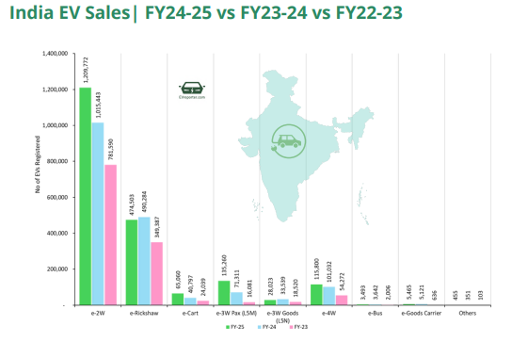

Source: Vahan Dashboard Data (Apr 2024-Mar 2025) as per 1378 out of 1479 RTOs across 35 out of 36 state/UTs and Telangana Regional Transport portal (Apr 2024-Mar 2025).
Note - Low-speed e-2w data not included. ‘Others’ includes Forklift, Adapted Vehicle, Crane mounted vehicle etc.

FY 2024-25 OEM Wise sales data | India
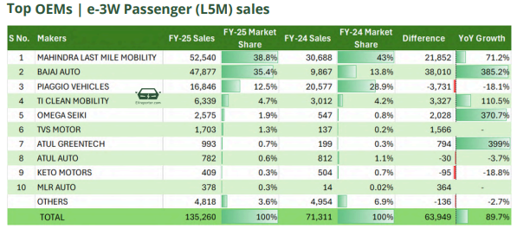
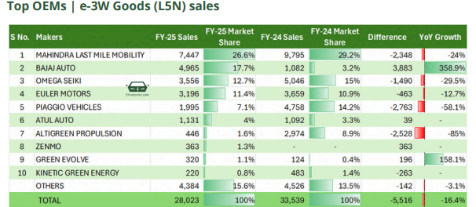
Source: Vahan Dashboard Data (Apr 2024-Mar 2025) as per 1378 out of 1479 RTOs across 35 out of 36 state/UTs and Telangana Regional Transport portal (Apr 2024-Mar 2025). Low speed e2W data not included.

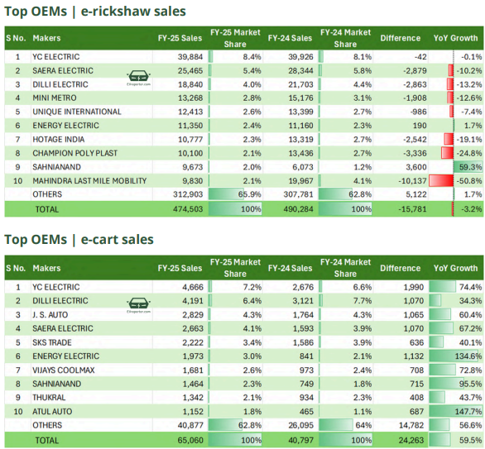
Source: Vahan Dashboard Data (Apr 2024-Mar 2025) as per 1378 out of 1479 RTOs across 35 out of 36 state/UTs and Telangana Regional Transport portal (Apr 2024-Mar 2025).
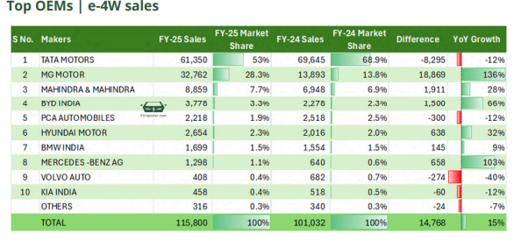
Source: Vahan Dashboard Data (Apr 2024-Mar 2025) as per 1378 out of 1479 RTOs across 35 out of 36 state/UTs and Telangana Regional Transport portal (Apr 2024-Mar 2025)

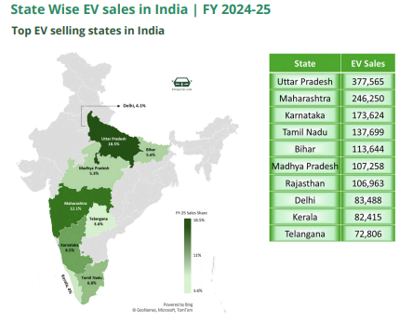

Tesla cost of Revenues and Gross margins
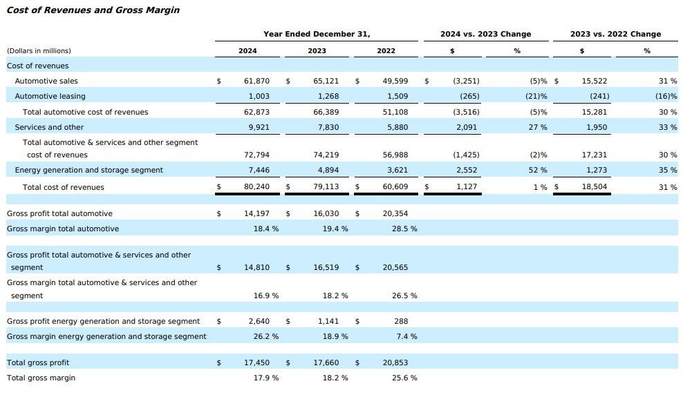
Source: (Tesla, 2024)

Tesla Balance sheet
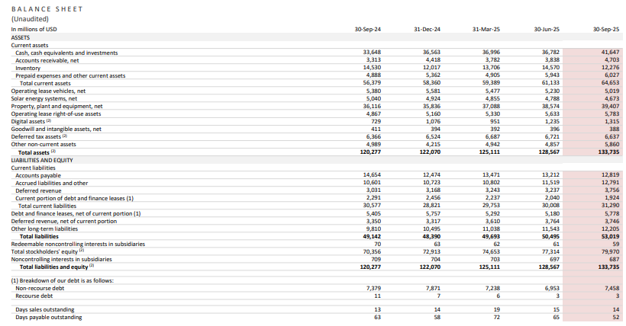
Source: (IEA, 2024).
Statement of cash flows
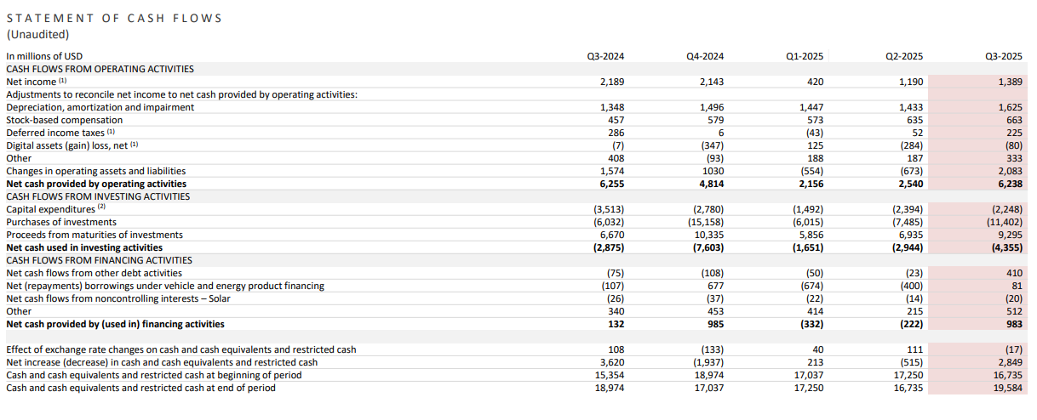
Source: Tesla Annual Report, (2024).

Financial Summary
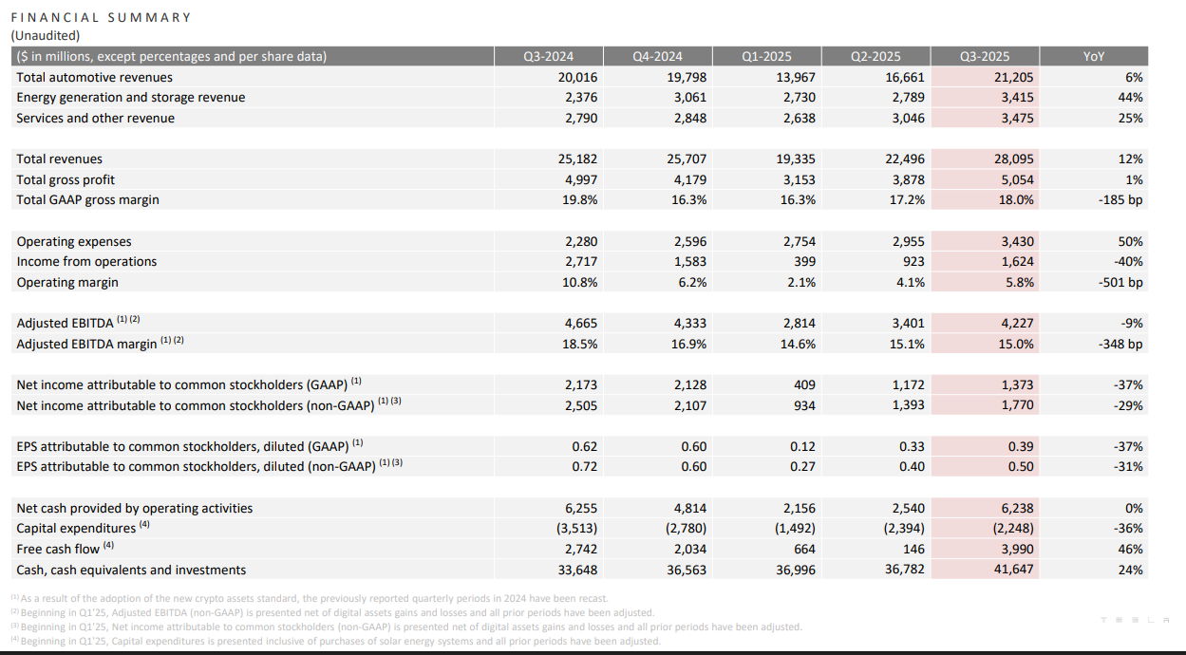
Source: Tesla Annual Report, (2024).

Share of total cumulative venture capital investment in electric mobility technology areas by country or region, 2018-2023
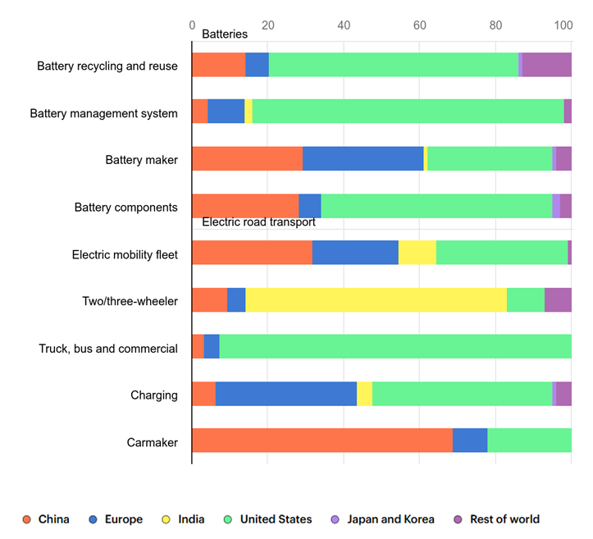
Source: IEA, (2024).

