University of Wales Trinity Saint David
School of Engineering
“ Rubber band experiment review and how the properties are affected”
Aubriel Ndlovu
2224770
Materials and introduction to processing
ACMA400
14/11/2022

Introduction
So to begin with theory of elastomer behaviour relates to viscoelasticity which in turn refers to the property of elastomers to have both viscosity and elasticity. A polymer that exhibits low Young's modulus, high yield strength, or high failure strain is generally an elastomer. It is held together by weak intermolecular forces. Even after being stretched significantly, they regain their original shape and size. I have been tasked with finding the stress strain curve for the rubber material used to create a rubber band of my choice. To do this I have to produce an experiment that looks into the stress and strain of the curve material and how that affects the properties. Throughout this report I will critically evaluate my experiment and the results that I produced.
Now before I start I want to quicky go over the chemical and structure of the rubber band. Two reasons account for rubber's useful properties. A rubber's molecules are unique because of its structure and arrangement, and a rubber's temperature is higher than absolute zero, which means that the molecules are always moving around. A tiny, random jiggling motion is always present in any material warmer than absolute zero. The molecules that make up rubber resemble spaghetti strands. The spaghetti-shaped molecules in a rubber band are pulled into a relatively straight line if the rubber band is stretched. Yet the molecules continue to move.
There is a lot of shaking and bumping between them. Molecules spread sideways as a result of this motion, so they curl up, kink, and tangle as a result. Consequently, the rubber bands pull inward. So to speak, stretched rubber tries to expand and become short, thick, and flabby in order to leave more space for molecules to move sideways.
As soon as the rubber band snaps back, the band is released. It is the interconnections and jiggling motion of these spaghetti-shaped molecules that give rubber its elastic properties. Molecules resist straightening because of that motion.

Experimental method
Firstly I will list of the equipment I used during the experiment this included a rubber bands, kitchen weighing scales, 2 sets of rulers, plastic cup, paper, pen, vernier, marker pen and the plastic bucket.
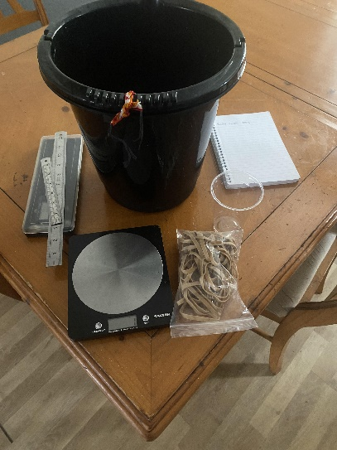

The picture should be able give you an idea of the equipment I used during the experiment.
So the first thing I done was weigh the bucket using the kitchen scales and this gave me 225grams. I then proceeded to check the length of the rubber band with no force acting upon it so that I will know the original length which was 88.5mm I used a ruler for this. After that I attached a piece of string to the bucket so the tension isn’t mainly on rubber band. I used my bathroom door hook to attach the rubber band and bucket so that I can measure the new length of the band with bucket weight acting on it this gave me 101.6mm. Before officially beginning the experiment I quickly took the weight of the plastic cup without water which gave me 8grams I then zeroed the kitchen scales proceeded with experiment.
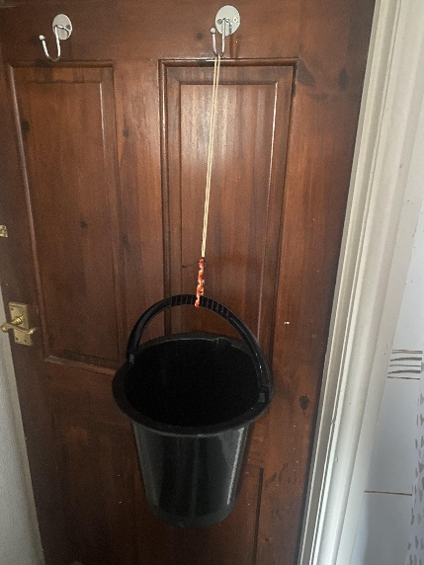
Now to start the experiment I poured water from the sink into my plastic cup, weighed it and wrote down how much was being poured into the bucket after which I measured the change in length of the rubber band and also wrote that down. I repeated this process until the rubber band snapped and the water spilled onto my floor. So to measure the change in length of the rubber band I used a ruler and my thought process was, if the rubber has outstretched the ruler I would mark up the last point it reached and measure the rest of the rubber before adding both measurements together.

The next picture clearly shows the results of the experiment and how the rubber band was able to stretch by a factor 6 before snapping and ruining my flooring.
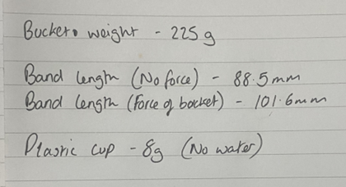
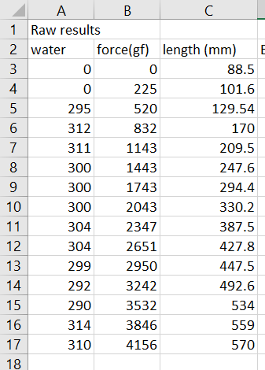

Results
After doing my weighing up and writing down everything and cleaning up my floor. I needed to find the stress and strain curve of the rubber band but to do that I needed to transfer my results onto excel so I can validate the results I had. This is all done so I can understand material properties of rubber. The first graph I produced was a scatter graph that showed a clear trend line between length of the band the increasing with the amount of tension applied to it by the bucket of water.
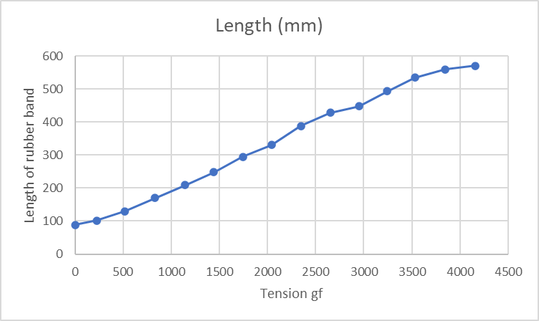

This graph was a good base for future analysis I would need to take in the future.
The next graph I needed to produce was the engineering stress/strain and true stress/strain curve graph. Before that I will explain what the difference between them is, so if you were deforming a sample, engineering stress simply doesn’t take into account the cross sectional area change while, the true stress makes sure to correctly take account of this change. The true stress stain curve is ideal for material property analysis, while the engineering stress and strain curve is more useful for performance application. Now to produce the engineering strain for graph I need to get the difference of the original length and current length and divide the answer by the original length. However for the true strain I used integral calculus to find the equation I would need. The picture below highlights the process I used for engineering and true strain.
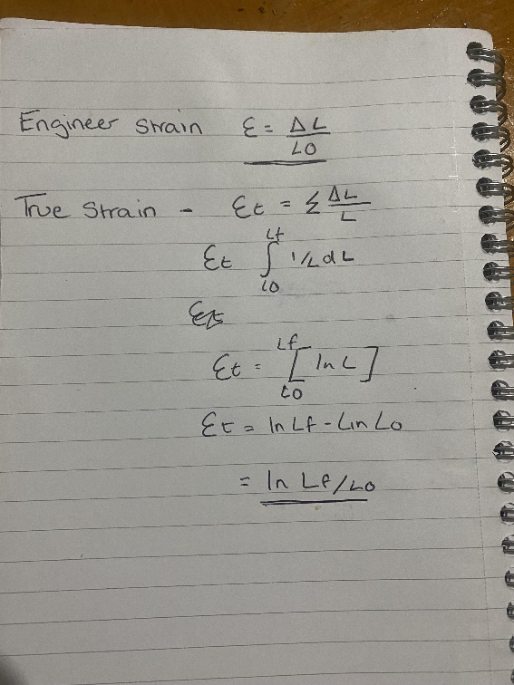

So after I had my equations for both I used excel so produce the table columns of both engineering strain and true strain. This shown in the pictures below and also how I was to input the equations on each one.
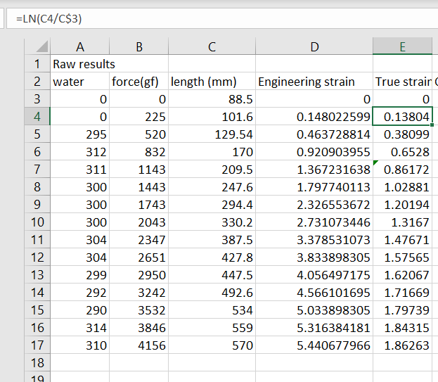
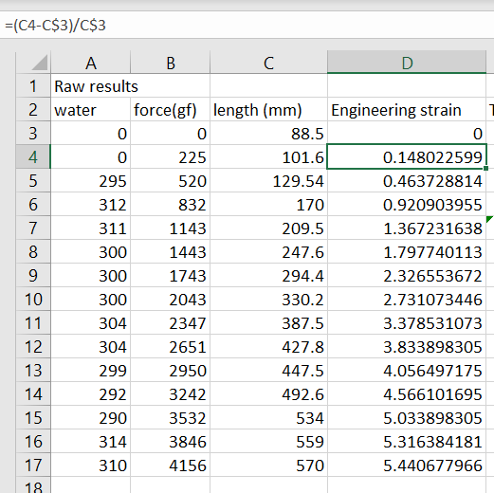

The next step was to find the engineering stress and true stress. To do this I first had to get the total cross sectional area of the rubber band using the vernier. I measured one section of band had 1.7 and 2.6 as the results so I then multiplied both answers so I can get the area and times that by 2 because the rubber band has 2 sides this gave me answer of 8.84 as shown in the picture below.
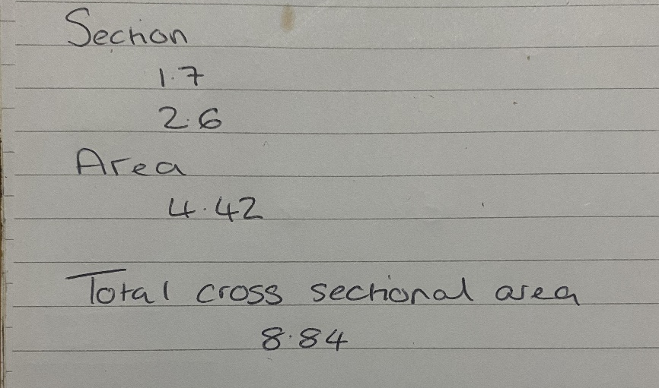

The next step was get the ratio of length for the first stretch and then multiply it by the original this then gave me the results for the cross sectional area as shown in the picture below.
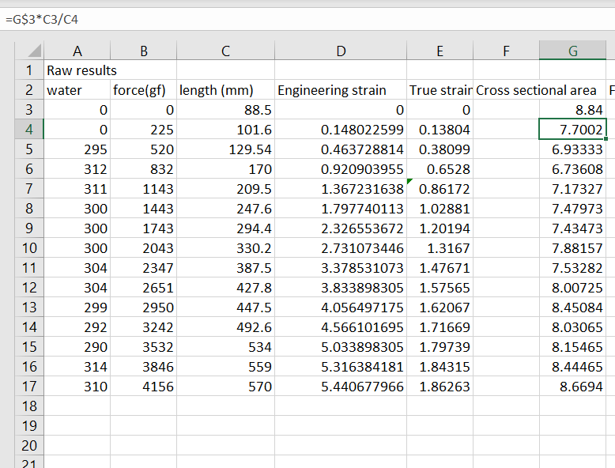

So now the next step was get force in newton, so do this I had to convert the forces from the results that I had found earlier mg into newtons. I used the equation f= mg, m being the mass and g being the acceleration due to gravity (9.81). I divided that by 1000 and was able to get the force (N). The picture below shows the equation I input into excel to get the necessary results.
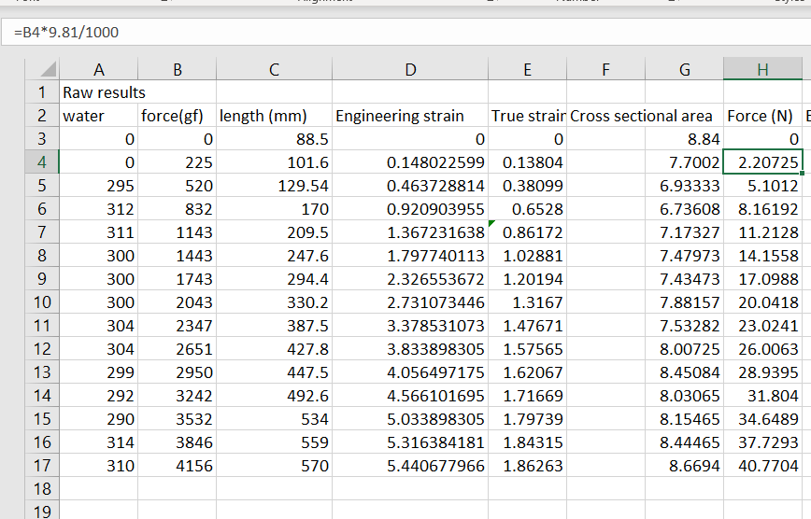

So now I have both the force(N) and cross sectional area I can find engineering stress by dividing the force over the original cross sectional area and use that equation to find the rest of the results. To find the true stress I would divide the force by the actual area giving me my answer. This will allow me to produce two columns.
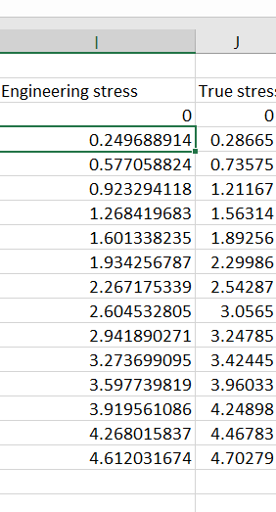

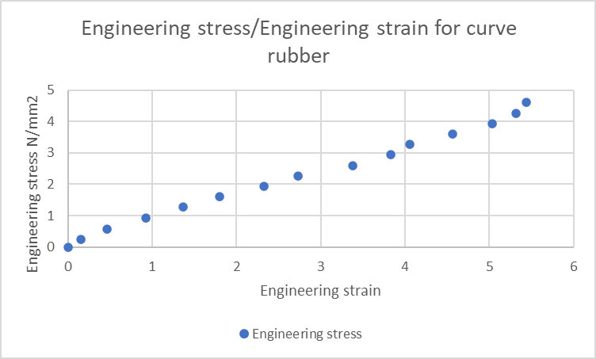
The next step for me to do is to plot the engineering stress strain curve and the true stress strain curve into two sets of graphs using the results I have found. So for the engineering stress strain curve you can clearly see that it takes 4.6 n/mm2 before for my rubber band snaps so this means if I was to design an elastic stretch component I couldn’t have stress applied to it over 5N/mm2 if I don’t want it breaking. This could mean the rubber band I was using was faulty because when looking at other engineering stress strain curve the snapping point reached 16.5n/mm2. The graph also shows the stress and strain was proportional to each throughout the experiment this is signified by using the gradient of the curve this also meant I could find constant young’s modulus. This is due to the fact the graph shows a slight curve at the end of the points but If I look at the stress at 4 N/mm2 and the engineering strain 5 I can easily workout the youngs modulus to be 0.8*10^6. The graph also clearly shows that rubber band will stretch nearly 5.5 times its original length.

When looking at the true stress strain curve graph for the rubber band. The first thing you notice is the ultimate tensile strength which is given to us at true stress point being 4.7 and the true strain point being 1.9. When looking at other true stress strain curve graph for rubber bands I notice that they significantly have a higher curves compared to mine and like the engineering stress strain curve this could mean there was an issue with either the rubber band I used or human error in the use of my vernier while I was working out the cross sectional area of the band. Even though there’s slight curve in my true stress strain curve I don’t think it’s enough to show how rubber should exhibit a hardening property the more stress applied to it. So the graph should have more of a curve on it.
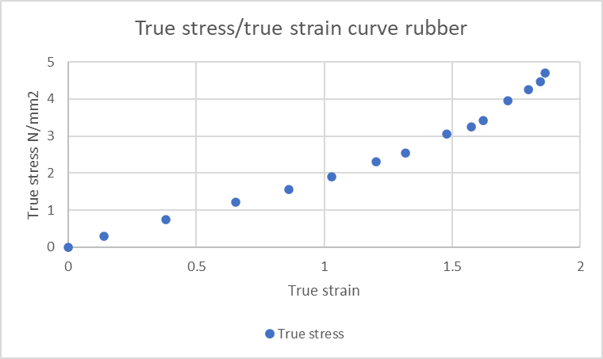

Analysis of experimental inaccuracy
This next part of the report I will be looking at how the experiment could be improved, how do I reduce the variations caused by the experiment and what they are?. Also how could the band itself be better prepared. So to begin with the first way I could improve the experiment would be the use of a stop watch so, at the start of the experiment I could of had a constant timing of 1 min when I was pouring the water so this would allow the rubber band stretch within that time limit. This would eliminate the problem of the rubber band having long stretch period on the hook or not getting enough time to fully stretch allowing the results to be more consistent.
The next improvement would be the way I measured the cross sectional area so, if I had used a micrometre and simply going around the rubber band measuring every point then worked out the average I would have a more accurate reading for the cross-sectional area.
Another problem that I could look at improving would be rather than using a rubber band as the sample I could perhaps look into purchasing rubber sample that has a tapered shape. This is down to first measurement I took on the rubber band sample on the hook with string what I didn’t realise was stress razor produced by the string on the rubber band would cause it to have more stress on the end when compared to the middle of the rubber band. The new sample I would be purchasing would allow the stress to affect the long bit in the middle allowing for a more accurate result.
The next problem I would need to look into so that my experiment can be done better would be to find a way in which I could minimise the compound errors caused by the water as I was using kitchen scales to weigh the plastic so, if I could somehow weigh the bucket with the water after every pour without unloading the rubber band so in one continuous stretch I could have a more accurate result.
Another problem I could look into improving for the experiment would be having another rubber band to compare with and check if there was problem with my results and especially if could compare the engineering stress strain curve graph and the true stress strain curve graph I could see if they match or perhaps it was all down to human error.
The other issue I would have to look into would be the use of thermostat to measure the temperature this could prove the properties of rubber are temperature dependent. So perhaps in the future I could have two experiments with two rubber bands. So I could do one rubber band at hot temperatures, another rubber band at lower temperature and compare the results. This would only work If I can guarantee the temperature remain consistent throughout both experiment without variation and make sure the rubber bands are similar to see if there’s any change.
The final problem I would need to look into so that my experiment can improve would be the measurement of the strain rate. So we know that rubber isn’t static material the properties will depend on the speed at which we stretch the band.

Discussion
So after doing the experiment I can say there are many things I would of improved on during the experiment, if I had more time and money to work with. As a first cut experiment for the properties of rubber I can say that I am not satisfied with my experiment I feel too many flaws hinder the success of it and by looking at my results they are further highlighted. If I was tasked with getting a more accurate experiments perhaps within 2% I would struggle and possibly fail. The fact that I used the least amount cost shows how much the experiment lacked.
For instance if I had invested in a tape measure rather than using a ruler I could of avoided the constant need to mark the last point the ruler reached the rubber band and added that to what was left over to measure the stretch of the rubber band while it was being weighed down by the water this allowed for errors to occur.
I also realised had my results been more accurate I would had a better curve on the true stress strain graph showing how the rubber band should be reacting to the stress applied to it so at the start they would be an easier stretch on the band but over time that would get harder as more weight is added on until the breaking point where the rubber band would snap in half.
In conclusion, you can see in my report how I carried out the experiment, you can also see the results of said experiment. I also review the results and reflect on what I think went wrong and what I can improve if I was to do the experiment again. Throughout the report I hope you can see my thought process and the steps I took while working out the equation necessary for curve graphs. I personally feel this was not a successful experiment so if possible I hope I could learn and improve from with the problems I stated before.

References
Miller, J. (2018). Elastomers: Definition, Examples, Properties, Types, Applications. [online] BYJUS. Available at: https://byjus.com/physics/elastomers/#what-are-the-properties-of-elastomers [Accessed 15 Nov. 2022].
Brandon (2017). True Stress-Strain vs Engineering Stress-Strain. [online] Materials Science & Engineering Student. Available at: https://msestudent.com/true-stress-strain-vs-engineering-stress-strain/ [Accessed 9 Nov. 2022].
Fentress, S. (2015). The Science of Rubber Bands. [online] News - Indiana Public Media. Available at: https://indianapublicmedia.org/amomentofscience/rubberband.php [Accessed 5 Nov. 2022].
R.P. Feynman, The Feynman Lectures on Physics, chapter I-44.
Frederick T. Wall, Chemical Thermodynamics, 2nd ed., chapter 15, "Statistical Thermodynamics of Rubber.

