Pembrokeshire college
James Gale
2025
Contents
Introduction 2
Justification of your choice of queries and reports 10
Queries 10
Reports 10
Critical evaluation 11
Methods 11
Tools 12
Techniques 12
References 13
Bibliography 14
Table of Figures 15

Introduction
A database system was created to help CraftGem to improve the efficiency of their operations and provide data in a structured way to help make important decisions. The system will allow users to see detailed information about their customers, stock and orders while also being able to add, edit or delete it. It was created to help reduce the amount of manual work CraftGem do and replace it with an easy to use and effective database system.
For admin: Username: Admin & Password: Admin123
For default user: Username: DefaultUser & password: DefaultUser123

Screenshots – with labelling and numbering
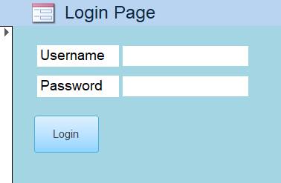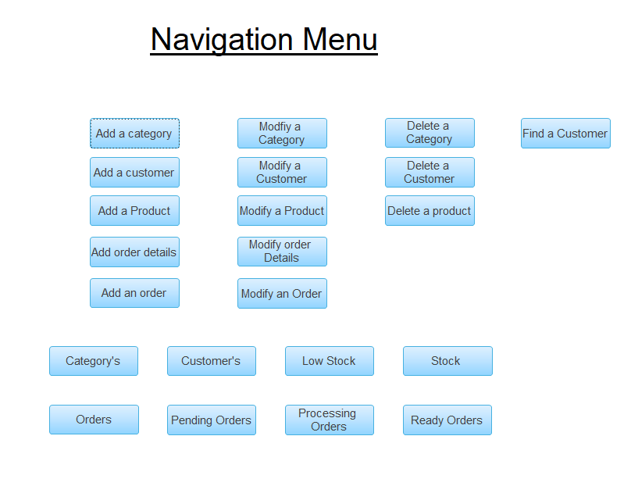
Figure 1 - Login page Figure 2 - Navigation Menu
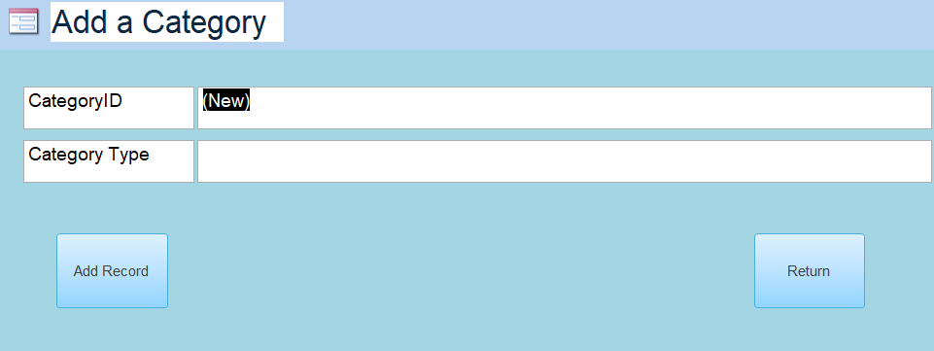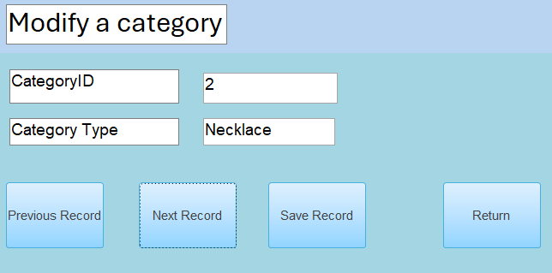
Figure 3 - Add a category Figure 4 - Modify a Category

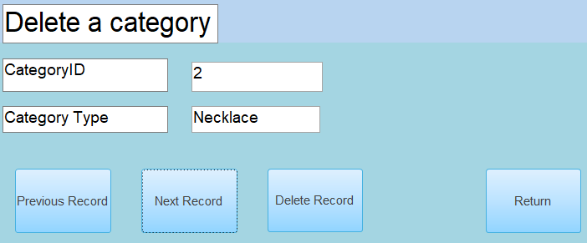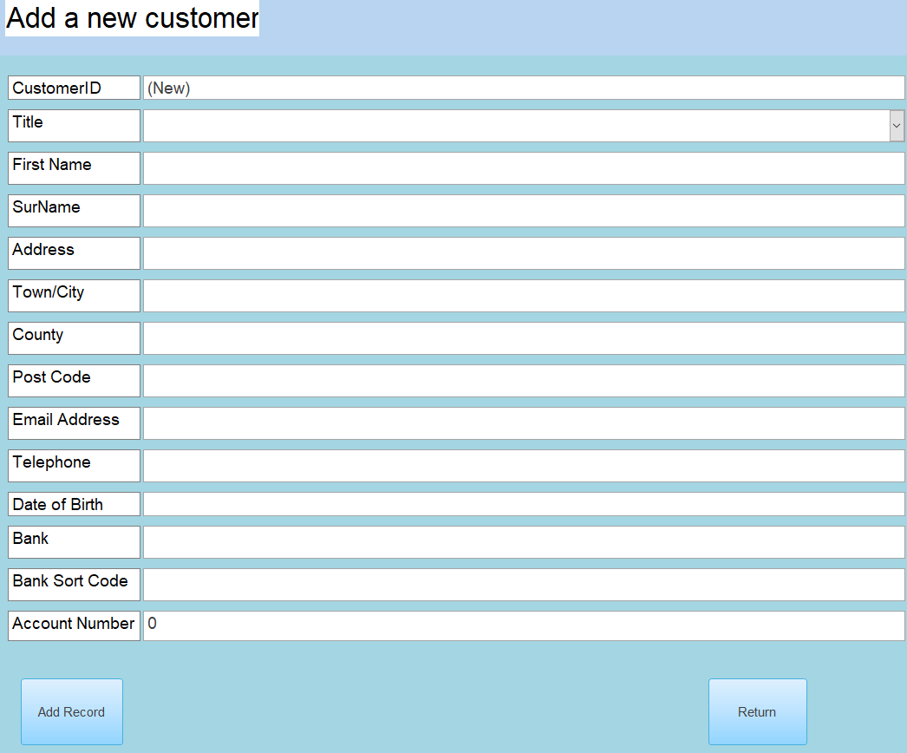
Figure 5 - Delete a category Figure 6 - Add a customer
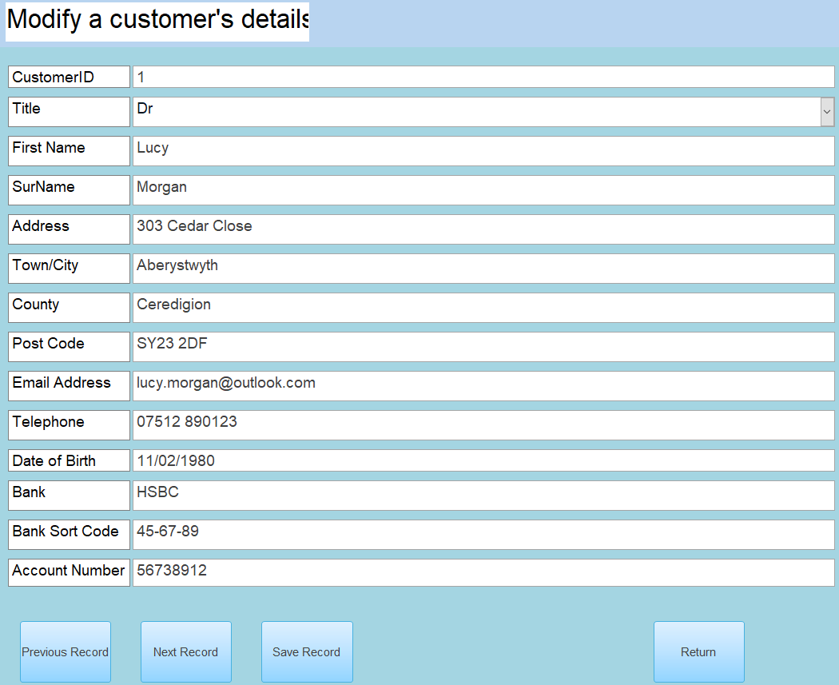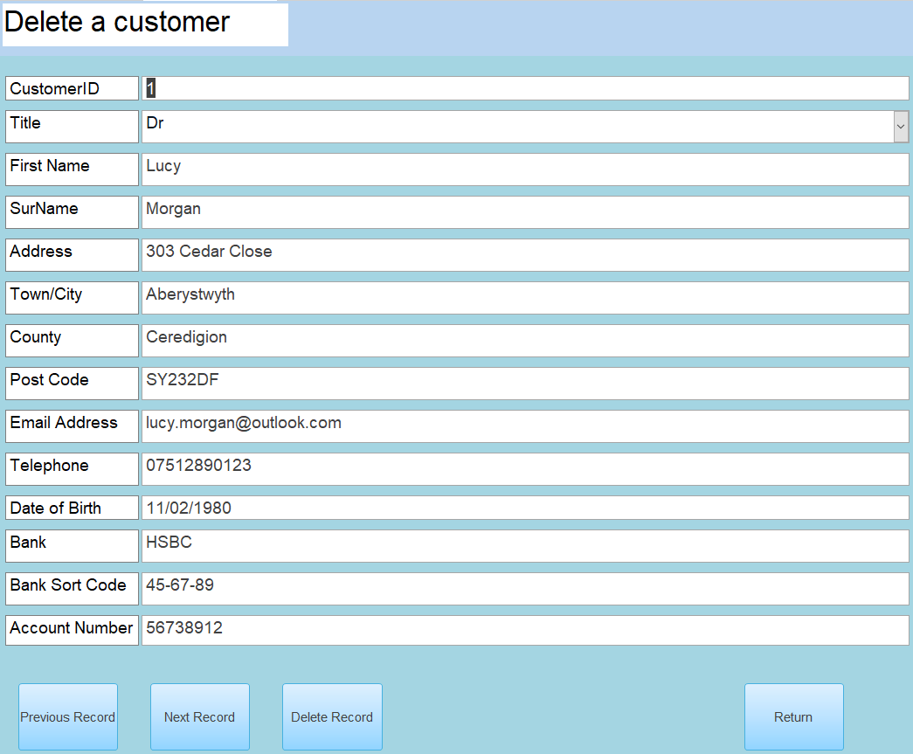
Figure 7 - Modify a customer’s details Figure 8 - Delete a customer

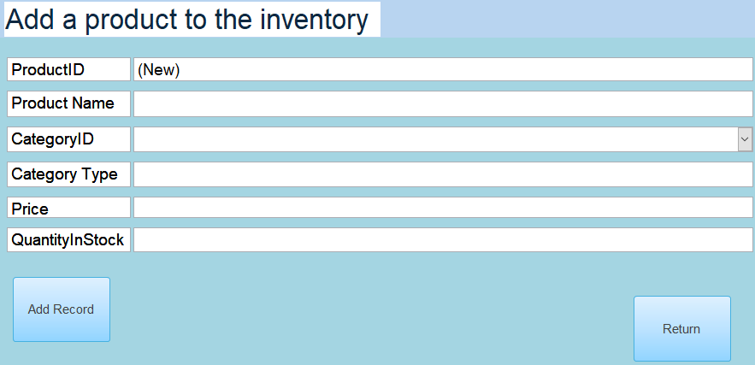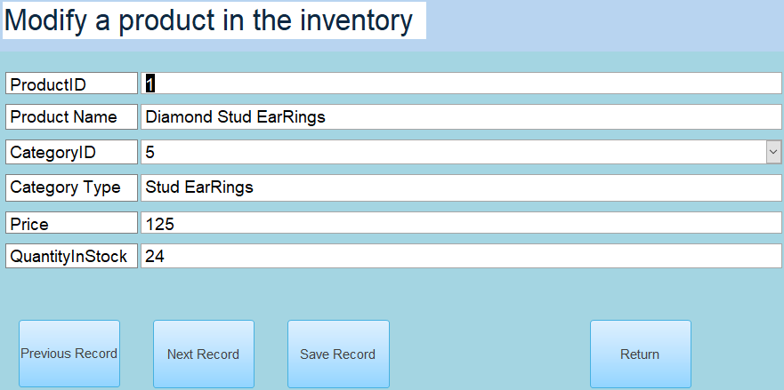
Figure 9 - Add a product to the inventory Figure 10 - Modify a product in the inventory

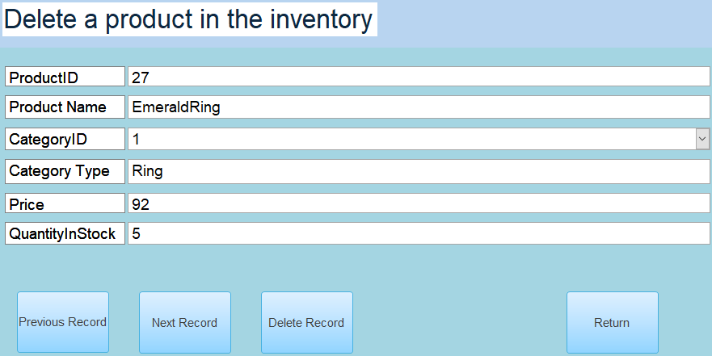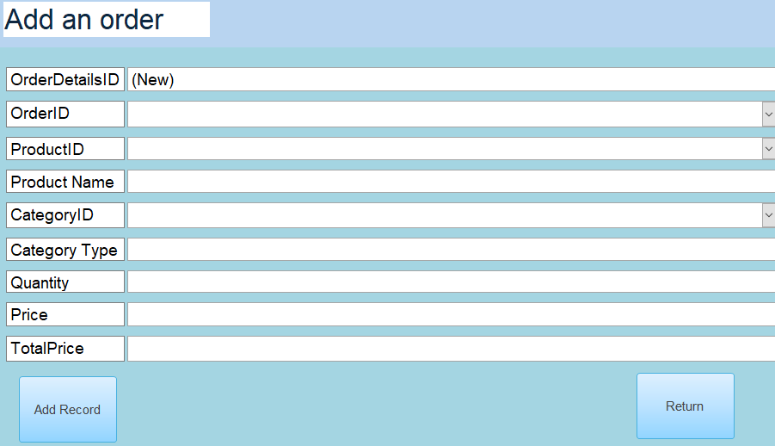
Figure 11 - Delete a product in the inventory Figure 12 - Add order details
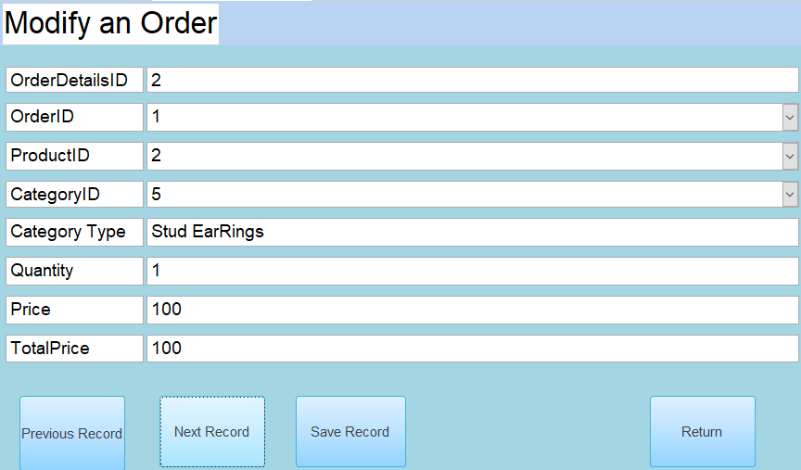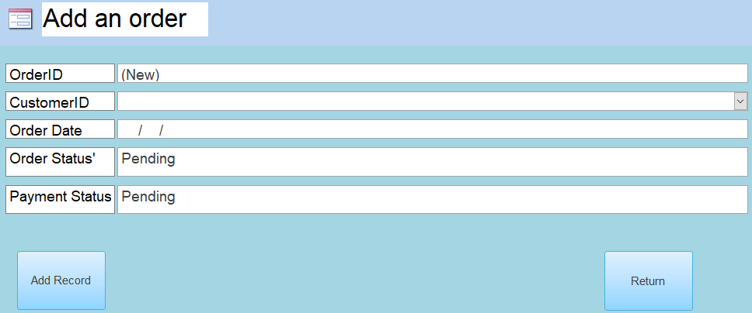
Figure 13 - Modify an order Figure 14 - Add an order
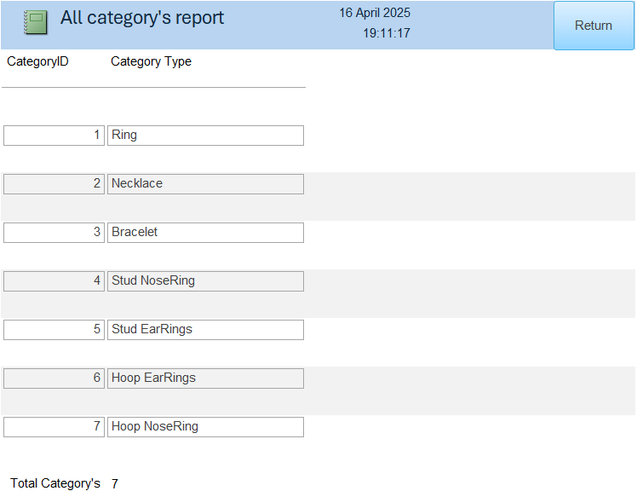
Figure 15 - All Category's report

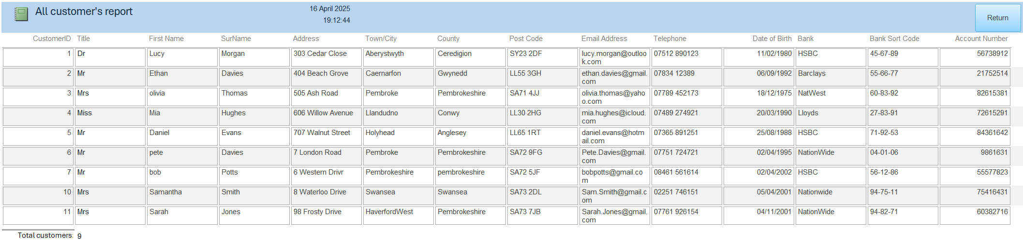
Figure 16 - All customers report

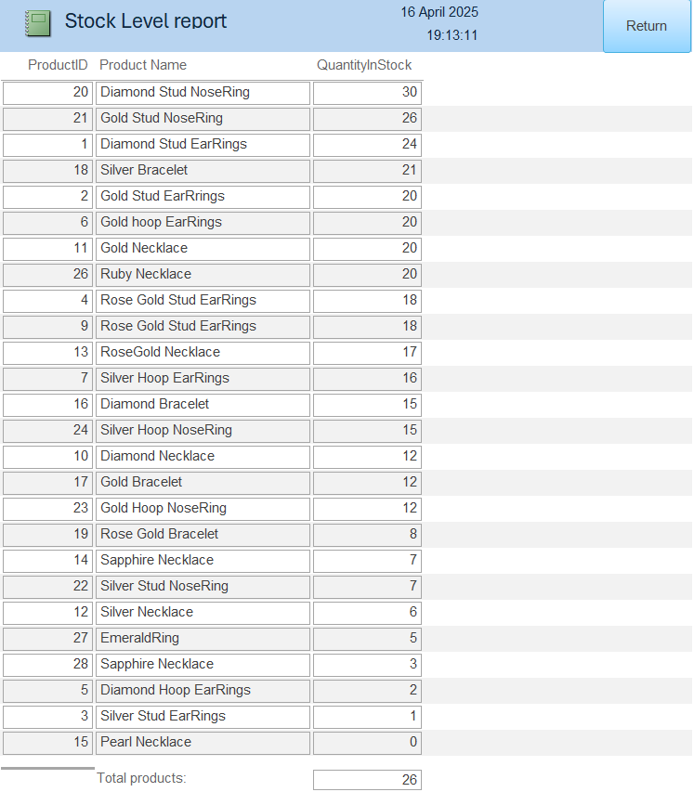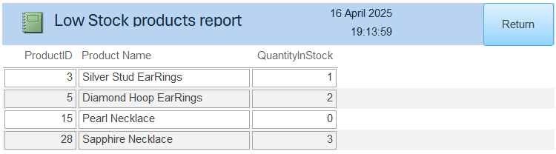
Figure 17 - Stock level report Figure 18 - Low stock products report

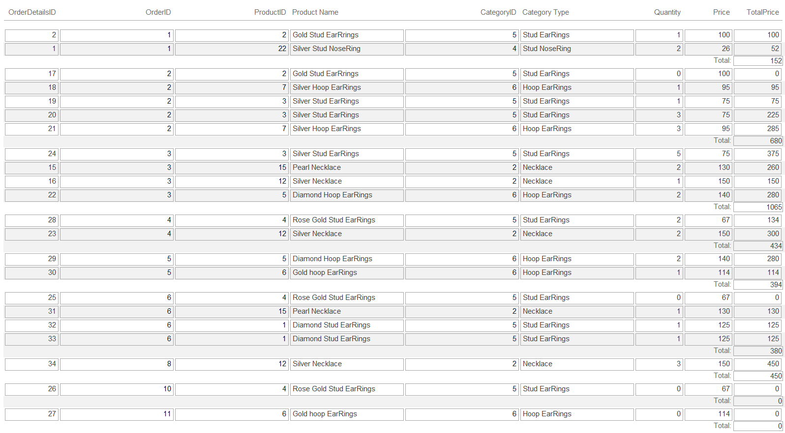
Figure 19 - All orders report
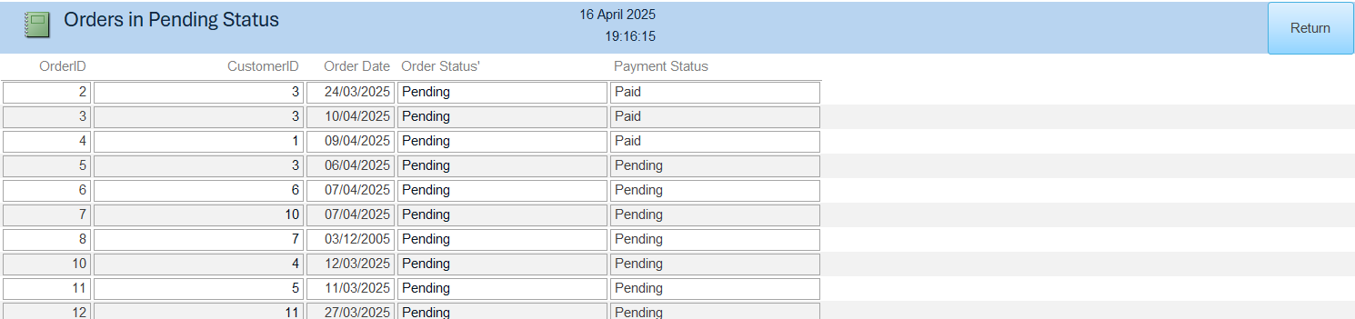
Figure 20 - Orders in Pending Status report
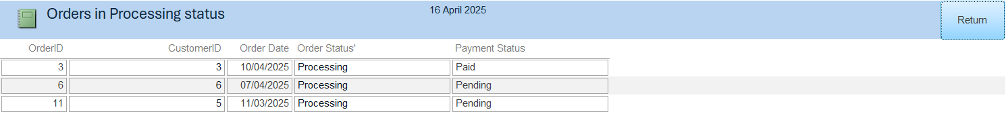
Figure 21 - Orders in Processing status
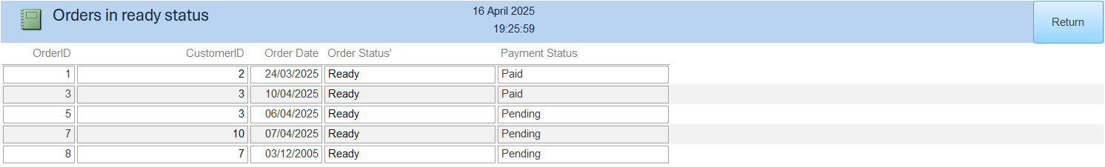
Figure 22 - Orders in Ready status
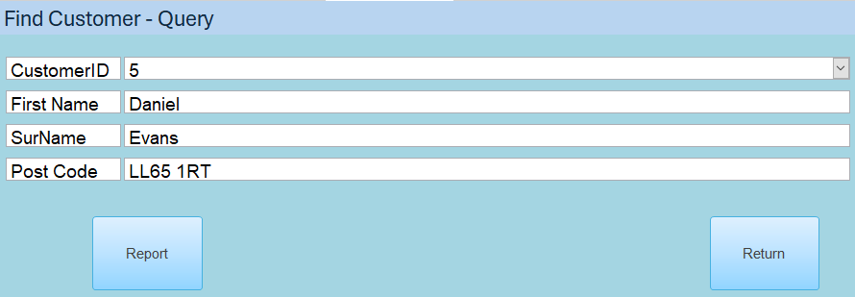
Figure 23 - Find a Customer
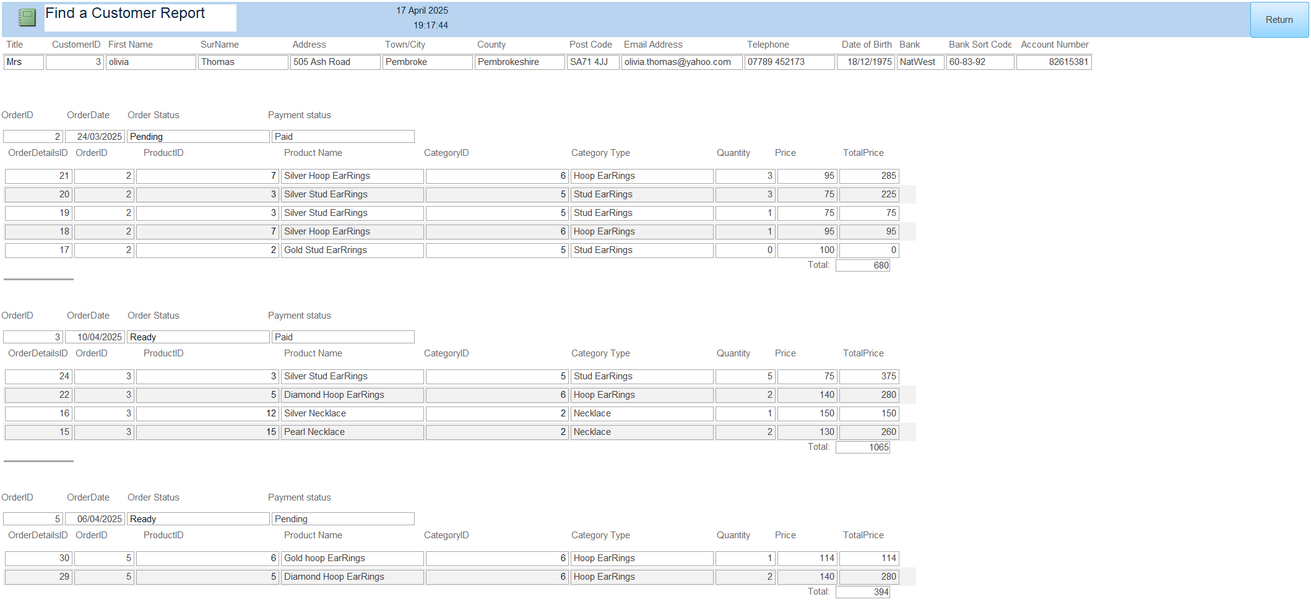
Figure 24 - Find a customer report

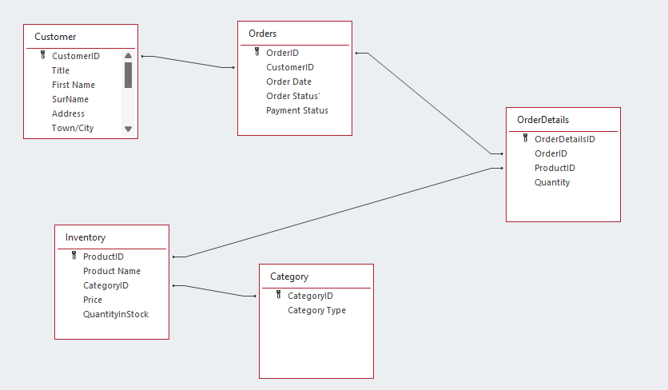
Figure 25 - Entity relationship diagram
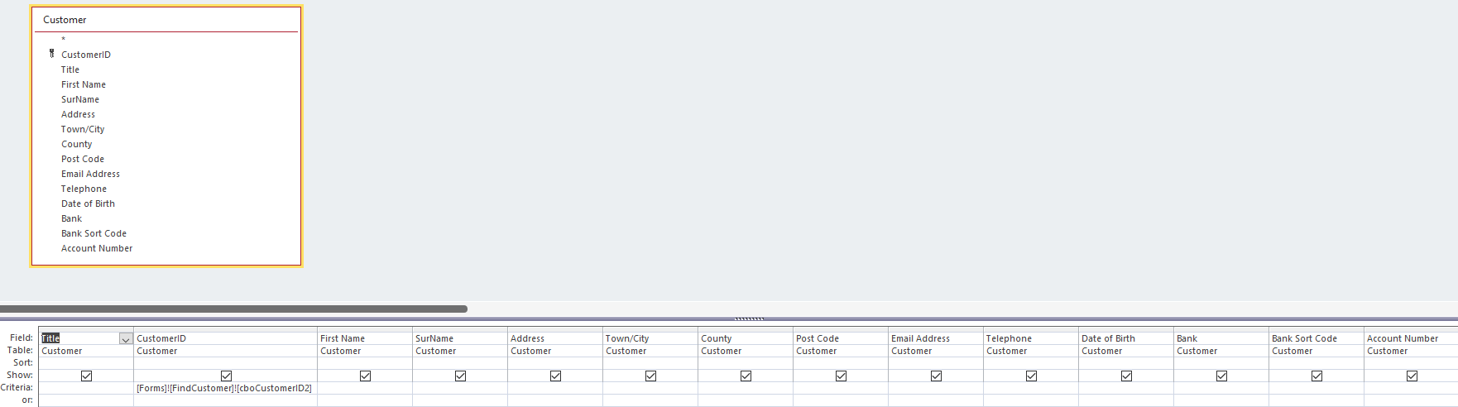
Figure 26 - Find a customer Query
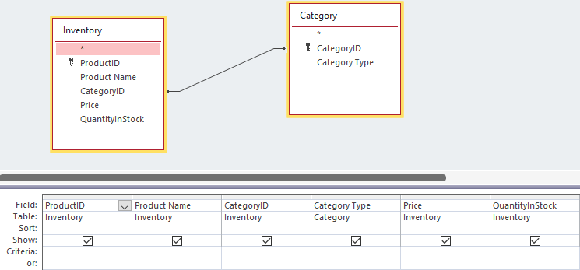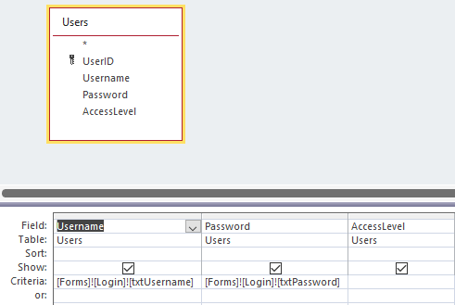
Figure 27 - Inventory ADD query Figure 28 - Login Check query

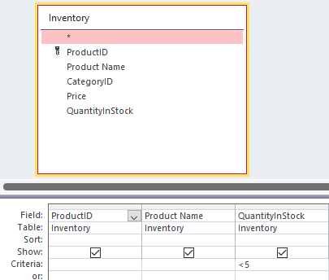
Figure 29 - Low Stock Query
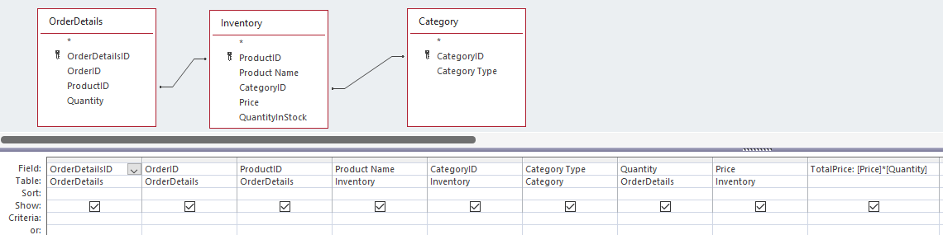
Figure 30 - Order Details ADD query
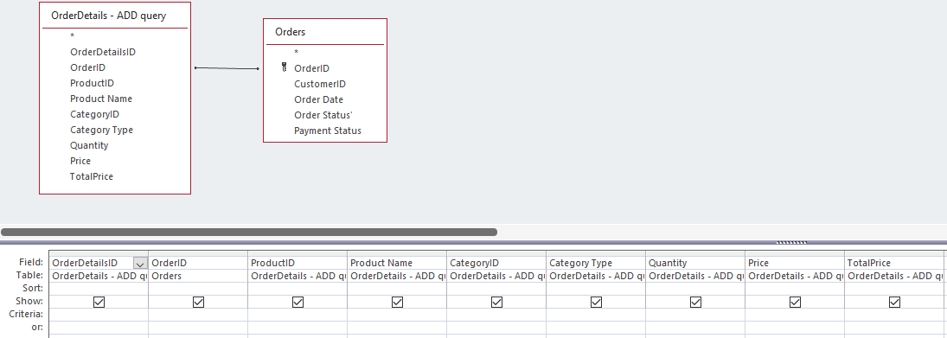
Figure 31 - Order Details sub report query
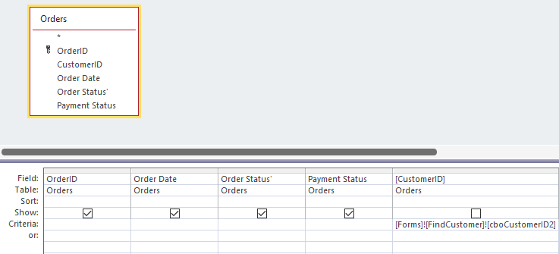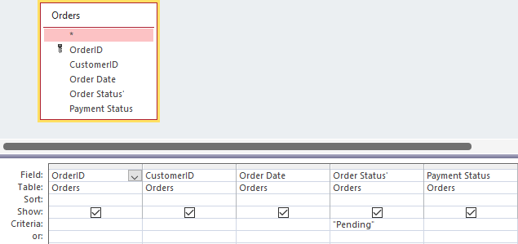
Figure 32 - Find a customer Order Query Figure 33 - Pending Orders Query

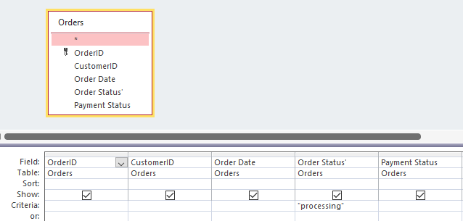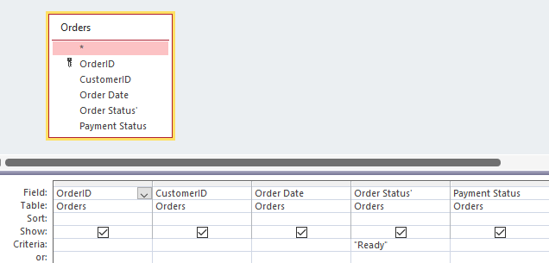
Figure 34 - Processing orders query Figure 35 - Ready orders query
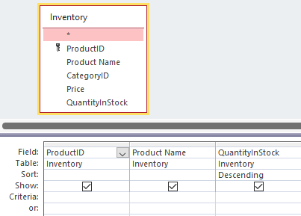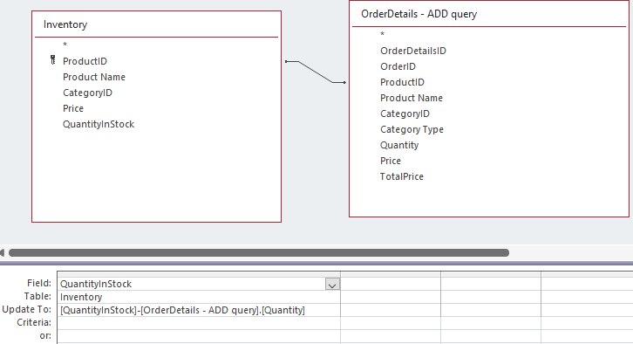
Figure 36 - Stock Query Figure 37 - Update Stock Query
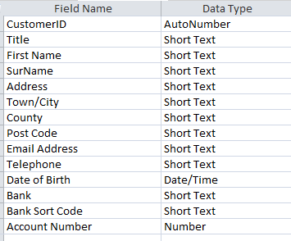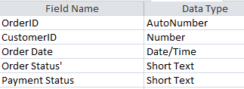
Figure 38 - Customer Table Figure 39 - Order Table
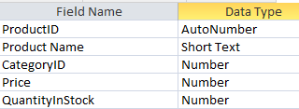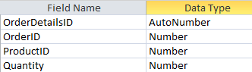
Figure 40 - Inventory table Figure 41 – Order Details Table
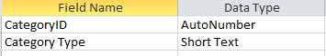
Figure 42 - Category Table

Justification of your choice of queries and reports

Queries
The ‘Find customer query’ was used to select a customer’s record based of the customerID a user selects in a form. This helps narrow the search down to bring up a specific record for the user and will be used with other queries to generate a detailed report on a customer selected by a user. The ‘Inventory Add query’ combines the inventory and category tables together, this was then used to create a form called ‘Add a new product’. When a user selects a CategoryID, the query will pull in the category type automatically, this gives the product more detail. The ‘Login Check’ query checks if the username and password entered by the user in the ‘login’ form matches with any from the ‘users’ table. If they match, the query displays the data, this is used to authenticate user credentials and allow or deny access to the database. The ‘stock’ query selects the required fields from the inventory table to display the products and their quantity level. This was chosen to reduce the amount unnecessary data from the inventory table and just select the fields needed to show stock level. The ‘Low stock query’ shows any products where the quantity level is below 5. This was created to display any products where more stock needs to be ordered and to easily display this data. The ‘OrderDetails – Add query’ uses fields from the OrderDetails, inventory and category tables and is used as the OrderDetails – add form. It was created so when a user selects a product ID in the form, it will automatically pull in the product name, CategoryID and categoryType allowing the user to easily see what their entering into the form without having to cross reference data in other tables. The query has an extra field created called ‘total price’ where the quantity of the order is multiplied with the price of the product. The ‘OrderDetails – sub report’ displays any OrderDetails that have the OrderID field filled out. This was created to be used in a sub report to display any OrderDetails associated with a specific OrderID. The ‘Order – Query’ will display all the order data based off a CustomerID selected by a user from a form. This was created to be used as a sub-report in the ‘Find Customer’ report to show orders associated with a specific customerID. The ‘Pending orders’, ‘Processing orders’ and ‘ready orders’ queries will display orders depending on their order status. This was created to help track orders and give the user an easy view of what stage different order were at. The final query is an update query called ‘UpdateStock query’ where it subtracts the quantity the user selects in a form from the qunatityInStock level. This was created to have a stock level system in place so when an order is placed the amount of product ordered gets automatically reduced from the quantityInStock.

Reports
The ‘All category’s report’ displays all the categories data such as categoryID and category type. This report was created to display all the categories currently active and displaying to the users easily. The ‘All customers report’ displays all the customers with their details on one report, it totals the overall number of customers as well. This was created as a general report for users to see how many total customers there are and to for them to check/view customer records. The ‘stock report’ displays all the products with how much quantity is left in stock for them. This was created to allow users to easily check how much stock of a product is left. The ‘Low stock’ report displays products when their stock level is below 5. This report was created to notify users when products have low stock so they can order more and keep the stock level sustainable. The ‘Find customer’ report displays a customer record based off the CustomerID the user selects from the ‘find customer’ form. This was created to help users narrow their search and query for a specific user. Two sub-reports are used to make up the report. The ‘Orders – sub report’ will display all the orders associated with the CustomerID already selected. The ‘Orders Details – sub report’ will then display all the order details associated with the OrderID. Together this creates one report where once a customerID is selected by the user, it will display all orders and OrderDetails associated with them. This was created for users to query a customer and bring up all their customer details and orders they’ve placed. The ‘Orders’ report displays all the orderDetails grouped by OrderID and totals the total price of them. This was created for users to see all the orders and products placed by customers. The final reports are ‘Pending orders’, ‘processing orders’ and ‘ready orders’. These display orders based off their order status. They were created to help users keep track of orders and know which stage they are at.

Critical evaluation

Methods
The database is a relational database using foreign keys to link tables together, all the relationships are one to many being only linked once to another table. This reduces data redundancy as data should only be stored once, not repeat itself in other tables and should be easy to understand how tables are linked. The tables are well organised with suitable field names to store only the data wanted and needed. They follow the third normal form principle, “Reaching 3NF ensures that the database is well-structured, efficient, and free from data issues or inconsistencies” [1]. Third normal form builds off the 1st and 2nd normal form principles. “1NF requires atomic (indivisible) values in each cell, and 2NF removes partial dependencies on a composite primary key” [2]. 3NF then builds upon these where there are no Transitive dependencies. For example, the ‘OrderDetails’ table has productsID, OrdersID etc. Then the associated ID number has all the details attached to it in the related table. Queries are created to give more detail and store additional data to the original tables. For example, a query is used on the Order Details table to pull in the product name and price, then an extra field is created to total the price. This gives the data more context and makes it easier to understand. To improve the methods used for the database, an additional table could be created for the payments. Currently, only basic payment details are stored such as account number or the sort code, but this is not the data that would typically be stored for payment details. A new table could be created and linked together with the CustomerID, to have more detailed payment details to store against users to pay for their orders.

Tools
Forms are used in the database for users to add, modify and delete different records from the underlying tables. “A form in Access is a database object that you can use to create a user interface for a database application” [3] . They provide access for the users to view and edit without having direct access to the underlying data. Each form is limited to what it can do, within the ‘add’ record forms, users cannot view other records or in the ‘modify’ record forms users cannot add a new record etc. This reduces the risk of human error and forms are restricted to do what their meant to. A navigation menu was created through a form for users to navigate through the different forms and reports. Forms are created from queries and use macros/VBA to perform tasks. “Used in Access to automate repetitive tasks, control user interaction, and add complex functionality that is not easily achievable through standard queries or forms” [4] . Some of the macros/VBA code are used to open forms, reports, move between records and limit user access. To improve the database, more VBA/macros can be used to automate repetitive tasks and improve data integrity. Currently, users can put in orders even when a product has 0 quantity level, some VBA could be implemented to stop users from adding the record. Queries are used to select and display the data based off criteria to be used in forms and reports. “Queries allow users to ask specific questions or perform actions such as inserting, updating or deleting data” [5] . Most queries are effective and used in the database to improve efficiency and accuracy of data. They update records automatically, retrieve data and authenticate logins. To improve, some queries are created and not used anywhere, they should be deleted to save space and improve performance. Reports are used to display data retrieved from queries or added from forms for users to view in an easy to read format. “reports provide summaries of the information contained in the database” and offer a “customized view of your data” [6]. To improve, more detailed reports could be created with sub-reports to provide users with more insightful data to help make informed decisions. For example, a monthly sales report highlighting total sales with data about most & least sold and what categories performed the best.

Techniques
All the tables are normalized to ensure no data redundancy and data is not stored twice in different tables. One to many relationships were used for all tables to improve data integrity and have no “Redundancy, update anomalies, and deletion anomalies” [7]. Queries are optimised to keep retrieval times very fast and keep the performance of the database high. “Optimizing these queries, we can cut down on how long they take to execute, make apps run smoother” and “make data retrieval faster” [8] . Most queries will only select the columns it needs to run the query, very little will select all the data from a table as this increases retrieval time. The database has a login system in place to limit user access and only users who have login credentials can gain access. Currently there are two user roles, admin and default user. A query is used to check the user credentials, then macros are used to limit what the user has access to. For example, the default user cannot see that navigation pane or the ribbon whereas the admin can. To improve, more users and roles should be created to limit access. This can be users who only have view or modify permissions etc. Validation rules are in place for all forms, only the data wanted can be entered into the database. Data can only be entered, when necessary, as some fields are blocked for data entry, other fields only accept letters or number. Input masks are used for the correct format to be used and keep all the data consistent.

References

[1] | geeksforgeeks, “Third Normal Form (3NF),” geeksforgeeks, 09 01 2025. [Online]. Available: https://www.geeksforgeeks.org/third-normal-form-3nf/. [Accessed 20 4 2025].
[2] | M. Fayard, “What is Third Normal Form (3NF)?,” datacamp, 18 11 2024. [Online]. Available: https://www.datacamp.com/tutorial/third-normal-form?dc_referrer=https%3A%2F%2Fwww.google.com%2F. [Accessed 21 04 2025].
[3] | microsoft, “Introduction to forms,” microsoft, 30 05 2024. [Online]. Available: https://support.microsoft.com/en-gb/office/introduction-to-forms-e8d47343-c937-44e8-a80f-b6a83a1fa3ae. [Accessed 22 4 2025].
[4] | J. Korol, BY EXAMPLE: with VBA, XML, and ASP, J. Korol, 2019.
[5] | Secoda, “Query definitions,” Secoda, 20 11 2024. [Online]. Available: https://www.secoda.co/glossary/query#:~:text=A%20database%20query%20is%20composed,constructing%20effective%20and%20efficient%20queries.. [Accessed 26 4 2025].
[6] | M. Alexander, Access 2019 Bible, Wiley, 2018.
[7] | J. W. &. H. Garcia-Molina, Database Systems: The Complete Book: Pearson New International Edition, Pearson, 2013.
[8] | T. Kaur, “Optimizing SQL query performance: A Comprehensive Guide,” Medium, 7 3 2024. [Online]. Available: https://medium.com/womenintechnology/optimizing-sql-query-performance-a-comprehensive-guide-6cb72b9f52ef. [Accessed 24 4 2025].

Bibliography

[1] | geeksforgeeks, “Third Normal Form (3NF),” geeksforgeeks, 09 01 2025. [Online]. Available: https://www.geeksforgeeks.org/third-normal-form-3nf/. [Accessed 20 4 2025].
[2] | M. Fayard, “What is Third Normal Form (3NF)?,” datacamp, 18 11 2024. [Online]. Available: https://www.datacamp.com/tutorial/third-normal-form?dc_referrer=https%3A%2F%2Fwww.google.com%2F. [Accessed 21 04 2025].
[3] | microsoft, “Introduction to forms,” microsoft, 30 05 2024. [Online]. Available: https://support.microsoft.com/en-gb/office/introduction-to-forms-e8d47343-c937-44e8-a80f-b6a83a1fa3ae. [Accessed 22 4 2025].
[4] | J. Korol, BY EXAMPLE: with VBA, XML, and ASP, J. Korol, 2019.
[5] | Secoda, “Query definitions,” Secoda, 20 11 2024. [Online]. Available: https://www.secoda.co/glossary/query#:~:text=A%20database%20query%20is%20composed,constructing%20effective%20and%20efficient%20queries.. [Accessed 26 4 2025].
[6] | M. Alexander, Access 2019 Bible, Wiley, 2018.
[7] | J. W. &. H. Garcia-Molina, Database Systems: The Complete Book: Pearson New International Edition, Pearson, 2013.
[8] | T. Kaur, “Optimizing SQL query performance: A Comprehensive Guide,” Medium, 7 3 2024. [Online]. Available: https://medium.com/womenintechnology/optimizing-sql-query-performance-a-comprehensive-guide-6cb72b9f52ef. [Accessed 24 4 2025].
[9] | K. Pitch, Microsoft Access Guide to Success, Kevin Pitch, 2024.
[10] | A. G. Taylor, Database Development for Dummies, For Dummies, 2000.
[11] | M. McGrath, Access in easy steps, In Easy Steps Limited, 2019.
[12] | D. T. W. T. T. a. Tutorials, “Microsoft Access Tutorial: How to build your database from an entity relationship diagram,” Dr. Todd Wolfe Technology Training and Tutorials, 2022.
[13] | SachAccess, “What is the difference between Macro and VBA code in MS Access,” Access-Programmers, 22 10 2022. [Online]. Available: https://www.access-programmers.co.uk/forums/threads/what-is-the-difference-between-macro-and-vba-code-in-ms-access-which-one-is-preferred-at-which-step.324490/. [Accessed 20 4 2025].
[14] | W. Wang, “How to Query an MS Access 2019 Database,” Dummies, 12 5 2018. [Online]. Available: https://www.dummies.com/article/technology/software/microsoft-products/general-microsoft/how-to-query-an-ms-access-2019-database-257976/ . [Accessed 20 4 2025].
[15] | TutorialsPoint, “MS Access - Reports Basics,” TutorialsPoint, 25 3 2025. [Online]. Available: https://www.tutorialspoint.com/ms_access/ms_access_reports_basics.htm . [Accessed 24 4 2025].
[16] | R. A. Silva, “Microsoft Acces: Everything you need to know to manage data efficently,” Microsoft Acces: Everything you need to know to manage data efficently , vol. 12, no. 1, p. 7, 2003.

Table of Figures
Figure 1 - Login page Figure 2 - Navigation Menu 2
Figure 3 - Add a category Figure 4 - Modify a Category 2
Figure 5 - Delete a category Figure 6 - Add a customer 3
Figure 7 - Modify a customer’s details Figure 8 - Delete a customer 3
Figure 9 - Add a product to the inventory Figure 10 - Modify a product in the inventory 3
Figure 11 - Delete a product in the inventory Figure 12 - Add order details 4
Figure 13 - Modify an order Figure 14 - Add an order 4
Figure 15 - All Category's report 4
Figure 16 - All customers report 4
Figure 17 - Stock level report Figure 18 - Low stock products report 5
Figure 19 - All orders report 5
Figure 20 - Orders in Pending Status report 6
Figure 21 - Orders in Processing status 6
Figure 22 - Orders in Ready status 6
Figure 23 - Find a Customer 6
Figure 24 - Find a customer report 6
Figure 25 - Entity relationship diagram 7
Figure 26 - Find a customer Query 7
Figure 27 - Inventory ADD query Figure 28 - Login Check query 7
Figure 29 - Low Stock Query 8
Figure 30 - Order Details ADD query 8
Figure 31 - Order Details sub report query 8
Figure 32 - Find a customer Order Query Figure 33 - Pending Orders Query 8
Figure 34 - Processing orders query Figure 35 - Ready orders query 9
Figure 36 - Stock Query Figure 37 - Update Stock Query 9
Figure 38 - Customer Table Figure 39 - Order Table 9
Figure 40 - Inventory table Figure 41 – Order Details Table 9
Figure 42 - Category Table 9

