BA (Hons) Management – Skills for the Workplace
BMSW5102
21
Developing relationships and Workplace achievement
3000 Words Essay
Zujaja Tabassum Kharal 1919419

Introduction
HR's job has changed significantly recently, and its key focus is on developing useful techniques that empower the fruitful execution of major corporate initiatives. Human resources and the process of working together are, somehow or other, in harmony with each other. HR nowadays is focused on empowering and expanding worker performance by creating a positive work environment and allowing representatives whatever number of opportunities they could have under the circumstances to participate in hierarchical arranging and dynamic. Human resources' essential functions include growing elite pioneers and expanding representative inspiration. Thus, HR has moved from the role of an appraiser to a facilitator and an empowering agent.
It is well explained by Maslow`s Hierarchy five levels of needs (5 Self – Actualisation), The need to fulfil oneself by maximising the use of one`s abilities, skills and, potential. (Pichère et al., 2015)
Execution of the board is ebb and flow trendy expression and a necessity in these times of savage competition and corporate wars for authority. It is more comprehensive and more complicated than HR work alone. Consisting of tasks like joint objective setting, continuous progress evaluations, and continuous correspondence, criticism, and instruction for further developed execution, execution of worker improvement programs, and remunerating accomplishments.
Execution begins when a new employee joins a framework and ends when a representative leaves the organization. An association's general show can be improved by focusing on individual execution within a group structure. The purpose of the executive board, according to Armstrong and Baron (1998), is to improve individual and team performance and build abilities to deliver viable outcomes in organizations. He suggests four aspects that constitute the meaning full version of Human Resource management.
- The Specific inevitability of values and postulation
- Making informed decisions about managing people based on a preconceived core
- The key involvement of the line manager
- Employer-employee relationships are shaped based on a group of 'leavers'
(Armstrong et al., 2006)
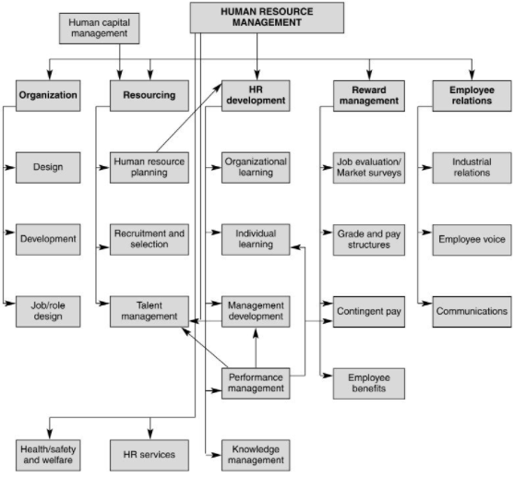
(Armstrong, 2006)

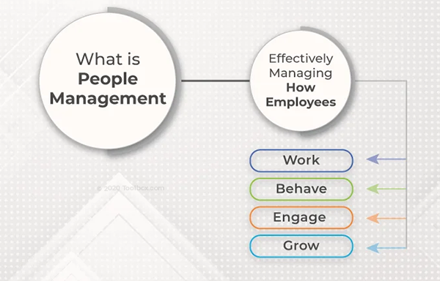
(Ghosh, 2021)

- Benefits of organization of developing individuals in the workplace:
The organization
It is an executive's responsibility to organize presentations conducted by groups and individuals to achieve the overall goals and objectives of the organization. Organizations can present their message more effectively if they develop a compelling board framework that includes the following:
- Observing that the association's representatives are aware of the commitments they made.
- Each representative gets what is generally expected of them, regardless of whether they possess the essential skills or abilities.
- Ensure the goal is appropriately adjusted or linked, while promoting good communication within the company.
A positive and trust-based relationship between the worker and their line administrator.
Work fulfilment and performance can be affected by the board's implementation of the methods in the accompanying ways
- Providing genuine and straightforward occupation input to workers consistently.
- Creating an unmistakable connection among execution and pay
- Providing bountiful opportunities for learning and development through addressing labourers in initiative improvement programs, etc.
- Evaluating execution and dispensing impetuses and compensations on a level battleground.
- By cultivating open correspondence and a common discussion, clear execution targets might be set up.
- Recognizing and compensating phenomenal accomplishment in the work environment.
- Providing whatever number of opportunities for proficient headway as could reasonably be expected.
In establishing corporate competencies and key skills shortages, clearly defined goals, frequent evaluations of employee performance and company-wide needs, training and development plans can then be developed for employees.

Evaluation Objectives
- By determining whether workers are ready to pursue more tasks.
- By giving employees feedback on their existing skills and areas for growth.
- By connecting performance to the breadth of promotions, incentives, awards, and advancement opportunities.
To Individual
A mindfulness training program enhances interpersonal relationships, increases emotional bonding and resilience, encourages innovation and creativity, and increases attention span as well. (Chaskalson, 2011). It improves organizational performance; a well-trained and knowledgeable employee not only communicates confidently and effectively but also saves conflicts resulting in saving time, money and better performance. 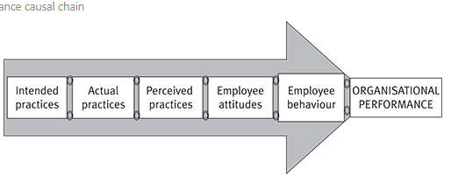
(Hutchinson, 2013)
Developmental Objectives

By determining the training needs of workers based on the results of individual and organizational competency evaluations and diagnostics, the developmental goal is met. The benefits of coaching and counselling include gaining the trust of employees and increasing their performance, as well as enhancing relationships between superiors and subordinates. Vertically and horizontally aligning and integrating an organization's objectives and KPIs across all job categories and levels aids in aligning actions upwards towards a coherent goal.

Task 02

Using PDP template development of a plan to identify expectations of an individual’s:

Enhancing employee productivity can be achieved by implementing a performance development plan. Using the PDP process, managers and employees can identify areas for development, set goals, measure progress, and design a plan to reach those goals.
Doing performance development planning quarterly (concurrent with regular quarterly performance evaluations) allows employees and supervisors to assess progress and adjust as needed. A PDP is a great way to enhance and assess a company's overall performance.

PDPs provide many benefits, including:
- Enhanced alignment with team and organizational goals
- Measurable progress and outcomes a sense of accountability
- Strategic development of employees
- A clearly defined strategy for achieving objectives

The development planning process allows employees to direct their personal and professional progress within the organization. An effective tool for managing and rectifying performance, as well as extending and inspiring your team's growth. Employees (and supervisors) can use it to evaluate their careers and professional objectives, allowing them to make meaningful and successful contributions.

Objectives/  Area of development | Measure | Priority | Support and development  Internal and External | Review Dates | Other Comments
Plan-Do-Review exercises | Use prepared sheets provided by the company to tick the required | Set up target sheets to achieve result-oriented objects within an agreed time frame | Work shoulder to shoulder to rectify areas of opportunity on the spot | Always follow up review meetings according to prearranged and preplanned schedules/ every 3 months | Celebrate success while focusing upon the area of improvements and highlights areas of opportunities  Always give next steps at the end of performance review meetings to minimize errors in future
Customer service –handling difficult situations | Training | Medium | Continuous follow up on customers and colleagues’ feedback | Every 6 months or as needed | Always standby your staff and their decisions while handling customer queries and in complex conflict situations  Boost their confidence level so they can respond independently and optimize their performance believing in themselves
Management training course | Online | Medium | Equip and polish your skills for management training by courses provided by internally and external training institutes | Yearly
Technical knowledge learning - up skills | Online | High | Train with the state of the art technology being used at work platform and follow up consistently conducting regular individual and group meetings | Every 3 months | It’s always important to explore your nature of interest in technical/digital learning. Learn in group discussions to materialize your performance.
Consistency in delivering assigned targeted tasks | Report | High | Use motivational techniques |  | Think out of the box inspire of delivering routine work –every day

Each activity offers an opportunity to expand knowledge, gain new skills and share abilities within and beyond the company.
1. Review performance
Employees should assess what went well and what didn't in the previous quarter (or whatever period is being measured) and what they'd want to focus on in the current quarter.
Managerial advice: Provide staff with a concise performance review summary ahead of time to help them prepare their reports. Resultingly, when you meet, you'll be on the same page.

2. Identify goals for improvement
Goals should be explicit, linked with the company’s objectives and achievable. It's great to set objectives that push your workers, but they must be workable within the timeframe according to the resources available. To assist your team members in setting objectives that can be realistically attain, consider utilizing the SMART goals framework.
Managers may assist their teams in fine-tuning their goals such that they benefit both the person and the team/business.

Theories and concepts
The availability of normative standards for judging such ‘success' is required for evaluating personal growth as ‘successful.' Psychological theories, like any other scientific theories, are restricted by the actual evidence and underlying concepts that may be provided.

Norms and values cannot be inferred merely from observed facts. Even though facts alone do not provide a sufficient basis for acceptable assessments and standards, they are an essential component.

Matching Models
There is a lot of evidence that there are strong links between social situations and people's well-being, performance, and personal growth. However, much of the impact of social situations is determined by the personal qualities of those who encounter them. Adaptation is therefore evaluated in terms of the fit or congruence between the environmental needs of a specific setting and an individual's unique pattern of personal vulnerabilities and strengths, according to person–setting matching theories. Individuals with minimal personal weaknesses, for example, adapt effectively in most situations unless the expectations are exceptionally severe. Those with a lot of personal weaknesses, on the other hand, usually don't adapt well, unless they're in a situation where there aren't many demands. Individuals with a moderate number of personal weaknesses adapt poorly in situations that test their vulnerabilities, but effectively in situations that focus on their strengths.

Individuals who require a well-structured environment, for example, benefit from a moderate concentration on system maintenance elements. However, a heavy focus on system maintenance elements, particularly among developmentally mature and inwardly oriented people, might limit individual progress and encourage inactivity. In the same way, expressive interactions are thought to boost morale. Interaction-oriented situations, on the other hand, might feel confining or over stimulating to highly independent or introverted people who prefer fewer social ties.

Is a PDP Effective for Professional Development?

Albeit the instrument might be utilized for an assortment of goals, it is regularly accepted that it is best when it is utilized to advance representatives' expert development (developmental assessment) (Darling-Hammond and Snyder 2000; McDowall and Fletcher 2004; Smith and Tillema 2003). More explicitly, the Beausaert et al. survey study (2011) on the viability of PDPs as evaluation apparatuses (which included 54 investigations) discovered that PDPs are observed to be powerful for individual or proceeding with the proficient turn of events, animating reflection, and working on proficient practice or execution in most experimental examinations. Evans et al. (2002), for instance, researched the utilization of PDPs to energize the constant expert development of General Practitioners by utilizing polls, assessing PDPs, and directing top to bottom meetings (GPs). On the reason that it prompts upgrades in understanding consideration, they presumed that PDPs are incredible instruments to support GPs' consistent expert development and self-improvement. By concentrating on the PDPs of five clinical teachers, Tigelaar et al. (2006) examined how a PDP energizes reflection on different components of instruction. They found that PDP assessment can assist individuals with reflecting, regardless of whether the reflection isn't in every case profound. The analysts reasoned that a supportive mentor ought to empower reflection as a suitable arrangement. By performing portfolio examination, finishing a review, and directing perceptions, Wildy and Wallace (1998) explored whether taking on a PDP upgrades the expert information and practice of school pioneers (N = 73). They found proof that overseers who use a PDP work on their expert information and apply it to their training.
Albeit the instrument might be utilized for an assortment of goals, it is regularly accepted that it is best when it is utilized to advance representatives' expert development (developmental assessment) (Darling-Hammond and Snyder 2000; McDowall and Fletcher 2004; Smith and Tillema 2003). More explicitly, the Beausaert et al. survey study (2011) on the viability of PDPs as evaluation apparatuses (which included 54 investigations) discovered that PDPs are observed to be powerful for individual or proceeding with the proficient turn of events, animating reflection, and working on proficient practice or execution in most experimental examinations. Evans et al. (2002), for instance, researched the utilization of PDPs to energize the constant expert development of General Practitioners by utilizing polls, assessing PDPs, and directing top to bottom meetings (GPs). On the reason that it prompts upgrades in understanding consideration, they presumed that PDPs are incredible instruments to support GPs' consistent expert development and self-improvement. By concentrating on the PDPs of five clinical teachers, Tigelaar et al. (2006) examined how a PDP energizes reflection on different components of instruction. They found that PDP assessment can assist individuals with reflecting, regardless of whether the reflection isn't in every case profound. The analysts reasoned that a supportive mentor ought to empower reflection as a suitable arrangement. By performing portfolio examination, finishing a review, and directing perceptions, Wildy and Wallace (1998) explored whether taking on a PDP upgrades the expert information and practice of school pioneers (N = 73). They found proof that overseers who use a PDP work on their expert information and apply it to their training.
What would we be able to think about these different outcomes? Contrasts inadequacy may be clarified by an assortment of issues with the PDP appraisal measure. The vast majority of the examination centre on how the device is used and how it is affected by how the administrator animates and empowers the representative, just as how the director triggers the worker's appearance through orders and remarks. The main inquiry to address while surveying an appraisal cycle, as per Tillema (2003, 362), is "What do the executives need the appraisal to achieve for the organization, and what does the appraisal yield?" Or, to put it another way: What is the objective of the assessment movement? This review checks out the main evaluative inquiry to comprehend the effect of utilizing a PDP more readily on proficient development and execution.
Organizations have been grappling with fundamental changes in general. Limited-term contracts are becoming more common, qualified workers are in short supply in some areas, the workforce is aging, and employee mobility is increasing. Simultaneously and inextricably linked to these developments, the significance of human capital has become more acknowledged. "It is in an association's greatest benefit to zero in on effective staff advancement strategies, since firms solid on preparing and improvement might be picked over those giving the biggest motivating forces," McDowall and Fletcher (2004, 8) compose. The social and persuasive parts of evaluation or survey methodology are one methodology for creating people." They utilize the word examination to allude to human asset exercises that help a representative's expert development or improvement, though the term audit is utilized to allude to human asset rehearses that help a worker's expert development or advancement. Multi-source or 360-degree criticism draws near, vocation chats with directors, and Personal Growth Plans are generally famous approaches to work on the proficient turn of events (PDPs). Most investigations to date, be that as it may, have would in general zero in on execution or motivators instead of development, as McDowall and Fletcher (2004) recommend, conceivably mirroring the customary act of retroactive assessment (Nathan et al. 1991).

PDPs are presently broadly utilized in an assortment of areas, including wellbeing and instruction, just as business and government associations (Beausaert et al. 2011). As indicated by a study directed in the Netherlands among firms in the Limburg locale, 89% of associations use PDPs with regards to ability the board (GITP 2008). A few authors in the United Kingdom accentuate the public authority's solid exhortation to utilize PDPs to empower the proceeding with proficient advancement of medical services labourers (Evans et al. 2002; Bullock et al. 2007). Notwithstanding their prominence, logical information on the handiness of PDPs is confined, for the most part to instructive and medical services settings. Besides, there are huge contrasts across the investigations as far as the parts of PDP execution. The justification for which PDPs are used is one huge qualification. Learning/advancement from one perspective, and advancement/choice/responsibility on the other, are two general classifications of objectives that are regularly recognized (Smith and Tillema 2001).

Conclusion and Discussion

This study examines whether the learning objectives for which the PDP is used have an impact on the employee who participates in learning exercises and, consequently, the quality of their presentations. Learning and improvement instrument as a development and determination apparatus is a decisive element influencing a worker's participation in learning exercises and their exhibition. However, resulting in progressive straight relapse investigations, which included the three perceptions for a PDP reveal that (hierarchical and individual) learning and advancement purposes, as opposed to advancement and choice intentions, are the most impressive indicators of participating in learning exercises and delivering excellent results.

Researchers have found that when the PDP is viewed as a learning and advancement tool, a representative is more likely to engage in learning exercises, and subsequently perform better than when the device is viewed as a progression and determination tool. Beck et al. (2005) investigated the effects of developmental and summative portfolios on pre-administration and beginning instructor expert results, and the findings are consistent with prior and similar investigations. According to them, the portfolio focused on instructor improvement and supported proficient objectives better than the summative responsibility portfolio. Analysts even concluded that the instrument shouldn’t be used for summative educator evaluation.

References
Armstrong, M. & Baron, A., 1998. Performance management: The new realities, London: Institute of Personnel and Development.
Armstrong, M., 2006. Human Resource Management Defined . In A Handbook of Human Resource Management Practice. London: Kogan Page, pp. 4–4.
Armstrong, M., 2006. Models of HRM. In A Handbook of Human Resource Management Practice. London: Kogan Page, pp. 5–5.
Beausaert, S., Segers, M. & Gijselaers, W., 2011. The Personal Development Plan Practice Questionnaire: The development and validation of an instrument to assess the employee's perception of Personal Development Plan Practice. International Journal of Training and Development, 15(4), pp.249–270.
Broadbent, J. and Laughlin, R., 2009. Performance management systems: A conceptual model. Management Accounting Research, 20(4), pp.283-295.
Chaskalson, M., 2011. The Business Case for Mindfulness Training. In The mindful workplace: Developing resilient individuals and resonant organizations with MBSR. Malden, MA: Wiley, pp. 23–23.
Darling-Hammond, L. & Snyder, J., 2000. Authentic assessment of teaching in context. Teaching and Teacher Education, 16(5-6), pp.523–545.
Hutchinson, S., 2013. In Performance management. London: Chartered Institute of Personnel and Development, pp. 27–27.
Evans, J.R. & Lindsay, W.M., 2002. The management and control of Quality, Cincinnati, Ohio <<>>: South-Western Thomson learning.
Eccles, R.G. and Pyburn, P.J., 1992. Creating a comprehensive system to measure performance. Strategic Finance, 74(4), p.41.
Farrelly, R.W. and Chew, E., 2017, January. Designing a primary personal information market as an industry platform: A service innovation approach. In 50th Hawaii International Conference on System Sciences| 2017.
Ghosh, P., 2021. What is People Management? Complete Process with Best Practices. https://www.toolbox.com/hr/performance-management/articles/what-is-people-management/.
Iran‐Nejad, A., 1989. A no connectionist schema theory of understanding surprise‐ending stories. Discourse Processes, 12(2), pp.127-148.
McDowall, A. & Fletcher, C., 2004. Employee development:an organizational justice perspective. Personnel Review, 33(1), pp.8–29.
Pichère Pierre, Cadiat, A.-C. & Probert, C., 2015. Maslow's hierarchy of needs, Namur,Belgium?: 50minutes.com.
Smith, K. & Tillema, H., 2003. Clarifying different types of portfolio use. Assessment & Evaluation in Higher Education, 28(6), pp.362–362.
Smith, K. & Tillema, H., 2003. Clarifying different types of portfolio use. Assessment & Evaluation in Higher Education, 28(6), pp.625–648.
Tarng, J.J., Yu, Q. and Reilly, K.D., 1995. A digital conference like software tool for PDP programs. ACM SIGICE Bulletin, 21(1), pp.25-29.
Van der Vleuten, C.P. et al., 2012. A model for programmatic assessment fit for purpose. Medical Teacher, 34(3), pp.205–214.
Voortman, T.P., 2012. The Phase behavior of PS-b-P4VP (PDP) x (Doctoral dissertation, Faculty of Science and Engineering).
Wildy, H. & Wallace, J., 1998. Professionalism, portfolios and the development of school leaders. School Leadership & Management, 18(1), pp.123–140.
Yuan, J. and Yu, S., 2013, October. Secure and constant cost public cloud storage auditing with deduplication. In 2013 IEEE Conference on Communications and Network Security (CNS) (pp. 145-153). IEEE.
Zhang, J., Wang, X., Huang, J., Chen, A. and Liu, D., 2020. Testing the process dissociation procedure by behavioral and neuroimaging data: The establishment of the mutually exclusive theory and the improved PDP. Frontiers in Psychology, 11.

