Data Security and Compliance Assignment

William Baker Oliver
Student Number: 2314716
Computing (Games Development)

Table of Contents
3 – Task 1: Research in Data Security and Compliance
8 – Task 2: Case Study

Task 1: Research in Data Security and Compliance

A STUDY OF CRYPTOGRAPHY
William Baker Oliver
Student University of Wales Trinity St David, Swansea, Wales
2314716@student.uwtsd.ac.uk

Abstract- With organizations needing to protect and safeguard personal and sensitive information, they need to employ a variety of methods to accomplish this. This paper looks at research regarding the cryptography field and its effectiveness in securing data and information, including ciphers, algorithms, cryptographic systems and tools to find out how applications within organizations can be secured and protected with cryptography.
- Introduction
The advent of internet communications has essentially changed the way data and information travels to multiple parties, becoming the main communication channel by which messages are sent. With a worldwide network consisting of multiple individuals and organizations sending data through these channels, a crucial need arises for keeping a lot of this information secure. Take a process that requires sensitive data to be sent over a network. For example, payment transactions and online banking, something which in 2019 was done by 73% of adults in the United Kingdom [1]. Credit/Debit card numbers, account numbers, security numbers, banking passwords, all of them must be sent over an online network for verification. If this information was sent over as just simple plaintext data over an unsecure network channel, a potential criminal could intercept this data transfer and, with no protection to the data whatsoever, take this highly sensitive information for themselves.
It is essential that whenever such information is sent over a network, it is secure and safe from interception during transit. This is a big reason why cryptography plays a massive part in computing and data security.
This paper looks at certain different methods of cryptography, both in terms of cipher methods and cryptographic tools. The research is used to show how businesses and organizations can use cryptography to help create an environment that can protect and safeguard their own applications.

- Main Principles of Cryptography
Cryptography defines the processes of both creating codes from plaintext and deciphering codes back to their original form. Cryptography can be divided into two processes: encryption, which ensures data is unreadable or unusable during transit, and decryption, which will unscramble any data that it receives into a usable state. Both processes require a cipher, an algorithm that dictates how data is encrypted and decrypted. Cryptography has been extensively used in history for sending secure messages between parties and is still the main foundation for secure methods of communication today.
Cryptology relies on certain principles which form the foundations of the field itself. Any data sent needs to be consistent throughout transmission and cannot be modified by a third-party. The information sent over to the network can only go to and be accessible for the intended recipient. There must also be a level of authentication for both the information sent as well as the sender and receiver. These make up the essential backbone of cryptography, as well as the methods and different tools related to it.

- Ciphers and Hash Functions

With ciphers being mathematical algorithms,
there exist multiple different implementations.
A basic example of a cryptographic cipher would be the Substitution cipher. This cipher works by taking a value and substituting it for a different value.

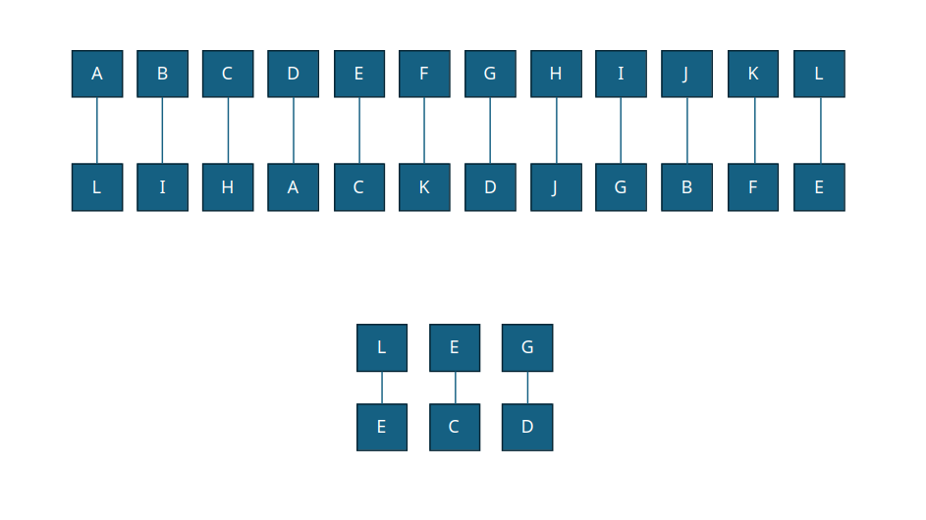
Fig.1: A diagram showing a basic Substitution cipher, showing how the word “leg” is encrypted using the cipher.

Shown above is a simple diagram showing how
the cipher works, you can see that the word “leg” has
been encrypted into “ecd”, making it unreadable
unless decrypted with the cipher. This is an example
of a bit stream cipher, where each individual
character is ciphered one at a time. Whilst this
cipher’s implantation is incredibly basic, it
shows the fundamentals of how a cipher works: it
acts as both the encryption and decryption using
specified rules. The characters are swapped for the
encryption and are then swapped back for the
decryption. This cipher does not see any use in
professional cryptography implementations, as it is
incredibly easy to crack.

An example of a more sophisticated cipher is the XOR cipher, which uses Boolean logic.
Fig.2: A table showing the truth table of an XOR gate using 2 inputs.

The XOR table above shows how XOR logic operates. Exclusive Or, or XOR, works by taking inputs, and displaying a true value as its output if only one of those inputs are true. If all values are either true or false, the output will be false.

The way we can use XOR for encryption is by taking the plaintext data represented in binary, using another binary string, and using XOR logic to encrypt it. This is known as the cryptographic key, essentially locking the data from being readable. On its own, XOR is still a very weak cipher, however, can be used with other cryptographic methods to be an effective way of securing information and making data harder to decrypt [2].

Fig.3: A table showing the word “cat” in binary being used with the key “fov” to encrypt the word.

Alongside ciphers, hash functions are also used. As the data is encrypted and decrypted, you will want to ensure that the data has not been altered from its original state. This is where the hash function is used to verify and authenticate the data. It uses algorithms to take the input and generate a string called a hash value. Examples of hash functions include the SHA-2 algorithm made standard by NIST [3].

- Encryption Methods

Cryptographic algorithms can be categorized as either symmetric or asymmetric, which relates to the keys that each algorithm uses.

Symmetric algorithms use the same key for the encryption and decryption processes. An example of an algorithm that does this is the Data Encryption Standard, or DES. DES divides the data into 64 blocks, using a 56-bit sized key. This algorithm has been rendered obsolete, as the key size is too small for the encryption to be secure. DES was superseded by Triple DES, or 3DES for short. 3DES works by applying the DES encryption to each individual block three times as opposed to a single time. This is a much stronger method of encryption as opposed to the normal DES algorithm due to not only more computations but also an increased key size and has been defined as a standard encryption algorithm by NIST. However, NIST has replaced 3DES with AES, which is a current encryption standard. Compared to both DES and 3DES, AES is a much more robust and secure cryptographic algorithm, due to it having much larger key sizes as well as block sizes, as well as being more fast and secure. An AES method is recommended for securing data in transit.

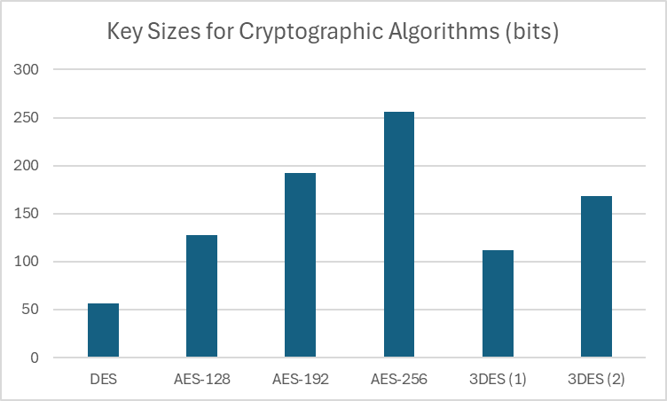
Fig.4: A chart showing the key sizes for different cryptographic algorithms.

- Public-Key Infrastructure and Implementation
When sensitive information is being sent over a network, you want to ensure that both the sender and receiver’s identities are genuine and authenticated. Public-Key Infrastructure is a system for verification that allows for authentication between sender and receiver. It uses asymmetric encryption, where a pair of keys are used to encrypt and decrypt data. These keys are commonly known as a public key and private key. PKI is an effective way for an organization to further tighten network security when handling sensitive files.

- Digital Certificates and Signatures
Verifying the identity of certain users is done with a Digital Signature, an encrypted signature embedded into documents, files, or any other kind of information. If you take an email which is sent to another address for example, the email will have a digital signature imprint when it is sent, so that the sender’s identity can be verified when the address receives it. This provides a level of authentication that ensures the identity of the sender is irrefutable. This is known as non-repudiation, and in many countries, including the United Kingdom and European Union Members, it is legally binding [4] [5].
For a digital signature to be verified, a Digital Certificate is required. This acts as an identifier for a public key, containing information about the key, including the owner and the key value. A certificate needs to be issued by what’s known as a certificate authority, which manages the issuing and revoking of certificates [6]. If an organisation wants to implement a PKI infrastructure, they need to ensure that they have an effective certificate authority.

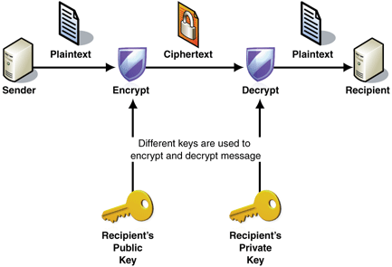

Fig.5: A diagram showing the structure of Public-Key Infrastructure. Taken from [7].

The diagram above showcases how the structure of PKI works. The two keys are used to encrypt and decrypt any data sent across the network, with the decryption verifying the signature of the sender. The signature will be checked with the digital certificate to authenticate its legitimacy.

- Standards for Digital Signatures
With regards to standardisation for Digital Signature algorithms, the NIST established a Digital Signature Standard (DSS) standard which is detailed in FIPS 186-5, the fifth revision of the publication [8]. According to NIST, the standard defines and specifies a suite of algorithms that can be used to generate digital signatures. Examples of algorithms defined in the publication include the Digital Signature Algorithm, the RSA Digital Signature Algorithm, and the Edwards-Curve Digital Signature algorithm.
Organizations need to follow these outlined standards and implement them accordingly. A failure to implement these algorithms to specification can result in potential security risks. For an example, in 2010, Sony’s implementation of Edwards-Curve for their PlayStation 3 console was found to be implemented incorrectly, with a parameter for key generation having no real entropy, always being a static value. This oversight was identified by a hacker group called ‘fail0verflow’ and would allow anyone to run custom code on the PS3 without the need for digital signatures from Sony [9]. Sony eventually released a patch for the console, but by that time the key was already leaked to the public [10].

- Cryptography in Wi-Fi Networks
Wi-Fi networks require different cryptographic methods compared to other types of communication Wi-Fi, whilst commonplace in the modern world, has a major flaw of being highly susceptible to interception. Public Wi-Fi for example, uses no forms of encryption as anybody can log onto the network, meaning any traffic that travels across the network can be intercepted. Studies conducted in 2017 showed that data packets transmitted on public Wi-Fi networks in Japan could be captured easily [11].
In addition, many of these packets showed that certain applications were not encrypting data that was being sent over the network. This presents a major issue: the fact that data can be intercepted and viewed from anybody besides the intended recipient. This shows why encryption for Wi-Fi networks is a must for any organization or person dealing with sensitive information.

- Implementations for Wi-Fi
When the IEEE 802.11 standard was introduced for wireless local area networks, the Wired Equivalent Privacy algorithm, or WEP, was used as the cryptographic algorithm for securing Wi-Fi networks.
Initially being the only method of encryption for 802.11 devices, in 2001 a group of 3 published a paper detailing a major flaw in the algorithm, known as the Fluhrer, Mantin and Shamir attack [12]. This was such a severe flaw for WEP that it was unfixable and required a completely new protocol to be introduced. This came in the form of Wi-Fi Protected Access, WPA, introduced in 802.11i. Over time, WPA was built upon and superseded by WPA2 and WPA3, which have rendered the original WPA obsolete.
One issue with WPA2 is that there was a flaw with regards to its cryptographic implementation, making it susceptible to the KRACK vulnerability. In 2017, two researchers at KU Leuven discovered an exploit in WPA2, called the Key Reinstallation Attack, commonly referred to as KRACK [13]. The exploit takes advantage of a vulnerability with handshakes the protocol initiates to make a connection. This exploit can allow a potential hacker to intercept the connection and steal information, or modify data sent over the network for malicious purposes [14]. Whilst fixes have been made to counter this exploit such as patches from Microsoft [15], WPA2 by default is still vulnerable to this exploit. WPA3 however, is a more secure protocol compared to WPA2. The Wi-Fi Alliance specifies a version of WPA3 for enterprise [16], which uses 192-bit keys compared to WPA3-Personal, which uses 128-bit keys. An organization would want to consider the protocol used within their network if they are using Wi-Fi.

- Organizations and The Need for Cryptographic Methods
Organizations need to demonstrate a level of precaution when handling personal data. In a sense, cryptography and cryptographic methods are an essential backbone to support this. An organization needs to develop a good level of encryption and decryption when handling data, which can be done with standardised ciphers and cryptographic algorithms, such as AES and SHA-2. Organizations also have to ensure that the identity of people handling such data is verified and irrefutable. A PKI structure implementation within an organization’s information security structure can help ensure this.
Throughout the research, one thing that was apparent was the rapid change of certain standards. Throughout the years, organizations such as NIST have revised their standards for cryptography many times over with new algorithms, methods, ciphers, hash functions, etc. This shows that whilst implementing effective cryptography methods within an organization can safeguard applications, the world of cryptography is constantly changing and organizations will have to look at new methods depending on the circumstances of rapidly changing technologies and discoveries, whether for good or bad. This is a core element of data security in general. Whilst there will never be a perfect implementation for any area in particular, methods can constantly be developed and improved on to get as close as possible.

- Conclusion
Due to the vast size of a field such as cryptography, many areas of the field could not be covered in this paper. Cryptography plays a crucial role in data security both today and for the future and as techniques, algorithms and standards further develop with new methods being discovered, organizations will always be able to promote a secure environment for data security.

- Bibliography

[1] | Office for National Statistics, Internet banking, by age group, Great Britain, 2019, Newport, 2019.
[2] | H. J. M. Michael E. Whitman, Principles of Information Security, Sixth Edition, Boston: Cengage Learning, 2018, pp. 461-462.
[3] | NIST, “Hash Functions,” NIST, 9 September 2024. [Online]. Available: https://csrc.nist.gov/projects/hash-functions. [Accessed 2 December 2024].
[4] | The Law Commission, Electronic execution of documents, London, 2019.
[5] | European Union, “REGULATION (EU) No 910/2014 OF THE EUROPEAN PARLIAMENT AND OF THE COUNCIL of 23 July 2014 on electronic identification and trust services for electronic transactions in the internal market and repealing Directive 1999/93/EC,” Official Journal of the European Union, L257, vol. 57, pp. 73-114, 2014.
[6] | Microsoft, “Digital signatures and certificates,” Microsoft, 2 December 2024. [Online]. Available: https://support.microsoft.com/en-gb/office/digital-signatures-and-certificates-8186cd15-e7ac-4a16-8597-22bd163e8e96. [Accessed 2 December 2024].
[7] | ProcessMaker, “3.1 - Public Key Infrastructure (PKI) for ProcessMaker,” ProcessMaker, 2 December 2024. [Online]. Available: https://wiki.processmaker.com/3.1/Public_Key_Infrastructure_PKI_for_ProcessMaker. [Accessed 2 December 2024].
[8] | Digital Signature Standard, NIST Standard 186-5, 2023.
[9] | C. Johnston, “PS3 hacked through poor cryptography implementation,” Ars Technica, 30 December 2010. [Online]. Available: https://arstechnica.com/gaming/2010/12/ps3-hacked-through-poor-implementation-of-cryptography/. [Accessed 2 December 2024].
[10] | K. Stuart, “PlayStation 3 hack – how it happened and what it means,” The Guardian, 7 January 2011. [Online]. Available: https://www.theguardian.com/technology/gamesblog/2011/jan/07/playstation-3-hack-ps3. [Accessed 2 December 2024].
[11] | N. Sombatruang, Y. Kadobayashi, M. A. Sasse, M. Baddeley and D. Miyamoto, “The continued risks of unsecured public Wi-Fi and why users keep using it: Evidence from Japan,” in 16th Annual Conference on Privacy, Security and Trust (PST), Belfast, Northern Ireland, 2018.

[12] | I. M. A. S. Scott Fluhrer, “Weaknesses in the Key Scheduling Algorithm of RC4,” Lecture Notes in Computer Science, vol. 2259, pp. 1-24, 2001.
[13] | F. P. Mathy Vanhoef, “Key Reinstallation Attacks: Forcing Nonce Reuse in WPA2,” KU Leuven, Leuven, 2017.
[14] | S. Gallagher, “How the KRACK attack destroys nearly all Wi-Fi security,” Ars Technica, 16 October 2017. [Online]. Available: https://arstechnica.com/information-technology/2017/10/how-the-krack-attack-destroys-nearly-all-wi-fi-security/. [Accessed 2 December 2024].
[15] | Microsoft, “Windows Wireless WPA Group Key Reinstallation Vulnerability,” Microsoft, 18 Oct 2017. [Online]. Available: https://msrc.microsoft.com/update-guide/en-US/advisory/CVE-2017-13080. [Accessed 2 December 2024].
[16] | Wi-Fi Alliance, “Security,” Wi-Fi Alliance, 2 December 2024. [Online]. Available: https://www.wi-fi.org/discover-wi-fi/security. [Accessed 2 December 2024].

Task 2: Case Study

Introduction

CyStresSolution, a cybersecurity company, are creating a new information security unit for their organization. This unit will be mainly responsible for implementing procedures and policies company-wide for information security, in addition to setting the standards for information security within the company. As a company mainly focused on cybersecurity solutions and consultancy, it is vital that this unit represents the company’s main objectives and services. This report will detail possible approaches to implementing this security unit, using research as well as other pieces of information to find the best implementation methods that suits CSS.

Organisation Structure and Management

The first thing that must be considered when implementing this cyber security unit is the organization structure. In terms of management, there are two potential implementations that can be used: top-down and bottom-up approach. Consider this example diagram as the potential structure of CSS.

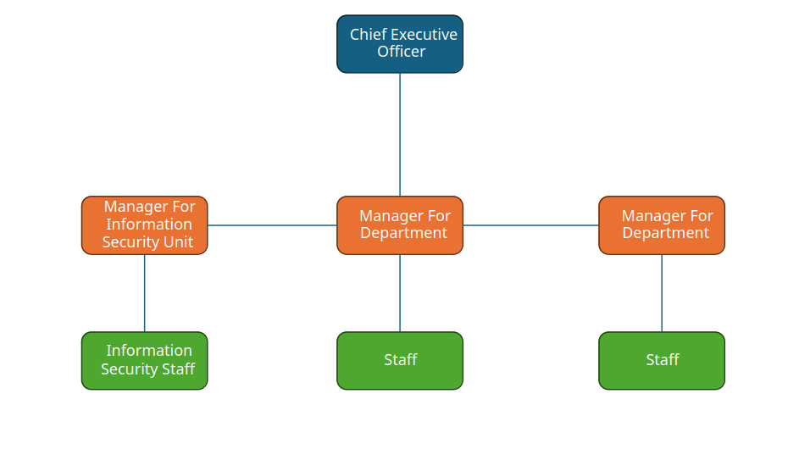
Fig. 1: A diagram showing an example of an organization and its structure.

As you can see from this diagram, there is a CEO which runs the company, managers for different areas of the company including the Information Security unit, and staff which work under the supervision of the managers. To implement this information security unit, we can take a bottom-up approach: where the IS staff that work in security will apply improvements to the organization’s systems and infrastructure. This method can be very effective as it relies on people who are experts within the IS field, meaning they would have a better understanding of the needs of such a unit compared to upper management. Getting employees involved in the planning and implementation also can boost morale within the organization. This approach however lacks input from higher management, this can be argued as leading to being more dysfunctional, as the suggestions or implementations employees may suggest may not fit in line with the vision or goals of the organization. Communication between lower and higher levels within the organization may also be harder and there may also be issues concerning budgeting, as expectations of financing may be different compared to senior management.

The other approach that can be taken is a top-down approach. Essentially, rather than let planning come from lower levels of the organization, all decision making comes from the top, the CEO, who will set goals, policies and expected outcomes. Taking this approach would allow for better planning and management as opposed to a bottom-up approach.
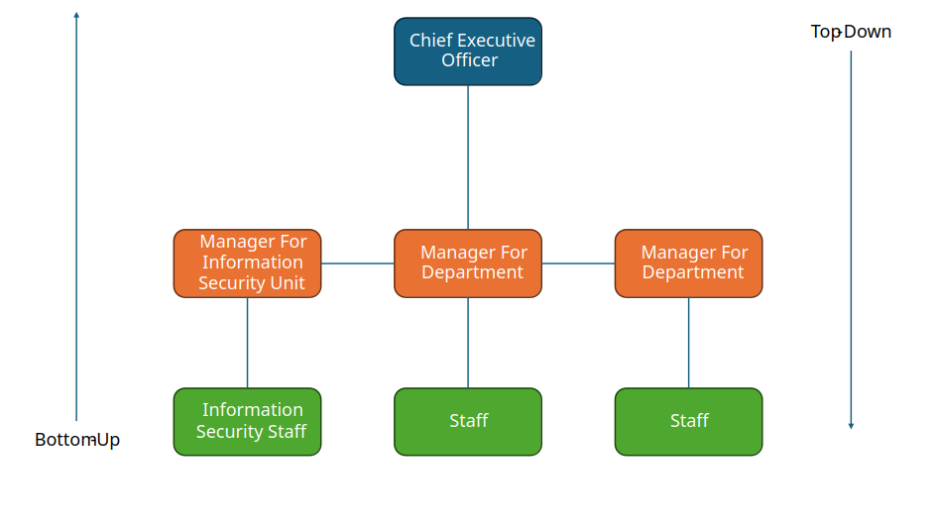
Fig. 2: A diagram showing an example of an organizational structure and how bottom-up and top-down implementations work.

Whilst potentially being more in-line with the organization’s objectives and values, in addition to being more organized, the suggestions or implementations from higher management may not be relevant or ignorant to the real issues with regards to information security, whereas a bottom-up approach will have more involvement with people within more relevant fields [1].

The implementation chosen depends entirely on the strategy the organisation wants to take. As the organisation specialises in cybersecurity specifically, a top-down approach may be the better choice here, as the organisation is already well versed in the field. There wouldn’t be much of an issue regarding understanding data security.

Strategic Planning for Security
With regards to strategic planning, one implementation that could be added to the unit is using Public-Key Infrastructure. Sensitive data will be sent constantly throughout the organisation, so a level of verification and authenticity would be a must. By implementing PKI, this would ensure that the identities of sender and receiver regarding information are verified and irrefutable, increasing data security when handling sensitive information [2]. This will also require CSS to have a certificate and signature authority.

Laws, Ethics and Standards Compliance

This organization deals with many different clients for their cybersecurity protection services, in addition to their consultancy services. This means that the organization must deal with the personal information of their clients with extra care and confidentiality. Whilst ethics and law are separate in the way that ignorance of ethics is an acceptable defence compared to legal issues, both need to be considered equally.

With regards to UK law, the main ones that CSS should focus on are the Police and Justice Act 2006 [3], General Data Protection Regulation, GDPR [4], as well as the Data Protection Act 2018 [5]. These laws all specifically relate to information systems and security. A code of ethics regarding information systems and security can be drafted up to ensure a reduction in potential risk as well as acting as a guide for policies and implementation, ensuring that it allows the unit to stay within both a legal and ethical area.

Risk Management and Contingency

Whilst the information security implementation needs to be effective, there is always an element of risk with regards to security measures and implementations failing. For this reason, there needs to be a risk management strategy in place to try and eliminate the possibility of risks occurring [6]. Risk identification and assessments need to be carried out to identify threats within the information security unit and risk control strategies need to be used. Residual risks will also have to be considered as there may be risk left over after the implementation.

The NIST outlines a Risk Management Framework [7], which defines a step-by-step process for managing risks regarding information systems. They are categorized into 7 steps: prepare, to prepare the organization to manage potential risks, categorize, to categorize information stored and transmitted, select, to select different control methods based on previous risk assessments, implement, to implement the control method and detail how they are deployed, assess, to assess if the control method is operational and producing the desired outcome, authorize, to authorize a risk-based decision, and monitor, which monitors the implementation to the system.

Economic feasibility studies also need to be conducted to measure the potential effect of risks on the economic side of the business.

Even with risk management and mitigation in place, a contingency plan may also be required in the event of a risk occurring. In the event of a cyberattack or a Denial-of-Service attack, a contingency plan would allow for failover and for an effective response in the event that it does occur.

Implementation Plan

With many potential areas considered, I have outlined a plan for the implementation of this information security unit. The plan is as follows.

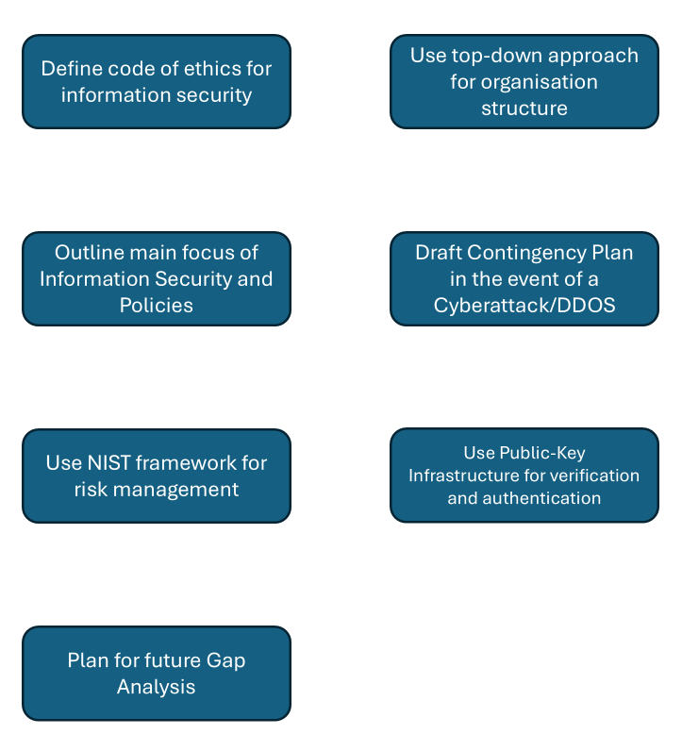

The CIA triad will be the basis for the plan. The information security unit’s main objective is to promote Confidentiality, Integrity, and Availability for CSS.
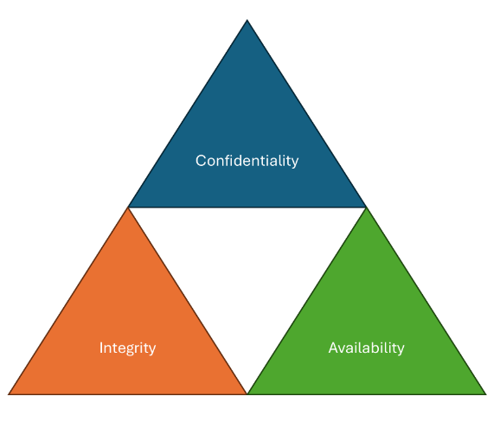

With regards to management, a top-down approach suits the organisation well here: the company’s main objective is to provide effective cybersecurity, so having a clearer sense of management would be a much better choice for CSS. The CEO will set the policies for information security. Having a top-down approach will allow us to outline a vision for the information security unit and implement policies that are sensible, match the objectives and aims of the organization, and fit within a specified budget. This will outline our main policies for information security and the information system.

In terms of structuring, the unit will have a manager which will report to the CISO and CTO. A risk manager will also be in place to be responsible for risk assessment and management.
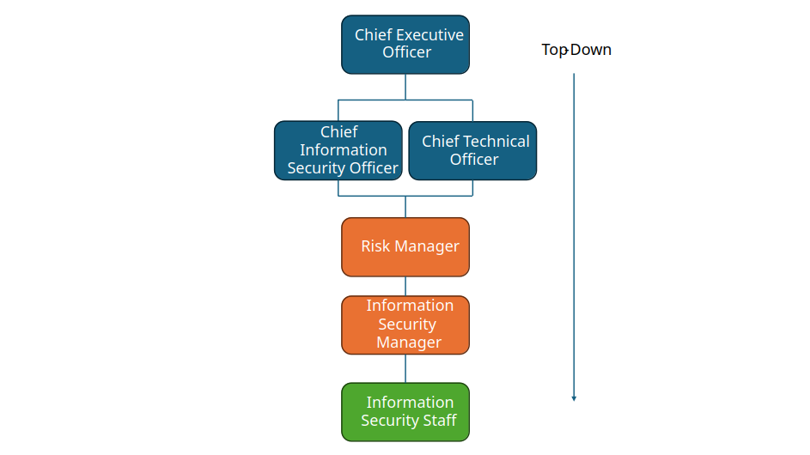

For the information security risk management, the NIST model will be used as a framework for our implementation, as it correlates directly with security and information systems. Risk identifications and assessments will be carried out frequently, and the information gathered can be used with this model.
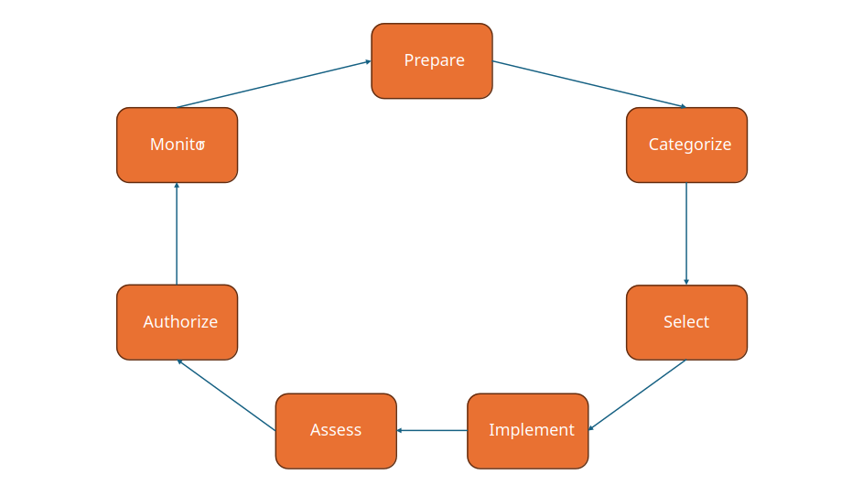
Contingency plans will also be drawn up in the event of a DDOS attack or cyberattack.

Legality-wise, a code of ethics will be drawn up for the information security unit to assist in policy making, to ensure that policies and implementations are within legal and ethical limits. This is important, especially with a company that handles important data.

To safeguard sensitive information within the information system, a PKI implementation will be used, to ensure both encryption and verification of sender and receiver is in place.

Future Gap Analysis will be used to assess the overall effectiveness of this plan, judging the financial costs, the effectiveness of certain polices and implementations, as well as future standards and procedures that can be used to further improve the unit.

Conclusion

In conclusion, I believe that this implementation plan for CSS’s new information security unit would be very effective. The organization structure, management, risk management and contingency plans, policies and standards chosen, I believe are the best for the organization. Going forward, I would like to further improve my work by researching more ways to implement data security, as well as potentially draw up a more detailed plan that delves into other areas.

Bibliography

[1] | H. J. M. Michael E. Whitman, Principles of Information Security, Sixth Edition, Boston: Cengage Learning, 2018, pp. 24-25.
[2] | W. Stallings, Cryptography and Network Security: Principles and Practice, Seventh Edition, Harlow: Pearson Education Limited, 2017.
[3] | "Police and Justice Act 2006," 8 November 2006. [Online]. Available: https://csrc.nist.gov/projects/risk-management/about-rmf. [Accessed 3 December 2024].
[4] | Information Commissioner's Office, "The UK GDPR," Information Commissioner's Office, 3 December 2024. [Online]. Available: https://ico.org.uk/for-organisations/data-protection-and-the-eu/data-protection-and-the-eu-in-detail/the-uk-gdpr/. [Accessed 3 December 2024].
[5] | "Data Protection Act 2018," 23 May 2018. [Online]. Available: https://www.legislation.gov.uk/ukpga/2018/12/contents. [Accessed 3 December 2024].
[6] | IBM, "What is risk management?," IBM, 3 December 2024. [Online]. Available: https://www.ibm.com/topics/risk-management. [Accessed 3 December 2024].
[7] | Risk Management Framework for Information Systems and Organizations: A System Life Cycle Approach for Security and Privacy, NIST Standard, SP 800-37 Rev.2, 2018.

