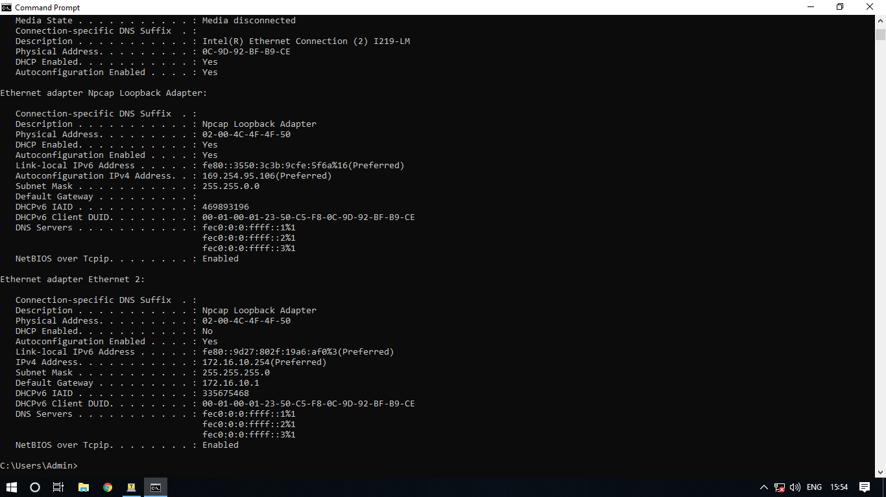
R1#show config
Using 1605 out of 33554432 bytes
!
! Last configuration change at 15:33:00 UTC Tue Dec 12 2000
!
version 16.9
service timestamps debug datetime msec
service timestamps log datetime msec
service password-encryption
platform qfp utilization monitor load 80
no platform punt-keepalive disable-kernel-core
!
hostname R1
!
boot-start-marker
boot-end-marker
!
!
enable secret 5 $1$v3nw$K6FGOcoDM4Ms23IsQ6Dl51
enable password 7 01100F175804
!
no aaa new-model
!
no ip domain lookup
--More--
ip admission watch-list expiry-time 0
!
!
!
!
!
!
!
!
!
!
subscriber templating
multilink bundle-name authenticated
!
!
!
crypto pki trustpoint TP-self-signed-1020466531
enrollment selfsigned
subject-name cn=IOS-Self-Signed-Certificate-1020466531
revocation-check none
rsakeypair TP-self-signed-1020466531
!
!
crypto pki certificate chain TP-self-signed-1020466531
certificate self-signed 01 nvram:IOS-Self-Sig#6.cer
!
license udi pid ISR4221/K9 sn FGL224190DM
no license smart enable
diagnostic bootup level minimal
!
spanning-tree extend system-id
!
!
!
!
redundancy
mode none
!
!
!
!
!
!
!
!
interface GigabitEthernet0/0/0
description pc11
ip address 172.16.10.1 255.255.255.0
shutdown
negotiation auto
!
interface GigabitEthernet0/0/1
description pc12
ip address 172.12.11.1 255.255.255.0
shutdown
negotiation auto
!
interface Serial0/1/0
!
interface Serial0/1/1
!
ip forward-protocol nd
ip http server
ip http authentication local
ip http secure-server
!
!
!
!
!
!
control-plane
!
banner motd ^CUnautorized access is prohibited^C
!
line con 0
password 7 0822455D0A16
login
transport input none
stopbits 1
line vty 0 4
login
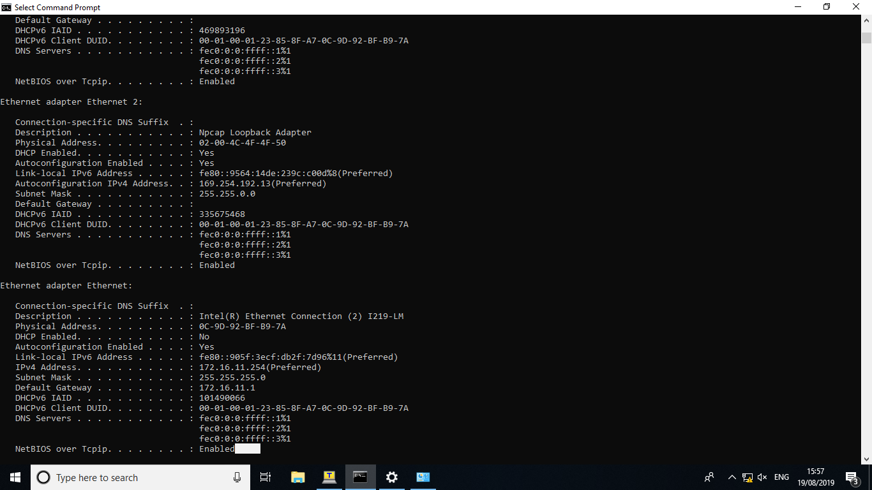

S1#show config
Using 1453 out of 65536 bytes
!
! Last configuration change at 00:49:11 UTC Mon Mar 1 1993
!
version 15.2
no service pad
service timestamps debug datetime msec
service timestamps log datetime msec
no service password-encryption
!
hostname S1
!
boot-start-marker
boot-end-marker
!
!
no aaa new-model
system mtu routing 1500
!
!
!
!
!
--More--
!
!
no ip domain-lookup
!
!
!
spanning-tree mode pvst
spanning-tree extend system-id
!
vlan internal allocation policy ascending
!
!
!
!
!
!
interface FastEthernet0/1
!
interface FastEthernet0/2
!
interface FastEthernet0/3
!
interface FastEthernet0/4
!
interface FastEthernet0/5
!
interface FastEthernet0/6
!
interface FastEthernet0/7
!
interface FastEthernet0/8
!
interface FastEthernet0/9
!
interface FastEthernet0/10
!
interface FastEthernet0/11
!
interface FastEthernet0/12
!
interface FastEthernet0/13
!
interface FastEthernet0/14
!
interface FastEthernet0/15
!
interface FastEthernet0/16
!
interface FastEthernet0/17
!
interface FastEthernet0/18
!
interface FastEthernet0/19
!
interface FastEthernet0/20
!
interface FastEthernet0/21
!
interface FastEthernet0/22
!
interface FastEthernet0/23
!
interface FastEthernet0/24
!
interface GigabitEthernet0/1
!
interface GigabitEthernet0/2
!
interface Vlan1
ip address 172.16.11.10 255.255.255.0
!
ip default-gateway 172.16.11.1
ip http server
ip http secure-server
!
no vstack
banner motd ^CAuthorized Access Only^C
!
line con 0
password letmein
login
line vty 0 4
login
line vty 5 15
login
!
end

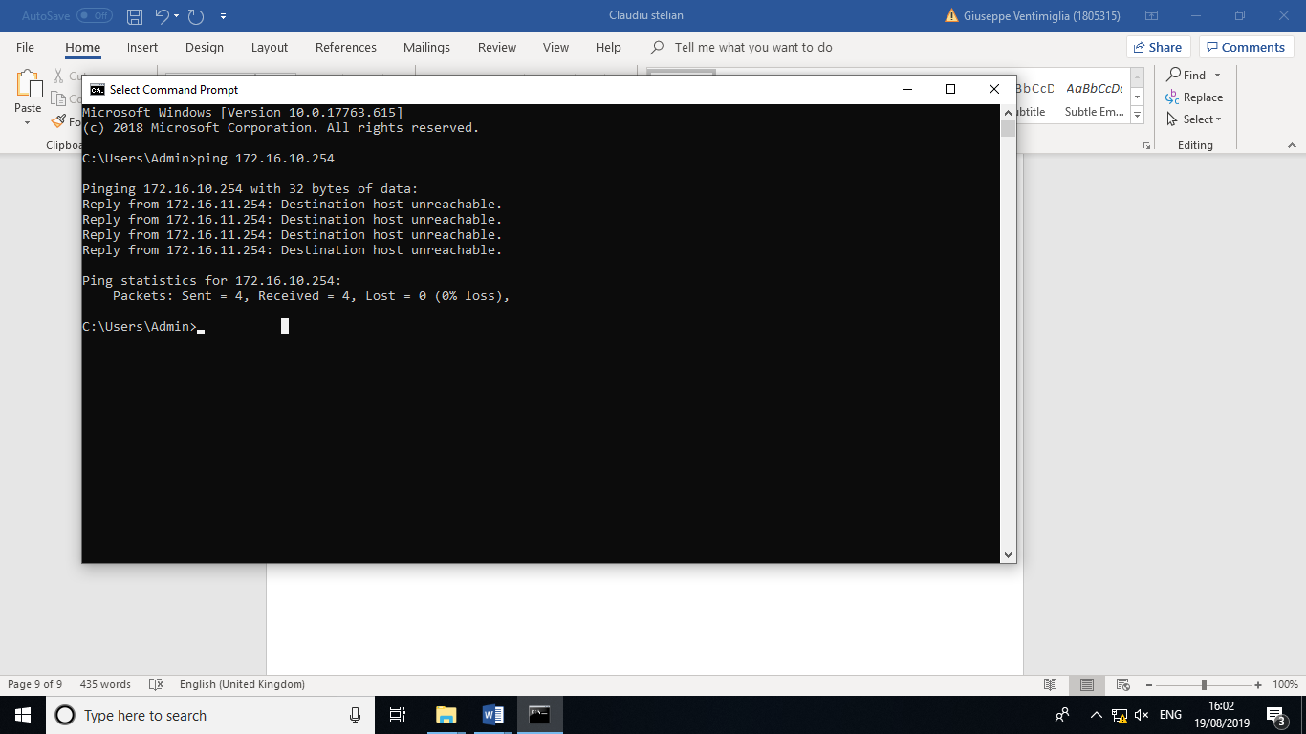
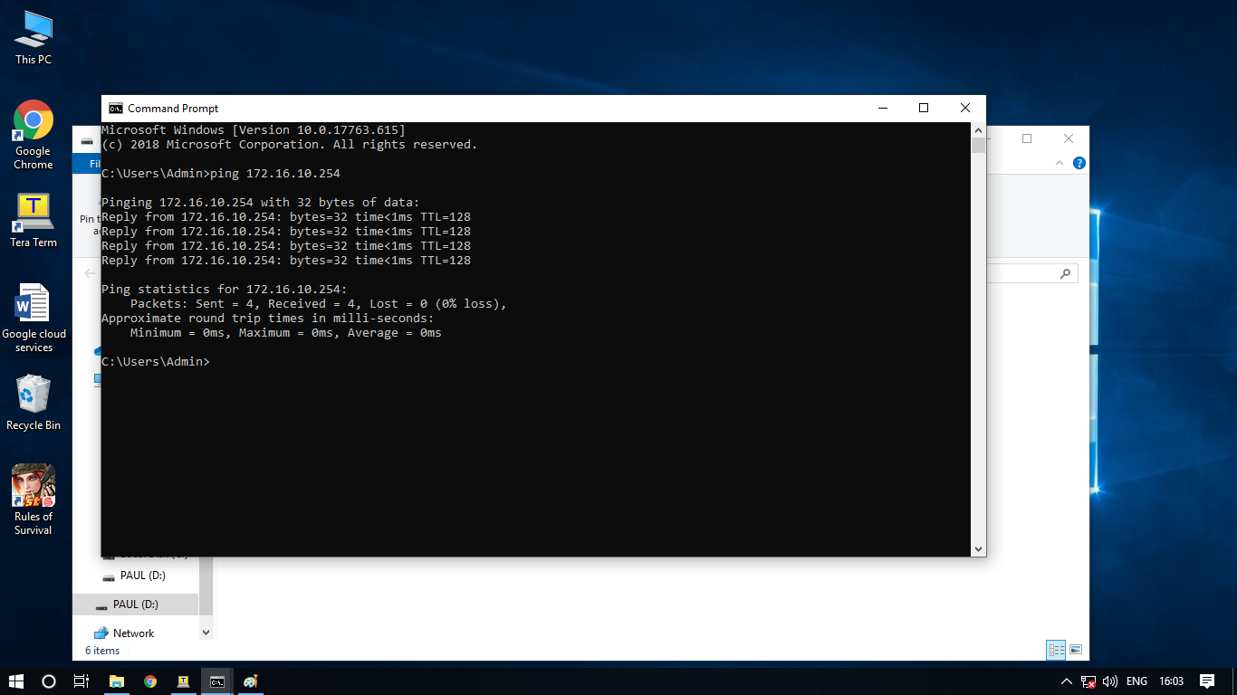
R1#show ip int brief
Any interface listed with OK? value "NO" does not have a valid configuration

Interface IP-Address OK? Method Status Protocol
GigabitEthernet0/0/0 172.16.10.1 YES manual administratively down down
GigabitEthernet0/0/1 172.12.11.1 YES manual administratively down down
Serial0/1/0 unassigned NO unset down down
Serial0/1/1 unassigned NO unset down down
R1#

S1#ÿsÿhow ip iÿnt brkef
Interface IP-Address OK? Method Status Protocol
Vlan1 172.16.11.10 YES manual up up
FastEthernet0/1 unassigned YES unset down down
FastEthernet0/2 unassigned YES unset down down
FastEthernet0/3 unassigned YES unset down down
FastEthernet0/4 unassigned YES unset down down
FastEthernet0/5 unassigned YES unset down down
FastEthernet0/6 unassigned YES unset down down
FastEthernet0/7 unassigned YES unset down down
FastEthernet0/8 unassigned YES unset down down
FastEthernet0/9 unassigned YES unset down down
FastEthernet0/10 unassigned YES unset up up
FastEthernet0/11 unassigned YES unset down down
FastEthernet0/12 unassigned YES unset down down
FastEthernet0/13 unassigned YES unset down down
FastEthernet0/14 unassigned YES unset down down
FastEthernet0/15 unassigned YES unset down down
FastEthernet0/16 unassigned YES unset down down
FastEthernet0/17 unassigned YES unset down down
FastEthernet0/18 unassigned YES unset down down
FastEthernet0/19 unassigned YES unset down down
FastEthernet0/20 unassigned YES unset down down
FastEthernet0/21 unassigned YES unset down down
FastEthernet0/22 unassigned YES unset down down
FastEthernet0/23 unassigned YES unset down down
FastEthernet0/24 unassigned YES unset down down
GigabitEthernet0/1 unassigned YES unset down down
GigabitEthernet0/2 unassigned YES unset down down

