Effective Team Working and Communication
BMSW4002
Group nr. 3
Maria M. Tataru (1916727)
Afzal Munna
2000 Words assignment

Table of Contents
Introduction 3
Communication Definition 3
Importance of communication 3
Importance of effective communication 4
Methods of communication 5
Verbal communication 5
Non-verbal communication 6
Models of Communication 7
SW Model of Communication 7
Berlo Model of Communication 8
Schramm Model of Communication 9
Effective Communication at The Workplace 10
Conclusion 11
References 12

Introduction
Communication is an essential component in the day to day activities. Some of the major purposes of communication involve passing information and messages from a sender to a receiver. Good and effective communication ensures that the intended message is passed to the receiver. In analyzing the communication processes, several scholars came up with different communication models that explain how communication leaves a sender and reaches the recipient. In analyzing different communication models, this report analyses the importance of communication and the importance of effective communication in the workplace.

Communication Definition
Communication, according to Lesikar & Marie (2002), is the process of passing written or spoken information from one party to another. Communication is also defined as the passing or exchange of ideas, thoughts, or information from one person to another. Communication, according to Monippally (2001), is the process of human beings having meaningful interactions among them. It is the process by which human beings perceive and understand meanings. Moore et al. (2010) defined communication as the act of passing and conveying messages and meanings from a group or an entity to another by using mutually understood semiotic rules, symbols, and signs. Communication involves a person encoding a message and passing it to a channel that decodes the message for the receiver.

Importance of communication
Communication plays an essential role in the successful operations of a company. Communication is essential for organizational managers to help in performing basic management functions such as planning, leading, organizing, and controlling (Sharma & Krishna, 2007). Communication is important as it helps in promoting motivation at the organization by informing the employees about the tasks that they are required to do, their performances, and how to improve their performances (Sharma & Krishna, 2007). Communication is an essential source of information to the members of an organization. Communication helps these members to make good decisions as it provides them with an alternative course of actions. Communication is essential in changing the attitudes of individual employees, where well-informed people have positive attitudes compared to less-informed individuals (Sharma & Krishna, 2007). Communication makes it possible for people to understand each other by creating clarity of expressions and thoughts and thus removing possible misunderstandings. In an organizational setting, communication is important as it brings together the managerial function, which helps in bridging the gap between groups and individuals through flow and understanding of information (Sharma & Krishna, 2007).

Importance of effective communication
Effective and good communication is essential in maintaining strong working relationships and achieving productivity at all organizational levels. Effective communication enhances relationships in an organization, and in the process increases the overall employee engagement and effectiveness of the workers (Adair, 2003). Good communication helps in improving team building. This is based on the fact that when employees work together by consulting each other, discussing the team’s progress, and sharing their opinions, they are likely to collaborate more resulting in a strong working unit (Bovee, John, & Barbara, 2010). Effective communication also boosts growth in an organization for it helps in eliminating uncertainties and speeding up the policies processes to make sure that the organizational projects are delivered smoothly.
Effective communication in the workplace improves the productivity of employees and the overall organization. This is based on the fact that with effective communication, managers are able to understand the skills and talents of the employees and thus give directions based on people who are best suited for a task (Bovee, John, & Barbara, 2010). Effective communication increases efficiency and the overall quality since it involves the clear provision of instructions, which reduces the possibilities of mistakes happening (Adair, 2003). Effective communication helps in increasing employee engagement as it involves connecting and engaging the employees.

Methods of communication

Verbal communication
Verbal communication can be described as a type of communication that uses auditory language to exchange messages, information, or ideas with other people. Verbal communication includes speaking, words, or sounds. Verbal communication can be effective or ineffective depending on the volume, tone, and pitch used in the voice of a person (Hasson, 2012). With verbal communication used to communicate in daily interactions, different verbal statements are given. The verbal statements are classified using a system known as Group Development Observation System (GDOS) which was developed by Wheelan to categorize and analyse verbal interactions (Griffith & Dunham, 2015). The classification is based on the fact that a member of a team might communicate a message at a face value or imply hidden meanings of the message. This helps in classifying the type of meaning intended in verbal communication (Griffith & Dunham, 2015). There are four types of verbal communication; intrapersonal communication, interpersonal communication, small group communication, and public communication.
Intrapersonal communication is a communication form that is extremely private and restricted to an individual. Interpersonal communication is the communication form taking place between individuals. Interpersonal communication involves the communicating individuals swapping the communication roles of receiver and sender (Hasson, 2012). The small group type of verbal communication takes place when the people involved are more than two. These include team meetings, board meetings, and press conferences. The public communication is the type of communication that involves addressing a crowd or large gatherings (Hasson, 2012). The benefits of verbal communication are that it helps in saving time in communicating and provides an understanding of the communication delivered. The disadvantages of verbal communication are that emotions are visible and that there is no legal validity (Hasson, 2012).

Non-verbal communication
Non-verbal communication, on the other hand, can be described as a type of communication that involves using visual cues or non-verbal cues. Some of the major cues used in non-verbal communication are facial expressions, gestures, body movement, touch, and timing (Moore et al. 2010). The non-verbal cues used in non-verbal communication are also known as body language. Body language is explained as the use of expressions, mannerisms, and physical behaviour to communicate with other people non-verbally (Moore et al. 2010). Non-verbal communication is essential in effective communication since it helps in telling whether one is listening and whether one is being truthful or not. Matching verbal communication with non-verbal cues increases clarity, rapport, and trust.
Nonverbal communication can be in several types. For instance, non-verbal communication can be in the form of facial expressions. The human face can convey countless emotions in a person without uttering a single word, where one can show anger, sadness, happiness, disgust, or fear using the face (Moore et al. 2010). Another type of nonverbal communication is body posture and movement, where how one carries him or herself communicates a lot of information. Another type of nonverbal communication is gestures, where a person can emphasize his or her point using hands such as pointing and waving. Eye contact is also an essential type of nonverbal communication, where maintaining eye contact can communicate things such as hostility, affection, attraction, and interest (Moore et al. 2010).

Models of Communication
Communication models are defined as the systematic representation of communication processes that help in getting a clear meaning of how communication is done (Adair, 2003). Communication models can also be described as conceptual models that are used to explain the communication process in human beings. The major models of communication are the Shannon-Weaver model, Berlo Model, and Schramm Model.

SW Model of Communication
The Shannon-Weaver communication model asserts that communication between individuals can be broken into six major concepts, which are the sender, encoder, communication channel, noise, decoder, and the message receiver (Adair, 2003). The SW communication model was designed to improve and develop effective communication between the person sending the message and the person receiving the message. The Shannon and Weaver communication theory was first developed in 1948 (Adair, 2003). It states that communication starts with the sender, who is described as the source of information. The sender starts the communication process by coming up with a message to send and sending the message to the desired recipient.
The second stage in the communication process according to the Shannon and Weaver model is the encoder, which is also the transmitter of the message. This is described as a person or machine that converts the communication ideas into signals that are sent to the receiver. The third stage of the model is a communication channel, which is the infrastructure that moves the information to the receiver from the sender (Adair, 2003). For instance, the internet would be a channel used to send information through the email. According to the model, the message is interrupted by noise when it is moving to the receiver from the sender. Noise can either be internal noise or external noise. Internal noise takes place if the sender makes a mistake when writing or encoding a message, such as misspelling the word, while external noise when the message is impeded by an external force, such as sounds of cars (Moore et al. 2010). The fifth stage of the Shannon and Weaver model is the decoder, where the sent message is decoded from waves or digits back to a format that the receiver can easily understand. The sixth stage is the receiver or destination of the message. This is the end-point of the model, where the receiver finally gets the message.
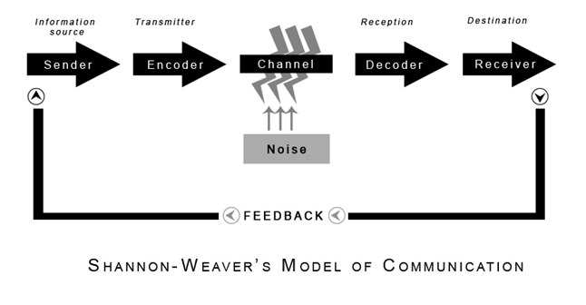
Figure: Shannon-Weaver communication model
Source: communicationtheory.com

Berlo Model of Communication
Berlo’s SMCR communication model represents the communication process in its simplest form. The SMCR acronym means Sender, Message, Channel, and Receiver. Berlo Model describes the components that form the communication process (Neuliep, 2003). The model is used for efficient communication since it emphasizes the encoding and decoding of the message. The four components of Berlo Model are influenced by several factors.
The sender is the source that forms and sends the intended message or information to the receiver. The sender is affected by several factors such as communication skills, attitude, knowledge, culture, and social systems. The message component is defined as the package of meaning or information that is sent to the receiver from the sender (Neuliep, 2003). It can be in different forms such as video, speech, text, or audio. The message is influenced by content, elements, treatment, structure, and code. Channel is the medium used to send a message. The receiver is the individual or person that receives and decodes a message (Neuliep, 2003). For communication to be effective, the Berlo Model assumes that the thinking pattern of the receiver must be in line with the senders.

Figure: Berlo’s SMCR communication model
Source: communicationtheory.com

Schramm Model of Communication

The Schramm communication model is based on a theory that communication happens between a sender and a receiver. The Schramm Model was first popularized by Charles Egerton Osgood, who claimed that communication was not linear but circular, which meant that for a message to be sent, a message sender and recipient had to be there (Adair, 2003). The model has three major elements, which are the source (encoder), the recipient (decoder), and the message.
The encoder is the party that sends a message to the intended party. According to the model, the encoder has to be clear during the sending process to ensure that the receiver is able to read and understand the message. The model states that the success in sending the message depends on whether the message will be understood (Adair, 2003). The message receiver or decoder is the party to whom the encoder sends the message. Several factors influence whether the receiver can decode the message. Some of these factors include whether the receiver knows the topic, the source, and whether he or she trusts the source (Adair, 2003). The message in the Schramm Model is the information sent by the encoder to the decoder. The information is passed through words, symbols, and characters.
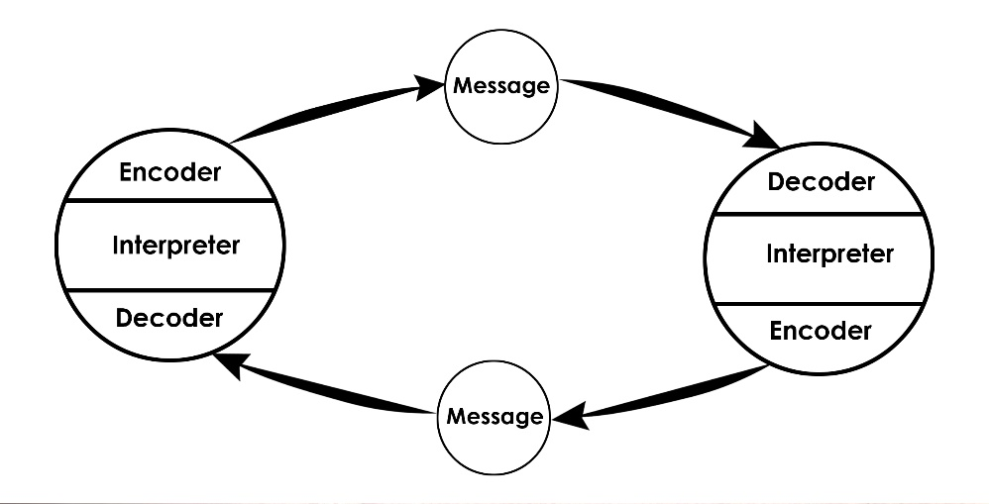
Figure: Schramm communication model
Source: communicationtheory.com

Effective Communication at The Workplace
Effective communication is essential in the successful completion of duties and hence productivity in my workplace. As a team leader in London Underground, I work night shifts checking trains as they are cleaned. I work with a team of 15 workers. To ensure that everything is done in order every night, I ensure that I communicate to the workers of their responsibilities and duties. This is done because every night we have a different team, and thus job requirements are different for every night. Thus, to ensure productivity, I make sure that I come up with a duty roster and communicate it to the whole group during the early evening meetings to ensure that everyone knows about what is expected of him or her on the night.

Conclusion
In conclusion, communication is a vital and essential aspect of an organization. Effective communication improves the productivity of an organization, which implies that ineffective communication would negatively affect an organization. For communication to be effective, the major components of a communication model should align. This means that the line of thinking of the sender should be in line with that of the receiver for him or her to be able to decode the encoded message.

References
Adair, J. 2003. Effective Communication. London: Pan Macmillan Ltd.
Bonet, D. 2004. The Business of Listening: Third Edition. New Delhi: Viva Books, 2004.
Bovee, C. L, John V. T., & Barbara E. S. 2010. Business Communication Today: Tenth Edition. New Jersey: Prentice Hall.
Griffith, B.A. & Dunham, E.B. 2015. Working in Teams: Moving from High Potential to High Performance. London. SAGE Publications Ltd.
Hasson, G. 2012. Brilliant Communication Skills. Great Britain: Pearson Education.
Lesikar, R.V. & Marie E. F. 2002. Basic Business Communication: Skills for Empowering the Internet Generation: Ninth Edition. New Delhi: Tata McGraw-Hill, 2002.
Monippally, M. M. 2001. Business Communication Strategies. New Delhi: Tata McGraw-Hill Publishing Company Ltd., 2001.
Moore, Ninja-Jo, et al. 2010. Nonverbal Communication: Studies and Applications. New York: Oxford University Press.
Neuliep, J. 2003. Intercultural Communication: A Contextual Approach. Boston: Houghton Mifflin Co.
Rutherford, A. 2007. Basic Communication Skills for Technology: Second Edition. Delhi: Pearson Education.
Sharma, R. C. & Krishna M. 2007. Business Correspondence and Report Writing: Third Edition. New Delhi: Tata McGraw-Hill Publishing company Limited.

