pROBLEM ANALYSIS AND SOLUTION DEVELOPMENT

Module Name: Analysing & Solving Problems
Module Code: ACCA4019
Student Name: Alina Firu
Student ID:
Lecturer’s Name: Dr Redhwan Al-amri

Table of Contents
Table of Contents 1
1. Introduction 2
2. Deconstruct the Problem 2
2.1 MoSCoW Technique Requirement 2
2.2 Variables Identification 2
3. Proposed Solution 3
3.1 Flowchart 3
3.2 Flowchart Explanation 3
4. Reflection and Justification 5
4.1 Abstract thinking 5
4.2 Sub-dividing 5
4.3 Justification of solution 6
4.4 Limitation 6
4.5 Assumption 6
5. Conclusion 6
References 7

1. Introduction
This task will highlight a detailed description of the core issues currently faced by the local college to understand the brief challenges with applying the MoSCoW technique and evaluating the requirements. Additionally, a clear explanation of the proposed solution with the visual representation through the flow chart.

2. Deconstruct the Problem
Considering the scenario, the current issues have been explained through different components, such as overcrowded classrooms, clashes observed in the timetable, underutilised rooms and lack of efficient movement. It has been mentioned that the problem has to be defined or addressed in the context of problem solving [1]. The first issue of 'overcrowded classrooms' is due to there being too many students compared to the room capacity, and the second issue is the clash regarding the timetable, as multiple classes are scheduled at the same time and the same class. The third issue is with the underutilised room, as a result of spaces being filled, particularly with emptiness. Similarly, the fourth issue is with a lack of effective movement, such as unnecessary travelling of staff or student travel between distant rooms.

MoSCoW Technique Requirement
The MoSCoW technique is defined as the process which is mainly used by teams as well as stakeholders with the purpose of classifying the requirements, ideas, tasks, and features into the different categories. In the context of the MoSCoW technique, M indicates 'must have', S represents 'should have', C defines 'could have', and W indicates 'won't have', which collaboratively addresses the method in order to negotiate the values or prioritise the focus of the team [2]. Considering the issues, the essential requirements are that each class must have an assigned room, must have a timeslot individually in order to arrange the individual class for individual time slots, and the room capacity must exceed the class size. Another requirement that should have prioritised the minimal unused spaces in the classroom, and should balance the room usage distribution. Additionally, the other requirements that could have scheduled systems automatically, optimising for the comfort and particular room preferences. However, major expansion of the infrastructure won't have as well as won't personalised schedules for the student.

Variables Identification
Variables | Description
Room capacity and equipment availability | For the overcrowding prevention and ensuring comfort and safety with providing the safety equipment.
Room and instructor availability | Avoiding timetable clashes with the help of instructor
Class Size | Have to be aligned with the capacity
Time slots | Core structure for effectively managing the time and arranging allocations within slots
Table 1: Variables

3. Proposed Solution

3.1 Flowchart
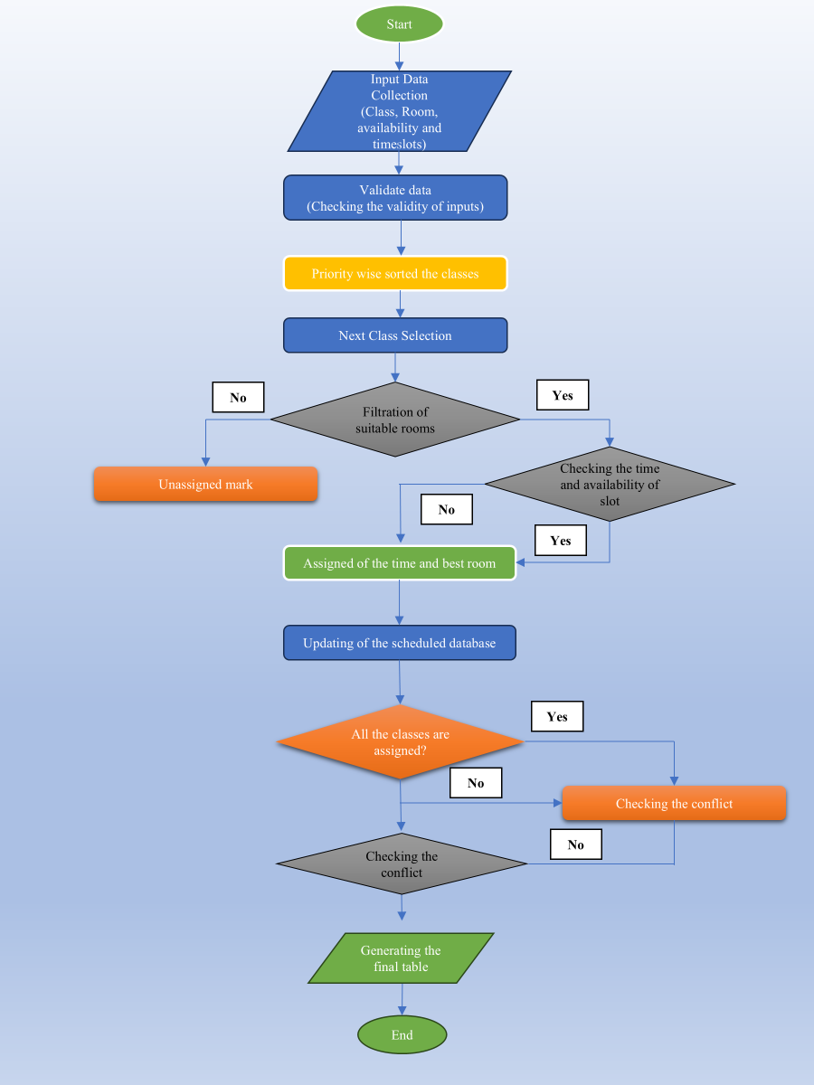
Figure 1: Flow Chart

Flowchart Explanation
Explanation of the solution works with the decision point and assumptions
This is a flowchart which represents an effective process of optimising the allocation process of the classroom and offers a significant solution for the addressed issue. Solution of the problem or the issue consists of an organised sequence of the process or steps, and developing significant solutions that has to be applied to the same problem [3]. The first process is the collection of input data and considering the scenario and application of the MoSCoW technique, the essential input data are related to the capacity and size of the classroom, timeslot and availability, which is the foundation of decision formation. The second step is the validation of the gathering input data with an aim of removing the duplicity in the entries, and the Computational Thinking skill is necessary to validate it. The significant role of using the model of the Computational Thinking Skill has been explained in three stages, such as defining, proposing, solving and analysing [4]. The third step is to sort all the classes based on the priority, such as larger class, regular class or the specific class needs.
The next process is the selection of the next class from the priority list, and then focusing on the appropriate room filtration. This fifth step is based on the criteria, for example, the room capacity should be bigger than the class size, as well as the availability of the facilities. This is mainly considered as the decision point; for instance, if the decision is no, then the class is marked as unassigned, and if the decision is yes, then the class is marked as assigned. Checking the time slot with the help of computational thinking skills is also the decision point, as this helps in thinking logically. Influenced by this thinking skill, if the time slot is yes, then proceed towards the assignment or not. The Computational Thinking Skill is considered the fundamental competency in the contemporary world [5]. The seventh step is the optimising step in assigning the rooms and time slots for ensuring efficiency, such as checking the match between class size and the capacity of the room, and balancing the use of the room. After that, the database will be scheduled and continuously updated in the eighth process with the motive of avoiding double booking.
In the ninth step, it should be checked whether all the classes are assigned or not, considering it as another critical decision point. So, if this result is no, then proceed to the next class again, and if the result is yes, then proceed to check the conflicts. Then, the next step has to be to check the conflicts with the process of scanning the system, for example, clashes between the room and the student, and ineffective allocations. While checking the conflicts, if they exist, then triggering for the reallocation, and if not, then the final table has to be generated. The last step of the proposed solution will be to produce an optimised and complete timetable.
Ensuring the proposed approach
Considering the case scenario, the flowchart and application of the MoSCoW technique clearly indicated how the proposed approach can ensure efficiency and solve the issues positively. Use of the MoSCoW technique is to be stated as the foundational framework, which ultimately results in the enhancement of the accuracy and efficiency [6]. In order to ensure the efficiency of the room usage, class size should be matched with the capacity of the room, and this approach has the ability to minimise underutilised spaces by assigning the class as per the size fit. Apart from this, balancing the room usage will also improve the efficacy of the resources by avoiding the overbooking of rooms.
Another issue of the movement time between the classes can be reduced by adopting the optimisation regarding the allocation of the rooms, depending on the preferences. In addition to that, another suitable feature must be the automated scheduling system, which can not only manage the time loss, however, minimise the fatigue and provide comfort. In the educational setting, using the automated scheduling system for generating the timetable simplifies the scheduling of academics [7]. In order to solve the issue of scheduling conflict, each class should be within an individual timeslot, and each room will occupy or hold one class/time slot. This system has to ensure that two classes will not overlap or be at the same time, so the validation process is very effective in this situation.

4. Reflection and Justification

Abstract thinking
Abstract thinking is linked to the process of eliminating the details of a situation to understand and differentiate the context of a problem and the content. The use of abstract thinking in solving mathematical problems is to derive a result and derive abstract meanings out of the different parts. It is also associated with establishing relationships based on hypothetical linking which involves the usage of generalisations, symbols and capacity to make and prove such generalisations [8]. In the case of the discussed problem, such different components involved such elements as the size of classes, the size and availability of the room, timeslots, and conflict checks. This concept was especially crucial as not all details of a problem are equally relevant to its resolution. This has enabled me to come up with a generic solution that can be replicated over and over again as opposed to solving a single problem.

Sub-dividing
Decomposition is also a part of problem-solving where larger problems are broken down into smaller ones. The issue was divided into several steps, which are seen in the flowchart that consists of data collection, input validation, sorting of classes by their priority, determining the suitability of the rooms, assigning timeslots to the classes, identifying conflicts, and creating the final timetable. This process enhances the reasoning ability of the problem-solving models in relation to [9], and the effective use of this process led to the creation of the flowchart.

Justification of solution
The solution is justified due to its transparent, logical structure which, in line with the MoSCoW prioritisation technique, satisfied essential requirements before considering less critical preference. For instance, in the flowchart, each class was assigned to one room whereas, timetable clashes were avoided and class size was matched with room capacity. Furthermore, conflict-checking principles also decrease double-booking risks, effectively addressing a real-world problem.

Limitation
One of the weaknesses is that the challenges of the real world are marked by unexpected or unpredictable events. As an example, last-minute changes may arise due to unexpected room maintenance or risky conditions, which are not taken into consideration by this model. The other constraint is that it assumes that all the data is correct before the allocation is made.

Assumption
The assumptions made for this task include assuming that all data i.e., room capacity, class sizes, and timeslot data are accurate. It is also assumed that only one class can be hosted in one room for each timeslot.

5. Conclusion
In conclusion, a real-world problem was addressed with the use of several problem-solving techniques. The flowchart demonstrates how the college can resolve its difficulties of managing classroom allocations effectively.

References
[1] S. Maharani, M. N. Kholid, L. N. Pradana, and T. Nusantara, “PROBLEM SOLVING IN THE CONTEXT OF COMPUTATIONAL THINKING,” Infinity Journal, vol. 8, no. 2, p. 109, Sep. 2019, doi: https://doi.org/10.22460/infinity.v8i2.p109-116.
[2] Washington Government, “MoSCoW Method,” Your Washington, Aug. 22, 2025. https://your.wa.gov/cx-resources/moscow-method/.
[3] L. Dall’Acqua, Computational Thinking for Problem Solving and Managerial Mindset Training. Hershey: IGI Global, 2021.
[4] T. PALTS and M. Pedaste, “A Model for Developing Computational Thinking Skills,” Informatics in Education - An International Journal, vol. 19, no. 1, pp. 113–128, 2020, Available: https://www.ceeol.com/search/article-detail?id=840782.
[5] T. Doleck, P. Bazelais, D. J. Lemay, A. Saxena, and R. B. Basnet, “Algorithmic thinking, cooperativity, creativity, critical thinking, and problem solving: exploring the relationship between computational thinking skills and academic performance,” Journal of Computers in Education, vol. 4, no. 4, pp. 355–369, Aug. 2017, doi: https://doi.org/10.1007/s40692-017-0090-9.
[6] N. S. Vijayakumar, K. Prasad, and Raviraja Holla M, “Assessing the Effectiveness of MoSCoW Prioritization in Software Development: A Holistic Analysis across Methodologies,” EAI Endorsed Transactions on Internet of Things, vol. 10, Oct. 2024, doi: https://doi.org/10.4108/eetiot.6515.
[7] Dr. Smitha Padshetty, Abdul Jaleel Khan Anas, Abdul Rahman Syed, and Harsh Kulkarni, “Automated Time-Table Management System,” Journal of Scientific Research and Technology, pp. 363–372, Dec. 2025, doi: https://doi.org/10.61808/jsrt398.
[8] M. N. Kholid and N. N. Aisyah, “Classification of Abstract Thinking in Solving Mathematical Problems,” Educational Process International Journal, vol. 16, no. 1, 2025, doi: 10.22521/edupij.2025.16.194.
[9] S. Xue, Z. Huang, J. Liu, Y. Ning, B. Jin, X. Li, and Q. Liu, "Decompose, analyze and rethink: Solving intricate problems with human-like reasoning cycle," Advances in Neural Information Processing Systems, vol. 37, pp. 357-385, 2024.

