
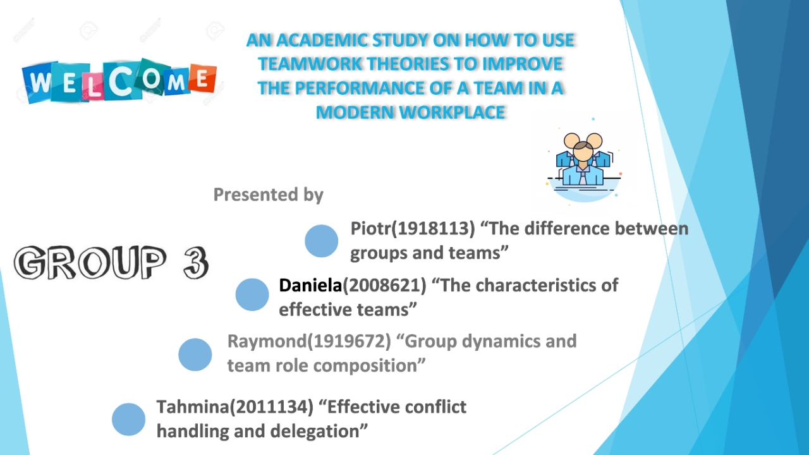
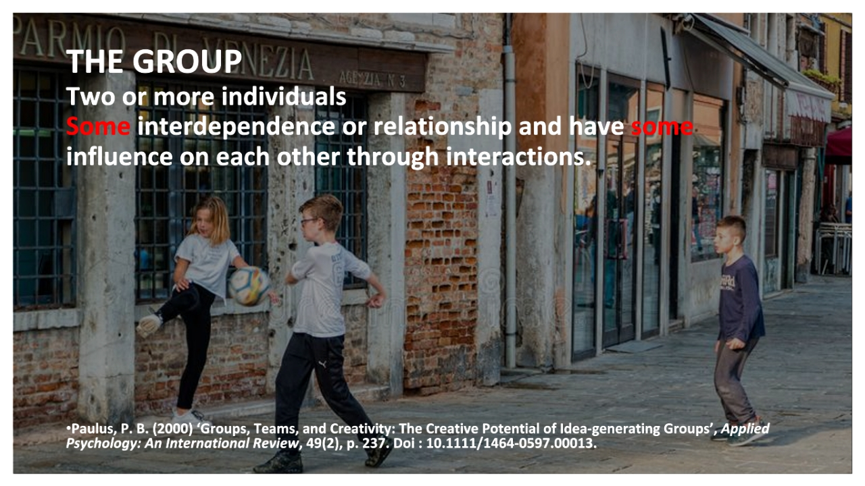
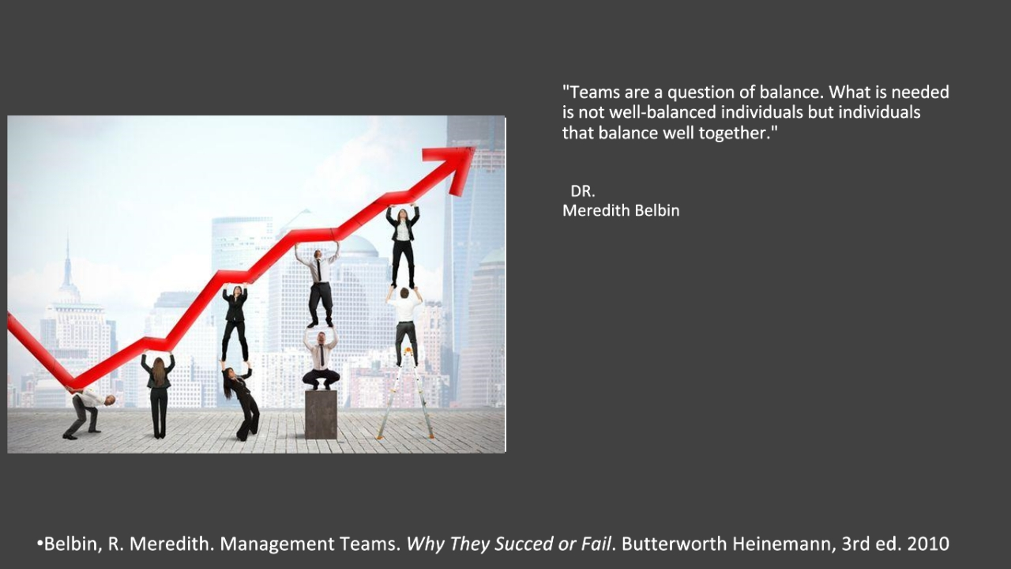
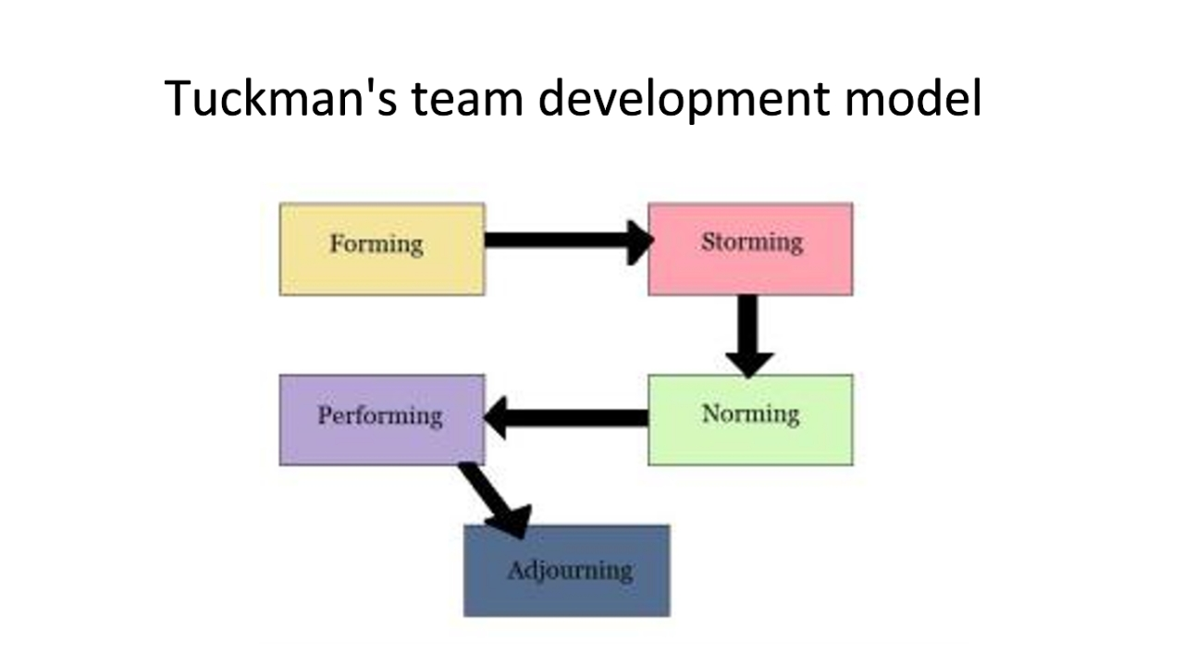
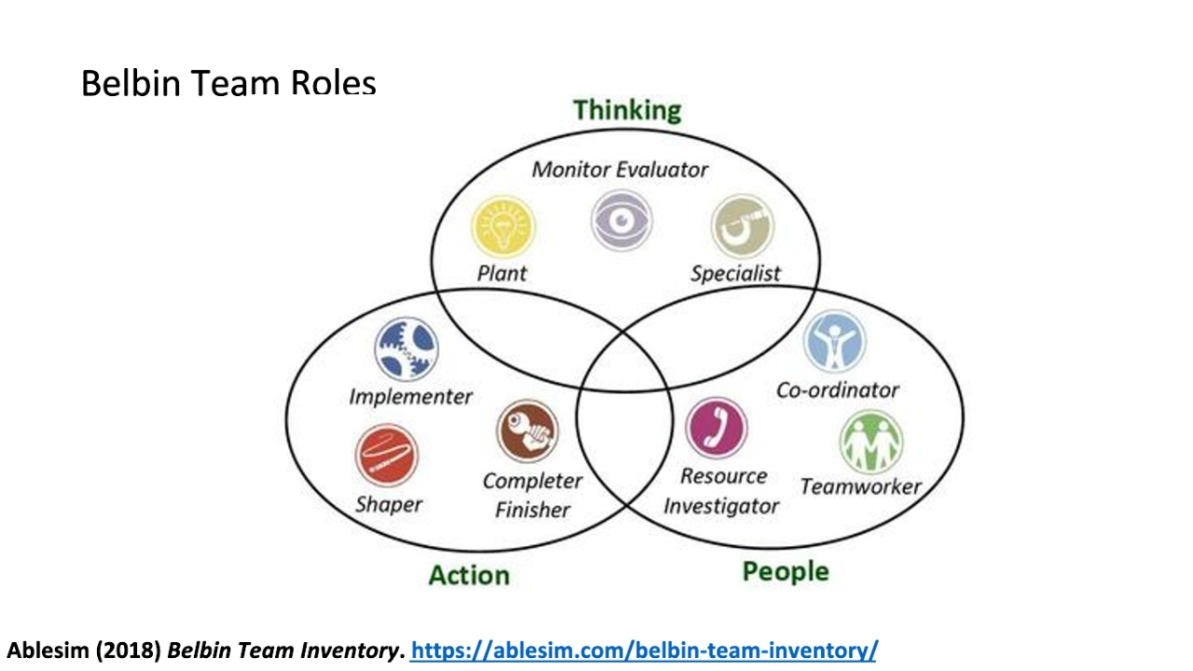
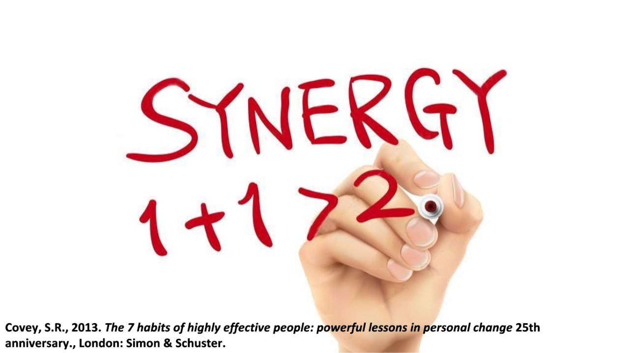
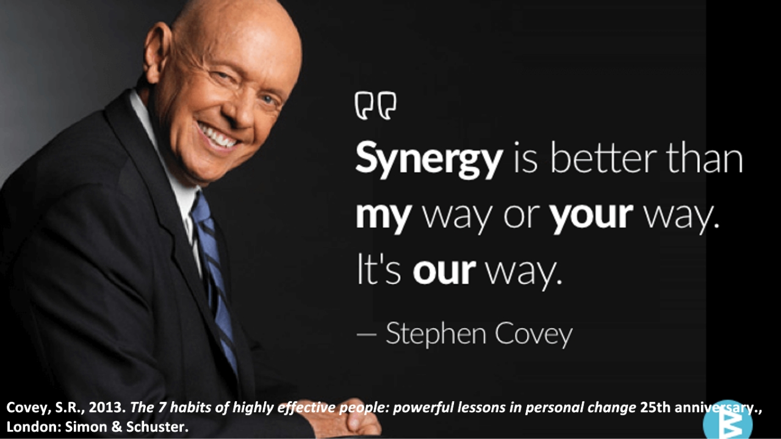
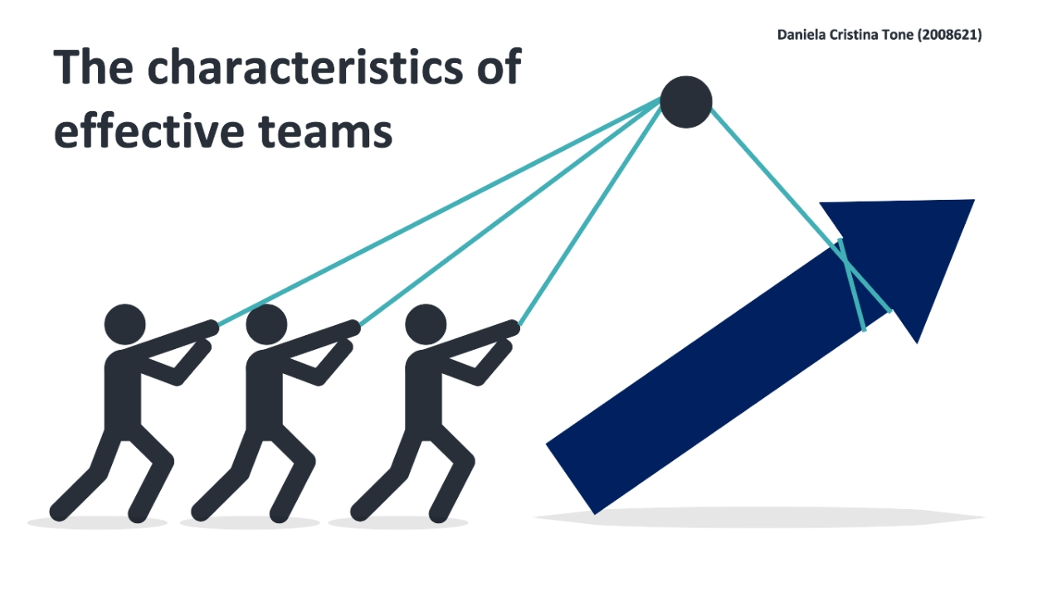
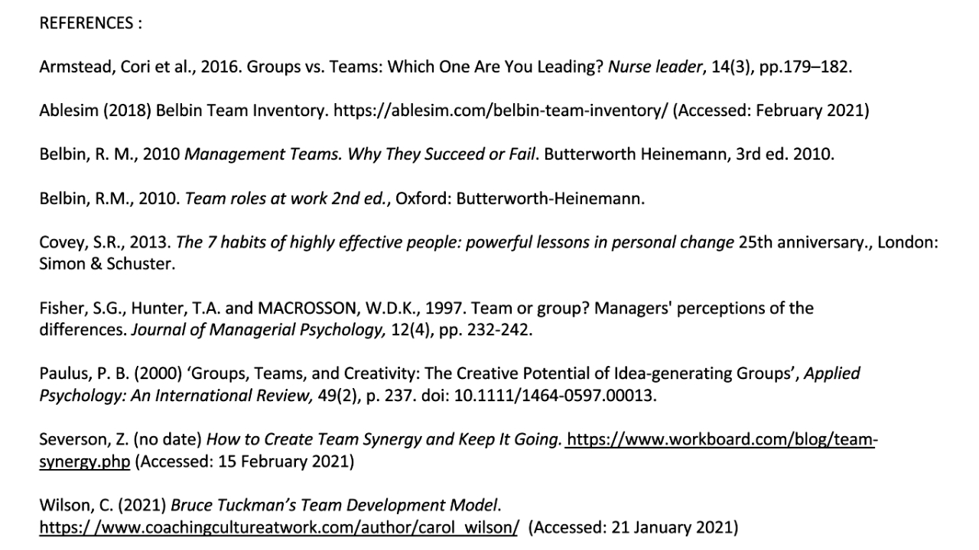
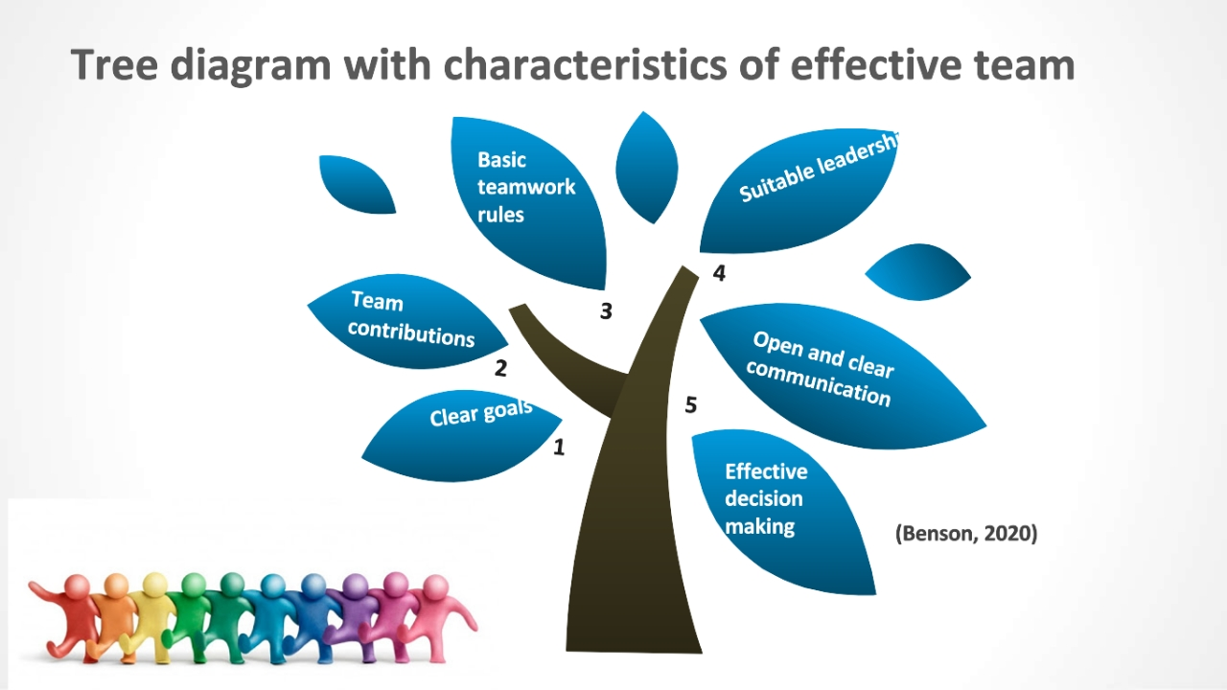
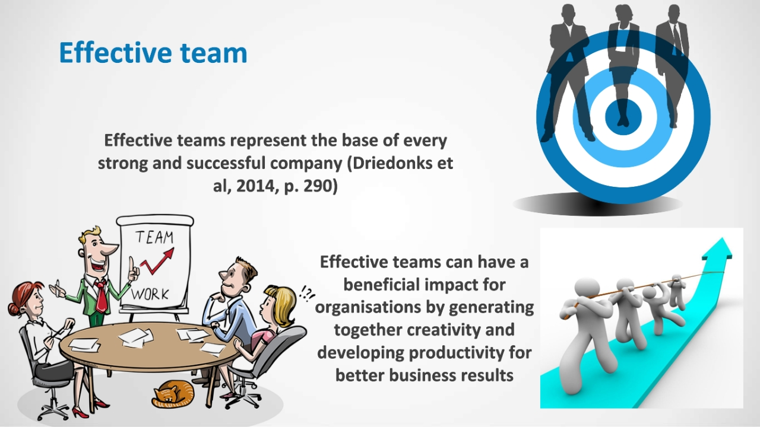

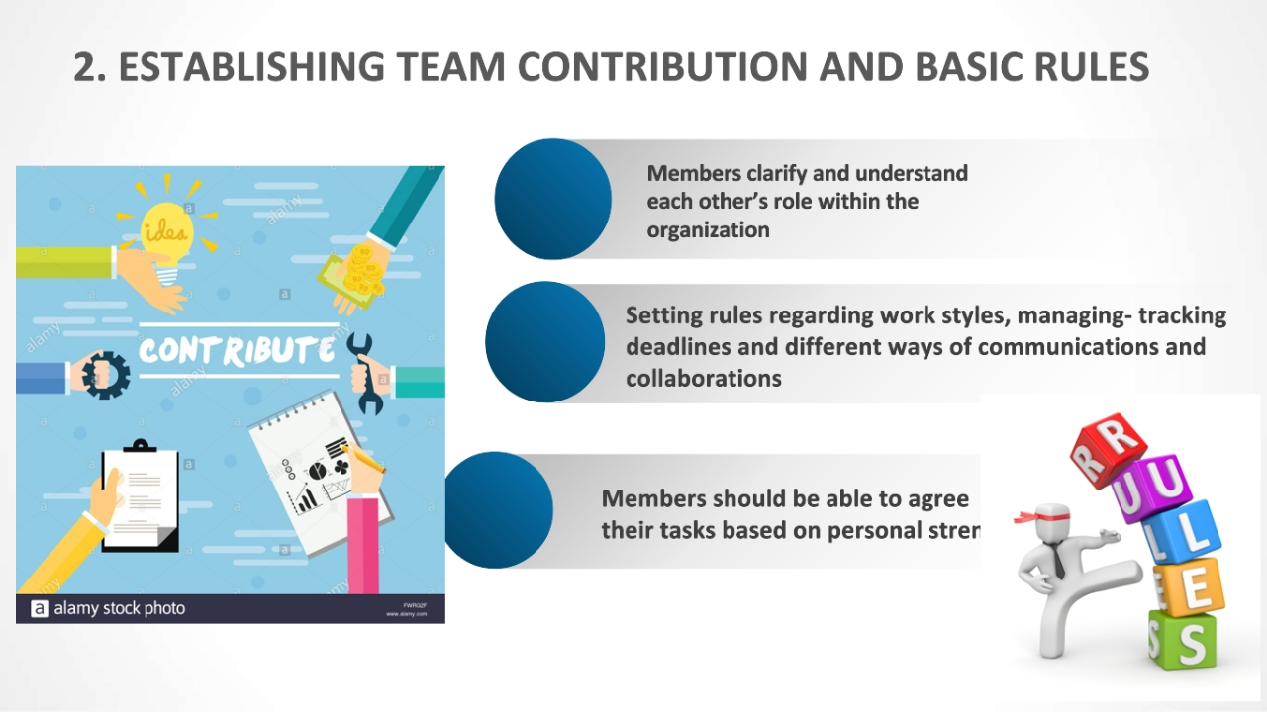
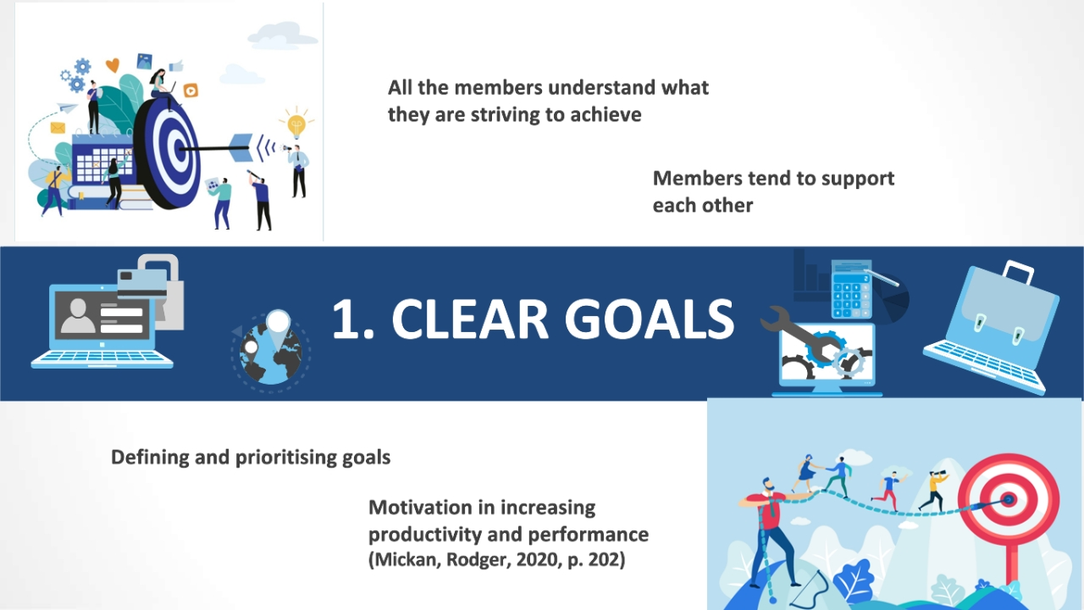
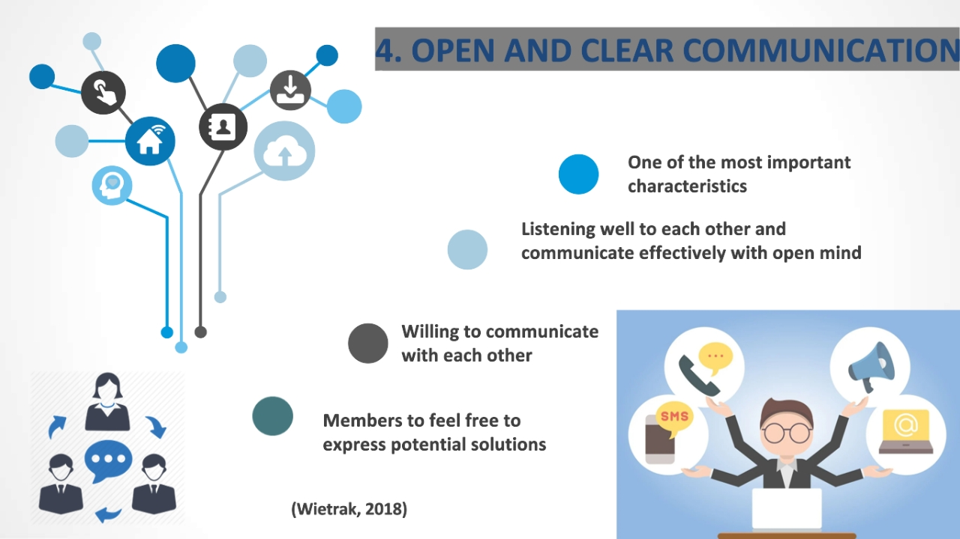
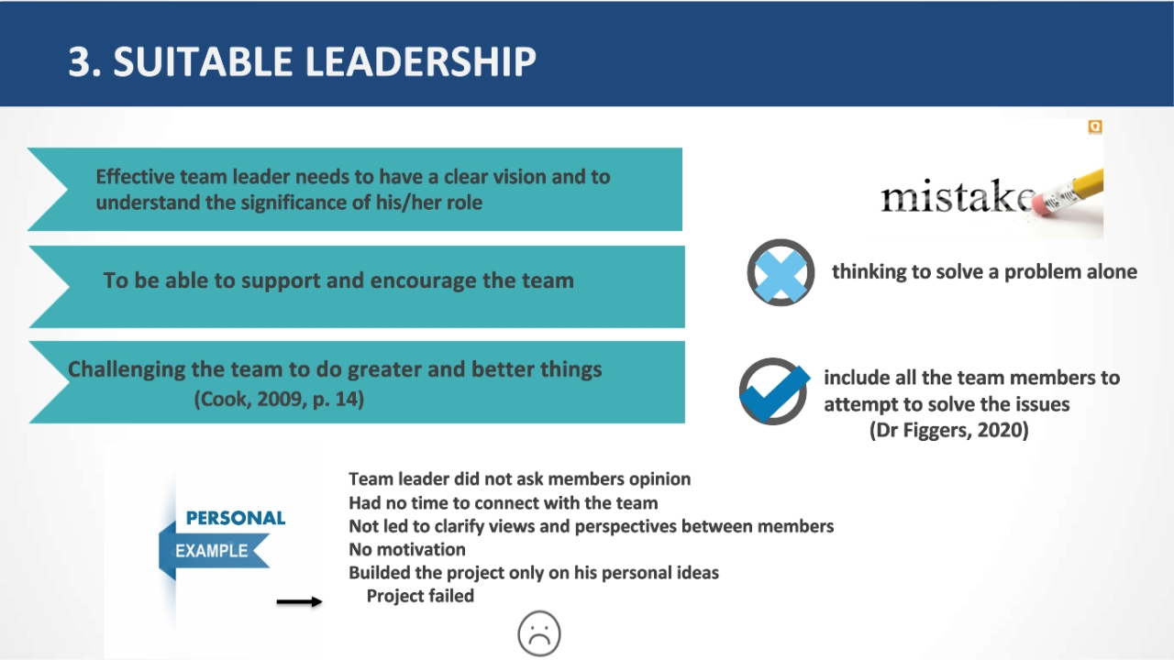
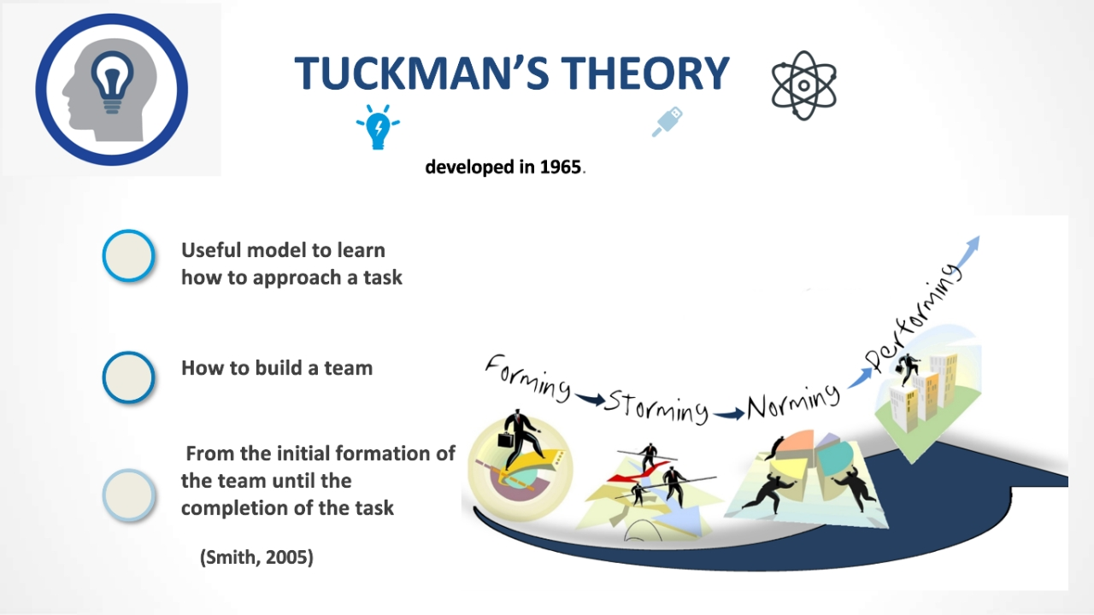
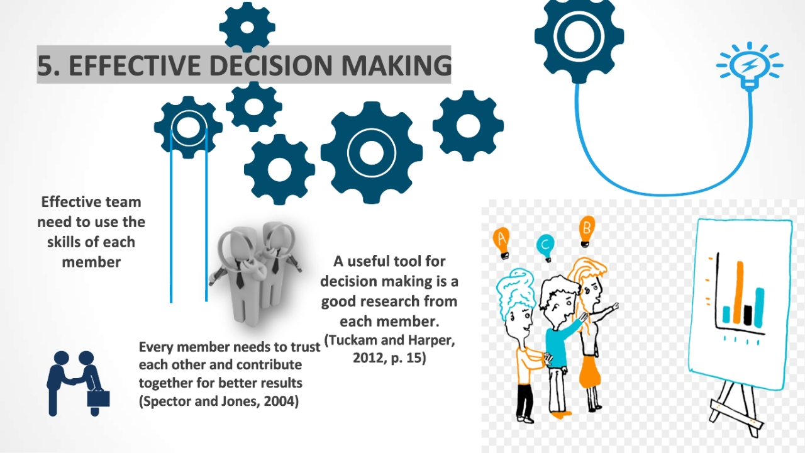

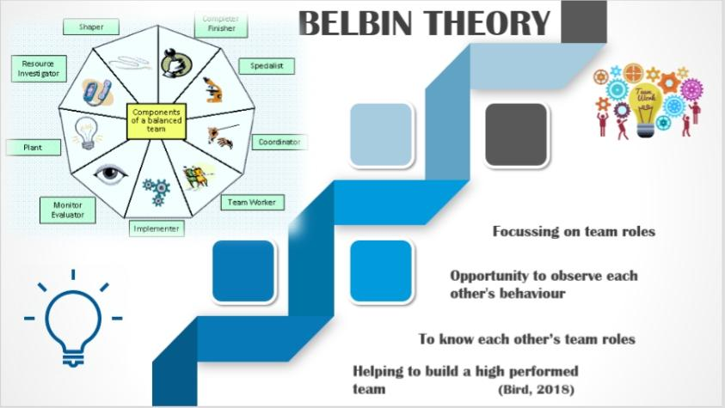

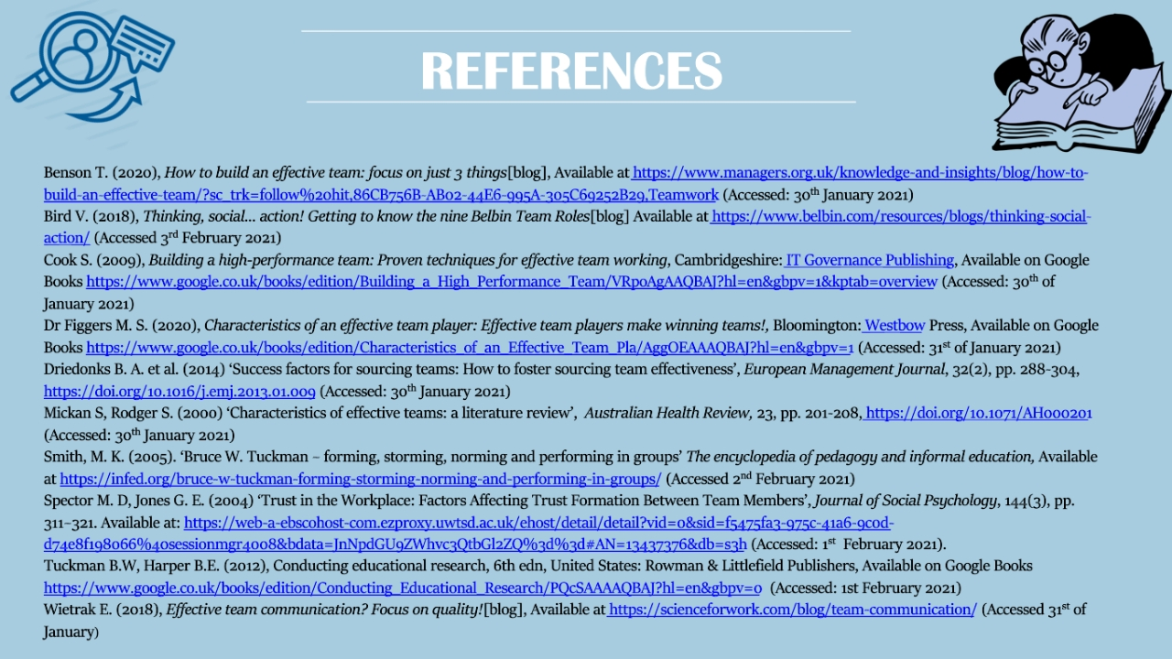

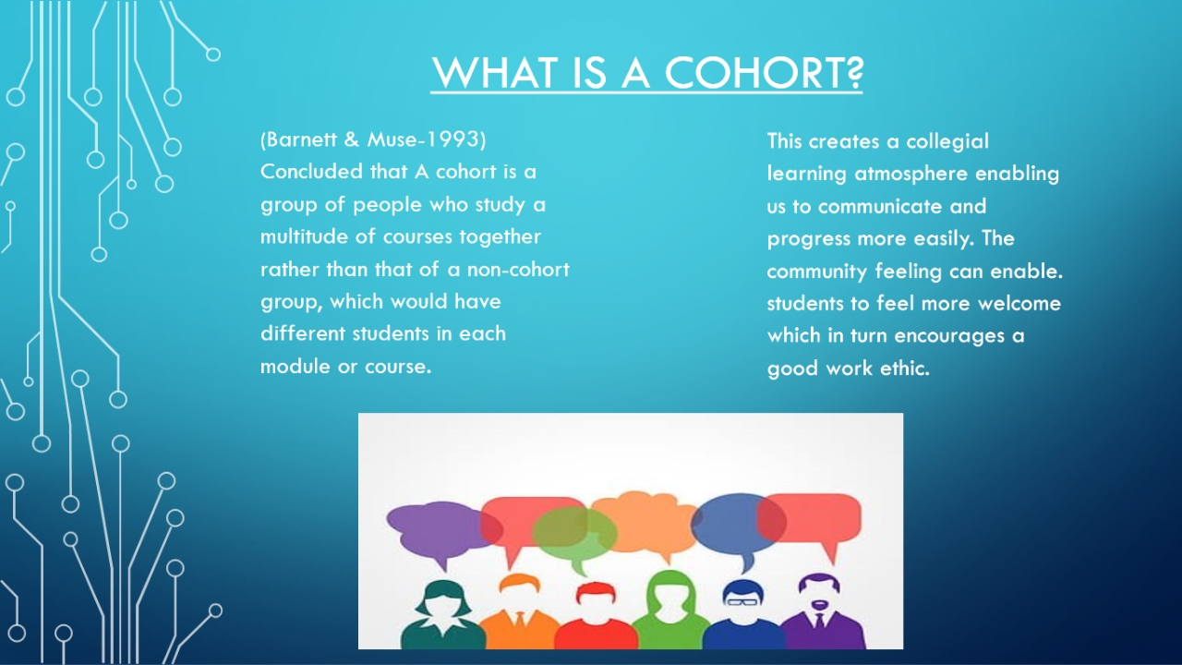
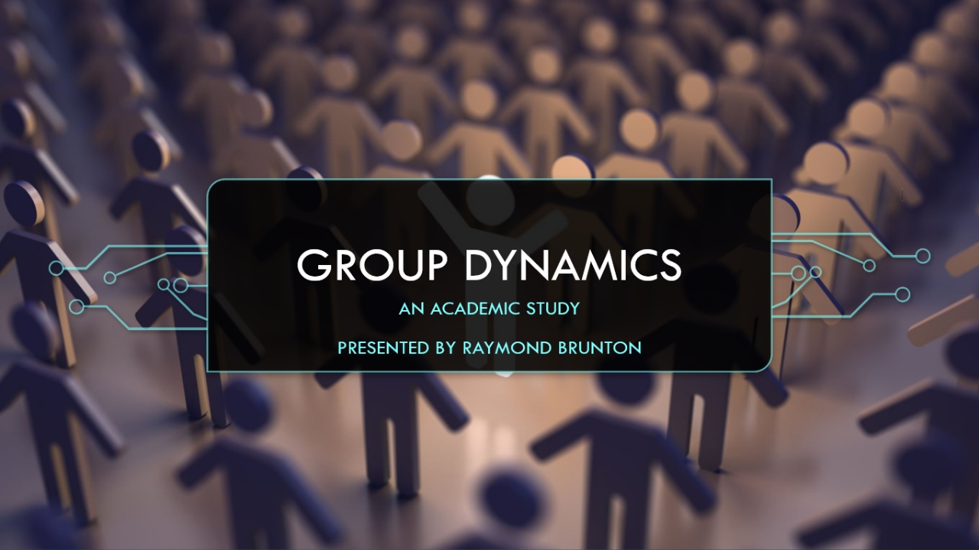
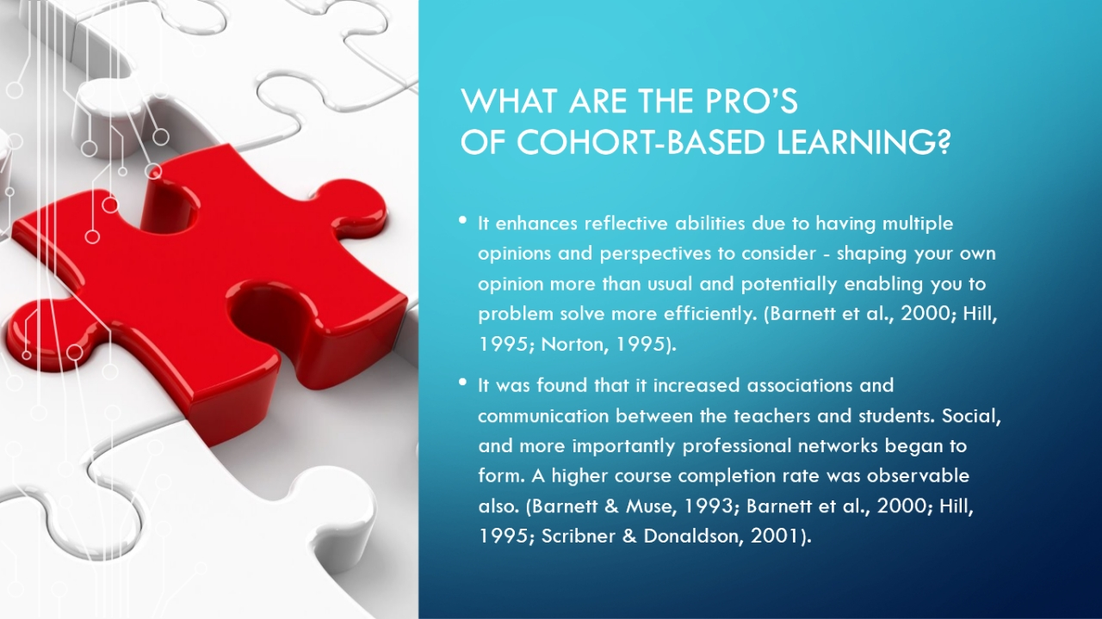
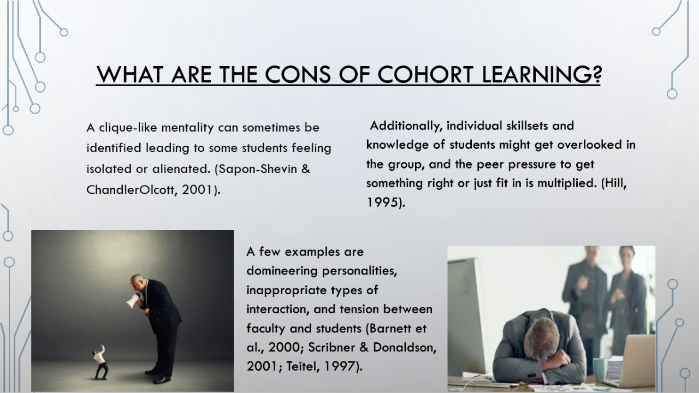
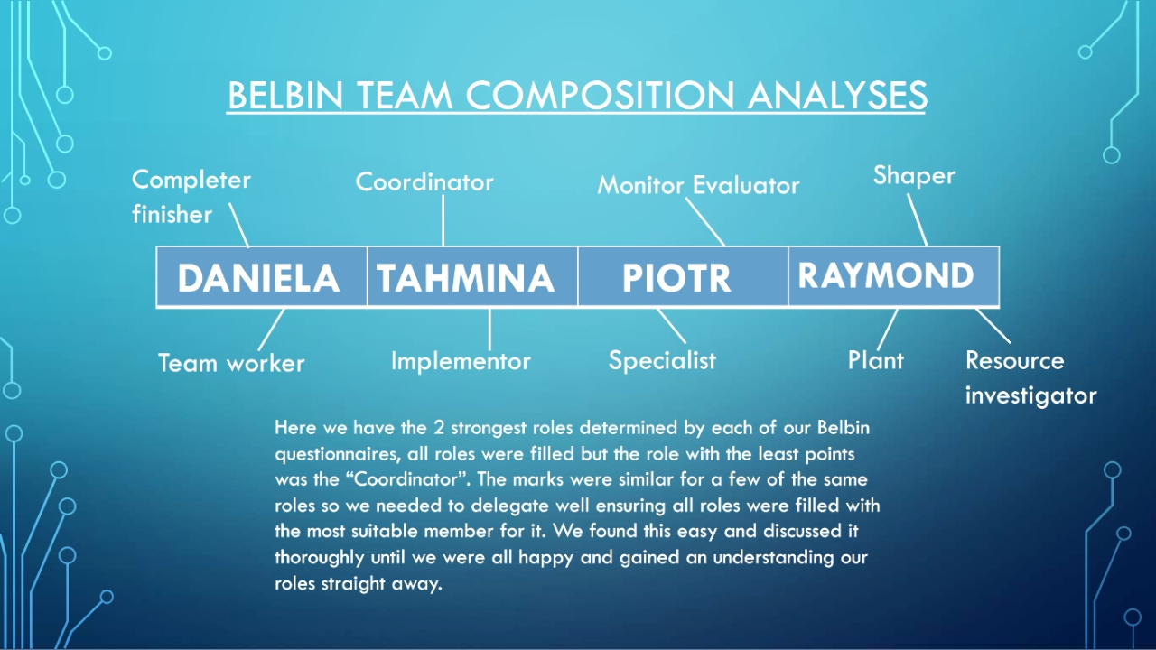

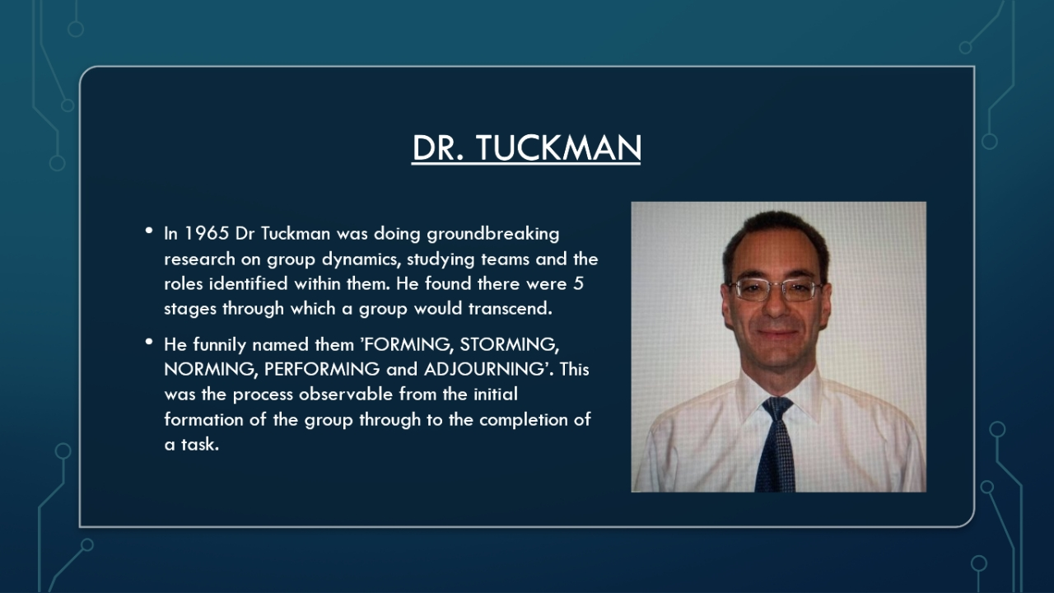
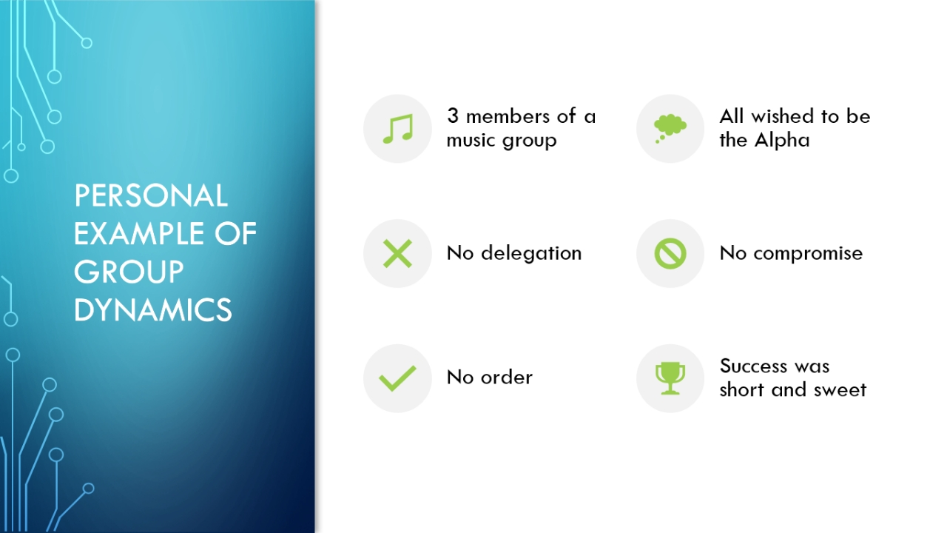
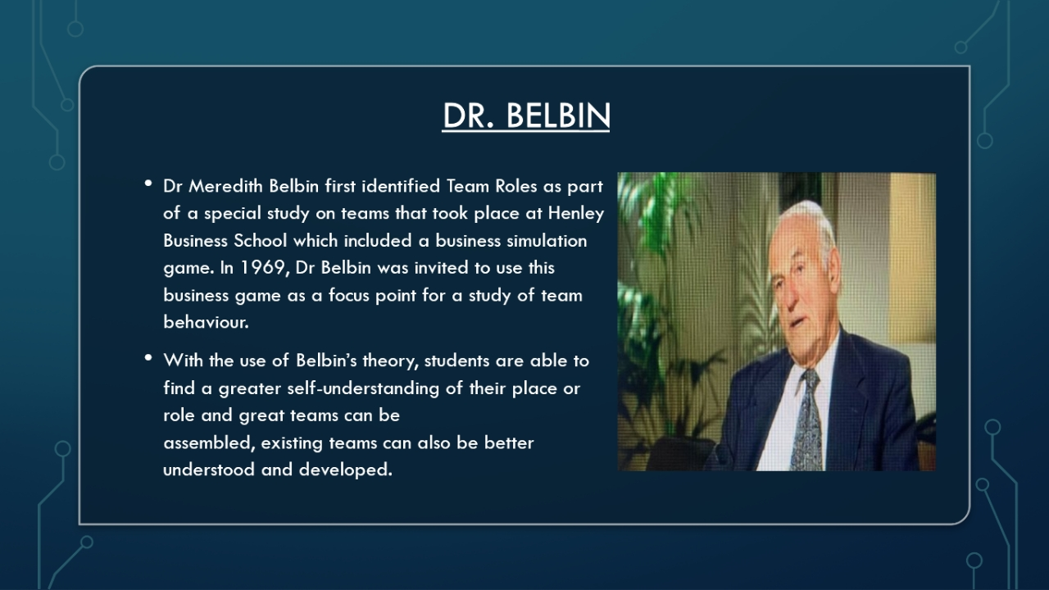

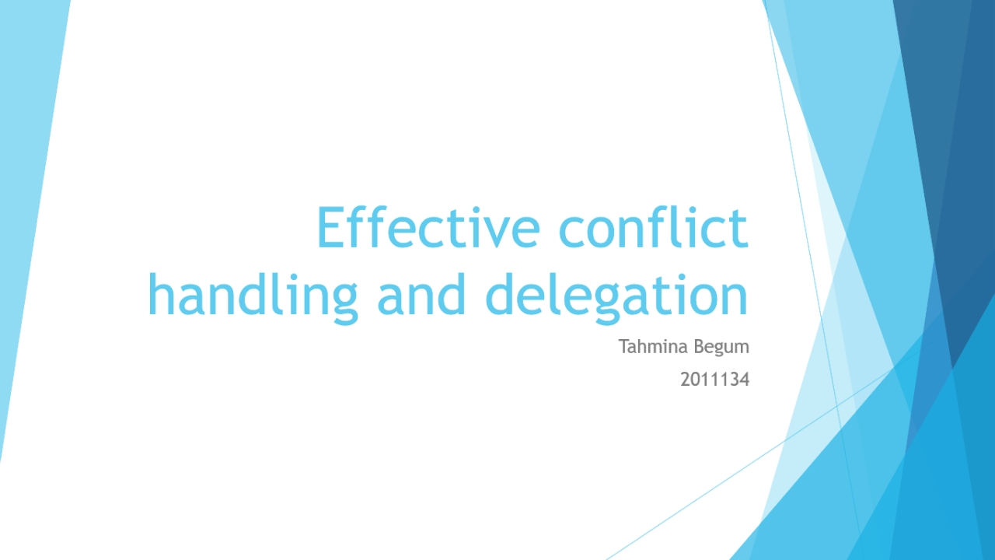
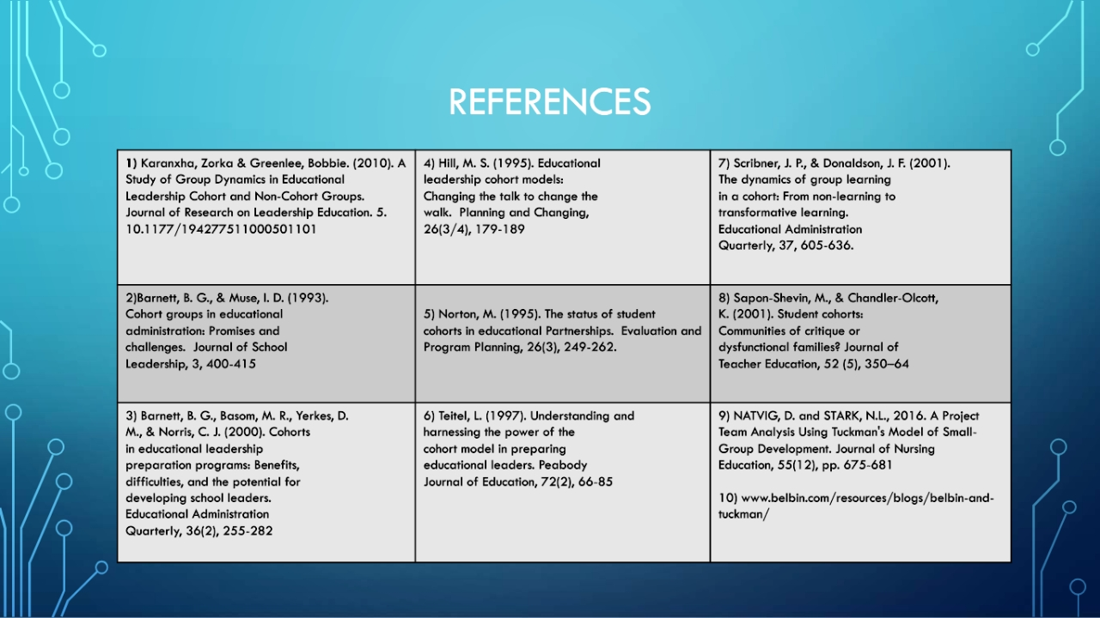
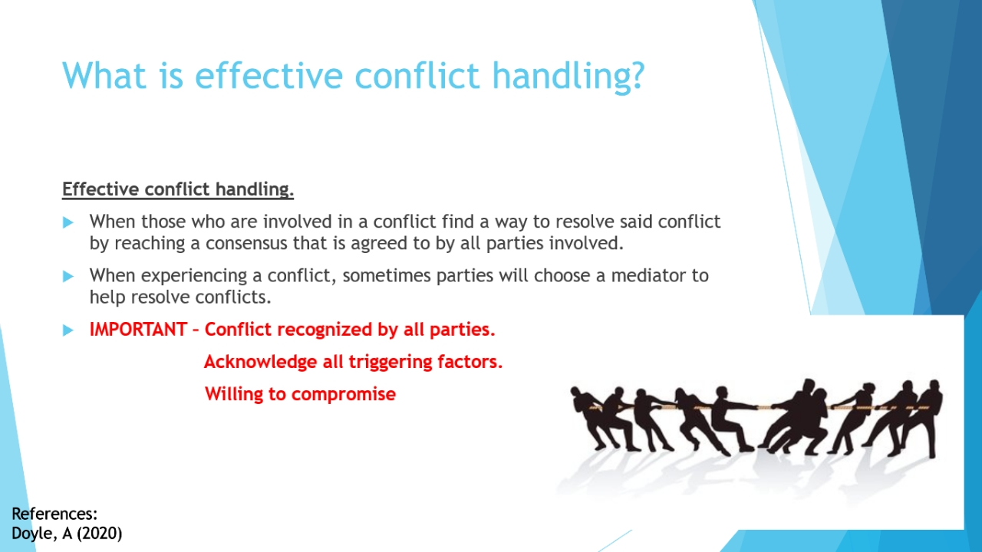
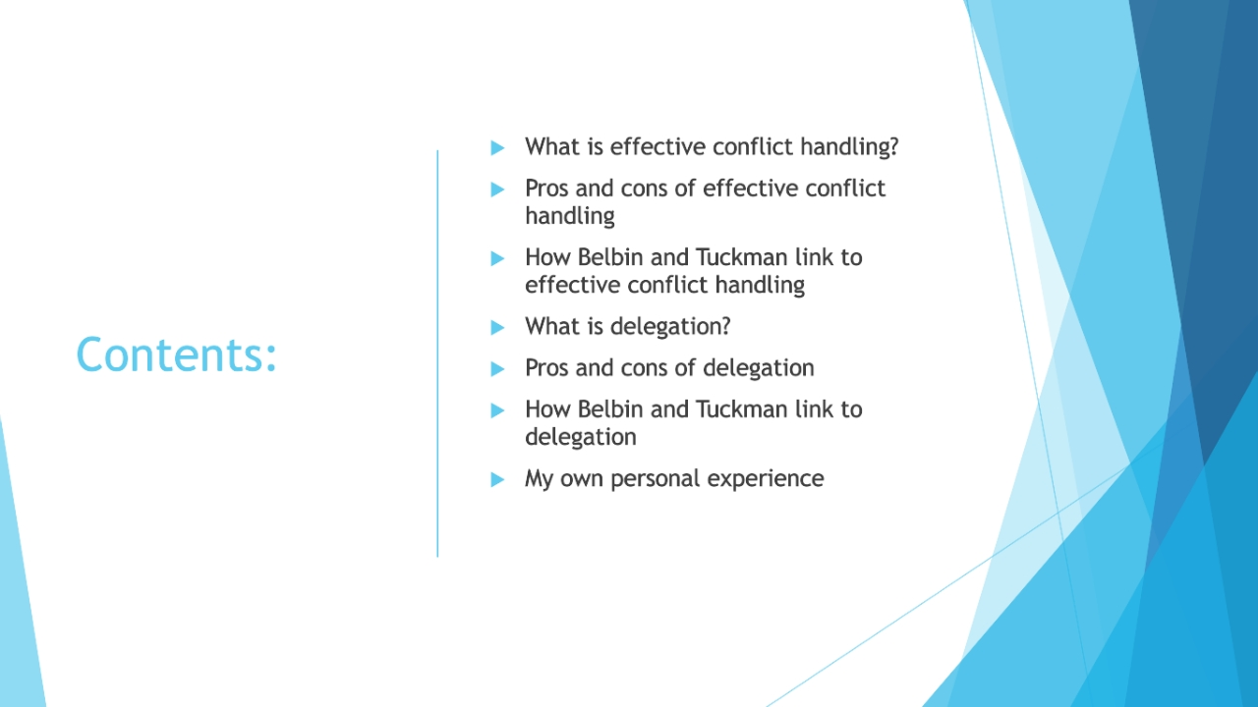

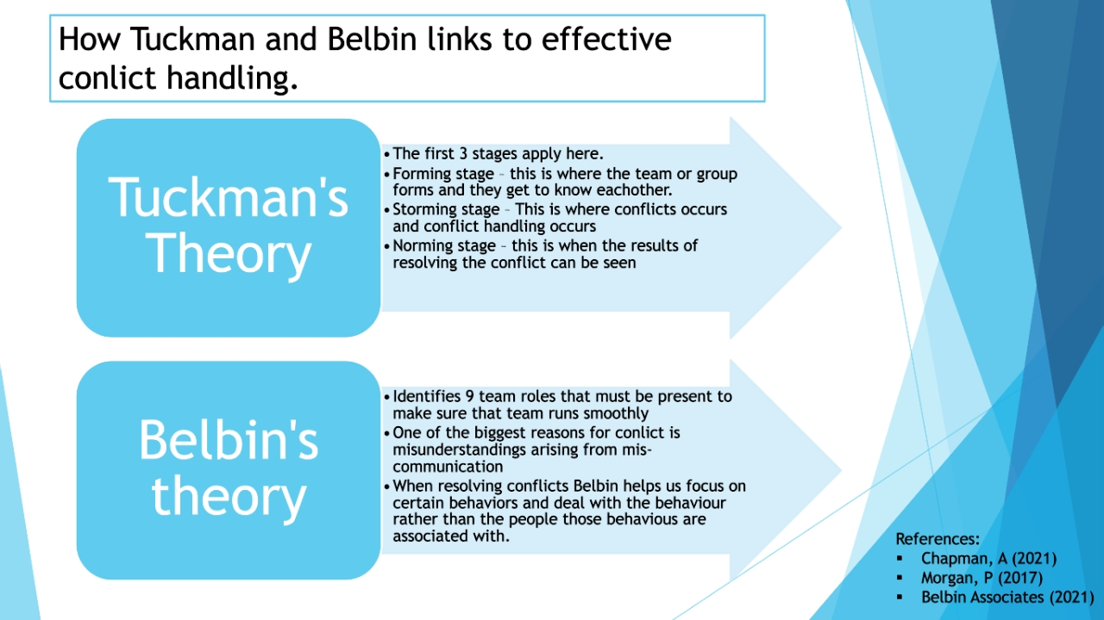
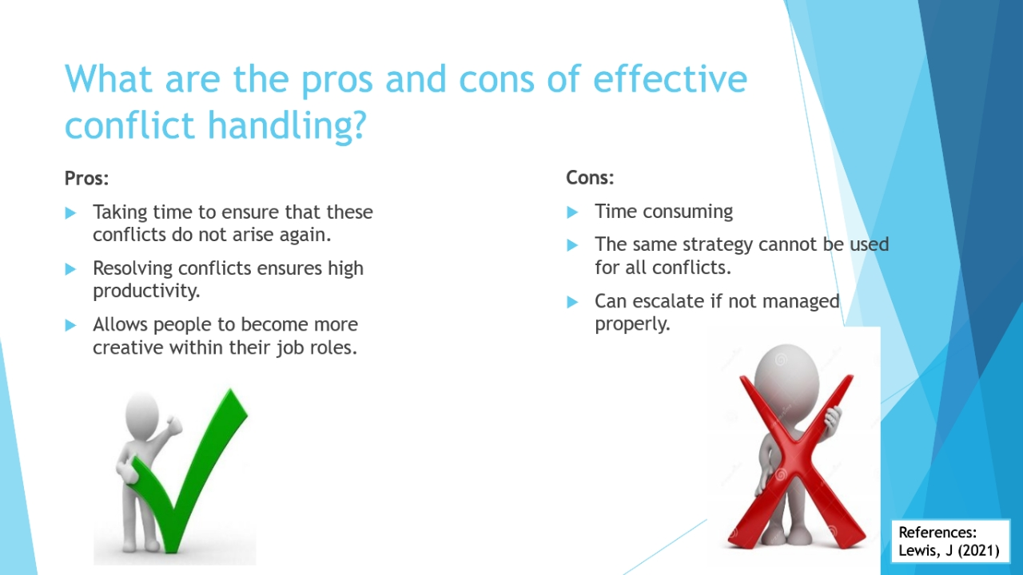
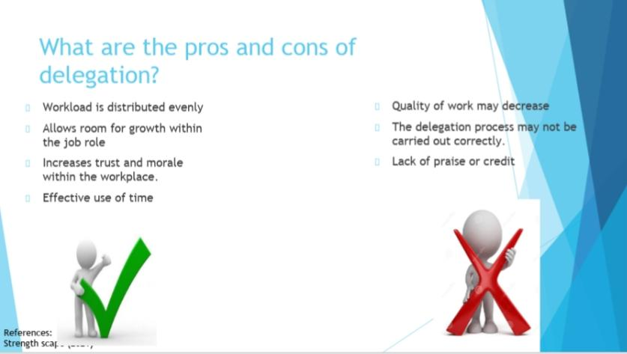
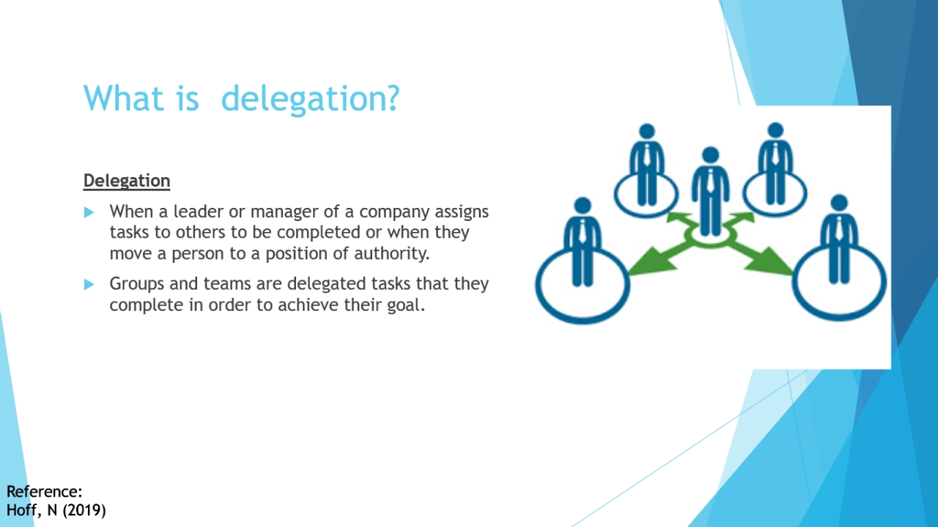
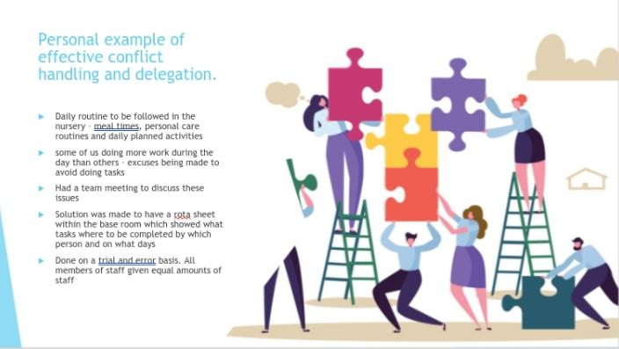
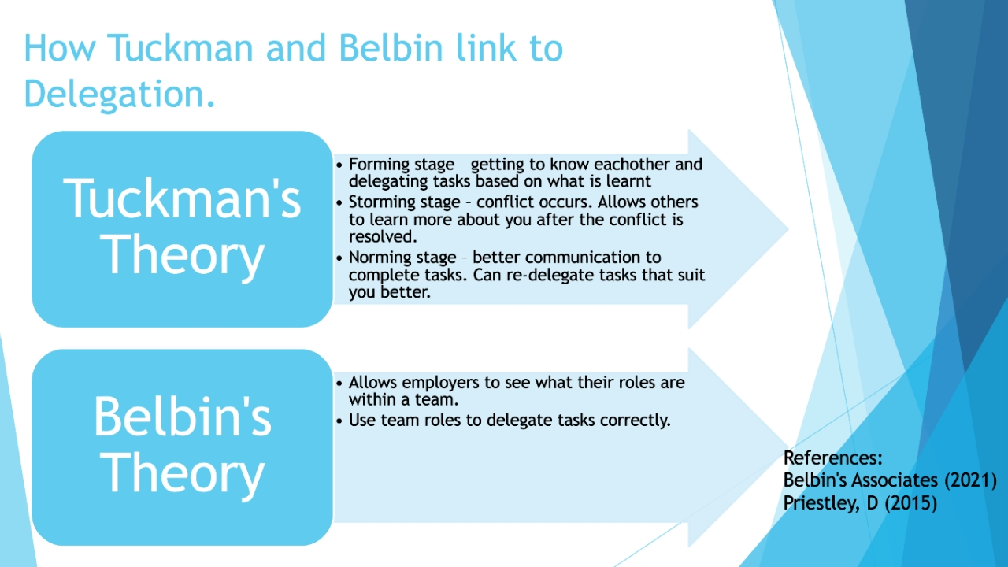
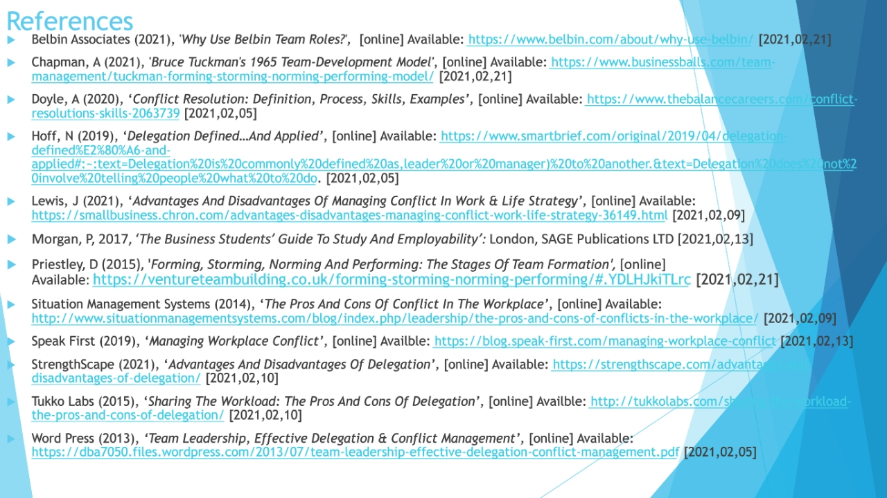

Tahmina Begum – 2011134
Group 3 presentation – speaker notes
Hello everyone, today I will be talking about effective conflict handling and delegation.
(Read contents page)
Slide 3
Bullet point 2 – A mediator will most likely be a 3rd party person who has no biased opinion on the conflict at hand.
Bullet point 3.2 - Knowing the triggering factors will help stop the same conflict from arising again because everyone will be aware of what action or inactions caused the conflict.
Bullet point 3.3 - everyone involved must be willing to compromise in order to be able to reach the best possible solution for the conflict.
Slide 4
Bullet point 3 – people will be more productive and creative if they are in a positive working environment.
Bullet point 5 – every conflict is different so different methods must be used.
Bullet point 6 – if the conflict is not managed properly then it can lead to more conflicts which will then take more time to resolve.
Slide 5
Bullet point 1 – forming stage is where everyone in the group get to know each other.
Bullet point 2 – storming stage is where the conflict will occur and where it will be resolved
Bullet point 3 – norming stage is where you will see the results of resolving the conflict.
Bullet point 4 – these team roles must be present to ensure that the team is running smoothly and effectively.
Slide 7
Bullet point 1 – this makes sure that everyone is doing the same amount of work.
Bullet point 2 – it allows you to show your group leader what you are capable of.
Bullet point 3 – it shows that your manager or leader trusts you to do what needs to be done.
Bullet points 4 and 5 – the quality of work decreasing will be a knock-on effect from the tasks not being delegated properly.
Slide 8
Bullet point 1 – the team gets to know each other, and tasks will then be delegated based on what is learnt.
Bullet point 2 – this is where conflict will begin to arise and as bad as conflict is, it also allows your team to learn more about you.
Bullet point 3 – at this stage the team will have an improved method of communication and this is also where tasks can be re-delegated based on any new information that is learnt.
Slide 9
Bullet point 1 – the routine consists of mealtimes, personal care routines and daily planned activities.
Bullet point 2 – we found that 2 of us in the team were always doing activities or taking care of mealtimes and personal care routines and the other 2 members were always making excuses as to why they are not able to do the tasks.
This went on for about a month when 2 of us decided that we had had enough and set up a team meeting.
Bullet point 3 – during the meeting we discussed everything that had been going on and what changes we wished to see.
Bullet point 4 – the rota sheet showed who was going to be doing what tasks throughout the day.
Bullet point 5 – we always made sure that everyone was doing the same amount of work.
Thank you so much for listening, I hope you enjoyed our presentation, we look forward to hearing what you think.

