

GRADUATE CERTIFICATE in Consolidation of Social Work Practice
LEVEL 6 - 60 Credits
BMPF6044

LEARNER PORTFOLIO
(PORTH AGORED and UNIVERSITY OF WALES TRINITY SAINT DAVID)

Learner’s name: Lisa Davies

Email address: Lisadavies22@hotmail.com

Learner’s University Registration Number: 1203199

Cohort: 18 onwards

Task 2

Observation of Practice
Guidance:

A learner must choose an observation of direct social work practice with people in need of care and support and/or their carers. The observation cannot be from giving evidence in court, contributing to strategy group meetings, case conferences or tribunals or any other indirect activity. The consent of the individual/s in need of care and support and/or their carers must be sought before the observation is undertaken. The observation must be undertaken by an observer who is social work qualified and has at least 3 years’ experience (criteria set out in the Programme Handbook). The observation must be for a minimum of 30 minutes. The observer will gain feedback from the individual/s in need of care and support and/or their carers using either the pro forma below or one of the learner’s own design at the end of the visit.

The learner is responsible for providing a method of gathering feedback for the observer to use. This can be of their own design, and/or adapted to meet the needs of the individual. The provided pro forma can be used where appropriate. The method used will depend on age, ability and language/communication needs of the individuals in need of care and support and/or their carers.

This section will include examples of the ways in which effective communication impacts on practice in relation to language use, language needs and cultural sensitivity. You must demonstrate the principles of the “Active Offer” and make reference to “More than Just Words” (Welsh Government, 2012).

Please ensure you meet the Learning Outcomes for this task (See appendix 5 of the handbook).

Please answer the questions below.

Observation Summary

Please include name of the expert witness observing in learner’s details section of the portfolio.

Date of observation: 9th June 2022

To be completed by learner.

Question:
Context
Set out the social work objectives and give a brief description of the situation including geographical and legislative contexts and any relevant cultural, ethnicity and language issues, including how consent was gained and how you have considered the impact of the observation on the individual in need of care and support and/or their carers.

300 words (+/- 10%: include your actual word count at the end of each section).

The observation is a visit to a young person to gain her wishes and feelings. Social Services and Well- being Act 2014 (SSWBA, 2014) She has been accommodated in local authority foster care after an Interim care order was granted by the court under section 38 of the Children Act (1989). Child 1 was removed from her mother care after witnessing serious domestic abuse as well as suffering from emotional harm and neglect. In addition, concerns were highlighted around parental drug and alcohol misuse.

I have been working with child 1 for several months now. Child 1 was living at home with her parents and siblings being supported on a child protection plan. Daily visits for several weeks
were undertaken due to the local authority concerns as stated above. This enabled me to build a working relationship with child 1 and her siblings. Initially child 1 struggled being removed from her parents, however over the last few weeks she is thriving and enjoying being a child without having to worry and care for her siblings. Regular visits are undertaken to child 1 in school and in placement to ensure she is managing with the change.

Child 1 wishes and feelings and voice of the child will be obtained during the visit in line with the SSWBA (2014). This is to ensure that child 1 voice is at the centre of decisions being made in and out of court. The three houses exercise will be completed with Child 1 in school where she is able to talk freely. Child 1 is in a Welsh medium school; therefore, after the wishes and feelings are completed I would get the paper work translated in Welsh to ensure she has a copy in both English and Welsh. I ensured I had consent from birth mother to speak with child1 as well as discussed with the foster carers to ensure they could provide any support to child 1 after our meeting if she was struggling emotionally.
329

Question:

Critically reflect on your communication methods and skills during the observation; including how you identified whether you had the necessary communication skills to work with the individual in need of care and support and/or their carers.

You must use a person-centred approach to demonstrate the integration of social work ethics, values and the Code of Professional Practice. This must include culturally and linguistically sensitive practice and the principles of the “Active Offer” and make reference to “More than Just Words” (Welsh Government, 2012).

1300 (+/- 10%: include your actual word count at the end of each section).

I used Kolb’s (1984) Experiential Learning Cycle reflective model, I was able to reflect on this model and learn from my observation about what I would do differently next time and what I thought went well. I felt apprehensive about the visit, as since child 1 has been removed from the care of her mum, she has been able to express traumatic events that happened when living at home. This made me feel nervous about what she was going to say during my visit and how I would support her if she wanted to disclose concerns to me during the visit.

The visited I completed to child 1 was important to ensure I have her continued wishes and feelings in line with the Social Services and Wellbeing Act 2014 SSWBA (2014). For child 1 I reflected on the importance of her understanding what the visit was about and why it is important that her wishes and feelings be heard. I ensured during the visit that child 1 understood that her wishes and feelings would be taken into consideration when thinking about her long term planning with regards to where she was going to live. It is important that you respect the views of people you are working with. SCW (2020). The visit I undertook was in school in a private room, giving child 1 the opportunity to be open and honest about her views and feelings with no one else hearing. Reflecting on previous visits that were in placement I found child 1 was more relaxed and calm in school during my visits.

As I had been working with child 1 for some time and have a good understanding about how to communicate with her. I ensured that I used a child friendly language, by keeping my language simple and kept my sentences short. I ensured I gave child 1 time to process the information we were discussing and reflected what she said back to me to ensure I had heard her correctly SCW (2020). In addition to this, I used a soft calm tone to relief any anxieties she may have had about my visit. She was nodding to me when I am reflecting back what she had said to me, which gave me the confidence that I heard correctly, what she was saying. Gardner (2011) states the core principles of person- centred practice is listening, responsive action and connecting with people.

Child 1 attends a Welsh speaking school, therefore she can communicate in both English and Welsh. The Active offer Welsh Government (2012) was applied during the initial stages of working with the family and taken up. All paper has been provided to the family in both English and Welsh. Child 1 expressed that she was happy for our communication to happen in English, however any direct work that is completed with Child 1 is provided to her in both English and Welsh, giving her the choice in which language she reads it in. This ensured that Child 1 was offered a tailored made, person centred service. (More than Just Words). (Welsh Government, 2012).

During the visit with Child 1 I was used the three houses paper tool exercise to gather her wishes and feelings, this paper tool is in line with the signs of safety framework looking at what the person is worried about, what is going to happen and what needs to happen.( Signs of Safety) .I have found this tool useful to use as it allows me to gather wishes and feelings of a child within a well-known framework, which can be used within court proceedings to ensure the child’s views are at the centre of all decisions that are being made. I was able to use this tool to further my discussion with child 1, I was also able to look at her safety whist living at home with her mum, and explore the safety house. I was able to discuss what people used to be visit her house, who she felt unsafe being around and why. The tool enabled me to give me the confidence to ask these questions and I found as we were doing it on paper it took away child 1 having to give me eye contact, which I have found in the past she has struggled with.

The three houses exercise is also being completed to enable me to complete work with child 1 around words and pictures. Turnell and Essex (2006) states words and pictures are used to tell a children about their story and what concerns we have around their life. This is going to enable me to give child 1 an age appropriate explanation about why she is not living home.

Whilst completing the wishes and feelings with child 1 she asked me would she being going back to live with her mum. I was open and honest with child 1 and advised her that the judge will be making decisions about her further but her wishes and feelings will be taken into consideration. I found this conversation with child 1 difficult; as I did not have an answer for her, but understood I had a duty to work with her in an open and honest way. (SCW,2020) I also reflected on the United Nations Convention on the rights of a child (UNCRC 1989) Article 3 reflecting on child 1 being priority to all decisions and actions that effect the child. UNICEF,(1989)

I also felt In a dilemma that if I was going to give her information that would have upset her and may have affected the positive progress she was making now living in a safe and secure home. Child 1 has blamed herself for being removed into foster care, therefore I used a strength based perspective with her drawing upon her strengths and the positive changes that she has made. This was to ensure she was not critical or negative about herself. (Saleebey 1996) explains that strength based work is drawing up peoples, strengths, hopes, opportunities, wellness and repair.

Although during my visit Child 1 appeared happy, I completed a scaling exercise with her about the way she was feeling, she scored herself low. I advised child 1 that I would need to feed back to her class teacher and foster carer about our session to ensure they could check in with her to make sure she was feeling ok. Although she said she was ok with it, I saw a change in her body language; she started to look away from me, rubbing her hands together. Therefore, I had to make child 1 aware that I have a duty to share information with the relevant people to ensure her safety; this is in line with Part 7 of the SSWBA (2014).

Upon reflection from the visit I felt it had gone well, however reflected on my owns feelings and feeling empathy for child 1 as she wanted answers that at present I could not give her. Although this was out of my control, it did not make me feel any better. I feel that I have built the necessary skills and resilience to deal with difficult conversations. I felt I was able to empower child 1 to be a part of her long term planning and have a say in where she is going to live.

1221.

Feedback and comments from individual in need of care and support and/or their carers

Information for the observer

This section of the Observation should not be completed in the presence of the learner.

No formal written feedback is required from the observer on the learner’s practice. However verbal feedback should be provided to the learner as soon as possible after the observation. If the observer is not the mentor, then feedback should also be provided to the mentor.

Some or all of the questions below may be used by the observer who can rephrase and add explanations and prompts as required. The observer should record responses from the individual in need of care and support and/or their carers below, or by using an alternative method if required/provided.
Before asking the questions, the observer must explain to the individual comments will be shared with the learner. It may be useful to explain that it is used as a learning tool for the learner to develop their own practice.

If the observer is unable to gain feedback, they should briefly say why.

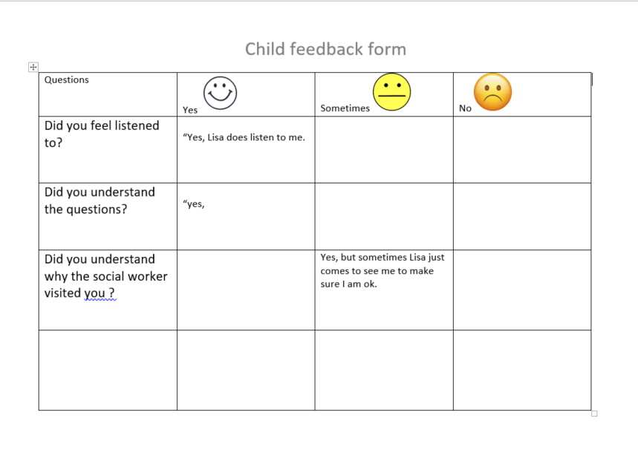

Was the social worker on time? Or, if delayed, did he or she contact you?

Did the social worker get your permission in advance for the observer to be present?
Did they explain why they were being observed?

Were you clear why the social worker met with you today?

How well prepared do you think the social worker was for his or her meeting with you?

How has the social worker listened to you and respected your views and wishes?

Did the social worker talk to you in a way that you understood?
Did the social worker consider your language needs?

How has the social worker’s involvement met your expectations for this visit?

Are there any other comments or suggestions that you would like to make?

