Managing projects in the Organization - BMSW5104

Lecturer: Charles Nwaogwugwu
Student- Andreia Buliga - 2018956

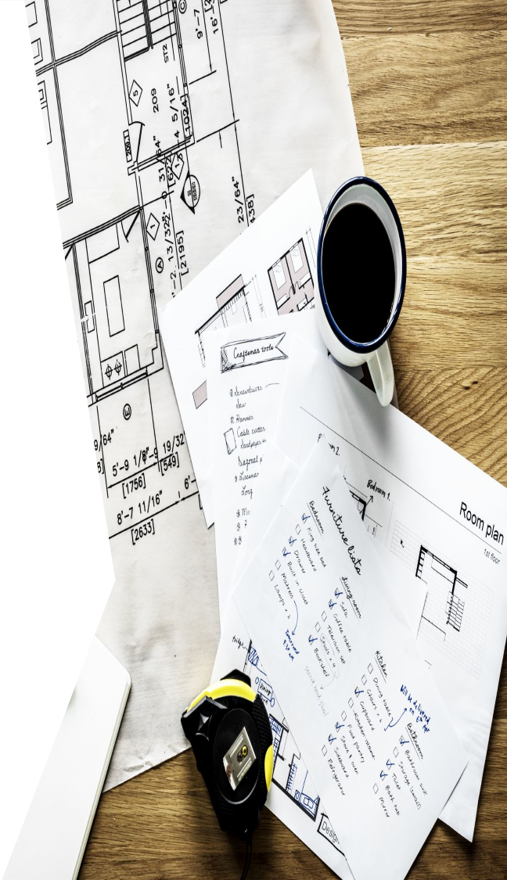

Table of Contents
Executive summary 3
Introduction of Starbucks 3
Project scope 4
Quad chart 4
Project Work break down structure (WBS) 5
- Gantt chart 6
Stakeholders’ analysis and communication plan 7
Stakeholder Communication plan 8
Cost analysis 9
Evaluation 10
Project life cycle 10
Conclusion 10
Appendices 10
References 11

Executive summary
In this report, I will be talking about the development of a planned training project within the organization Starbucks, to demonstrate this I will be using a Project life cycle theory that will help to have a well-planned and organized project.
During this module, we have learned about project management and the ability to manage projects within the workplace using appropriate tools and techniques to facilitate the organization of projects.
The report also consists of the effects or impact of the Covid- 19 pandemic that has had on Starbucks and takes in consideration the project plan adapting to the regulations of the pandemic and how this could have impacted the current situation.
The project plan will have a clear WBS structure to show a clear understanding of the tasks and also the stakeholder’s analysis and communication plan.

Introduction of Starbucks

Starbucks is an American global coffeehouse and roastery reserve chain headquartered in Seattle, Washington. It was started in 1971 and has since opened around 3300 locations worldwide.
They sell a variety of things including coffee, tea, fresh food, gifts, and artisan beverages. Furthermore, the company sells a variety of items such as whole-bean coffee, bottled water, and a variety of tea and coffee. Starbucks works in a sector that is highly competitive and fragmented (Starbucks, 2019).

Starbucks has been functioning well and profitably for many years; but, with the current epidemic of covid- 19, the company's financial and economic situations have been badly impacted. The world economy was in shock at the start of the year 2020.Moreover, there has been a reduction in the demand of customers at Starbucks which has impacted the income of the company. Moreover, as the pandemic has eased restrictions now, still need to be taken into consideration several rules placed by the government in addition to the Pandemic.
Starbuck’s senior managers have gotten new plans and projects to increase its profit and provide more efficient customer service by adopting its baristas to training programs.
Starbucks has made a contract with Princi which are a famous Italian Bakery with the intention of bringing their bakery to the stores of Starbucks. Schultz has stated that they have never baked pastries in their store, but all of that will change with the creation of their new partnership with Princi , who will be in charge of delivering the fresh pastres ready to be baked at Starbucks staff delivered by them. Therefore there is a need for a training in this area .

Project scope

The scope of this project is to implement new training for Starbucks staff in order to make Princi’s fresh pastries within their store and advanced customer service.
The senior management team wants Starbucks barista team to update their training to a higher level, willing to invest in training for the employees to participate and learn to bake the Princi’s fresh pastries, as some of the pastries will come frozen and some are already baked but Starbucks baristas will need to be ready to adopt to the changes implemented at Starbucks as this will bring new skills and benefits to them and gain more confidence in their front service.
Starbucks plans to roll out the in-store bakery concept worldwide, in order to set itself apart from its coffee chain rivals.
The training will take place within Starbucks store, there will be a trainer from Princi that has have arranged to hold a 4-week training course for the staff. After the training, there will be a project review and an evaluation by senior managers at Starbucks and Princi bakery supervisors that will check if there will be a need for further training for the staff.

Purpose of the project  implement a new training for Starbucks staff in order to make fresh pastries within their store and advanced customer service. The company’s owner wants all staff to update customer service at a higher level, for some of the staff to serve more efficiently at the till and for some to make fresh bakery into the store. | Stakeholders  Customers,  Employees  Neighbors  Trainers  Starbucks owners  Senior management  Universities  Suppliers  Environment
Desired Results  Quality customer service offered  Nearby workers and students will come and enjoy the new bakery every morning  Will increase Starbuck’s profit | Measures of success  Improved bakery experience in the store  Employees gained more confidence in their roles  Increased Starbucks profit

Quad chart
The Quad is used to clarify exactly what is in the project and what the project is about it’s a tool used for a variety of planning and communication purposes which can help to give a better structure to the project into manageable pieces so you can define what you do before you start this includes
The purpose of the project, stakeholders, desired results and measures of success. Each element is very important to the project as it has an easier structure for the project, to begin

with.

Project Work break down structure (WBS)

A WBS is an essential part of the project lifecycle and timeline the part of project planning as it will begin with the hierarchy of tasks and levels that helps to identify how the project will flow within a designed timeline set by the by the project manager. The project is more manageable if it is broken down into other small tasks and individual components.
Its benefits are; will assist with accurate project organization, assigns responsibilities show control points and project milestones, allows an accurate estimation of costs risks and time and it will help explain the project to stakeholders easier.

 | Work break down structure | Start date
Deliverable 1: Arrange meetings with a senior manager to approve the project. | Arrange a meeting, buy tea coffee, and lunch for the meeting, and final approval. | 12/12/2022
Deliverable 2: Book a meeting with Princi’s trainer and make the first payment. | Make a payment towards the trainer cost of £3.000, and inform Starbucks baristas and staff about training | 14/12/2022
Deliverable 3: Schedule the training times, have a meeting with staff to attend the training | Arrange dates and times of the 4 weeks of training so it will be accessible for all baristas and staff at Starbucks. | 15/12/2022 – 15/01/2023
Deliverable 4: Check the progress of the training and finalize training. | Check how the training is progressing and assist if any other needs like printing, tea coffee, lunch, etc. | 15/12/2022 – 20/01/2023  every two weeks in between the dates

- Gantt chart
The Gantt chart are used in projects to plan daily or weekly production and tracking the allocated task against the planned goals of the projects ahead in this project I have used to plan each time for the WPS and allocate to each candidate.
From deliverable 1 – to arrange meeting with senior management date Monday 12, December 12, 2022, to the last deliverable 4 check training progress on Friday, January 20.2023 this training is for 4 weeks. 1 month with the time arranged for extra activities such as meetings and the closure of the project.
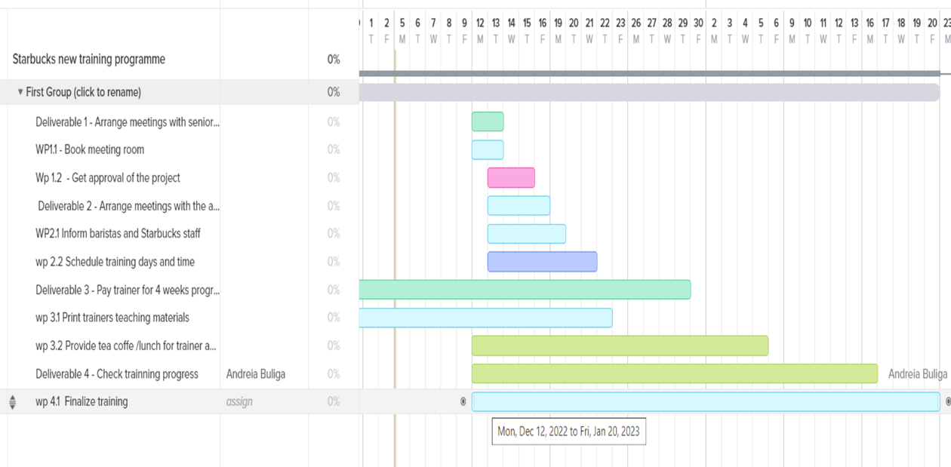

Stakeholders’ analysis and communication plan

“Stakeholder analysis is a technique that helps first to identify and analyze the key stakeholders, and later to manage relationships with them. Usually, stakeholder analysis includes the following type of information: names and organization of the key stakeholders, their roles in the project, unique facts about each stakeholder, level of interest in the project, their influence on the project and suggestions for managing relationships with each stakeholder”. (Schwalbe 2009: 82.)
High Power  Senior Management – 5  Investors – 5  Environoment - 4 | Low  Trainers - 2  Neighbours – 1  Employees – 2  Customers – 1  Suppliers – 2
High interest  Trainers - 5  Senior Management - 6  Investors - 6  Neighbours – 5  Customers – 5  Employees – 6  Suppliers – 5  Interest 1- 6 | Low  Environment - 2
A stakeholder is anyone who is or may be involved/affected by your project and therefore may have an interest in it. Below is a stakeholder analysis of the power and interest of the stakeholders involved in my project.

Stakeholders
Customers,
Power 1- 6
Employees
Neighbors
Trainers
Senior management
Suppliers
Environment

Stakeholder Communication plan

It is important in a project to have a good plan of communication with the stakeholders and understand the individual’s communication needs. to succeed as project managers, we must be able to communicate effectively with our stakeholders as ineffective communication can lead to misinformation and can be very harmful to the project.
A strong communication plan keeps stakeholders focused on strategic messages and minimizes the risk of insecurity. Keeping them informed and making needed information available in a short period of time.
The process of the communication plan for this project is to Plan communications management, executing the plan by managing the communications with stakeholders using different channels of communication and monitoring and controlling process.
Below is the list of stakeholders and the communication plan made with them.
Stakeholder names | Engagement action | Communication channel | Frequency
Senior management | Keep satisfied | Emails, regular meetings | Start of the project
Investors | Keep satisfied | Emails | Start of project
Employees | Manage closely | Emails and regular meetings | Star of the project
Neighbors | Keep informed, monitor | Emails | After the project
Trainers | Monitor | Conversations, email, meetings | Beginning of the project, during and end of the project.
Customers | Monitor and keep informed | Advertisements | End of the project

er names

Risk Assessment and matrix
Covid has made a huge impact on businesses such as distancing between people has made large queues at Starbucks and not only;
People not socializing with each other like before.
shortage of stuff for the safety of the employee.
Because of safety measurements, serving is taking longer at Starbucks
Risk is the quantifiable likelihood of loss or less than expected returns”

Identify the risks and identify the possibility of the impact of the risks within the matrix
Health and safety risks, environmental risks, financial risks, the trainers being sick.
The risk could be for the trainer (cooker) to cancel at last moment the training.
Matrix
In this matrix table, I am showing the probability of the risks that can happen within the project
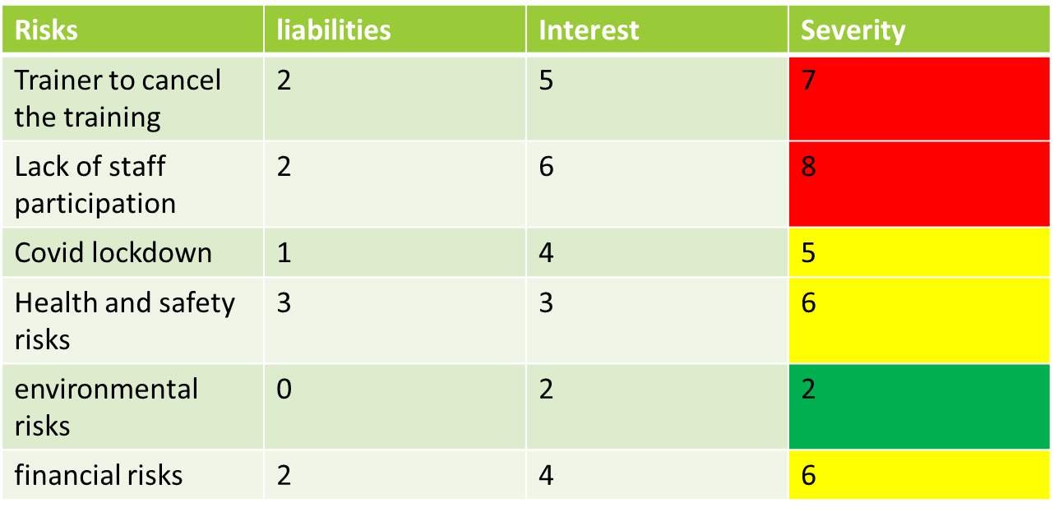
0 -2 = Low - Green
3 – 6 = Medium - yellow
7- 8 = High - red

Cost analysis

The cost analysis in a project is designed to assess the costs and comparing to the benefits in the project proposal this includes a list with all the expenses of the project.
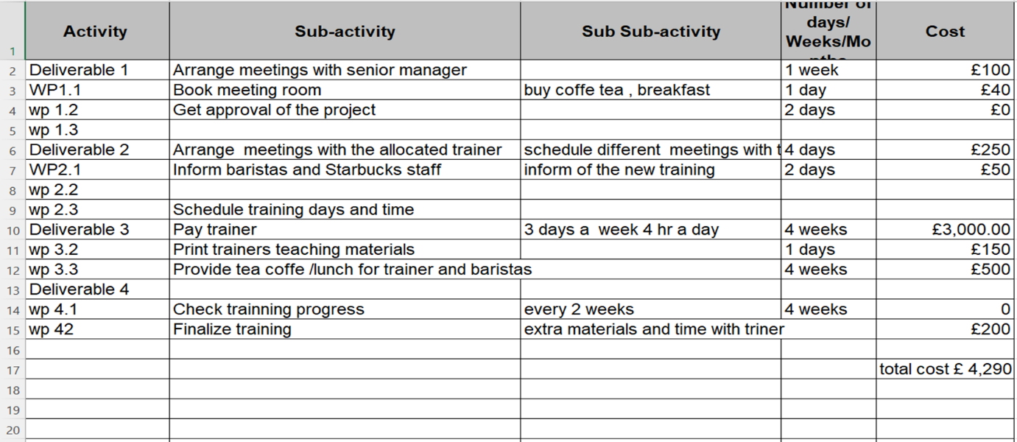
Below I have the list of the project cost for the training which will be a total of £4.290 including the deliverables divided in small part and my own time.

Evaluation

This project is initiated with the project life cycle theory, to make a structure for the project which is easier to follow, and which means we have to go through each phase for the next one to happen from start to end of the project. The phases are Project initiation, planning, execution project monitoring and controlling and project closure the end of the project.

Project life cycle theory
“It’s the order of processes and phases used in delivering projects. It describes the high-level process of delivering a project and the steps you take to make things happen.
how project stages guide a team from brief to delivery. Every project has a beginning and an end; it is born, matures, and ultimately "dies" at the conclusion of the project life cycle."

Conclusion
Furthermore, from this study it has been concluded that there is a need for a structure and various stages of project management tools and techniques to be followed in order to obtain a successful project.
Taking a project from a start to an end could be very difficult if the planning is not done accurately. I have learned how to develop my planning skills within this module and make my work easier by dividing it into small parts.
Even small projects in life can be managed very successfully if there is a proper plan in process and an appropriate communication structure to follow as communication is the most important aspect in a project in order to succeed.

References

Chuang, H.J., 2019. Starbucks in the world. Journal of Business and Public Administration. 10(3). pp.99-110.
Atkinson, R. 1999, "Project management: cost, time and quality, two best guesses and a phenomenon, its time to accept other success criteria", International Journal of Project Management, vol. 17, no. 6, pp. 337-342. [Accessed 29 Nov. 2022].

Devi, T. Rajani, and V. Shobha Reddy. "Work breakdown structure of the project." Int J Eng Res Appl 2.2 (2012): 683-686. [Accessed 2 Jan. 2023

Desk3 (2016). Starbucks partners with Italy’s Princi bakery. [online] Comunicaffe International. Available at: https://www.comunicaffe.com/starbucks-partners-with-italys-princi-bakery/ [Accessed 20 Dec. 2022].

Starbucks stories & News. 2020. At a glance: What customers need to know about Starbucks response to Covid-19. [Online]. Available through: https://stories.starbucks.com/press/2020/what-customers-need-to-know-about-starbucks-response-to-covid-19/ [Accessed 04 Jan 2023].
Starbucks. 2019. Starbucks Company Timeline. [Online]. Available through: https://www.starbucks.com/about-us/ [Accessed 04 Jan 2023].
Andrew Thompson (2015). Starbucks Coffee’s Stakeholders: A CSR Analysis. [online] Panmore Institute. Available at: https://panmore.com/starbucks-coffee-stakeholders-csr-analysis. [Accessed 30 Dec. 2022].
A.Cooke (2016). Starbucks to bake in-store. [online] British Baker. Available at: https://bakeryinfo.co.uk/finished-goods/starbucks-to-bake-in-store/622151.article [Accessed 4 Dec. 2022].
app.teamgantt.com. (n.d.). TeamGantt. [online] Available at: https://app.teamgantt.com/projects/gantt/edit/127417552?ids=3319155 [Accessed 4 Dec. 2022].
Evelyn F. (2013). ENTERPRISE RISK MANAGEMENT: STARBUCKS´ [online] ENTERPRISE RISK MANAGEMENT. Available at: http://risk-management-hra.blogspot.com/2013/12/starbucks-risk-management-plan.html. [Accessed 28 Nov. 2022].
Uusitalo, J. (2013). Project Management in Practice: Evaluating a Case Project through Project Management Theories. [online] Available at: https://www.theseus.fi/bitstream/handle/10024/62707/Uusitalo_Jenni.pdf?sequence=1&isAllowed=y [Accessed 28 Nov . 2022].
Manager, T.D.P. (2022) What Is The Project Life Cycle: The 5 Phases & Why It’s Still Important. Available at: https://thedigitalprojectmanager.com/projects/pm-methodology/project-management-life-cycle/.
[Accessed 20 Dec. 2022].
Wilson, J. M. (2003). Gantt charts: A centenary appreciation. European Journal of Operational Research, 149(2), 430-437.
Eldridge, J., & Mason, T. (2010). Communicating with stakeholders. New directions for student services, 2010(129), 43-58.

