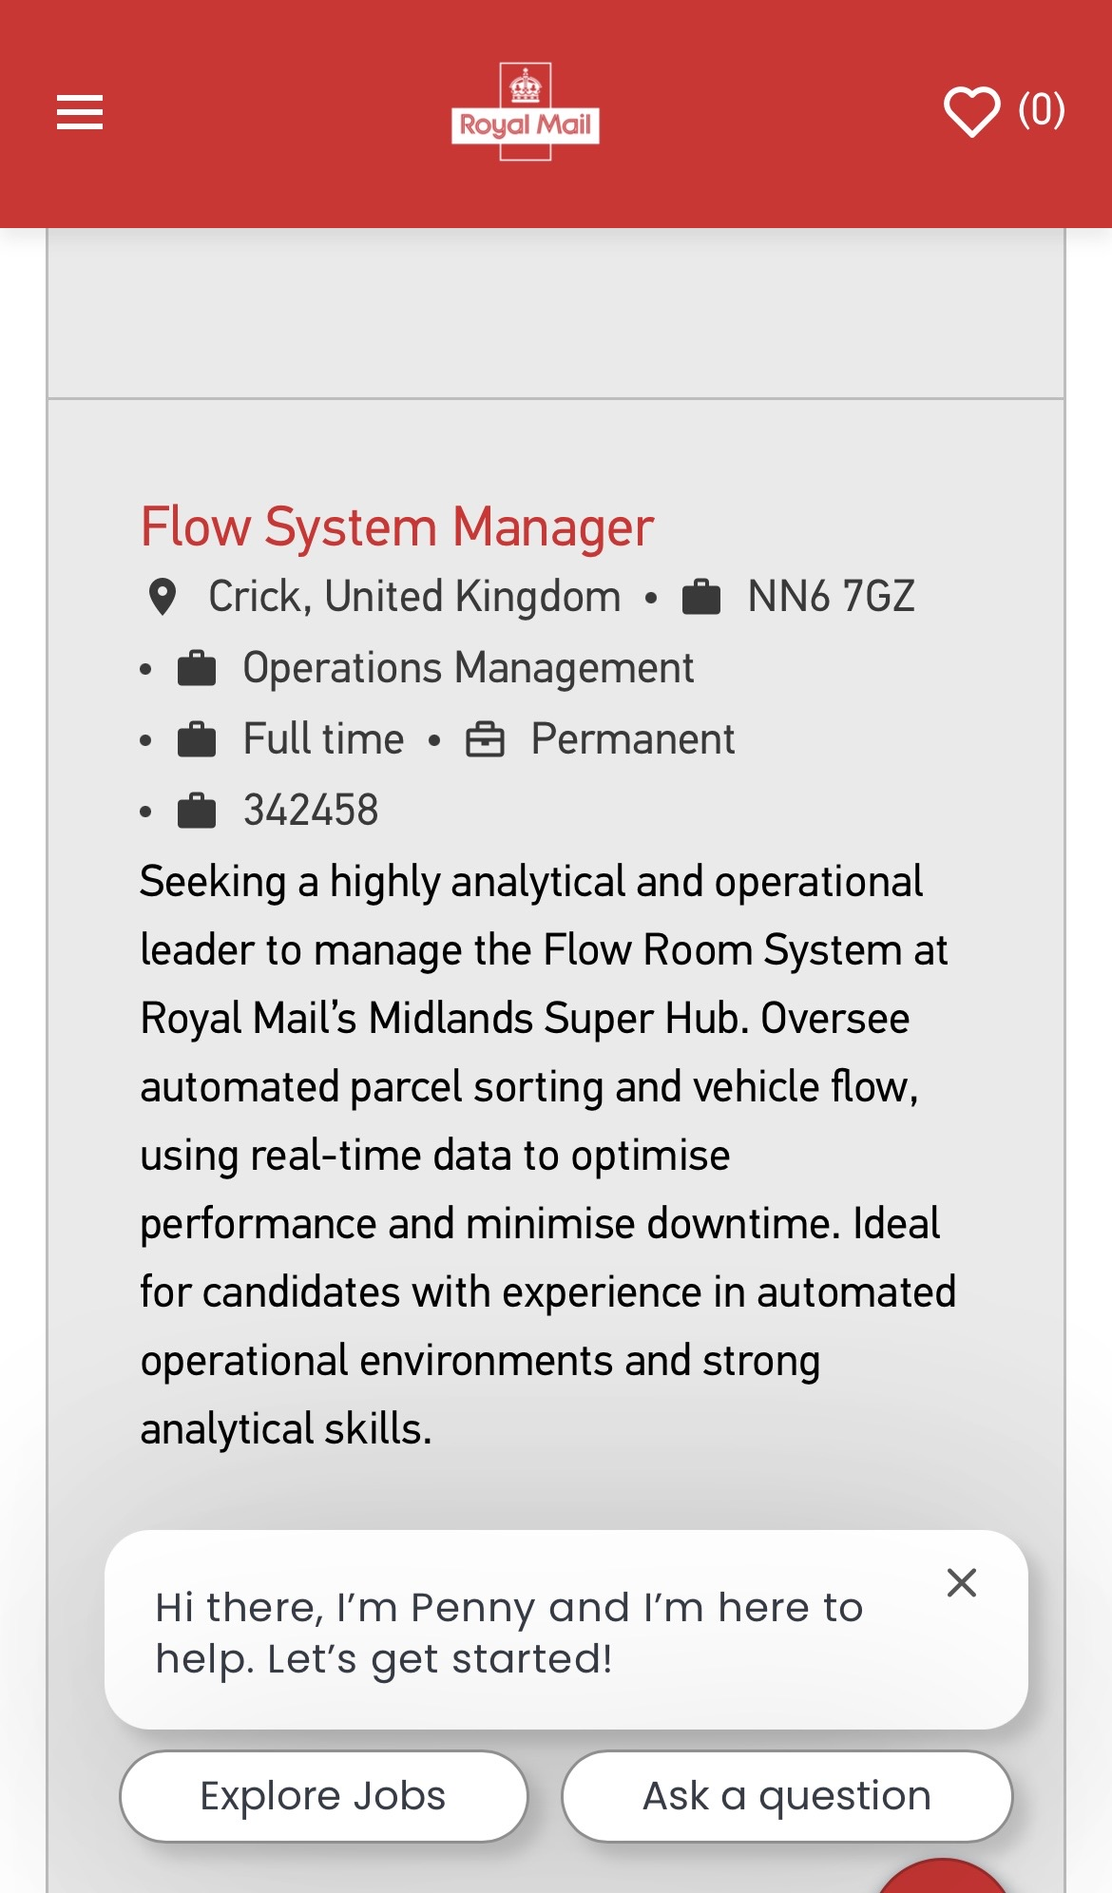
FULL JOB ADVERT — FLOW SYSTEM MANAGER (REF: 342458)

Flow System Manager
Salary: Starting at £36,353, 10% bonus potential, 25 days annual leave, company pension scheme
Location: Midlands Super Hub, Dirft Drive, Crick, NN6 7GZ
Type: Permanent, Full time
Shift Pattern: Tuesday to Saturday
• Tuesday: 10am – 7pm
• Wednesday, Thursday, Friday & Saturday: 11am – 7pm
About the Role

Royal Mail is looking for a highly analytical and operationally focused Flow Room System Manager to join the Midlands Super Hub. Working at the heart of one of Royal Mail's most advanced automated operations, you'll ensure parcels flow efficiently through the Automated Parcel Sorting System (APSS), supporting the movement of millions of items through the network.

This is a critical operational role, acting as the link between Operations and Engineering teams while using live system data to maximise performance, minimise downtime and ensure efficient flow of parcels, vehicles and automated equipment across the site.

You'll monitor and manage a range of systems that control the flow of parcels, trailers and automated vehicles across the hub. You'll make business-critical decisions using real-time operational data, helping prevent bottlenecks, responding to incidents and coordinating engineering activity to maximise system availability and operational efficiency. You'll become a key point of expertise for the APSS, SCADA, Warehouse Management System and Yard Management systems.

Key Responsibilities
• Monitor and manage automated sorting systems to maximise performance, utilisation and availability
• Make real-time operational decisions to manage flow, bottlenecks and system issues across the site
• Coordinate engineering activity and prioritise faults to minimise operational impact
• Manage vehicle flow through the yard management system to optimise site efficiency
• Review operational data and identify opportunities for preventative maintenance and continuous improvement
• Provide first-line support for operational, mechanical and system-related issues
About You

You enjoy working in fast-paced operational environments where technology and decision-making come together. You're comfortable analysing data, solving problems and making informed decisions under pressure. You can quickly build strong relationships with both operational and technical teams and are confident translating technical issues into practical solutions.

What You'll Bring (Person Specification)
• Experience working within a control room, flow room or automated operational environment
• Strong analytical and problem-solving skills
• Experience using operational systems such as SCADA, WMS or similar platforms
• Strong Microsoft Office and Excel capability
• Ability to communicate technical information to non-technical audiences
• Understanding of continuous improvement principles and operational performance management
Interview Process

The next stage will be a face-to-face interview consisting of competency-based and role-specific questions along with a scenario exercise. Interviews planned for w/c 21st September at Midlands Super Hub. Royal Mail will provide interview questions in advance.

CURRICULUM VITAE
Betty Anita Owusu
37 Deepmore Road, Rugby, Warwickshire, CV22 7PY, England.
Contact: 07947 548850 | erynholly2@yahoo.com
Professional Summary
An experienced postal operations professional with over twenty years of service at Royal Mail Group, encompassing extensive frontline experience in sorting, parcel flow and delivery operations. Skilled in the operation of automated sorting machinery, including the Intelligent Letter Sorting Machine (ILSM), Parcel Sorting Machine (PSM) and Flats Letter Sorting Machine (FSM). Possesses a strong understanding of high-volume automated environments and the operational requirements of major mail hubs. Currently undertaking a Level 4 Certificate in Business Skills for the Workplace, developing competencies in leadership, project management and organisational operations. Aspires to progress into the Flow System Manager role at Royal Mail’s Midlands Super Hub, bringing substantial operational expertise, hands-on technical capability and a long-standing commitment to Royal Mail’s performance standards.
Operational Competencies
- Automated sorting machine operation: ILSM, PSM, FSM
- Parcel and letter sorting processes
- Understanding of automated flow systems
- Route planning and delivery logistics
- Consistent achievement of daily operational targets
- Health and Safety compliance
- Process accuracy and quality assurance
Analytical & Problem-Solving Skills
- Proficient in Microsoft Excel and Word
- Monitoring and interpreting operational performance data
- Identifying and resolving workflow inefficiencies
- High attention to detail in fast-paced environments
Teamwork & Communication
- Effective team collaboration and coordination
- Supporting colleagues during peak periods and staff shortages
- Reliable and consistent under pressure
- Strong verbal and written communication skill

Work Experience
Royal Mail Group — Postwoman, Operational Grade December 2022 – Present
- “Sort parcels and letters efficiently to meet strict daily operational targets.”
- Operate and monitor automated sorting machinery (ILSM, PSM, FSM).
- Respond to machine alerts and flow issues to minimise downtime.
- Manage delivery routes to ensure timely and accurate completion.
- Work within a high-volume operational environment to maintain smooth mail flow.
- Uphold accuracy and security standards when handling mail and parcels.
- Liaise professionally with customers and colleagues to resolve issues.
- Adhere to and promote health, safety and operational procedures.
- Support team workflows during peak periods and staff shortages.
Royal Mail Group / Courier Industry — Operational Roles 2002 – 2022
- Extensive frontline experience across sorting, and mail centre depot operations.
- Operated automated sorting systems for letters, parcels and flats.
- Developed strong knowledge of postal logistics, routing and operational standards.
- Consistently met performance, punctuality and accuracy targets.
- Built strong working relationships across teams and depots.
Safeway Supermarket — Cashier 2000 – 2002
- Delivered friendly and efficient customer service at checkout.
- Accurately handled cash and card transactions.
- Assisted customers with queries and resolved issues professionally.
Education
University of Wales Trinity Saint David Level 4 Certificate in Business Skills for the Workplace (In Progress, 2026) Modules include: Effective Teams and Communication, Problem Solving.
City and Essex College Functional Skills: Maths and English (2024 – 2025)
Additional Information
- Trained operator: ILSM, PSM, FSM
- Available for shift work and flexible hours
- Fluent in English
- Long-standing Royal Mail employee with strong understanding of organisational culture and operational standards
- References
Available upon request.
COVER LETTER
Betty Anita Owusu
37 Deepmore Road Rugby, Warwickshire, CV22 7PY
Contact: 07947 548850 | erynholly2@yahoo.com
16th September 2026
Hiring Manager Royal Mail — Midlands Super Hub Crick, NN6 7GZ
Re: Flow System Manager (Ref: 342458)
Dear Hiring Manager,
“I am writing to apply for the Flow System Manager position at Royal Mail's Midlands Super Hub.” With over twenty years of operational experience at Royal Mail, including extensive hands-on work with automated sorting machinery, I have developed a deep understanding of the systems, workflows and performance standards that underpin Royal Mail’s operations. I am now seeking to apply this knowledge within a management capacity.
Experience in automated operational environments is central to this role, and I bring direct, practical expertise. “I am a trained operator on the Intelligent Letter Sorting Machine (ILSM), the Parcel Sorting Machine (PSM) and the Flats Letter Sorting Machine (FSM).” This experience has given me a detailed understanding of how machine performance, parcel and letter flow, and vehicle movement interact to drive output. I am accustomed to monitoring real-time performance, responding promptly to machine alerts and flow issues, and working to minimise downtime.
Across two decades on the frontline, I have developed strong analytical and problem-solving skills. I am confident making informed decisions under pressure, whether responding to a machine alert, clearing a blockage or adapting to changes in flow. I am comfortable working with operational systems and am keen to further develop my capability in SCADA, Warehouse Management Systems and Yard Management Systems.
I am currently studying a Level 4 Certificate in Business Skills for the Workplace, which is strengthening my knowledge in leadership, project management and business operations. Alongside my Functional Skills in Maths and English, this demonstrates my commitment to continuous improvement and my readiness to progress into a management role. I am also actively developing my Microsoft Office and Excel skills to support the data analysis requirements of the position.
As an existing Royal Mail employee, I have a strong understanding of the organisation’s values, safety standards and operational expectations. My first-hand experience with automated systems at the Midlands Super Hub further positions me to contribute effectively to the Flow Room System. I am enthusiastic about the opportunity to continue developing within Royal Mail and to support the success of the Midlands Super Hub.
Thank you for considering my application. I would welcome the opportunity to discuss how my operational background and developing management skills can contribute to your team.
Yours sincerely,
Betty Anita Owusu

Reference
Royal Mail Group Careers

