F2 Essay
Tim Corfield
MA Commercial Music Producer
Word Count: 3082

Introduction
This essay is to reflect on the music genres, production techniques, and the defining characteristics of the reference tracks that I have chosen and to discuss how these techniques have been applied to my music.
I have analysed three contemporary commercial music tracks from three different genres and I have even chosen genres that I am not comfortable with, nor have any experience in making music for. The three genres music are pop as represented by Taylor Swift’s Lavender Haze (Swift, 2023), synth and 80s pop as represented by The Weeknd’s song Blinding Lights (The Weeknd, 2020), and for my favourite genre I have chosen an electronic artist called Orbital with the song There Will Come a Time (Orbital, 2019).
Orbital is one of my favourite electronic artists, having listened to their music since I was eleven years old. I have always enjoyed their music as it appeals to some of my other interests such as science fiction. In particular, what draws me to the sounds of Orbital is the use of sampled sound bites from various film and TV shows, as well as the use of big synthesiser sounds and the mix of analogue and digital hardware.
Taylor Swift is an artist that I have admired over the years. To me she is an artist that can adapt her musical styles to suit growing trends within the music industry, not relying on one genre to define her music through the years. She has worked with several producers on her albums, such as Jack Antonoff, a producer who I admire for his use of analogue synthesise sounds and mixing them with live instruments. Her silky voice combined with storytelling lyrics I have also enjoyed.
The third artist that I used as my inspiration is a Canadian singer The Weeknd. His song Blinding Lights touches on another genre of music that is also one of my favourites, 80s pop. If we look at the music of the 80s, we are blessed with a joyous sounds of Phil Collins and we only have to imagine somebody dressed in a gorilla suit playing the drum kit to In The Air Tonight which was seen on a advert released in the UK (The Guardian, 2015).
We will explore the defining characteristics of the genres and try to conform some of these arrangements and production techniques to my own music production, I will also be developing my own techniques taking inspiration from all three songs for example, the big cinematic sounds of Blinding Lights (Vulture, 2021), all the science fiction sounds of Orbital (ReGen Magzine, 2019) and applying those from some of my favourite films. The inspiration I shall take from artist Taylor Swift is the storytelling lyrics (Castillo, 2022) combined with silky smooth vocals.

Orbital – There Will Come A Time
To choose my favourite orbital song is trying to choose my favourite type of curry there are just so many dishes out there that really do appeal to the pallet, this is quite essentially the same when choosing your favourite tune from the two brothers that formed in 1989. Orbital is an English electronic music duo brothers Phil and Paul Hartnoll. When you listen to the albums that Orbital have created you can hear melodic soundscapes, blending elements of techno, trance, ambient, and break beat genres. The duo also for known for their unconventional instruments samples such as the NASA transmission of challenger disaster in their music, Prof Brian Cox talking about the universe how eventually will also come to our demise. Orbital's sound has been described as innovative and adventurous and their live performances are renowned for their energetic and immersive nature (Resident Advisor, 2023). Their music often features intricate melodies and builds up to euphoric and hypnotic climaxes, creating a sense of transcendence and emotional intensity.
The band has released numerous critically acclaimed albums and singles, including their debut self-titled album Orbital (1991) and the hit single "Chime" (1989). Their music has been significant in the development of the electronic music scene in the UK and around the world, inspiring many other artists to experiment with electronic sounds and styles, as well as how these came together in albums (Cardew, 2021). Overall, my view of Orbital is that they are a pioneering band in the electronic music genre known for their innovative in boundary pushing approach to music production.
If we look at Monsters Exist which is the ninth studio album by orbital and released in 2018. The album is a combination of the bands signature sound, characterised by hardware-based synthesisers and live instrumentation. Listeners can expect there to be one or two vintage synthesisers such as the Roland TR90 nine and TR 808 (see appendix B) and potentially sounds from the Jupiter six; “of course, vintage boxes like the original Roland TR90 nine, TR NATO eight, Jupiter six, SH 101, and TB 303 are represented along with modern classics such as the Korg Prophecy” (Keyboard, 2002).
Despite being limited with funds to purchase hardware synthesisers and drum machines there are some great virtual sounds which are produced by native instruments and Steinberg’s Cubase software. Using the Vital Synth made by Vital Audio is a powerful tool with its four sound generators and spectral oscillator warping features list goes on “Give new life to wavetables by using Vitals’ spectral oscillator warping” (Vital, 2023). Using this VST plug-in gives a human element to creating similar production techniques that Phil and Paul Hartnoll have used in their notable Orbital sound. Using VST plugins combined with a MIDI controller giving a human element to that control of a synthesiser. Using the Akai Midimix, the user is able to assign certain controls to some of the settings if the VST plugin thus humanizing the performance of that sound. “There are all kinds of ways to humanize programmed music. You can change the velocity of notes, shift things slightly so they do not perfectly align, and program changes in overall tempo, among others” (DIY Film Composer, 2020).
Other techniques of this human element is to use hardware synths such as the Roland Juno 6 and the Korg microKorg synth (see appendix D). Some of the advantages of using the Korg were in being able to control the playback through the midi interface which allowed the human to keep control on the sound. Unfortunately, this level of connection is not available on the Roland Juno 6 (see appendix E) and so therefore it relies solely on the human element of control when creating the sounds applied to the Orbital track.
One notable technique used in Monsters Exist is the layering of sounds. According to Phil Hartnoll, one half of the musical duo, the layering of sounds was used to create depth and complexity in the album's tracks (Waters, 2018). The layering of sounds involved the use of multiple synthesizers and drum machines to create different textures and tones. This technique is evident in tracks such as "P.H.U.K.", where the use of multiple synth lines creates a dense and intricate sound. Incorporating multiple synth lines using Steinberg’s Cubase VST plug-ins as well as vital synth and the massive X plug-in from native instruments I was able to create similar production techniques to create a dense and intricate sounds particularly layering multiple drum sounds to create different textures and tones.
Another technique used in the production of Monsters Exist is the use of field recordings. The duo utilized sounds from everyday life, such as the sound of birds chirping, and incorporated them into their tracks to create a sense of realism and immersion (Collins, 2018). This technique is evident in tracks such as "Monsters Exist," where the use of field recordings helps to create a sense of place and atmosphere.
If we look back to 1996 when orbital release the album insides you can certainly hear their use of field recordings used in songs. Not only do you feel recordings but also you can hear a more human touch to their music, such as when their big track Dwr Budr which was inspired by the big oil’s slick disaster of the Pembrokeshire Coast (Wikipedia, 2022). I was able to create the same atmospheric feel by using layered sounds from which were VST plugins from native instruments and vital audio.
You can hear the influence of Orbitals techniques in my White Whale Come track where I have sampled Capt. Picard from Star Trek quoting his famous Moby Dick poem (Star Trek: First Contact, 1996). Along with my other favourite iconic film directed by Ridley Scott’s The Martian, (2015).
Another important aspect of the production on "There Will Come a Time" is the use of dynamic processing to shape the sound of the track. Compression and limiting are used to control the levels of individual elements in the mix, ensuring that the track sounds balanced and cohesive. Additionally, the track features a number of subtle effects, such as reverb and delay, which add depth and space to the sound. Some of the dynamics have been used in a similar way such as side chaining the kick drum with the bass line so that there is a balance to the sounds.
If we look at similar retro acts then we look to the sounds of Leftfield and their debut album in 1995 Leftism. Their use of hardware since such as the 808 and the Jupiter six layered up amongst other sounds on this album. “There Will Come a Time” is one of Orbitals iconic tunes which has features a range of techniques and technologies to create a powerful and immersive listening experience. Orbital have stuck to their roots of using analogue synths combining with digital work stations.
To conclude my song the Whale White Come uses lot of techniques and processes inspired by artist Orbital. You can certainly hear other inspirations from similar artists such as Hybrid, Leftfield and many more. I certainly enjoyed making this piece of music and being able to indulge genre of film TV to get my samples to use on my track.

Taylor Swift – Lavender Haze
Taylor Swift's Midnights album, released in November 2021, has been one of the most anticipated albums of the year (Balasaygum, 2022). The album marks a departure from Swift's previous sound, incorporating more experimental elements of production and instrumentation. The album is consistent, focusing on the themes of love, loss, and rebirth. The lyrics are reflective, and Swift's vocals are delivered with an emotional strength that captures the raw emotion of the album.
One of the defining characteristics of Midnights is its use of atmospheric sounds and production techniques to create a dreamy, ethereal soundscape. As music critic Andy Von Pip notes, "a beautifully crafted album of minimalist ambient electronic pop imbued with subtle elegance" (Von Pip, 2022). This is evident throughout her album, though particularly in tracks such as "Lavender Haze" and "Anti Hero" which feature layered vocals, ambient sounds, and intricate instrumentation. The techniques of layering vocals have been used extensively in the board game pieces track. In some cases the decision was made to duplicate the main vocal four to five times. One could certainly would describe Taylor Swift vocals as heavenly, particularly when you add in various harmonies which adds to the layering of those vocals.
In Midnights Jack Antonoff likes to add movement into the various pads some of which are arpeggios. In board game pieces I have used up to several different pad sounds from various plugins ranging from native instruments, vital audio, and Steinberg's own plugins. I have attempted to produce my own feel of movement with the sounds including having an arpeggio and an ostinato. Finally, to finish the sense of movement and feel within the music I created a single melody line which hovers in the background of my music inspiration that I have taken directly from Jack Antonoff.
Some of the other techniques used in Taylors albums and certainly have been presence since her 1989 album has been these bass drones. Using the vital (see appendix C) sythn I was able to create the type of low drone bass that she uses in her songs “There are filtered synth tones, swoops of dubstep-influenced bass, trap and house-inspired beats and effects” (Petridis, 2022).
In addition to these production techniques, Antonoff also experimented with unconventional sounds and production methods. In his book Music Production Techniques (2018) Tomasz Stanko notes that "unconventional sounds and production methods can add a unique character and personality to a track." Antonoff's use of unconventional sounds, such as the distorted vocals in "Lavender Haze” adds a distinct and memorable element to the album. In order to create a sense depth to the vocals I added distortion which was a VST plugin from native instruments called bit crusher. The effect is subtle but achieves this sense of depth to the vocal. (see appendix F)
Antonoff also utilized various production techniques to create unique textures and atmospheres in Midnights. In his book, The Mixing Engineer's Handbook (2019) Bobby Owsinski notes that "reverb and delay can be used to create a sense of space and depth in a mix." Antonoff's use of reverb and delay in tracks such as Anti-Hero and Snow of the Beach ft. Lana Del Rey creates a dreamy and ethereal atmosphere that perfectly complements Swift's introspective lyrics. To achieve a similar effect, there was the desire to be creative with some of the vocals I wanted to get a specific delay to add more space which can be found in the chorus.
An artist that I have also been listening too which share similarities with Taylor Swift is Suki Waterhouse. Suki Waterhouse's music is characterized by a dreamy, ethereal quality, with hints of folk and indie influences. Her vocals are soft and delicate, often accompanied by simple guitar or piano melodies. This is in contrast, Taylor Swift's music, which is generally pop-infused country or pop, with catchy hooks and relatable lyrics. However, Taylor Swift also has those influences from indie music and if you look at her album Folklore it is a stripped down acoustic sound which contains those dreamy vocals “Critics and fans are calling Swift’s eighth full-length her “indie” album. Its stripped-down, quiet, filled with subtle piano, acoustic guitar and atmospheric production from The National’s Aaron Dessner….and the music certainly feels less concerned with pop for popularity’s sake” (Landry, 2023)
In conclusion I, personally, have found writing music for the pop genre most challenging; not only is it a genre that I am not particularly fond of or have any experience but it is clear that there are many different production techniques that are used. Certainly it is giving me a new appreciation for the work and efforts that go into the making of these albums, specifically that of the writers and producers.

The Weeknd - Blinding Lights
The Weeknd's album After Hours, released in March 2020, has been critically acclaimed for its genre-bending sound and introspective lyrics, “ultra-cinematic keyboards, pulsating sub-bass, hard beats, ‘80s synthesizer flourishes and caverns of echo, all of which contrast with his high, angelic voice” (Aswad, 2020). The album is considered by many to be a defining moment in The Weeknd's career, showcasing his growth as an artist and his ability to seamlessly blend genres.
One of the defining characteristics of After Hours is its use of retro influences. The album features an eclectic mix of sounds and genres, including 80s synth-pop, funk, and R&B; The Weeknd has cited Michael Jackson, Prince, and David Bowie as some of his major influences, and their presence can be felt throughout the album (Scott, 2013; Skinner, 2012; Reed, 2016). The use of retro influences is particularly evident on tracks such as Blinding Lights which features an 80s-inspired synth melody, and Save Your Tears, which has a disco-inspired beat.
The album's production features a mix of electronic and organic instruments, with orchestral elements adding to the cinematic feel. The Weeknd's vocals are also heavily processed (Make Pop Music, 2021), giving them an otherworldly quality that adds to the album's dreamlike atmosphere.
One of the most distinctive production elements of "Blinding Lights" is its use of 1980s-inspired synthesizer sounds. The song's retro aesthetic is achieved through the use of instruments like the Roland Juno-60, a classic synth used heavily in 80s pop music. The synths used in Blinding Lights are not only reminiscent of the era but also contribute to the song's infectious energy and driving rhythm.
The song's drums are another crucial component of its production. The drums in Blinding Lights are punchy, powerful, and expertly programmed to create a driving, upbeat feel. The snare and kick drums in particular are mixed to sit prominently in the mix, driving the song forward and contributing to its overall energy (Schofield, 2020). The use of drum machines and electronic percussion elements helps to create a polished, modern sound that fits with the song's pop sensibilities.
The gated snare drum sound is a distinctive production technique that was popularized in 80s pop music. This technique involves heavily compressing the snare drum track and using a noise gate to cut off the decay of the snare sound. The result is a sharp, explosive sound that has become iconic in many 80s pop hits. One of the pioneers of the gated snare sound was producer Hugh Padgham, who used the technique on Phil Collins' hit single "In the Air Tonight" in 1981 (The Guardian, 2015).. Padgham used a combination of close-miking and heavy compression on the snare drum, followed by a noise gate with a fast attack and release time. The result was a snare sound that cut through the mix with a powerful, percussive attack and minimal decay.
Another key factor in the gated snare sound is the use of reverb. Rather than applying reverb to the entire drum kit, producers would often send just the snare track to a reverb unit, creating a big, ambient tail that would contrast with the sharp, gated attack of the snare. This technique was used on many iconic 80s tracks, including Girls Just Want to Have Fun by Cyndi Lauper and West End Girls by Pet Shop Boys.
In conclusion the production techniques used in Blinding Lights are expertly crafted to create a cohesive, engaging listening experience. The use of vintage synths and drum machines contributes to the song's nostalgic feel while also giving it a modern edge. The layered vocals and effects add depth and variation, keeping the listener engaged throughout the song's runtime.

References:
Aswad, J. (2020) The Weeknd’s ‘After Hours’: Album Review. Variety. 20th March. Available at: https://variety.com/2020/music/reviews/the-weeknd-after-hours-album-review-1203539981/
Balasaygum, K. (2022) How Taylor Swift went back to the past and turned ‘Midnights’ into her biggest album success yet. Available at: https://www.cnbc.com/2022/11/01/how-taylor-swift-made-midnights-her-biggest-success-yet.html
Cardew, B. (2021) How Orbital’s exploratory debut album re-wrote the rule book for rave. Available at: https://djmag.com/longreads/how-orbital-s-exploratory-debut-album-re-wrote-rule-book-rave
Castillo, L. (2022) Taylor Swift is a storytelling mastermind in ‘Midnights’. Available at: https://tomasinoweb.medium.com/taylor-swift-is-a-storytelling-mastermind-in-midnights-1e79b43b7bc5
Collins, H. (2018). Orbital: Monsters Exist. Available at: https://www.popmatters.com/orbital-monsters-exist-review-2591679091.html
DIY Film Composer. (2020) Next-Gen Midi Controllers. Available at: https://www.diyfilmcomposer.com/next-gen-midi-controllers/
Harding, C. and Sloan, N. (2012) How ‘Blinding Lights’ Used Retro Sounds and Modern Bass to Break Records. Vulture. 7th February. Available at: https://www.vulture.com/article/how-the-weeknd-blinding-lights-chart-records.html
Landry, W. (2023) IS TAYLOR SWIFT'S NEW ALBUM AN INDIE RECORD?. Available at: https://www.naturalmusic.co/blog-posts/is-taylor-swifts-new-album-an-indie-record
Lauper, C. (2010) Cyndi Lauper - Girls Just Want To Have Fun (Official Video). Available at: https://www.youtube.com/watch?v=PIb6AZdTr-A
Make Pop Music (2021) How To Make A Song Like The Weeknd (Blinding Lights, In Your Eyes, Faith) | Make Pop Music. Available at: https://www.youtube.com/watch?v=H2d3y58rSYU
Make Pop Music (2022) How To Make A Song Like Taylor Swift's Album Midnights (+ FREE SAMPLES & PRESETS) | Make Pop Music. Available at: https://www.youtube.com/watch?v=EVZJzwHahDo
Media Monkey (2015) Is Cadbury's drumming gorilla the best ad of all time?. The Guardian. 21st September. Available at: https://www.theguardian.com/media/mediamonkeyblog/2015/sep/21/is-cadburys-drumming-gorilla-the-best-ad-of-all-time
Orbital (2019) Orbital - There Will Come A Time feat. Prof. Brian Cox (official audio). Available at: https://www.youtube.com/watch?v=g0w6fpTo5Tg
Owsinski, B. (2019) The Mixing Engineer's Handbook. Routledge.
Pet Shop Boys (2010) Pet Shop Boys - West End Girls (Official Video) [HD REMASTERED]. Available at: https://www.youtube.com/watch?v=p3j2NYZ8FKs
Petridis, A. (2022) Taylor Swift: Midnights review – small-hours pop rich with self-loathing and stereotype-smashing. The Guardian. 21st October. Available at: https://www.theguardian.com/music/2022/oct/21/taylor-swift-midnights-review-small-hours-pop-rich-with-self-loathing-and-stereotype-smashing
Preeve, F. (2002) Band: Orbital. Keyboard. Volume 28, Issue 4.
Reed, R. (2016) The Weeknd Talks David Bowie, Prince Influences on New Album. Rolling Stone. 2nd November. Available at: https://www.rollingstone.com/music/music-news/the-weeknd-talks-david-bowie-prince-influences-on-new-album-122216/
Regen Magazine (2019) Orbital – Monsters Exist. Available at: https://regenmag.com/reviews/orbital-monsters-exist/
Resident Advisor (2023) Orbital: Biography. Available at: https://ra.co/dj/orbital/biography
Schofield, N. (2020) THE WEEKND - Blinding Lights [Musician's] Reaction & Review!. Available at: https://www.youtube.com/watch?v=OsfzKEP1wBg
Scott, D. (2013) The Weeknd: Kiss And Tell (2013 Cover Story). Available at: https://www.complex.com/music/2013/07/weeknd-interview-cover-story
Skinner, T. (2021) The Weeknd says ‘Grand Theft Auto: Vice City’ “opened my eyes to a lot of ’80s music”. NME. 24th November. Available at: https://www.nme.com/news/music/the-weeknd-grand-theft-auto-vice-city-80s-music-3103875
Stanko, T. (2018) Music Production Technology. Routledge
Star Trek: First Contact. 1996 [Film] Jonathan Frakes, dir. USA; Paramount Pictures.
Swift, T. (2022) Taylor Swift - Anti-Hero (Official Music Video). Available at: https://www.youtube.com/watch?v=b1kbLwvqugk
Swift, T. (2022) Taylor Swift ft. Lana del Rey - Snow On The Beach (Official Lyric Video). Available at: https://www.youtube.com/watch?v=ycE7bUq3-2k
Swift, T. (2023) Taylor Swift - Lavender Haze (Official Music Video). Available at: https://www.youtube.com/watch?v=h8DLofLM7No
The Martian. 2015 [Film] Ridley Scott, dir. UK and USA. 20th Century Fox.
The Weeknd (2020) The Weeknd - Blinding Lights (Official Audio). Available at: https://www.youtube.com/watch?v=fHI8X4OXluQ
Vital (2023) Vital. Available at: https://vital.audio/
Von Pip, A. (2022) Taylor Swift Midnights. Available at: https://www.undertheradarmag.com/reviews/midnights_taylor_swift
Waters, J. (2018) Orbital: Monsters Exist review – 'Their music is a reflection of what's going on in society'. Available at https://www.theguardian.com/music/2018/sep/13/orbital-monsters-exist-review-their-music-is-a-reflection-of-whats-going-on-in-society
Wikipedia (2022) In Sides. Available at: https://en.wikipedia.org/wiki/In_Sides#cite_note-8

Appendixes:
- Appenix A Tascam DAP1 (Image taken from Sound on Sound) 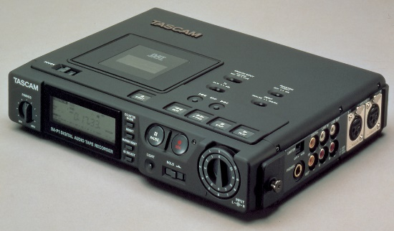
- Appendix B Roland TR-808 (Image taken from BBC) 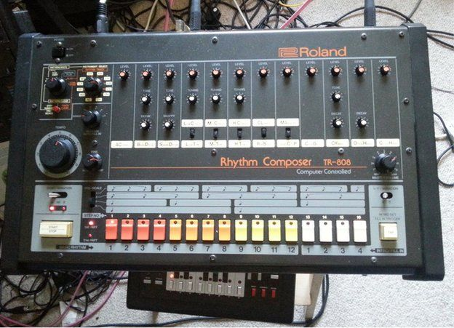
- Appendix C Vital Sythn (Image taken from KVR Audio)
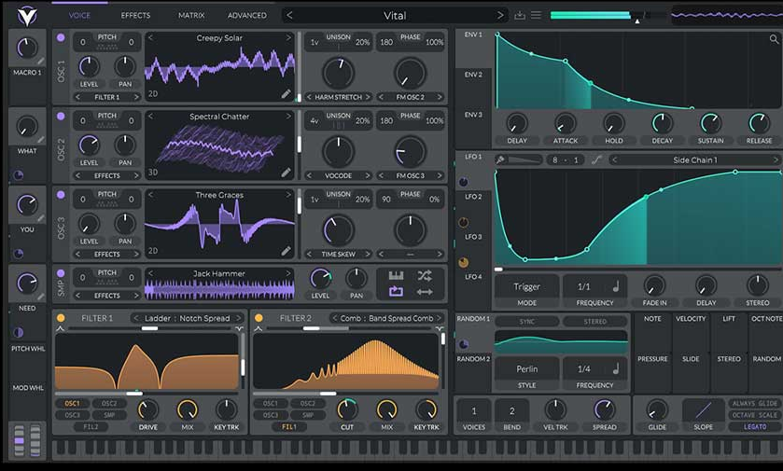
- Appendix D Korg Microkork (Image taken from Wikipedia)
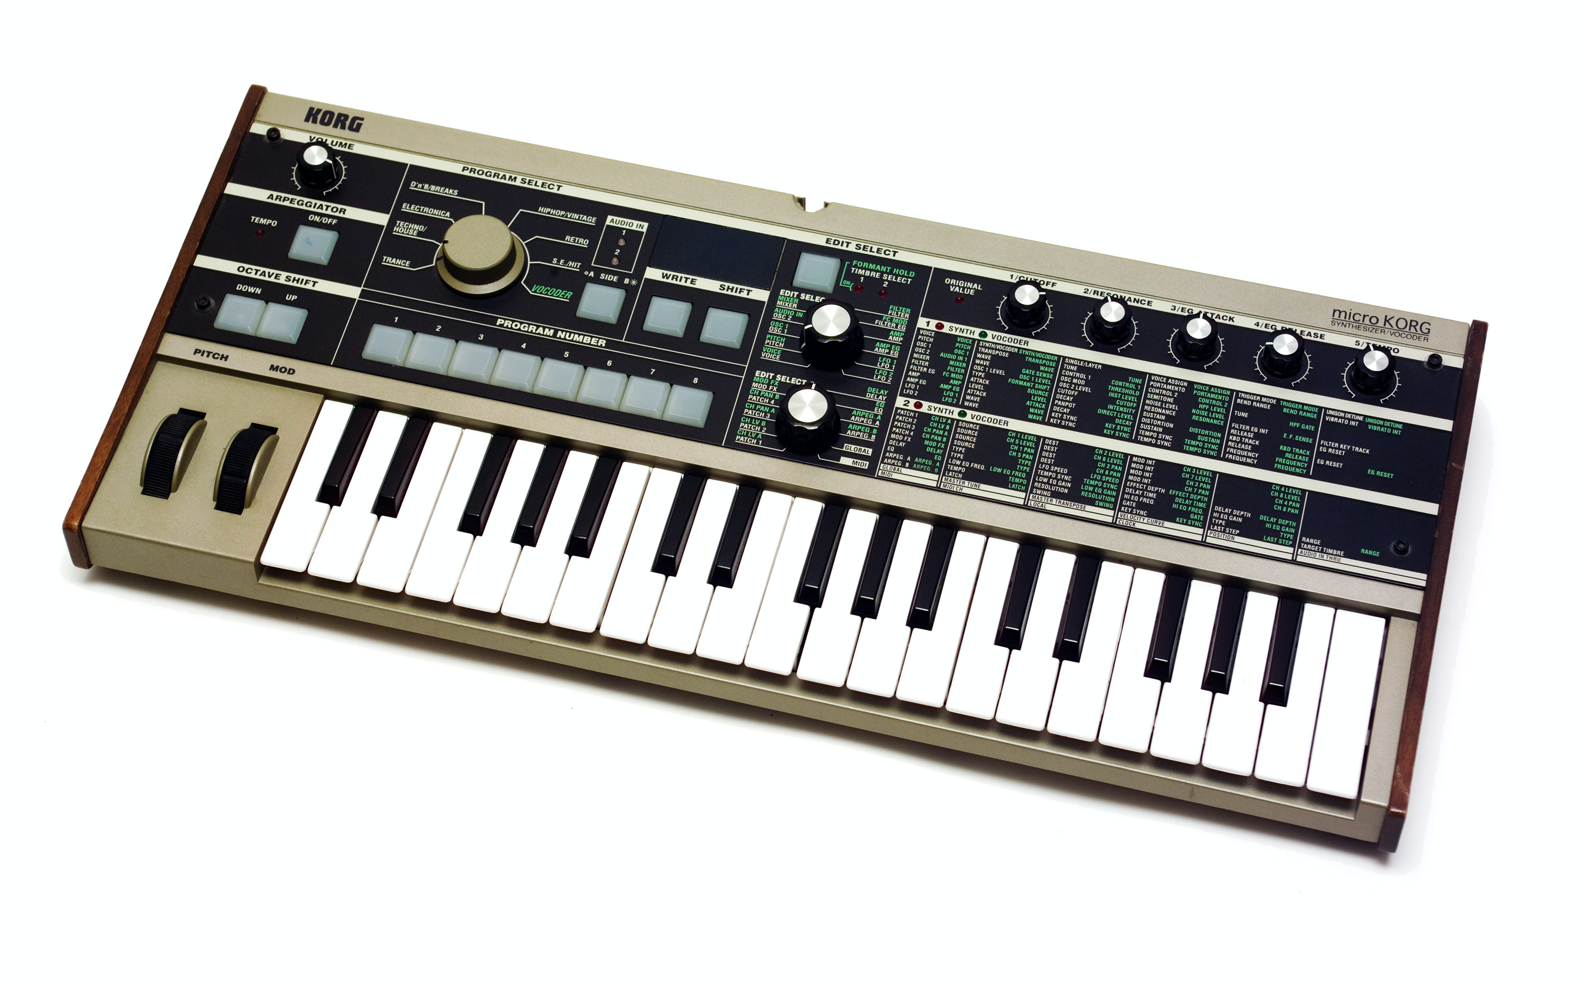

- Appendix E Roland Juno 6 (image taken from Reverb)
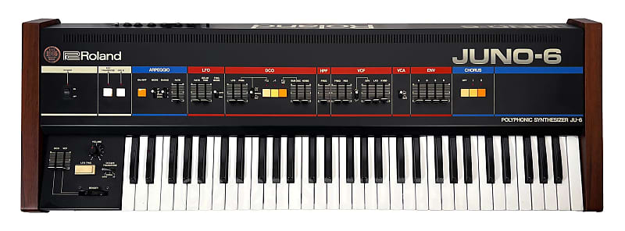
- Appendix F Bitcrusher (imagen taken from Native Intruments)


