
Past Peoples, Present Societies

The Social Lives of Late Cypriot Cylinder Seals

8th November, Wednesday, 5pm (GMT) online

A talk presented by Thomas Humphreys, UWTSD

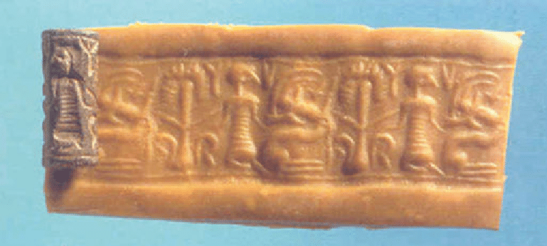

Abstract - This paper discusses the findings of my PhD research into how cylinder seals became embedded in Cypriot society shortly after their introduction to the island at the beginning of the Late Bronze Age. As a novel technology to their Cypriot audience, cylinder seals serve as a nearly ideal case study for studying how objects and ideas that cross cultural boundaries are recontextualised and reconfigured within their new social context. This paper outlines the results of a diachronic and inter-contextual study of 148 cylinder seals from secure LC contexts, and the patterns of socialisation that emerged suggestive of uses distinct from – but connected to – those of their Near Eastern antecedents.

Tickets and links available on Eventbrite (Past Peoples, Present Societies) or through email to 1811607@student.uwtsd.ac.uk (Please use Subject: TICKETS PPPS)

