

Module: Population Health and Digital Health Promotion
Student Name: Khushboo Dadlani
Student ID: 2333435

Table of Contents
Task 1: Blog Writing 2
Blog 1: How Continuous Glucose Monitors are Revolutionizing Diabetes Management 2
Diabetes: A Global Public Health Crisis 2
Continuous Glucose Monitors (CGMs): The Power of Real-Time Data 3
Are CGMs Effective in Managing Diabetes? 4
The Pros and Cons of CGMs in Health Promotion 5
Advantages: 5
Challenges: 5
Addressing CGM Limitations for Greater Impact 6
Looking Forward 6
Blog 2: Empowering Diabetes Care with GlucoGuide+: A Holistic Health Solution 7
Introducing GlucoGuide+: A Comprehensive Digital Health Companion 8
How GlucoGuide+ Enhances Health Promotion 10
Impact of GlucoGuide+ on Diabetes Health Promotion 10
Advantages: 10
Shortfalls: 11
Addressing the Challenges 11
Conclusion 12
Task 2: Poster 13
References 14

Task 1: Blog Writing

Blog 1: How Continuous Glucose Monitors are Revolutionizing Diabetes Management

Diabetes: A Global Public Health Crisis
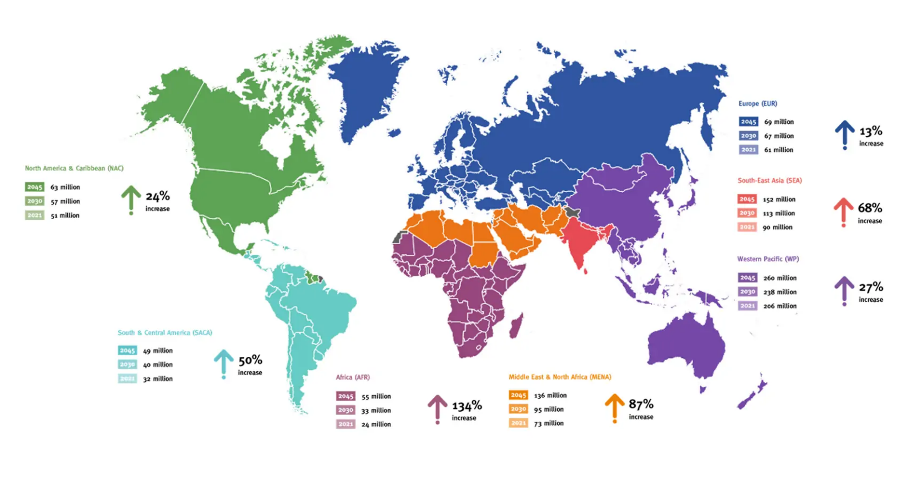
Diabetes has transformed into a global epidemic, impacting millions. In 1990, around 200 million people were living with diabetes. By 2022, that number had risen to an astounding 830 million, with most new cases appearing in low- and middle-income countries where healthcare access is limited. This condition’s toll is severe: unmanaged diabetes can lead to kidney failure, blindness, heart attacks, stroke, and even limb amputations (World Health Organization, 2023). In 2021 alone, diabetes and related complications caused over 2 million deaths, with about 11% of cardiovascular deaths linked to high blood glucose. Effective management is vital, and continuous glucose monitors (CGMs) have emerged as a powerful tool in the fight against diabetes.
Figure 1 Global diabetes cases rising sharply, highest growth projected in Africa, MENA.
Source: (International Diabetes Federation, 2024)

Continuous Glucose Monitors (CGMs): The Power of Real-Time Data
CGMs are wearable devices that monitor blood glucose levels in real time, providing an essential alternative to traditional “finger-prick” tests that offer only a single reading. Popular CGMs, like Dexcom’s G7 and Abbott’s FreeStyle Libre 3, send frequent glucose readings to a smartphone app, allowing users to monitor trends and make immediate adjustments. Today’s CGMs also offer improved accuracy, with a margin of error under 10%, and often don’t require frequent calibration through finger pricks. Some models even integrate with automated insulin delivery (AID) systems, creating a seamless experience for diabetes management (Lacy et al., 2024).


Are CGMs Effective in Managing Diabetes?
The impact of CGMs on diabetes care is backed by solid evidence. More than 9 million people worldwide use CGMs, and studies show that users benefit from improved blood sugar control, fewer dangerous glucose spikes and dips, and, ultimately, fewer hospital visits. Research further indicates that CGM users experience better glucose stability, reducing the risk of complications and improving quality of life. Imagine receiving an alert when your glucose level is dropping, enabling you to act immediately—this is life-changing for many (Manov et al., 2023).

The Pros and Cons of CGMs in Health Promotion

Advantages:
- 24/7 Monitoring: CGMs provide constant glucose tracking, empowering users to take quick, informed action.
- Better Glycemic Control: Studies show that users achieve greater blood glucose stability, reducing risks like cardiovascular issues.
- Convenience: Unlike finger-prick tests, CGMs are a painless, hassle-free option.
- Integrated Data: Most CGMs sync with smartphone apps, enabling users and healthcare providers to track long-term trends.
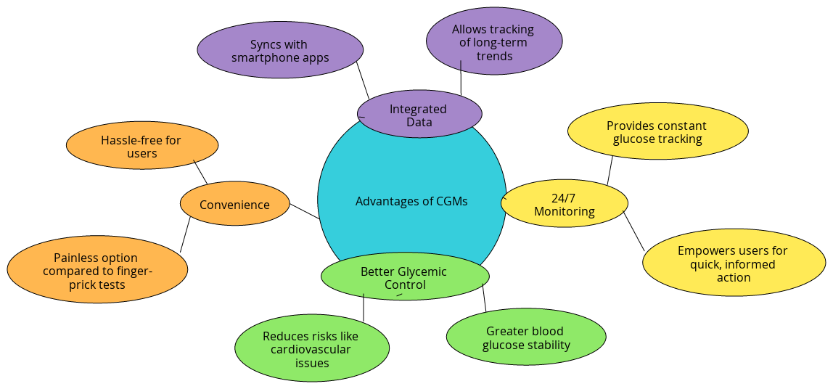
Figure 2 Created by the learner

Challenges:
- Cost: CGMs remain expensive and aren’t universally covered by insurance, making them inaccessible for many, especially in low-income regions.
- Limited Accessibility: While CGMs are common in high-income countries, they are scarce in low- and middle-income areas, where diabetes is rising fastest.
- Technical Glitches: Some users report connectivity issues and occasional inaccuracies, though newer models are improving on these fronts.

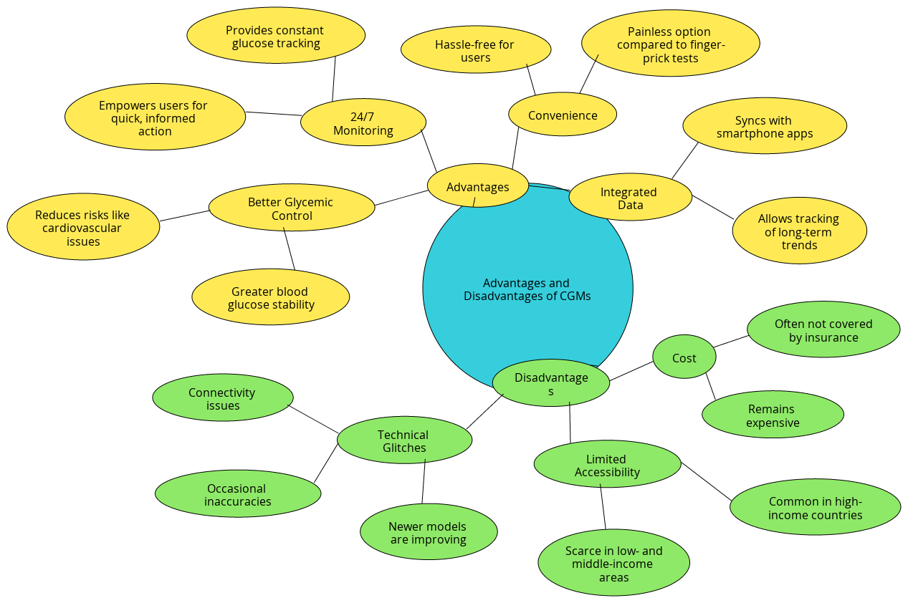
Figure 3 Created by the Learner

Addressing CGM Limitations for Greater Impact
To maximize CGMs’ impact, lowering costs and expanding access are essential steps. Manufacturers and policymakers can work together to make these devices more affordable, especially for those in resource-poor areas. Abbott is already innovating with combined glucose and ketone monitoring, planned for release in 2024, which could benefit patients at risk for ketoacidosis. The integration of CGMs with AID systems also holds promise for enhancing diabetes management.

Looking Forward
CGMs are empowering millions to manage diabetes with greater ease and control. While barriers remain, these technologies offer a promising future in diabetes care, allowing individuals worldwide to lead healthier, fuller lives.


Blog 2: Empowering Diabetes Care with GlucoGuide+: A Holistic Health Solution
Diabetes is an ever-emerging world problem and it is gradually taking a leading role modifying the demographics of healthcare all over the world. In such developing countries with poor health care, more than fifty percent of diagnosed diabetics are not treated. According to Md. Jamal Hossain et al. (2024), in 2022, 59% of booths, adults over 30 with diabetes were in no way receiving medications, therefore at the risk of developing complications including blindness, kidney failure, and nerve disorders. That is why satisfying these needs requires an innovative approach that does not limit itself to glucose measurement for overall health and prevention.


Introducing GlucoGuide+: A Comprehensive Digital Health Companion
GlucoGuide+ is the future generation digital health solution aimed at revolutionizing diabetes care. While the GlucoGuide+ glucose monitor also provides all the basic attributes of other existing monitors it comes with added features that promote lifestyle management, telehealth support, and health advisories; novel features that can help make diabetes conscious healthier for especially minority and low-income individuals.


How GlucoGuide+ Enhances Health Promotion
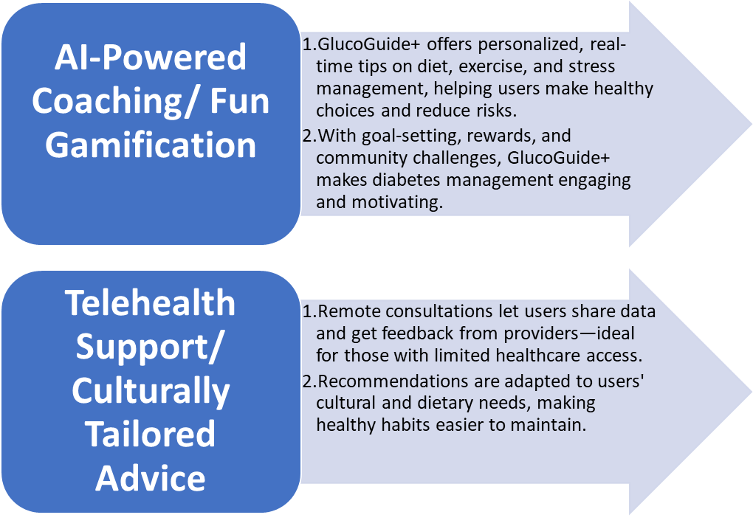

Impact of GlucoGuide+ on Diabetes Health Promotion

Advantages:
- Empowers Self-Management: GlucoGuide+ puts diabetes care directly in the user’s hands, enabling informed, data-driven health decisions without the need for frequent clinical visits (Lee et al., 2019).
- Boosts Long-Term Engagement: The app’s gamified features encourage consistent interaction, helping users stay motivated in reaching health goals (Patil, 2024).
- Offers Comprehensive Support: Beyond glucose monitoring, GlucoGuide+ provides a holistic approach that integrates diet, activity, and mental wellness, supporting well-rounded diabetes management (Laura Cipullo, 2024).
- GlucoGuide+ empowers patients by providing real-time health data and personalized insights, enabling them to make informed decisions and take proactive steps in their diabetes care. The app's gamified features and holistic health management tools encourage active engagement, fostering better self-management and improved outcomes.

Shortfalls:
- Data Privacy Concerns: Handling sensitive health information requires robust privacy measures. GlucoGuide+ addresses this by using high-level encryption and giving users control over data-sharing settings.
- Cost and Accessibility: Advanced features like AI coaching and telehealth can increase costs, potentially limiting access for low-income users.
- Digital Literacy Gaps: While GlucoGuide+ is designed to be user-friendly, those less familiar with technology may find it challenging, particularly older adults or those with limited digital skills.
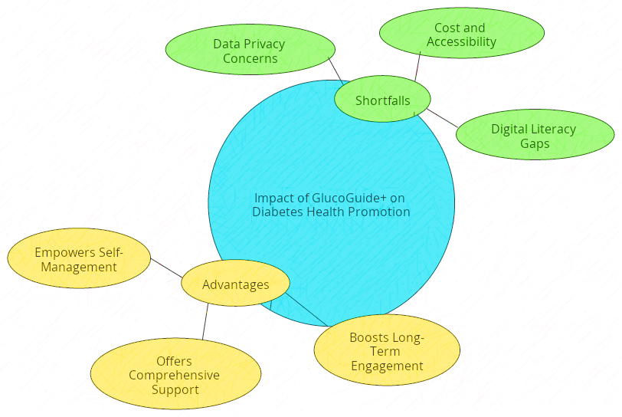
Figure 4 Created by the Learner

Addressing the Challenges
To expand access, GlucoGuide+ is building partnerships with public health organizations to subsidize app costs, especially in resource-limited areas. In-app tutorials, multilingual support, and simplified navigation further ensure the platform is accessible to diverse demographics.

Conclusion
GlucoGuide+ is more than a glucose monitor; it’s a health partner that empowers individuals to manage their diabetes through real-time support, culturally relevant guidance, and accessible healthcare. By combining technology and empathy, GlucoGuide+ addresses the complexities of diabetes care, aiming to build a healthier future for millions worldwide.

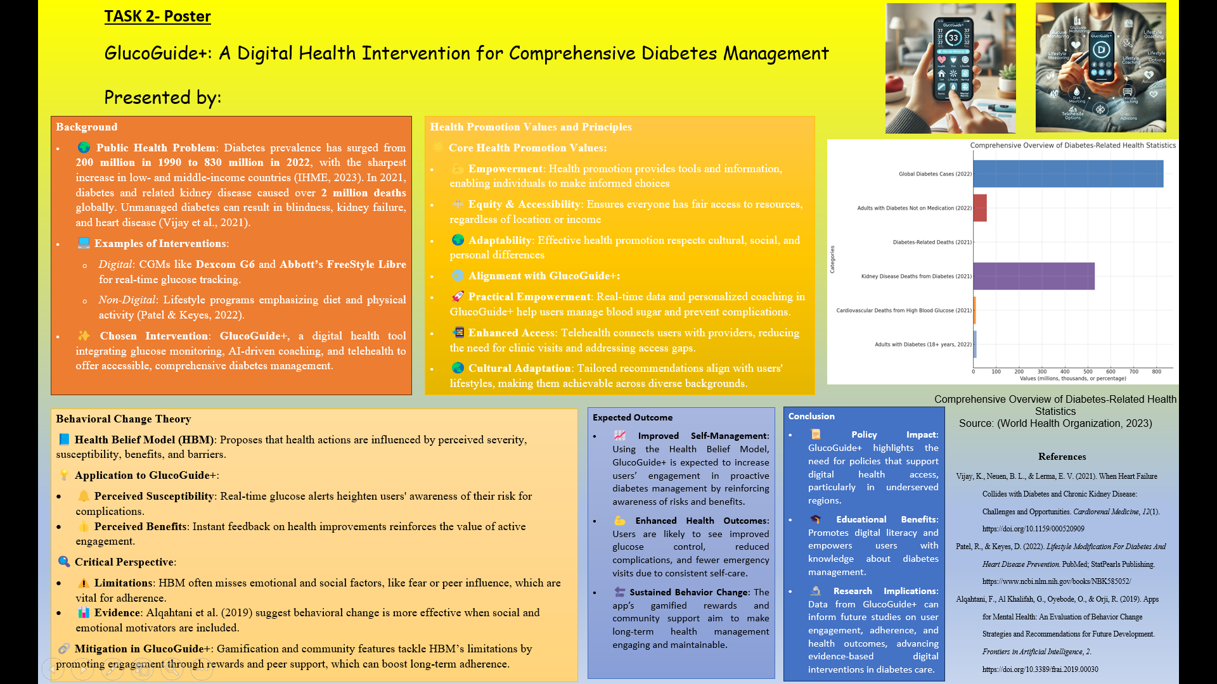

References

Banerjee, A. (2020). Equity and Quality of Health-care Access: Where Do We Stand and the Way Forward? Indian Journal of Community Medicine: Official Publication of Indian Association of Preventive & Social Medicine, 45(1), 4–7. https://doi.org/10.4103/ijcm.IJCM_183_19
IHME. (2023, June 22). Global Diabetes Cases to Soar from 529 Million to 1.3 Billion by 2050 | the Institute for Health Metrics and Evaluation. Www.healthdata.org. https://www.healthdata.org/news-events/newsroom/news-releases/global-diabetes-cases-soar-529-million-13-billion-2050
International Diabetes Federation. (2024). Diabetes Facts & figures. International Diabetes Federation. https://idf.org/about-diabetes/diabetes-facts-figures/
Kumar, S., & Preetha, G. (2012). Health promotion: an Effective Tool for Global Health. Indian Journal of Community Medicine, 37(1), 5–12. https://doi.org/10.4103/0970-0218.94009
Lacy, M. E., Lee, K. E., Atac, O., Heier, K., Fowlkes, J., Kucharska-Newton, A., & Moga, D. C. (2024). Patterns and Trends in Continuous Glucose Monitoring Utilization Among Commercially Insured Individuals With Type 1 Diabetes: 2010–2013 to 2016–2019. Clinical Diabetes. https://doi.org/10.2337/cd23-0051
Laura Cipullo. (2024, July 30). Blood Sugar Control Diet & Continuous Glucose Monitoring. Laura Cipullo. https://lauracipullo.com/blood-sugar-control-diet-with-continuous-glucose-monitoring/
Lee, A. A., Piette, J. D., Heisler, M., Janevic, M. R., & Rosland, A.-M. (2019). Diabetes self-management and glycemic control: The role of autonomy support from informal health supporters. Health Psychology, 38(2), 122–132. https://doi.org/10.1037/hea0000710
Manov, A. E., Chauhan, S., Dhillon, G., Dhaliwal, A., Antonio, S., Donepudi, A., Jalal, Y. N., Nazha, J., Banal, M., House, J., Manov, A. E., Chauhan, S., Dhillon, G. S., Dhaliwal, A., Antonio, S., Donepudi, A., Jalal, Y. N., Nazha, J., Banal, M., & House, J. (2023). The Effectiveness of Continuous Glucose Monitoring Devices in Managing Uncontrolled Diabetes Mellitus: A Retrospective Study. Cureus, 15(7). https://doi.org/10.7759/cureus.42545
Md. Jamal Hossain, Md. Al‐Mamun, & Md. Rabiul Islam. (2024). Diabetes mellitus, the fastest growing global public health concern: Early detection should be focused. Health Science Reports, 7(3). https://doi.org/10.1002/hsr2.2004
Patel, R., & Keyes, D. (2022). Lifestyle Modification For Diabetes And Heart Disease Prevention. PubMed; StatPearls Publishing. https://www.ncbi.nlm.nih.gov/books/NBK585052/
Patil, G. (2024, February 13). Benefits Of Gamification In Healthcare App. IdeaUsher. https://ideausher.com/blog/gamification-in-healthcare/
Tveiten, S. (2021). Empowerment and Health Promotion in Hospitals (G. Haugan & M. Eriksson, Eds.). PubMed; Springer. https://www.ncbi.nlm.nih.gov/books/NBK585651/
Vijay, K., Neuen, B. L., & Lerma, E. V. (2021). When Heart Failure Collides with Diabetes and Chronic Kidney Disease: Challenges and Opportunities. Cardiorenal Medicine, 12(1). https://doi.org/10.1159/000520909
World Health Organization. (2023, April 5). DIABETES. World Health Organisation; WHO. https://www.who.int/news-room/fact-sheets/detail/diabetes

