
Reflective report
BMSW4005 Professional Career Development Assessment 1

Razvan c. rizea
2122615

1 - EXECUTIVE SUMMARY

The purpose of this report is to develop my personal and professional strategies and competences, to gain confidence and apply the best I can what I have learned at PROFESSIONAL CAREER DEVELOPMENT module, presided by Melanie Squire, Lecturer and Academic Ethnic Minority Liaison Officer. Taking part in this class is an amazing experience that I will always try to apply and develop everything that I am learning. Concluding, all the information gained will help me develop and strategize my future career development, and all that we have learned, SWOT analysis, Johari Window, SMART goals, Personal Development Plan and Learning Stiles Questionaries are the key factors to do that. Thank you very much Melanie!

2 - CONTENTS
1 - EXECUTIVE SUMMARY
2 - CONTENTS
3 - TERMS OF REFERENCE
4 - PROCEDURE
5 - INTRODUCTION
6 - MAIN FINDINGS
6.1 - JOHARI WINDOW
6.2 - SWOT
6.3 - SMART
6.4 - PERSONAL DEVELOPMENT PLAN
7 - VARK
8 - REFERENCES

3 - TERMS OF REFFERENCE
This report was requested by Melanie Squire, Lecturer and Academic Ethnic Minority Liaison Officer, for PROFESSIONAL CAREER DEVELOPMENT module at University of South Wales Trinity Saint David.

4 - PROCEDURE
For the creation of this report, I used information from articles, books and academical journals. This reflective report is based on my own thoughts and as a result of the classes I have attended at University of South Wales Trinity Saint David, CERTHE Skills for the Workplace, PROFESIONAL CAREER DEVELOPMENT module.

5 - INTRODUCTION
By submitting this reflective report, I, Razvan Rizea, student at the University Of Wales Trinity Saint David, and studying CERTHE Skills for the Workplace, want to show and expand in details, the knowledge that I have gained, in what situation/situations I will apply, and, how I hope that taking part in the classroom from the module, professional and career development, it is a great opportunity for my career progress, along with my personal growth, in aptitudes, skills, self-awareness, critical thinking, academical thinking, and many more, and how this will guide me to reach my personal development plan. Taking part, in the last few months, in the classroom was a comfortable and unique experience. My colleagues and I are radiating with excitement, during the lecture, and even more after, when we discuss what we learned and how to apply the knowledge that we just obtained. Please find below how I think it will apply the knowledge I gained to achieve my goal.

6 - MAIN FINDINGS

6.1 - Johari Window, Luft, J.; Ingham, H. (1955), is a technique designed to help people better understand their relationship with themselves and others. It is a tool created by Joseph Luft and Harry Ingham in 1955. The technique applies using four quadrants, and they are, as you can see in Fig. 1, composed of open area, blind area, hidden area and the unknow area.
When I will have the interview for the Customer Advisor, position that I have applied for, I will use the Johari Window technique to assess what do I know about the company I am applying for, what do I need to find that I don’t know about the company, how to present myself during the process, how to “sell” myself at the interview and to prepare the best I can for what it is to come and it is unknown to myself and the company. Following the Johari Window technique will help me respond to most of the knows and unknows related to the position I am applying for. With certainty it is a tool that I will use constantly moving on, in my personal life and career development.

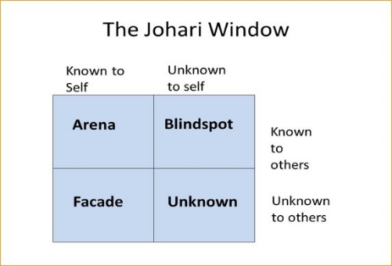

Fig. 1 –

6.2- SWOT analysis (or SWOT matrix), en.wikipedia.org (2022) is a technique that helps a person or organization to identify the strengths, weaknesses, opportunities, and threats!
SWOT stands for STRENGTHS, WEAKNESSES, OPPERTUNITIES AND THREATS, as you can see in Fig. 2, and below I am presenting some examples.

Strengths:
- What advantages do you have that others don't have?
- What do you do better than anyone else?
- What personal resources can you access?
- What do other people (and your boss, in particular) see as your strengths?
- Which of your achievements are you most proud of?
- What values do you believe in, and others fail to exhibit?
- Are you part of a network that no one else is involved in?
- Do you have connections with influential people?
Weakness:
- What tasks do you usually avoid?
- What do you and the people around you see as your weaknesses?
- Are you completely confident in your education and skills training? If not, where are your weakest?
- What are your negative work habits?
- Do you have personality traits that hold you back in your field?
- Are you restricted in how far you can travel to work?
Opportunities:
- Is your industry/sector growing?
- Do you have a network of strategic contacts to help you, or offer good advice?
- What trends do you see and how can you take advantage of them?
- What new technology can help you?
- Are any of your competitors failing to do something important?
- Is there a need in your company, industry, or sector that no one is filling?
- Do your customers, internal or external, complain about something in your company? If so, could you create an opportunity by offering a solution?
Threats:
- What obstacles do you currently face at work?
- Are any of your colleagues competing with you for projects or roles?
- Is your job (or the demand for the things you do) changing?
- Does changing technology threaten your position?
- Could any of your weaknesses lead to threats?
Related to my personal development plan, obtaining the position of Customer Advisor, I will analyze with the SWOT tool my findings and in what position I present myself.

Strengths:  Positive attitude, good with people, great communication skills, good level of computer literacy, quick learner, prompt, eager to learn, adaptable. | Weaknesses:  Sometimes shy, too meticulous, too straight forward, too ambitious.
Opportunities:  To develop and follow a bank society career and the start is in front of the customer. To grow and go up the ladder for a better position. | Threats:  The fear of the unknown. Possibility to fail. Prospects in the current world situation.
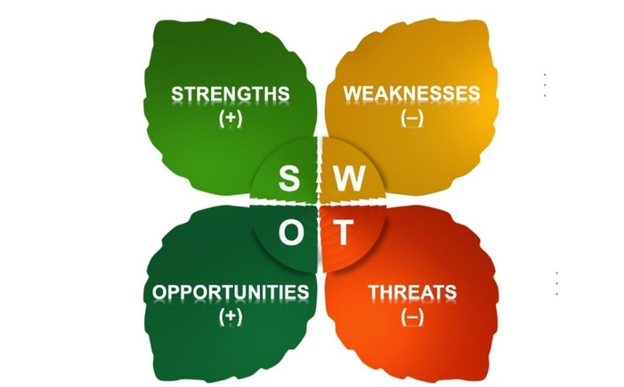
Fig. 2

6.3 - It is generally accepted that the SMART acronym was first written down in November 1981 in Spokane, Washington. George T. Doran, a consultant and former Director of Corporate Planning for Washington Water Power Company published a paper titled "There's a S.M.A.R.T. Way to Write Management's Goals and Objectives".
SMART acronyms, as you can see in Fig. 3, represents the following:
S – Specific, goal should be clear, detailed and to explain definite what are you going to do.
M – Measurable, goal should be measurable. For instance, indeed.co.uk explains in one of the SMART goals examples that “Success can be measured by the number of applications, interviews and job offers. If one of the initial interviews does not result in a job immediately, the goal setter can still celebrate the win of completing an interview and consider it a learning experience.” (https://uk.indeed.com/career-advice/career-development/smart-goals, 2022)
A – Achievable, your goal should motivate you and have a positive outcome. Usually, impossible goals will only demotivate you.
R – Relevant/Realistic, your goal must coincide with your overall objective and fit within the bigger picture.
T – Timely, goal should have a set timeline with specific start and specific end date, which will confirm that your goal is “set in stone” and set to be delivered.

To complete my personal development plan, my SMART goal is to gain the position of Customer Advisor at a well-known bank. I will use all my knowledge in order to achieve this position. Skills that I possess, related to the role, as people person, communication skills, positive attitude, customer service. I will take, even only the experience, as a positive and constructive outcome and I am confident that it will help me in the future. From the date of the interview, Monday 14th of March 2022, even if I will not achieve this position, until I will get it, I will do my best.

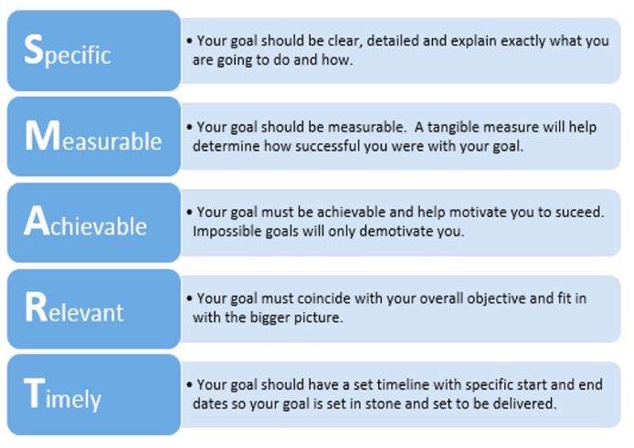
Fig. 3

6.4 - Personal development plan is an active process of reflection that it gives space to evaluate your own skills, strengths, and weaknesses. It structures your thinking and generate the information to make decisions and take actions. It is a tool that helps you plan your future, that helps you achieve a clear focus. Following your personal development plan also helps you to produce a reflective, strategic, analytical, and creative thinking to strengthen your performance.
Please see below, my personal development plan, as a Morgan P. (2017) example.

Skill/Behaviour | Action  Needed | Resources Needed (including people) | Date(s) for Action | Date for Review (i.e., next opportunity to practise and demonstrate skill) | Aspirational Goal (Specific, Measurable, Achievable, Realistic/ Resourced, Time-based) | Met?
To gain the position of Customer Advisor | Develop confidence and self-awareness. Put in practice my positive attitude, and my good way with people. | Books on Customer Advisor job  Online resources  Computer | Daily rehearsing of priorities and self-awareness. Reflect and practice my charisma. Continuously improve my communication skills. | Monday 14th of March 2022 until I will be successful. | I want to succeed in the Customer Advisor role, in the next step of my career, using my skills and aptitudes, applying them in every situation I encounter, as soon as possible. | TBA

7 - VARK Questionnaire acronym stands, according to blog.definedlearning.com (2022), for Visual, Aural, Read/Write, and Kinesthetic sensory modalities. These modalities can be used for learning and reinforcing information. Drawing connections to personalized learning applications, this process can have value for students and their learning of information through a more independent means. Encouraging learning experiences that use one or more learning styles may help course developers and instructors provide multiple opportunities to learn content and transfer their knowledge to different situations.

Please see below my results from The VARK Questionnaire:

Your VARK Results
Your scores were:
- Visual 6
- Aural 10
- Read/Write 9
- Kinesthetic 13
Your learning preference: Multimodal (VARK)
People with your preference like:
different formats, graphs, diagrams, maps, interesting layouts, space, listening, discussing, talking, questioning, notes, handouts, print, text, practical exercises, experiences, examples, case studies, trial and error, things that are real, ...

8 - CONCLUSION
As a conclusion, everything that we have learned and practice during the lectures of the module Professional Career Development, introduced me to new strategies of personal reflection, personal skills expansion, and career development planning. I can now progress in my career with a better understanding and perception of the process, with a clearer notion about myself and what a recruiter wants, with updated and improved skills of communication, self-awareness, and positive attitude.

I will take this moment to thank you all very much for all the help and support that I received during the past lectures.

9 - REFERENCES

https://blog.definedlearning.com/blog/varkandpersonalizedlearning#copy_link (Accessed 11th of March 2022)
George T. Doran, November 1981 in Spokane, Washington,"There's a S.M.A.R.T. Way to Write Management's Goals and Objectives".
Luft, J.; Ingham, H. (1955). "The Johari window, a graphic model of interpersonal awareness". Proceedings of the Western Training Laboratory in Group Development. Los Angeles: University of California, Los Angeles.
Morgan P. (2017), Personal Development Plan.
https://uk.indeed.com/career-advice/career-development/smart-goals (Accessed 11th of March 2022)
Wikipedia contributors, 'SWOT analysis', Wikipedia, The Free Encyclopedia, 10 March 2022, <https://en.wikipedia.org/w/index.php?title=SWOT_analysis&oldid=1076318495> [accessed 11 March 2022]

