Name: Onika Nembhard
Student ID: 2432998
Module Code: LCHS4003
Module title: Introduction to Health and Social Care
Assignment Title: Part 1: Poster Community antenatal midwifery services Part 2:
Part 2: Essay The Origins of the National Health Service (NHS), exploring the historical context and key principles that led to its establishment.
Lecturer: Azida Zaino
Submission Date: 20th October 20
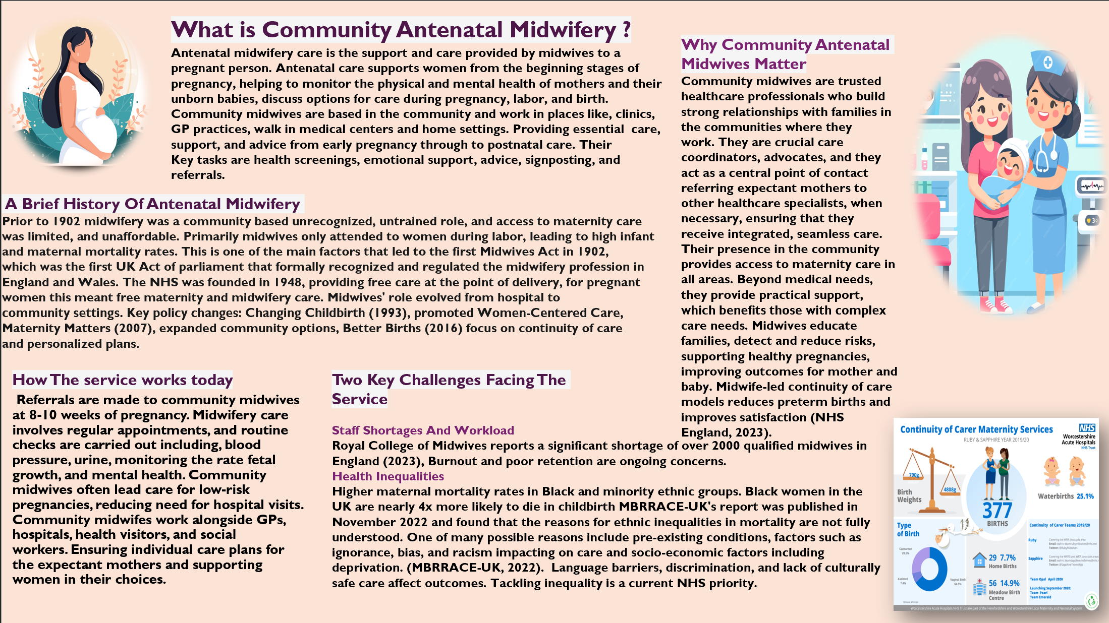
Poster references:
NHS (2025) Refer yourself for NHS pregnancy care. Available at: https://www.nhs.uk/nhs-services/refer-yourself-for-nhs-pregnancy-care/ (Accessed 10 October 2025)
NHS England. 2023. Maternity care and midwifery. Available at: https://www.engladd.nhs.uk/publications/maternity-care-and-midwifery (Accessed 10 October 2025)
Guy’s and St Thomas’ NHS Foundation Trust (2025) Maternity: care during pregnancy- Community midwives. Available at: https://www.guysandstthomas.nhs.uk/our-services/maternity-care-during-pregnancy/community-midwives (Accessed 10 October2025).
Royal College of Midwives (RCM). 2023. Midwifery workforce shortage report. Available at: https://www.rcm.org.uk/media-releases/2023/midwifery-workforce-shortage-report/ (Accessed 10 October 2025).
MBRRACE-UK. 2022 Perinatal mortality surveillance report-UK perinatal deaths for births from January to December 2020. Available at: https://www.npeu.ox.uk/mbrrace-uk/reports (Accessed 10 October 2025).
University Hospitals Birmingham NHS Foundation Trust (2025) Community Midwifery. Available at: https://www.uhb.nhs.uk/services/maternity/our-maternity-servicer/community-midwifery/ (Accessed 10 October 2025
The National Health Service: Origins, Core Principles and Contemporary Structure.
The United Kingdom's National Health Service (NHS) was established in 1948, to provide universal healthcare. The NHS has evolved under changing political, economic and analytical pressures. This essay explores the historical context and key principle that led to the NHS’s establishment, then critically examines its current functioning and structure, using qualitative recent research.
The NHS was created to provide healthcare based on need and not affordability. This stems from broader developments during and after the Second World War, particularly the Beveridge Report of 1942, which argued for a welfare state that would tackle the “five giants” of want, disease, ignorance, squalor, and idleness. The Labour government elected in 1945, under Clement Attlee, pledged to implement these ideas, including comprehensive healthcare (Timmins, 2001). The legal basis for the NHS was the National Health Service Act July 1948, establishing undivided health service for England and Wales (NHS, 2023).
The key principles were articulated by Aneurin Bevan, Minister of Health. They included care available to all, free service at the point of delivery, and provision is based on clinical need rather than affordability. (Bevan,1948). These principles reflected a political climate favouring equality and social citizenship, in the aftermath of wartime sacrifices and the desire for social reconstruction (Webster, 2002).
The core principles that influenced the legal architecture are; (NHS Act 1946), Universality- health care should be accessible to all, regardless of social or economic status (NHS England, 2023). Free care at point of delivery- patients should not be charged when receiving care. And Clinical need – treatment based on need, not affordability.
Over time the NHS, has evolved through successive reforms. Following the Health and Care Act 2022, 42 integrated care systems (ICSs) became statutory bodies, responsible for coordinating NHS organisations, local government, social care providers, and voluntary services across defined geographics (Commons Library, 2023; Parliament, 2023). The aim is to achieve effective integration of health and care services (commons Library 2023).
The oversight, governance and accountability arrangements of ICSs were examined in the Hewitt Review (2023). Which recommended granting ICSs liberty while maintaining accountability through national framework. It advised reducing the number of central prescriptive targets, moving towards multi-year funding settlements, and emphasising on prevention (Hewitt Review, 2023; NHS Confederation, 2023). ICSs are accountable through their Intergrated Care Boards (ICBs), with expectations to deliver on national priorities set out in mandates to NHS England (Hewitt Review, 2023).
Regardless of these changes, the NHS continues to be financed largely through national insurance contribution, taxation, and a small proportion of funding (1% of the total Department of Health and Social Care budget in 2023/24) comes from charges for dental care and prescriptions (kingsfund.org.uk). In recent years, health and care spending has increased, however, concerns persist that funding has not kept pace with rising demand, aging population, and prevalence of chronic disease. The gap between need and resource is hindering system performance (Commons Library, 2023).
Primary care is central to the delivery of NHS services, but qualitative research identifies tensions between primary care practices and ICS structures, around resource allocation, coordination, and local influence. For example, Mitchell et al. (2023) report that misalignment of financial incentives, fragmented information systems and limited voice for GPs hinder integration. In addition, the introduction of digital health and modernisation is constrained by dissolution across all levels of the NHS (Castelli, 2023).
Although the founding principles of the NHS, namely comprehensiveness, free care at point of use, and clinical need as the basis for access, Remain legally enshrined. Critics argue, market – oriented reforms introduced since the 1980s and 1990s, including internal markets, competition, and payment by results, have shifted levers of governance, potentially challenging ideals of universality and equality (Castelli, 2023; Litchfield, 2022).
In conclusion, the system is under sustained financial and staffing pressures, which exacerbate tensions across ICSs and primary care. The complexity of governance arrangements, evolving responsibilities, and competing priorities may weaken accountability and impede modernisation of the NHS.

Essay references:
Castelli, M. (2023) ‘The forgotten dimension of integrated care: barriers to implementing integrated clinical care in the English NHS; Health Economics, Policy and Law. Available at: https://www.cambridge.org/core/journals/health-economics-policy-and-law/article/forgotten-dimension-of-intergrated-care-barriers-to-implementing-intergrated-clinical-care-in-english-nhs-hospitals/CB2DE5BFAD78F069B71FC881281AF972 (Accessed:15 October 2025).
Commons Library (2023) The structure of the NHS in England. Available at: https://commonslibrary.parliment.uk/research-briefing/cbp-7206/ (Accessed: 15 October 2025).
Litchfield, I. (2022) ‘The move towards integrated care: lessons learnt from implementation in England,’ Health Policy.
Mitchell, C., Higgerson, J., Tazzyman, A. et al. (20230 ‘Primary Care Services in the English NHS: are they a thorn in the side of integrated care systems? A qualitative analysis, BMC Primary Care, 24, Article 168. Available at: https://bmcprimcare.biomedcentral.com/articles/10.1186/s12875-023-02124-3 (Accessed: 14 October 2025).
NHS Confederation (2023) Hewitt review: What you need to know. Available at: https://www.nhsconfed.org/publications/hewitt-review-wnat-you-need-know. (Accessed: 14 October 2025).
Parliament (2023) Intergrated Care Systems: Autonomy and Accountability, Health and Social Care Committee report. Available at: https://publications.parliament.uk/pa/cm5803/cmselect/cmhealth/587/report.html (Accessed 15 October 2025).
Hewitt Review (2023) An independent review of integrated care systems. Available at: https://assets.publishing.service.gov.uk/media/642b07d87de82b00123134fa/the-hewitt-review.pdf (Accessed: 13 October 2025

