BMHS4005: Skills for academic success.
Assessment 1 Practice activity
Instructions
You have 30 minutes.
You may use:
- University Harvard Referencing Guide
- Printed or electronic copy (if permitted)
You may not:
- Use AI tools
- Access the internet (unless your referencing guide is online)
- Discuss answers with other students

Activity 1: Read each question carefully and indicate the correct answer.
Question 1: Which is the correct in-text citation? (3 Marks)
A.) (Lewis)
B.) (Lewis 2026)
C.) (Lewis, 2026)
D.) 2026 Lewis.
Answer:

Question 2: Which citation could correctly be used to show a direct quotation?
A.) (Lewis, 2026)
B.) (Lewis, 2026, p.15)
C.) Lewis, p15
D.) Lewis (2026)
Answer:
Question 3: Which answer is one of the ways to correctly present a citation for a source with two authors?
A.) (Williams and Marshall, 2025)
B.) (Williams & Marshall 2025)
C.) (Williams, Marshall 2025)
D.) Williams and Marshall
Answer:

Activity 2: Each of the following references contain mistakes. Spot the errors and rewrite the reference correctly. (4 Marks)
Question 1: World Health Organization (2023) World health statistics 2023: monitoring health for the SDGs, sustainable development goals. Geneva: WHO. Available at https://www.who.int/publications/i/item/9789240074323 (Accessed 10 September 2026
Answer:

Question 2: London. Institute of health equity. Marmot, M., Allen, J., Boyce, T., Goldblatt, P. & Morrison, J. 2020. Health equity in England: The Marmot Review 10 years on.
Answer:

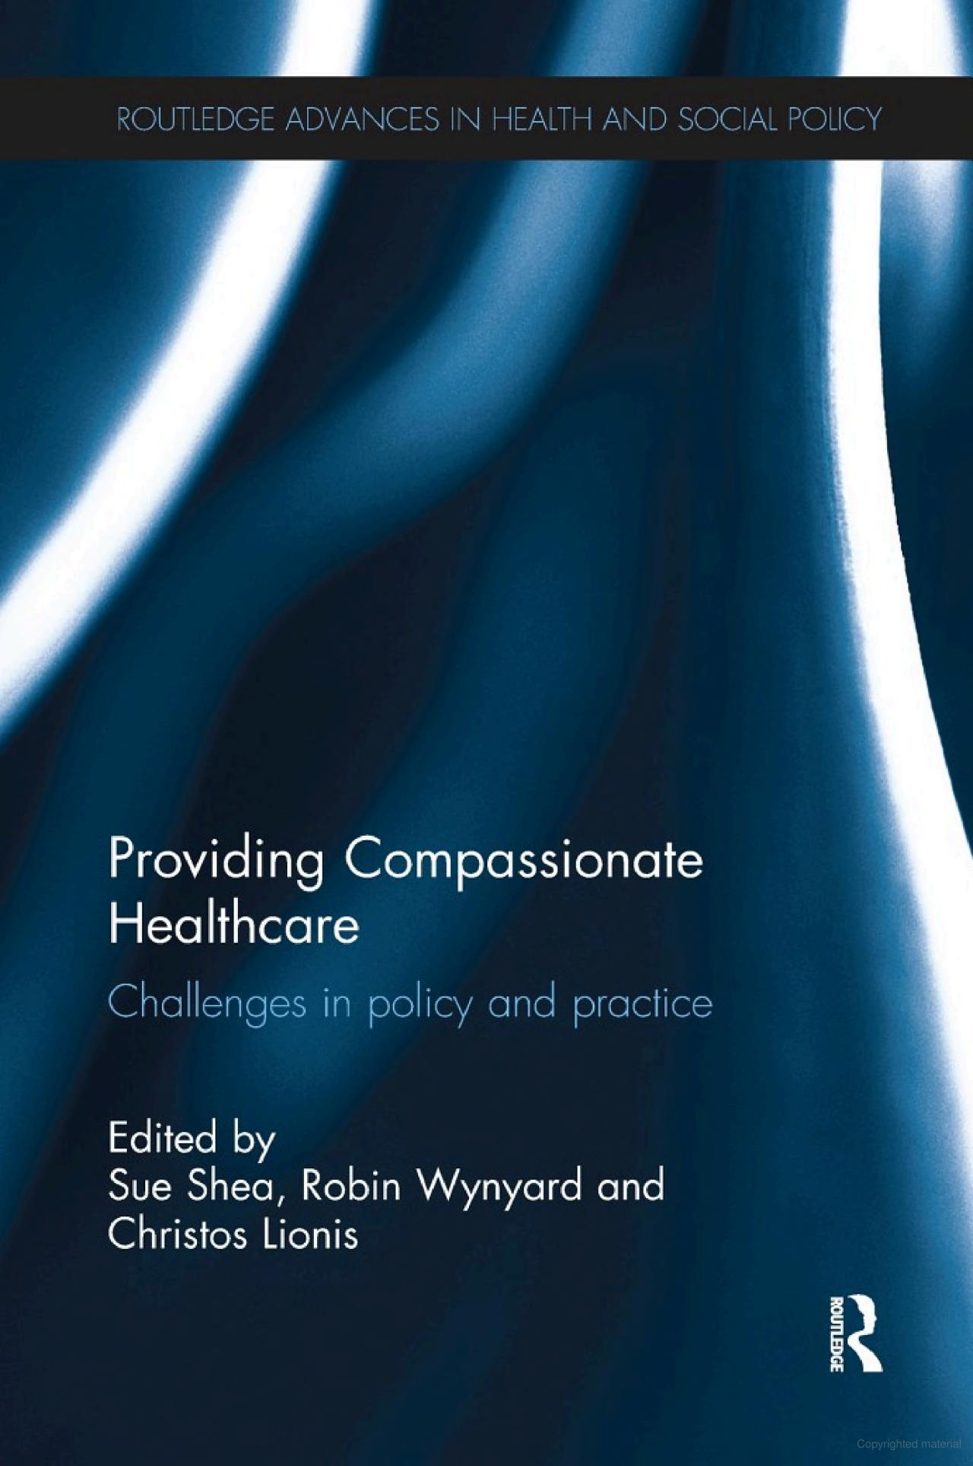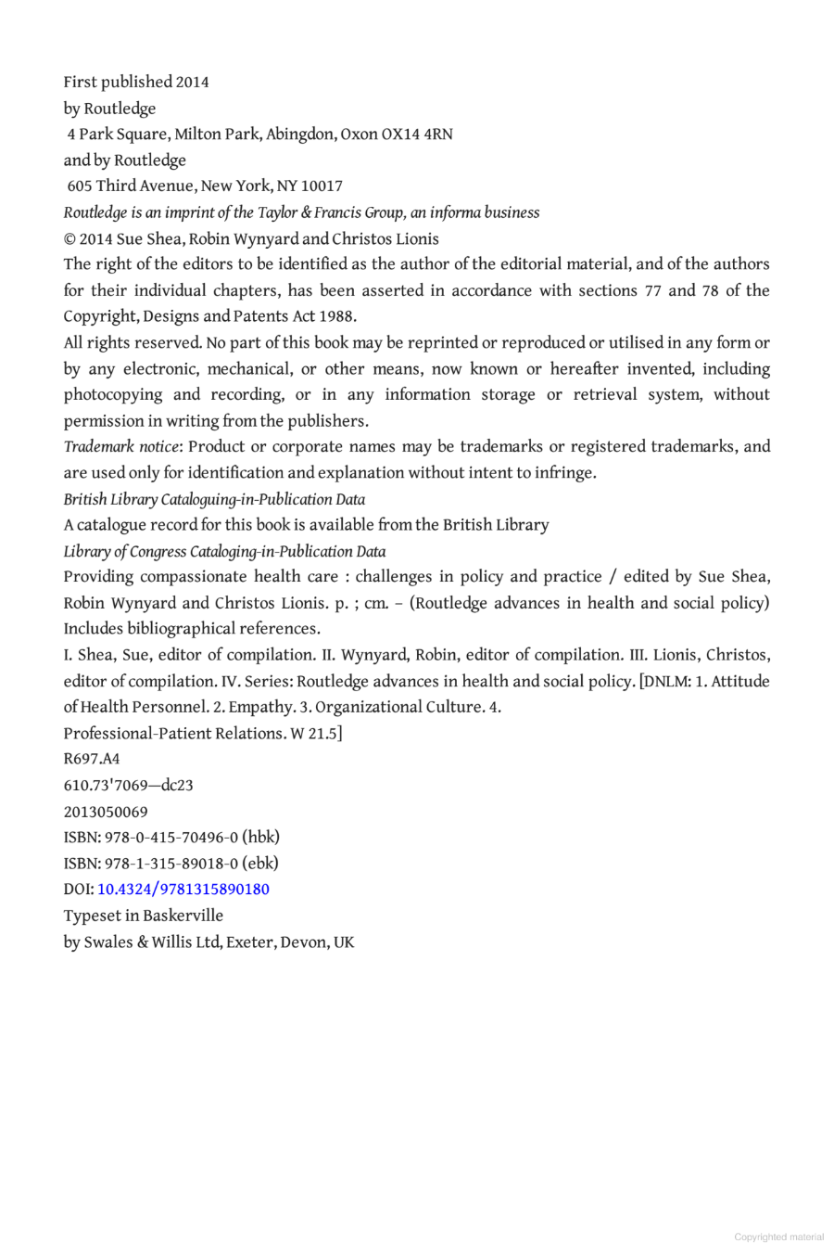
Activity 3: In the following Activity you will find 2 different credible sources
You need to identify the source type, provide the citation (both variations) and the full reference in the spaces provided. (8 Marks).

Answer:
Source type:
Citation variation 1:
Citation variation 2:
Reference:

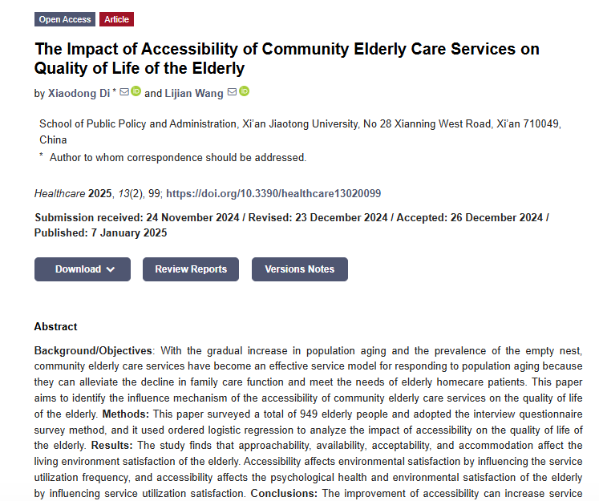

Answer:
Source type:
Citation variation 1:
Citation variation 2:
Reference:

Activity 4: Match each reference to the correct source type by writing the correct letter (A–C) in the table. (3 Marks)
References
A.) NHS (2026) Social care and support guide. Available at: https://www.nhs.uk/social-care-and-support/ (Accessed: 18 September 2026)
B.) Edwards, D. and Best, S. (eds.) (2020) The Textbook of Health and Social Care. London: SAGE Publications.
C.) Rand, S., et al. (2022) ‘Applying a dyadic outcomes approach to supporting older carers and care-recipients: A qualitative study of social care professionals in England’, Health & Social Care in the Community, 30(6), pp. e5001–e5009. doi: 10.1111/hsc.1391
Answer table:
Source Type | Correct Answer/Letter
Books
Website
Journal

Activity 5: Insert appropriate in-text citations using the sources below. (3 Marks)
(Phillips, 2021)
(Royal college of nursing, 2025)
According to Edwards (2023)
Paragraph for citation practice:
In order for nurses to effectively support patients, effective interdisciplinary care is needed. This warrants excellent communication skills. It also requires nurses to thoroughly assess patients to anticipate their needs.

Activity 6: Academic Integrity. Read each question carefully and select the best answer. (5 Marks)

Question 1: What is plagiarism?
A.) Working with classmates to create an essay together.
B.) Using AI to write an essay which includes references
C.)Using another person's ideas without acknowledging them.
D.) Using the reference list from a journal article to support an essay.
Answer:

Question 2: What is the correct approach when using a direct quotation?
A.) Copy the words and change a few words
B.) Use quotation marks and provide an appropriate reference
C.) Remove the author's name
D.) Include the quotation without a reference if it is from a website

Answer:
Question 3: A student changes a few words in a sentence copied from a textbook but does not provide a reference. What is this most likely to be?
A.) Effective paraphrasing
B.) Academic proofreading
C.) Plagiarism
D.) Independent research

Answer:

Question 4: What is academic misconduct?
A.) Making a spelling mistake
B.) Failing to meet a deadline because of illness
C.) Behaviour that breaches the rules of academic integrity
D.) Using a textbook to research an assignment

Answer:

Question 5: A student invents research findings and presents them as genuine results. What is this known as?
A.) Paraphrasing
B.) Fabrication
C.) Citation
D.) Collaboration
Answer:

