Advance Character!

The planning phase of animation is the most important part to achieve a good shot, there is a lot of work that goes into each shot to capture the energy and emotion of a character. In my animation I will study an in depth analysis on facial expressions and how we can make them come to life with advance believability.

Character Animation: My posing approach

Creating a 3D short is a time-consuming process. Therefore being tasked with animating a 20-30 seconds shot/shots I had to use a rigged character from online to help achieve a believable movement. During the design phase I have two ideas in which I wanted to study and approach. Firstly was to experiment and understand facial expressions in order to display them in action and which would be suited to each situation, secondly is to take the facial expressions created and add them to an environment with a matching scenario.

Research

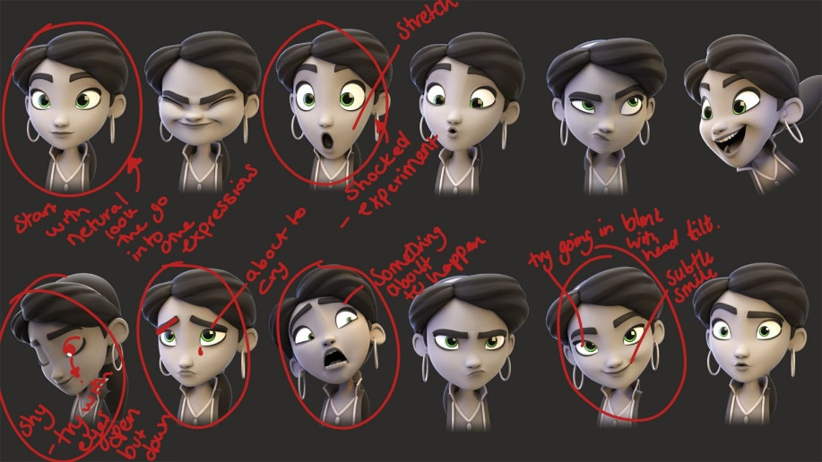
https://www.artstation.com/artwork/WAJYN

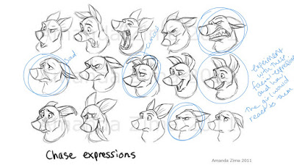

I began by breaking down another artists pose work, in order to find underlying patterns in the use of facial features. I highlighted aspects of particular importance with a draw over. This allowed for a greater focus on the aspects that mattered. More emphasis was given to the eyes in the research as this is where the emotion is mainly accentuated within an animated character. Over exaggerating the eyes helps emphasise the emotion I am trying to achieve.

‘Our eyes don’t lie: they’re windows to the soul. They show the truth, no matter what face we put on, in any situation. The best way to get to know someone is to look them in the eyes and observe what they reveal about their emotional state.’ (Exploring your mind, 2016).

Animation One
My main focus on my first animation is to have an up close camera shot of ‘Mery’s' face transitioning into several facial expressions showing different emotions.

Animation Two
My second focus is to repeat the same animation but sticking with an original idea of her sitting down and experiencing themes within the space of using different sound approaches towards her reactions.

Camera Introduction

In the design stages of my advance character module, I wanted to keep in mind the angle of the camera just right in order to achieve the right mood I am trying to deliver for my audience, but also to capture an emotional yet heartwarming animated short, by trying to capture this I did some research on how this could be completed within the space of 20-30 seconds using as little movement on the camera as possible.

Delivering

This is going to be a challenge for me as I am animating a quadruped and biped but my challenge is to capture different emotions and the greeting of 2 strangers. Animating a 3D character is a time consuming process and there are many different approaches to explore with delivering a high quality animation. During the developing stages my approach to achieving a smooth animation is to use the guidelines located within the ‘The
Animator's survival kit’ (Williams, 2009). along with the more traditional 12 principles of animation.
When it comes to animating the dog I also wanted to look into how the dog would react around someone and to use facial expressions. I want to capture the time-lapse of the two interacting but showing different emotions, and how one another would rub off on each other.
I will be delivering my process of production using the software Maya to created my 3D short.

The research I found helped me with an idea of capturing different emotions. Although the videos I found mainly went from one to another I found as I did not know much about animation especially the emotion side of things I felt as though it would be to difficult to approach this, although what I did come up with was to have a base pose where she would transition back into this pose after an affection facial reaction.

Research



After discovering these videos I had a better understanding of where to take my animation and how to approach it. I used all three videos to help develop my animation skills and understand more about character expressions in order to help me animate my own version.

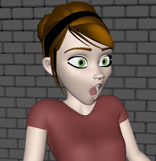
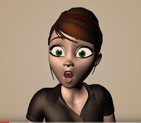

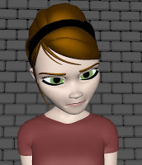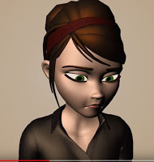

The two left images are shot captured from the videos from from Youtube and the two right ones are the ones I animated towards my final animated short.

Using the online clips I used help guide me towards developing my own style of the emotion and changing the angels, when I approached the crying emotion something did not quite feel right when watching the animation in Maya, therefore after some experiments I enlargement of the pupils in order to make her look more upset.

After researching specific pose’s from another artist I took the rig 'Mery’ which will be used within my animation. I then took the one I wanted to experiment more with by making a flowing scene of different emotions. After creating a rough draw over I took it upon myself to go further with each emotion and animate them into little clips.

After creating some small test animations I came up with a hand full of different expressions which I stitched together, I found this subconscious helped me figure out which emotions I wanted to take forward and experiment more with so therefore I did some draw overs. I started with the female as she was my mainly focus toward the final animation.

Body language and facial expressions are used to animate an appealing character and bring them to life, it is to understand the emotion taking place from the characters perspective within the animation. It is also a great tool to understand what the character is feeling on the inside and to create depth in your character. All my research from the book the animator's survival guide has helped me create a smoother animation once I understood the reasoning and shape behind each facial expressions and body language.
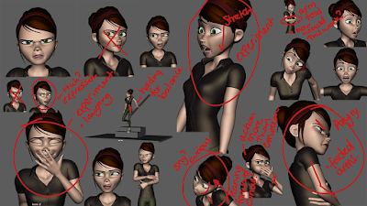
After choose specific movements I developed forward by posing out the key expressions I was going for, my decisions was to capture Shocked, Angry, Sad, Laughing, Shy and Yikes.

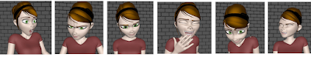

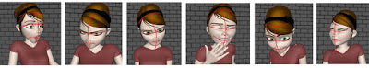

Subsequently, when I have the key poses I added some draw overs for my own purpose in order to understand how to arcs and curves worked within the facial expressions, it was very Interesting to see the squash and stretch and arcs coming through. During the research stages I also took a look at 'The animator survival kit'. This explained a lot about the 12 principles of animation.

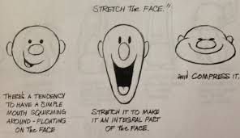

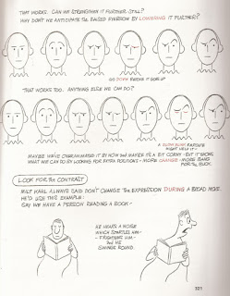

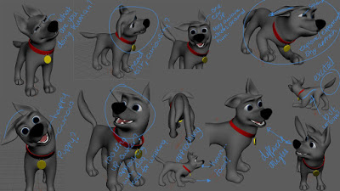

When in the early stages of developing an idea for my animation I chose to do an expressions mood boards in order to key the main facial expressions I wanted to portray within my animation. My main focus was to get the dogs expressions very puppy like and curious of the world which is why he is chasing the leaf and approaches the girl and these things are all new to him I also wanted his body language to be very clumpy and happy all the time.
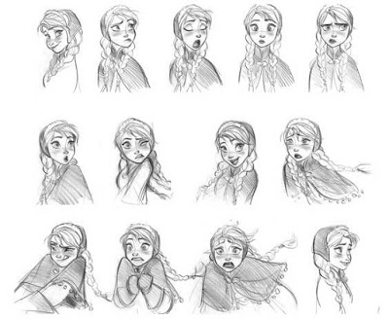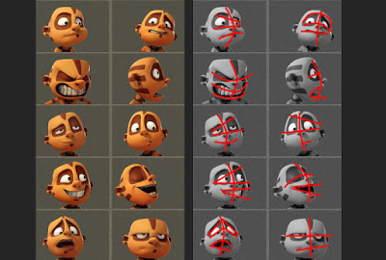

Theses two images helped me gain a better understanding of facial expressions and how in animation we can push theses expressions further than natural. The image on the right shows a
draw over of basic shapes that we can break the expressions down into. From this I was able to create my own version using the 'Mery’ rig.

During the developing stage I came up with an idea of a dog chasing a leaf and suddenly becomes aware of a female crying therefore the dog was to approach her in a stealth mode and once he becomes closer she stops crying and starts laughing, but this was not working for me I did not seem to catch the emotional connection I was after, therefore I went back to researching other ways to connect the dog and the girl. Then I found a quote from ‘The art of Up’ which really helped me towards my final developing stages. (Jim Henson) 'simple is good' (Hauser and Docter, 2009) .’ this helped me towards a more well put together animation, I feel like I was trying too hard to achieve something very complex. Therefore I stripped it all back again and decided to take away the dog approaching her and to have the dog there already but reacting with different emotions such as anger etc, and that 'Mery’ would react to the dogs action. Therefore the animation I would put out for my audience would be simplistic but also they would know what was going on in each situation using mainly facial expressions to react with one and other.

Rough Design
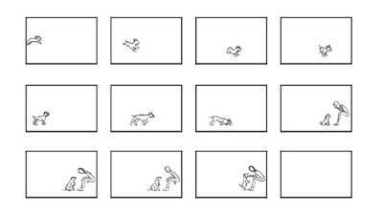
Above are my rough thumbnails of my previous idea for the animation. Here you can see
the dog approaches the girl from left to right to show he is advancing towards his objective. The way this has been designed allows me to showcase my skills at animating a quadruped and a biped.
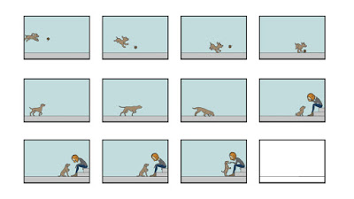

Updated Storyboard

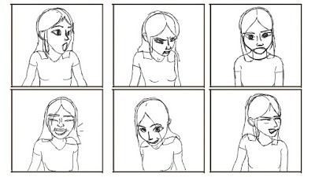
After having complications with the dog rig I decided to double down and focus on 'Mery's' facial performance. I created a new storyboard containing key poses and expressions that she would display within the animation. I then had an idea that it would be better for her to react to a stimulant which has not yet been decided. The two ways I could go with this is to either have a model prompt on screen or possibly a sound which would prompt a reaction.

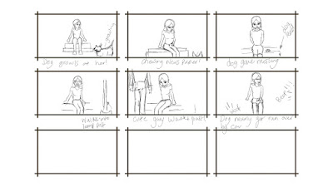

Following this new change in direction I set about thinking what would work as a prompt for each key pose. I created each pose to portray and emotion so I then had to think what action would spark that emotion. Under each frame you can see examples that settled on. I ended up collecting a variety or sounds and model prompts for the animation so that each pose was more believable.

After my research and stripping everything back I created some 2D animatics just short and simple ones to see how the character would be in the 2D world. Jumping between both 3D and 2D to achieve the emotion I was going for really helped me to create the both different types of animation. Although switching between the two helped me a lot, I created a different hair style from the Mery rig as I wanted to experiment the slightest of movements within each pose.

This clip found from Youtube helped me achieve a 2D animatic of a dogs reacting to seeing someone.

When approaching adding the dog to the animation I wanted to experiment with giving the dog a bit more of a personality, There for I created a dog running after a ball but is very clumsy and dopey when he attempts to catch it I also wanted the design to be more of a pup so you can get this clumsiness through how young the dog would be.

Developed Design.

After experimenting with a personality of a dog I decide to talk this forward and test out a slightly different version in 3D. The overall animation I was going for to a dog to jump up on an object with a very happy facial expression.

when creating theses animated clips I used the step setting in Maya, although the animations have turned out very blocky, The stepped setting helped me gain the general emotion I am trying to achieve.

Lighting

Personally lighting for me is very important it helps solidify the mood you are trying to put across to the audience. Although depending on the story you could always change the mood with lighting changes to fit more with what your character is feeling.

I tried a few different lighting techniques in order to gain the mood I was going for, I attempted to change the lighting to fit with each mood but it was far too distracting so I then settled for a simple light with a slight yellow tint and added area lights so that I could gain a shadow around the characters silhouette. This ended up taking the form of a more traditional 3 point lighting setup.

Rendering
Due to a small issue with Mery's eyes not rendering correctly in Arnold I began looking to render on a different platform. After attempting to use Maya software and Hardware as theses were the only two able to render the eyes properly, I compared the outcomes and was unsatisfied with the quality compared to Arnold. After some problem solving and sharing the issue with class mates we were able to get to the bottom of the problem. Because the rig was referenced in it needed to be altered in the original file to turn off the settings preventing the renderer from seeing the eye. Once this was solved then I could use Arnold and the outcome was much better.

Final Animation

The below clip is my final animated short, there is a two part section to this animation.

Conclusion

During the early stages of development I was very unhappy with what I had animated but after reading a quote about ' simple is good' which made me rethink my idea was the best decision I made. I am very happy with the second latter of the animation and the changes achieved in order to gain a smooth animation. If I were to redo this I would focus more on simpler animations at the start to understand more about animation. There is a part I enjoyed the most where I focus solemnly on the facial expressions and the transitions I would like to experiment more with more complex expressions in the future now I have learned a lot about the basic once.

I am very happy with all the experiments I have achieved in the study and have learned a lot about facial expressions but also the environment around it. I have realised that simplicity is where to start within animation. Once understanding the simple movements and expressions then the more complex animations will come in.

Bibliography

Boadway-Masson, D. (2016). Facial Animation 101 | Animation Mentor Blog. [online] AM Blog. Available at: https://blog.animationmentor.com/facial-animation-101/ [Accessed 11 Nov. 2019].
Exploring your mind. (2016). Eyes Are Windows to the Soul — Exploring your mind. [online] Available at: https://exploringyourmind.com/eyes-windows-soul/ [Accessed 15 Nov. 2019].
Williams, R. (2009). The animator's survival kit. London: Faber and Faber, pp.246-250.

Hauser, T. and Doctor, P. (2009). The Art of Disney Pixar Up. California, p.18.

f

