
APPENDIX GA36

LEVEL 4 ASSESSMENT SPECIFICATION

Student name: | Lewis Sullivan | Student ID number: | 1910628
Programme: | Foundation
Module: | Science
Module code: | M3X01513 | Contribution to Overall Module Assessment (%): | 30
Lecturer: | Dr. G Owen | Internal Verifier: | Dr. A Marotin
Assignment Title: | Science Coursework | Word count (or equivalent): | NA
Submission deadline: | 24/01/20 | Return date of provisional marks & written feedback: | 17/02/20
Submission method: | All written assessments, where practical and possible, must be submitted via Turnitin unless otherwise instructed by the Lecturer. (Please DO NOT put this assessment specification into Turnitin or it will match many similarities with other students’ submissions.)  Alternative submission method (if applicable):  Late submission of the assessment will result in a late penalty mark. Penalties for late submission: Up to one week late, maximum mark of 40%. Over one week late, 0%. Only the Extenuating Circumstances Panel may approve a change to submission dates.
Academic honesty / referencing: | Academic honesty is required. In the main body of your submission you must give credit to authors on whose research and ideas your work is based. Append to your submission a reference list that indicates the books, articles, etc. that you have used, cited or quoted in order to complete this assessment.

Module Learning Outcomes
(from module syllabus)
- Identify and apply appropriate physical principles and relationships in the solution of engineering problems

- Manipulate equations to produce numerical values in engineering units

TASK DESCRIPTION

You are going to answer a series of questions surrounding engineering scientific applications. Most of the content will have been covered in the series of lectures but some additional research is required.

ANSWER ALL QUESTIONS

- The diagram below shows a box which is resting on an inclined plane. Forces F₁ and F₂ represent the component of weight which acts parallel to the slope and perpendicularly into the slope respectively.
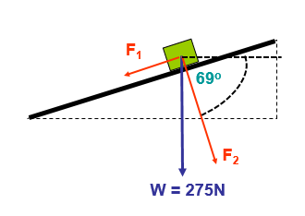

a) Given that g = 9.81ms⁻², and Weight = mass X gravity;
Calculate;
i) the magnitude of friction [2]
= 98.55N
Working out…

90 – 69 = 21degrees

(sin)21 = 0.323917418 x 275 = 98.55N

F1 = 275 x (sin)21degrees = 98.55N

ii) the angle between the direction of the force of friction and the vertical [2]
= 21 degrees

90 – 69 = 21degrees

iii) the normal reaction between the box and the plane [2]

(cos)21 = 0.933580426

F1 = 275 x (cos)21degrees = 256.73N

b) Newton’s second law states that the resultant force is proportional to the rate of change of momentum. Given that
Momentum = mass × velocity

i) Write out the above statement mathematically [2]

p = mv

ii) State the units of momentum, [2]

kg m/s

c) Newton’s second law is commonly written as,
Resultant force = mass × acceleration or F = ma

- Considering this, what would be the required magnitude of a force that pointed parallel to the slope, and in the opposite direction to F₁ so that the box would accelerate up the slope at 2.5ms⁻² [4]

F1 / 2.5ms-2 = 98.55 / 2.5 = 39.42kg ms-1

ii) What would be the change in momentum between the moment just before the box began to move up the slope and when its velocity reached 7.5ms⁻¹ [2]

98.55 / 7.5 = 13.14 kg ms-1

iii) Using the statement given in b) What resultant force would be required to increase the velocity of a 5kg box from rest to 12.5ms⁻¹ in 3.2s. [4]

5kg x 3.2s = 16.25 kg ms-2

- The circuit shown below shows a 12V battery connected to a combination of three resistors and a thermistor.
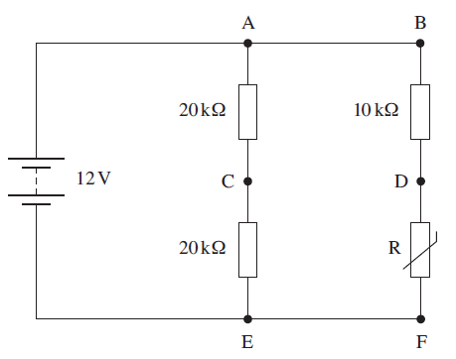

a)

When the resistance of the thermistor is 5KΩ

i) Calculate the total resistance of the circuit [4]

20kOhms + 20kOhms = 40kOhms
10kOhms + 5kOhms = 15kOhms

Resistors in a Parallel is 1/Rt = 1/R1 + 1/R2

1/((1/40k)+(1/15)) = 10.9k

10.91 kOhms

ii) Calculate the current leaving the battery [2]

V = IR

12V = 10.9 x ?

12 / 10.9 = 1.10 which also is the equivalent to 10.9 x 1.10 = 12

Converted back = 1.1mA

iii) Calculate the power used by each of the three resistors and the thermistor [8]

P for 20k resistors = 1.8mW

P=IV
I = 0.3mA
V = 6V
1.8mW

P for 10k resistor =
P=IV
I = 0.8mA
V= 8V
P= 6.4mW

P for 5k thermistor =
P=IV
I=0.8mA
V = 4V
P= 3.2mW

b) A voltmeter is used to measure the potential difference (PD) between points on the circuit. What PD would you expect to see between points:

i) A-C

20kOhms x 0.3mA = 6V

- D-F
5kOhms x 0.8mA = 4V
iii) C-D

= 10V

[6]

- a) Define the moment of a force about a point. [2]
The moment of force about any point is defined as force multiplied the perpendicular distance from the turning point to the line of action of the force.
The relative equation would be: moment = force x distance.

b) The diagram below shows a ‘gripper’ used for hand strengthening exercises.

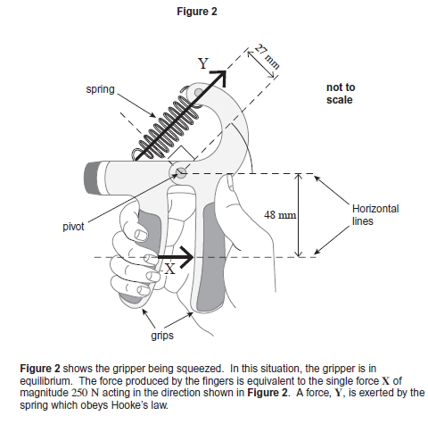

i) Calculate the moment of force X about the pivot. State an appropriate unit [3]

250 x 48 = 12000 Nm

Force X = 12000Nm

ii) Calculate the force Y [3]

12000Nm / 27mm = 444.44N

Y = 444.44N

iii) The extension of the spring is 15mm. Given the fact that ‘Hooke’s Law’ states that the applied force is proportional to the extension, or;
F = kx

iv) Calculate the spring constant and state its unit. [4]

F = Kx

X = 15x10^-3

F = 444.44

444.44 / 0.015 = 29629Nm

v) Given that;
Work done = Force × Distance

Calculate the work done on the spring to squeeze it to the position shown in figure 2. [3]

Wd = F*D

F = 444.44N
D= 0.015m
F*D = 6.67J

c) Given the definition, Power is the rate of working

i) Write down an equation for Power in terms of Energy and Time stating its units. [2]

Power = Energy / Time

ii) Assuming it takes 2.2s to squeeze the trigger, what is the power being applied. [2]

6.666J / 2.2s = 3.03W

d) If the total amount of energy that was used during the exercise session was 3.2kJ, how many times will the trigger be squeezed. [3]

3.2kJ / 6.666J = 480.0048

Diwedd/End

GUIDANCE FOR Students IN THE COMPLETION OF TASKS

NOTE: The guidance offered below is linked to the five generic assessment criteria overleaf.

- Engagement with Literature Skills
Your work must be informed and supported by scholarly material that is relevant to and focused on the task(s) set. You should provide evidence that you have accessed an appropriate range of sources, which may be academic, governmental and industrial; these sources may include academic journal articles, textbooks, current news articles, organisational documents, and websites. You should consider the credibility of your sources; academic journals are normally highly credible sources while websites require careful consideration/selection and should be used sparingly. Any sources you use should be current and up-to-date, mostly published within the last five years or so, though seminal/important works in the field may be older. You must provide evidence of your research/own reading throughout your work, using a suitable referencing system, including in-text citations in the main body of your work and a reference list at the end of your work.

Guidance specific to this assessment: N/A

- Knowledge and Understanding Skills
In this section you need to consider measured quantities and how they are displayed graphically and also how you intend to use the data gained from the graph to inform a scientific judgement. Clear explanations of your understanding of the reasons for your choices and why they are scientifically relevant will demonstrate this. Comments on what measures you took to reduce uncertainties in your results should be given.

Guidance specific to this assessment: Well explained processes will get you high marks here.

- Cognitive and Intellectual Skills
You should be able to present, evaluate and interpret qualitative and quantitative data, in order to develop lines of argument and make sound judgements in accordance with basic theories and concepts of your subject(s) of study. You should be able to evaluate the appropriateness of different approaches to solving problems related to your area(s) of study and/or work. Your work must contain evidence of logical, analytical thinking. For example, to examine and break information down into parts, make inferences, compile, compare and contrast information. This means not just describing what! But also justifying: Why? How? When? Who? Where? At what cost? You should provide justification for your arguments and judgements using evidence that you have reflected upon the ideas of others within the subject area and that you are able to make sound judgements and arguments using data and concepts. Where relevant, alternative solutions and recommendations may be proposed.

Guidance specific to this assessment: Good quality calculations and excel data with a good methodology is essential.

- Practical Skills
At level 4, you should be able to apply the basic underlying concepts and principles to evaluate and interpret these within the context of your area of study. You should be able to demonstrate how the subject-related concepts and ideas relate to real world situations and/or a particular context. How do they work in practice? You will deploy models, methods, techniques, and/or theories, in that context, to assess current situations, perhaps to formulate plans or solutions to solve problems, or to create artefacts. This is likely to involve, for instance, the use of real world artefacts, examples and cases, the application of a model within an organisation and/or benchmarking one theory or organisation against others based on stated criteria.

Guidance specific to this assessment:

- Transferable Skills for Life and Professional Practice
Your work must provide evidence of the qualities and transferable skills necessary for employment requiring the exercise of some personal responsibility. This includes demonstrating: that you can communicate the results of your study/work accurately and reliably, and with structured and coherent arguments; that you can initiate and complete tasks and procedures, whether individually and/or collaboratively; fluency of expression; clarity and effectiveness in presentation and organisation. Work should be coherent and well-structured in presentation and organisation.

Guidance specific to this assessment: You need to use the report writing handbook to get the best structure here, if you do this now and make an assignment template as instructed in class, this will save you time in future.

Student FEEDBACK FORM

This section details the extent to which the assessment criteria are demonstrated by you, which in turn determines your mark. The marks available for each category of skill are shown. Lecturers will use the space provided to comment on the achievement of the task(s), including those areas in which you have performed well and areas that would benefit from development/improvement.

Generic Assessment Criteria | Marks available | Marks  awarded
1. Engagement with Literature Skills
.
Appropriate scientific research to allow you to solve the problems

 | 15
2. Knowledge and Understanding Skills
Relating quantities as derived from graphical information

Relating quantities as derived from graphical information | 35
3. Cognitive and Intellectual Skills

a. Working with graphs

b. Handling data

a. Working with graphs  b. Handling data | 50
4. Practical Application Skills

Experimental Technique

5. Transferable Skills for Life and Professional Practice

Use the report writing handbook from Moodle.

Use the report writing handbook from Moodle. | 0

Assessment Mark (Assessment marks are subject to ratification at the Exam Board. These comments and marks are to give feedback on module work and are for guidance only until they are confirmed. ) | Late Submission Penalties (tick if appropriate) |  | %
 | Up to 1 week late (40% Max) |  | %
 | Over 1 week late (0%) |  | %

