University of Wales Trinity Saint David

Wales Institute of Science & Art



Analyse and Simulate a Mechanical Energy Recovery System
Stress Analysis and Dynamics (AMC5010)

Andrew Johnson
2405685
September 2025

Contents
Report Summary 3
Key Findings 3
Conclusion 3
Task A 4
Introduction of flywheels 4
History and origins of flywheels 4
Types of flywheels 5
Advantages of flywheels 7
Disadvantages of flywheels 7
Kinetic Energy Recovery systems (KERS) 7
Design implications of flywheels 8
Mechanical batteries and advantages over chemical batteries 9
Task B 9
Part 1….. 9
Part 2….. 9
Part 3….. 9
Part 4….. 10
Part 5….. 10
Part 6….. 13
Part 7….. 13
Part 8….. 16
References 16
Word count 17

Report Summary
The purpose of this report looks into the history of flywheels and their applications.

Section A looks at the types of flywheels available, their design implications and their advantages over chemical batteries.
Section B looks at calculations of different flywheels for vehicles using a KERS system to work out energy loss, reacceleration speeds and how the diameter of flywheels affects rotational speed.
Graph have been created to visually show the findings of the calculations

Key Findings
- Flywheels have evolved over hundreds of years bringing large benefits.
- Its purpose must be considered considering the cost to performance ratio for flywheels in cars.
- The diameter of a flywheel is proportional to its speed (RPM)
- Removing friction by vacuum or magnetism is essential to improve efficiency.
- Many different types of flywheels are made and used depending on application.

Conclusion
Flywheels have been used extensively for hundreds of years and are still in use today. They started by being used to make pottery to helping grind clay to powering the locomotive steam engine during the industrial revolution. It is now being used in regenerative braking systems and are being used to store energy efficiently by helping the environment by making vehicles more efficient by converting heat into electrical energy from braking. Advancements in technology have continued to push the simple concept making it useful many years after it was originally used.

Task A

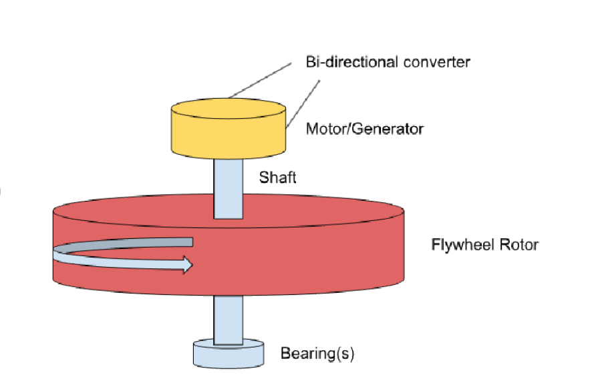
Introduction of flywheels
Image 1 - Flywheel storage system - Joshi (2025)
A flywheel is a machine that holds rotational energy by using the resisting change in rotational speed. The total energy stores inside a flywheel are proportional to the speed of rotation of the flywheel. The energy stored inside of the flywheel is proportional to the speed of the rotation of the flywheel. By applying torque, you can increase or decrease the rotational speed. A great example of flywheels in use is inside of vehicles such as cars. A flywheel is used to preserve the energy used when a vehicle is braking which can then be used to help reaccelerate a vehicle making the process much more efficient and less energy consuming.
Meister (2023)



History and origins of flywheels

Flywheels originated from potters wheels. Which used a flywheel beneath the potters wheel which was kicked to allow the table to spin quickly and at a constant speed while leaving the hands free to create the pottery.
Davy (2024)

Image 2 Potters table - Peterson (2019)

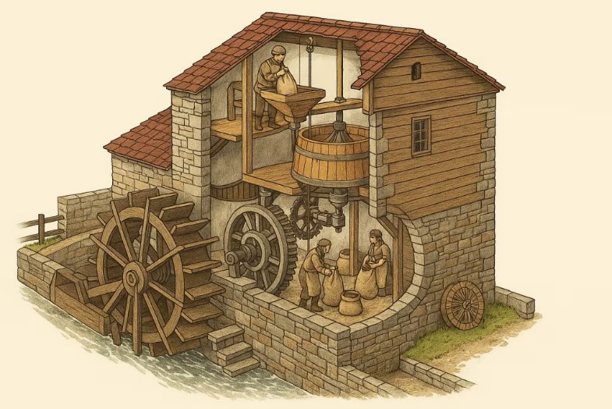

This technology was then used in water mills to use the energy from the flowing water to turn a flywheel which in turn moved a Wheatstone. This stone grinded grain into flour for use in bread automating the process.
Nakaya (2020)

Image 3 - Water mill - worldriv-adm (2025)
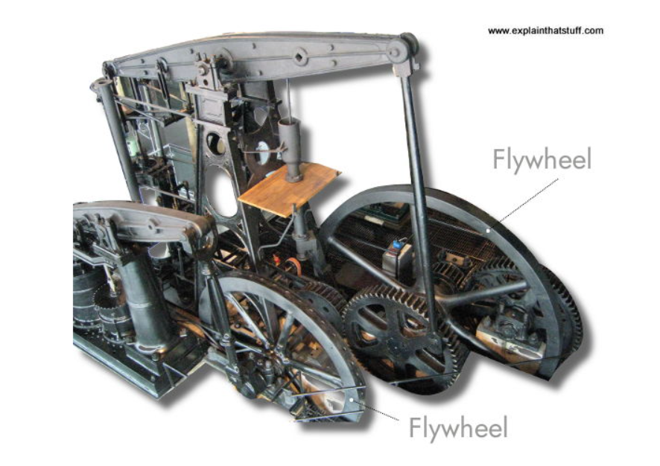

Flywheel technology was then refined in the industrial era to be used in steam engines. Steam power was intermittent in pulses but by using a flywheel, the energy created could be regulated to constant power allowing steam engines to pull carriages and cargo.
Woodford (2012)

Image 4 – Steam engine - Woodford (2012)

Types of flywheels
Different types of flywheels are used depending on the application required. This can also affect what materials are used in their construction and design.

Solid Disc
A solid disk flywheel is made simply out of cast iron. Using cast iron gives it better stability and strength compared to other types of flywheels. These can be used on vehicles on all sizes

Rimmed
Rimmed flywheels are used as an alternative to solid discs; they are much lighter than solid disks but will wear down under lower RPM than solid disks when comparing flywheels of similar dimensions. This means that they are much better suited to vehicles with higher torques and lower velocity vehicles.

High Velocity
High velocity flywheels are designed to operate in the high range between 30,000 – 80,000RPM. These flywheels are designed of lightweight materials due to the high velocity that they spin at during operation. An example of their use is in hybrid vehicles such as racing bikes and performance vehicles where stored energy from braking can be used to reaccelerate the vehicle quickly while also keeping the vehicle light to improve performance.

Low velocity Flywheel
Low velocity flywheels are designed to work under 10,000RPM. They are normally used in uninterruptable power supplies (UPS) where reliability and durability is prioritized over higher energy storage. These are mainly used in support structures where if a fault has occurred within a power system, this will allow them to operate until the issue has been resolved.

Single mass flywheel
Single mass flywheels are made by only using a single material when creating the flywheel through casting during the manufacturing process. By doing this, there are no moving parts inside making them very reliable and resilient to changes such as speed. They are often used In fast revving engines where they aid the connection between the engine itself generating power and the clutch system. Due to its manufacturing process of singular casting, the flywheel can withstand high temperatures and will resist warping. These resistances also allow them to be reliable at high-speed changes.

Another great aspect of single mass flywheels is their durability. When they become damaged or worn over time, it is possible to resurface them allowing them to last much longer than other flywheels. This will bring down the cost overall due to less replacements being required in the vehicles using them. Their manufacturing process also makes them cheaper to product than dual mass flywheels making them much more affordable.
Durability is one of the most important features of any flywheel variety. Single mass flywheels are resurfaced as and when required, in order to boost their overall reliability and service life. Their cost is relatively lower as well. However, excessive vibration and noise can be a problem associated with using these flywheels. two disadvantages with single mass flywheels are they can produce a large amount of noise and vibration requiring balancing and dampening.

Dual mass flywheel
A dual mass flywheel is made up of two distinct parts which are fitted to different parts of the vehicle. The first being fitted to the clutch and the second being fitted to the crankshaft. This allows them to be much larger than their single mass counterparts, allowing them to be used in heavier machinery. A great example of this is inside of a diesel vehicle such as a truck. They are especially useful inside manual transmission vehicles that require high toque fur moving cargo. This is due to the larger flywheels being able to store larger amounts of energy while braking with additional weight. Springs are also built into the flywheel to help protect the gearbox. Dual mass flywheels also have good energy storage and transmission capabilities allowing the rotations between the piston pulses to synchronize and become a lot smoother. One disadvantage with dual mass flywheels is that unlike single mass flywheels, they cannot be resurfaced and will instead require replacement.
admin (2022)

Advantages of flywheels
- Smooth power transmission to and from flywheels.
- High energy output depending on size of flywheel determining energy stored.
- Simple design for maintenance and replacement if required lowering maintenance costs.
- Can charge through the motor or using energy generated from braking systems.
- when increasing efficiency of vehicles.
- Flywheels are not affected by temperatures affecting their energy storage.
- Aids in protecting the transmission and gearboxes of vehicles by absorbing energy reducing strain on those components.
- High durability allows for long service life.

Disadvantages of flywheels
- Speeds are limited inside the flywheel, type and material of flywheel must be considered prior to use due to high and low velocity flywheels having specific uses and operating speeds.
- Flywheels are susceptible to fatigue failure.
- Checks and maintenance are required due to the high chance of bearings failing inside of the flywheel.
- Flywheels cannot be controlled by the operator of the vehicle.
Kumar (2021)

Kinetic Energy Recovery systems (KERS)
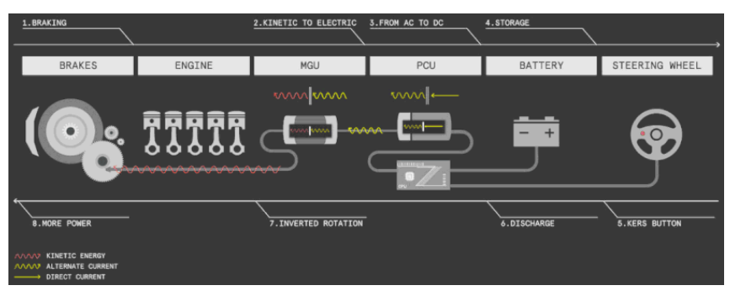
KERS system image Canbolat (2020)
A Kinetic energy recovery system or (KERS) for short is a system that converts braking energy into usable energy in many different types of vehicles such as within high performance vehicles, an example is a formula one car, to transportation such as trains. This process works by converting heat energy created by using the brakes on a vehicle such as a car and where the breaks convert energy from the car braking in the form of heat energy into electrical energy that is stored to allow for faster reacceleration. A great example of this is within formula one cars, they are almost constantly braking for turns and corners, allowing them great opportunities to store electrical energy which can then be used in electrical motors to increase acceleration when coming out of those corners.
An MGU or motor generator unit converts heat energy into electrical energy. This energy is then stored inside a battery ready to be used when required.

A PCU or power control unit is then used to convert the energy from AC to DC voltage, a boost converter is used to increase the DC power available to use and then followed by a DC-to-DC converter to lower the voltage to be suitable for the required motors ready for use.

This system allows the energy to be quickly stored and released to make vehicles more efficient, reducing wasted energy in the form of heat energy.
Canbolat (2020)

Design implications of flywheels
Flywheels have very specific implications that need to be balanced between performance, safety, efficiency and cost.

The shape and design of a flywheel is a strong implication due to which type is best suited to its application, solid disk flywheels provide great stability and strength but are much heavier whereas rimmed flywheels are much lighter.

Material selection is also important for flywheels depending on what criteria needs to be met. Most flywheels are made of cast iron and steel making them reliable, durable and relatively cheap but Kevlar and carbon fiber can also be used to reduce its overall weight but is much more expensive and used for higher strength to weight ratios.

Tensile stress is another factor to include such as safe RPM operating ranges to ensure that the flywheel is able to handle the immense stresses prior to being built.

Their behavior while in use should be considered such as its ability to operate in a moving vehicle and must be designed to reduce vibration and imbalance due to a risk of catastrophic failure, this is resolved by better design and by using finite element analysis.

Energy storage efficiency must also be considered to ensure it is able to store enough energy and to remove issues that can lower that efficiency. An example of this is by using a vacuum sealed unit or magnetic bearings to reduce friction. Friction will reduce the total energy stored, making it less efficient overall.

The final implications to consider is its cost and performance. The lower weight materials with high strength will increase cost. This means its performance must be considered with its cost to ensure the highest energy is stored with the overall lowest cost in materials.
Hulatt (2019)

Mechanical batteries and advantages over chemical batteries
- Mechanical batteries can last many years with little to no issues ensuring maintenance is completed. Chemical batteries will become less efficient with less charge making them less useful with each charge.
- Mechanical batteries are much more beneficial for the environment than chemical batteries. Materials such as lithium and cobalt are very harmful to the environment when they have finished their lifecycle, but mechanical batteries can be simply melted down and reused.
- Mechanical batteries are much less temperature sensitive than chemical batteries which can degrade when exposed to extreme heat or cold.
Bryce (2024)

Task B

Part 1

𝐾𝐸=12𝑚𝑣2
𝐾𝑒𝑛𝑒𝑡𝑖𝑐 𝑒𝑛𝑒𝑟𝑔𝑦=12𝑚𝑎𝑠𝑠 𝑜𝑓 𝑣𝑒ℎ𝑖𝑐𝑙𝑒 𝑥 𝑠𝑝𝑒𝑒𝑑 𝑜𝑓 𝑣𝑒ℎ𝑖𝑐𝑙𝑒 𝑠𝑞𝑢𝑎𝑟𝑒𝑑
𝐾𝐸=12𝑥 2,080𝑘𝑔 𝑥 24.59𝑚/𝑠 2
𝐾𝐸=0.5 𝑥 2,080 𝑥 (24.592)=628,854.824 𝐽𝑜𝑢𝑙𝑒𝑠=628𝐾𝐽
KE = 628KJ

Part 2

Total Kinetic energy stored is KE = 628,854.824Joules = 629KJ
Flywheel energy efficiency = 80%
Total stored energy in flywheel = 629KJ x 0.80 = 503KJ

Part 3

Moment of inertia calculations:
𝐼=𝑀 𝑥 𝑟2
𝑅=3002=150𝑚𝑚=0.15𝑚
𝐼=6.5𝑘𝑔 𝑥 (0.15𝑚)2= 0.14625kg

Angular velocity calculations:

𝐾𝐸= 12𝐼𝑤2= 2 𝑥 5030000.14625=2622.715𝑟𝑎𝑑/𝑠2
Convert to RPM:
𝑅𝑃𝑀= 60 𝑥 𝑊2𝜋=60 𝑥 2622.715 2𝜋=25,045 𝑟𝑝𝑚

Calculation accounts for 80% efficiency of flywheel.

Part 4

E= 503,000J
M= 2080Kg

Final velocity from stored energy:
𝐸= 12𝑚𝑣2=𝑣= 2𝑒𝑚= 2 𝑥 503,000𝑗2080𝑘𝑔 =21.992 𝑚𝑒𝑡𝑒𝑟𝑠 𝑝𝑒𝑟 𝑠𝑒𝑐𝑜𝑛𝑑
21.992 𝑚𝑝𝑠=𝑥 2.23694=49.145𝑚𝑝ℎ

Part 5

Mph to m/s conversion calculation:

𝑉=𝑚𝑝ℎ ÷ 2.237 m/s
Kinetic energy calculation

Final speed after reacceleration calculation:
𝐾𝐸=12 𝑥 𝑀𝑎𝑠𝑠 𝑜𝑓 𝑐𝑎𝑟 𝑥 𝑠𝑝𝑒𝑒𝑑 𝑜𝑓 𝑐𝑎𝑟 (𝑚𝑝𝑠)2

𝐾𝐸 𝑠𝑡𝑜𝑟𝑒𝑟𝑒𝑑 𝑒𝑛𝑒𝑟𝑔𝑦= 12𝑚𝑣2=𝑤𝑜𝑟𝑘𝑖𝑛𝑔 𝑓𝑜𝑟 𝑣= 2 𝑥 𝐾𝐸𝑚

20mph
𝑉=20 ÷ 2.237= 8.04m/s

𝐾𝐸= 12𝑥 2080 𝑥 (8.04)2=67,227𝑗
𝐸𝑓𝑓𝑖𝑐𝑖𝑒𝑛𝑐𝑦= 80%=67,227 𝑥 0.8=53,782𝑗
2 𝑥 53,7822080= 51.713=7.19 𝑚𝑝𝑠

25mph
𝑉=25 ÷ 2.237= 11.18m/s
𝐾𝐸= 12𝑥 2080 𝑥 $11.18$2=129,992𝑗
𝐸𝑓𝑓𝑖𝑐𝑖𝑒𝑛𝑐𝑦=80%=129,992 𝑥 0.8=103,994𝑗
2 𝑥 103,9942080= 99.99=9.99 𝑚𝑝𝑠

30mph
𝑉=30 ÷ 2.237= 13.41m/s
𝐾𝐸= 12𝑥 2080 𝑥 $13.41$2=187,021𝑗
𝐸𝑓𝑓𝑖𝑐𝑖𝑒𝑛𝑐𝑦=80%=187,021 𝑥 0.8=149,617𝑗
2 𝑥 149,6172080= 143.86= 11.99𝑚𝑝𝑠

35mph
𝑉=35 ÷ 2.237= 15.64m/s
𝐾𝐸= 12𝑥 2080 𝑥 $15.64$2=254,394𝑗
𝐸𝑓𝑓𝑖𝑐𝑖𝑒𝑛𝑐𝑦=80%=254,394 𝑥 0.8=203,515𝑗
2 𝑥 203,5152080= 195.69=13.99 𝑚𝑝𝑠

40mph
𝑉=40 ÷ 2.237= 17.88m/s
𝐾𝐸= 12𝑥 2080 𝑥 $17.88$2=332,482𝑗
𝐸𝑓𝑓𝑖𝑐𝑖𝑒𝑛𝑐𝑦=80%=332,482 𝑥 0.8=265,986𝑗
2 𝑥 265,9862080= 255.77=15.99 𝑚𝑝𝑠

45mph
𝑉=45 ÷ 2.237= 20.12m/s
𝐾𝐸= 12𝑥 2080 𝑥 $20.12$2=421,007𝑗
𝐸𝑓𝑓𝑖𝑐𝑖𝑒𝑛𝑐𝑦=80%=421,007 𝑥 0.8=336,806𝑗

2 𝑥 336,8062080= 323.85= 17.99𝑚𝑝𝑠

50mph
𝑉=50 ÷ 2.237= 22.35m/s
𝐾𝐸= 12𝑥 2080 𝑥 $22.35$2=519,503𝑗
𝐸𝑓𝑓𝑖𝑐𝑖𝑒𝑛𝑐𝑦=80%=519,503 𝑥 0.8=415,603𝑗
2 𝑥 415,6032080= 399.62=19.99𝑚𝑝𝑠

55mph
𝑉=55 ÷ 2.237= 24.59m/s
𝐾𝐸= 12𝑥 2080 𝑥 (24.59)2=628,855𝑗
𝐸𝑓𝑓𝑖𝑐𝑖𝑒𝑛𝑐𝑦=80%=628,855 𝑥 0.8=503, 084𝑗
2 𝑥 503,0842080= 483.73=21.99𝑚𝑝𝑠

60mph
𝑉=60 ÷ 2.237= 26.82m/s
𝐾𝐸= 12𝑥 2080 𝑥 (26.59)2=735,309𝑗
𝐸𝑓𝑓𝑖𝑐𝑖𝑒𝑛𝑐𝑦=80%=735,309 𝑥 0.8=588,247𝑗
2 𝑥 588,2472080= 565.62=23.78 𝑚𝑝𝑠

Graphs of results

Graph 1 Reacceleration - M/S

Graph 2 Reacceleration - MPH

Reacceleration discussion
When looking at the results from braking speed to reacceleration. It is clear to see that some of the energy is lost between the braking and the reacceleration process. This is due to the 80% efficiency added to the calculations to account for the overall efficiency of the flywheel for the vehicle. Looking at the graph made above of the results of the calculations, it is clear to see that the speed of the vehicle is lower when reaccelerating, this is consistent when looking at the different speeds. This reduction of efficiency is added to the calculations when the total energy is calculated and 20% is removed to account for efficiency.

Part 6

Acceleration calculation:
𝑎𝑐𝑐𝑒𝑙𝑒𝑟𝑎𝑡𝑖𝑜𝑛= 𝑣𝑒𝑙𝑜𝑐𝑖𝑡𝑦𝑡𝑖𝑚𝑒=𝑎𝑐𝑐𝑒𝑙𝑒𝑟𝑎𝑡𝑖𝑜𝑛= 𝑣𝑡
V= 23.78m/s
T=6.5 seconds
𝑎= 23.786.5=3.66𝑚𝑝𝑠

Part 7

Calculations used for question

Mph to m/s conversion calculation:

𝑉=𝑚𝑝ℎ ÷ 2.237 m/s
Kinetic energy of smaller vehicle

𝐾𝐸=12𝑚𝑣2
𝐾𝑒𝑛𝑒𝑡𝑖𝑐 𝑒𝑛𝑒𝑟𝑔𝑦=12𝑚𝑎𝑠𝑠 𝑜𝑓 𝑣𝑒ℎ𝑖𝑐𝑙𝑒 𝑥 𝑠𝑝𝑒𝑒𝑑 𝑜𝑓 𝑣𝑒ℎ𝑖𝑐𝑙𝑒 𝑠𝑞𝑢𝑎𝑟𝑒𝑑

Flywheel kinetic energy calculation
𝐸𝑓=12𝐼𝑤2=12(𝑚𝑓𝑟2)𝑤2

Rearrange for angular velocity w

𝑤2=𝐾𝐸 𝑥 2𝑀 𝑥 𝑟2

Convert angular velocity to RPM

𝑁=𝑤 𝑥 602𝜋

Rotational flywheel energy
Ef = kinetic energy
M= mass = 4.5kg
R2 = radius squared = diameter
W = angular velocity

120mm Diameter

$V=60 ÷2.237 m/s$= 26.8224m/s
$$KE=\frac{1}{2}x 1,510kg x {26.8224m/s }^{2}$$
$$KE=543,178J=543.178KJ$$
$$543,178=\frac{1}{2}x\left(4.5\right)x(0.06)^{2} w^{2}$$

$$w^{2}=\frac{543178 x 2}{\left(4.5\right)x (0.06)^{2}}=67,059,012$$
$$W= \sqrt{67,059,012}=8,189 Radians per second$$

$$N=\frac{8189}{2 x π}=1303319 RPM=1303 RPM$$

140mm Diameter
$$w^{2}=\frac{543178 x 2}{\left(4.5\right)x (0.07)^{2}}=49,267,845.804$$
$$W= \sqrt{49,267,845}=7,109 Radians per second$$

$$N=\frac{7109}{2 x π}=1131.432 RPM=1131RPM$$

160mm Diameter
$$w^{2}=\frac{543178 x 2}{\left(4.5\right)x (0.08)^{2}}=37,720,694$$
$$W= \sqrt{37,720,694}=6,141 Radians per second$$

$$N=\frac{6141}{2 x π}=977.370 RPM=977RPM$$

180mm Diameter
$$w^{2}=\frac{543178 x 2}{\left(4.5\right)x (0.09)^{2}}=27,804,005$$
$$W= \sqrt{27,804,005}=5,273 Radians per second$$

$$N=\frac{5273}{2 x π}=839.224 RPM=839RPM$$

200mm Diameter
$$w^{2}=\frac{543178 x 2}{\left(4.5\right)x (0.1)^{2}}=24,141,244$$
$$W= \sqrt{24141244}=4,913 Radians per second$$

$$N=\frac{5273}{2 x π}=781.928 RPM=782RPM$$

220mm Diameter
$$w^{2}=\frac{543178 x 2}{\left(4.5\right)x (0.11)^{2}}=19,951,442$$
$$W= \sqrt{19951442}=4,467 Radians per second$$

$$N=\frac{4467}{2 x π}= 710.945 RPM=711 RPM$$

240mm Diameter
$$w^{2}=\frac{543178 x 2}{\left(4.5\right)x (0.12)^{2}}=16,764,753$$
$$W= \sqrt{16764753}=4,094 Radians per second$$

$$N=\frac{4094}{2 x π}= 651.580 RPM=652 RPM$$

Flywheel change discussion.

When looking at the graph below, it is clear to see that as the diameter of the flywheel increases, the RPM of the flywheel decreases. This is due to the moment of inertia increases with the squared radius of the flywheel. With more weight away from the center of the flywheel, it must balance this by having a lower angular velocity. Woodford (2012)

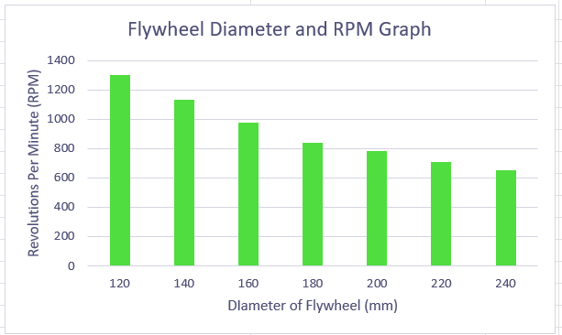
Graph 3 - Flywheel diameter vs RPM

Part 8

Assumptions made during the calculations
- The total efficiency of all parts is 80% this is only added once in calculations.
- The flywheels used are perfect in design and function, imperfect flywheels could reduce efficiency further.
- The gross weight of the car is 2080kg and 1510kg, respectively. This would be different in a real-life scenario with people and objects on board.
- The calculations are assuming that there is no friction between the bearings which will absorb some of the energy used for re-accelerating the vehicle.
- An assumption is made that the Vacuum seal for the flywheel is perfect to stop any energy dissipation.
Woodford (2012)

References
admin (2022). Types of Flywheels and Their Usage. [online] Crescent Foundry. Available at: https://www.crescentfoundry.com/blog/types-of-flywheels-and-their-usage/ [Accessed 12 Nov. 2025].
Bryce, E. (2024). Flywheel Energy Storage: A Promising Alternative to Batteries for Balancing Solar Power. [online] Bryce Energy Services. Available at: https://www.bryceenergyservices.com/2024/10/05/flywheel-energy-storage-a-promising-alternative-to-batteries/ [Accessed 12 Nov. 2025].
Canbolat, A. (2020). Basics of Kinetic Energy Recovery System (KERS). [online] Medium. Available at: https://medium.com/@alpoller/basics-of-kinetic-energy-recovery-system-kers-29e621b16319 [Accessed 12 Nov. 2025].
Davy, M. (2024). The Fascinating History of the Pottery Wheel. [online] Kiln Crafts. Available at: https://www.kilncrafts.co.uk/blogs/news/the-fascinating-history-of-the-pottery-wheel [Accessed 12 Nov. 2025].
Hulatt, L. (2019). Flywheel Design: Calculation & Considerations | StudySmarter. [online] StudySmarter UK. Available at: https://www.studysmarter.co.uk/explanations/engineering/mechanical-engineering/flywheel-design/ [Accessed 12 Nov. 2025].
Joshi, A.P. (2025). Material Investigation and Development of a 9310 Alloy Steel-Based Flywheel System for Cost-Effective Frequency Regulation. Material Investigation and Development of a 9310 Alloy Steel-Based Flywheel System for Cost-Effective Frequency Regulation. [online] doi:https://doi.org/10.13140/rg.2.2.31467.86560.
Kumar, E.A. (2021). Flywheel: Definition, Function, Construction, Working Principle, Material, Advantages, Application [Notes & PDF]. [online] THEMECHANICALENGINEERING.COM. Available at: https://themechanicalengineering.com/flywheel/ [Accessed 12 Nov. 2025].
Meister, P. (2023). How Does A Flywheel Work? Explained In Simple Words. [online] CAR FROM JAPAN. Available at: https://carfromjapan.com/article/how-does-a-flywheel-work/ [Accessed 12 Nov. 2025].
Nakaya, R. (2020). How does a watermill work? From grain to flour with water power. [online] The Kid Should See This. Available at: https://thekidshouldseethis.com/post/watermill-demonstration-video-flour-water-power [Accessed 12 Nov. 2025].
Peterson, B. (2019). 6 Features of an Electric Potter’s Wheel. [online] The Spruce Crafts. Available at: https://www.thesprucecrafts.com/aspects-of-electric-potters-wheels-2745977 [Accessed 12 Nov. 2025].
Selin, N.E. (2019). renewable energy | Types, Advantages, & Facts. In: Encyclopædia Britannica. [online] Available at: https://www.britannica.com/science/renewable-energy [Accessed 10 Nov. 2025].
Woodford, C. (2012). How do flywheels store energy? [online] Explain that Stuff. Available at: https://www.explainthatstuff.com/flywheels.html [Accessed 9 Nov. 2025].
worldriv-adm (2025). Where Water Turns to Wonder: The Charm of River Watermills - World Rivers. [online] World Rivers. Available at: https://worldrivers.net/2025/04/08/watermills/ [Accessed 12 Nov. 2025].

Word count


