Assignment Title: Component 1(Written Report)
NHS App, A Digital Solution for Healthcare

Student Name: Nasreen Akhtar
Student Id: 2316030
BSc (Hons) Health and Social Care
Module: Digital Transformation in the Health and Care Professions
Module Code: BMHP6026
Word Count: 1888

Table of Contents
1. Introduction: 2
2. The Healthcare Problem: 3
3. The Digital Innovation as a Solution: 3
4. Workforce Outcomes: 4
5. Service Delivery Outcomes: 5
6. Patient and User Outcomes: 6
7. Conclusion 7
Reference list 8

Introduction:
Digital transformations are the innovative solutions offered by digital technology to benefit society and the healthcare sector. Modern Era of connectivity, advanced analytics, automation, wearable technology, virtual reality, and the Internet of Things are Industry 4.0 and can help healthcare institutions come up with innovative solutions to medical issues to improve healthcare delivery (McKinsey, 2022).
One of the most important ways healthcare can deliver a safe, practical, and individualised health and care service is by facilitating information exchange (NHS England, 2025). One such innovation is NHS app. The NHS App was introduced in 2019 as the "digital front door" to the National Health Service in England (Kc et al., 2023). Its primary functions include scheduling appointments with general practitioners (GPs), rewriting prescriptions, granting patients access to medical records, and giving certificates for the COVID-19 vaccine (NHS England, 2019a). (Fig.1)
The report will critically evaluate the impact of the NHS App's implementation in the UK's health and social care system on the workforce, service delivery, patients and service users by using the Problem-Solution-Outcome Approach. The report identified the strain on healthcare system that the NHS App targets, the App offered the users more control over their health outcomes by offering multiple services right in their hands.
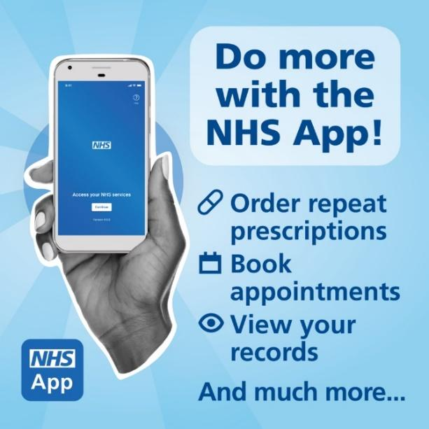

Fig.1 (Todd, 2024)

The Healthcare Problem:
For the generation that plans their life at the click of a button, the NHS seems more and more outdated and slow. (Wes Streeting, Secretary of Health and Social Care). For more proactive care management, patients require easy access to their medical records. The waiting times are high, barriers to access services forced many patients to miss their appointments (Hadley, 2024). To improve patient access to general practice (GP) and expedite patient flow, to reduce elective care waiting times the NHS App proved to be the most crucial tool for patients to obtain health information and manage their care as a result of the 10 Year Health Plan's transformation from analogue to digital (GOV.UK, 2025a).
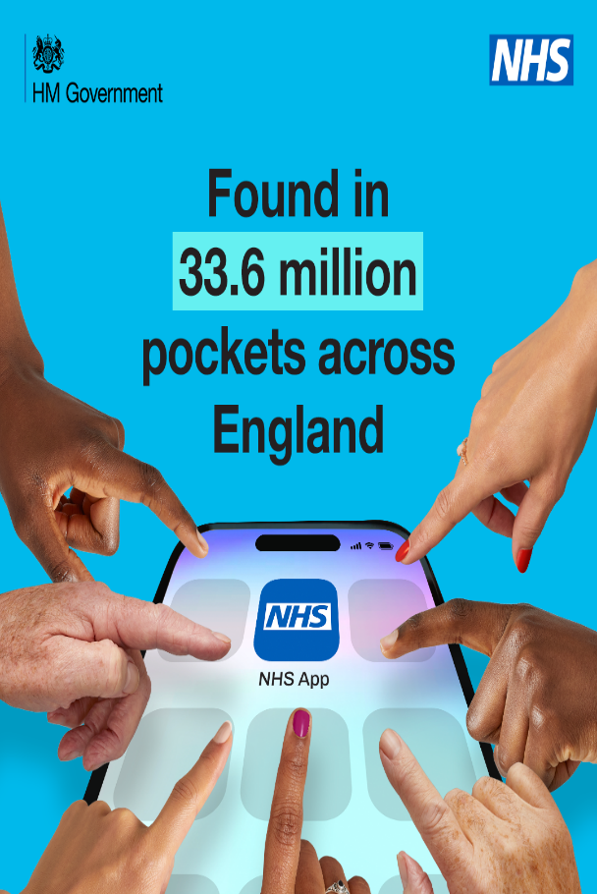
The App is a significant step in creating a digitally accessible NHS and gives patients confidence that anything they access through the app is secure, reliable, and will improve their health and well-being. A top priority for both NHS England and the Department of Health and Social Care is the digital transformation of the health service (UK Parliament, 2022). According to Wendy Clark, executive director of product development at NHS Digital, the NHS App will provide an easy platform for everyone in England to access the NHS, much like other services like banking or booking a trip (NHS, 2021).

The Digital Innovation as a Solution:
The NHS App presents one of the most digital ambitious transformations within UK healthcare system. It makes healthcare services more patient centred, efficient and technology integrated. The 2019 NHS Long Term Plan outlined the goal of providing patients with digital consultations with their general practitioner (GP), access to their own health information, vaccination records, connected profiles, GP messaging, and authentication infrastructure. COVID-19 paved the way for this breakthrough, and by December 2023, the app had been downloaded over 33 million times (NHS England, 2023). (Fig.2)
The main objective to implement the NHS App is to improve patient experience, facilitating self-care, saving time in general practitioner (GP) offices, and better access to primary care services for everyone (NHS England, 2019b). The goal was to "free up valuable clinician time," "provide more effective, personalised care," and "ease pressures on GPs" (Gov.UK, 2022). However, the technology's features and usability, staff and public interactions and perceptions, organisational culture and systems, and external factors (such as the political and cultural context) all interact to make the implementation process bit challenging and complex (Ross et al., 2016).
Fig.2(Gaston, 2024)

Since January 2023, the NHS App is continually being developed, and new features are being added under the leadership of Joe Harrison, National Director of Digital Channels at NHS England and Chief Executive of Milton Keynes University Hospital NHS Foundation Trust. However, sustained success depends on balancing inclusivity, and equitable access. Patients are receiving speedier care; more elective care patients are experiencing shorter wait times at trusts that use the app and patient online platforms than those who do not. If extended to all hospitals nationwide, this would result in up to 211,000 additional treatments reaching the 18-week goal in the same time frame (GOV.UK, 2025a).

Workforce Outcomes:
The introduction of digital technology through NHS App has significantly reshaped workforce roles, efficiency and service delivery in UK healthcare. As the population ages, there is a greater need for healthcare services (Mallorie, 2024). With over 1.4 million workers, the NHS needs to create and assess workforce solutions supported by technology to lessen staff workloads and enhance patient outcomes (NHS Digital, 2024). NHS Long-Term Plan emphasised the increased use of technology in health care to support its workforce (Powell, 2023). According to Stoumpos, Kitsios and Talias (2023), digital technologies facilitate more sustainable employment models, improve the number of people assisted by a qualified professional, and save time for healthcare workers. However, this shift demands new competencies such as digital literacy, data management and virtual communication skills showing a shift from traditional job roles.
Yet, the shift demands extensive training, technical support and different management strategies.
NHS App has delivered measurable productivity gains and its impact show benefits in workforce adaptation (Fig 3). It modernised general practice by switching all general practitioner offices from analogue to digital systems (NHS England, 2025b). More than 400,000 hours of GP time were saved last year by using the NHS App (NHS England). According to NHSE CEO Amanda Pritchard, the technological investments like NHS App, is an effort to boost general practice productivity. The NHS App and other patient-facing services have already freed up 3.2 million hours of administrative time, 416,000 hours of GP time, and 99,000 hours of nursing time, according to Ms. Pritchard (Colivicchi, 2025).
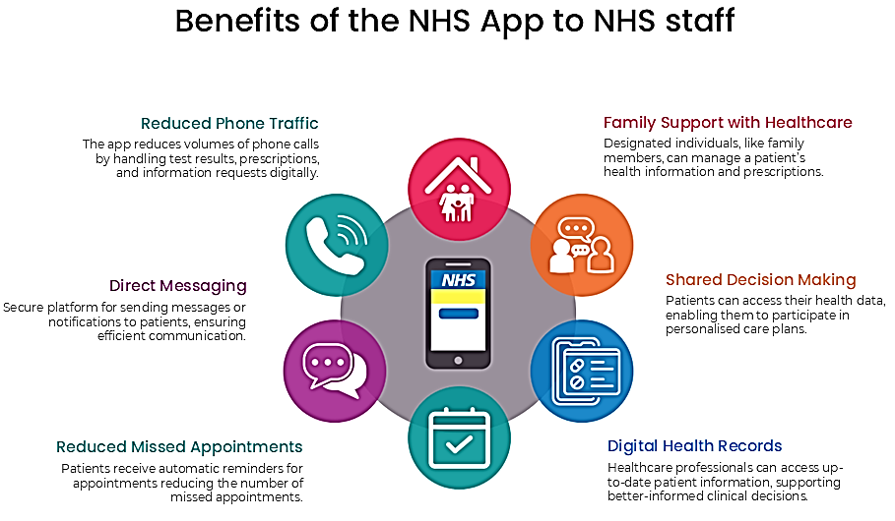

Fig. 3 (Tree View Designs, 2023)

Service Delivery Outcomes:
NHS App gained a significant importance regarding the improve accessibility and efficiency of health care provision. This App shows how digital innovation has the potential to enhance patient experience while reducing burden on healthcare system. Recent figures show that the government has already surpassed its goal of 85% of hospitals enabling patients to view appointment details on the NHS App by the end of March 2025. Since July 2024, this has increased from 68% to 87% (GOV.UK, 2025). By giving patients access to the newest technology to receive services more quickly, which will free up more time for doctors to treat patients and reduce waiting lists. According to government data, the number of trusts waiting less than 18 weeks in November 2024 increased by three percentage points for those that make use of the app's primary functions (Sollof, 2025).
The App assists users to switch between profiles to order child's repeat prescriptions or view parent's current meds by requesting general practitioner to link profiles in clinical system. This helps patients avoid making phone calls or going to the doctor. To eliminate more paper and time from the system, the message feature enables parties like eConsult or Patients Know Best to access the capability. It may be used to remind people to schedule referral visits and online consultations (Day, 2020). Patients will be able to select from a variety of providers via the NHS App as part of planned updates. NHSE conducted a "ping and book" pilot between December 2024 and February 2025, inviting participants to their breast screening appointments via the NHS App. According to NHSE, millions of women will be able to schedule breast screening appointments via the NHS App starting in early 2026, and the service will be extended to cervical screening in the spring of 2025 (Sollof, 2025).

Patient and User Outcomes:
NHS App is becoming a pivotal digital health innovation that supports the government's 10-year health plan to eliminate the significant health disparities that millions of people face. The NHS App continues to evolve to provide every patient with information, choice, and control over their own healthcare. People will be able to locate everything on the app, including the best-rated physicians for knee, hip, or heart surgery, as well as the location of their closest drugstore, due to a new feature called My Choices. It will offer a variety of information about healthcare providers nationwide, including which ones have the best patient outcomes, the shortest wait times, and the highest patient satisfaction ratings (GOV.UK, 2025a). This will put a stop to the "one size fits all" strategy, which frequently ignores the unique needs of various groups, such as women, members of ethnic minorities, and residents of more rural areas, among many others (GOV.UK, 2025b). According to recent data, the app has 33.6 million registered users, and monthly traffic has increased by more than 50% over the last 12 months. From 16.8 million in November 2022 to 25.8 million in November 2023, or 10 logins per second, the total number of monthly logins has grown by 54% over the course of a year (NHS England, 2023).
However, a digital-first approach to healthcare also runs the risk of leaving out older persons and deprived communities, who lack the resources or abilities to confidently use the digital apps. Therefore, it could worsen previously existing health disparities and put more strain on certain already overburdened service locations. According to estimates from the media watchdog Ofcom, about 6% of UK families do not currently have access to the internet at home. According to data from the charity Age UK, 33% of UK adults over 75 do not possess basic internet skills. In terms of health in particular, a 2024 study discovered that elderly people were more likely to misinterpret automated symptom checkers, which could result in needless worry or postpone therapy. To promote digital literacy, the NHS plan must acknowledge this gap and collaborate with other organisations (Walsh, 2025).
NHS App has gained public trust by balancing security and usability through data handling. Confidential patient information is a type of data found in patient’s medical records. Patient data is essential for managing care and is also critical for planning health services, enhancing diagnosis and treatment, and assessing the efficacy of policies. Users on NHS App have the option to limit the usage of private patient data (NHS, 2023). The GDPR guidelines introduced in 2018 for data handling and data protection further enhanced the data privacy mechanism of NHS App and other digital platforms (Evans, 2018). The most significant aspect of NHS App regarding data privacy is its usability features which offer the use to opt between authentication and data sharing (Lee, 2025).

Conclusion
Concluding, the NHS Long Term Plan focuses upon patient centred care which makes NHS App and other digital innovations integrated in NHS Digital a transformative step. It enhanced accessibility, reduced burden and empower patients in their health decisions. However, the challenges regarding digital inclusion and equitable access remain. There is need to invest in digital literacy programmes, enhanced functionality and internet access to make it more accessible for marginalised communities (Hadley, 2024). To maximise the NHS App's functionality and make sure it successfully satisfies user needs, patient insights must be incorporated into its development. It is important for healthcare providers to make their systems user-friendly for both patients and all those who interact with them.

Reference list
Colivicchi, A. (2025) NHS App saved 400,000 hours of GP time last year, NHS England claims, Pulse Today. Available at: https://www.pulsetoday.co.uk/news/technology/nhs-app-saved-400000-hours-of-gp-time-last-year-nhs-england-claims/ (Accessed: 14 October 2025).
Day, S. (2020) How the NHS App is upping its game, NHS Digital. Available at: https://digital.nhs.uk/blog/transformation-blog/2020/how-the-nhs-app-is-upping-its-game.
Evans, H. (2018) Using Data In The NHS: The Implications Of The Opt-Out And GDPR | The King’s Fund, The King’s Fund. Available at: https://www.kingsfund.org.uk/insight-and-analysis/long-reads/using-data-nhs-gdpr#conclusion (Accessed: 13 October 2025).
Gaston, G. (2024) The simple way to access NHS services in an instant, The Mirror. Available at: https://www.mirror.co.uk/news/health/simple-way-access-nhs-services-32086800 (Accessed: 13 October 2025).
GOV.UK (2025a) Major NHS App expansion cuts waiting times, GOV.UK. Available at: https://www.gov.uk/government/news/major-nhs-app-expansion-cuts-waiting-times.
GOV.UK (2025b) NHS App overhaul will break down barriers to healthcare and reduce inequalities, GOV.UK. Available at: https://www.gov.uk/government/news/nhs-app-overhaul-will-break-down-barriers-to-healthcare-and-reduce-inequalities.
Gov.UK (2022) NHS App hits over 30 million sign-ups, GOV.UK. Available at: https://www.gov.uk/government/news/nhs-app-hits-over-30-million-sign-ups.
Hadley, T. (2024) The NHS App and how it is scaling personalised and effective care - Health Innovation Network, Health Innovation Network. Available at: https://healthinnovationnetwork.com/insight/the-nhs-app-and-how-it-is-scaling-personalised-and-effective-care/.
Kc, S. et al. (2023) ‘Uptake and adoption of the NHS App in England: an observational study’, British Journal of General Practice, 73(737). Available at: https://doi.org/10.3399/BJGP.2022.0150.
Lee, S. (2025) What Regulations Must Your Mobile Health App Comply With?, Thisisglance.com. Glance group. Available at: https://thisisglance.com/learning-centre/what-regulations-must-your-mobile-health-app-comply-with.
Mallorie, S. (2024) NHS Workforce Nutshell | The King’s Fund, The King’s Fund. Available at: https://www.kingsfund.org.uk/insight-and-analysis/data-and-charts/nhs-workforce-nutshell#reasons-for-leaving.
McKinsey (2022) What are Industry 4.0, the Fourth Industrial Revolution, and 4IR?, McKinsey & Company. Available at: https://www.mckinsey.com/featured-insights/mckinsey-explainers/what-are-industry-4-0-the-fourth-industrial-revolution-and-4ir.
NHS (2021) About the NHS App, nhs.uk. Available at: https://www.nhs.uk/nhs-app/about-the-nhs-app/.
NHS (2023) Choose if data from your health records is shared for research and planning – Overview, nhs.uk. Available at: https://www.nhs.uk/your-nhs-data-matters/overview/.
NHS (2025) Promoting the NHS App - Primary Care Access Recovery Plan (PCARP) ✅, MLCSU Academy. Available at: https://academy.midlandsandlancashirecsu.nhs.uk/user-guides/promoting-the-nhs-app-primary-care-access-recovery-plan-pcarp/#AP10 (Accessed: 14 October 2025).
NHS Digital (2024) NHS Workforce Statistics - NHS Digital, NHS Digital. Available at: https://digital.nhs.uk/data-and-information/publications/statistical/nhs-workforce-statistics.
NHS England (2019a) NHS England» NHS App begins public rollout, England.nhs.uk. Available at: https://www.england.nhs.uk/2019/01/nhs-app-begins-public-rollout/.
NHS England (2019b) The NHS Long Term Plan. Available at: https://www.longtermplan.nhs.uk/wp-content/uploads/2019/08/nhs-long-term-plan-version-1.2.pdf.
NHS England (2023) NHS England» NHS App reaches record users on fifth anniversary, England.nhs.uk. Available at: https://www.england.nhs.uk/2023/12/nhs-app-reaches-record-users-on-fifth-anniversary (Accessed: 13 October 2025).
NHS England (2025a) NHS England» Digital Primary Care, www.england.nhs.uk. Available at: https://www.england.nhs.uk/digitaltechnology/digital-primary-care/.
NHS England (2025b) NHS England» Review of NHS Performance and Delivery, England.nhs.uk. Available at: https://www.england.nhs.uk/long-read/review-of-nhs-performance-and-delivery/.
Powell, M. (2023) Digital technology in healthcare: reducing staff pressures, NIHR Evidence. Available at: https://evidence.nihr.ac.uk/collection/digital-technology-in-the-nhs-reducing-staff-pressures-improving-care/.
Reidy, C. et al. (2025) ‘Qualitative evaluation of the implementation and national roll-out of the NHS App in England’, BMC Medicine, 23(1). Available at: https://doi.org/10.1186/s12916-024-03842-w.
Ross, J. et al. (2016) ‘Factors that influence the implementation of e-health: a systematic review of systematic reviews (an update)’, Implementation Science, 11(1). Available at: https://doi.org/10.1186/s13012-016-0510-7.
Sollof, J. (2025) NHS App expansion saves 1.5 million appointments, Digital Health. Available at: https://www.digitalhealth.net/2025/04/nhs-app-saves-1-5-million-appointments-and-cuts-waiting-times/.
Stoumpos, A.I., Kitsios, F. and Talias, M.A. (2023) ‘Digital Transformation in healthcare: Technology Acceptance and Its Applications’, International Journal of Environmental Research and Public Health, 20(4). Available at: https://www.mdpi.com/1660-4601/20/4/3407.
Todd, R. (2024) NHS App - Norfolk & Waveney Integrated Care System (ICS, Norfolk & Waveney Integrated Care System (ICS. Available at: https://improvinglivesnw.org.uk/nhs-app/ (Accessed: 13 October 2025).
Tree View Designs (2023) The NHS App, Whiteladiesmedical.nhs.uk. Available at: https://www.whiteladiesmedical.nhs.uk/nhs-app.
UK Parliament (2022) Digital transformation in the NHS - Health and Social Care Committee, Parliament.uk. Available at: https://publications.parliament.uk/pa/cm5803/cmselect/cmhealth/223/report.html#heading-0.
Walsh, T. (2025) ‘Overhauling the NHS app is at the heart of UK healthcare plans, but it could leave some people behind’, The Conversation [Preprint]. Available at: https://doi.org/10.64628/ab.mvhc9h6yg.

