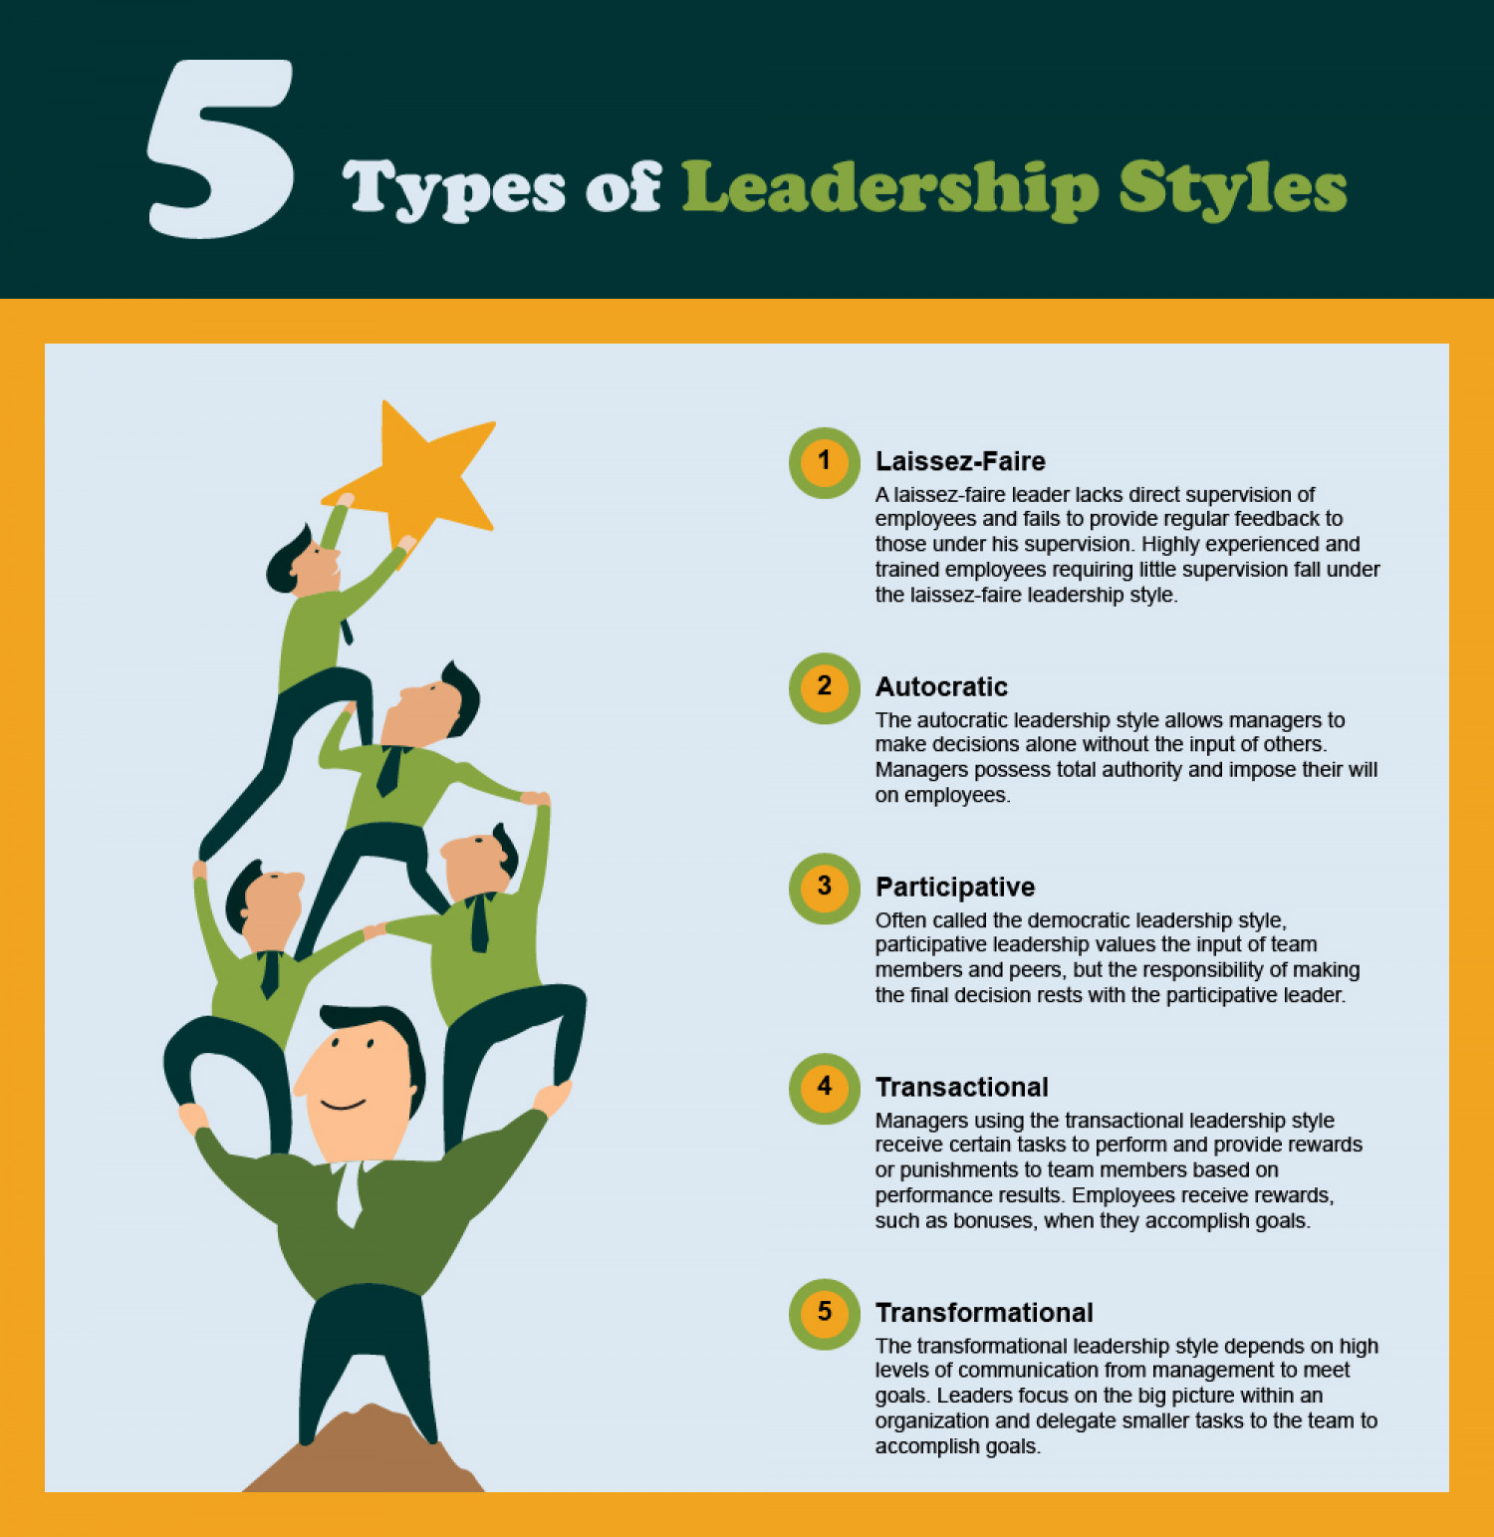
The theories of leadership and their application in practice

Leadership is one of the most important aspects in any employment organization and especially in the public sector. The police force and its leaders can lead their teams using various leadership styles that all affect individuals and their ability to perform. Effective health and safety performance comes from the top (Health and Safety Executive 2021), good leadership ensures that employees are safe, happy and their needs are met. Chosen leadership styles will be evaluated using theory, how it is applied in practice in relation to the police force and how the styles affect the team in a work environment. The leadership styles that will be covered include transformational, transactional, laissez faire. The main objective of this paper will be to analyze and evaluate the leadership styles mentioned while comparing and understanding how they are used in practice to gain an understanding of which one is most effective when applied to the police force. Real life examples and theories of leadership will be used to achieve this objective.

Transformational leadership is a style where the leader empowers team members to participate and make a great effort to be a role model to their team members. They ensure the team works through inspirational motivation and individual consideration (Tokong, 2019). The theory was first developed by James V Downton in 1973, however, the theory was later developed by Bernard Bass (1990) who expanded on the psychological concept of transformational leadership which also became known as Bass’s transformational leadership theory in which he developed ways to measure the success of transformational leadership. Bass argued that the followers must not only feel trust and admiration of their leader but also, loyalty and respect. Bass suggested that these emotions create an environment where the team works harder than their capabilities.

Avolio, Bass, and Jung (1997) identified the components of transformational leaders which included idealized influence where the leader acts in ways that allows him/her to be a role model. The team admires and respects the leader resulting in the followers wanting to emulate them. Inspirational Motivation is where the leader behaves in a manner that provides purpose and challenge to their team. This leads to the team's spirit being aroused, increased motivation and desire to complete tasks. Intellectual Stimulation argues that the leader encourages creativity and questions assumptions. The team is encouraged to find new solutions to problems. Individualized Consideration is where the leader pays attention to each member's needs. Tasks are delegated to ensure that followers develop while monitoring their performance to see if they need further guidance.

Thus, transformational leadership can be applied to the police force in many ways as transformational leadership is seen as enabling legitimate organizational change (Mastrofski 2004) meaning that this leadership style aids the police force in applying positive change for example, becoming a more diverse force. Gov.uk (2021) Ethnicity facts and figures shows that a total of 4.3% of senior officers in the police force were from ethnic minority backgrounds in 2020 compared with 2.8% in 2007.

According to a large study (Jermier and Berkes, 1979) found that leaders within the police force who adapted a transformational leadership style achieved greater job satisfaction and organizational commitment from their teams. Thus, the leaders were able to achieve greater goals due to their team's morale and confidence being high which relates to Avolio et.al (1997) components of transformational leaders.

A further study by the Home Office (Dobby et al, 2004) which consisted of a large sample of officers from all ranks across 36 forces in England and Wales. The study was concentrating on psychological effects of transformational leadership. It found that leaders that scored high on the transformational behaviors had a positive psychological impact on their subordinates. However, leaders that scored low showed that they could potentially have negative psychological effects on their teams. Therefore, police leaders that choose to inspire, motivate, and set a vision for their team, can appeal to their followers’ moral values (Campbell & Kodz, 2021) and can make a positive contribution to the police force than those to seek otherwise

The use of transformational leadership can be seen in the Manchester Arena bombing where officers rushed to the scene and provided lifesaving first aid used their own clothes to use as bandages and built make-shift stretches from metal bars (Abbit, 2018). Thus, if Jermier and Berkes (1979) study is taken into consideration it could be argued that the reason behind those officers risking their lives during a terrorist attack was because they had reached greater organizational commitment.

On the other hand, transactional leadership to which transformational leadership is most often compared to is the complete opposite. Transactional leadership focuses on results, sticks to strict routines, and measures success based on the organization’s system of rewards and consequences (STU Online, 2014).

The leader maintains complete control and delegates tasks accordingly without the team's input. The theory was first described by Max Weber and later developed by Burns (1978), who suggested that leaders use bargaining tools such as rewards to motivate workers' behavior. Thus, this would suggest that transactional leadership concentrates on the leader utilizing positional power so that benefits can be issued to encourage positive behavior.

Bass (1981) argued that leaders utilize contingent rewards for example time of work or sick pay to meet the arrangements on goals to be reached for the rewards to be reached. Thus, in practice transactional leadership can be an effective leadership style police managers can use to ensure that their teams achieve set goals due to them being motivated by the rewards on offer. Effective police leaders are expected to understand their responsibility to be a good role model to their teams (Singer, 1990) which leads us onto a practical example such as the declaration of a Major Incident under the Civil Contingencies Act 2004.

The Emergency Powers Act 1920 defines an emergency as an interference with specific resources which will deprive the community of the essentials of life. Therefore, in a state of emergency Blue light responders alongside local authorities can declare a major incident to deal with incidents such as hostile attacks, floods, earthquakes, and other incidents that lead to a large loss of life, large scale damage to infrastructure and as mentioned depriving the community of life essentials. The police force has a statutory obligation to provide an effective response (North Umbria Police, 2017). The plan outlines the actions to be taken and what procedures are to be followed in the event of a major incident.

Hubert’s, Kapten, and Lasthuzen (2007) found that effective role modelling especially in demonstrating moral behavior, while being strict was effective in limiting corruption, fraud, and the misuse of resources. Thus, with the extensive concentration of rules the ethics of law enforcement is greater for example officers are expected to follow procedures and conduct themselves in a professional manner when interacting with civilians. In relation to the example of a major incident the research by Hubert’s et al (2007) shows that if the leaders take charge and make decisions based on their experience their subordinates are going to accept the decisions made and conduct themselves to effectively respond to the incident effectively.

A real-life example where transactional leadership proved vital in saving lives can be seen in the Boscastle Floods of 2004, which is considered as the worst flooding incident in the UK however, due to the effective response, zero lives were lost that day and damage was caused to personal belongings and infrastructure. This example shows how following rules and having a plan in place can be essential in preventing the loss of life during major incidents (Met Office, 2004).

Traditionally leadership research has focused solely on constructive leadership behaviors, such as transformational and transactional leadership, and how they create a positive impact on job satisfaction and organizational effectiveness (Barling, Weber & Kelloway, 1996). On the other hand when it comes to Laissez Faire leadership it is often seen as a destructive leadership style that has detrimental effects on subordinates and effects the ability of a team performing to their maximum potential for example Ashforth (1994), describes so called leaders as “petty tyrants” as leader belittle subordinates, lack consideration and empathy, have a forcing style of solving problems rather than taking the views of subordinates on board and discourage initiative. Problems must be solved in a way they feel appropriate with a single input while leaving the team to complete tasks without guidance or direction.

Bass and Avolio (1990) describe Laissez Faire leadership as the absence of a leader, where the avoidance of leadership and decision making. Decisions, feedback, and rewards are usually delayed or ignored and there aren’t any transactions with subordinates regarding team decisions in which the leader makes no effort to motivate the team. According to Lewin, Lippit and White (1939), Laissez Faire leadership represents a leadership style where the leader has been nominated and still occupies the position without contributing to any positive change, essentially creating an environment without any leadership.

Thus, the research shows that Laissez Faire can create an environment where subordinates struggle to interact, participate and reach their goals as the leader is never present and, in a way, doesn't care about the well-being of the team. Lack of communication between leader and subordinates has proven to negatively impact role ambiguity experienced at work (Johlke & Duhan, 2001), this results in high levels of conflict amongst co-workers due to the absence of the leader; some subordinates may find themselves in a struggle of power.

An example of Laissez Faire leadership being used in practice can be seen in the Sarah Everard, who was tragically kidnapped, raped and murdered by Metropolitan Police officer Wayne Couzens while on her way back home after visiting a friend. It is important to understand that individuals such as Wayne Couzens do not represent what the British Police Force stands for and what its core norms and values are. However, an inquiry into Wayne Couzens and his policing career identified concerning evidence which would have suggested that he should not have been employed by the Metropolitan Police as many accounts of sexual assaults were raised after the murder of Sarah Everard.

Metro news outlet reported that Wayne had assaulted a drag queen performer on a night out and requested sex in the alley. The performer stated that Wayne had boasted that he was a police officer when he was asked by the performer to stop molesting him. (Courtney-Guy, 2021). When taken into perspective such actions should have been enough to prosecute Wayne and sack him however, the Metropolitan Police failed to notice the concerning signs of behavior displayed by Couzens. It could be argued that this style of behavior shows Laissez Faire as the leaders failed to evaluate performance or to extensively investigate Wayne Couzens past before hiring him as a police officer.

As described by Johlke and Duham (2001), lack of communication between leaders and subordinates leads to conflict and role ambiguity. Therefore, when applying this theory to Wayne Couzens is it fair to suggest that the leaders of the Metropolitan police failed to fulfil their duties? Bass and Avolio (1990) and their arguments against Laissez Faire would suggest that this is the case as in this case it is evident that the leaders were missing when they were needed most. Thus, this could suggest that the leaders adopted a Laissez Faire leader style which led to them ignoring the breakdown of professionalism, and the code of ethics by Wayne Couzens.

To conclude, the findings suggest that transformational and transactional leadership allows the police force to uphold the strict standards they set for every police officer and suggest how the police force should reach their goals. Theories have suggested that transformational leadership offers the most benefits in terms of how it affects teams. Modern research was carried out to suggest how leadership styles have adapted and changed the way teams are being led which provided a reliable perspective of modern leadership and how it is applied to the police force.

However, research that may be classed as outdated was also vital in showing how theories from decades ago still holds up against modern theories, for example the work of Lewin, Lippitt and White (1939) on Laissez Faire leadership showed how the style was a consequential way of leading a team. Ultimately it could be suggested that the theories suggested by Bass (1990), Burns (1978) and Avolio et al (1997) showed a clear understanding of how the police force could implement leadership styles to deliver an effective service to their communities.

As a team leader at JD Wetherspoon, I have the responsibility and the duty of care to lead my team in the most effective way possible to ensure we achieve our goals daily. Being a Team Leader/Supervisor fulfils me with many responsibilities such as managing staff, managing breaks, well-being of staff and delegating tasks. The leadership styles that I implement totally depend on the team that is on shift due to the various capabilities of staff members.

Thus, the first leadership style that I apply is the style of a transformational leader which allows me to consider the views of my team and concentrate on their wellbeing. Being a transformational leader allows my staff to feel fully confident in their abilities and to understand that I will provide guidance when necessary. I place great importance on communication to ensure that I am aware of what stage my team members are at. The study conducted by Jermier and Berkes (1979) found that leaders that used transformational leadership achieved greater job satisfaction from their teams. When applying this research to how I lead my team when at work it shows the importance of being a transformational leader. I ensure that my team is motivated by being treated as equals rather than a hierarchical system whereby the leader assumes full control and hands out control to lower ranks based on ability.

For me, being a transformational leader at work means that I will always try to ensure that every team member in my team understands every job. For example, training staff members on food service if they struggle with this aspect of the workplace. I ensure that the staff receive guidance and learn the necessary thighs to provide a good food service at JD Wetherspoon.

Avolio, Bass and Jung (1997), identified the main components for transformational leadership which is something I place great importance on. For example, one of their components include inspirational motivation which suggests that a leader behaves in a way that provides purpose and challenge to his/her team, I implement this theory in a work environment because I conduct myself as a professional and always seek to ensure my staff learn something that can benefit them on days where I may not be available. An example that could be used to suggest how I adapt to this theory is showing my staff how to respond to rude customers that may create a tense and difficult situation to deal with.

I train my staff in a manner where they can learn from me by seeing how I interact with such situations and taking on board my actions and how they can implement such actions to themselves. Personally, I believe that being a good role model and providing inspirational motivation allows me to get the most out of my staff and their loyalty to me and compassion to provide a good service makes them work harder. When a leader creates a friendly environment, the team will thrive and enjoy the workplace which allows us all to reach our targets, big or small. Thus, I would suggest that transformational leadership is the most effective leadership style that I use in my workplace to ensure that myself and my team can enjoy every shift while working in a stressful and demanding environment that can in many cases affect one's ability to perform.

In some cases, I may differentiate to transactional leadership when I understand that tasks need to be completed. This most often occurs at the end of the shift where my superiors expect me to delegate closing tasks to my team to ensure that we can close the pub within a reasonable time and go home. Thus, I must adapt to the situation and become a transactional leader whereby I delegate tasks without communicating with the team. This is important because it allows me to delegate tasks based on individual strengths and enables me to avoid being biased e.g., giving my friends the easiest close tasks. At the end of the shift the leader must assume responsibility and take control of the situation which is what I try to do by being a transactional leader.

Huberts, Kapten, and Lasthuzen (2007) found that effective role modelling especially in demonstrating moral behavior while being strict in terms of sticking to rules created loyalty and set standards for subordinates. Thus, when applying this theory to my role in work, it is essential for me to ensure that my team members understand what we expect from them in terms of how to conduct themselves, maintain professionalism and uphold the highest of standards. Therefore, although I personally believe that transformational leadership is the best method to lead a team, transactional leadership can be used when implemented correctly and used when appropriate.

References

Abbit, B., (2018), The stories of some of the heroes who rushed to help following Manchester Arena attack. Manchester Evening News.
Available at:The stories of some of the heroes who rushed to help following Manchester Arena attack - Manchester Evening News
Accessed: 30/12/21

Ashforth, B. (1994). Petty tyranny in organizations. Human Relations, 47, 755-778.

Avolio, B.J., Bass, B.M., & Jung, D.I. (1997) Replicated confirmatory factor analyses of the Multifactor Leadership Questionnaire. Binghamton, NY: Center for Leadership Studies, Binghamton University.

Bass, B.M (1990) From transactional leadership to transformational leadership: learning to share the vision.

Bass, B.M. (1981), Stogdill’s Handbook of Leadership: A Survey of Theory and Research, The Free Press, NewYork, NY.

Bass, B.M. (1990). Bass and Stogdill’s handbook of leadership: Theory, research, and managerial applications (vol.3). NewYork: Free Press.

Barling, J., Weber, T. & Kelloway, E.K. (1996). Effects of transformational leadership training on attitudinal and financial outcomes: A Field Experiment Journal of Applied Psychology, 81, 827-832

Campbell, I., Kodz, J., (2021), What makes great police leadership? What research can tell us about the effectiveness of different leadership styles, competencies and behaviours. A rapid evidence review. National Policing Improvement Agency.
Available at: Microsoft Word - Great Police Leader REA.doc (college.police.uk)
Accessed: 30/12/21

Civil Contingencies Act 2004: a short guide. Cabinet Office, Civil Contingencies Secretariat

Courtney-Guy, S. (2021). Wayne Couzens ‘assaulted drag queen and demanded sex in alley’.
Metro.News.
Available at: Wayne Couzens 'assaulted drag queen and demanded sex in alley' | Metro News
accessed:30/12/21

Dobby, J., Anscombe J., Tuffin, R., 2004, ‘Police Leadership: expectations and impact’ London: Home Office Research, Development & Statistics Directorate

Ethnicity facts and figures (2020).
Available at: Police workforce - GOV.UK Ethnicity facts and figures (ethnicity-facts-figures.service.gov.uk)
Accessed: 30/12/21

Health and Safety Executive (2021) Why leadership is important.
Available at:Why leadership is important: Leading health and safety at work (hse.gov.uk)
accessed:30/12/21

Huberts, L. Kaptein, M. and Lasthuizen, K. (2007). A study of the impact of three leadership styles on integrity violations committed by police officers. Policing: An International Journal of Police Strategies & Management, 30 (4), 587-607.

Jermier, J. and Berkes, L., 1979,’Leader Behaviour in a police command bureaucracy: A closer look at the quasi-military style’ Administrative Service Quarterly, vol. 79, 1-23

Johlke, M.C., & Duham, D.F. (2001). Supervisory communication practices and boundary spanner role ambiguity. Journal of Managerial Issues, 13, 87-111.

Lewin, K., Lippitt, R., & White, R.K, (1939). Patterns of aggressive behavior in experimentally created social climates. Journal of Social Psychology, 10, 271-301.

Mastrofski, S.D. (2004) ‘Controlling street-level Police Discretion’, The Annals of the American
Academy of Political and Social Science, 593/1: 100-118

Northumbria Police, (2017). Major Incidents. Chief Inspector, Force Resilience Unit.
Available at:Major incidents : Northumbria Police
Accessed:30/12/21

Singer, M. and Singer, A. (1990). ‘Situational Constraints on Transformational Leadership vs. Transactional behaviour, Subordinates Leadership Preference and Satisfaction.’ The Journal of Social Psychology 130 (3): 385-396

STU Online, (2014), What is Transactional Leadership? How Structure Leads to Results.
Available at:What is Transactional Leadership? Structure Leads to Results (stu.edu)
accessed:30/12/21
Burns, J.M. (1978), Leadership, Harper & Row, NewYork, NY.

Tokong, R., (2019) Transformational Leadership theory in organizational communication.
Available at: Transformational Leadership Theory (communicationtheory.org)
accessed:30/12/21

