

A Study on Simulating the Humans Iris Response to Amounts of Light

by
Jack Partridge

Supervisor: Andrew Baker
Second Marker: Gordan Dickers

Project submitted as part of the requirements for the award of BSc (Hons) Computing (Games Development)

November 15th

Declaration Form and Form of consent

DECLARATION

I, Jack Daniel Partridge declare that I am the sole author of this Project; that all references cited have been consulted; that I have conducted all work of which this is a record, and that the finished work lies within the prescribed word limits.

This work has not previously been accepted as part of any other degree submission.

FORM OF CONSENT

I, Jack Daniel Partridge hereby consent that my Project, submitted in candidature for the B.Sc. (Hons) Computing (Games Development) degree, if successful, may be made available for inter-library loan or photocopying (subject to the law of copyright), and that the title and abstract may be made available to outside organisations.

Abstract
Lighting within games design is a key feature that helps make the games form into what they are. Changing the amount of light or intensity of a given light source can affect play. This change allows the scene’s visibility to be altered alongside evoking more emotion within the space and producing a range of dynamic and atmospheric elements or details. The current lighting design techniques within games, along with effects, are not being utilised to the maximum potential. The very purpose of this study is to investigate the gap within effect designs. And moreover, simulate life like responses to light (from the iris) inside a virtual reality scene.
Qualitative research surrounding visual response times and the anatomy of the eye will play a significant role in making the effect as true to form as possible. This information will also later be applied into code and assists in the planning and designing of a virtual scene used to test results. Shader programming will also be a key aspect in the development of this project. Along with ensuring the correct use of features and aspects within a virtual scene.
A realistic approach and breakdown of how games can incorporate such a fine feature will be explored in relation to heightening the use of senses for the player and expanding the gaming industry’s ability to produce more life-like details. The research will contribute to the implementation of game effects as well as their purpose and significant. Visual appearance is also important when analysing how this research can be applied to gaming, there is the possibility that the simulation of a real-life response may be more beneficial in the aesthetic of the scene than used in actual gameplay.

Contents
Declaration Form and Form of consent 2
Abstract 3
Introduction: 4
Research Questions: 6
Literature Review: 7
Understanding the Human Visual System Accommodating to Light/Dark Environments? 7
What Are the Benefits and Drawbacks Effects Have Within Games? 9
How Does Different Lighting Techniques Impact the Player’s Gameplay Experience? 12
Research Methodology: 14
Research Approach: 14
Research Design: 14
Questionnaires 14
Secondary sources 15
Data Collected Pre-Experiment: 15
Lab Experimental 17
Design & Implementation: 19
Software, Hardware and Equipment 19
Game Engines 19
Shader Programming 19
Application Processing Interfaces 20
Virtual Reality 21
Conducting of The Lab Experiment 22
RenderTexture Technique, Via C# Scripts in Unity. 22
Raycast Light Detection Checking 26
ToneMapping Using Vertex & Fragment shader 27
Limitations 34
Lab results 35
Evaluation: 38
Conclusions & Recommendations: 39
Reflection: 41
References 43

Introduction:
Digital gaming is forever expanding along with it being the most complex type of interactive media there is. Games are increasingly developing not just for entertainment but to be used to simulate and develop skills humans may lack. There are many components of games; Characters, Story lines, Sound, Graphics, Lighting, Music and Combinations of them all. These artifacts play essential roles in the user(s) experience. Yet, the human eye is at the very centre of this gaming experience. The use of human visual perception plays a huge part in objects observed through its sensitivity to light. When incorporating a range of diverse lighting effects into a game space it can transform not only the aesthetics of a scene, but most importantly produce indicators seen in real life to enhance and situate players within the game.
With this idea in mind, examples such as the lighting system which affects sanity, can be seen in Amnesia: The Dark Descent [1] . It’s a way of focusing on making the players experience more realistic and life like. This example effect shows that intricate details are key to improving gaming experience and have positive reactions from those who interact with it. Charles Onyett from IGN says “Sanity degrades while in the dark, causing the scene to shift like the webs of light across sands under shallow water as sounds intensify, controls are muddied, and eventually insects crawl across your field of vision. It contributes to a feeling of isolation and helplessness that adds to the sense of terror.” [2] Other visual strategies like Sun glares, Blooms and Lens flares are at the forefront of involving real life eye reactions and focusing into games. Yet, there is a slow advancement in terms of replicating eye reactions to bright and dark scenes and implementing that reaction into virtual reality.
Although games use lighting effects, they don’t implement them as a core gameplay aspect. Finding a realistic implementation of the eye adapting to surrounding light would be beneficial for both the quality of the gameplay and the players experience. A main aim is to make the effect as realistic as possible and so the adaption times lighting will have to be tested out. The natural eye in real life can take up to seven hours [3] to adjust to its environment and so this would need to be revised in the virtual scene. The timescale in relation to the players interactions is also important. But with keeping these adjustments a focus it will challenge the interactions players make within a scene as well as test the players patients.
This study will explore different lighting strategies within virtual scenes and attempt to identify how lighting impacts the user’s gameplay. The research findings will assist the setup of a 3D virtual reality scene in which a simulated iris’ response will occur. References to other case studies and relevant topics will be made to discover informative and applicable material to aid in the creation of the simulation effect.
When setting up a suitable scene, comparisons of techniques and possible current examples will help distinguish techniques most effective for the implementation of this feature. For the scene to be best represented and for a continuous flow of realism, the simulation will be tested through VR. This will create a more sensitive environment for the lighting to be controlled and showcased, but also will be able to fully immerse the player within the space.

Research Questions:
This study will be collecting a diverse amount of knowledge to answer the following questions.
- Understanding the human visual system accommodating to light/dark environments?
- What are the benefits and drawback effects have within games?
- How do different lighting techniques impact the player’s gameplay experience?

Literature Review:

Understanding the Human Visual System Accommodating to Light/Dark Environments?
Within the human visual system an abundance of complex information. Research shows that the speed of sight for human is a bandwidth of 8.75 megabits/s. [4] How it all works can be related to the aperture of a camera. [5] Like aperture of a camera, the pupil controls the amount of light that enters the eye. In Brief terms, light reflects & refracts off objects and bounce until the light rays enter through the pupil. Once entering the pupil, it is then focused through more complicated optical components within the anatomy of the eye.
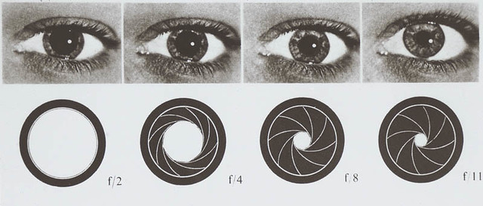
https://www.macular.org/eye-camera - ‘Related to the aperture of a camera’
Figure 1, Aperture vs eye. Source [6]
The image above shows an example of the aperture of a camera compared to the human pupil. The smaller the F-stop on the camera aperture the more amount of light being let into the camera lens. This is then compared to the size of the Pupil when receiving more light. Like the aperture it opens when processing environments with different light levels. The Pupil is smaller when in bright environments and larger in darker spaces.
The following section will focus on the fundamentals & understanding of how the eye functions. [7] The research explores the structure of the eye, the Key features used in order for humans to envision the surrounding environment, The time taken for the iris to adapt to light and The visual systems reaction to light and dark exposures.
The Anatomy of The Eye
The anatomy of the eye & how we humans can perceive vision is complex at first glance. The eye consists of many variables along with a large amount of information being processed to the brain for us humans and animals to interpret our vision. Key structures of the anatomy of the eye to allow for accommodation of light we let in are known as the cornea, iris, pupil and retina. Cornea transmits light into the eye that the iris works collaboratively to regulate the amount of light let in. With large amount of light coming in, iris will adjust the pupil size down to allow for less light to enter and then the retina located towards the back will sense the amount of light and send electrical impulses through optical nerves towards the brain. The impulses are then processed within the brain.
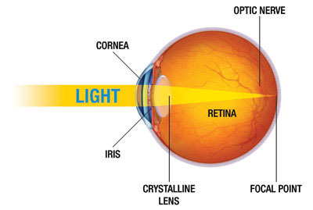

Figure 2, How the human eye works. Source [8]
The Eyes Accommodation Time
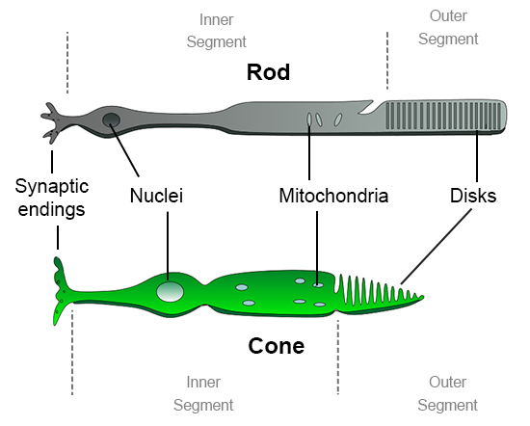
A study conducted by author Dr. Christopher S. Baird explores the eyes accommodation time to various light intensities and parts of the eye’s reaction times. Within the eye structure over 130 million Rod cells and 7 million Cone cells [9] become responsible for vision, the Rod cell activate during low light levels and the Cone cells activate during higher light level. Both types of cell are in the pupil. The Cone cells take an estimate of ten minutes to adapt to darkness until they start to over perform. In comparison to the Rod cells, it can take an approximation of seven hours to reach their full optimal performance to low light conditions. [10] To strengthen Dr. Christopher’s study other Articles of study’s were compared alongside his research. One by Uta Wolfe suggested that the same time frame of around ten minutes for Cone cells adaption and seven hours for rod cells. [11]
Figure 3, Rod & Cone cell image. Source [12]
When analysing the initial research surrounding the adaption of the eye to darkness and the function of the anatomy, it became clear that the eye takes in a significantly large amount of information. It is at the centre of perception and sight and its adaption to light proves it can withstand a large spectrum of light intensities. From this, it is then able to process the light for the purpose of vision. By also studying adaption times in regard to lighting, it provided a clear set of results that could be applied to the design stage of the virtual eye adaption, and moreover suggested the sensitivity of the eye.

What Are the Benefits and Drawbacks Effects Have Within Games?
This segment will delve into why effects in games prove to beneficial or not. Sub questions that will be kept in mind include: What is the purpose for effects to be inside of games? Are they a necessity? Is it for better looking visuals? or Can games maintain gameplay without them? The research allows a clearer understanding of why effects are implemented into games and what positives or negatives can be applied to the creation of a visual effect.
When it comes to effects within games, many users have been known to edit what effects are visible in games. Either for the reasons of Performance, Visual preference or to stop the impairing of focus during gameplay. Many examples of effects have been featured in games for a significantly long time, and it has been suggested they will stay that way.
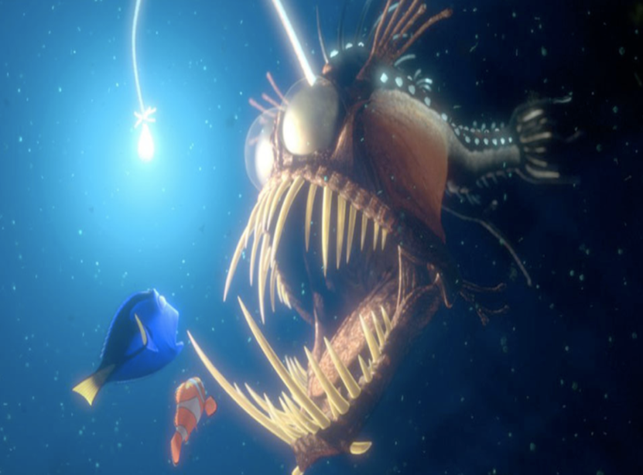
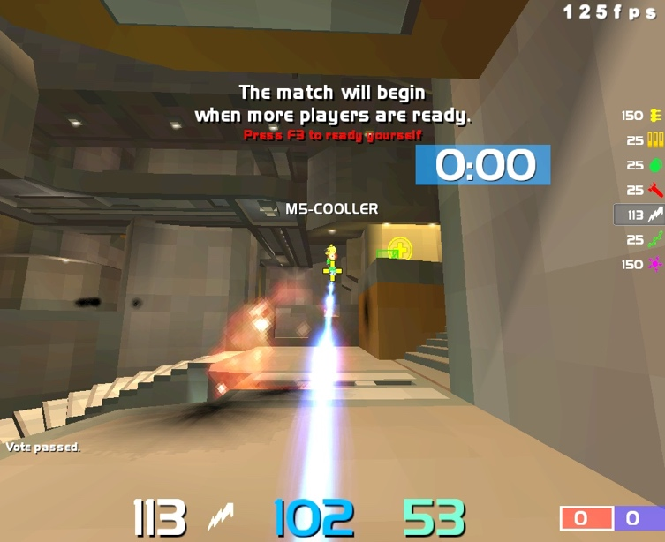
A visual Bloom is a respectable example of a shader effect that can be seen in many games to date. The bloom effect was popularized in the game development community around 2004-2005. A study by Greg James & John O’Rorke [13] explained the effect has been used in games such as Quake Live, Halo 2 and more. The effect is also popular in the within animation and is used in the popular Pixar film, Finding Nemo. [14] The bloom effect simulates a more realistic burst of light and brings real life experiences into games and animation.
Figure 4. Quake live bloom Source [15] Figure 5. Finding Nemo. Source [16]

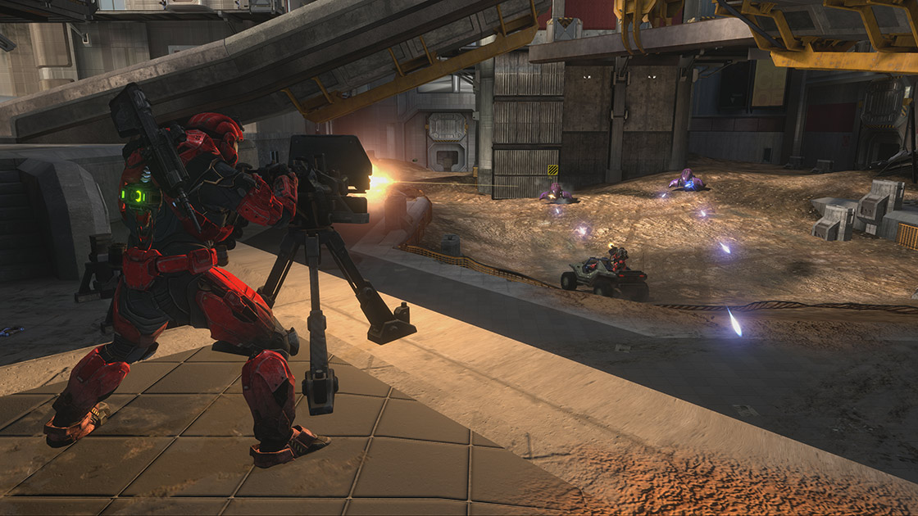
Figure 6, Halo Bloom. Source [17]
Many effects can also be applied for more visually pleasing environments. Games such as Minecraft whose game structure is a survival building game, have texture packs and shaders that can be applied for more realistic and smoother looking surfaces. Beneficially this enables the player to further develop their creations transforming the classic Minecraft blocks and structures into materials that look like real world materials.
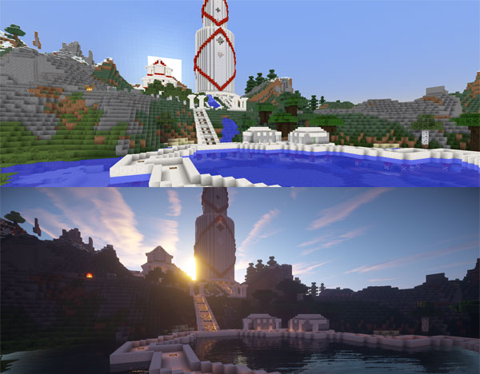

Figure 7, Minecraft shaders. Source [18]
On the other hand, some users decide to disable effects as it can have a negative effect on performance. When using a low-end budget pc/game console effects such as bloom can be disabled to help boost the number of frames per second to allow for a more playable game. Many players would argue that some effects are obsolete and have no need to be implemented in games. [19]

Motion Blur is an example of an effect that is disabled regularly by users and effects accuracy while playing. The effect itself creates the illusion of a fast-passed environment when moving quickly, similar to that of a fast-moving car. With an increase in speed the visuals then become blurred. Call of duty: Modern warfare, is an example of a game that uses Motion Blur but is often disabled.
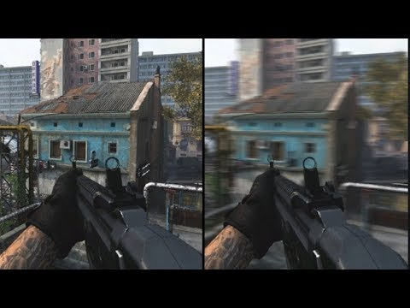

Figure 8, Call of Duty motion blur. Source [20]

Upon discovery Motion blur is actually one of the most disliked graphics effects used in games. Kelvin Wireko from Tech consumer guide said, “Motion blur is one of the most disliked graphics features in the gaming community.” and “makes the game unpleasant to look at.” [21] Although being realistic effect it’s not beneficial for gameplay. But with this in mind it’s important to recognise the use of motion blur can be down to the individual. Papia Nag [22] in the article “Motion Blur in Games and Should you Turn it On or Off” suggests it is down to personal preference along with other factors, but does suggest to turn it off.
Its significant to reference that within the exploration of benefits and drawbacks game effects can have, it varies for the type of game and the payer involved. When the player is within a fast-paced environment where accuracy is key in being successful, certain effects can have a negative impact on game play and sometimes are not used at all. On the contrary visually effects can enable games to become more realistic and enjoyable for the player. When implementing such an effect into a virtual space the consideration of the scene and use of the effect will be key. Overall effects enable a higher quality of game play when used in the correct way.

How Does Different Lighting Techniques Impact the Player’s Gameplay Experience?
When researching lighting techniques, it’s clear that lighting can be implemented to do much more than brighten up a scene. Information surrounding the implementation of lighting and why developers choose one form of lighting over another is what the main focus of this sub-question rested upon. When thinking about 3D virtual scenes it was also important to consider what offers a realistic playable scene and what is captivating as an experience.
Lighting being a key component for games visually, means there are different aspects to a light source. They include: Colour, Intensity, Vibrancy and Type of light. The right combination of these elements can achieve striking effects. Lights are often used to guide the players or indicate a route for them to take. As well as this light can feature as a tool for further advancement within a game. When thinking about Horror games, there is often a lack of light and it is down to the player to use a flashlight or flame to see their possibly dangerous surroundings. The use of a single light within the dark space produces the player to feel scared and forces the player to rely on other senses more, such as sound. As the player has limited perception from their light source, they must learn to trust their surroundings and adapt to the intensity of the setting. An effective example of this can be seen within the game Amnesia. [23] The player is limited to the time their lamp stays lit, once the lamp stops working the player slowly starts to hallucinate and is required to find another light source. This dependence of the light source is at the heart of the game and can either save you or cause you to become incredibly scared or even lose the game. If this scene was vibrant, well-lit and set in daytime then the experience wouldn’t have the same outcome.
When researching, the impact lighting has within a game space. Pluralsight in the first article says “Light has a drastic effect on the feel of a game; it determines how a player interacts with and views the world they're playing in.” [24]. Other forms of lighting like Baked lighting or Real-time lighting are detrimental to the performance of a scene, within the article “54” from Qubicle [25] “Light Mode: Realtime” & “Light Mode: Baked” from Unity [26], ideas are discussed surrounding their efficiency. Qubicle elaborates that real-time lighting uses twice the computing power of a graphics card to perform the shadow calculations. But Baked lighting is precompiled light meaning it has a better performance at the cost of static or non-moving shadows. These ideas are also referenced by Mathew Omernick in his article on “Lighting principles for game design”. [27]
The findings for this section show that lighting must be considered before being implemented to any game. It not only brightens the 3D virtual world but sets the atmosphere, scene and emotions for the person playing. Findings show that lighting being a massive part of games can cause performance issues, change gameplay dramatically and make or break a game fully. This segment of Qualitative research later impacts development and is essential to testing players patients along with vision when faced in a dark environment with limited emitted light.

Research Methodology:
The purpose of this segment is to explain in fine detail the research methods and the chosen methodology that the study implemented. Intended to gather a qualitative research strategy that will assist knowledge towards the experiment to help have an outcome of the eye accommodating to the amount of surrounding light. This chapter will firstly, go over my research approach, then my research design and the implementation. With the use of a book called Doing your Research Project by Judith Bell [28] to help get an understanding of approaches and solutions there are to go down when collecting, reading and doing an analysis of the information. This part will explain how I will collect up a diverse yet measurable of reliable information based on the chosen approach and participants.

Research Approach:
The approach taken for the gathering of information consisted of further researching a potential gap within Visual effects. Through the exploration and analysis of data, information was found surrounding the application of a simulating a human eye response to light and dark environments. By using a qualitative approach, carefully selected samples of self-entered data, enabled a flexible and wide variety of research to be discovered.
Furthermore, the aim was to use the data to an advantage in the development of following stages. Through the use of various research methods mainly secondary sources information able to be refined, compared then applied to the workings of the visual effect. The hypothesis for this is that to test the players patience and see how long their finding of the duck in the dark takes.

Research Design:
When focusing on what data was needed, materials and opinions from people was going to be most effective type of data collected. As the player and the individuals experience is the very reason for playing games the research must focus around them. To home into this, the focus was to use Questionnaires, Interviews and Secondary Resources as well as Experimental Strategies. Any relevant information was then used to further explore different approaches or help to improve upon a current strategy all for the making of a virtual in game eye response. When beginning I referred to the work of Dr. Karim Abawi, which was useful when breaking down what the data would mean for the study. [29]

Questionnaires
The use of questionnaires allows for large amounts of data to be collected. Very often in business research and developing stages of products questionnaires are one of the most common methods used. By gathering large amounts of data, from often a wide diverse amount of people, it can help find a gap in a potential market. With the ability to make questions more precise and controlling what group of people receive the questionnaires, can focus your target audience and produce much more valuable information.
Within a tight timeframe, questionnaires were suggested by Saul McLeod, from SimplyPhychology.org as “…being relatively cheap, quick and an efficient way of obtaining large amounts of information from a large sample of people.” [30] Although the data can be collected with the option of people being anonymous, the facts may not always be accurate, and respondents can lie due to social desirability.
For the creation of the questionnaire the website Surveymonkey.com [Needs a reference] was used. The website suggest seven tips when crafting questions for a questionnaire which was kept in mind they were: “Focus on asking closed-ended questions, Keep your survey questions neutral, Keep a balanced set of answer choices, Don’t ask for two things at once, Keep your questions different from each other, Let most of your questions be optional to answer and Do a test drive”. [31] When designing the study’s survey there was no name input allowing the participants to remain anonymous and reduced the risk inaccurate data.
Interviews
Another potential method of research was to carry out interviews or one-to-one focus groups. This method allows for information to be gathered face to face with the advantage of assessing people’s reactions and emotions. In comparison to surveys this is the added quality as the interviewer can potentially gauge overall feelings or moods. Typically interviews allow for a longer period of time for the interviewee to respond or possibly go back to questions if they feel the need. With this in mind, to focus the interviews specifically to VR users or gamers, it would have involved scheduling and finding a significant number of people that would volunteer. Interviews would also take an increasingly larger amount of time than surveys, ranging from an average of 10-30 minutes. Within the same space of time multiple uses can answer survey questions and more information can be gathered. And so, the interview process was a secondary choice over online surveys.

Secondary sources
As another way of gathering information for this study and more so to aid the development of a 3D scene, was the use of Secondary sources. Typically, secondary sources allow for more accuracy than primary recourses and (if popular) are often tried and tested approaches to tackling problems. The use of Forums, Books, YouTube videos and Articles allowed for the process of Designing, Crafting and Launching of a 3D scene to be as effective as possible. For the development of the visual effect secondary sources such as the website Learn.unity.com [32] were significant in providing clean and precise information for technical advancements.

Data Collected Pre-Experiment:
When analysing the responses collect from a survey produced before the lab experiment. Questions were aimed to provide feedback on what other people think about specific effects associated with lighting and understanding what knowledge of pre-exists.
Within Question two, individuals were asked if they knew What Eye Adaption Means? Over half of the answers stated “no”. But when following up with Question six; Do You Think Lights Within Games Is Important For Gameplay?” 72.73% went on to say yes. The remaining 27.27% said it depends on the game. With these results gathered from questions two and six, it was shown that although individuals may not understand fully what eye adaption is, they still appreciated its importance within games.
When traversing through the results, Question seven prompt members of the survey to note any games that used light as a gameplay feature. It was interesting to establish that the majority of answers leant towards games with lighting mechanics and stealth mechanics where a player can hide in shadows or a game where night/darkness makes the difficulty go up. Minecraft was a game mentioned often, not only for its night-time feature which enables mobs to spawn, but also for the popularity of mods such as RTX shaders. One participant followed up with the comment, “Not a game but RTX Minecraft, not many games focus on light but mainly mods”. Skyrim is another popular example of a game where players dedicate time to mod the environment. [33] This made an excellent point as some games implement standard looking graphics and lighting and modders improve the game visually for other as well as themselves. This illustrated that although games may not include all effects within their game, mods can help these effects to excel in popularity.
Question eight was to see how many effects are known by the chosen participants. Results consist of a wide range of answers signifying people knew of the majority of effects. Motion blur and Depth of Field were the most popular selections and suggest they are the most well-known effects. Screen space reflection is the least acknowledged effect within the group of people. This effect is mainly used inside of games with reflection such as water or mirrors [34]. From these results, it suggested that even though the effect is often disabled, motion blur it still is the most used and known about effect.
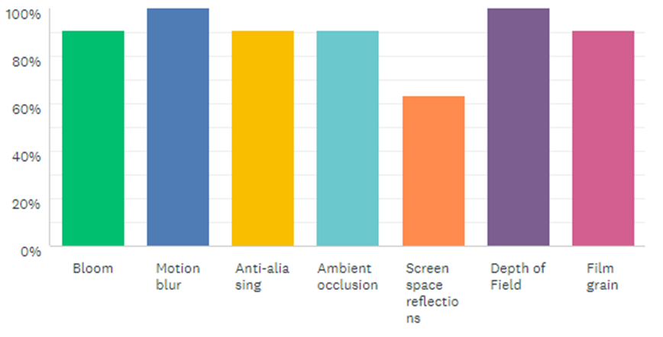
Figure 8. Survey Monkey question 8.
Questions 9 & 10 were linked to ask if an effect like eye adaptation a good investment within a game space would be. Within the answers the main concern was the effect changing the fairness of the game. The Majority of the answer state that it would be beneficial depending on the motive of the game. Its suggested that participants would not see the effect working inside of a competitive game.
This was an efficient way to collect information by including closed-ended questions, leaving the members of the survey to answer both openly and precisely. Before the creating stage of the study this information enabled further planning of specifics within the simulation design.

Lab Experimental
The type of requirements needed for the lab experiment was first a 2d scene designed to demonstrate the chosen effect. There also needed to be clear reasoning behind types of software and hardware used and why. An Assessment of the reliability and real-life form of the effects needed to constantly be challenged. As well as an enjoyable and interactive environment for the player.
The table below helped to aid the basics of deciding reasons to use specific software and hardware. Once decided the physical setting of the lab experiment was able to take place.

Software and Hardware Used for the Experiment:
Type | Name | Reason
Software | Unity3D | The experiment itself will be crafted within Unity3D along with scenes.
Software | Oculus Integration | This is used to link the Oculus headset SDK with Unity3D to get a VR scene working.
Software | Visual Studio 2017/2019 | An IDE for writing scripts within Unity3D in order to program.
Hardware | Oculus Rift VR headset | A virtual reality headset created by Oculus for the effect of the experiment to have more realistic feature.
Hardware | GTX 1060 6GB | A strong GPU would be needed for the VR headset to work at a playable state.

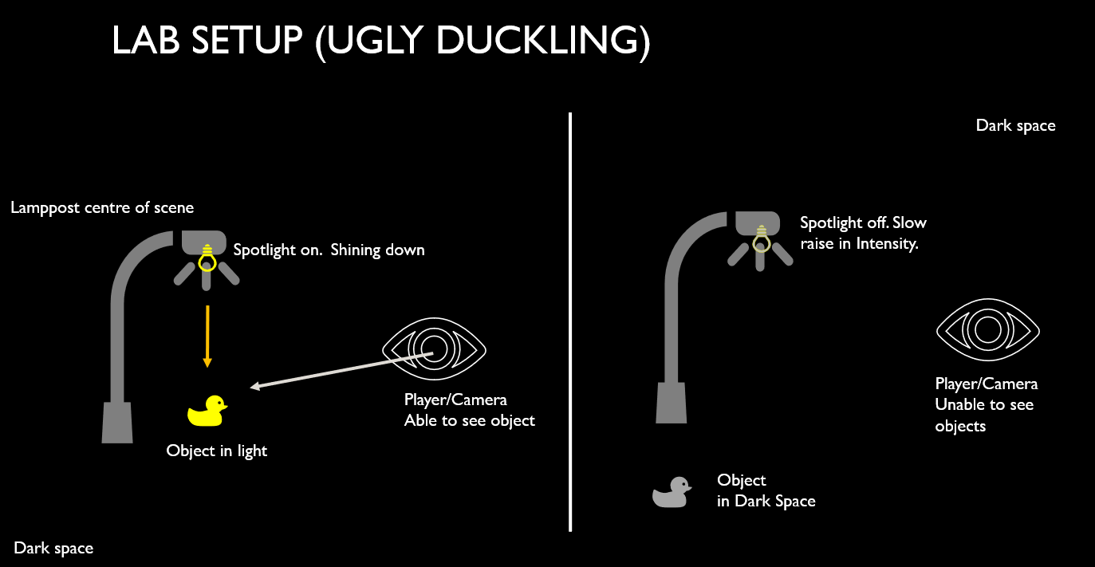
Figure 9, Ugly Duckling Experiment. Source [35]
Above shows the original set up of the lab scene, on with the left a spotlight is central to the scene and the duck were visible under its light source. After a short duration of five seconds the light goes off and player are then situated within darkness. During this time the duck relocates position and the iris effect begins taking place. As time progresses the player/user should be able to locate the duck in the dark space as the eyes, or the camera within the experiment adapts to the new environment of light. Like the human eye it would adapt to the dark environment and vision would slowly regain. To confuse and test the durability of the space other objects such as a ball and a banana would also be positioned in the room to encourage players to hunt for the correct object. This means the user tests their patience and must wait slightly longer time before object are completely visible. This is how the effect can be most true to form.
This experiment setup is an interesting way to test the effect and gather both user data and technical data. The advantages are a fair timer that starts at zero for every participant, so every player starts at the same skill level. The same scene and effect are used throughout for each person. Meaning this will allow for a fair set of results, the downsides were that the objects spawned randomly causing the object to appear closer to the player meaning some were found very quickly and didn’t fully test the effect. To combat this, the spawn points for the objects were set to specific locations for each test performed. This then reduced the luck or randomness of a player finding the object.

Design & Implementation:
The designing of the 3D virtual reality scene was set up to feature a simulation replicating the human Iris’s adaption to light and dark Spaces. Within the following section various Techniques, Functions and Methods were used to create a lab experiment. Areas such as Shader Programming, APIs, Virtual Reality, Software, Hardware and How they link to the experiment were explored for the completion of a simulation. A high level of consideration was also applied when choosing specific approaches over others.
There was experimentation within the advanced hardware used for the development, regular testing was also key in the process of maintaining a high level of precision. It was also important discovering issues involving hardware and software in every stage of the design as sometimes complexity of the set up meant for a complete changing of approach.
The chosen VR headset used for testing was the Oculus Rift. When setting up the device for testing the Graphics card had to be capable to run VR but also required a HDMI input. Down to the equipment a lot of space was required to test virtual reality scenes and so rearranging the physical space of working was a requirement.

Software, Hardware and Equipment

Game Engines
Many variables were at play when deciding on a game engine to develop the ultimate scene. When choosing an engine both variating factors and alternative platforms exist. Some game engines working significantly better for 2D set ups rather than 3D and vice versa. A selection of considered game engines were as follows: Unreal Engine 4, CryEngine, Unity3d and my own via OpenGL (API). For this study and simulation Unity3D is best suited due to the simplicity of such advanced yet easy to use interface. It gives the users clear documentation for following and a wide range of resources can be found online for the improvement of development.
The engine Unity3D, was developed by Unity Technologies and was built for the purpose of users to be able to design, create and play games across multiple platforms. These games can range from Single Player, Co-op or even Multiplayer games in 2D and or 3D. [36] Additionally, Unity offers adjustable settings for their users if they prefer a particular means for how the engine renders. Found under “Rendering platforms” [37] are the several rendering APIs listed from Vulkan, DirectX, OpenGL Core and others. This means it can be adaptable across multiple platforms.

Shader Programming
Shaders have a similar effect to using a pen or pencil to draw shapes and shade in colours. Shaders simultaneously manipulate a large number of pixels to arrange and become a specific colour. It runs on a Central Processing Unit (CPU) but with the use of Parallel Processing, having it run through a Graphics Processing Unit (GPU) with lots of microprocessors, would perform the calculations much more quickly. This way the Pixels render at a faster rate. Why they are referred to as shaders is simply, they are most typically used to control shading and lighting effects. But can also (if used correctly) be used to produce other special effects. “The book of Shaders” by Patricio Gonzalez & Jen Lowe is referred to in the process of making shaders. [38]
Shader programs will be required to develop the simulation for the lab experiment. The program was developed using selected engine Unity3d render pipeline. With assistance from the VR headset, it allowed the program to be implemented into Unity within both past and recent versions. This enables the player to be fully emerged in darkness and for the simulation to be as realistic as possible.
Having some pre experience of developing games within Unity also made it a strong contender for the selected engine. It offers a clean and sleek user-friendly interface and is adaptable for the use of shaders. The way Unity3D shaders are handled is broken into Surface Shaders, Vertex & Fragment Shaders and Shader graphs. Surface shaders don’t allow for modification of lights as it does it for you, using this feature means it is harder to implement effects. But, with the use of a Vertex and Fragment shader (labelled as effects shader) it enables a more manageable and modifiable way to code for the goal effect.

Application Processing Interfaces
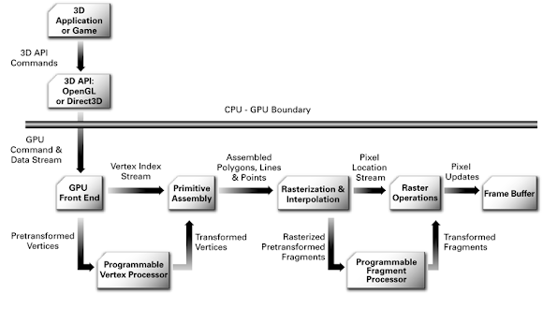
Application processing interface or APIs are used to characterize the way in which applications can communicate to components within a computer system. This can be known as a bridge between the CPU to the GPU. A graphical API is a type of interface that would allow for developers to control functions more so for Graphical Content, Sound Sampling, Graphical Interfaces and all Networking Games. Below is a comparison of modern graphical APIs by Alain Galvan [39] . It shows how the APIs communicate to the programming language for the display of graphics.
Figure 11, OpenGL graphics pipeline. Source [40]

Although, the GPU & CPU are unable to communicate with the same languages it’s an effective way to be able to get the GPU to take on a lot of calculations. It also completes tasks that the CPU wouldn’t be able to do without help. The GPU in this case would use the buffers to manipulate how the vertex and pixel shaders are drawn. This with a shader language is high level functionality and can give a large amount of power to the user. Effects and graphic features then benefit from this.
In relation to the study, it is relevant as the effect would be completed on the graphics processing unit, with the help of APIs and shader programming (GLSL language). Within Unity the vertex and fragment shader can then produces shadows and lighting, thus making effects like the bloom easier to make. Note, that there are also a whole range of different APIs, Shader languages and Versions that the system can handle. This per pixel - per vertex methods will then allow the programmer(s) to do special effect by changing colours or vertices.

Virtual Reality
Virtual reality or VR can also be referred to as ‘near-reality’ simply down to the definition of virtual meaning near and reality being what is real. This technology can offer users an experience that simulates what it’s like to be inside of any given game or space. When producing a life-like effect, virtual reality lends itself to showcase the effect as real as possible. Giving the user a realistic simulation, it helps to encapsulate the user(s) fully into the scene. With light being one of the main feature’s players get to experience the 3D scene without any other light interactions, only from what they see within the headset that’s equipped. It allows for a greater control of intensity of the effect. Along with being physically interactive it can be controlled to produce different player reactions. And so, the use of the oculus rift along with its library/SDK it will enable the most effective process.

Oculus integration
Virtual reality or VR can also be referred to as ‘near-reality’ simply down to the definition of virtual meaning near and reality being what is real. This technology can offer users an experience that simulates what it’s like to be inside of any given game or space. When producing a life-like effect, virtual reality lends itself to showcase the effect as real as possible. Giving the user a realistic simulation, it helps to encapsulate the user(s) fully into the scene. With light being one of the main feature’s players get to experience the 3D scene without any other light interactions, only from what they see within the headset that’s equipped. It allows for a greater control of intensity of the effect. Along with being physically interactive it can be controlled to produce different player reactions. And so, the use of the oculus rift along with its library/SDK it will enable the most effective process.

Conducting of The Lab Experiment
When searching for ways to achieve virtual Eye Adaption to light, a discussion found upon Unity’s forum page lead to a suggestion by Skovacs1 [41] and gave a clear place to begin for the creation of the effect. He mentions Unity’s ‘SetTexture’ function assigns a texture that can form as a shader, then gets compiled onto the GPU.
The first attempt using a shader was conducted with only a basic understanding of shaders, and so Skovacs1’s [21] approach was explored in further depth. This then led to the development and creation of multiple scenes that challenged both the system being used and multiple attempts at creating the effect. The four attempts include the RenderTexture Technique via C# Scripts in Unity, Raycast Light Detection, ToneMapping using Vertex & Fragment Shader and the Lab Experiment using Different Light Sources.

RenderTexture Technique, Via C# Scripts in Unity.
To begin, the set-up of a buffer texture was needed as well as a texture itself to test the cameras visibility if the player is in light. Through using the RenderTexture, the light level/shadow of an object could be altered and was the first method thought of when researching solutions. This approach is like sending out a ray cast for checking the player’s collider. Although ray-casting is much more cost efficient and is a method that comes up again later in the study. The image below demonstrates how the player is under a light source. The player and the light source are then situated upon a plain and a texture of the camera POV was also applied. The camera for this test was used to detect how the light hits the player/Capsule. Using a layer mask attached to the player labelled “player” and with the Camera only able to render the said layer. This meant that only the light hitting the player was getting detected. The plane located at the back of the picture shows a clear representation of the camera’s point of view regarding where on the player to detect for light.
The light level on the first test was around ~4.539246 and this was because the player starts the scene under the light. When the player to light is blocked, the level drops down. Like ray casting, the camera is used to project and do tests or calculations in order to get a result back.
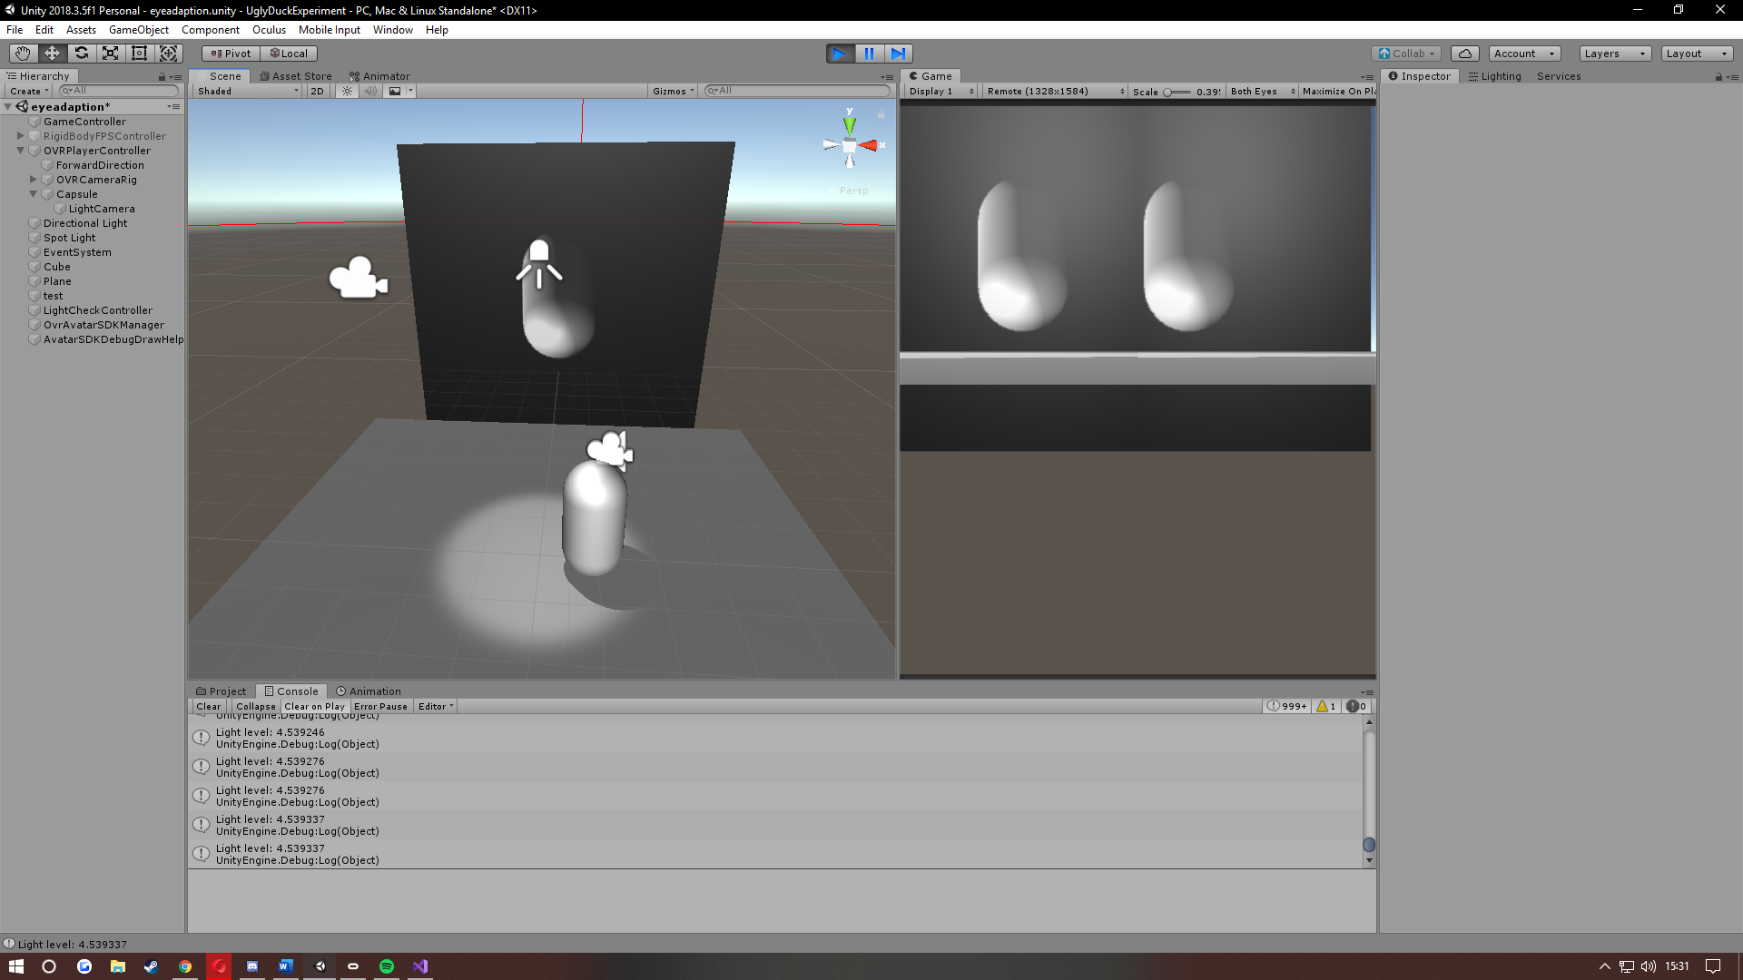

Now, when any object, or cube was used (example below) the light level droped to around ~1.520264. When an object blocks the perspective of the player or is situated inbetween the light source, the light hitting that player lowers rapidly. By making sure the only puropse for it not to hit less than 1.5 is due to a directional light placed within the scene used for as a means for light when demonstrating this example. (Another light sorce hitting the player).

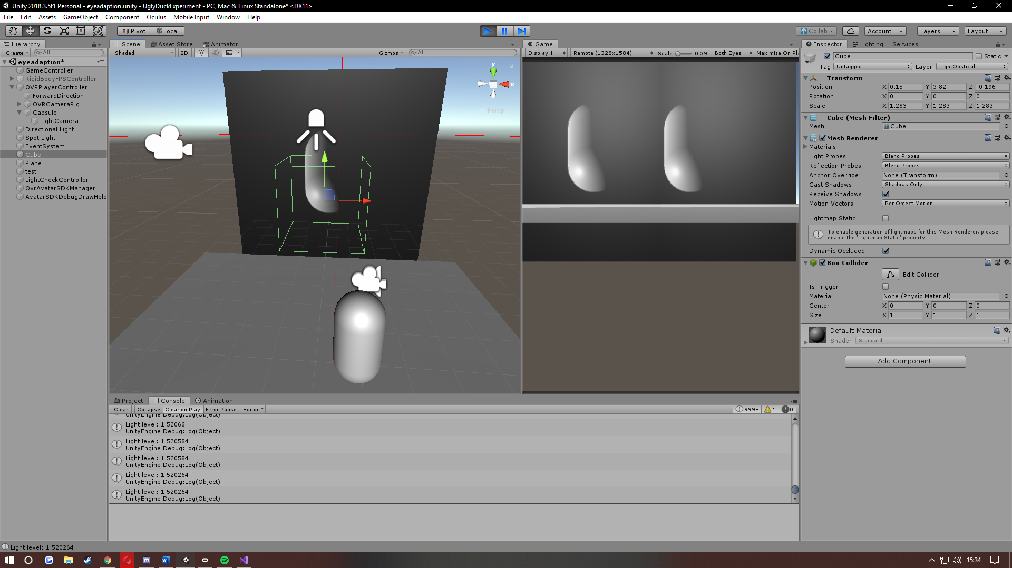
lowered dramatically. The only puropse for it not to hit less than 1.5 is due to a directional light placed within the scene to used to be able to show the example. (Another light sorce hitting the player).

Overall this demonstrated an efficent way of guaging light readings off the player within a scene and can work effectivly. Although it does have its limitations and bounderies. Such as A near estimate of light hitting the player along with the need for a camera to detect the light ontop or around the player.

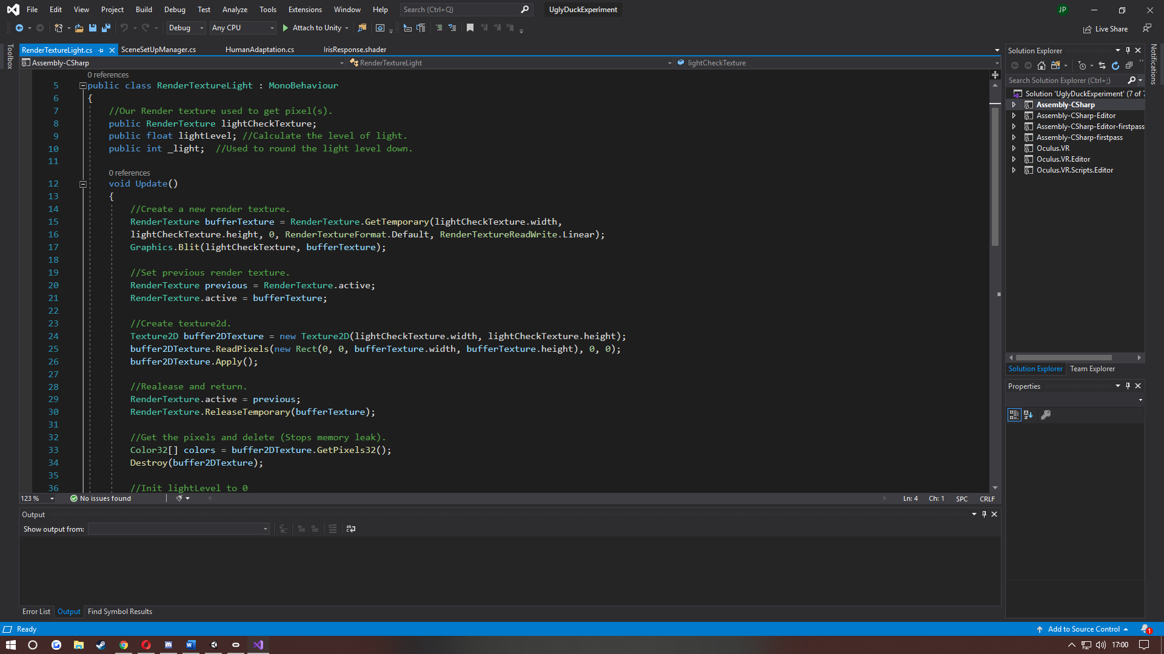
The image below shows the RenderTextureLight.cs script.

Here shows, the steps taken in reltion to the render texture example. For this a render texture buffer was used to relay the render texture information back and forth. Graphics.Blit Unity function was also incorpereated to copy the information across buffer to buffer. The previous render texture was then set to active and enabled bufferTexture. Creating a Texture2D buffer to do the same but to ReadPixels, allowed for information of colours such as Red Green Blue Alpha for the user to later manipulate how they desire.
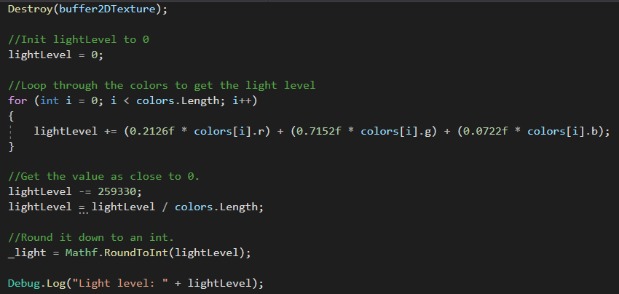
Release & return of memory call to the renderTexture buffer then had to be created in order to release the memory of textures stored stop memory leaks from occuring. Then whats needed was collection of the pixels from the 2dTextureBuffer and was promtly followed by destroying to stop futre memory leaks.

Following this, initilising the lightLevel to equal zero was important so that it wouldn’t become a random or uninitialised number. When further making a loop to go through all the colours (RGB), a Brightness analysis formular was used to evaluate the brightness of the image by the mean. Then from this the relative luminance of RGB is performend in the following formular:
X = 0.2126 * RED + 0.7152 * GREEN + 0.0722 * BLUE. [42]
Once the light level is established a large sum of the mumber is subtracted to get an estimate that is more readable. From this it’s then rounded to the nearest inteiger using: Mathf.RoundToInt.
With this approch the soloution was then to check if light level was higher than a particular value. Then when starting a bloom or changing the intesity of light it it would be achived by clamping “x” to ensure that is did not exceed a value that was too high. The brighness of the scene would need to be changed if the level was less than “x” value.
From this test alone a clear development and understanding of how Textures, Texture2d and Light level mechanisims are made in order of creating a light sensitive enviroment. Although efficenncy wise this wasn’t the most proactive choice when producing the desired effect, it is a reasonable avenue to achieve light readings. With more time and reserch the effect could have been made with this method but with a limitation of it being static the process became tedious.

Raycast Light Detection Checking
The second attempt was tested using a Raycast. To detect a player, the raycast was projected from the light source. This meant that if the player’s collider comes in contact with the Raycast, the player is under the lightsorce. Although accurate it became an inefficient way to check light detection as multiple raycasts are needed for more complex pools of light.
Implementing the raycast was relitavly easy to acheive by creating a spot light with a ray of the transform to point in the same direction of the light. The range was then used to stop the ray from going any further than intended. Though of solution at the time was to enable rays using a distance calculation or when a player is within the isTrigger colider then enable raycasting. This would dramatically increase performance and allow for multiple versions of ray casting to be used in a single scene.
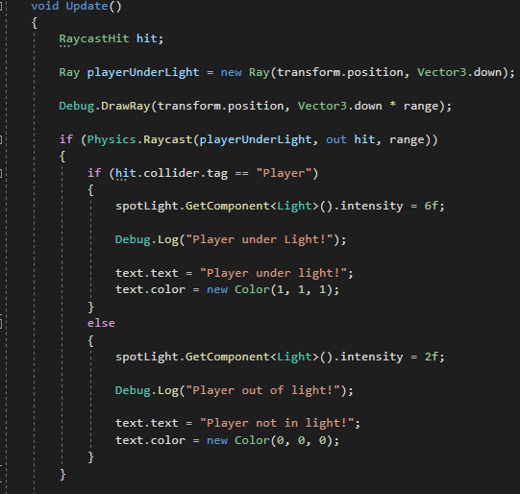

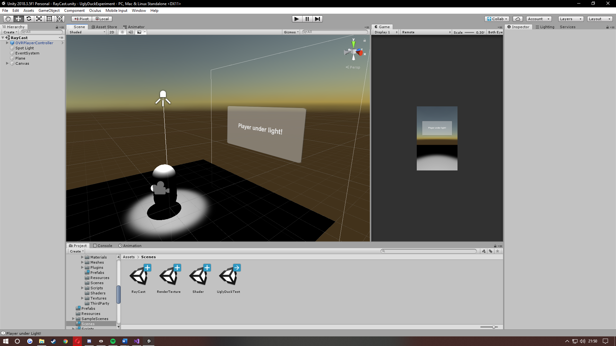

This worked well to test if a player was under a given light but wasn’t effective enough to produce a workable effect. If multiple lights were within the scene then more ray cast calulations would be required and the scene would become very complex, leading to possible performance problems. Although an accurate approch the method became unimprovable. Shadow volumes were also placed in the same category as raycasting due to the metod simply being too slow and expensive to perform. These methods can be used effectively in specific scenarios but for this study’s effect it has more disadvantages than advantages.

ToneMapping Using Vertex & Fragment shader
Tone mapping is used in order to give a shader effect. It uses a temporary render texture to work out calculations then releases the texture. This method with the combination of a shader can modify or collect information about the Brightness, Colour and Luminosity of a scene.
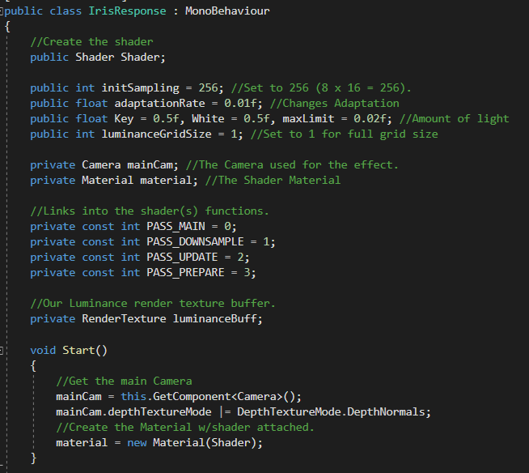
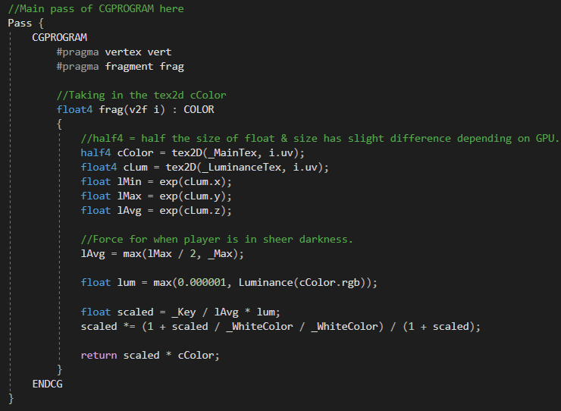
IrisResponse.shader IrisResponse.cs

When forming the basis of this effect tone mapping was implemented. Tone mapping can be used to project an infinite amount of brightness or a high dynamic range (HDR) from 0-∞. For the effect to work in HDR, the first step was to structure a form of screen buffer that was greater than 1.
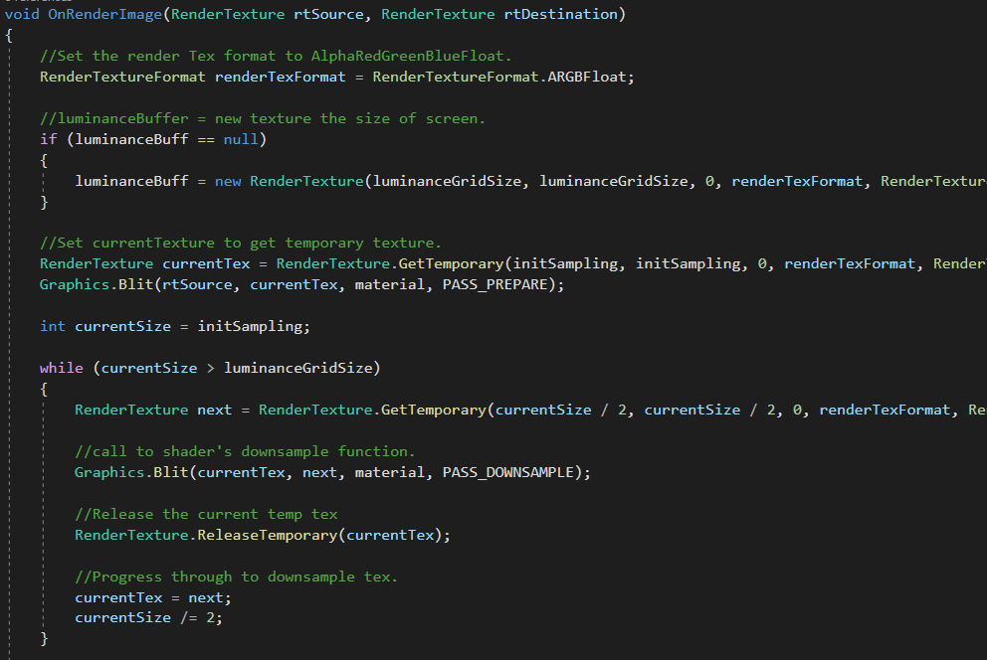
IrisResponse.cs

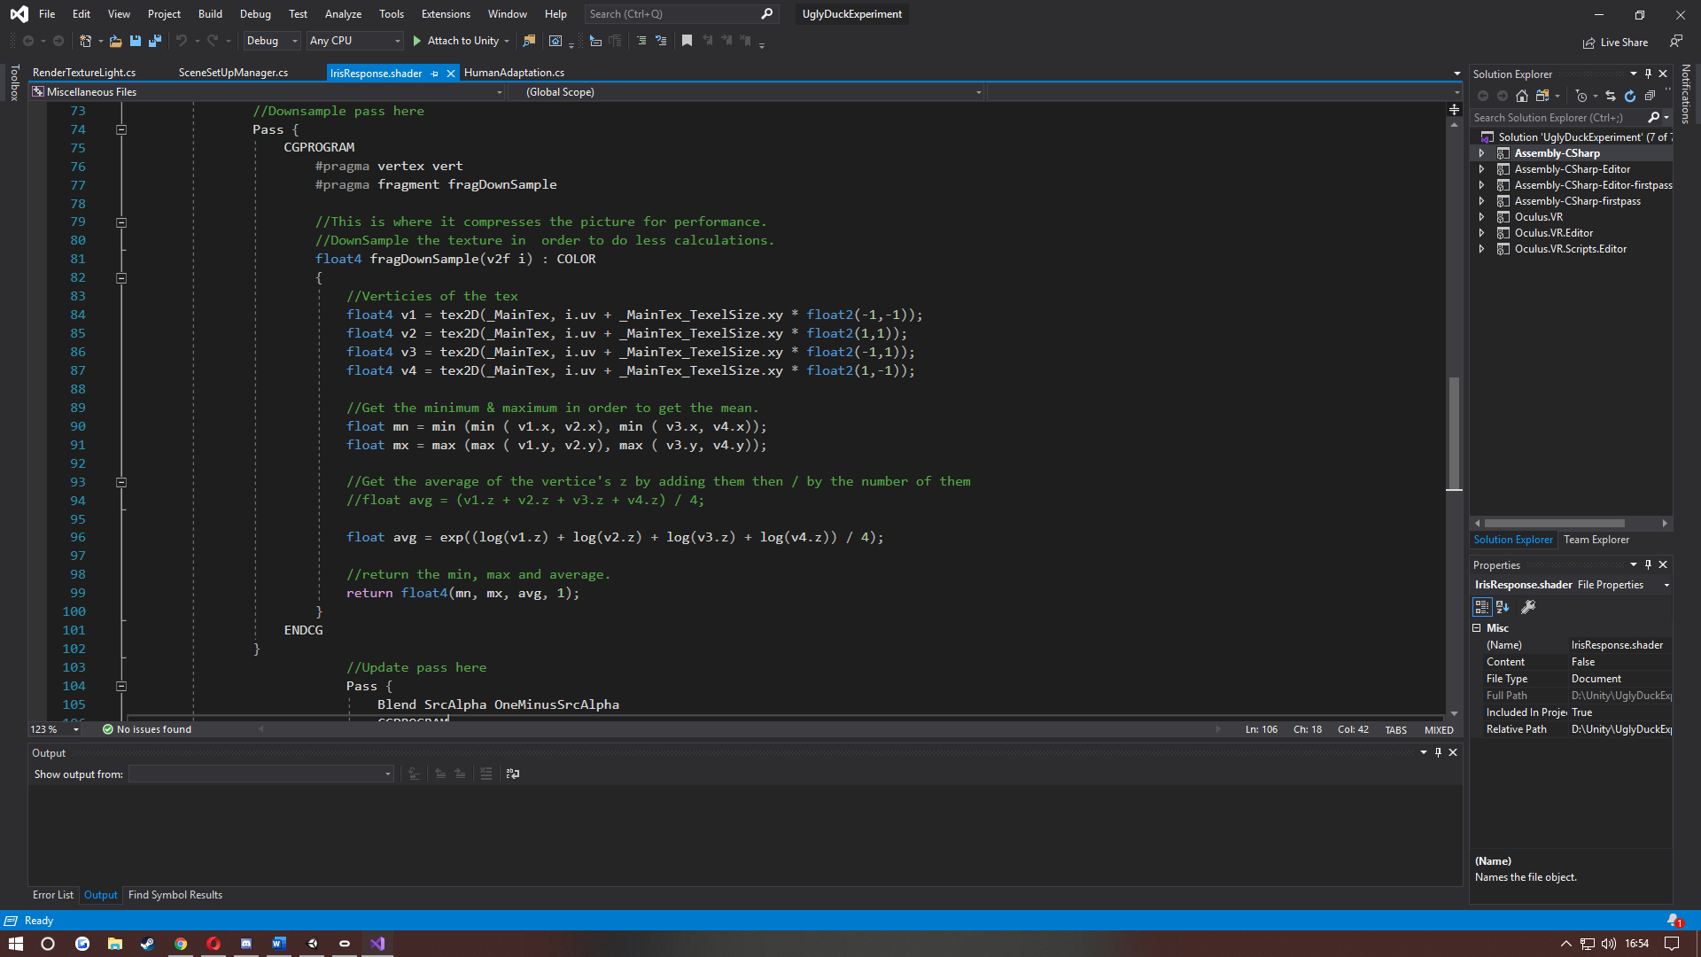
IrisResponse.shader

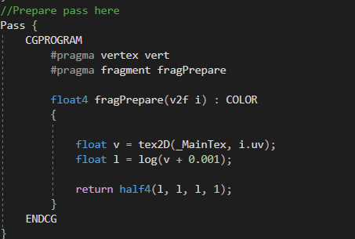
The solution was to first get the overall brightness of the 3D scene the player is within. To do this, the mean of the pixel’s brightness had to be calculated to get the value. If working within a dark environment it was not reliable due to a rather large proportion of the image area being darkness or of a low pixel brightness. For such effect it would be worth using down sampling for more efficiency. This is done by reducing the given image to a near square which has a side equal to ^2 and then finally discolouring it. From this it’s able to be compress by 2 each time until only one pixel is remaining. But in order to compress the actual picture, it was key that neighbouring pixels (four of them) were found and selected from the middle four, which then allowed the maximum to be left. By using a geometrical mean, it rounded it up to the highest value. Since the pixel brightness was what the method was going off, this was be the best solution to get back the correct information we need.
When developing shaders further, the original image needed the use of logarithm by adding a small increment to clamp it from going completely black, meaning it was equal to 0. Then for each part of the reduction a minimim of the Red, maximum of the Green and mean log() of Blue was needed. This meant that brightness data could be stored within the texture. In simple terms the shader program was then able to store and get the texture, log(). This with a increase of a small value and it returned back the RGBA colour values for the centeral processing unit to manipulate.
When simply tricking the user into the adaptation effect it got a brightness value that over time would become the current value. This made the texture constant with a standard size equal to one pixel. With each frame, it was then able to create a new brightness being one pixel in size. This is similar to the texture’s size but with a small alpha value.
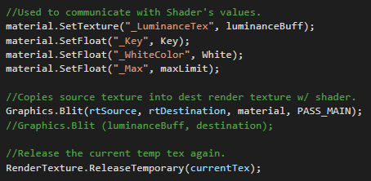
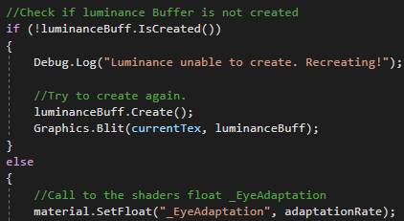
HumanAdaption.cs

Towards the end of the effect eye adaption rate was applied that travelled from graphics card to the CPU. This was in order to simulate the rate in which the iris adjust to the amount of light that the player is faced with.
//Call to the shaders float _EyeAdaptation
material.SetFloat("_EyeAdaptation", adaptationRate);
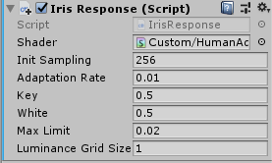
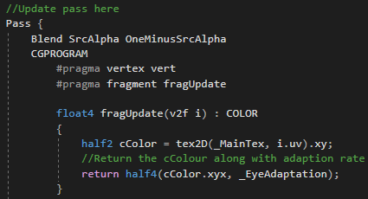
This considered both textures, one being the original image and the other being a texture to handle brightness information. This modifies the exposure of light for the first texture and then finally using the adaption rate value in the second.

This showcased the values inputted to get an estimate of eye adaption in play. There still needed to be a way of restoring the brightness from the log() algorithm that was used. First the coefficient for the scaled factor was applied to correct the white level.
//Brightness correction to our _whitecolor
float scaled = _Key / lAvg * lum;
scaled *= (1 + scaled / _WhiteColor / _WhiteColor) / (1 + scaled);

return scaled * cColor;

To end, scaled * the out cColor must be returned which handled the correction in brightness with the colours from the shader. The effect is then finished and if connected to the camera intended, it runs smoothly.

This image below was the scene within Unity that demonstrated the effect was being achieved. It was used to let users of the effect walk around and get a visual understanding of the effect taking place.
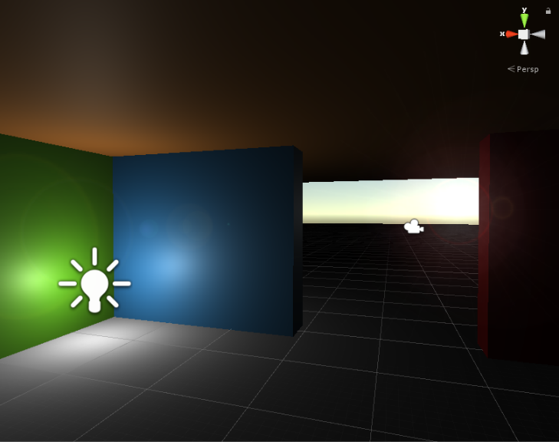
With a simple scene(s) set up within Unity3D, it was then able to demonstrate what visual outcome it had when situated inside of virtual reality and faced with different light scenarios. The images below show the transition within five seconds of the spotlight adjusting from a high intensity to a more subtle pool of light. There are visible bands of light shows throughout the time frame. For testing purposes the ugly duck experiment was a simple scene to demonstrate both the pool of light and an object within it.
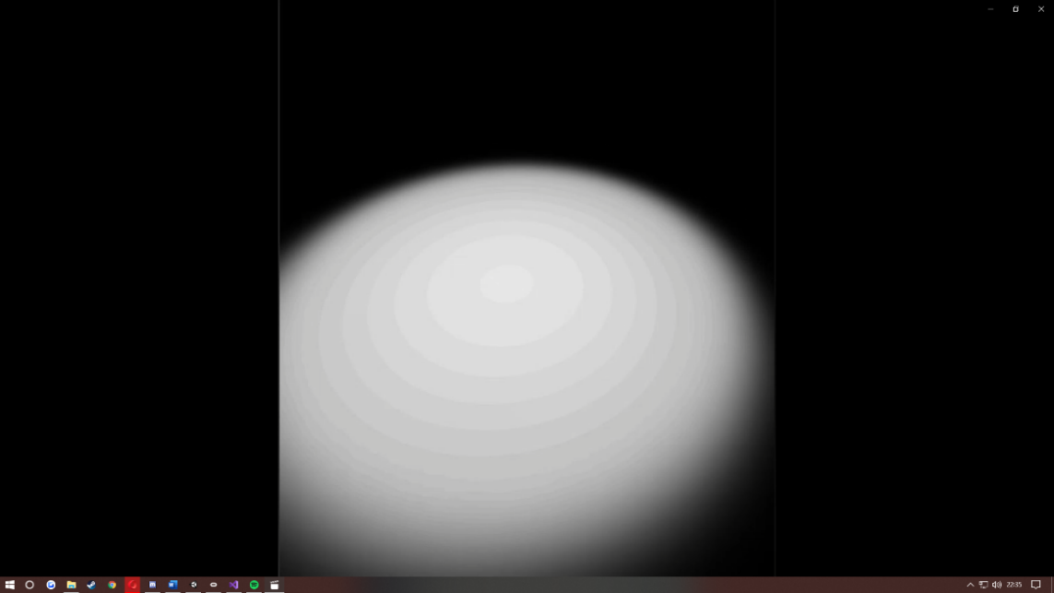
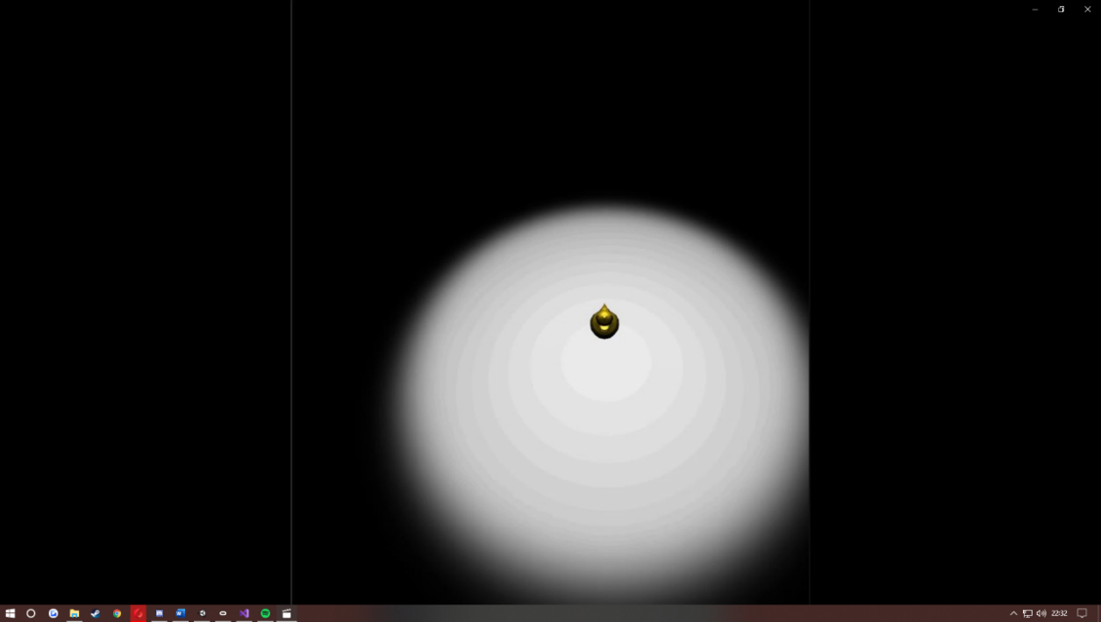
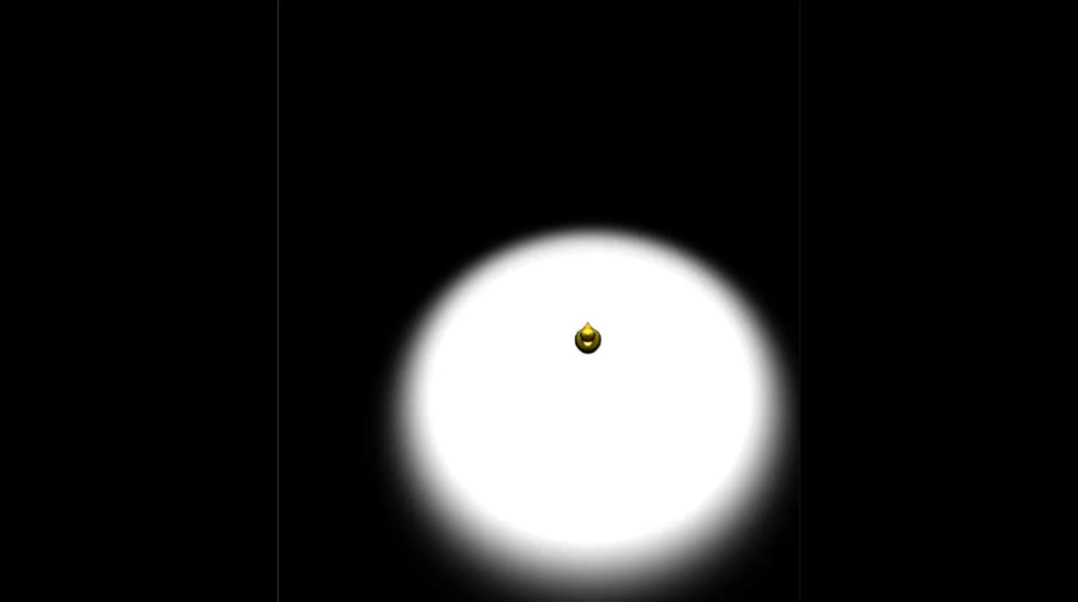
Full five Seconds
2 Seconds Onwards
0 Seconds Onwards

After a given time of five seconds, the duck rellocates from in front of the player. The one underlaying aim is to seek out the duck inside of a dark space but to use the effect as an advantage. The player is then timed to find the duck as fast as they can.
For the scene setup two variables were used to change the speed in which either an area light’s range would increase or a directional light’s rotation. These were declared in the mySceneSetup.cs:
public float coneCellIncrease = 0.02f;
public float rodCellIncrease = 0.002f;
bool coneCellActivated;
bool rodCellActivated;
“coneCellIncrease” and “rodCellIncrease” were used to adjust times for the amount of light inside of the ugly duckling scene. The higher the value means the faster the visablilty of an object and in tern the higher intensity of light.

A timer was used to demonstrate to the player how quickly the ugly duck was found. As well as indicate how quickly the indavidual adapted to the light effect. This meant an average time was found from player of around 50 seconds to 1 minute 45 seconds.
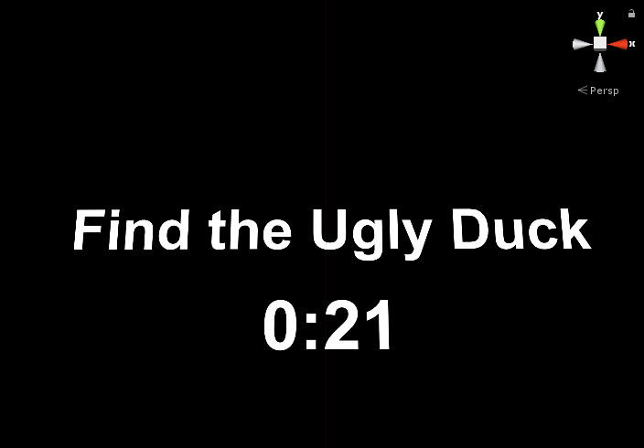
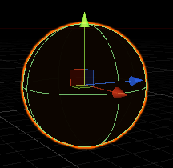
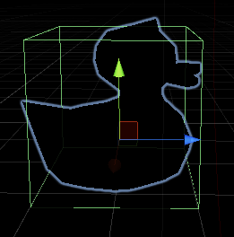
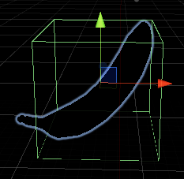
Not only was there an Ugly Duckling object prescent with in the scene but for testing purposes a Banana and Ball was added into the space. Both additional objects were yellow similar to the duck. This meant the player was challenged by their patience to find the correct object but also were tested by their visiability within the darkness.

Limitations
When reflecting upon barriers and limitations that occurred during the project it led the process to end chosen solutions or outcomes that were more successful than others. Given that, the design and development wasn’t fully up to the standards of expectations before starting this project. It’s something that challenged both personal abilities and the reliability of software. Within this segment limitations are broken done into groups of how they were an issue and from this, what influenced the following stages of development.
Firstly, the idea of a shader effect for how the eye adjusts was the most obvious approach, adding it to the virtual reality scene was intended to enhance players experience. But this caused issues further down the programming line due to originally wanting VR to be crafted inside of my own openGL engine without the need of another game engines help. With extra work added on top of what was thought to be an achievable openGL route, it had taken up time and restricted what was achievable in the time dedicated to programming. Due to the tenuous knowledge and large development scale that was needed it was more logical to resort to a game engine that was more familiar and time efficient.
Secondly, the process of understanding and developing a shader equivalent of the desired effect proved challenging and time consuming. When trying to reach the goal of getting the effect to work within Unity there was a struggle to understand how it functioned. To have the shader fully functional within Unity this wasn’t possible with the current amount of knowledge. The chosen method was to come up with another way of achieving said effect or to fake the shader solution of the effect. Although at first it had its limits, it was somewhere to begin. As progressing through reading, gaining insight and having developed similar effects outside of shaders.
The attitude towards this was to further develop research needed for the use of a shader. By testing simple effects inside of shaders and finalising the fundamentals of the HLSL shader language, allowed progression to re-test from a more equipped position. The UnityLearnPremuim [43] website offered tutorials for proceedings and enabled gaps in understanding to be filled.
Overall limitations regarding software and knowledge meant that certain routes had to be abandoned and new methods had to be started from scratch. Although this was tedious, it enabled a better understanding for the importance of light effects and challenged the space the effect is achievable within. An additional limitation was that of a lack of participants to test the experiment. This was due to a restriction of VR equipment and a functioning and representative scene. Only users that had access to a VR device at home were able to fully test the Lab Experiment. Although from this there was a slight disadvantage for amount of feedback possible. But it didn’t seem to affect the quality of written feedback from the participants because they were asked to be as descriptive and critical as possible.

Lab results
The main topic for this study was; “Simulating the Human Iris Response to Amounts of Light”. This was kept in mind when traversing over the data gathered from sources, surveys and input. The following survey was completed after the lab experiment was tested by the players. When analysing the data from the sources there is a focus on comparing the data collected to how the effect can be adapted and if it was a realistic representation of an eye adapting to different light intensities.
With the respondents giving a plethora of good answers and all the given questions responded to. It demonstrates how well of an effect it truly is or can be with tweaking coefficients or applying new ones. The results below show the answers from the three players that was able to partake within the lab experiment. The first question asked: “Did you Notice the Effect when first Entering the Scene?”

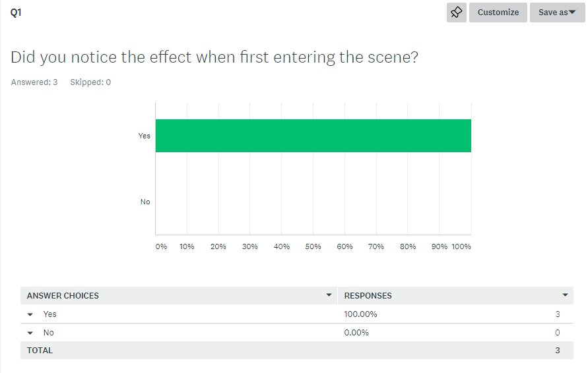

All three results said they had noticed the effect upon starting the experiment. This indicates that the effect is instantiated from the beginning of the test. During Question two, the multiple-choice results lead to all three agreeing the VR headset helped to enhance the effect and in turn proved that VR was an effective choice to demonstrate the scene. Although the data was received from three players a positive common trend is visible within the responses to the questions. If there was no headset there would be light from the monitor or from the room where they participate from and this would dampen the effect.
When asking Question three “Do you Think the Times of the Effect is Correct? A 50/50 split between the players was discovered. Half of the respondents voted “Yes”, and the other half voted “Near Enough”. From this question its clear that the reduction of time carried from real life eye adaption had been effectively reduced for the virtual reality space. With 50% responding “Near Enough” it suggests that there is still room for improvement to gauge the perfect times.

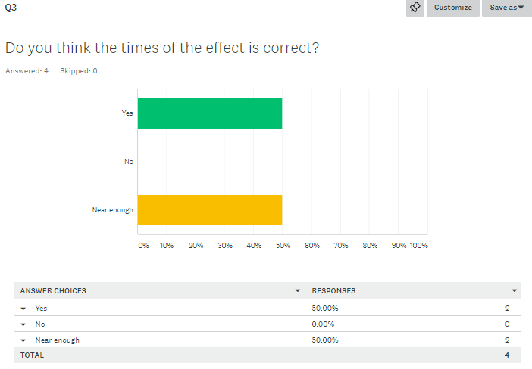

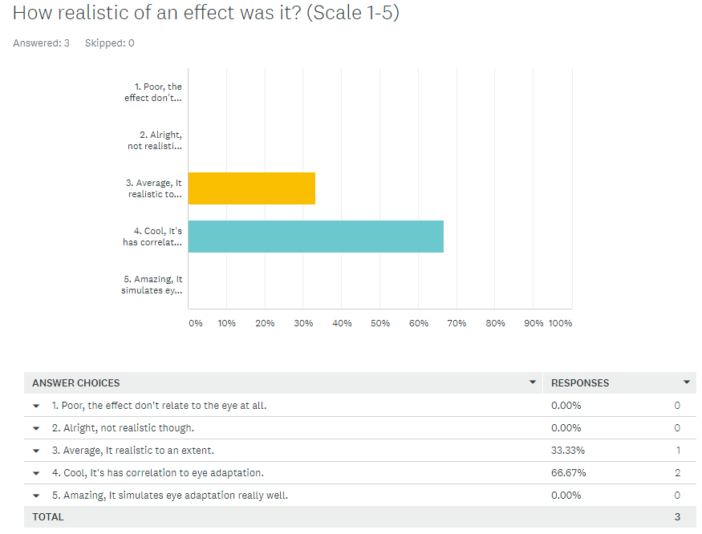
Within Question five of the survey, it asks the player “How Realistic of an Effect Was it? With a scale rating between 1-5.

One respondent rated the effect a three out of five. Which suggests the effect was average and realistic to an extent. Were as two participants voted it a four out of five meaning it was a “Cool, [and] It has correlation to eye adaptation. This indicated even though the effect is at the testing stage it’s still an effective simulation. Although receiving some positive feedback there is again room for improvement when making the simulation as true to form as possible.`

Evaluation:
Conclusions drawn from this data indicate that visual effects are a pleasing way to implement real life effects inside of a virtual world. Taken from this data is that although an interesting visual effect the use of it is very limited to the situation or preference of the player. Research from both surveys before and after the lab experiment goes to show that the question within the lit review here proven correct. The pre-lab participants who said no to eye adaption learned quickly about what it meant along with the players who tested in the experiment got a good representation of how the human visual system works. With there being a huge importance of lighting methods and where the lights are situated in games. It shown from the data collected that players understand without lighting the game can become dull and dependent on that game is how lighting impacts moods or changes a scene drastically. Although not simulating to the full potential of what the human visual system does. It was down to a how highly complex of a system it is in order to fully replicate. There simply isn’t a well simulated effect to that of the eye since the use of monitors to perceive the eyes point of view is used. With this in mind, the effect hits most of its aims & objectives of simulating the eye adaptation. To justify if effects are beneficial or has drawbacks within games the information collected says that the eye adaptation effect limits players vision when in competitive play and would be both beneficial for the person in dark but a draw back for those inside shadows. Survey as well as lab data wasn’t the results expected as a need for the effect was thought to be in all genres of games but proven to be game dependant.
Though it was an incredible challenge along the way, there was a lot of remarkable findings and information learned. When gaining insight from the study and what different approaches are to be done next time would be. Manage larger amount of data with different means for collecting and a more controlled lab experiment with a larger set of results. Doing so, the data from larger sources and a more controlled environment would allow for a more reliable way to back up the effects similarity to the human visual systems. In correlation to the results, the unfinished effect had a large impact on the end results of the experiment and thus impacting the results from the lab test. The quality had started off rather well with light detection methods being implemented fast but as time was lost on this idea in mind it’s safe to say that it was a static and non-realistic way to simulate the iris response. Having a more fluid and dynamic handle for the effect would be beneficial for the setup of the experiment and would significantly reduce risk of errors. Managing scripts would be tedious and unorganised. With a working shader program, it would allow for less code, more performance due to it utilising the GPU instead of CPU.
The learners can have good understanding of how video game and movie effects are made with knowledge of how it works for both the human visual system shown in the lit review as well as code demonstration shown in the design and implementation stage. Games, getting more realistic with graphics, gameplay, storyline and more means that there is a need for new effects to come. Its key that if readers understand how these effects work, they will understand the complexities that programmers face when trying to develop a new complex shader program.

Conclusions & Recommendations:
To conclude this study a large amount of Testing, Reading, and Programming went into the build-up of achieving the effect. Understanding, firstly how the eye works in order to create a the most representative effect possible was significant in my initial research. By combining this with adapted timeframes and light intensities was it possible. Within this so many combinations of times and sources of light could have been used. Developing shaders was another significant feature of this project and once establishing the correct game engine, the scene and effect was most able to be shown off.
Gaining useful feedback from people allowed for the most important and liked effects within the gaming community to be highlighted. This helped to create and understand the potential user base for this effect and the types of games it could feature within. Finding the area between visuals and practicality was also a challenge but accomplished by appreciating what other effects have to offer the player. This being said, it was challenging to produce a visual that wasn’t distracting for the players involved. As seen in my early research this can often lead to players not liking a game or completely disabling the effect. Lighting being such a huge aspect within games meant that there was interest from the people surveyed for the potential effect. This suggested a gap within the gaming industry that wasn’t fully being explored yet.
Working in VR was challenging but to showcase the true performance of the effect and being the closest console to real life replication, VR was the right fit for the simulation. It also allowed for the player to be completely submerged in the scenario created, no distractions from the outside world and increased how intimately the players were interacting with the space. Incorporating new technology like the virtual reality also posed potential designs for future developments. It was important that this study focused on something that needed to be brought up to the speed of gaming or that hadn’t been explored as much as it should.
When developing the effect Multiple dead ends were found due to this being a new area of study. But from this multiple platforms and techniques were explored for the first time. Information and research runs through every aspect of the study from the user to console interface, and to the intensity or placement of lights. As there is such an abundant of information available being able to find correct and precise information was sometimes hard.
Overall, the creation of the effect was achieved most effectively by using a shader program, not only this but results from the questionnaire suggested it was working correctly and was enjoyed by its players. Although there was a lack of participants testing out the effect there were many test runs through the entire process. The effect was suggested in the surveys as being “good” but still having room for improvement if possibly working on a larger scale. And so, its realistic quality could also be developed. Functionality wise the simulation works and so proves it could be implemented into future games.
This study also provides potential research for other Games Developers. The tried and tested results can be transferrable to other much larger or higher funded projects. This method also can be adapted to work on other consoles such as PC and could provide benefits not explored in this study. To have a working effect proves the advancements that can be made within visual lighting effects within a relatively short period of time. If applied to study with a larger team or longer timeframe the execution of this effect could be perfected and polished even more.
Possible future avenues from this study have opened up. One includes more human responses or the manipulation of sound or movement within a space to heighten senses. The use of Ray Casts was also touched upon within the study and could be developed further for detection techniques within games. And finally, future development of shaders and textures could be an option. Though the course of the study a large focus has been to develop a shader that is realistic as possible.

Reflection:
Having had first-hand experience conducting a shader effect for the 3rd year of my degree. Although, it had enjoyable areas of interest, mistakes were made during the process. In this experience learned, was for me the most significant aspect was the research and taking in of information. There was a lot of key information that previously, I thought was the eye adaptation but didn’t hit all the desired requests so the need to relearn different approaches was a must. For the most part of this study throughout was that the results would be egregious, after finding respondents enjoyed the idea of having such an effect in a game environment it had shown a need for more visual effects to be developed. This experience has highlighted that there is a need to develop skills within shader programming and test various effects that may be beneficial for game industries. In regards for addressing this, it’s intended that making more sense of the programming language and how other effects are developed will also help craft these various effects for game industries. The uses of keywords when searching for the appropriate research was important due to correlation of real-world lighting and video game lighting being a confusion if keywords were to be used wrong. Upon tackling this task, it began to move at a steady pace and then slowed down due to dead ends and limitations. This wasted some time trying to fix, reincorporate already previously implemented features. Having said that, it taught valuable information to think of idea, approaches or types of solutions to the problems before jumping right in. The unfinished effect had a large impact on the end results of the experiment and thus impacting the results gathered in the lab test. The quality had start off rather well with light detection methods being implemented fast but as time was lost on this idea in mind it safe to say that it was a static and non-realistic way to simulate the iris response. Having a more fluid and dynamic handle for the effect would be beneficial for the setup of the experiment and would significantly reduce risk of errors. Managing scripts would be tedious and unorganised. With a working shader program, it would allow for less code, more performance due to it utilising the GPU instead of CPU.
With the assistance of books, online resources to be able to aid in the study having different views upon how particular methods work. This being for methods of research, collecting participants data and how to view a person’s opinion. These are all needed and are important factors for research and without would lead to a lake of knowledge within that study area. In the stages of development, understanding shaders programming and how it’s used for effects is an important reflection to look back at and see the achieved outcome. Big or small, during the study the main learning was the entirety of the study. What’s learned throughout is that development, data collection methods and what information is irrelevant to the topic is essential as it’s the information you are presenting to the reader. This knowledge is essential to not only me, but learners interested. It develops everyone in such a way to take in vast amounts of valuable information, have excellent approach on their academic skills, management of time and resources available and what’s to be expected in the real world when faced with difficult tasks. Not sufficiently writing the greatest standard of a thesis/essays; improvement upon grammar, correct implementation of information used throughout and ensuring precision when answering questions can help in the future. This also helped to galvanize me as beginning to realise how salient the study is and how impactful it can be when writing, creating and developing a lengthy essay that requires a lot of structure. It was a ubiquitous task for the research, understanding, development, testing and other important stages of the study.
Furthermore, looking back the improvements can be made in all areas. Research used within the study was relevant to light, how the eye works and effects in games, but tangents are natural for anyone writing. Encapsulating the data into a more defined and straight to the point approach can be looked at when doing more writing in the future. Making a more reliable experiment, testing it with a more diverse group and trying maybe two or three experiments to understand what factors make it a good one and don’t. Further this, testing people with glasses or vision is slightly more impaired would be considered to see a variety in the results and if the effect impacts people who already have a disadvantage. Give different methods a try and see what the results of that approach is and if it’s worth digging deeper. If it doesn’t work, then ask why? Find the appropriate one that fits the requirements situated for that study in discussion.

References

[1] | K. Sake, “giantbomb,” gamespot, 02 Febuary 2019. [Online]. Available: https://www.giantbomb.com/amnesia-the-dark-descent/3030-30087/. [Accessed 07 January 2020].
[2] | C. Onyett, “IGN,” IGN, 06 May 2012. [Online]. Available: https://www.ign.com/articles/2010/09/03/amnesia-the-dark-descent-review. [Accessed 26 April 2020].
[3] | D. C. S. Baird, “Science Questions with Surprising Answers,” Science Questions with Surprising Answers, 09 Augest 2013. [Online]. Available: https://wtamu.edu/~cbaird/sq/2013/08/09/how-long-does-it-take-our-eyes-to-fully-adapt-to-darkness/. [Accessed 19 March 2020].
[4] | M. Reilly, “New Scientist,” New Scientist Ltd, 28 July 2006. [Online]. Available: https://www.newscientist.com/article/dn9633-calculating-the-speed-of-sight/. [Accessed 19 March 2020].
[5] | “AMDF,” AMDF, [Online]. Available: https://www.macular.org/eye-camera. [Accessed 19 March 2020].
[6] | “flickr,” 06 February 2007. [Online]. Available: https://www.flickr.com/photos/13827586@N03/2397384383. [Accessed 25 April 2020].
[7] | “Vision Initiative,” January 2010. [Online]. Available: http://www.visioninitiative.org.au/uploads/assets/files/infosheets/vi_infosheet_how_your_eyes_work.pdf. [Accessed 12 January 2020].
[8] | https://www.nkcf.org/about-keratoconus/how-the-human-eye-works/, “How does the human eye work,” ational Keratoconus Foundation, [Online]. Available: https://www.nkcf.org/about-keratoconus/how-the-human-eye-works/. [Accessed 12 March 2020].
[9] | T. E. o. E. Britannica, “Rod retinal cell,” BRITANNICA, [Online]. Available: https://www.britannica.com/science/rod-retinal-cell. [Accessed 15 March 2020].
[10] | D. C. S. Baird, “Science Questions With Suprising Answers,” 9 August 2013. [Online]. Available: https://wtamu.edu/~cbaird/sq/2013/08/09/how-long-does-it-take-our-eyes-to-fully-adapt-to-darkness/. [Accessed 11 November 2019].
[11] | Uta Wolfe, “National Center for Biotechnology Information,” J Undergrad Neurosci Education, 15 March 2015. [Online]. Available: https://www.ncbi.nlm.nih.gov/pmc/articles/PMC4380301/. [Accessed 15 November 2019].
[12] | “rods and cones of the Human Eye,” Arizona State University, [Online]. Available: https://askabiologist.asu.edu/rods-and-cones. [Accessed 15 March 2020].
[13] | J. O. Greg James, “gamasutra,” Informatech, 26 May 2004. [Online]. Available: https://www.gamasutra.com/view/feature/2107/realtime_glow.php. [Accessed 12 January 2020].
[14] | “Finding Nemo,” IMDb, 10 October 2003. [Online]. Available: https://www.imdb.com/title/tt0266543/. [Accessed 25 April 2020].
[15] | t1e, “High Visibility config,” esreality, 08 December 2010. [Online]. Available: https://www.esreality.com/index.php?a=post&id=1950022. [Accessed 25 April 2020].
[16] | M. andlor, “Finding Nemo,” Is This Movie Suitable, 05 April 2013. [Online]. Available: https://www.isthismoviesuitable.com/2013/04/05/finding-nemo/. [Accessed 25 April 2020].
[17] | postums, “The recap of our mcc journey,” 343 industries, 29 May 2019. [Online]. Available: https://www.halowaypoint.com/en-us/news/mcc-development-update-may-2019. [Accessed 25 April 2020].
[18] | O. Shehata, “A Beginner's Guide to Coding Graphics Shaders,” Envatotuts+, 15 April 2015. [Online]. Available: https://gamedevelopment.tutsplus.com/tutorials/a-beginners-guide-to-coding-graphics-shaders--cms-23313. [Accessed 25 April 2020].
[19] | B. Moore, “Which graphics settings should I always disable?,” PC GAMER, 14 January 2017. [Online]. Available: https://www.pcgamer.com/uk/which-graphics-settings-should-i-always-disable/. [Accessed 25 April 2020].
[20] | O. Sense, “Youtube.com,” Youtube, 12 September 2019. [Online]. Available: https://www.youtube.com/watch?v=F7A0aRuvSos. [Accessed 25 April 2020].
[21] | K. Wireko, “Tech Consumer Guide,” 14 July 2019. [Online]. Available: Motion blur is one of the most disliked graphics features in the gaming community. Because they make the game unpleasant to look at. And the FPS takes a hit, especially during heavy gameplay sessions or combat.. [Accessed 12 March 2020].
[22] | P. Nag, “thesharedweb,” 14 April 2020. [Online]. Available: https://www.thesharedweb.com/motion-blur-in-games-and-should-you-turn-it-on-or-off/. [Accessed 18 April 2020].
[23] | F. games, “Amnesia the dark descent,” Frictional games, 08 September 2010. [Online]. Available: http://www.amnesiagame.com/#game. [Accessed 25 April 2020].
[24] | Pluralsight, “Pluralsight,” Pluralsight, 15 March 2014. [Online]. Available: https://www.pluralsight.com/blog/film-games/understanding-the-importance-of-lighting-for-games. [Accessed 13 January 2020].
[25] | “Qubicle,” 07 Dec 2016. [Online]. Available: http://minddesk.com/learn/article.php?id=54. [Accessed 12 January 2020].
[26] | “Unity3d,” Unity Technologies, [Online]. Available: https://docs.unity3d.com/Manual/LightModes.html. [Accessed 12 January 2020].
[27] | M. Omernick, “Peachpit,” 09 July 2004. [Online]. Available: https://www.peachpit.com/articles/article.aspx?p=174370. [Accessed 13 January 2020].
[28] | J. Bell, Doing your research Project, Open University Press, 2005.
[29] | D. K. Abawi, “Data collection Instriments,” pp. 1-10, 2013.
[30] | S. A. McLeod, “Questionnaire: definition, examples, design and types.,” Simply Psychology, 2018.
[31] | “Survey Monkey,” SurveyMonkey, 26 September 2018. [Online]. Available: https://www.surveymonkey.com. [Accessed 25 April 2020].
[32] | U. Technologies, “Unity Learn Premium,” Unity Technologies, [Online]. Available: https://learn.unity.com. [Accessed 26 April 2020].
[33] | Hivemind, “The best skyrim mods 2020,” Rock Paper Shotgum, 21 February 2020. [Online]. Available: https://www.rockpapershotgun.com/2020/02/21/the-best-skyrim-mods-in-2020/. [Accessed 26 April 2020].
[34] | Thomas, “Screen space Reflections,” GitHub Inc., 15 November 2018. [Online]. Available: https://github.com/Unity-Technologies/PostProcessing/wiki/Screen-space-Reflections. [Accessed 25 April 2020].
[35] | J. Partridge, “Ugly Duckling experiment,” Jack Partridge, Swansea, 2020.
[36] | U. Technologies, “Unity,” Unity Technologies, [Online]. Available: https://unity.com. [Accessed 02 March 2020].
[37] | U. Technologies, “Writing vertex and fragment shaders,” Unity Technologies, [Online]. Available: https://docs.unity3d.com/Manual/SL-ShaderPrograms.html. [Accessed 02 March 2020].
[38] | P. G. Vivo and J. Lowe, The Book of Shaders, Patricio Gonzalez Vivo, 2015.
[39] | A. Galvan, “alain,” 31 January 2020. [Online]. Available: https://alain.xyz/blog/comparison-of-modern-graphics-apis. [Accessed 02 Febuary 2020].
[40] | i. hurtado, “Iker Hurtado's pro blog,” 24 March 2015. [Online]. Available: http://www.ikerhurtado.com/notes-opengl-es-graphics-pipeline. [Accessed 18 12 2019].
[41] | skovacs1, “Unity.com,” 27 Aug 2010. [Online]. Available: https://answers.unity.com/questions/24662/detect-lightshadow-falling-on-object.html. [Accessed 12 March 2020].
[42] | “PrettyWebsite,” Giluio Gabrieli, [Online]. Available: https://prettywebsite.readthedocs.io/en/latest/brightness.html. [Accessed 15 March 2020].
[43] | U. Technologies, “rendering and shading,” Unity Technologies, [Online]. Available: https://learn.unity.com/tutorial/rendering-and-shading#. [Accessed 21 March 2020].
[44] | “oculus,” [Online]. Available: https://www.oculus.com/rift/setup/?locale=en_GB. [Accessed 13 03 2020].
[45] | J. Partridge, “Survey Monkey,” Survey Monkey, [Online]. Available: https://www.surveymonkey.com/. [Accessed 26 April 2020].

APPENDICES
Pre-Lab Experiment Survey Results
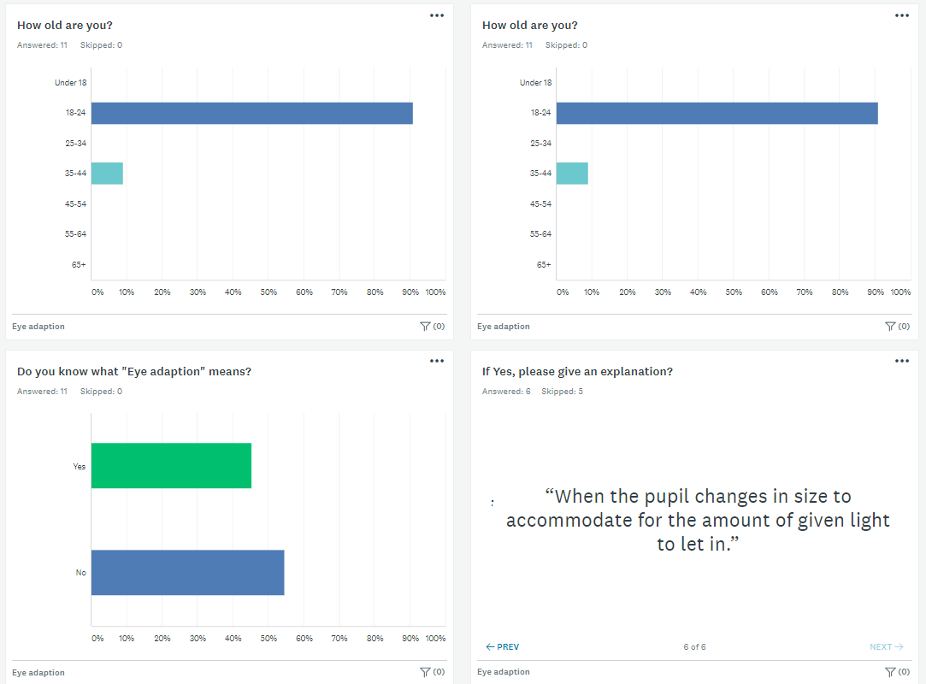

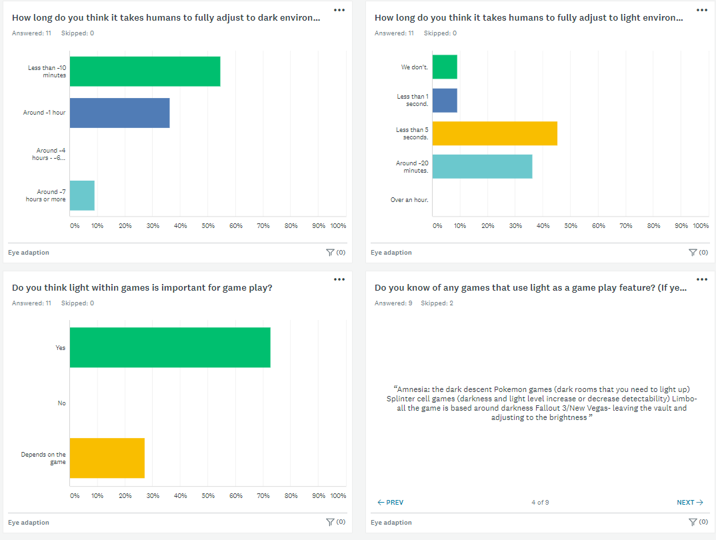

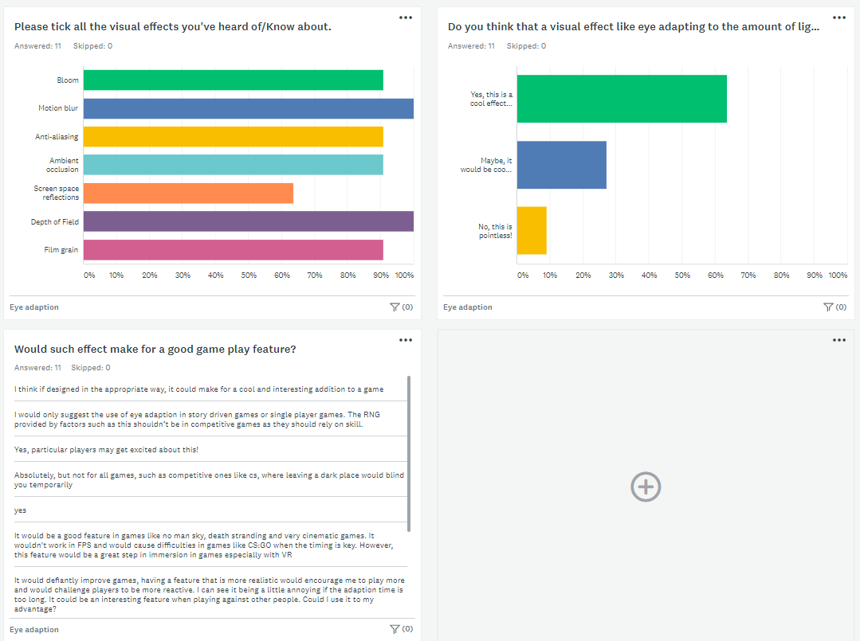
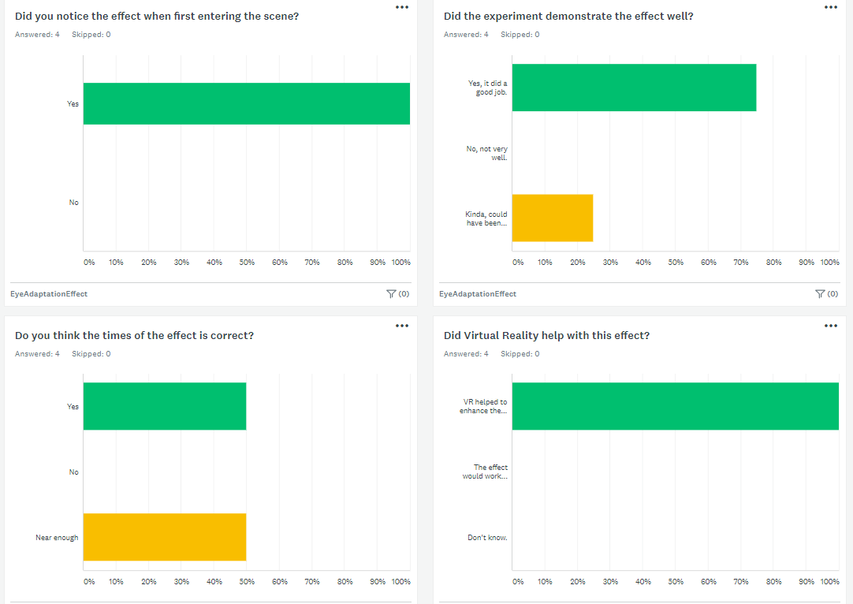
Lab Experiment Survey Results
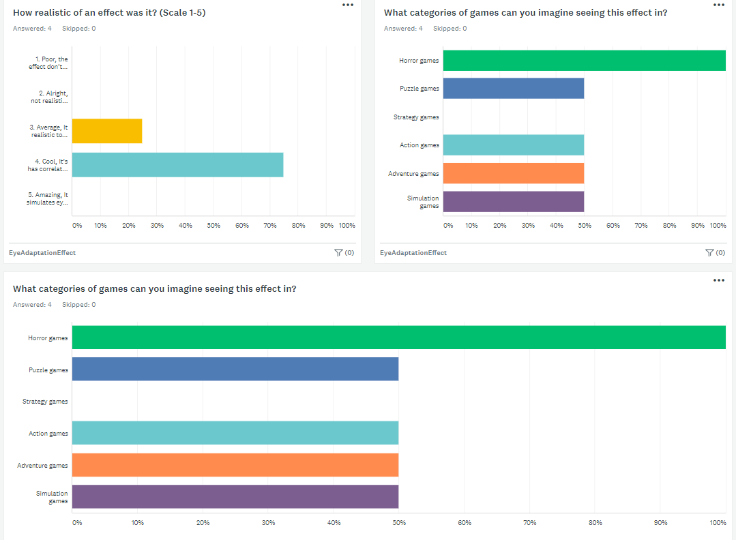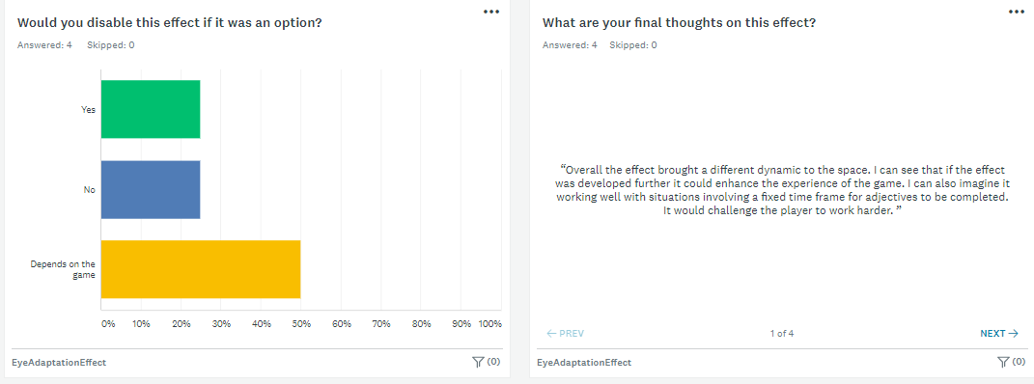

IrisResponse.cs

using System.Collections;
using System.Collections.Generic;
using UnityEngine;

//Used to see in realtime (Unity edit mode)
[ExecuteInEditMode]
public class IrisResponse : MonoBehaviour
{
//Create the shader
public Shader Shader;

public int initSampling = 256; //Set to 256 (8 x 16 = 256).
public float adaptationRate = 0.01f; //Changes Adaptation
public float Key = 0.5f, White = 0.5f, maxLimit = 0.02f; //Amount of light
public int luminanceGridSize = 1; //Set to 1 for full grid size

private Camera mainCam; //The Camera used for the effect.
private Material material; //The Shader Material

//Links into the shader(s) functions.
private const int PASS_MAIN = 0;
private const int PASS_DOWNSAMPLE = 1;
private const int PASS_UPDATE = 2;
private const int PASS_PREPARE = 3;

//Our Luminance render texture buffer.
private RenderTexture luminanceBuff;

void Start()
{
//Get the main Camera
mainCam = this.GetComponent<Camera>();
mainCam.depthTextureMode |= DepthTextureMode.DepthNormals;
//Create the Material w/shader attached.
material = new Material(Shader);
}

//Swaps the image effect from HDR to LDR mode.
[ImageEffectTransformsToLDR]
void OnRenderImage(RenderTexture rtSource, RenderTexture rtDestination)
{
//Set the render Tex format to AlphaRedGreenBlueFloat.
RenderTextureFormat renderTexFormat = RenderTextureFormat.ARGBFloat;

//luminanceBuffer = new texture the size of screen.
if (luminanceBuff == null)
{
luminanceBuff = new RenderTexture(luminanceGridSize, luminanceGridSize, 0, renderTexFormat, RenderTextureReadWrite.Default);
}

//Set currentTexture to get temporary texture.
RenderTexture currentTex = RenderTexture.GetTemporary(initSampling, initSampling, 0, renderTexFormat, RenderTextureReadWrite.Default);
Graphics.Blit(rtSource, currentTex, material, PASS_PREPARE);

int currentSize = initSampling;

while (currentSize > luminanceGridSize)
{
RenderTexture next = RenderTexture.GetTemporary(currentSize / 2, currentSize / 2, 0, renderTexFormat, RenderTextureReadWrite.Default);

//call to shader's downsample function.
Graphics.Blit(currentTex, next, material, PASS_DOWNSAMPLE);

//Release the current temp tex
RenderTexture.ReleaseTemporary(currentTex);

//Progress through to downsample tex.
currentTex = next;
currentSize /= 2;
}

//Check if luminance Buffer is not created
if (!luminanceBuff.IsCreated())
{
Debug.Log("Luminance unable to create. Recreating!");

//Try to create again.
luminanceBuff.Create();
Graphics.Blit(currentTex, luminanceBuff);
}
else
{
//Call to the shaders float _EyeAdaptation
material.SetFloat("_EyeAdaptation", adaptationRate);

//Check if isEditor && if the application isn't playing (start effect)
if (Application.isEditor && !Application.isPlaying)
{
Graphics.Blit(currentTex, luminanceBuff);
}
else
{
//A call to shader's PASS_Update
Graphics.Blit(currentTex, luminanceBuff, material, PASS_UPDATE);
}
}

//Used to communicate with Shader's values.
material.SetTexture("_LuminanceTex", luminanceBuff);
material.SetFloat("_Key", Key);
material.SetFloat("_WhiteColor", White);
material.SetFloat("_Max", maxLimit);

//Copies source texture into dest render texture w/ shader.
Graphics.Blit(rtSource, rtDestination, material, PASS_MAIN);
//Graphics.Blit (luminanceBuff, destination);

//Release the current temp tex again.
RenderTexture.ReleaseTemporary(currentTex);
}
}

IrisResponse.shader

Shader "Custom/IrisResponse" {
Properties{
//Get the main Texture
_MainTex("Base colors (RGB)", 2D) = "white" {}
}
SubShader{
Tags { "RenderType" = "Opaque" }
//Set higher for better LOD (100-400)
LOD 200

CGINCLUDE
//Use fast precision & use target 3.0 features
#pragma fragmentoption ARB_precision_hint_fastest
#pragma target 3.0
#include "UnityCG.cginc"

//Textures going in and out of shader
sampler2D _MainTex;
float4 _MainTex_ST;
float4 _MainTex_TexelSize;

sampler2D _LuminanceTex;
float4 _LuminanceTex_ST;

float _EyeAdaptation;
float _Key, _WhiteColor, _Max;

struct v2f {
float4 pos : POSITION;
float2 uv : TEXCOORD0;
};

//Takes in the appdata_img for vertexs
v2f vert(appdata_img v)
{
v2f o;
o.pos = UnityObjectToClipPos(v.vertex);
o.uv = v.texcoord.xy;
return o;
}
ENDCG

//Main pass of CGPROGRAM here
Pass {
CGPROGRAM
#pragma vertex vert
#pragma fragment frag

//Taking in the tex2d cColor
float4 frag(v2f i) : COLOR
{
//half4 = half the size of float & size has slight difference depending on GPU.
half4 cColor = tex2D(_MainTex, i.uv);
float4 cLum = tex2D(_LuminanceTex, i.uv);
float lMin = exp(cLum.x);
float lMax = exp(cLum.y);
float lAvg = exp(cLum.z);

//Force for when player is in sheer darkness.
lAvg = max(lMax / 2, _Max);

float lum = max(0.000001, Luminance(cColor.rgb));

//Brightness correction to our _whitecolor
float scaled = _Key / lAvg * lum;
scaled *= (1 + scaled / _WhiteColor / _WhiteColor) / (1 + scaled);

return scaled * cColor;
}
ENDCG
}

//Downsample pass here
Pass {
CGPROGRAM
#pragma vertex vert
#pragma fragment fragDownSample

//This is where it compresses the picture for performance.
//DownSample the texture in order to do less calculations.
float4 fragDownSample(v2f i) : COLOR
{
//Verticies of the tex
float4 v1 = tex2D(_MainTex, i.uv + _MainTex_TexelSize.xy * float2(-1,-1));
float4 v2 = tex2D(_MainTex, i.uv + _MainTex_TexelSize.xy * float2(1,1));
float4 v3 = tex2D(_MainTex, i.uv + _MainTex_TexelSize.xy * float2(-1,1));
float4 v4 = tex2D(_MainTex, i.uv + _MainTex_TexelSize.xy * float2(1,-1));

//Get the minimum & maximum in order to get the mean.
float mn = min (min ( v1.x, v2.x), min ( v3.x, v4.x));
float mx = max (max ( v1.y, v2.y), max ( v3.y, v4.y));

//Get the average of the vertice's z by adding them then / by the number of them
//float avg = (v1.z + v2.z + v3.z + v4.z) / 4;

float avg = exp((log(v1.z) + log(v2.z) + log(v3.z) + log(v4.z)) / 4);

//return the min, max and average.
return float4(mn, mx, avg, 1);
}
ENDCG
}
//Update pass here
Pass {
Blend SrcAlpha OneMinusSrcAlpha
CGPROGRAM
#pragma vertex vert
#pragma fragment fragUpdate

float4 fragUpdate(v2f i) : COLOR
{
half2 cColor = tex2D(_MainTex, i.uv).xy;
//Return the cColour along with adaption rate
return half4(cColor.xyx, _EyeAdaptation);
}
ENDCG
}
//Prepare pass here
Pass {
CGPROGRAM
#pragma vertex vert
#pragma fragment fragPrepare

float4 fragPrepare(v2f i) : COLOR
{

float v = tex2D(_MainTex, i.uv);
float l = log(v + 0.001);

return half4(l, l, l, 1);
}
ENDCG
}
}
FallBack "Diffuse"
}

SceneSetup.cs
using System.Collections;
using System.Collections.Generic;
using UnityEngine;

public class SceneSetUpManager : MonoBehaviour
{
[SerializeField]
private GameObject duck;
[SerializeField]
private GameObject[] objects;

private GameObject spotLight;
public Light pointLight;
private Transform dirLight;
public Timer timer;
public GameObject player;

public Vector3 center;
public Vector3 size;

public float coneCellIncrease = 0.02f;
public float rodCellIncrease = 0.002f;
bool coneCellActivated;
bool rodCellActivated;

public bool dirLightActive;
public bool pointLightActive;

// Start is called before the first frame update
void Start()
{
StartCoroutine(findObjects());
spotLight = GameObject.Find("Spot Light");

player = GameObject.FindGameObjectWithTag("Player");
player.GetComponent<OVRPlayerController>().enabled = false;

timer = this.GetComponent<Timer>();

if (dirLightActive)
dirLight = GameObject.Find("Directional Light").GetComponent<Transform>();
else
dirLight.gameObject.SetActive(false);
if (pointLightActive)
pointLight = GameObject.Find("Point Light").GetComponent<Light>();
else
pointLight.gameObject.SetActive(false);

coneCellActivated = false;
rodCellActivated = false;
}

// Update is called once per frame
void Update()
{
if (pointLightActive)
PointLightSetup();
if (dirLightActive)
DirectionLightSetup();
}

IEnumerator findObjects()
{
//Print the time of when the function is first called.
Debug.Log("Started Coroutine at timestamp : " + Time.time);

//yield on a new YieldInstruction that waits for 5 seconds.
yield return new WaitForSeconds(5);
if (pointLightActive)
pointLight.range = 0.0f;

sceneSetUp();

//After we have waited 5 seconds print the time again.
Debug.Log("Finished Coroutine at timestamp : " + Time.time);
}

private void sceneSetUp()
{
//Setting up the scene
//Spawn Objects for player to find.
//Start timer.
//Start the lighting effect.

spawnObjects();
Destroy(duck);

timer.startTimer(timer.timeStart);
player.GetComponent<OVRPlayerController>().enabled = true;

//spotLight.SetActive(false);
if (dirLightActive)
dirLight.GetComponent<Light>().intensity = 0.01f;

coneCellActivated = true;
}

private void spawnObjects()
{
for (int i = 0; i < objects.Length; i++)
{
Vector3 pos = center + new Vector3(Random.Range(-size.x / 2, size.x / 2), Random.Range(-size.y / 2, size.y / 2), Random.Range(-size.z / 2, size.z / 2));
Instantiate(objects[i], pos, Quaternion.identity);
}
}

//Shows the box for where object(s) spawn.
private void OnDrawGizmosSelected()
{
Gizmos.color = new Color(1.0f, 0.0f, 0.5f);
Gizmos.DrawCube(center, size);
}

//If you was using the point light method
public void PointLightSetup()
{
if (coneCellActivated)
pointLight.range += coneCellIncrease * Time.deltaTime;
if (pointLight.range > 10.0f)
coneCellActivated = false;
rodCellActivated = true;
if (rodCellActivated)
pointLight.range += rodCellIncrease * Time.deltaTime;
}

//If you was using the dir light method
public void DirectionLightSetup()
{
if (coneCellActivated)
{
dirLight.GetComponent<Light>().intensity += coneCellIncrease * Time.deltaTime;
dirLight.GetComponent<Transform>().Rotate(+0.001f, 0f, 0f);
}
if (dirLight.GetComponent<Light>().intensity == 0.1)
rodCellActivated = true;
if (rodCellActivated)
dirLight.GetComponent<Light>().intensity += rodCellIncrease * Time.deltaTime;
dirLight.GetComponent<Transform>().Rotate(+0.002f, 0f, 0f);
}

}

HumanAdatption.cs
using System.Collections;
using System.Collections.Generic;
using UnityEngine;

//Used to see in realtime (Unity edit mode)
[ExecuteInEditMode]
public class HumanAdaption : MonoBehaviour
{
//Create the shader
public Shader Shader;

public int initSampling = 256; //Set to 256 (8 x 16 = 256).
public float adaptationRate = 0.01f; //Changes Adaptation
public float Key = 0.5f, White = 0.5f, maxLimit = 0.02f; //Amount of light
public int luminanceGridSize = 1; //Set to 1 for full grid size

private Camera mainCam; //The Camera used for the effect.
private Material material; //The Shader Material

//Links into the shader(s) functions.
private const int PASS_MAIN = 0;
private const int PASS_DOWNSAMPLE = 1;
private const int PASS_UPDATE = 2;
private const int PASS_PREPARE = 3;

//Our Luminance render texture buffer.
private RenderTexture luminanceBuff;

void Start()
{
//Get the main Camera
mainCam = this.GetComponent<Camera>();
mainCam.depthTextureMode |= DepthTextureMode.DepthNormals;
//Create the Material w/shader attached.
material = new Material(Shader);
}

//Swaps the image effect from HDR to LDR mode.
[ImageEffectTransformsToLDR]
void OnRenderImage(RenderTexture rtSource, RenderTexture rtDestination)
{
//Set the render Tex format to AlphaRedGreenBlueFloat.
RenderTextureFormat renderTexFormat = RenderTextureFormat.ARGBFloat;

//luminanceBuffer = new texture the size of screen.
if (luminanceBuff == null)
{
luminanceBuff = new RenderTexture(luminanceGridSize, luminanceGridSize, 0, renderTexFormat, RenderTextureReadWrite.Default);
}

//Set currentTexture to get temporary texture.
RenderTexture currentTex = RenderTexture.GetTemporary(initSampling, initSampling, 0, renderTexFormat, RenderTextureReadWrite.Default);
Graphics.Blit(rtSource, currentTex, material, PASS_PREPARE);

int currentSize = initSampling;

while (currentSize > luminanceGridSize)
{
RenderTexture next = RenderTexture.GetTemporary(currentSize / 2, currentSize / 2, 0, renderTexFormat, RenderTextureReadWrite.Default);

//call to shader's downsample function.
Graphics.Blit(currentTex, next, material, PASS_DOWNSAMPLE);

//Release the current temp tex
RenderTexture.ReleaseTemporary(currentTex);

//Progress through to downsample tex.
currentTex = next;
currentSize /= 2;
}

//Check if luminance Buffer is not created
if (!luminanceBuff.IsCreated())
{
Debug.Log("Luminance unable to create. Recreating!");

//Try to create again.
luminanceBuff.Create();
Graphics.Blit(currentTex, luminanceBuff);
}
else
{
//Call to the shaders float _EyeAdaptation
material.SetFloat("_EyeAdaptation", adaptationRate);

//Check if isEditor && if the application isn't playing (start effect)
if (Application.isEditor && !Application.isPlaying)
{
Graphics.Blit(currentTex, luminanceBuff);
}
else
{
//A call to shader's PASS_Update
Graphics.Blit(currentTex, luminanceBuff, material, PASS_UPDATE);
}
}

//Used to communicate with Shader's values.
material.SetTexture("_LuminanceTex", luminanceBuff);
material.SetFloat("_Key", Key); //Used for brightness of the scene.
material.SetFloat("_WhiteColor", White); //Set what the texture considers white.
material.SetFloat("_Max", maxLimit); //Changes the sensitivity of eye.

//Copies source texture into dest render texture w/ shader.
Graphics.Blit(rtSource, rtDestination, material, PASS_MAIN);
//Graphics.Blit (luminanceBuff, destination);

//Release the current temp tex again.
RenderTexture.ReleaseTemporary(currentTex);
}
}

Timer.cs
using System.Collections;
using System.Collections.Generic;
using UnityEngine;
using UnityEngine.UI;

public class Timer : MonoBehaviour
{

public float timeStart = 0.0f;
public bool stop = true;

private float minutes;
private float seconds;

[SerializeField]
private Text timerText;

private void Start()
{

}

public void startTimer(float from)
{

stop = false;
timeStart = from;
Update();
StartCoroutine(updateCoroutine());

}

void Update()
{
if (stop) return;
timeStart += Time.deltaTime;

minutes = Mathf.Floor(timeStart / 60);
seconds = timeStart % 60;
if (seconds > 59) seconds = 0;

}

private IEnumerator updateCoroutine()
{
while (!stop)
{
timerText.text = string.Format("{0:0}:{1:00}", minutes, seconds);
yield return new WaitForSeconds(0.2f);
}
}
}

RenderTexture.cs
using System.Collections;
using System.Collections.Generic;
using UnityEngine;

public class RenderTextureLight : MonoBehaviour
{
//Our Render texture used to get pixel(s).
public RenderTexture lightCheckTexture;
public float lightLevel; //Calculate the level of light.
public int _light; //Used to round the light level down.

void Update()
{
//Create a new render texture.
RenderTexture bufferTexture = RenderTexture.GetTemporary(lightCheckTexture.width,
lightCheckTexture.height, 0, RenderTextureFormat.Default, RenderTextureReadWrite.Linear);
Graphics.Blit(lightCheckTexture, bufferTexture);

//Set previous render texture.
RenderTexture previous = RenderTexture.active;
RenderTexture.active = bufferTexture;

//Create texture2d.
Texture2D buffer2DTexture = new Texture2D(lightCheckTexture.width, lightCheckTexture.height);
buffer2DTexture.ReadPixels(new Rect(0, 0, bufferTexture.width, bufferTexture.height), 0, 0);
buffer2DTexture.Apply();

//Realease and return.
RenderTexture.active = previous;
RenderTexture.ReleaseTemporary(bufferTexture);

//Get the pixels and delete (Stops memory leak).
Color32[] colors = buffer2DTexture.GetPixels32();
Destroy(buffer2DTexture);

//Init lightLevel to 0
lightLevel = 0;

//Loop through the colors to get the light level
for (int i = 0; i < colors.Length; i++)
{
lightLevel += (0.2126f * colors[i].r) + (0.7152f * colors[i].g) + (0.0722f * colors[i].b);
}

//Get the value as close to 0.
lightLevel -= 259330;
lightLevel = lightLevel / colors.Length;

//Round it down to an int.
_light = Mathf.RoundToInt(lightLevel);

Debug.Log("Light level: " + lightLevel);

}
}

RayCastLightDetection.Cs
using System.Collections;
using System.Collections.Generic;
using UnityEngine;
using UnityEngine.UI;

[ExecuteInEditMode]
public class RayCastLightDetection : MonoBehaviour
{
public GameObject spotLight;
public GameObject player;
public float range;
public Text text;

void Start()
{
spotLight = GameObject.Find("Spot Light");
player = GameObject.FindGameObjectWithTag("Player");
}

void Update()
{
RaycastHit hit;

Ray playerUnderLight = new Ray(transform.position, Vector3.down);

Debug.DrawRay(transform.position, Vector3.down * range);

if (Physics.Raycast(playerUnderLight, out hit, range))
{
if (hit.collider.tag == "Player")
{
spotLight.GetComponent<Light>().intensity = 6f;

Debug.Log("Player under Light!");

text.text = "Player under light!";
text.color = new Color(1, 1, 1);
}
else
{
spotLight.GetComponent<Light>().intensity = 2f;

Debug.Log("Player out of light!");

text.text = "Player not in light!";
text.color = new Color(0, 0, 0);
}
}

}
}

CollectDuck.cs

using System.Collections;
using System.Collections.Generic;
using UnityEngine;

public class CollectDuck : MonoBehaviour
{
public Timer timer;

private void Start()
{
timer = GameObject.FindGameObjectWithTag("GameController").GetComponent<Timer>();
}

void OnTriggerEnter(Collider other)
{
if (other.gameObject.CompareTag("UglyDuck") && (OVRInput.GetDown(OVRInput.Button.PrimaryHandTrigger, OVRInput.Controller.LTouch) || (OVRInput.GetDown(OVRInput.Button.SecondaryHandTrigger, OVRInput.Controller.RTouch))))
{

Debug.Log("You found the Ugly Duck!");
other.gameObject.SetActive(false);
//EndExperiement();
timer.stop = true;
}
}
}

