

Developing Workplace and Critical Thinking
BMSK5101

Student: Irina Merlan
Student number: 1818268
Lecture name: Yajesh Kumar

Table of content:
1 Introduction...................................................................................................
1.1 Company Background.............................................................................
1.2 Critical Thinking Concept and Importance
2.2Organisation Value Systems (Edgar Schein) and Workplace behaviour............
2.2 Organisation Structure ……….……………………………………………………………….
2.3 COVID 19 Impact................................................................................
2.4 Creative Thinking – A Tool in Workplace Communication.......................
3. Management Theories
4. Methods and Models Red Model, De Bono’s six thinking hats
5. SWOT Analysis,
6. PESTLE
Benner’s Novice to Expert Theory etc. (Workplace + Covid 19)
8. Recommendations
9. Conclusion
10. References

Abstract
“It’s our associates who bring our business to life, and we aim to support them by making TJX Europe a terrific place to work”


Image 1: Originally taken by me
TkMaxx Store in Westfield-Stratford City

’’We take great pride in our culture at TJX Europe. As our business has grown, maintaining our culture has been key to our success. In fact, you’ll find we talk about it quite a lot!We strive for a workplace where our Associates feel welcomed when they walk in the door, valued for their contributions, skills, and experience, and engaged with our mission to provide value to our customers.’’
Executive Summary
This assignment is an individual report which contains different details about the chosen organization and it is evaluated in a critical thinking way it’s developing stage and also the culture of the organization, especially during Covid19 period of time. The chosen organization is TKMaxx and I choose a specific store which is located in London in Westfield-Stratford City. I have included the background of the company followed by the importance of the concept of critical thinking and also the importance of it. After that I have identified the organizational values, structure and the workplace behaviour. Also I have applied all the theories related to developing workplace and critical thinking and also in which way affects the beliefs, attitudes and values systems the workplace behaviour of TkMaxx.
An important step was the next one which was to analyse the impact of Covid19 for the business and which are the positive and negative aspects of it. After that, I have analysed an important tool in the workplace communication which is named creative thinking. Also I have includes management theories, methods and models such as… I made a SWOT Analysis for the organisation and PEST. A model of creative thinking is DeBono, Alfaro Lefevre 4 and many others. At the end, I made investigations for the organizations developing workplace and critical thinking and found some recommendations. Also I added some conclusions and references regarfing the content of the individual report.
- Company background
TK Maxx is the name of the organization that I choose to critically evaluate. TK Maxx store is one of the most popular off-price retailer from Europe. The store is part of the Massachusetts based TJK inc. Group of companies. The first store its opened in Bristol in 1994. In the present there are over 260 TK Maxx stores across the UK mostly but also in Poland, Germany and Ireland. TK Maxx is still a relative new concept because every item from TK Maxx is different. Also this concept is unique and has no direct competitors because of this.
The business model success of TK Maxx lies in offering greater designer labels for up to 60 percent less. TK Maxx talented buyers negotiate fantastic deals from a huge number of suppliers all the way through the season, scouring the fashion and style markets across the world to seize buying opportunities whenever they find them. The relationship with those labels and designer is critical.
The“off-price” retailing method was introduced to the UK from the United States in 1994. TK Maxx is still the only fashion off-price retailer in Europe because it collabs with designers in a modern but simple way, our stores deliver a SMART shopping experience for our customers. TK Maxx is the tenth biggest design store in the UK. (Source: TNS Fashion Tracker)
T. K. Maxx is the fourth most loved retailer in the UK, the third most loved attire retailer and shoe store in the UK for 2009. (Source: Verdit Retail Group). TK Maxx has over 500 employees in its home office with more than 10,000 people who are employed throughout the UK and Ireland in the TK Maxx stores and distribution centres. European expansion continued in 2015 with TK Maxx stores opening in both Austria and the Netherlands. In 2017 Home Sense opened its doors to Ireland and we expect to expand in many more countries from Europe. As a progressive, fast-paced business high energy is the symbol of our working ethos. The company describes their company as being polite, accessible and friendly. Likewise, our people share a real passion for fashion and are enthusiastic, make the most of opportunities, are passionate and determined to succeed. Eve if the TK Maxx stores are best known for selling fashion items, don’t forget that our stores sell fabulous accessories like bags, shoes, belts, beauty products, luggage, toys, pets items and home ware such as home accessories or products. TK Maxx value diversity, encouraging different vies, backgrounds and origin and the company is constantly searching diverse ways in which TK Maxx can make a difference to people’s lives and to make it easier. TK Maxx also raises money for charities – NCH, Enable Ireland, Cancer Research and Comic Relief.

2. Critical Thinking Concept and Creative Thinking Tool
CT comes from Critical Thinking and it means everything which stands for beliefs, emotions,trust,values and the attitudes of the people and the organizations which is analysed. According to Ennis (1996), critical thinking is a reasonable reflective thinking focused on deciding whatto believe or to do. The accentuation is on sensibility, reflection, and the way toward deciding". As per him, the meaning of the basic reasoning hypothesis identifies with the idea of basic reasoning disposition that incorporates: an obligation to keep to common implications contrasted with researchers' advantage to produce new understandings for existing maxims;the distinction among airs and capacities;concealed highlights ;relationship to inclinations, weaknesses, abilities.
Additionally, another author named Facione(2000) states that skill in CT is empathically connected to the compatible internal motivating force to contemplate and that CT abilities tone with CT temperament. Even if the assertions of the two creators appear to be antiquated, they remain actual nowadays.
McGregor(2007) states that „Thinking critically is the mental actof reviewing, evaluating or appraising something(including a picture, play, information, evidence oropinion) in an attempt tomake judgements, inferences or meaning about that something in arational reasoned way. ”
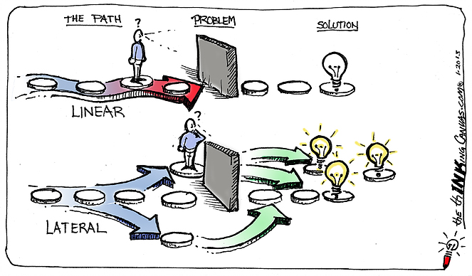
Image 2. The thinking CANVAS-com(2015)
An example of CT that TK Maxx is using is lateral thinking. This term appeared first in the book written by Edward de Bono which is named The Use of Lateral Thinking. This book was published in 1971. The author defines the term lateral thinking as ”methods of thinking concerned with changing concepts and perceptions. ” Also he stated that is all about reasoning which may not be obvious at first and about the ideas which are obtained in a different way, not by using only the traditional step-by-steplogic.
2.1. The Value System of TK Maxx and the impact on the workplace behaviour
To help TJX's future development, we are ceaselessly searching for energetic and submitted people from a wide scope of foundations and encounters to join our group. We accept that the variety of our Associates makes us a more grounded Company and better ready to serve our clients around the globe. We additionally accept that establishing a comprehensive climate wherein Associates are locked in and enabled fortifies our business and cultivates a culture where Associates are roused to buckle down, challenge themselves, and be creative in their reasoning. At TJX, consideration and variety are both imperative to us. We empower organizations among pioneers, chiefs, and Associates so all Associates feel welcome in the Company, esteemed for their commitments, and drew in with our business mission.
Our cultural factor is that value that make us what our personality is. TJX is an empowering working climate and we rely upon our accessories to reestablish our association. Keeping up our assessments of dependability, decency and treating others with satisfaction and respect is our need - through all that we do.

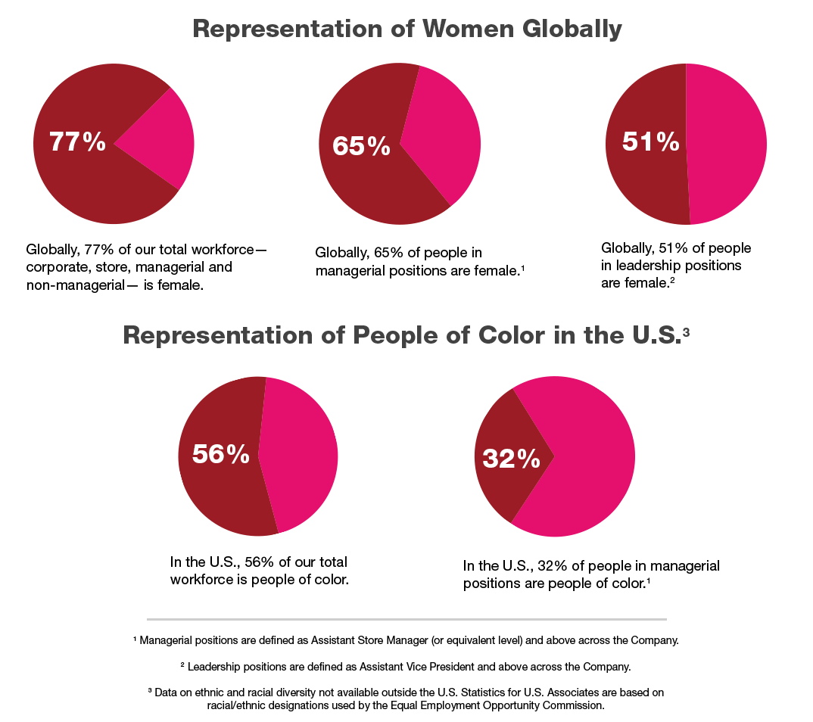
Image 3. TkMaxx Database

INCLUSION AND DIVERSITY
We are centered around a complete workplace where the responsibilities of our various affiliations add to our thriving. We empower a culture where people feel spurred to lock in, challenge themselves and think energetically and create. Whoever you are, any spot you come from, you will find that TJX Europe is certainly not a thing clearly.
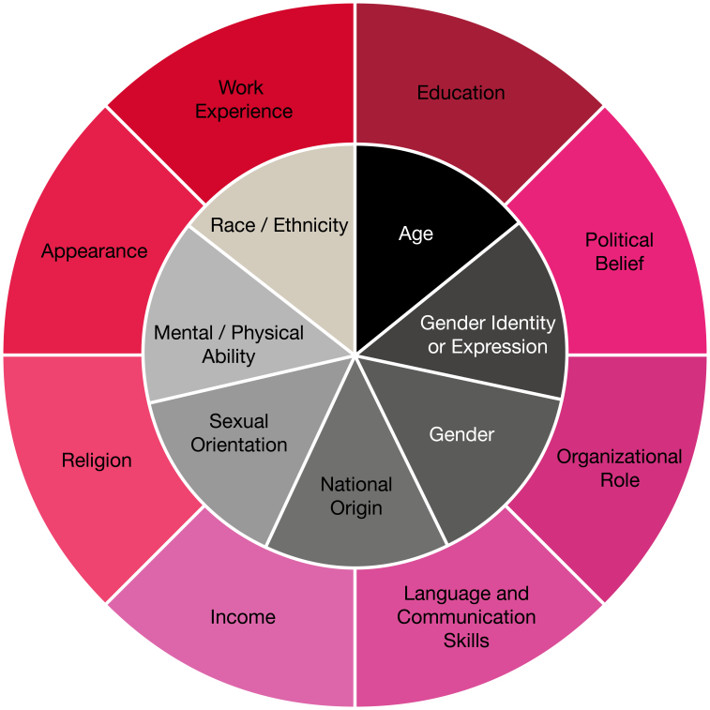
Image 4. Diversity at TkMaxx
OUR PHILOSOPHY OPENS THE DOOR: YOU HAVE A VOICE
Having a thorough work environment reinforces our continued with progress. Right when everyone feels great running their fascinating perspectives, ends and capacities, we get new and innovative musings that we can use to deal with issues and find new possibilities. We acknowledge that all of our agents conveys something intriguing to our total culture: a grouping of experiences, sex, ethnicity, age, viewpoint and generously more. At TJX, assortment isn't something we record on a plan, anyway something we are satisfied with and celebrate.
HOW WE WORK
LEARNING AND DEVELOPMENT
We are focused on giving the instruments and backing important to engage our accomplices to arrive at their maximum capacity. Our extraordinary learning experience starts with incredible usage. It at that point proceeds with a progression of courses, preparing programs and continuous tasks, all intended to help you assume liability rapidly.

OUR QUALITY
We energize a sound work-life offset with admittance to a wellness place, palliative consideration community and occasions to take an interest in social and altruistic exercises. Above all, you will be submerged in a fun, quick and pragmatic business climate.
PEOPLE DO NOT JUST WORK HERE, THEY STAY HERE
It is significant for us to draw in eager and skilled people, show them the fundamentals of our outside plan of action and backing their expert development. We accept that this urges individuals to go along with us, for function as well as to assemble professions.
The regions that make troubles are those where proficiency can't meet the 100% rules.
2.2 Figure 1. TK Maxx company organisational structure

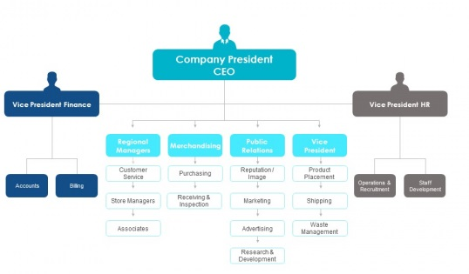
The organization structure is presented in the upper picture. For example, me as an employer at Tk Maxx I can fiind myself in the organigram as an associate who have a store manager and also knows the regional manager. I wish to be a store manager but I need more experience and to gain more skills and to develop more the ones that I have and also the knowledge.
2.3. SWOT ANALYSIS OF THE BUSINESS
Strengths -A moderate cost and a quality item are the interest of the biggest number of clients and the TK Maxx has the positive effect of clients. TK Maxx covers a wide scope of ventures and individuals have not many choices yet purchase new garments and different extras they decide for TK Maxx. The decrease in the expense of items in the course of the most recent decade has driven purchasers to purchase items more frequently than before. Retail showcasing in the UK has a solid custom in style and plan. T. K Maxx was likewise included.
Weaknesses- Sales are occasional, costly things like coats, party garments and different presents are basically required during the Christmas season. Numerous huge retailers convey set up attire and it is hard to contend in new TK Maxx stores. The downturn additionally set off a value war that further disintegrated net revenues.
Opportunities-The T. K Maxx chain, which offers generally modest merchandise, should perform well during the downturn. UK inhabitants keep on saving on dress than Europeans on the grounds that there is proceeded with development potential in the general market. Men save on garments than ladies. also, there is occasion to urge men to be more intrigued by style.
T. K Maxx offers the quality item at a limited value that turns into a possibility for those with low earnings. Thusly, it is anything but difficult to get clients to change their purchasing conduct because of the uncommon attributes of the items. An item with uncommon highlights showed in suitable spots can pull in the consideration of clients and result in their buying choice.
Threats-Growth in the retail market gives little indication of a stoppage in the business because of expanded rivalry. So the client's alternatives may diminish.
The fall in the estimation of the pound can prompt the expense of the TK Maxx retail market additionally on the grounds that imported dress and different adornments will build, which may bring about lower deals volumes. A delayed and profound downturn can change shopping propensities over the long haul with another accentuation on saving. Customers can scale back to spend more cash on attire and different zones of utilization. The development in modest creation and expanded rivalry can influence the general business.
3.4. PESTLE Analysis External components impact the corporate area. Outside elements that impact movement are managed in the PESTLE examination. PESTLE represents political, monetary, social, mechanical, legitimate and natural elements.
1. Political elements: Politics is the craftsmanship and study of government. Government arrangements directly affect business. Similarly, T. K Maxx is influenced by monetary arrangement, exchange limitations, political strength, customs limitations, and so on
2. Financial elements: The worldwide downturn and monetary plunge have diminished deals of retail items and other home adornments. The vast majority are as of now jobless. The joblessness rate was unaltered for the quarter from October to December 2009 at 7. 8%. The quantity of jobless fell 3,000 in the quarter to 2. 46 million. The quantity of jobless for over a year rose 37,000 for the quarter to 663,000, the most significant level in the three months finished September 1997.
The quantity of individuals guaranteeing joblessness benefits (the quantity of occupation searchers) expanded by 23,500 to 1. 64 million between December 2009 and January 2010, the most noteworthy since April 1997. This expansion in month to month request was gone before by two continuous month to month diminishes . (Source: Office for National Statistics) Rising joblessness is affecting the economy. This likewise applies to the organization T. K Maxx. T. K Maxx dominated in offering to everybody and subsequently offers a scope of items and administrations going from an incentive to the best costs, hence pulling in all portions of the market.
3. Social components: Society and culture are significant elements that all organizations should underline. Today, the vast majority go refined and wild about chic garments and shoes. T. K Maxx offers these in vogue garments and shoes at reasonable costs. Clients additionally positively affect the item nature of T. K Maxx Company.
4. Innovative elements: Technology offers organizations another approach to speak with buyers. Innovation can decrease costs and improve item quality, web based shopping, online gift voucher rivalry, facebook T. K Maxx fan, CCTV recording for security reasons, and so forth are instances of innovation utilized in T. K Maxx. Clients can choose and arrange items from the closest T. K Maxx store of their decision utilizing a specialized instrument.
5. Ecological Factors: To keep the climate perfect and clean in each T. K Maxx store, the cleaners are provided by the UK Initial Company. The new business offers cleaners preparing in waste cleaning and reusing
6. Legal Factors: as far as possible, the expansion in the lowest pay permitted by law, the different work laws for representatives (understudy 20/10 hours, full-time worker 40 hours) are instances of late laws influencing organizations. Changes in business strategy, wellbeing and security, item security are legitimate variables.
3. Management Theories
As indicated by Peek (2020), Taylor's logical hypothesis in the working environment regarded individuals as machines that should work in unhuman conditions. Look (2020), is bound to follow Elton Mayo's Human Relation Theorywhich builds up the conduct of individuals in gatherings and which at last discovers that people like to work cooperatively in groups to develop, create and be more productive, both themselves and the consequence of the work itself. A human connection based organizationmust ask its directors, notwithstanding an entire rundown of abilities, for 5 significant aptitudes, for example, correspondence, tackling clashes, performing multiple tasks, bargain (give-and-take) and exceptionally coordinated (discipline). Individuals reward, individuals inspiration and significance of human relations in the associations arecomprised in this theory.Abraham Maslow shows how persuasive hypothesis attaches with human relations. TK Max shows for 2 years in retail that base up way to deal with administrative hypotheses and the deep rooted connections assemble the business maintainability. Recommending that the 5 fundamental human requirements (physiological, safety,belonging, regard and self-acknowledgment) are fulfilled. Douglas McGregor underpins inspirational requirements concurring that workers are probably going to be more productive on the off chance that they are valued(Bridgman, Cummings, and Ballard, 2019). Bruce Tuckman nonstop with the 4 phases model of group development which are forming, stormig, norming and performing (Nestor, 2013.
The essential assertion of Contingency Theory is that there is no single most ideal approach to lead a business(Flinsch-Rodriguez,2010).It goes on the possibility that it is important to dissect all the interior and outer elements that apply a specific effect on the improvement of the business movement and relying upon them to figure a reasonable method.
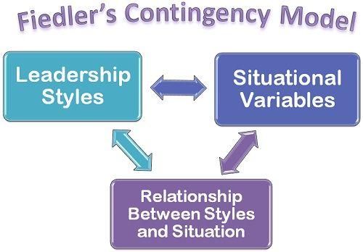
Figure 2. Contingency Model
Fiedler's Contingency Theory interface it straightforwardly to the pioneer and the changesdepending on conditions, circumstances or emergency. He thinks about that the director should know that in specific circumstances he should know and move toward a specific administration style that will prompt the accomplishment of the organization's goals.The fundamental component in his hypothesis is LPC scale – the most un-favored associate, that gauges the pioneer's inclination:task-situated or relationship-arranged. The three qualities it leads by are: the way all around observed and acknowledged the pioneer is by representatives; how itemized the business' position is depicted; what authority does the pioneer have in the position he holds inside the association. The association climate thought about comprises of association's size, innovation being used, initiative style, how the association conform to methodology changings. An alternate course of action is bound to be utilized by the public authority when it needs to tackle earnestly a financial crisis(Princewill,2015).
For, instance Covid-19 pandemic circumstance required dire insurance measures, so the public authority issuedstrict guidelines, for example, lockdown, face masks, hand sanitizers, social-separating and distancing(GOV.UK, 2020).
4. Critical Thinking Models and methods taken during Coronavirus and post-Covid 19
The pandemic situation and its global impact of coronavirus had many influences mostly negative for all the people and every aspects around the world. The rate of poverty has raised, the number of deaths and also the living standars are goind down. It affected also the business in a Political Economical Social and Legal way. First, when the pandemic situation have starded all the TkMaxx Stores were closed, after 3 months they were opened for a short period of time and with less employees on a shit and with all the safety measuerements and to touch the standars of an open business in the CORONAVIRUS situatiosn. After many months of ups and downs in the last month of the year 2020 the security and prosperity of colleagues, clients and TkMaxx people group remains a need for the store. For that, TK Maxx took a series of security steps to assure the security and prosperity of the people and the business. Some of them are mentioned bellow:
• To improve buying wellbeing, we are broadening the opening times of some of our stores during the period of December. View the opening times of your neighborhood store here.
• All conveyance alternatives are accessible and Click and Collect is accessible in all open stores. Locate your nearby store here.
• To get familiar with the progressions we've made, we welcome you to peruse underneath.
• We have zeroed in on three key security territories as per the most recent government rules:
• Supporting our representatives' very own assurance rehearses
• Implementation of clear social distance measures
• Improved cleaning of our stores and online offices
• Supporting safe shopping in our stores
• We have actualized the accompanying security measures for the wellbeing of our clients and store workers
• Provision of individual defensive gear for the individuals who work in our focuses dispersion and usage of clear social distance measures
• We request that all clients wear a face veil when shopping in our shops, except if you are medicinally absolved
• Install security screens in our gems checkouts and counters, just as change the format of our shop to help keep a protected social distance
• Provide hand cleaning stations for all store workers and clients when you enter the store. Request contactless installment in the event that you can. The breaking point has been briefly expanded to £ 45 to make this simpler for our clients.
• Limiting the quantity of clients in the store and in our lifts whenever. This may imply that you need to stand by somewhat more, so we sympathetically request that you remain with us. • To help you shop securely, we are expanding the opening times of a portion of our stores during the period of December. Check your nearby store's opening times here
• Some of our stores may have to incidentally change their opening times. We suggest that you check the individual working hours of your nearby store on the store finder before your appearance.
• Temporary conclusion of all our storage spaces Support safe web based shopping - We have made changes in wellbeing following for the individuals who shop on the web
• Make individual defensive hardware accessible for those working in our dispersion places and actualize clear social distance gauges all over
• Apply contactless conveyance to help ensuring the security of our deliverers and you, our dear clients
• In request to work securely, conveyance times might be somewhat more than typical. Snap here for the most recent conveyance refreshes.
4.1. The RED Model
A CT model which was implemented by TK Maxx and many other businesses during the pandemic situation was the RED Model. This model is composed by 3 simple stages which are the keys to critical thinking.
These are: R for recognise assumptions, E for evaluate arguments and D for draf conclusions.
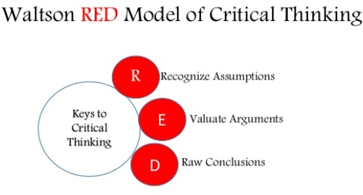
Figure 3. Red Model
An example of the RED Model is this one:
R- it is anything but difficult to tune in to an introduction or even a news broadcast on TV and accept it in that capacity. Be that as it may, questioning this data and making it look like presumptions will make the individual tirade about how right what others state boisterous and clear is.
E- this stage requires exact and target examination of the data, questioningthe proof and understanding the passionate effect on the given circumstance.
D-Choosing the sensible advocated and contended proof from the different data set up - implies having "great decisions" skills which can help with implementing the RED critical thinking model.
4.2. De Bono's Six Hats model
Another method used for CT is De Bono's Six Hats model which was presented in 188 by Edward de Bono as a role-playing model. Usually, this model is used for problem-solving as a team and leads to a brainstorming technique which is explained in the figure 4 which is represented bellow.
The main purpose of using this model of critical thinking is to explore any kind of issues and to discover ideas which can lead to obtain bold solutions that might be overlooked by the team members. It also uniforms all the perspectives which can be different and each of the perspective have one of the specific colours.
a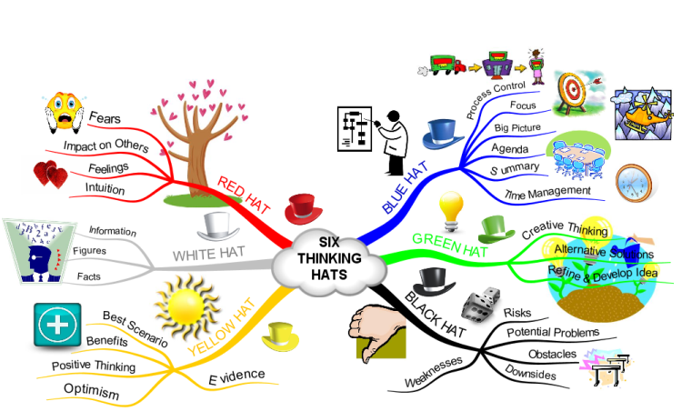
Figure 4. Six Thinking Hats brainstorming
This model specifically refers to a thing seen in different ways. Funny picture attached bellow:
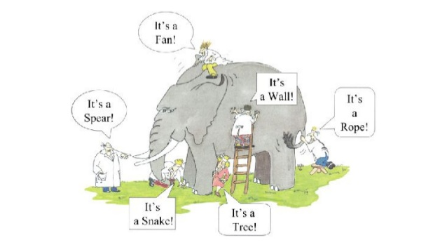
Figure 5. Six Thinking Hats- Blind Man Story
These ways are split in different colours, each of the colour having a meaning. These colours are white, black, red, yellow, green and blue and are explained bellow in the figure number 6.
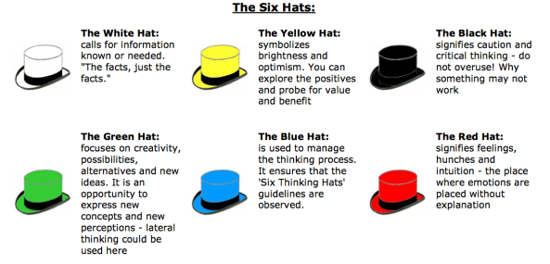
Figure 6.The six hats
An associate at TkMaxx if would see all the perspectives:
We are in a pandemic situation due to COVID-19 virus.
We are gonna get through this and everything will be fine soon.
If we are not going to respect all the sanitizing and distancing steps it is going to take forever to be well.
I can make it fun to wear a mask by decorating it and I will express my creativity.
I need to print all the information about the steps that needs to be taken during this lock-down process.
I feel overwhelmed, no, more than this, exhausted and sad that it’s taking fo-re-ver.
4.3.Benner’s Novice to Expert Theory
Benner's Novice to Expert Theory presents a methodical way of seeing how a student whether an understudy, new or prepared attendant creates aptitudes and comprehension of a training circumstance/occasion after some time. The hypothesis has been material to a wide assortment of circumstances, including nursing training, maintenance of graduate attendants, and nursing the board and organization. Benner's hypothesis was gotten from the Dreyfus Model of Skill Acquisition, and drew from information on designing and theory. Seeing that the hypothesis has been discovered to be pertinent for nursology, it tends to be viewed as a shared hypothesis.

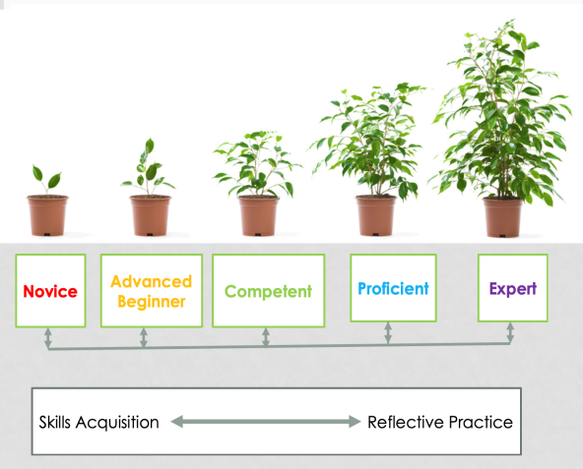
Figure 7. Benner’s Theory example

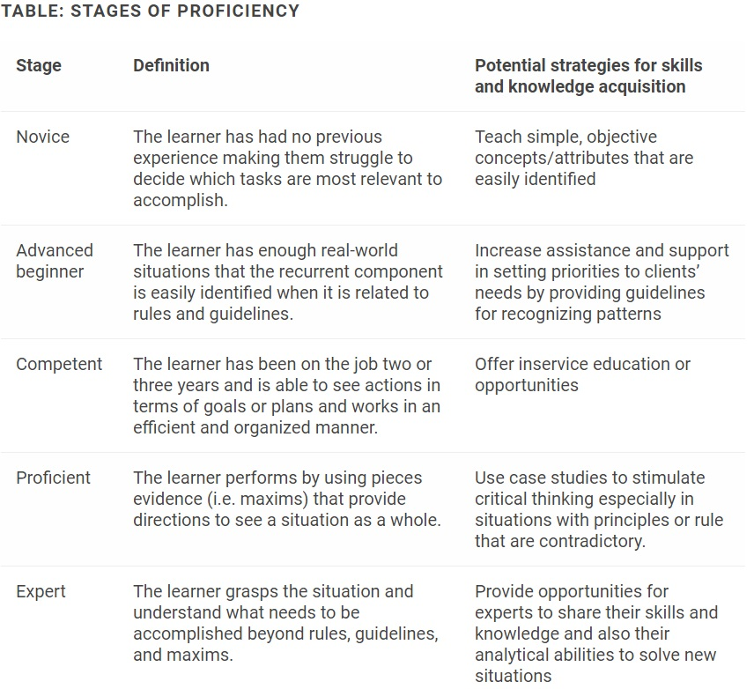

From where can an associate of TkMaxx searches information by stages:
- Novice- Socializing with another person about the Covid-19
- Advanced beginner- TV and Socializing
- Competent- Searching information about Covid-19 left-right at the colleagues from the workplace and the manager.
- Proficient- Searching and comparing informations on different articles on the internet and comparing different realistic situations which turned out differently from others during the pandemic.
- Expert- Informing himself from scientifical articles and official news and following the right steps to get through the pandemic easier and by taking care of his health and other people s health such as family, friends, co-workers, strangers.

5. Proposals
From the above investigation and end, I might want to make a few recommendations to improve the organization T. K Maxx.
An appropriate model for Changing the organization changed its regulatory ethos, utilizing the labor force in a perplexing way and saving the expenses of many locale executives. With the new announcing framework, an organization saves the administration time just as the rate and net working season of representatives of an organization. An organization changes the request for accessibility of an item to an accessible item in line with a head and furthermore changes the request for additives. The consequences of this change are cost-viability and viable correspondence of the executives to their workers.
To improve the quality control measure, a business needs to utilize great, experienced and proficient staff, as there is a market pattern nowadays that items are constantly sold for the sake of value, highlights, benefits and fantastic introduction. There is no requirement for adifferent lead trainer. An organization should give this obligation to a HRM office, by receiving a change, a business can save a spending plan.
An organization needs to dispatch a few motivators for representatives on the grounds that propelled in assorted types consistently persuades workers and these representatives are the foundation of a business.
Garments and merchandise should be completely investigated before the products are shipped off T. K Maxx stores, as they might be harmed or worn. 2. T. K Maxx stores are just situated in European nations and the United States. To build its business and give great client support, it is suggested that T. K Maxx stores additionally be opened in non-industrial nations.
To decrease the trusting that clients straight will pay for shares T. K Maxx needs to build the quantity of representatives be opened in non-industrial nations.
During the covid – 19 everybody needs to follow the steps which are recommended by official sources, at the workplace and in day-by-day life. For TkMaxx business during pandemic I would recommend focusing on online shopping and more advertising on the internet to promote the business and the products and online shopping is helping to reduce all the main causes that keeps this pandemic situation still in 2021.
Conclusion
For the businesses which survived until 2021 such as TkMaxx the important thing was to critically thinking and right tools for decision making and techniques to help run the business. The adaptability is another important fact and the best method was using all the methods and models for making it easier at work, for individuals, society. The critical thinking is an important tool which can help to create a sustainable management system which can face any new problems and to develop new ways to promote the TkMaxx Store.

BIBLIOGRAPHY
Cartwright, R. (2002) Mastering Marketing Management, Palgrave
Frain, J. (1999) Introduction to Marketing 4th edition, London: Thomson Business Press
http://www.tkmaxx.com 14 Feb 2010 at 00:35
http://www.tjx.com 17 Feb 2010 at 15:37
“About T.K Maxx”. T.K Maxx Retrieved 26 Feb 2010 20:26
Ennis, R., 1996. Critical Thinking Dispositions: Their Nature and Assessability. Informal Logic, [online] 18(2), pp.165 -182.
Facione, P., 2000. The Disposition Toward Critical Thinking: Its Character, Measurement, and Relationship to Critical Thinking Ski. Informal Logic, [online] 20(1), pp.61-84.
Frey, L.R. (2002). New directions in group communication. Sage
UKEssays. November 2018. T.K.Maxx Strategic Analysis. [online]. Available from: https://www.ukessays.com/essays/retail/tk-maxx-strategic-analysis.php?vref=1 [Accessed 14 December 2020].

