The Professional Practitioner.

Table of Contents:
Personal Development Plan - Pages 2 to 3
Reflective Brief Paper – Exploring Early Years – Page 4
The Importance of Professional Practice in Early Years – Page 5
References – Pages 6 to 7

Personal Development Plan
Objective | Actions (How will I achieve this objective/ what needs to be done?) | Resources (What support and resources are needed to achieve this objective?) | Target Date for achieving objective | Success criteria (How will I know I have achieved this goal, how will I review this?)
Complete Safeguarding Group A and B | I plan to do my Safeguarding Group A by completing an online course. To further improve my knowledge and in line with the Care Inspectorate Wales (CIW) requirements I will complete my Group B by attending a full day course. This will allow me to be up to date with all legalities and policy procedures. | A power point will be presented, filled with information on safeguarding – articles, and real-life scenarios will be discussed.  Group discussions, giving unbiased opinions on topics.  Access to links/websites and telephone numbers to relevant professional multi agencies. | November 2024. | Certification at the end of both Group A and B Safeguarding courses.
Complete First Aid course | I plan to complete my First Aid course by attending a training program in a local venue. I plan to do this so that I have a wealth of knowledge and the skill to be able to tackle a medical emergency in the event that I ever had to – giving not only myself peace of mind as I have children myself, but my workplace and parents of the children that are under my/our care. | A Power Point presentation.  Visual demonstartions and the opportunity to practise a medical emergency.  Access to books in the library or onlines research to better my knowledge and understanding of First Aid. | Next 3 months. | Wealth of knowledge on First Aid and completion of the training so that I am able to feel confident in the unfortunate event a Medical Emergency arrises.
Self-Confidence and Organisation | I plan to work on both my confidence and organisation skills as I believe these will give me my best chance at success. To work on my confidence, I will need to take on board feedback from my marked assignments and ask my lecturer for reassurance and guidance that I am on the correct path when writing academically, instead of second guessing myself. I plan to keep a diary and organise myself wisely to maintain a healthy working mentality and to keep on top of deadlines. | Reflect on feedback, taking on board things that I have done well and focusing on how I can improve myself academically each time.  Research – Giving myself the best opportunity of progressing whilst learning and enhancing knowledge so that I am confident in what I am trying to put across, ensuring I solidify my findings with references.  Purchase a diary so that I can create a timetable, prioritising what needs to be done first and eliminating as much stress from myself so that I can meet deadlines healthily. | 1 year | Self-reflection – look back at previous assignments and see how I have improved through each submission.  Speak to lecturer/employer for reassurance and a better understanding of where I am at, and how I could improve if needed.

Reflective Brief Paper.
Word Count: 1082
What is reflection and reflective practise?
According to Deakin University (2024) to be an effective practitioner, it is critical to be conscious of reflection. It is having the awareness that reflection alone is not reflective practise, and rather reflective practise is a process of thinking of an experience you have had, to be able to learn from that and to be able to impactfully change and prevent wrong doings for future events to be successful.
Why is reflective practice important to Early Years practice?
There are endless benefits in using reflective practice in an Early Years setting. As mentioned by Toole (2023) reflective practice in Early Years is important as it provides the ability to gain a better understanding of how children develop and learn from having reflected on your own interactions with them. Having formed these relationships with the children you can use your knowledge to implement better learning experiences and plan around them and their needs forming a professional practice and a healthy and beneficial environment for the children to develop in.

The theory of reflective practice:
According to (Infed.org, 1996-1999) Dewey says that reflection is ‘active, persistent, and careful consideration of any belief or supposed form of knowledge in the light of the grounds that support it and the further conclusions to which it tends’ (Dewey 1933 P.118). You can see on Wikipedia (2024 – last updated) Dewey set up 5 phases to reflective thinking – 1. Suggestions, 2. And intellectualization of the difficulty or perplexity that has been felt, 3. The use of one suggestion after another as a leading idea, or hypothesis, to initiate and guide observation and other operations in the collection of factual material, 4. The mental elaboration of the idea or supposition as an idea or supposition and lastly 5. Testing the hypothesis by overt or imaginative action.
According to (Nursinganswers.net, 2003-2024) Schön reflection is the ability that professionals should think what they are doing while they are doing it. It is the ability to think as you are doing it and use previous experiences to present conditions. Reflection in action is reflecting as something happens and reflection on action is the ability to reflect after something has happened.

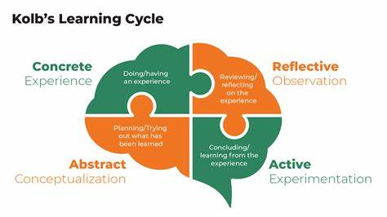
(Figure 1 - https://tse2.mm.bing.net/th?id=OIP.1hRRobKcaxDZ7KkCf2a9MAAAAA&rs=1&pid=ImgDetMain)
Explore Psychology (2024) shows that Kolb’s Learning model is made up of 4 stages –
Concrete experience, Reflective observations, abstract conceptualization and Active experimentation which emphasizes learning through experience.

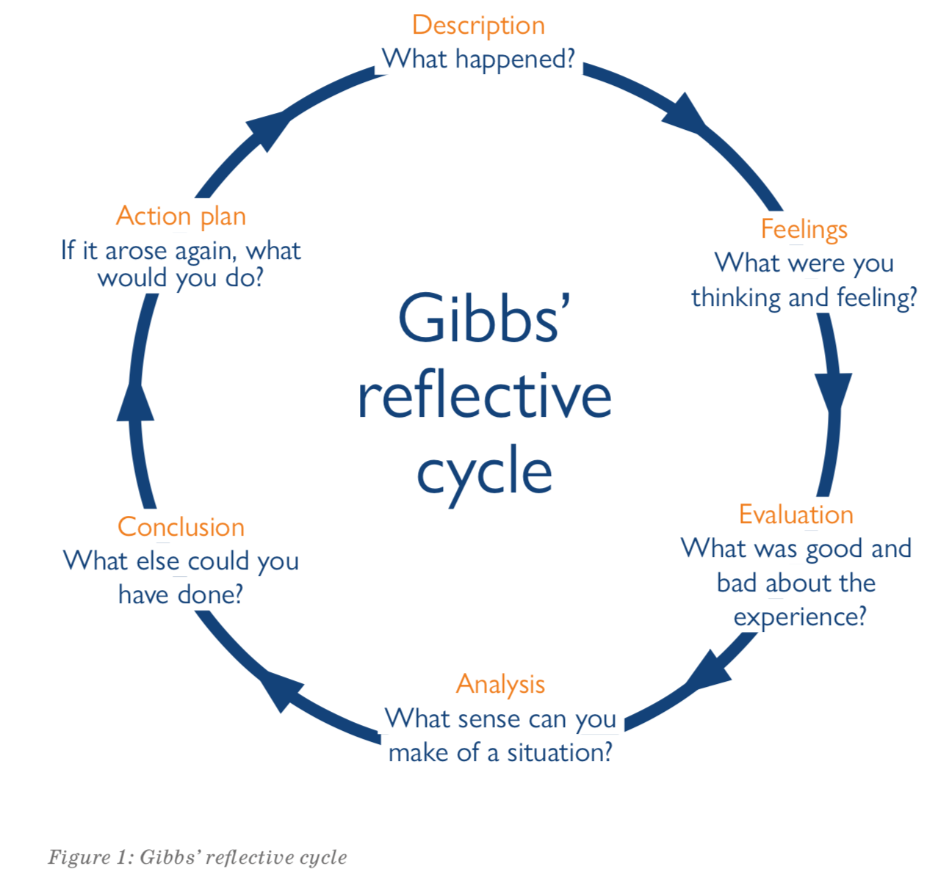
Figure 2-https://www.sor.org/getattachment/News/Students/Reflection-means-more-than-keeping-a-diary/gibbs-cycle.png
The University of Edinburgh (2020) says that Gibb’s reflection cycle is made up of 6
stages – Description, Feelings, Evaluation, Analysis, Conclusion and Action plan.

Analysis: According to (This vs. That, 2023) Kolb’s is described as a learning cycle, in reflection it is a model for experimental learning whilst Gibb’s is a reflective cycle meaning that it is a model for structures reflection on experiences. (StudyPrism, 2024) Kolb’s model of reflection is made up of 4 key stages. The first stage is Concrete Experience – this is the stage whereby the individual has experienced something for the first time. It is a stage where there is little understanding of a subject and growth of their knowledge begins. Mistakes may be made, and it is about figuring things out. Stage 2 – Reflective observations is the follow-on stage where you progress from your concrete experience and reflect, think about what happened, why it happened and the result. Stage 3 – Abstract conceptualisation is creating a mental image of what was experienced to provide a ‘bigger picture’ of the experience. A conclusion is based on self-observations. The last stage is Active experimentation, and this is the stage whereby ideas can actively be tested, putting theories into practise and seeing how effective a method can be. The cycle continues to go around as each time a person experiments something new it is deemed a concrete experience and so the cycle starts again. According to (Explore Psychology, 2024) Kolb’s learning cycle is a practical tool that is applied in different contexts to better learning and development – such as educational purposes, professional development, leadership development, personal growth et cetera. It is said that Kolb’s learning cycle is a simple process that is easy to follow and put into practise and so it is a useful source to put in place to structure self-reflection. It is widely used and a flexible method to be applied in everyday life scenarios. (StudyPrism, 2024) There is suggestion that it is an oversimplified method as it does not accept reflection based on other people’s perspectives or an offer of feedback from others to action from.
According to (McLeod, 2024) Gibb’s Reflective cycle is made up from 6 stages. Stage 1 – Description; the foundation stage whereby the goal is to have a clear and factual account of the event of what happened without over-analysing why or feelings, 2 – Feelings; whereby you reflect on initial reactions, any emotional shift/the feelings of others involved, 3– Evaluation; focus critically on the experience and identify what worked/what did not work so well, 4 – Analysis; grasping a deeper understanding of what has happened, time to make sense and bring it all together, 5 – Conclusion; to consolidate the insights gained through the reflective period and the ability to share what you have learned and how you think it could be changed for future purposes, 6 – Action Plan; putting everything together to create a concrete plan to improve things moving forwards to create personal and professional growth. Gibbs reflective cycle has many pros as it offers a versatile approach and can be used flexibly in various professions, it is user friendly and has a clear structure for anyone to follow, and flexible timing which allows for reflection comfortably at your own pace to schedule into your time and daily schedules. It does however have cons where it offers little external input and is primarily focused on a personal reflection, it needs for a lot of self-motivation to engage fully through each stage and could be difficult for some individual to provide constructive and honest feedback to themselves, which could mean further development in specific skills to be able to self-assess (Channell, 2023).

Conclusion: Reflection and reflective practises are used by individuals and professionals every day. Reflection allows for people to look back and better prepare for any future experiments. There are many different methods of reflective practice and whilst Kolb and Gibbs are two that have been focused on, one thing that can be agreed is the importance of having a reflective method in practise to prevent wrong doings and progress professionally.

The Importance of Professional Practise in Early Years.

Reference List
Page 4 -
Deakin University (2024) Critical reflection for assessments and practice. Available at: Reflective practice - Critical reflection for assessments and practice - LibGuides at Deakin University (Accessed 1st November 2024)
Toole (2023) The importance of reflective Practice in Early Years. Available at: The Importance of Reflective Practice in Early Years - Showcase Training Ltd. (Accessed 1st November 2024)
Infed.org 1996-1999 Reflection, Learning and Education. Available at: Reflection, learning and education – infed.org (Accessed 1st November 2024)
Wikipedia (2024 – last updated) Learning Cycle. Available at: Learning cycle - Wikipedia (Accessed 1st November 2024)
Nursinganswers.Net (2003-2024) The Schön Reflective Model. Available at: Schon's Reflective Model (nursinganswers.net) (Accessed 1st November 2024)
Explore Psychology (2024) What is Kolb’s Learning Cycle and How does it Work? Available at: What is Kolb's Learning Cycle and How Does it Work? (explorepsychology.com) (Accessed 1st November 2024)
Kolb’s Learning Model Image – Figure 1. Available at: https://tse2.mm.bing.net/th?id=OIP.1hRRobKcaxDZ7KkCf2a9MAAAAA&rs=1&pid=ImgDetMain (Accessed 1st November 2024)
Gibb’s Learning Model Image – Figure 2. Available at: https://www.sor.org/getattachment/News/Students/Reflection-means-more-than-keeping-a-diary/gibbs-cycle.png (Accessed 1st November 2024)
This vs. That Gibbs Reflective Cycle vs. Kolb. Available at: Gibbs Reflective Cycle vs. Kolb - What's the Difference? | This vs. That (thisvsthat.io) (Accessed 1st November 2024)
Explore Psychology (2024) What is Kolb’s learning cycle and how does it work? Available at: What is Kolb's Learning Cycle and How Does it Work? (explorepsychology.com) (Accessed 2nd November 2024)
McLeod (2024) Gibbs Reflective Cycle. Available at: Gibbs Reflective Cycle (simplypsychology.org) (Accessed 2nd November 2024)
Page 5 -

