Sophie Walls

Student Number: 1801483

Research in Context – ADAD5003

BA Illustration

Tutor: Louise Burston

Question 2: ‘If ever one art movement consumed the entire illustration genre, it was surrealism’

Word Count: 2308

‘If ever one art movement consumed the entire illustration genre, it was surrealism’ (Heller: p70 2008)

Surrealism, an artistic movement that defies all odds of general art and explores deep into the unconscious mind as a way of creating art in a dreamlike, bizarre state across all of the mediums. In this essay, I will aim to explore the theories and writings that originally influenced this movement, along with the artists that kept the movement alive and what the impact has had on art today. As well as the positive and negative impact it can have on the viewers and the topics that are the main focus of this type of work in today’s society.

The Surrealism movement originally formed from the Dada movement, which was founded during the war as a response to the negative reactions towards the horror that it had brought along with it, the work produced was satirical and nonsensical – it brought “into question every aspect of a society capable of starting” (Tate, 2019) a war, destroying any traditional values of art and replacing the old with the new. This formed the basis for the surrealism movement, influenced by André Breton’s Manifesto of Surrealism as well as being “influenced by the theories and writings on the unconscious mind by psychologist Sigmund Freud”. (Gallery, 2018) “Artists and intellectuals were looking for an escape against the harshness of reality” after World War I, “they wanted to reform the world their own way, and Freud has provided them a strong influence; by tapping into the unconscious aspect of our brain.” (1stWebDesigner, 2017)

“Surrealism aimed to revolutionise human experience, rejecting a rational vision of life in favour of one that asserted the value of the unconscious and dreams. The movement’s poets and artists found magic and strange beauty in the unexpected and the uncanny, the disregarded and the unconventional.” (Tate, 2019)

Sigmund Freud’s theories and psychoanalysis determined that his aim was to understand the structure of the mind and from there being able to treat people’s disturbing psychological disorders and mental unbalance. There are certain events in one’s life which can vanish from one’s conscious for either a short time or completely from their conscious altogether, and as a result they become relegated to the unconscious mind – thus beginning the start of the marvellous artwork produced from surrealism, from the 1920s to now. By confirming the existence of the deep reservoir of an unconscious mind, surrealists were able to use the oppressed mind to unlock the power of the imagination. “Freud’s decoding of psychosexual instincts and complexes in everyday thoughts and actions also encouraged the surrealists to study themselves, the events in their lives and the world around them as if looking for hidden meanings, or clues to the secrets of existence.” (Mundy, Gille and Ades, 2001)
Freud’s controversy of hysteria was the main theme of psychoanalysis, he believed that traumatic memories were the cause of hysteria and from this he managed to assert that they were of a sexual nature. What was so perplexing about these traumatic events is that they were able to “produce anxiety and neurosis” (Mundy, Gille and Ades, 2001)
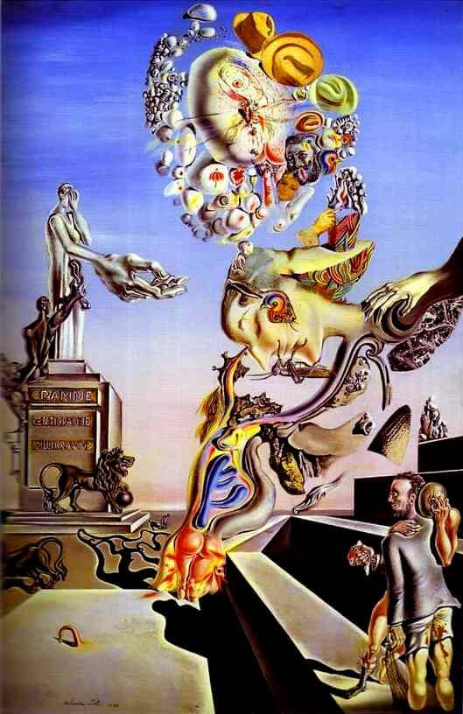
after years of reoccurring dreams of these certain events, as well as the contributing factor that sexual traumas were seen as immoral, inappropriate and were some form of taboo in that day and age, hence, the unconscious toying with these thoughts and reducing you to anxious breaks after the years of torture and tricks that the mind is playing – those that are unacceptable to the conscious mind. But it is believed that Freud had stretched the significance of this term out so much that he applied the term to almost everything and it had eventually lost its meaning.

Figure 1: The Lugubrious Game, Salvador Dali, 1929

One of the most successful artists of the Surrealism period was Salvador Dali, channelling the unconscious mind he created Figure 1, The Lugubrious Game, the main subject of this painting was masturbation, “made overt by the statue’s huge hand and Dali’s sexual fears and fixations.” (Dalipaintings.com, 2019) At the right-hand side of the painting is Dali himself, who’s mouth is covered by a grasshopper, “a creature of which he had an intense, irrational horror.” (Dalipaintings.com, 2019) Georges Bataille’s branded Salvador Dali’s paintings “frighteningly ugly, and his perverse metamorphoses took the viewer into the realm of evil.” (Ades and Baker, 2006) He also noted that “the great construction of the intelligence finally are prisons: that is why they are obstinately overthrown.” (Ades and Baker, 2006) There was a prisoner in the Bastille that was screaming from his cell about the slaughtering of other prisoners, it was said that the horrors of that prisoners “sadistic screams” (Ades and Baker, 2006) had “approximated the violence and brutal hilarity of Dali’s paintings” (Ades and Baker, 2006), which had lead “Bataille to one desire: ‘I am here only determined… to make myself squeal like a pig before his canvases.’” (Ades and Baker, 2006)

“Artists were very interested with the subconscious; with dreams, hallucinations and trances, as described in Sigmund Freud’s works. The group, along with André Breton, made artworks, poetry and sketches under hypnosis and automatic writing. Often, they produce surreal, dream-like and unconscious works.” (1stWebDesigner, 2017) It has been said that surrealism is the symbolic language of the subconscious, a universal language that does not depend on education, culture nor intelligence.
Artists who work in the Surrealist movements use several techniques to provide the inspiration and create the effect that they are aiming for. Collage; “assembling different elements to create a whole” (1stWebDesigner, 2017), Cubomania; where all images used are cut into squares and reassembled randomly, Decalcomania; spreading thick paint on a canvas and then covering it with paper or foil, removing it and using the outcome as the finished painting, Eclaboussure; placing paints down with water to create a random splattering and dotting effects, Frottage; using pencil rubbings over a textured surface, Fumage; a technique used to make an impression using smoke from a candle or lamp onto a blank canvas and finally Grattage; a process of scraping paint from the canvas to reveal the imprint below it.

Joan Miro, a modern Surrealist “painter, sculptor and ceramicist.” A founder of the movement, André Breton, “considered Miro as the most Surrealist of them all.” Although Miro signed the manifesto in 1924, he “rejected any membership to artistic movement”, but he still had many Surrealist influences like the use of automatism and sexual symbols in his work – which can be seen below in the Harlequin’s Carnival. (1stWebDesigner, 2017)
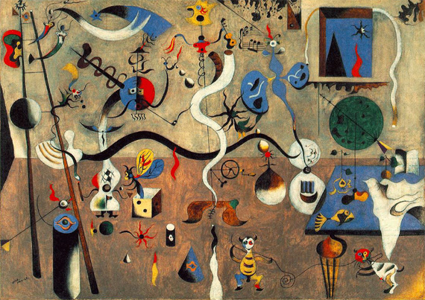

Figure 2: Harlequin’s Carnival, oil on canvas, 1924-1925
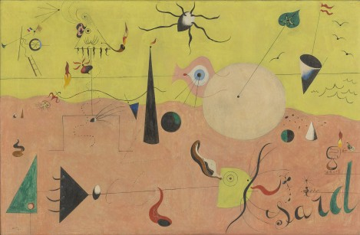
Figure 3: The Hunter (Catalan Landscape), oil on canvas, 1924

This painting may seem abstract at first but upon taking a closer look at it you notice that there is an “assortment of human and animal figures and natural forms that together comprise an iconography of the artist’s life.” (Moma.org, 2019)
The peasant has become a triangle with an ear, eye, pipe, the hairs of a beard and a hand. There is an airplane in the top left which is constructed of a propeller, a ladder and both the French and Catalan flags. In the foreground there is an animal, fish like creature – formed of a semi-circle, whiskers and a tail. The hunter himself is “standing at the left side of the composition, has a stick figure body and a triangular head.” (Moma.org, 2019)
The figure seems to be a “stand-in for Miró, and it appears in many of his other works.” The landscape reflects his life on the farm in Catalonia, “a politically autonomous region that has its own parliament, language, history and culture.” (Moma.org, 2019)
This possibly hints at the country’s contentious history, hence why there is always French, Catalan and Spanish flags in the background. The word ‘sard’ in the foreground is short for Sardana, the countries national dance – it also “references the fragmented letters and words of the Dadaist and Surrealist poetry” (Moma.org, 2019) of which he was influenced by. On changing his location for his work, he explained the impact on his work, “I have managed to escape into the absolute nature, and my landscapes have nothing in common anymore with outside reality…” (Moma.org, 2019)
For Joan Miro, the margins of his sketchbooks had become populated with visions of nightmarish couplings and weirdly erotic subhuman bodies, the outbreak of the Spanish Civil War and the rise of fascism across Europe had confirmed his worst fears. When asked about his state of mind in an interview, he stated: “I am pessimistic. I am tragically pessimistic. No illusions are permitted. More violently than ever before there will be a struggle against everything that represents the pure value of the spirit.”

The Surrealist art movement has had a tremendous impact on art, literature, culture and even politics. It is “a creative act of effort towards liberating the imagination. It is as dynamic as it is subtle.” (1stWebDesigner, 2017) It has taught me and the world that we are to see art “not merely visually and literally; but to appreciate it in a subconscious level as well.” (1stWebDesigner, 2017) It is an art form that is still familiar and continues to grow daily globally. “It is easy for artists to show their creativity through” (1stWebDesigner, 2017)
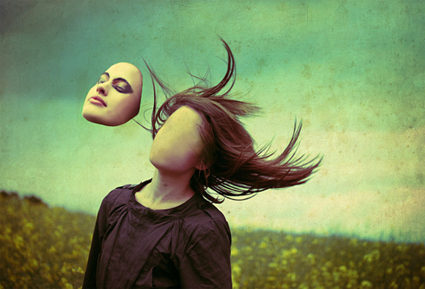
this movement, it provides them with the freedom to convey their feeling and thoughts and put this onto a canvas. Sometimes it “can be dreamy or gritty; or it can be optimistic or depressing.” (1stWebDesigner, 2017) The three images below are a prime example of this.
Figure 4: Faceless Composition, Lara Jade
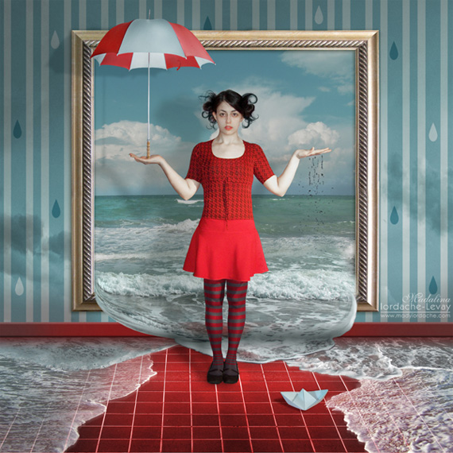

Figure 5: Rain Spell, Temporary-Peace
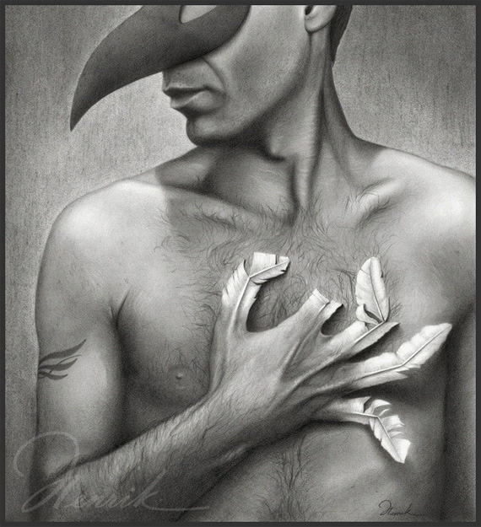

Figure 6: The Remnant, Henrik

The exhibition Surrealism: Desire Unbound “explores one of the central themes of the movement: the idea that man is a creature who is driven by desire. For the surrealist’s desire was the authentic voice of the inner self and at the same time a path to self-discovery. It was also an expression of the sexual instinct and, in sublimated form, the impulse behind love.” (Mundy, Gille and Ades, 2001) However, in 1959-1960, André Breton himself and others defined desire as a “profound, invincible and generally spontaneous tendency that drives all beings to ‘appropriate’ for themselves in some way or other an element of the exterior world” (Mundy, Gille and Ades, 2001), it was culminated in sexuality and had manifested into something that was “innumerable and enigmatic”. (Mundy, Gille and Ades, 2001) But desire was not the original dominant theme, it was love, revolution, dreams and poetry – yes, desire played a role in each theme but it was never “identified as a major aspect” (Mundy, Gille and Ades, 2001) of the surrealism movement. It eventually did take centre stage, sparking a new urge of willingness of which to confront the darker aspects behind sexuality and to explore the workings of the mind in a deeper and darker, possibly satirical way. Again Sigmund Freud had become the “influential founder of psychoanalysis and theorist” of desire, and had identified its sexual instincts and sublimation as factors “to the development of the individual and of civilisation as a whole.” (Mundy, Gille and Ades, 2001) The psychoanalytical concepts of desire, “repression, fantasy and the unconscious all emerged from the studies of hysteria.” (Mundy, Gille and Ades, 2001) By closely examining these themes “of hysteria in surrealist texts and visual iconography” (Mundy, Gille and Ades, 2001), it had ended up focusing on what was intertwined – historical and cultural trajectories – of the surrealism movement and psychoanalysis in France. Surrealists became to realise in Freud’s discoveries that it had both “radical artistic and cultural implications.” (Mundy, Gille and Ades, 2001)
From all this information that I have gathered so far, I have learnt that the Surrealism art movement has been solely and based around to this day that it has thrived off of nightmares, horrors and gore in today’s society but also it emerged from the peace and prosperity, the wounds that were left behind from the war – from the Dada movement. Also, that the main difference between the two movements is that “for Dada, life has no meaning, no reason, no purpose, and no logic. For Surrealism, life has meaning; one has to find its logic by unlocking visual and verbal codes secreted in the chambers of the unconscious mind where one finds Freud’s ‘uncanny’.” (Willette, 2019) It has not only had an impact on illustration and art itself but internationally throughout politics, culture and literature – it sculpts the way society works today and the way the world looks into art, as well as provoking them into thinking deeper into their conscious and unconscious thoughts. “The many aspects of surrealism – its art, its literature, its politics – were inspired by this vision of man as desirous of love, poetry and liberty.” (Mundy, Gille and Ades, 2001) I conclude that the surrealism movement is an extraordinary and intellectual movement that was “distinguished by enormous breadth and richness” (Mundy, Gille and Ades, 2001), embracing not only art but literature and psychoanalysis, politics and philosophy as well. They aim and achieve to disenthrall the human imagination and vision, which has been “expressed in the works of some of the great artists and writers” (Mundy, Gille and Ades, 2001) of the world.

I believe that Surrealism has had an extraordinary impact on illustration, among other topics as well, and hope that it continues to thrive and tackle the unconscious mind bringing to light what we are all really thinking of today’s world, its events and the society that we live in and I fully agree that is has encompassed the entire illustration genre, among many other topics as well.

BIBLIOGRAPHY
1stWebDesigner. (2017). Modern Surrealism and How It Is Used in Design Today. [online] Available at: https://1stwebdesigner.com/modern-surrealism/ [Accessed 12 Dec. 2019].
Ades, D. and Baker, S. (2006). Undercover surrealism. London: Hayward Gallery.
Dalipaintings.com. (2019). The Lugubrious Game, 1929 by Salvador Dali. [online] Available at: https://www.dalipaintings.com/the-lugubrious-game.jsp [Accessed 12 Dec. 2019].
Dalipaintings.com. (2019). The Lugubrious Game, 1929 by Salvador Dali. [online] Available at: https://www.dalipaintings.com/the-lugubrious-game.jsp [Accessed 12 Dec. 2019].
Gallery, P. (2018). What Is Surrealism? How Art Illustrates the Unconscious. [online] Park West Gallery. Available at: https://www.parkwestgallery.com/what-is-surrealism-art/ [Accessed 11 Dec. 2019].
Heller, S. and Chwast, S. (2008). Illustration. New York: Abrams.
Moma.org. (2019). MoMA | Joan Miró. The Hunter (Catalan Landscape). Montroig, July 1923–winter 1924. [online] Available at: https://www.moma.org/learn/moma_learning/joan-miro-the-hunter-catalan-landscape-montroig-july-1923-winter-1924/ [Accessed 12 Dec. 2019].
Mundy, J., Gille, V. and Ades, D. (2001). Surrealism: Desire Unbound. Princeton, N.J.: Princeton University Press.
Tate. (2019). Dada – Art Term | Tate. [online] Available at: https://www.tate.org.uk/art/art-terms/d/dada [Accessed 11 Dec. 2019].
Tate. (2019). Surrealism – Art Term | Tate. [online] Available at: https://www.tate.org.uk/art/art-terms/s/surrealism [Accessed 12 Dec. 2019].
Willette, J. (2019). Comparison of Dada and Surrealism | Art History Unstuffed. [online] Arthistoryunstuffed.com. Available at: https://arthistoryunstuffed.com/comparison-of-dada-and-surrealism/ [Accessed 12 Dec. 2019].

LIST OF FIGURES
Figure 1: The Lugubrious Game, Salvador Dali, 1929
https://www.dalipaintings.com/the-lugubrious-game.jsp

Figure 2: Harlequin’s Carnival, oil on canvas, 1924-1925
https://1stwebdesigner.com/modern-surrealism/

Figure 3: The Hunter (Catalan Landscape), oil on canvas, 1924
https://www.moma.org/learn/moma_learning/joan-miro-the-hunter-catalan-landscape-montroig-july-1923-winter-1924/

Figure 4: Faceless Composition, Lara Jade
https://digitalmediamarketingblog.wordpress.com/2013/02/09/modern-surrealism-faceless-composition-by-lara-jade/

Figure 5: Rain Spell, Temporary-Peace
https://1stwebdesigner.com/modern-surrealism/

Figure 6: The Remnant, Henrik
https://1stwebdesigner.com/modern-surrealism/

