Digital Skills and Research Methods

Gabriela Gherasim
Student ID: 2110945

Executive Summary
Virtual Learning Environment is a recent phenomenon that offers an online platform to students for effective learning. The questionnaire below will analyse the response of 50 students surveyed at The University of Wales about the way VLE has impacted their learning outcome at the University. The next part of the report will be based on the analysis which focuses on the secondary data analyses where it will mainly focus on the the virtual learning environment and its impacts on the university students of the Wales situated at London.

Table of Contents
Introduction 4
Primary Data Analysis 4
Secondary Data Analysis 13
Conclusion 15
Reference List 16

Introduction
Learning through virtual procedure known as Virtual Learning Environment is mainly an online platform that allows a student to take classes and lectures via the internet instead of attending physical classes. VLE is not a new thing in the field of education with the increasing number of innovations and development in technologies, and with the onset of pandemic and lockdown since 2020, there has been a complete shift in the mode of learning from offline to online. So major educational institutions have invented their own virtual learning platforms, making it easier for students to access lectures and notes. Researchers have suggested that VLE has impacted students’ learning process, achievements, encouraged independent learning, and has increased their will to learn. This report presents a primary, as well as secondary data analysis on the impact of Virtual Learning Environment on the students’ learning of the University of Wales. The primary analysis consists of certain relevant survey questions asked to 100 respondents or students of the University, and each question is followed by the explanation of the finding and data chart. The secondary analysis is mainly concerned with the literature review of the virtual learning environment and its impact on creative learning, access to resources and computer literacy among students of the University of Wales.

Primary Data Analysis
Q1. Which age group do you belong to?

Age group | Response | Total Respondents | Total Percentage
18-21 | 22 | 50 | 44
22-25 | 28 | 50 | 56

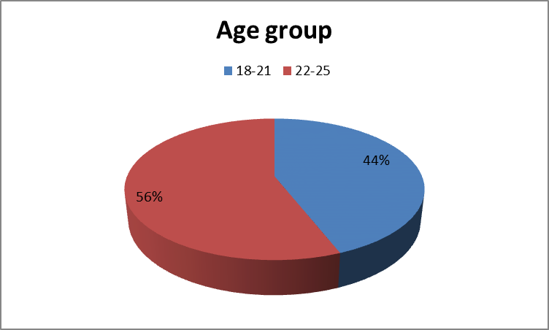
Findings: The survey was arranged and conducted among the students of the Wales within Trinity Saint David in the age range from 18 to 25. The above diagram shows that among the respondents, 44% of students belong to the age group of 18-21, pursuing their graduation mostly. And the remaining 56% of students belong to the age group of 22-25, most of whom are doing their post-graduation from the university.
Q2. Are you male, female or other?

Sex | Respondents | Total respondents | Total percentage
Male | 19 | 50 | 38
Female | 15 | 50 | 30
Other | 10 | 50 | 20
Preferred not to disclose | 6 | 50 | 12

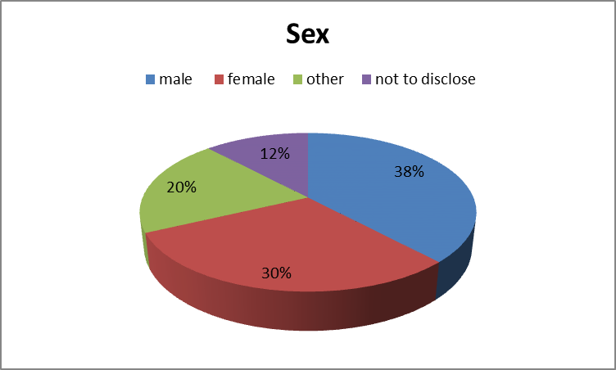

Finding:
Among the total 100 students surveyed at the Wales University situated in David London, 19 were males, 15 were females, 10 students belong to the ‘other’ gender, while 12% preferred not to disclose their sex at all

Q3. Do you think virtual learning has more positive impacts on learning outcomes than offline learning?

Response | Respondent | Total Respondent | Total Percentage
Yes | 30 | 50 | 60
No | 20 | 50 | 40

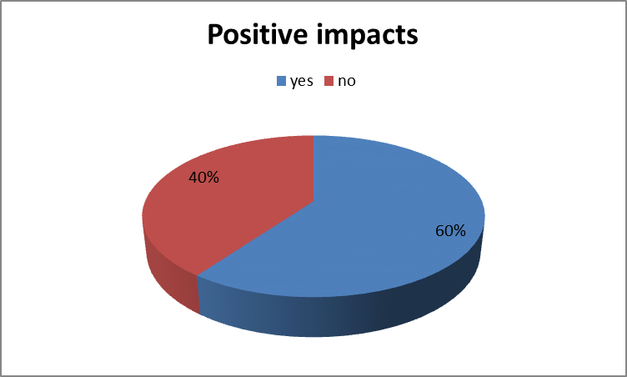
Findings:
In the above table we can see that out of 100 students surveyed at this said University, almost 60% students agree that virtual learning has more positive impacts on the learning outcomes, while 40% prefer the offline mode of study. The former 60 students attributed their choice to the reason that virtual classes are more easily accessible and can be utilized by anyone and any time without much hard work. But the latter 40 students think offline classes have better chances of interaction, hence the learning outcome is better there.

Q4. Is the accessibility of resources easier in VLE?

Response | Respondents | Total Respondents | Total Percentage
Yes | 41 | 50 | 82
No | 9 | 50 | 18
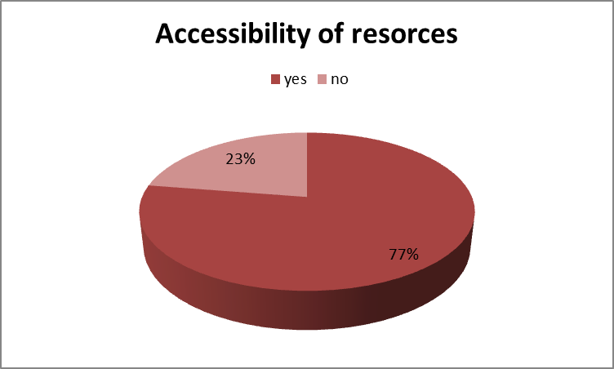
Findings: the above chart clearly shows that almost 82% of the university students surveyed in the said University, agrees that the accessibility of resources is far more easy in the VLE because the resources like the books, lectures and videos are available to all the students and can be accessed even at night if someone prefers so. The remaining 18% believe that physical lectures and books are better for learning and memorizing. So with the rise of VLE there has been a clear shift in preference towards online material.
Q5. VLE draws more attention from the students and keeps them engaged. Do you agree?

Response | Respondents | Total respondents | Total percentage
Agree | 10 | 50 | 20
Strongly agree | 2 | 50 | 4
Disagree | 25 | 50 | 50
Strongly disagree | 13 | 50 | 26

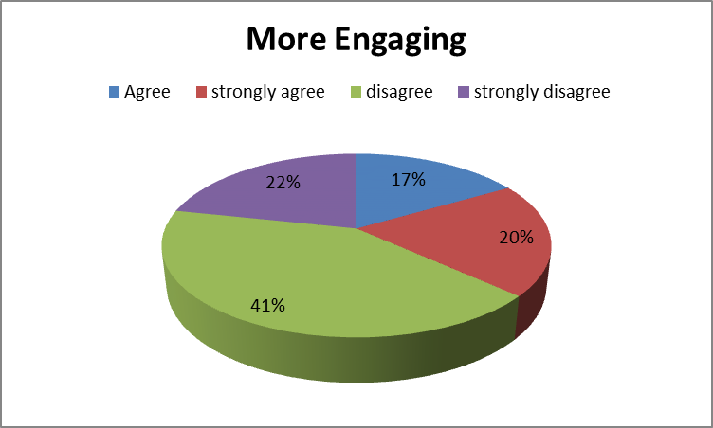
Findings: The table indicated that most of students surveyed in the said University do not agree that Virtual learning provides better engagements for the students because they believe that students get more distracted while studying online because of lack of proper studying environment, while on the other hand, 24% students believe that the students are able to pay more attention in virtual learning than in classrooms. Here the preference is clearly for the offline mode.
Q6. Do you think VLE is cheaper and more cost effective than offline mode?

Response | Respondents | Total Respondents | Total Percentage
Yes | 35 | 50 | 70
No | 15 | 50 | 30

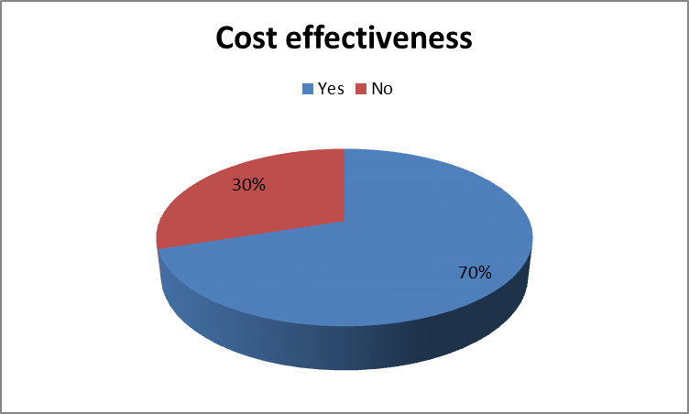
Findings: On the question of affordability there is almost a close competition among the students, as 55% of the students agree that VLE is more affordable and cost effective because the resources are available at nominal rates and also there is no travelling cost that is required to reach the classes. While 45% do not believe that VLE is cheaper because they think the cost of accessing the internet is high, as also the price of the technologies required to attend virtual classes, for instance, mobile phones and laptops.
Q7. Do you think communication with the teachers is better in VLE?
Response | Respondents | Total Respondents | Total percentage
Agree | 10 | 50 | 20
Strongly agree | 8 | 50 | 16
Disagree | 12 | 50 | 24
Strongly disagree | 20 | 50 | 40
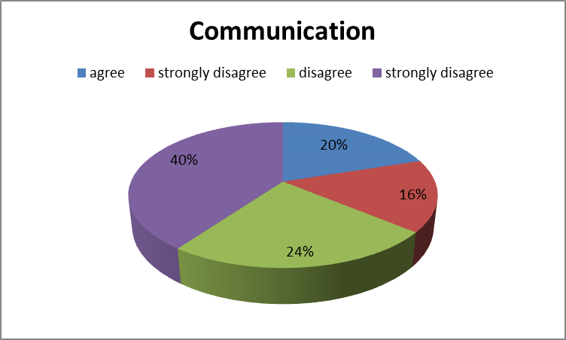
Findings:
The above diagram shows that 67% of students do not agree that communication is better in VLE. In fact they prefer offline classrooms because they can easily interact with the teachers there which helps in doubt solving and better understanding of concepts. And around 36% of students are of the view that VLE provides better opportunity to interact with the teachers through chat boxes and text messages or emails. In this case offline mode is clearly more preferable to VLE.

Q8. Do you think VLE has made learning more flexible?

Response | Respondent | Total respondent | Total percentage
Yes | 30 | 50 | 60
No | 20 | 50 | 40
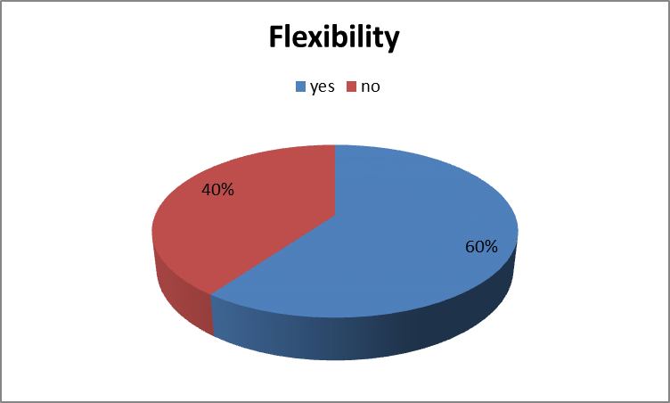

Findings: The table shows that 60% of students surveyed in the said University situated in London think that VLE has made learning more flexible, especially in terms of time. This is because VLE has enabled them to manage studies along with other activities and plans, especially with part-time jobs or internships. On the other hand 40% of students believe that VLE is not more flexible than classroom studies because online learning has seriously affected their health, thereby making it difficult to engage in any other activities.

Secondary Data Analysis
Emphasis on creative teaching
According to Ukolova et al., creativity generally means the innovation of new methods and is very important to the students in their higher education (Ukolova et al., 2020). It has always been witnessed that interactive teaching turns out to be the best out of all the other approaches to teaching in the education system. Virtual classes have turned out to be fruitful as this creative teaching method is an innovative way that has helped the University of Wales students within David London Campus. However, this virtual method of teaching requires the fulfillment of teachers who are generally innovative and have full access to imparting the students with vast knowledge (Pollard, Hains-Wesson and Young, 2018). This approach of learning has fully examined and focussed on the methods of a teacher as well as the university students of the Wales situated at London. This has resulted in the overall development of the students of the above-mentioned university starting from sound, physical, constructive, communication, and other development in their field of studies. Moreover, it has helped the students to accomplish their goals and ultimately become more absorbed in their driven needs of the teaching-learning process.
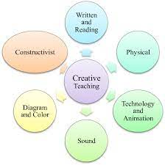
Figure: Diagram of the benefits of creative teaching.
Source: Pollard, Hains-Wesson and Young, 2018

Ultimate satisfaction to students on their access to computer literacy
According to Makhmudov, Shorakhmetov, and Murodkosimov, it has been assessed that computer literacy plays a major role in the virtual learning environment. It aids as an important tool for teachers imparting education to children. Computer literacy is however a very innovative and better tool for the the University of Wales students within David London Campus (Makhmudov, Shorakhmetov and Murodkosimov, 2020). It is a valuable component for understanding the relationship between the virtual teacher and students of the said University situated within David London Campus. Without access to the digital world, virtual learning is not possible. Thus it gives ultimate satisfaction to the students at the higher level of education. It however makes students more connected to the professors and their educators so that they can have better education which will enable them to have an established life. Ultimately the students will be well accustomed to the environment of computer education (Sandoval, Sandoval and Vernikova, 2019). It will also result in the ultimate success in the education status of the University of Wales students within David London Campus. As a whole, having computer knowledge is very important to students as it helps the students to have access to the virtual world of education.
Better access to resources
According to Coetzee, Leith, and Schmulian, it has been witnessed that a virtual learning environment has shown that the students are able to take actively participation in the teaching-learning process in spite of not being present physically. Likewise, there are various platforms available for virtual learning methods such as social media which has access to Facebook, Twitter, and so on (Coetzee, Leith and Schmulian, 2019). In no way a student can limit their access to their studies as there are various options available for them. Moreover, this virtual teaching environment has worked wonders in the above mentioned University at London Campus. The students are not just confined to the teaching of their university professors but they have access to different world-famous authors and so many other world-famous lectures which are usually posted on websites or so on. The students of the University can have access to various e-journals for their studies which have ultimately helped them to get success in the field of education to pursue their studies. However, this access to such resources has made the students confident enough to face any difficult situation that they might face in their education process.
Accessibility 24*7
According to Boulton, Kent, and Williams, a virtual learning environment can be practiced any time and anywhere based on the learner’s mode of accession (Goel, 2018). Moreover, the University of Wales students within David London Campus have access to their studies throughout the whole day or night. And like every student tries to get each information regarding their education or any other information related to their studies. Ultimately this has helped the students of the above-mentioned university that they can have access 24*7. This implies that not only they can watch or access the related search or any other related video not during their class hours but can access it whenever they like (Boulton, Kent and Williams, 2018). However, this will enable them to get stronger and confident as it will ultimately help them to have a stronger knowledge of the particular topic and can overview it whenever they require it (Huggins-Manley et al., 2019). Likewise, the students have been very much benefited from the virtual learning environment which helped them to access their related topics or any other educational video whenever required.

Conclusion
From the above report it can be concluded that virtual learning has created a different scenario in today’s world. However the main issue related to the search is that here the main focus is on the virtual learning at the University and how it has put an impact on the students' access to this type of studies. The whole report is based on the primary and secondary analysis that have been very well explained in the whole report to have a wider view regarding the ratio of the students studies at that particular university. In the first part of the analysis that is the primary data collection the report has used a very innovative method by preparing a questionnaire based on how the virtual learning environment has had an impact on the University of Wales students. Total 8 questions have been prepared based on the analyses of 50 students on their flexibility, how cheaper it is, age group, sex ratio, and so on to know how and how much it has affected the overall environment of the University of Wales situated in London. The secondary analysis however concerns the impact of the student that they have on the virtual learning environment and how they are benefited from it.

Reference List
Journal
Boulton, C.A., Kent, C. and Williams, H.T., 2018. Virtual learning environment engagement and learning outcomes at a ‘bricks-and-mortar’university. Computers & Education, 126, pp.129-142. Available at:https://www.sciencedirect.com/science/article/pii/S036013151830174X
Coetzee, S.A., Leith, K. and Schmulian, A., 2019. Accounting students access to social media related resources and the risk of tacit social exclusion. Accounting Education, 28(5), pp.465-483. Available at:https://www.tandfonline.com/doi/abs/10.1080/09639284.2019.1641116
Huggins-Manley, A.C., Beal, C.R., D’Mello, S.K., Leite, W.L., Cetin-Berber, D.D., Kim, D. and McNamara, D.S., 2019. A commentary on construct validity when using operational virtual learning environment data in effectiveness studies. Journal of Research on Educational Effectiveness, 12(4), pp.750-759. Available at:https://www.tandfonline.com/doi/abs/10.1080/19345747.2019.1639869
Makhmudov, K., Shorakhmetov, S. and Murodkosimov, A., 2020. Computer Literacy is a Tool to the System of Innovative Cluster of Pedagogical Education. European Journal of Research and Reflection in Educational Sciences, 8(5). Available at:https://d1wqtxts1xzle7.cloudfront.net/63317962/Computer_literacy_is_a_tool_to_the_system_of_innovative_cluster_of_pedagogical_education20200515-88116-kynner-with-cover-page-v2.pdf?Expires=1638457399&Signature=bpGuja~ANMy4ZEH3w1FYt-F2NPmDyGf1NlriqHa5laROrUR-MwH~oOnCl5ZfhZ~~ZUFQZT4Qg3zyZ~COp70jJ0l97-5PkER4nNMgz17LNHWIjHjTVRNAJ7l1cfCmfIUJ~xLAKCR2fGI6h7WyhnOWE2R5PcN0Xp~ccmjehdJFIFBSv1zCQa8v1zEfoJygbt49iJ6TW6L2PeHmAZwXhhDQWDo1LTTHj0AGiRND-NqNSQnNvt6bO~2CQ9jW8n1M0Id8sHqvLJc8MkVMD-KuOtZ3jJORq0Ha4-HUfxZkhTbuRg~HA5iCUiZgdXdzN~1y2XQgLm~HdHYbenPdtuQXDuFoYQ__&Key-Pair-Id=APKAJLOHF5GGSLRBV4ZA
Pollard, V., Hains-Wesson, R. and Young, K., 2018. Creative teaching in STEM. Teaching in Higher Education, 23(2), pp.178-193. Available at:https://www.tandfonline.com/doi/abs/10.1080/13562517.2017.1379487
Ukolova, L.I., Gribkova, O.V., Stolyarova, A.N., Shchetinina, N.N., Osipova, N.V., Akhmedova, J.U. and Emelyanenkova, A.V., 2020. The category of creativity in the formation of professional motivation of the teaching staff in the academic milieu of a higher education institution. Revista Turismo Estudos & Práticas, (S3), pp.32-32. Available at:https://www.elibrary.ru/item.asp?id=43050472
Books
Goel, A., 2018. Preliminary Evidence for the Benefits of Online Education and Blended Learning in a Large Artificial Intelligence Class. Blended Learning in Practice: A Guide for Practitioners and Researchers. MIT Press. Available at:https://books.google.co.in/books?hl=en&lr=&id=_4mNDwAAQBAJ&oi=fnd&pg=PA45&dq=book+on+online+education+benefits&ots=MHGwnL4G0d&sig=wXgLCVGHvY6YObeUTx64bOj0F-U&redir_esc=y#v=onepage&q=book%20on%20online%20education%20benefits&f=false
Sandoval, C., Sandoval, C.D.M. and Vernikova, 2019. Ancestral knowledge meets computer science education. Palgrave Macmillan US. Available at:https://link.springer.com/book/10.1057%2F978-1-137-47520-6

