COMPONENTS A MARKETING PLAN

MARKETING PLAN FOR CROWNE PLAZA

COMPONENT A

Student Name: Fragoso Eder Alberto

Student ID: 2234503

Module Name: Marketing Essentials

Module Code: BMIH4005

Table of Contents
Introduction 3
Discussion 3
Conclusion 7
Reference List 9
Appendix 12

Introduction
A marketing plan ensures a secure base for an innovative product recently launched into the market. The purpose of a marketing plan is to address the challenges that the launch of such goods may experience during its tenure of settling within the market (Indeed, 2023). Such plans are prepared for managing competition while keeping the scope for gaining a wide customer base. In this context, the report will utilise the SOSTAC model to outline the situation, objectives, strategy, tactics, action and control. A SWOT, PESTLE, marketing mix and Bowman’s Strategy will be conducted to frame the plan for Crowne Plaza.

Discussion
Situational Analysis
5Cs
Company
SWOT Analysis
Strengths | Weaknesses
- Clarity of performance  - Increasing profit margin(Pokora, 2022)  - Customer satisfaction  - Trained and skilled staff | - Controversial aspects  - Lack of private data security(Pokora, 2022)  - Negative customer reviews
Opportunities | Threats
- New geographical expansions  - Product exposure(Pokora, 2022) | - Financial crisis  - Increasing competition (Pokora, 2022)  - Training gaps
Table 1: SWOT Analysis
(Source: Created by the learner)
Customers
Segmentation and Targeting
The segmented group of individuals for Crowne Plaza can be corporate entities, group travellers, individual tourists and transient vacationers in the appropriate market. Moreover, the targeted group of individuals from these segments can be the ones with higher income facilities and a knack for travelling (Kari, 2022).
Competitors
Perceptual Positioning Map
(Refer to the appendix)
Bowman’s Strategy Clock
From Bowman’s Strategy Clock, the hybrid concept and a low-pricing form can be aligned with Crowne Plaza because of its combined digital and traditional marketing programs (refer to the appendix).
Collaborators
The collaborators of Crowne Plaza desires to launch a Global Entrepreneurship Network or GEN in terms of partnership. Holiday INN has been collaborated with the hotel in terms of B2B business awareness rate of the Hotel. In the context of franchises, the hotel aims to increase its brand awareness (IHG, 2022).
Climate
PESTLE Analysis
Political factors
The political stability index of the UK recorded 0.54 points in 2021 which is an affirmative impact on Crowne Plaza Hotel in terms of operational facilities (The Global Economy, 2023).
Economic factors
The economic growth rate of the UK had been 7.52% since 2021 and this is considered the scope for financial stability in Crowne Plaza (Macrotrends, 2023a).
Social factors
The population growth rate of the UK is 0.34% and the current population of the economy is 67,736,802 which may increase the count of employees and customers in Crowne Plaza Hotel (Macrotrends, 2023b).
Technological factors
According to the Global Innovations Index, the UK ranked 4th amongst 132 other nations and this can contribute to the implementation of advanced technologies in Crowne Plaza (WIPO, 2022).
Legal factors
The Consumer Protection Act of the United Kingdom states the importance of letting consumers return faulty commodities to organisations and Crowne is expected to abide by the law to gain customer satisfaction and engagement (GOV.UK, 2023).
Environmental factors
The Environmental Protection Act of the UK states an organisation to protect biodiversity, conserve nature and reduce carbon emissions and Crowne Plaza is estimated to serve eco-friendly products (Client Earth, 2022).
SMART Objectives
The marketing plan aims to identify a marketing opportunity or an issue while creating a communications strategy for Crowne Plaza in the current environmental situation.
Specific  (S) | Measurable  (M) | Attainable  (A) | Relevant  (R) | Time-bound  (T)
To identify an opportunity or an issue | With an increase in the count of opportunities to 4 | With the help of a marketing analysis | For gaining a competitive advantage | 3 weeks
To create a communication strategy | Increase the channels to more than 7 | With the initiation of digital applications | For adhering to digitalised promotion | 1 month
Table 2: SMART Objectives
(Source: Created by the learner)
Strategy
The value proposition of Crowne Plaza is that the hotel thrives to make organisational travel plans work better for individuals on a business tour. Conference halls and other business rooms are its Value Proposition. It is a modern business with a focus on blending personal and professional growth ensuring higher customer engagement rates. The value proposition can be delivered through digital marketing applications such as vlogs on YouTube, updates on official websites and personalised emails (Pearl, 2023). The target segments of Crowne Plaza may receive valuable information on the USP of the hotel to the remotest parts of the globe.
Tactics
Marketing Mix
Product
The products and services offered by Crowne Plaza include guest rooms, food, banquet halls, conference facilities, recreational activities and an executive lounge (Elliott, 2021). Moreover, the hotel offers digital check-in and check-outs along with the facilities of parking lots, travel desks, business centres, healthcare and an Internet connection (Elliott, 2021).
Place
Crowne Plaza is currently established in the United Kingdom and has decided to expand its business to the other economies with the benefit of its resort area location. The distribution channels that the hotel may follow are personalised advertisements, digital media campaigns, website booking systems, banner ads and travel agents (Deflorian, 2019).
Price
Crowne Plaza initiates a competitive pricing strategy to cope with the growing business within the same industry in other competitive economies and this can be informed to customers on the website of the hotel (Deland, 2022).
Promotion
The promotional strategy of Crowne Plaza can involve both digital and traditional marketing channels with ad-based revenue models to reach out to a wide target audience (Saura, 2021).
Communications mix
- Advertising through social media channels
- Direct marketing through emails and flyers
- Personal selling through door-to-door promotion
- Public relations through business events
- Sales promotion through print mediums (Indeed, 2022b)
Action
Both Digital and Traditional Marketing channels are chosen for better exposurein order to successfully promote business events while increasing its reach of worldwide customers(refer to the appendix).Digital and traditional marketing are considered omnichannel facilities and can boost the sales revenue of an innovative product while initiating such decisions to adapt to such measures.
Control
Brand loyalty
Increasing brand loyalty over the next 3 years can help measure the successful growth of Crowne Plaza in terms of its acceptance by worldwide customers.
Revenue growth
The revenue growth can help understand the increasing brand awareness and growth of the organisation (Indeed, 2019).
Profit margin
The increasing count of sales over the years from now can support measuring the exposure rate of Crowne Plaza.
Client retention rate
Client retention rate helps serve the business with more opportunities and determines the efficiency of strategies (Gleeson, 2019).
Customer satisfaction
Increasing customer satisfaction reveals brand awareness and its established identity.

Conclusion
It is important to create an appropriate marketing plan to analyse the situation before launching innovative products into the market. From the above report, it has been derived that the marketing plan for Crowne Plaza can be a feasible strategy for gaining global exposure, a wide customer base and a competitive advantage over the years.
Recommendations
- The measuring tactics of the hotel can be improved with added KPIs to understand its growth while motivating the organisation to move forward (Indeed, 2021).
- The target market can expand to the youth in today’s rapidly changing world to gain sustainable success (Indeed, 2022a).

Reference List
Client Earth, 2022. The UK Environment Act - what's happening now? [online] Available at: https://www.clientearth.org/latest/latest-updates/news/why-the-uk-environment-bill-matters/#:~:text=What%20does%20the%20Environment%20Act,%2C%20biodiversity%2C%20and%20waste%20reduction. [Accessed 2 March 2023]
Deflorian, A., 2019. Play To Your Strengths: Finding Your Hotel's Optimal Marketing Channel [online] Available at: https://www.forbes.com/sites/forbesagencycouncil/2019/11/18/play-to-your-strengths-finding-your-hotels-optimal-marketing-channel/?sh=4fed37f02e7e [Accessed 2 March 2023]
Deland, A., 2022. Understanding Pricing Strategies, Price Points And Maximizing Revenue. [online] Available at: https://www.forbes.com/sites/forbesbusinesscouncil/2022/08/22/understanding-pricing-strategies-price-points-and-maximizing-revenue/?sh=250aa7877e96 [Accessed 2 March 2023]
Elliott, C., 2021. How IHG Hotels & Resorts Reinvented Itself During The Pandemic. [online] Available at: https://www.forbes.com/sites/christopherelliott/2021/02/19/how-ihg-hotels--resorts-reinvented-itself-during-the-pandemic/?sh=322ef9157162 [Accessed 2 March 2023]
Gleeson, P., 2019. How to Measure a KPI? [online] Available at: https://smallbusiness.chron.com/measure-kpi-4697.html [Accessed 2 March 2023]
GOV.UK, 2022. Consumer rights. [online] Available at: https://www.gov.uk/consumer-protection-rights [Accessed 2 March 2023]
IHG, 2022. IHG partners with Msafiri Limited to open Holiday Inn and Crowne Plaza hotels across African markets. [online] Available at: https://www.ihgplc.com/en/news-and-media/news-releases/2022/ihg-partners-with-msafiri-limited-to-open-holiday-inn-and-crowne-plaza-hotels-across-african-markets [Accessed 8 May 2023]
Indeed, 2019. Key Performance Indicators (KPIs): Definition and Examples. [online] Available at: https://www.indeed.com/career-advice/career-development/key-performance-indicators [Accessed 2 March 2023]
Indeed, 2021. How To Plan a Marketing Strategy? [online] Available at: https://www.indeed.com/career-advice/career-development/marketing-strategy [Accessed 2 March 2023]
Indeed, 2022a. 18 Important Tips For Sales And Marketing Strategies. [online] Available at: https://in.indeed.com/career-advice/career-development/tips-for-sales-and-marketing-strategies [Accessed 2 March 2023]
Indeed, 2022b. What Are Channels In Marketing? (Definition And 14 Examples). [online] Available at: https://in.indeed.com/career-advice/career-development/what-are-channels-in-marketing [Accessed 2 March 2023]
Indeed, 2023. 6 Purposes of a Marketing Plan (And Why They're Important). [online] Available at: https://www.indeed.com/career-advice/career-development/purpose-of-the-marketing-plan [Accessed 2 March 2023]
Kari, R., 2022. Customer Segmentation: Taking A Multi-Lens Approach To Understanding Customer Behaviour. [online] Available at: https://www.forbes.com/sites/forbesbusinesscouncil/2022/01/26/customer-segmentation-taking-a-multi-lens-approach-to-understanding-customer-behavior/?sh=3e96048e4519 [Accessed 2 March 2023]
Lucidity, 2023. Introduction toBowman’s Strategy Clock. [online] Available at: https://getlucidity.com/strategy-resources/introduction-to-bowmans-strategy-clock/ [Accessed 2 March 2023]
Macrotrends, 2023a. U.K. GDP Growth Rate. [online] Available at: https://www.macrotrends.net/countries/GBR/united-kingdom/gdp-growth-rate [Accessed 2 March 2023]
Macrotrends, 2023b. U.K. Population Growth Rate. [online] Available at: https://www.macrotrends.net/countries/GBR/united-kingdom/population-growth-rate [Accessed 2 March 2023]
Pearl, D., 2023. A Quick Guide And Comparison To All 17 IHG Brands. [online] Available at: https://www.forbes.com/advisor/credit-cards/travel-rewards/ihg-brands/ [Accessed 2 March 2023]
Pokora, B., 2022. The New IHG One Rewards Is Here And It’s A Major Improvement. [online] Available at: https://www.forbes.com/advisor/credit-cards/the-new-ihg-one-rewards-is-here-and-its-a-major-improvement/ [Accessed 2 March 2023]
Saura, J.R. ed., 2021. Advanced digital marketing strategies in a data-driven era. IGI Global.
The Global Economy, 2023. United Kingdom: Political stability. [online] Available at: https://www.theglobaleconomy.com/United-Kingdom/wb_political_stability/ [Accessed 2 March 2023]
WIPO, 2022. Global Innovations Index (GII). [online] Available at: https://www.wipo.int/global_innovation_index/en/2022/?gclid=EAIaIQobChMItcmYvoK9_QIVapJmAh1Y6QlCEAAYASAAEgI2WvD_BwE [Accessed 2 March 2023]

Appendix
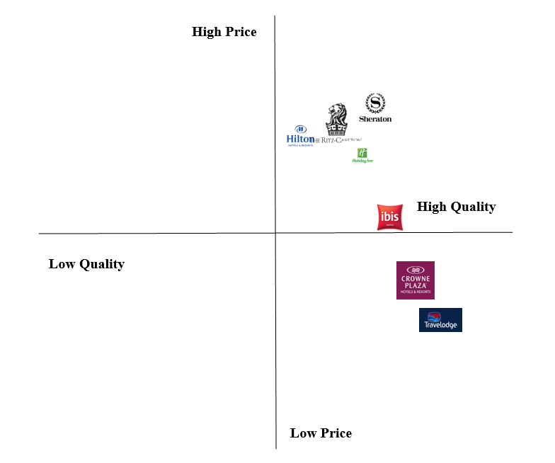
Figure 1: Perceptual Positioning Map
(Source: Created by the learner)
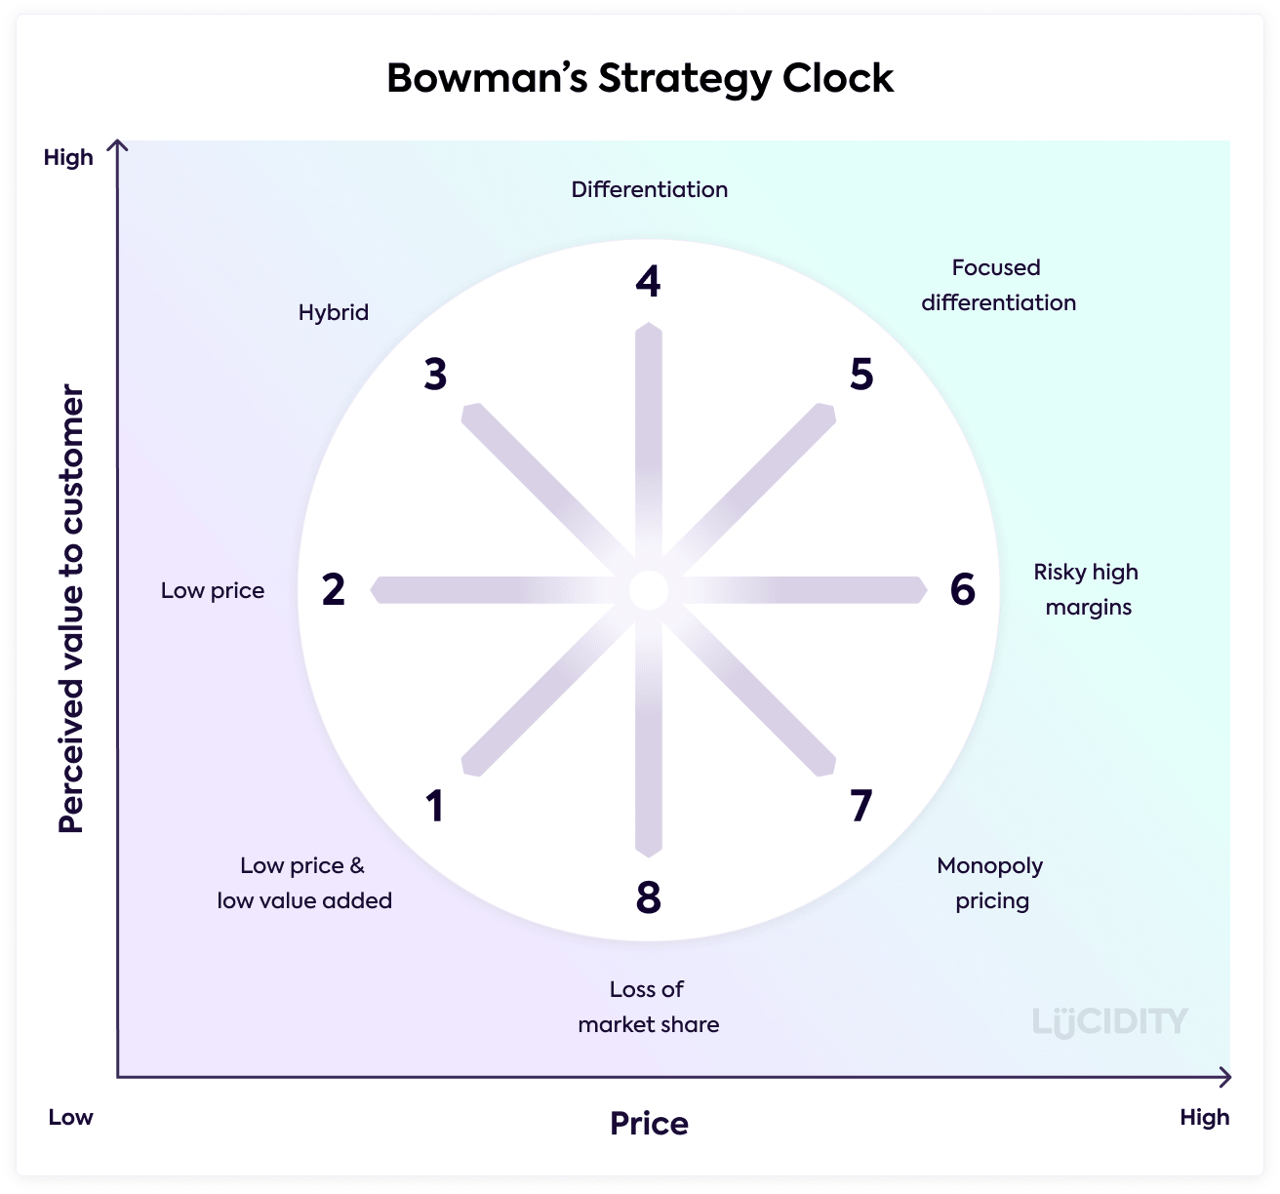
Figure 2: Bowman’s Strategy Clock
(Source: Lucidity, 2023)
Channels | Start date | Duration | End date
Deciding on the budget | 02-03-23 | 1 | 03-03-23
Social media marketing decisions | 03-03-23 | 3 | 06-03-23
Framing an influencer marketing plan | 06-03-23 | 7 | 13-03-23
Gathering knowledgeable influencers | 13-03-23 | 5 | 18-03-23
Contributing to payment-based ads | 18-03-23 | 11 | 29-03-23
Personalising emails for digital marketing | 29-03-23 | 6 | 04-04-23
Initiating Search Engine Optimisation | 04-04-23 | 2 | 06-04-23
Establishing traditional print mediums | 06-04-23 | 4 | 10-04-23
Application of the marketing channels | 10-04-23 | 1 | 11-04-23
Table 3: Marketing channels
(Source: Created by the learner)

Figure 3: Gantt Chart
(Source: Created by the learner)

