Marketing Fundamentals

Programme | BA Business Management
Module | Marketing fundamentals
Module Code | LCBB4004
Assignment Title | Assessment 1  Blogging to communicate
Lecturer | Ritz Bhatti
Student Name | Eleana Mateva
Student ID | 2030421

Table of Contents

Introduction……………………………………………………………………………………………………3
Blog Post 1……………………………………………………………………………………………………..3
Blog Post 2……………………………………………………………………………………………………..5
Blog Post 3……………………………………………………………………………………………………..6
Blog Post 4……………………………………………………………………………………………………..8
Blog Post 5……………………………………………………………………………………………………..8
Blog Post 6……………………………………………………………………………………………………..9
Blog Post 7……………………………………………………………………………………………………..9
Blog Post 8…………………………………………………………………………………………………….10
Conclusion…………………………………………………………………………………………………….11
References……………………………………………………………………………………………………..12/13

Introduction


The report will focus on the creation of few blogs; for the selected organisation; to have effective marketing communication. The portfolio will include various sorts of theories, and models that can be included in the organisation to effectively communicate the marketing practices. the various sorts of theories are been includes such as; marketing mix, Ansoff matrix, 5C model, will be included.

Blog post 1
Marketing mix
For Apple Inc. to be effective in its various projects and separate tasks, it can apply the 4Ps marketing mix. The 4Ps of marketing or the marketing mix are effective models for better awareness of the projects and their products in the market (Kotler, 2017). Apple has a wide range of the products in the market, and have various market competitors, and thus, it needs to be more effective and can use the marketing mix to have better market awareness and coordination of its various products. The marketing mix has four major elements which need to be coordinated such as;
Product: The products are the physical values created from raw materials in the factory; and are delivered to the customers. There are mainly physical products and goods, though; they may contain services (Išoraitė 2016). They are the actual values that have been delivered to the customer; for these, the customer pays money. The products for Apple Inc. includes; iMac, iPad, iPhone, MacBook, Apple Watch, Apple TV, etc. it has various accessories and peripheral as its products such as; AirPods, USB cable, apple pencil, earpods, it has its own operating system such as; iOS, macOS, watchOS, bridges and more. It also provides various services such as; iTunes stores, iCloud, apple store, apple card, safari, mac app store and more (Apple wiki, 2021).
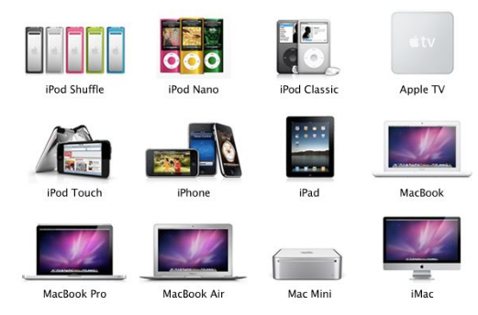
Figure 1 products of apple
(Source: Pinterest, 2021)

Price: The prices are the value set by the organisation for its various products and services. There are various sorts of pricing strategies are that could be chosen by the organisation, such as; value for money, the firm charging high process for the high-quality products. Apple uses this strategy; and charges high prices for its quality (Harker et al. 2015). The skimming pricing uses the high prices at the initial stage that can b affordable by a premium segment of the market, whereas; when the competition rises, the prices are lowered to be affordable by all and again attract the market.
Place: The element focuses on the location of the delivery of the products; it focuses on delivering the right product to the right individual at the right time. Apple has an effective location for the delivery of its products. The firm sells its products via Amazon and Alibaba, its physical stores, online sale from its website, and more. Apple Inc. has its own supply chain that ensures the delivery of the products on time (Thabit and Raewf, 2018).

Promotion: It is the way of promoting and aware the customer about new and current products in the market. Apple uses various sorts of practices for its effective marketing such as; mass media such as Amazon, newspaper, banners, social media, blogs and more. The firm also uses the celebrity endorsement to attract customers to purchase its products. The firm focuses on emotional appeals such as social pleasure and social capital gain to attract customers.
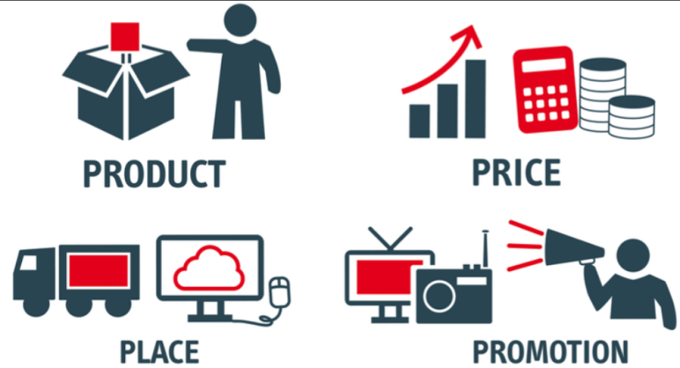
(Source: Blendspace, 2021)

Blog post 2
Extended marketing mix
As discussed before; the marketing mix is of the great importance to have effective coordination of various elements, but as the service industry is growing; the more elements are being added to the marketing mix such as earlier there were 4Ps of marketing such as product, place, price promotion whereas; with the rise in service industry and service; the marketing mix is being extended and 3 more Ps are being extended such as; process, people, physical evidence. For the service industry, the three other elements are important to have competitive advantages and stand different in terms of marketing aspects.
Process: This element shows the way; in which the product is been delivered; and the way of delivering values to the customers (Saidani and Sudiarditha, 2019). It is the way the operations are been done. The process of the Apple inc. its focus on the quality of its products; the firm focuses on products quality and creativity and delivers them. The firm provides the social capital and status with the products as part of its process; the customers are more likely to have more prestige and high social status after having Apple Inc. products. They provide innovative and unique packaging of its various products that make them feel like getting precious products and satisfies them.
People: They are the employees of the firm; since; the employees deliver services; the proper training and motivation of the employees needs to be considered in marketing as; it sets the high market approaches. The firm have; over 147,000 employees as per the last year’s data, the firm have proper benefit policies for employees and other approaches to satisfy them and have motivated employees who can focus on creativity and be motivated to provide effective customer services.
Physical evidence: These are the elements that can be touched and feel such as the products of Apple itself and their packaging, and the bill, brochures, signage are the physical evidences of the products (Grădinaru et al. 2016).
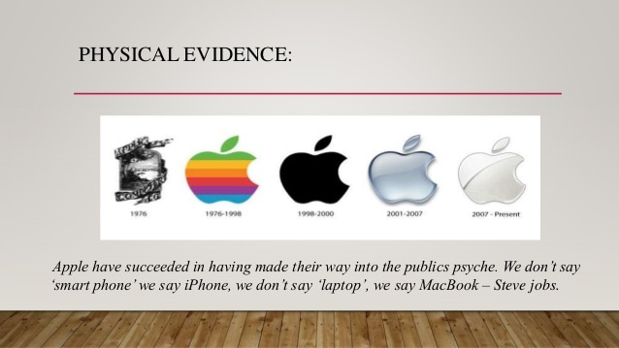
Apple has a wide range of products and services are there to offer; and the firm have effective use of those to develop effective marketing strategy and grow.
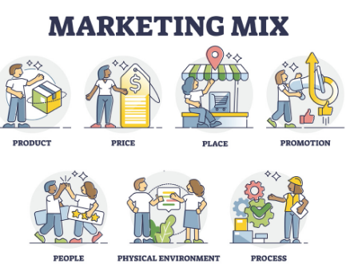
Figure 2 7Ps of marketing
(Source: Pierre Nicolas Schwab, 2021)

Blog post 3
Ansoff matrix
The organisation always aims to develop and be effective in the market though; for the organisation to expand; it needs to have proper strategies. The Ansoff model can be used to have proper expansion strategies. The model; is very effective as; it identified opportunities for the organisation to market such as in terms of market and products; it suggests whether the organisation should promote its current product or needs to have marketing in other markets or needs to launch new products. it is the source of revenue for the firm (Loredana, 2017). The Ansoff model has 4 matrixes such as;
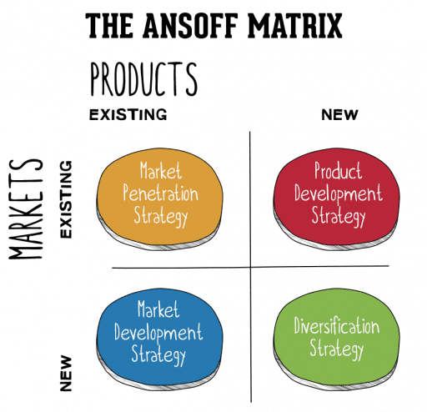
Figure 3 Anosff matrix
(Source: Annmaries Hanlon, 2021)
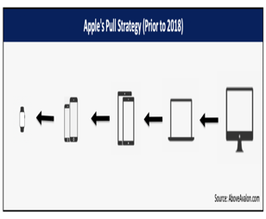
Market penetration: The first matrix suggests the organisation to launch the launch current products in the current market, when the organisation does not have enough budget or opportunities; then; it is used. The aggressive marketing is been to have market awareness. Apple can have this approach to make customers to purchase their products
Product development: In the product development, the new products are launched in the same market to attract more customers and the current ones. Apple mostly uses this approach and come up with trending and creative products to be the market leader and have new products to be launched (Schawel and Billing, 2018). Apple come up with new technology based on this and bring in sales.
Market development: The market development is the stage where; the firm can expand its current products and its marketing to over new markets, it can be done via digital marketing and new markets can be captured via online delivery and collaborations. Based on the market research if the current market is saturated; the firm can have its marketing to new markets.
Diversification: The strategy makes the firm to launch new products in new markets based on the current brand name (Kotler and Armstrong, 2018). Generally; the strategy is risky; but in case of Apple inc. the firm has a very high brand image and customer trust; it can go for this approach to launch new products (Cleberg, 2019).
The best approach is the market penetration and market development as; Apple has enough creative products.

Blog post 4
Porter’s five forces

For effective marketing, the firm needs to have market analysis as; the analysis allows a better understanding of off-market and customer needs. Accordingly, new products are delivered and projected in the market to satisfy customers. One of the best ways to have market analysis is the porter’s five forces. The tool is very effective to show the market competition and alternatives; and based on the same; Apple inc. can develop various sorts of marketing alternatives and strategies based on this.
Market competition: The market competition is the competition in the market and the number of rivals. More number of rivals shows high market competition. For Apple Inc., the market competition is high (Goyal, 2020).
Buyer’s power: The buyer’s power is low for Apple as; the customers are not able to bargain for apple as; the firm provide various benefits, market status, technology and quality. There are high market demands for the products.
Supplier’s power: The supplier’s power is the power of supplier to influence the prices of the various resources and raw materials; the supplier power is low in the case of Apple as; the number of suppliers is high in the market whereas; the brand value of Apple is high.
Threat to entrants: This is the threat of new technology start-ups in mobile and other white good devices. The firm has medium threat to new entrants as there are no barriers though; it needs high investment, and the customer trust in Apple brand is high; thus; the Apple inc has low threat to new entrants (Dobbs, 2014).
Threats to substitute: The threat to substitute is high for the firm as; there are various rivals in the market, such as Androids and more.
These all practices show the market attractiveness based on these new marketing strategies developed.

Blog post 5
Consumer decision making process
The consumer decisions making process is important as; the marketing will be done effectively if the customer steps and process are known; if the purchase behaviour is known; marketing decision making becomes easy. There are various steps for this such as; need recognition, this stage identifies various issues faced by the individuals, marketing can be done to recognise such issues such as apple watch is been developed to have better access to various features, their need for recognised by apple (Stankevich, 2017). Search for information, customers search for various products from various sources such as family, online banners, previous experiences and more. Evaluation of alternatives, based on the offers, discounts, usage, prices, quality and recommendations; the products are been compared; apple deliver various offers and features at this stage to attract customers.
Purchase decisions are to have the actual purchase decision of the products from Apple. The post-purchase evaluation is to seek customer feedbacks; Apple have various sources such as in device apps; email feedbacks, calls and more to seek customer feedbacks of products to improve the products and improve the marketing strategies to create better producers and have better customer attractions.

Figure 4 Purchasing decision
(Source: Author, 2021)

Blog post 6
Segmentation, targeting and positioning
The marketing can be effective if it is targeted to a specific audience, thus for the marketing to be effective. It needs to have proper segmentation, targeting and positioning.
Segmentation: Segmentation is categorising the big market customers into small parts that are similar to each other. The segmentation can be done based on age, size, sex, education, occupation, lifestyle, attributes, perceived values and more. Apple have segmented its customers based on the occupation, lifestyle attributes, income, age and more (Camilleri, 2018).
Targeting: Specific segments need to be targeted; the Apple inc. mainly targets its customer based on the income and lifestyle.
Positioning: The positioning can be done in various aspects such as; the firm position itself as think different. Apple inc. has positioned itself as high quality unique products providing organisation.

Blog post 7
5C’s analysis
For the marketing to be effective, it is important to have market analysis; the analysis allows to have various decisions and statistics and factors which are been used to develop the effective marketing. They are for the project of Apple inc. to have effective marketing. The 5C model has various elements such as;
Company: As per the part of the company; the firm produces; white goods such as technology, it has various sorts of products such as; iPhone, Mac, iPods and more. The products of Apple are unique from rivals (Corporate finance institute, 2021). The firm has a high brand image in the market and a wide range of quality products.
Customers: It is about to have customer analysis; it focuses on the customers in the market. The current target audience for the firm is the high income unique life style preferring customers. the firm have increasing customer base.
Competitors: The firm has huge market competition in the market as; there are various rivals in the market. For effective marketing strategy it is important to identify the products which are offered by the rivals but not offered by Apple. The firm needs to learn to differentiate itself.
Collaborators: As the part of the collaborations; the individual or institution the firm work with is known as collaborator, the currently Apple Inc. works with Amazon to sell its products, thus; the Amazon it is collaborator (Alexey Cherkasov, 2020).
Climate: It includes various sorts of market trends which are been shown in the market such as; the new sets of laws in the market affects the firm whereas; the social trends, technological advancement and more affects the climate or operations of Apple Inc. such as Samsung have come up with transparent smartphone whereas; the firm needs to meet up this trends to overcome the climate.

Blog post 8
BCG matrix
This is the most effective marketing model that allows making various marketing-related decisions. The model allows differentiating the products based o various products and developed various marketing decisions. The model is very important for the current project of apple. The model for the Apple Inc. is

Cash cows: The cash cows are the products which are launched in the market a long time ago but still make the expected sales, and are the major source of funds to the organisation (Mohajan, 2017). The product sales do not drop. There are various examples of its such as; Mac, Apple iTunes
Stars: They are the products which bring the highest income to the organisation.They are trending in the market and are high in demand. Every organisation tries to make its products to be stuck in the star category as long as possible to have the highest income, late the stars turn into cash cows. The example of star includes; iPhone, iPad, Apple smartwatch.
Question mark: These are the products which are in the question as they might go to the star or hoes to dogs. The sales of the products goes in fluctuations, they might go to star or dogs. They are mostly the newly launched products in the market (Khan et al. 2015). The example of the question mark category of apple Inc. is iPad, Apple TV, AirPods.
Dogs: This is the place where the products are placed which is not working well. The products whose sales are going down; and that do not bring the firm's income are placed in the dog segment. Such products need to be removed; from the product portfolio to reduce their investment. The best example of this is iPod.
The use of the model allows creating better marketing strategies for Apple Inc.

Conclusion

The report has identified the importance of marketing for the chosen organisation i.e. apple Inc, and have used various sorts of theories and models to effectively share the marketing communications. The various sorts of models are been used for the apple that are effective to have effective communication of the project of marketing in apple Inc. the various sorts of models are bee utilised such as; porter’s five forces, consumer decision making process, targeting, segmentation and positioning, BCG matrix and more.

References

Books and Journals
Camilleri, MA, 2018. Market segmentation, targeting and positioning. In Travel marketing, tourism economics and the airline product (pp. 69-83). Springer, Cham.
Dobbs, M.E., 2014. Guidelines for applying Porter's five forces framework: a set of industry analysis templates. Competitiveness Review.
Goyal, A., 2020. A Critical Analysis of Porter’s 5 Forces Model of Competitive Advantage. Goyal, A.(2021). A Critical Analysis of Porter’s, 5.
Grădinaru, C., Toma, S.G. and Marinescu, P., 2016. Marketing mix in services. Ovidius” University Annals.
Harker, M., Brennan, R., Kotler, P. and Armstrong, G., 2015. Marketing: An Introduction.
Išoraitė, M., 2016. Marketing mix theoretical aspects. International Journal of Research-Granthaalayah, 4(6), pp.25-37.
Khan, U.A., Alam, M.N. and Alam, S., 2015. A critical analysis of internal and external environment of Apple Inc. International Journal of Economics, Commerce and Management, 3(6), pp.955-961.
Kleberg, C., 2019. Strategic Success: The Ansoff Matrix vs. The Balanced Scorecard.
Kotler, P. and Armstrong, G.M., 2018. Marketing Mix: Selected Chapters From: Principles of Marketing, Philip Kotler and Gary Armstrong. Pearson.
Kotler, P., 2017. Philip Kotler: some of my adventures in marketing. Journal of Historical Research in Marketing.
Loredana, EM, 2017. The use of Ansoff matrix in the field of business. Annals-Economy Series, 2, pp.141-149.
Mahajan, H., 2017. An analysis on BCG growth sharing matrix.
Saidani, B. and Sudiarditha, I.K.R., 2019. Marketing Mix-7ps: The Effect on Customer Satisfaction. Jurnal Pendidikan Ekonomi Dan Bisnis (JPEB), 7(1), pp.72-86.
Schawel, C. and Billing, F., 2018. Ansoff-Matrix. In Top 100 Management Tools (pp. 31-33). Springer Gabler, Wiesbaden.
Stankevich, A., 2017. Explaining the consumer decision-making process: critical literature review. Journal of International Business Research and Marketing, 2(6).
Thabit, T. and Raewf, M., 2018. The evaluation of marketing mix elements: A case study. International Journal of Social Sciences & Educational Studies, 4(4).

Online
Alexey Cherkasov, 2020. 5C analysis. [Online] [Accessed through] https://www.marketing-psycho.com/5c-analysis/ [9th December 2021]
Annmarie's Hanlon, 2021. The Ansoff model.[Online] [Accessed through] https://www.smartinsights.com/marketing-planning/create-a-marketing-plan/ansoff-model/ [9th December 2021]
Apple wiki, 2021. List of apple products. [Online] [Accessed through] https://apple.fandom.com/wiki/List_of_Apple_products [9th December 2021]
Blendspace, 2021. Introduction to marketing. [Online] [Accessed through] https://www.blendspace.com/lessons/jy-CQY8kU8q-tg/week-3-introduction-to-marketing [9th December 2021]
Corporate finance institute, 2021. 5C analysis. [Online] [Accessed through] https://corporatefinanceinstitute.com/resources/knowledge/strategy/5c-analysis-marketing/ [9th December 2021]
Pierre Nicolas Schwab, 2021. Marketing Mix: definitions, analysis examples [Complete Guide 2021]. [Online] [Accessed through] https://www.intotheminds.com/blog/en/marketing-mix [9th December 2021]
Pinterest, 2021. Apple products. [Online] [Accessed through] https://www.pinterest.com/pin/498492252476248084/ [9th December 2021]

