Portfolio
For Module UNEH7010
Post Graduate Certificate in Teaching in Higher Education (Advanced HE accreditation)

Ruth Taylor-Davies, Student Number: 0201980
Tutor: Katie Gardner
April 2025

Table of Contents
1 Teaching Intervention Year 2 5
1.1 Introduction 5
1.1.1 Overview 5
1.1.2 CPD and Reflective Practice 5
1.1.3 The Teaching Intervention in an academic context 6
1.2 The Experience 8
1.2.1 The local context 8
1.2.2 The Process 8
1.3 The Reflection 11
1.3.1 Cohort 1 - Did it work? 11
1.3.2 Lesson learnt - what I’d do differently 11
1.4 Conclusion 12
2 Poster 14
3 Continual Professional Development Log 15
3.1 CPD Log 1.Castel Howell Trade Food Show, 19/2/2025, Parc Y Scarlets’ Llanelli. 15
3.1.1 Overview and content 15
3.1.2 Reflection 15
3.1.3 How it will benefit my teaching 15
3.2 CPD Log 2. Enhancing Inclusive Student Engagement in Higher Education, QAA 16
3.2.1 Overview and content 16
3.2.2 Reflection 16
3.2.3 How it will benefit my teaching 17
3.3 CPD Log 3. Jisc Webinar, 5/2/2025. Transforming assessments: the power of multimedia in education 17
3.3.1 Overview and content 17
3.3.2 Reflection 17
3.3.3 How it will benefit my teaching 18
4 Teaching Observations 19
4.1 Observation 1, 5/2/2025 19
4.2 Observation 2, 26/2/2025 20
4.3 Observation 3, 5/3/2025 21
5 Reflection 23
6 Teaching Log 25
7 References 29
8 Appendices 33
8.1 Programme Aims 33
8.2 Programme Learning Outcomes 34
8.3 Module Learning Outcomes 36
8.4 Module Indicative Content 36
8.5 Scheme of Work 37
8.6 Lesson Plan - Example 41
8.7 Food and Drink Wales Infographic 43
8.8 Teaching Observation Form 5/2/2025 44
8.9 Teaching Observation Form 26/2/202 48
8.10 Teaching Observation Form 5/3/2025 52

AI Acknowledgement
I confirm that I have not presented any AI generated materials as my own work. I confirm that I have copies of my drafts, notes, and other resources I used before and after the use of AI tools which I may be asked to provide in evidence.

Teaching Intervention Year 2

Introduction

Overview
This intervention happened during my time working for the Institute of Management and Health, within its Hospitality, Leisure and Tourism Department. I was working as part of the lecturing team for the International Gastronomy Management (IGM) degree course. I was given the job of delivering the following module at Level 5: BMGM 5000 ‘Embedding Sustainability within Organisations’. As this was a relatively new degree course it was the first time it would be taught. The module was to run over eight sessions, and had two assessments identified in the Programme Document (UWTSD, 2023) as one essay and one report. It needed to be developed for online delivery [K4] to small, but diverse student cohorts (ranging from 2 to 8 participants) [V1].
The Programme Document (UWTSD, 2023) specified the learning outcomes for the module, however, the delivery programme/scheme of work (Grey, Griffin and Nasta, 2005) and content were as yet undeveloped. This resulted in an exciting challenge, whereby my goal was to create and deliver content, learning activities and assessments [A1, A2, A3, K2] that achieved the desired learning outcomes (LO’s) (Reece and Walker, 2007); were appropriate to the level of study [K2]; considered the needs of learners (Petty 2009) [K1] and the learning environment (Blair, 2020) [A2]; and was current, supportive [A4], respectful [V1], relevant and engaging [V2].
Given the module has now been delivered to students, this is an ideal opportunity to critically evaluate it [K2, K3]. To do this I have used reflective practice (Biggs and Tang, 2011; Cambell and Norton, 2007) to help determine how successful the content and assessment were, and to identify ways in which they might be improved [A5, V3]. To assist in this, I have undertaken research into educational theory, current academic thinking and examples of best practice from my peers [V3, V5].

CPD and Reflective Practice
As a student on the Post Graduate Certificate in Teaching in Higher Education (PG Cert) at UWTSD [V3], I am committed to improving my skills as a lecturer through Continual Professional Development (CPD) [A5]. I am aligned with academics such as Cambell and Norton (2007) in the belief that CPD is a cornerstone of academic professionalism [A5, V3]. As such, I welcomed this opportunity to reflect upon one of my interventions and to see how, having developed my skills through the PG Cert, I could improve the module for future cohorts [A5, K3].
Self-reflection is recognised as a key tool for CPD (Blair, 2020; Cambell and Norton, 2007) [A5, V3]. Much has been written about reflective practice in lecturing, to the point that Farrell (2012, p. 8) suggests it is almost a ‘mandatory term’ within our trade. Indeed, educational theorists have espoused the merits of reflective practice for decades, crediting Dewey’s 1933 text (How we think) with first introducing us to the idea of the reflective thinker. Whilst there is merit in adopting this cognitive approach, I have found criticisms of Dewey’s model which resonate with me, for example, Hѐbert suggests that it relies too heavily on ‘rationalism and adherence to technical rationality’ (Hѐbert, 2015, p.363), countering that learning from experience does not lend itself to precise systematic study or rigid examination [K3, V3].
Aubrey and Riley (2011), identify that Schön was also an exponent of learning through self-reflection. However, he augmented reflective practice with the concepts of ‘reflection in action’ and ‘reflection on action’ (Bates, 2023, p.328). These mirror my experience of the dynamic and cyclical nature of reflection in the real world of Higher Education. Hebert (2015) agrees, suggesting that Schön’s view on reflective practise better appreciates the nuances of tacit knowledge, and recognises that educators often need to respond intuitively to new situations [K3,V3].
Overall, I support the need for reflection and agree with authors such as Biggs and Tang (2011) who suggest that by reflecting on our teaching, we can spot what’s not working and use that learning to improve and transform our future delivery [A5, K3]. I would argue that it is important to set aside planned opportunities for reflection, as the danger is we can get caught up in the academic year and may not always spend time going over what we have taught, how well it has been received, how much active learning it resulted in, or even how well our students did in assessment as a result [A2, A3, A4, K3]. This resonates with the concept of action learning (Biggs and Tang, 2011; Campbell and Sykes in Campbell and Norton, 2007) [V3].
In writing this reflection, I have also considered how my intervention stacks up professionally by identifying how it aligns with the dimensions of the UK Professional Standards Framework 2023, (Advance HE, 2023) [K5]. I feel that this opportunity to reflect upon the module is both necessary and timely [A1. A2, A3, A5, K3]. My hope is that the lessons identified during this reflection will help improve the module in future, whilst also demonstrating my ability to undertake CPD as a lecture in Higher Education (HE) [A5, V3]. I have used Jaspers’ (2013) ERA reflective model to frame my work because I value its simplicity. The three step model of experience, reflection and action outlined by Jasper (2013, p.8) will guide me in describing what happened, reflecting on what I did, and in proposing actions/improvements [A1, A5, K3, V3].

The Teaching Intervention in an academic context
HE has seen many changes over the last quarter of a century, including growth in student diversity which has been driven by Government policies of widening participation (Biggs and Tang, 2011, O’Donovan, Price and Rust, 2004) [V4]. This was reflected in the students on the online IGM degree programme, who were mostly mature with English as their second language. As Biggs and Tang (2011) identify, these students can require additional support, in terms of language, flexible access to learning, cultural inclusion and engagement [V1, V2, V4] (see also my CPD report 3.3). The same authors suggest that such students are best served by a student-focussed approach underpinned by constructive alignment (Biggs and Tang, 2011) [V3]. This spoke to me as I wanted to ensure that the content I developed would deliver the LO’s, whilst provoking engagement in an equitable and supportive way, and being mindful of differing learning styles and the need for respect [A2, A4, K1, V1, V2].
Despite the backdrop of broadening access, the sector has retained a focus on ensuring that educational standards are regulated and maintained (Bloxham and Boyd, 2012) [K5]. This has been achieved through quality assurance schemes including the Quality Assurance Agency’s (QAA) ‘UK Quality Code for Higher Education’ which ‘articulates the principles of UK higher education for securing academic standards and assuring and enhancing quality’ (2024a p.1). Of its twelve principles, the most pertinent to this reflection are ‘monitoring, evaluating and enhancing provision’; ‘teaching, learning and assessment’ and ‘supporting students to achieve their potential’ (QAA, 2024b p.1) [K5, V3]. The Programme Document for the module confirmed that the learning outcomes conformed in full to the QAA FHEQ (2014) expectations (NB this was subsequently updated in 2024) and were developed with reference to the QAA Subject Benchmark Statement (QAA, 2019) [K5]. The Programme Document also identified the indicative content, and the summative assessment methods (one essay and one report) [A3, K2].
Another change in HE has been the normalisation of online delivery since Covid, and whilst authors such as Lucas and Vicente recognise that it offers benefits in terms of inclusion, accessibility, flexibility and innovation, they also accept that it can create challenges in terms of ‘engagement, interaction… technical support [and] assessment’ (2022, p. 5083) [K4, V4]. Despite this, academics such as Lemov (2020) and Blair (2020) point out that the basics of teaching remain the same, even if the mode is different. This was central to my thinking in developing the module content because I wanted to ensure that online delivery did not detract from the student experience [A1, A2, K1, K4, V2].
A very current challenge for HE is Artificial Intelligence (AI) and its usage by students [V4]. Hughes and Linsey (2025, p.1) point out that ‘generative AI has the potential to do both great good and great harm’. This reflects that whilst AI can be used for legitimate purposes, there is also the danger that unscrupulous or misguided students can prompt it to create their assessment submissions for them. HE has been quick to acknowledge this challenge, but as AI is constantly evolving, our sector inevitably seems to be playing catch up. To combat this, lecturers need to become skilled in the art of creating assessments that are AI proof (Preece, 2023) and whilst no expert, I certainly tried to limit the potential for AI abuse in the assessment briefs for this module [A3, K5, V4].
Given this context, I was keen to ensure that the module was developed in a way that delivered the LO’s, supported the needs of the diverse student base, and ensured adherence to educational principles and quality standards [A1, A2, A4, K1, K2, K4, K5, V1, V2]. I enjoyed the detailed thought and planning required for developing an engaging 8 week online ‘scheme of work’ (Grey, Griffin and Nasta, 2025), the content for each individual lesson, the means of formative assessment and the briefs for the summative assessment elements [A1, A2, A3, K1, K2, V2]. Throughout the process, I applied reflection in action, professional leaning and learning from others (via teaching observations and discussion/knowledge sharing sessions) [V3, V5].

The Experience

The local context
As outlined above, the module was part of UWTSD’s relatively new International Gastronomy Management degree course. The first cohort of students had completed level 4 and were progressing onto level 5. One of their first modules at that level was to be BMGM 5000 ‘Embedding Sustainability within Organisations’. As it was being taught for the first time, there was no pre-existing scheme of work, no lecture content and no detail regarding assessments other that what format they should take (an essay and a report). I was asked to deliver this module because I had taught on modules relating to sustainability for other courses, I had both an academic and industry related interest in the subject, and I was considered capable of developing the module in line with the requisite LO’s, the QAA Subject Benchmark Statement (QAA, 2019) and the UKPSF (AdvancedHE, 2023) [K5].

The Process

Understanding the intentions of the programme and the module.
In setting about the intervention, the first thing I did was consult the Programme Document for the degree. This set the module in the context of the overall programme structure. It also identified the programme aims (see appendix 8.1) and the learning outcomes (see appendix 8.2) which were categorised under the headings of knowledge and understanding skills; cognitive/intellectual skills; practical and key skills. As noted, these conformed to the QAA FHEQ (2014) and aligned to the QAA (2019) subject specific benchmark for ‘Events, Hospitality, Leisure, Sport and Tourism’ [K5]. Underneath the programme LO’s, the document identified a set of module specific LO’s (see appendix 8.3). Working within the framework of these was vital in developing the module because they are ‘the statement of intention on the part of the curriculum designer to bring about measurable changes in the learner’ (Grey, Griffin and Nasta, 2025, p. 98). The Programme Document also set out ten statements of indicative content for the module (see appendix 8.4), which would help shape the module design and content, the form of assessment required (an essay and a report) and an indicative reading list. This information provided the basis on which to develop the module programme, content and assessment briefs [A1, K5].

Shaping the module scheme
‘The scheme of work may be defined as: a series of planned learning experiences, sequenced to achieve the course aims in the most effective way’ (Reece and Walker, 2007, p.245).
Armed with the skeleton provided by the Programme Document, I set about developing an 8 week scheme of works (appendix 8.5) identifying the core area of study for each week as informed by the LO’s and the indicative content list. I bore in mind Grey, Griffin and Nasta’s, (2025) observation that it is a lecturers’ role to organise and structure the course to make sure the workflow makes sense from one lecture to another [A1]. I was also keen to adopt the constructivist view that we need to create opportunities for students to become problem solvers (Owens in Cambell and Norton, 2007) and critical thinkers (Biggs and Tang, 2011), as I believe that prepares them for the real world [A4, V3].
This course was intended to equip students for working in a very specific industry, so I wanted to ensure that the module would provide them with quality, current industry examples, along with practical skills and tools that they would need in order to apply sustainable approaches in real life situations. I identified the best places to embed these elements within the module scheme [A1]. However, I also paid heed to Grey, Griffin and Nasta’s warning about the resources to hand and the need to be realistic about ‘what is possible’ with what is available to you (2205, p.93), especially given the financial constraints upon UWTSD and the wider HE sector at this time [V4].
I was also conscious of the importance of making the online learning environment as effective as possible [A2, K4] by adopting a student-focussed approach [A3, K1, V1, V2]. As such, I made sure to build-in ways to ‘dissolve the screen’ (Rugani and Grijalva, 2020, p.37), that is, to create connections with students using the ‘content and craft of teaching’ within the virtual learning environment [A2]. This included making the students feel known, i.e. speaking to them as individuals, taking an interest in them; and also adopting an atmosphere or normalcy and continuity by acting ‘as if you’re in the classroom’ (Rugani and Grijalva, 2020, p.42), and creating opportunities to monitor and support students in their learning processes [A1, A2, K2, K4, V1, V2]. Tools such as chat, sharing work on screen, Socratic questioning, breakout sessions, adding opportunities for self-reflection, including challenges, highlighting student successes and strategic cold calls were all methods I planned-in at the scheme of work stage in order to achieve this [A1, A2, A3, A4, K1, K2 V2].

Lesson planning
‘Lesson planning is an art, not a science’ (Petty, 2009 p.442).
As Reece and Walker (2007) point out, the scheme of work needs to be underpinned by good lesson planning and each lesson should have clearly stated aims, which in themselves will be informed by ideology, the qualification framework and student needs [A1, K2, K5, V1]. I set about doing this for each session (see example appendix 8.6). I was particularly careful to include what Bloom (discussed in Grey, Griffin and Nasta, 2005) referred to as cognitive objectives (i.e. linked to knowledge and understanding), and affective objectives (linked to how students feel about what they are learning). I then developed the detailed content which sat within a coherent lesson structure. I made sure the content was appropriate to Level 5 [K2] and respectful of the diversity within the cohort [V1]. I also detailed the delivery methods having considered the subject, the needs of the cohort, the importance of equity of opportunity for learning and various learning styles [A1, K1, K2, V2]. I wanted to ensure that the lessons were a communication process and not just an information sharing exercise (Blair, 2020) [K1]. I was also mindful of making sure the lessons were cognisant of other modules on the course and so consulted other lecturers to ensure complementarity and consistency [V5].
In terms of constructing each lesson, I adopted the ‘beginning-middle-end’ format suggested by Petty (2009, p. 442), whereby the beginning allowed for reflection on previous learning and set out what would be covered in that session and why (the LO’s) [A1]. That was followed by the middle/core of the session, which included content provided through presentation, PowerPoint and video, and activities that allowed students to ‘process or reason with this content’ (Petty, 2009, p 443) [A2]. I made sure to include a range of activities and tools throughout to help students maintain concentration (Petty, 2009) and to appeal to a range of learning styles [A1, A2, K1, K2, V2]. This typically included group work using guided research, Socratic questioning, discussions, quizzes, and creative tasks such as making their own PowerPoint presentations [A1, A2, K1, K2, V1, V2]. These activities also provided useful opportunities for formative feedback to students [A3] (see 1.2.2.4). It is worth noting that some of these activities were inspired by my colleagues within the discipline, through sharing of best practice and team collaboration [V5]. The end of each lesson reflected upon the learning from the session as well as an informal introduction to the next session’s learning objectives.

Assessment and feedback
‘Assessments measure the breadth and depth of learning’ (Petty, 2009, p.479)
Assessment and feedback are important tools for both students and lecturers. Formative assessment provides in-course opportunities for feedback and helps support learners by identifying their areas of strength and weakness and enabling us to help underpin those areas (Biggs and Tang, 2011) [A3, A4]. As shown in the previous section, I built-in a variety of types of activity to the sessions, along with feedback time, using them as formative assessment tools [A3, A4, K2].
Summative Assessment is a more formal indication of how much learning has taken place - the final mark that demonstrates a student’s level of learning as measured against ‘what they were supposed to have learned’ (Biggs and Tang, 2011, p.196). As mentioned, the forms of summative assessment were fixed by the Programme Document; one essay and one report. However, it was my job to create the assessment briefs as well as to mark and give feedback on the work [A3]. In setting the assessments I was mindful of the stated LO’s for the module and paid heed to Whetton’s question: ‘Given the stated learning outcomes… how can I best assess student learning?’ (2021, p.843). I also considered the Generic Assessment Criteria (GAC), (UWTSD, 2021), and the issues already discussed relating to AI [K2, K5, V4].
As such, I tried to create summative assessment briefs that would test what students had learned (theories, models etc.) but also required them to include elements from their own industry experience [A3] as this wasn’t something that AI could replicate [V4]. This was possible because the students could call upon the unique experiences of their course placements. In terms of summative feedback, I used the GAC [K5] as well as assessment-specific guidance to create a rubric. The general and specific criteria were made available in advance via the handbook (see 1.2.2.5). All marks and feedback were to be provided via Turnitin in a timely manner [K4].

Handbook
Once the scheme of work, content and assessment briefs were created, these fed into the Module Handbook which was to be given to every student at the start of the course [A4, K2]. The handbook followed the University’s pre-set format [K5]. I also updated and included the suggested reading list from the Programme Document, along with the GAC for level 5 [K5] and the specific assessment criteria. It is worth noting that this predated the inclusion of AI guidance/statements in handbooks.

The Reflection

Cohort 1 - Did it work?
The test came when I started delivering the module to the first cohort of students. I found that the preparations I had made to ‘dissolve the screen’ (Rugani and Grijalva, 2020, p.37) worked effectively, and the communication flowed well between myself and the cohort [V2, K4]. I discovered that students had an interest in sustainability because of its profile in the real world and this helped with engagement. They welcomed the handbook, with its overview of the 8-week scheme of work, as well as advance notice of the assessments, as it helped them to understand what to expect [A4]. This links to Reece and Walker’s (2007) view that it is important to provide the lecture structure to students as early as possible.
The cohort responded well to the theoretical background to the subject, but they particularly liked the industry-based examples and the signposting to practical tools e.g. regarding minimising waste in a restaurant kitchen [A2]. The planned activities worked well in engaging students, aiding their concentration, and allowed for opportunities to formatively assess their work and to provide real-time feedback [A3, A4, V2]. Students seemed to appreciate this, and it also helped highlight areas of content where I needed to provide more, or clearer explanation [A5]. The flow from lecture to lecture worked well, and week-to-week students were able to recall the key learning from previous sessions with minimal prompting [A2, K2].
Students were naturally nervous of the summative assessments, so I built-in time to go through the assessment briefs in detail and encouraged them to submit drafts [A3]. The cohort were also provided with opportunities to revise skills such as referencing, as it became apparent that this was still something they struggled with despite being at level 5 [A4]. Overall, feedback from students was good, and they did as well or marginally better in this module’s assessments compared to other modules.

Lesson learnt - what I’d do differently
Grey, Griffin and Nasta, (2025) state that when evaluating a course, you should think about quality, accessibility and validity [K3]. That is, did it achieve what it set out to do, did it meet students’ educational needs, and did it meet the needs of the industry we are equipping them to work in? On reflection, I think the module did hit these three criteria, but there is always room for improvement.
One aspect that I hadn’t anticipated in advance was that these Level 5 students still needed significant support in academic writing and referencing. As such, in future I would create opportunities to evaluate a cohort’s academic skills early on (via formative assessment) [A2]. Based on that, I would work with Library Services to help plug those gaps [V5].
Another change I would make would be to incorporate content around the use and abuse of AI in coursework [V4]. This is constantly evolving and would require me to upskill in this area [A5]. I would explore amending the modes of summative assessment to include more supervised elements where students were set timed problems to solve within a live, albeit virtual setting. However, I accept Lucas and Vicente’s findings that it is challenging to employ ‘effective methods and strategies to assess students in online environments’ (2023, p.5092) [K4].
In terms of the summative assessments, it was clear that students would welcome more support. As such I would consider building in assessment workshops [A3, A4]. These would be opportunities for students to ask questions, to dedicate time to concentrating on planning and developing their submissions, and to ‘virtually’ bring in work-to-date for feedback [A3. A4]. This would be in addition to the usual opportunity to submit drafts of submissions by email [A3, A4].
As noted in 1.3.1, having built-in opportunities for formative feedback allowed me to see where content needed to be revised to aid student understanding [A5, K2]. This insight led me to amend some elements of the lesson. This included providing more diagrams to explain certain concepts or identifying videos or articles which helped to reinforce those elements [A1, A2, A5]. This could be seen as a form of scaffolding the students’ learning (Bates, 2023, p.49), whereby for example, a simplified video explanation could then be built upon by more in-depth discussion.

Conclusion
This report has been an opportunity to for me to reflect upon the development of the Level 5 module ‘Embedding Sustainability within Organisations’ as part of my CPD [A5]. The intervention was necessary in order to provide the scheme of work, content and summative assessment briefs for the module which formed part of the IGM degree. In order to place this reflection in context, I have explored the relevant issues affecting HE. These included an increasingly diverse student base, the normalising of online teaching, the drive for quality assurance, and the issue of AI [V4].
In the report, I identified the challenges and opportunities faced when developing the module, and the importance of good planning and design in that process [A1]. I have discussed how the process started with an examination of the LO’s, and the indicative content outlined in the Programme Document [K5]. I then traced the development of the scheme of work, lesson planning and assessment design [A1]. I also reflected upon the issues around student engagement in online teaching environments and how I mitigated against them by prioritising a sense of presence and by including activities to avoid loss of concentration [A1, A4, K2, V2].
I have critically reflected upon delivering the module and what worked (such as engagement) as well as identifying areas that needed improvement [A5, K3]. The latter included the need to assess student’s academic skills [A4]. I have also identified the need to scaffold learning for some concepts and theories so that students can build up their understanding step by step [A1, K2, V1, V2]. In addition, I think there is a need to introduce more support via dedicated assessment workshops [A3, A4].
Reflection as a means of critical evaluation has proved to be a useful tool in assessing the effectiveness of the ‘Embedding Sustainability within Organisations’ module [A5, K3] as well as my efficacy as a lecturer. I have also been able to apply learning gathered during my PG Cert to help me rethink or redevelop some aspects of the module [A5], and I have underpinned my work with academic sources, demonstrating my ability to use scholarly and professional evidence to support my work [V3]. Finally, I have demonstrated that my work meets Descriptor 2 for professional practice in Higher Education, including all 15 statements that make up the dimensions of the framework, as described in the UKPSF (AdvanceHE, 2023).

Poster

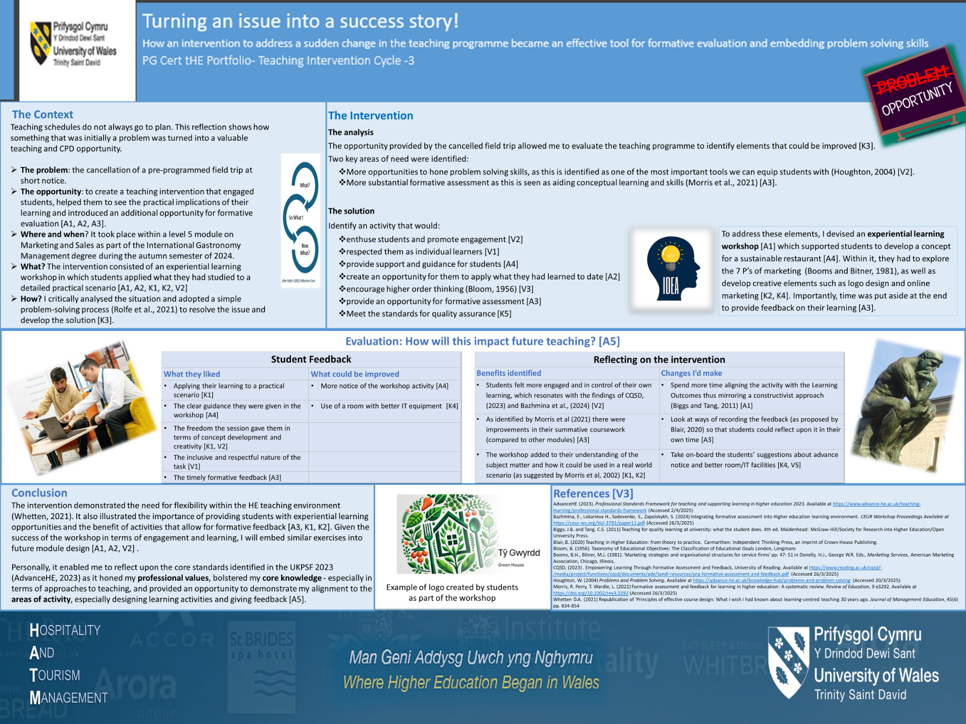

Continual Professional Development Log
This section reflects on three CPD activities undertaken whilst completing this module. I believe they have all had a constructive impact upon my lessons [A5]. The event was helpful in bringing industry-related evidence to my teaching, whilst the literature review and the Jisc webinar respectively emphasised the importance of student engagement and how digital/multimedia can help to achieve that [K4].

CPD Log 1.Castel Howell Trade Food Show, 19/2/2025, Parc Y Scarlets’ Llanelli.

Overview and content
This Trade Food Show was organised by Castell Howell ‘one of the UK's leading food service providers’ (Castel Howell, 2025). It was a unique local opportunity to refresh my subject knowledge [A5, V4] by speaking to specialists in the catering trade as well as offering networking opportunities with over 170 producers, most of which were Welsh. The event also featured cooking demonstrations showcasing local produce and alternative products such as peanut free satay and meat free chicken stock, reflecting the move towards less allergens in food and the popularity of vegan and vegetarian diets.

Reflection
This semester, I have lectured on the International Gastronomy Management degree course where industry knowledge and practical skills sit alongside theory. I have been teaching ‘Produce, Provenance and Sourcing’ to Level 4 Students, which looks at where food comes from, how sustainable it is, and the importance of a transparent supply chain. This event was ideal for updating my knowledge of Welsh produce and understanding the trends and challenges in the industry regarding sourcing and sustainability [A5]. It also allowed me to network with local suppliers, identifying some that would be willing to do guest lectures or host student visits [A1, K2, V3, V5].
Food and Drink Wales, a Welsh Government backed initiative promoting Welsh produce were represented. They provided very useful material relating to how restaurants and other catering outlets can use Welsh provenance to help them stand out in the marketplace. They also provided a food and drink map and useful food and drink tourism toolkits [V3, V5].

How it will benefit my teaching
The event allowed me to update and improve my knowledge of local suppliers which I can pass on to my students [A5, V3]. Of particular benefit in terms of lecture-based content was the source material provided by Food and Drink Wales [A1]. This included the food map which visually identifies over 160 suppliers across Wales and an infographic of statistics relating to consumer-based research. It effectively illustrates that customers’ place importance on the use of Welsh produce in restaurants. This information will also be shared with students in another module that I deliver - Marketing and Sales, as it gives a current and distinct Welsh perspective on how local produce can help make establishments more attractive to consumers (appendix 8.7) [A1, A2, K1, K2]. These types of graphical aids are particularly useful for learners who are ‘visualisers’, and prefer information presented pictorially or diagrammatically (Reece and Walker, 2007; Petty, 2009) [K1, K2, V1].

CPD Log 2. Enhancing Inclusive Student Engagement in Higher Education, QAA

Overview and content
This document delves into recent research on student engagement from around the globe and divides it into four key categories:
- ‘Defining student engagement
- Key elements of engagement
- Barriers to engagement
- Inclusive ways of engaging’ (Gulko et al, 2024, p. 4)

Reflection
I was interested to read this literature review, especially as it came under the umbrella of the Quality Assurance Agency for Higher Education [V3]. It began by lamenting the lack of a standard definition of student engagement. However, I agreed with its summation that several factors need to be taken into account when discussing it, including ‘behavioural, cognitive, psychological, socio-cultural and instructional aspects’ (Gulko et al., 2024, p. 6). The section on barriers also resonated with me, especially the warning that participation in and of itself, does not count as inclusivity (Gulko et al., 2024). This was further developed in a discussion around the differences between ‘‘engagement’ and ‘experience’’ (Kandico cited in Gulko et al., 2024, p. 8) where engagement requires the student to take an active role in their own education, suggesting an element of responsibility on their part. I welcomed the conclusion that this happens when the student is able to engage with content, with their fellow classmates and the lecturer and requires trust and respect between those involved (Leslie cited in Gulko et al., 2024), [V1, V2].
Having taught on programmes with large student cohorts where English wasn’t their mother tongue, the discussion about the barriers faced by students studying in a second language was very relevant (Gulko et al., 2024) [V1, V2]. The review also helped me reflect that those with other duties such as caring or working may be disadvantaged from attending extracurricular activities [V1]. Other obstacles identified related to physical, mental, and cultural barriers, whilst the type of learning environment, i.e. face-to-face or virtual classrooms also had an impact (Gulko et al., 2024) [A2, V1, V2]. The discussion made me reflect upon Biggs and Tang’s (2011) observations regarding the challenges created within HE by an increasingly diverse student population [A5, V3, V4].
The section on inclusive engagement was interesting and I took on board the suggestion that ‘considering inclusion should be a continuous and intentional process of creating a supportive learning environment’ (Gulko et al, 2024, p 13), [A2, A5]. It also addressed inclusive curriculum design and importantly made the correlation between engagement and success rates which reinforced my own opinion. It concluded that educators need to be more flexible in their approaches to learning and should be prepared to learn from student voices (Gulko et al, 2024), [A2, K1, V1, V2, V3, V5].

How it will benefit my teaching
The review provided practical pointers in improving student engagement that I will apply within my own teaching [A1, A2, A5, K2, V2, V3]. This includes the importance of creating content that empowers learners such as flipped classrooms and creating opportunities for more ‘interactive, hands-on activities’ (Gulko et al, 2024, p 8) [A2, A5, K2, K4]. By doing this, my students should feel that they own their learning and therefore become more engaged, i.e. they will cease being passive receivers of information and instead be active participants (Gulko et al, 2024) [V2, A1, A2, A4, A5].

CPD Log 3. Jisc Webinar, 5/2/2025. Transforming assessments: the power of multimedia in education

Overview and content
As a PG Cert student, I have been interested to learn from other lecturers regarding ways in which they teach and the tools they employ [A5]. This event was an opportunity to explore how colleagues in other universities are using multimedia to boost engagement, deliver learning and create engaging assessments [A5, K4, V4]. The webinar was organised by Jisc.

Reflection
The event consisted of two guest speakers who talked about their experience of using multimedia to enhance student learning. The first was Professor Louise Robson of the University of Sheffield. The second speaker was Dr Kok Choi Kong from Queen Mary University of London.
Professor Robson’s talk was relevant to me because she deals with large cohorts, similar to some courses within my own Discipline. She explained how she prioritises giving students’ core knowledge, and employability skills, the latter of which she equated with the ability to problem solve. This resonated with the courses I teach on, as we prepare students for practical jobs in hospitality where problem solving is a core skill [K2]. She explained how she uses active learning sessions to embed problem solving, adding that she employs ‘digital technologies to set them problems, problems that are novel they’ve not seen before’ (Robson, 2025) [A1, A2, A3, A4].
In terms of delivery, her students can attend live lectures in person or online (similar to UWTSD’s Hyflex system) or can just watch the recordings. She argued that this enabled students to engage in the way that best suited their lifestyle and avoided many barriers to participation [A2, A4, K4, V1, V2]. This is certainly different to the policy adopted in my Discipline, where live attendance (be it physical or online) is required.
The second speaker, Dr Kong explained how he solved the problem of creating engaging assessments [A3] for his pharmacology module – a subject he felt most medical students found boring as it consists of lots of drug names, facts and figures [K1]. This resonated with me, as I have to impart information about food regulations etc., which is necessary but not very exciting. His solution was to create group assignments where students worked together to make videos showcasing a drug and its properties. He showed an example and I felt it was really clever, impactful and demonstrated a high level of cognitive skills [K3 K4, K2, A3].

How it will benefit my teaching
This session reinforced my own use of multimedia platforms and inspired me by suggesting creative assessment methods [A1, A3, A5, K4]. I am keen to explore the idea of video creation as a form of assessment where appropriate to the subject and level of study not least because it ‘designs in inclusivity [is] effective in designing out plagiarism and gives students experience in developing digital, employability and enterprise skills’ (Challen, 2021) [A3, K2, K4]. I was also struck by Sheffield University’s approach in making lectures accessible to students at times that suit them i.e. without mandatory attendance [A2, K2, K4, V1, V2]. This is quite radical, but I would like to investigate doing this, if university policy allows [A5].

Teaching Observations
This section reflects upon teaching observations made by Dr. Louise Emanuel, Academic Director, Carmarthen Business School, [V5] of three Marketing and Sales lecturers delivered during the Spring term of 2025 to online students as part of their degree in International Gastronomy Management. As module lead for Marketing and Sales I had control over the content creation and delivery. This allowed me to adopt a constructive alignment approach (Biggs and Tang, 2011), embed activities and encourage engagement and provide formative feedback opportunities [A1, A2, A3, K1, V2]. As such, I was interested to see if this was reflected in Dr Emanuel’s observations.
As academics including Biggs and Tang (2011) Blackmore (2005) and Fullerton (2008) suggest, I have found that the feedback from the observations helped me to reflect upon what I do well and what further changes I can make to improve the quality of my teaching [A5]. In these instances, I have applied Schӧn’s ‘reflection on action’ (Bates, 2023 p.328), to identify improvements I have made since my first set of observations as part of my PGCert [A5, K2, K3,V3].

Observation 1, 5/2/2025 (observation form appendix 8.8)
Dr Emanuel’s feedback linked to the UKPSF (AdvanceHE, 2023) dimensions including the Areas of Activity. In terms of A1, she noted that the lecture used a well-designed PowerPoint presentation, and the slides aided discussion, allowing students to reflect on and move forward with their learning [A1]. This was welcomed as I had consciously embedded opportunities for discussion and student reflection within the structure of the sessions [A1, A2, K1].
With regards to A2, Dr Emanuel identified good student/lecturer rapport, with opportunities for students to raise questions or problems [A4, V1, V2]. It was observed that the session included a recap on the one before, and that links were made with learning from previous levels [A2, A4]. She noted the aims and objectives of the session were placed within the context of the module [A2]. She added that the learning environment was inclusive and resulted in high levels of attention and interest, creating ‘a real sense of a learning community’ [A1, A2, A3, K1, V1, V2]. This was encouraging as I had hoped to create an environment where students felt respected and engaged whatever their background or learning style [A1, K1, V1, V2]. In terms of formative assessment, it was remarked that discussion and activities had been embedded throughout the session, and that feedback was regular and affirmed student understanding [A3]. This was appreciated as I had consciously included more opportunities for formative feedback.
Dr Emanuel identified that I had aligned to the UKPSF’s (AdvanceHE, 2023) Core Knowledge dimension. In particular, I welcomed her recognition that I had thought about the online environment and I hadn’t just replicated a physical classroom [K1] as this was something I had intended. She also complimented the use of practical examples and case studies in encouraging discussion [K2, K5], as well as nurturing critical evaluation through activities [K3]. Furthermore, it was stated that my use of technology enhanced the learning experience [K4].
My alignment with UKPSF’s (AdvanceHE, 2023) Professional Values was also recognised including my respect for students [V1] and ensuring each voice is heard [V2]. It was identified that the session also had rigor in terms of theoretical and research-based underpinning [V3] whilst being rooted in the real world [V4]. Dr Emanuel also noted that the use of discussion encouraged collaboration and peer-to-peer learning [V5]. I was delighted with this feedback as I take my professional values very seriously and had considered them when planning the module.
Overall, the feedback was positive and demonstrated some conscious improvements when compared to last year’s observations [A5], as well as recognising my intentions regarding improving engagement and providing opportunities for formative feedback [A3, V2]. However, one area identified for action was collaborative learning. This is fair and is something I have since addressed in other modules though shared-task workshops (see 2. poster). I will continue to explore collaborative learning tools and have already identified ideas from colleagues and sources such as The Bell Foundation (2025) [V5]. Possibilities include game-based activities, listening triangles, role play and think-pair-share sessions [A1, A2, K2, K5, V2, V3].

Observation 2, 26/2/2025, (observation form, appendix 8.9)
Again, feedback was aligned to the UKPSF (AdvanceHE, 2023). In terms of Areas of Activity, the feedback for A1 noted that the slides were clear, engaging, and promoted discussion; and that both contemporary examples and academic literature had been embedded in the content [V3, V4]. It also identified that video had been effectively used to augment content [K4]. This was welcome feedback and reflected my intended design for the module [A1].
Dr Emanuel positively noted the structure and flow of the lecture, highlighting the progress from the learning objectives through to discussion-based learning and ending with a session on the assessment [A2, A3, A4]. She also welcomed the pace and the additional resources/extension activities provided [A2, K2]. In terms of A4, she identified the learning community that had been fostered despite the small cohort size. This feedback reflected my intention to respectfully support students by creating an effective learning environment [A4, V1]. Similarly Dr Emanuel’s positive reaction to my approach to A3 was reassuring, as it noted that the interactive learning environment I created had provided opportunities for feedback to students and ‘affirmation of their understanding of key concepts’ [A3]. This acknowledgement was useful in identifying what worked well and which approaches I could strengthen when developing module and lesson plans in the future.
Feedback on Core Knowledge was positive, and highlighted alignment with the statements in the UKPSF (AdvanceHE, 2023). Dr Emanuel again noted that I had focussed on how learning happens online [K1]; how the discussion sessions were stimulated by practical examples and case studies [K2, K5]; the use of appropriate digital technologies [K4] and how in-built activities had encouraged critical thinking [K3]. These observations will help to shape how I plan and deliver learning in future.
Dr Emanuel also highlighted how I had aligned with UKPSF’s (AdvanceHE, 2023) Professional Values statements. As before, she identified that I engaged with all students and acknowledged their voices [V1, V2]; that I had employed both contemporary theory and real-world applications [V3, V4], and had encouraged peer-to-peer learning through discussion [V5]. This was both heartening and helpful feedback as it highlighted good practice that I could transfer to other modules.
One area that was identified for action was the provision of preparatory reading. I think this is a useful point and I will build this into module design in future. I will also explore how I can incentivise the pre-reading in some way as this can have a ‘positive and significant effect on engagement’ (Shaker, Brignell & Pugh 2023) [A1, A2, K2, V2].

Observation 3, 5/3/2025 (observation form, appendix 8.10)
The observation was aligned to the UKPSF (AdvanceHE, 2023) framework including the Areas of Activity statements. In terms of A1, she noted that the slides and accompanying presentation provided ‘a solid framework for the session, blending discussion points and activities with informative content’. In relation to teaching and support, the feedback was complimentary regarding rapport, session structure, pace, and student engagement [A2, V2]. I have reflected upon these positive comments and identified the elements of my lesson design that worked well [A1].
Dr Emanuel noted that small groups can be challenging in terms of maintaining participation and interaction but stated that this lecture was highly effective in doing so [A4]. This was encouraging as by this point in the module, a number of students had been withdrawn, and I had adapted the lectures accordingly. The feedback suggested that I had done this effectively and without adverse effect on the remaining students. This demonstrates that I can apply Schӧn’s ‘reflection in action’ (Bates, 2023, p.328) [K3]. The successful use of formative assessment and evaluation [A3] was acknowledged and it was noted that clear instructions were provided to students [A4].
It was identified that the lesson reflected UKPSF’s (AdvanceHE, 2023) Core Knowledge statements. In particular, she recognised that it was pitched at an appropriate academic level [K2] and used a range of tools to appeal to a wide range of learning styles [K1]. Furthermore, she said the use of evidenced-based practice demonstrated critical evaluation [K3] and the lesson reflected the requirements for quality assurance [K5]. The use of appropriate digital tools was also highlighted [K4].
Dr Emanuel recognised that the UKPSF’s (AdvanceHE, 2023) Professional Values had been applied, through a demonstration of respect [V1] and the use of inclusive content within ‘an equitable learning environment’ [V2]. She also acknowledged the use of academic literature alongside contemporary examples [V3] which led to the session being relevant in the wider context [V4]. Finally, she noted that the lesson highlighted the benefits of collaboration through group work and shared experiences [V5]. This feedback helped me identify elements that can be enhanced and applied in future.
The action point was to include more breakout activities. I agree this is an area that was lacking from the session, and I will work to address this for future online cohorts using Teams’ breakout rooms [A5, K4]. As Panigrahi (2020) recognises, this type of change in the learning environment with its emphasis on student-led research can help enhance ‘confidence, performance, and productivity’ in learners. In conclusion, the feedback was welcomed, as was the recognition of my efforts to create a supportive and constructivist approach to lecturing (Biggs and Tang, 2011)

Reflection
Having completed the course work for the PGCert THE, it is timely to reflect on the impact this has had on me as a practitioner in HE. When I started the course, I had been a lecturer on and off for almost 20 years. I had no formal training in delivering education, and as such my teaching style and content was informed by instinct and my own experience of lectures as a student at graduate and postgraduate levels. The PGCert was offered to me as part of a move to increase professionalism within the University, echoing the drive in HE for quality assurance and enhancement in a competitive marketplace [K5, V4]. As a self-confessed life-long learner, I embraced this professional development opportunity [A5]. The course’s emphasis on reflective practice helped me realise that to make lectures more effective, inclusive and engaging for students, I had to revisit them and identify what I was good at, and more crucially, what needed improving [A5, K3, V1, V2].
The course opened my eyes to the world of educational theory and academia [V3]. I have discovered behaviourist, cognitivist and humanist theories of ‘human activeness in learning’ (Bates, 2023, p.92). I have been influenced by ideas such as Blooms Taxonomy (1956) in developing learning outcomes, and as shown in my teaching interventions, I have adopted Bigg’s (2005) approach of constructive alignment when designing and planning learning, thus ensuring that ‘learning outcomes, assessment and course content are all headed in the same direction’ (DADC, 2025, p.1) [A1, A2, A3]. Furthermore, developing the teaching intervention reports has enabled me to reflect upon my practice and to frame it within an academic context [A5, V3].
I found the teaching observations to be enlightening and took useful learning from watching how colleagues use the tools and techniques of our trade [V5]. I also valued the feedback when being observed, and by comparing it from year one to year two, I could see where ‘reflection on action’ (Schӧn in Bates, 2023, p.328) has already enabled me to make improvements [A5] particularly in terms of engagement and ensuring learning environments are created where all learning styles are catered for and supported [A2, A4, K1, K2, V2]. The course also encouraged me to seek out and reflect upon continual professional development opportunities [A5]. These included attending webinars, conferences and trade shows, and reading books and articles. I have enjoyed analysing the learning from these to help me to increase my knowledge and improve as a professional [A5, K3, K5, V3]. The PGCert has already led to improvements in my professional capability, but this learning journey will continue throughout my professional career [A5]. I have already identified developmental needs including keeping pace with AI and how it impacts upon HE [K4, V4].
I am also keen to expand my teaching toolkit so that I can continue to improve student support, inclusion and engagement [A1, A2, A4]. Based on the teaching observations this could include more opportunities for collaborative activities, better use of breakout rooms and incentivised pre-reading [A1, A2, K2]. I will also investigate more digital learning tools as means of making the subject matter accessible, exciting and engaging [A2, K1, K2, K4, V3]. My final reflection is that I have been very fortunate to be given the chance to study the PG Cert THE as it has helped me to grow both professionally and personally [A5]. I would like to thank my Tutor and the Programme Manager for their support.

Teaching Log
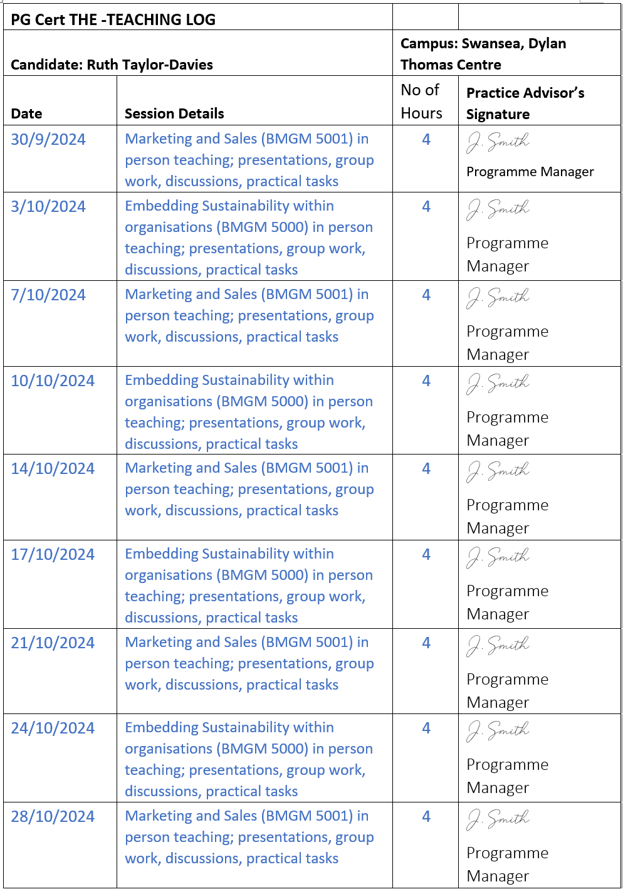
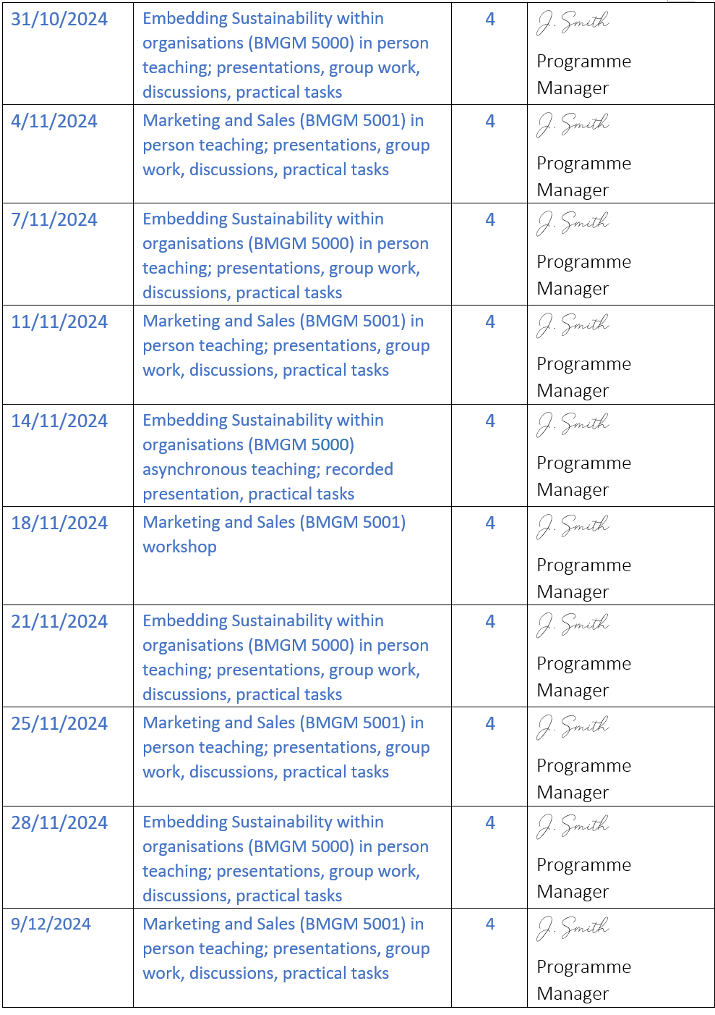
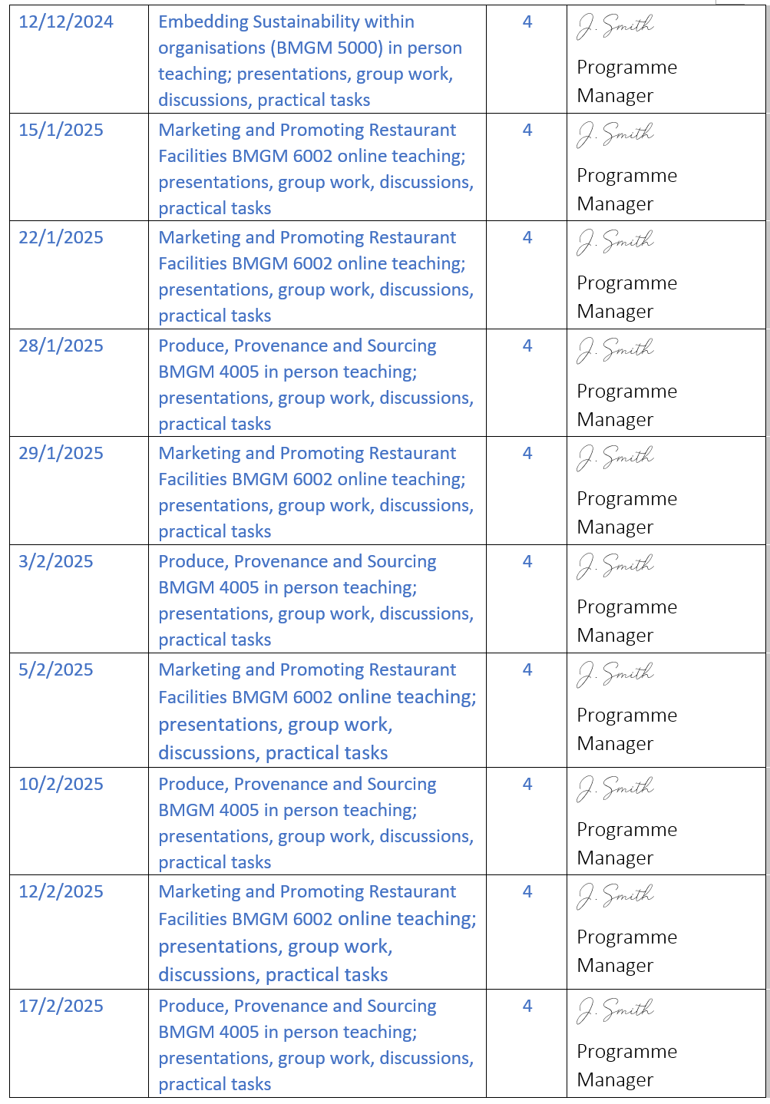
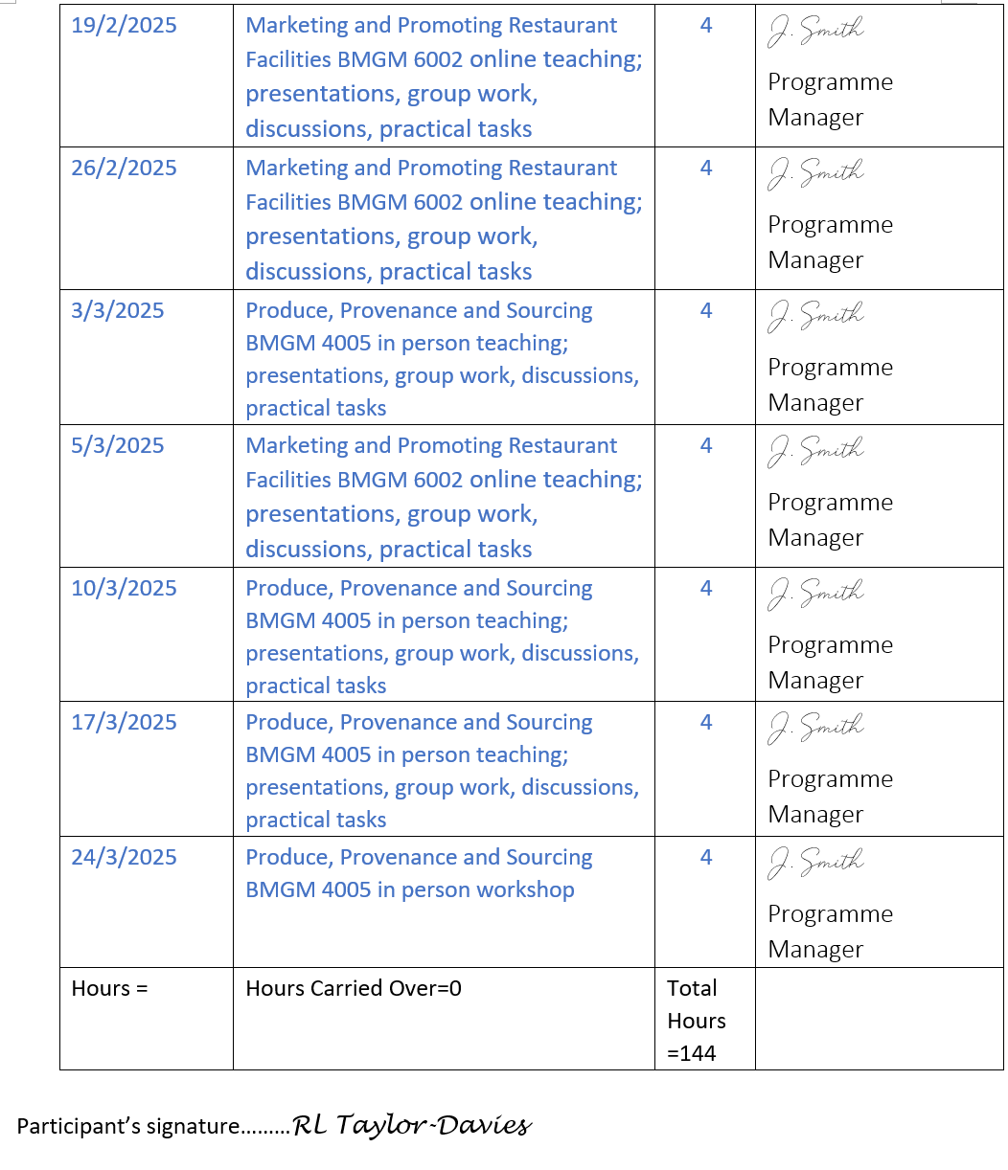

References

AdvanceHE (2023) Professional Standards Framework for teaching and supporting learning in higher education 2023. Available at https://www.advance-he.ac.uk/teaching-learning/professional-standards-framework (Accessed 2/4/2025)

Bates, B. (2023) Learning theories simplified: ...and how to apply them to teaching, 130+ theories and models from great thinkers. 3rd edition. London; SAGE.

Bazhmina, E., Lokarieva H., Sadovenko, S., Zapolskykh, S. (2024) Integrating formative assessment into Higher education learning environment. CEUR Workshop Proceedings Available at https://ceur-ws.org/Vol-3781/paper11.pdf (Accessed 26/3/2025)

The Bell Foundation, (2025) Great Idea: Collaborative Activities. Available at https://www.bell-foundation.org.uk/resources/great-ideas/collaborative-activities/ (Accessed 22/04/2025)

Biggs, J.B. (2005) Aligning teaching for constructing learning. Higher Education Academy Discussion Paper. Available at: https://www.heacademy.ac.uk/system/files/resources/id477_aligning_teaching_for_constructing_learning.pdf (Accessed 23/04/2025)

Biggs, J.B. and Tang, C.S. (2011) Teaching for quality learning at university: what the student does. 4th ed. Maidenhead: McGraw-Hill/Society for Research into Higher Education/Open University Press.

Blackmore, J.A. (2005) ‘A Critical Evaluation of Peer Review via Teaching Observation within Higher Education’, International Journal of Education Management, 19 (3), pp. 218-232. Available at: https://www.emerald.com/insight/content/doi/10.1108/09513540510591002/full/html (Accessed: 12 April 2025)

Blair, B. (2020) Teaching in Higher Education: from theory to practice. Carmarthen: Independent Thinking Press, an imprint of Crown House Publishing.

Bloom, B. (1956) Taxonomy of Educational Objectives: The Classification of Educational Goals, London, Longmans.

Booms, B.H., Bitner, M.J. (1981) ‘Marketing strategies and organisational structures for service firms’ pp. 47- 51 in Donelly, H.J., George W.R. Eds., Marketing Services. Chicago, Illinois, American Marketing Association, ,

Castell Howell, (2025). Who we are. Available at: https://www.castellhowellfoods.co.uk/en (Accessed 20/2/2025)

Challen, R. (2021) Inclusive pedagogy: using multimedia as a tool to enhance and transform assessment. Times Higher Education. Available at: https://www.timeshighereducation.com/campus/inclusive-pedagogy-using-multimedia-tool-enhance-and-transform-assessment (Accessed 3/4/2025)

CQSD (2023) Empowering Learning through Formative Assessment and Feedback, University of Reading. Available at https://www.reading.ac.uk/cqsd/-/media/project/functions/cqsd/documents/ade/tandl-resources/prp-formative-assessment-and-feedback.pdf (Accessed 26/3/2025)

Dewey, J. (1933). How We Think A Restatement of the Relation of Reflective Thinking to the Educative Process. Boston, MA D.C. Heath & Co Publishers.

DCAD Team, Durham University, (2025). Constructive Alignment. Available at: https://dcad-resourcebank.webspace.durham.ac.uk/2024/01/25/constructive-alignment/ (Accessed 26/3/2025)

Farrell, T. (2012) reflecting on reflective practice: (Re) visiting Dewey and Schӧn, TESOl Journal 3, 7-16 Available at: https://eric.ed.gov/?id=EJ1010488, Accessed 15/4/2025)

Fullerton, H. (1993) ‘Observation of teaching: guidelines for observers and observed:’ in Brown, S., Jones, G. and Rowley S. (eds) Observing Teaching. Birmingham: SEDA Publications. Available at: https://files.eric.ed.gov/fulltext/ED376756.pdf#page=74 (Accessed: 15 April 2024).

Gulko, N., Wood, N., Blondeel, E., Churyk, N.T., Derbyshire, L.E., Kawor, S., Lento, C., McGuigan, N., Merendino, A., Middelberg, S.L., Sahoo, S.K., Tong, J.T., and Withanage, N., (2024) Enhancing Inclusive Student Engagement in Higher Education: Literature Review. Quality Assurance Agency for Higher Education. pp. 1-22.

Hѐbert C. (2015) Knowing and or experiencing: a critical examination of the reflective models of John Dewey and Donald Schӧn. Reflective Practice, 16:3, pp 361-371 Available at https://www.tandfonline.com/doi/full/10.1080/14623943.2015.1023281
(Accessed 15/4/2025)

Houghton, W. (2004) Problems and Problem Solving. Available at https://advance-he.ac.uk/knowledge-hub/problems-and-problem-solving (Accessed 20/3/2025)

Hughes and Linsey (2025) How AI may make us rethink the purpose of HE. QAA Blog, 6 February 2025. Available at https://www.qaa.ac.uk/news-events/blog/how-ai-may-make-us-rethink-the-purpose-of-he Accessed 16/4/2025)

Jasper, M. (2013) Beginning reflective practice. Second edition. Australia: Cengage Learning.

Lemov, D. et al. (2020) Teaching in the Online Classroom; Surviving and Thriving in the New Normal. Jossey Boss, a Wiley Brand. Available at https://librarysearch.uwtsd.ac.uk/permalink/44WHELF_UWTSD/11c0l68/alma99100507102502421 (Accessed on 10/4/2025)

Lucas, M. and Vicente, P. (2022) A double-edged sword: Teachers’ perceptions of the benefits and challenges of online teaching and learning in higher education. Education and Information Technologies 28: pp. 5083-5103 Available at https://doi.org/10.1007/s10639-022-11363-3 (Accessed 9/4/2025)

Macher, R. (2017) Teaching Intervention Strategies that Enhance Learning in higher Education. Universal Journal of Education Research 5 (5) pages 733-743, Available at http://www.hrppub.org (Accessed 26/3/2025)

Morris, R. Perry, T. Wardle, L. (2021) Formative assessment and feedback for learning in higher education: A systematic review. Review of Education, 9 e3292. Available at https://doi.org/10.1002/rev3.3292 (Accessed 26/3/2025)

Petty, G. (2009) Teaching today: a practical guide. 4th ed. Cheltenham: Nelson Thornes.

Preece, K. (2023) AI-lluminating the path to adapting assessment. Available at https://www.advance-he.ac.uk/news-and-views/ai-lluminating-path-adapting-assessment, (Accessed 16/4/2025)

Quality Assurance Agency (2014) Frameworks for Higher Education Qualifications of UK Degree-Awarding Bodies. Available at: https://www.qaa.ac.uk/docs/qaa/quality-code/the-frameworks-for-higher-education-qualifications-of-uk-degree-awarding-bodies-2024.pdf?sfvrsn=3562b281_11 (Accessed 9/4/2025)

Quality Assurance Agency (2019) Subject Benchmark Statement: Events, Hospitality, Leisure, Sport and Tourism. Available at https://www.qaa.ac.uk/docs/qaa/subject-benchmark-statements/subject-benchmark-statement-events-leisure-sport-tourism.pdf?sfvrsn=c339c881_11(Accessed 14/4/2025)

Quality Assurance Agency (2024 a.) UK Quality Code for Higher Education. Available at https://www.qaa.ac.uk/docs/qaa/quality-code/uk-quality-code-for-higher-education-2024.pdf?sfvrsn=19a5b881_32, (Accessed 14/4/2025)

Quality Assurance Agency (2024 b.) UK Quality Code for Higher Education 2024 - Sector-Agreed Principles. Available at https://www.qaa.ac.uk/docs/qaa/quality-code/uk-quality-code-for-higher-education-2024-sector-agreed-principles.pdf?sfvrsn=6da5b881_11 (Accessed 14/4/2025)

Reece, I and Walker, S. (2007) Teaching, training and learning: A practical guide 6th edn. Tyne and Wear, Business Education Publishers

Robson, L. (2025). Transforming assessments: the power of multimedia in education. In: Jisc Events, Online, 5/2/2025. Recording available at https://www.jisc.ac.uk/events/transforming-assessments-the-power-of-multimedia-in-education (Attended live, 5/2/2025)

Rugani J and Grijalva K. Dissolve the Screen in Lemov, D. et al. (2020) Teaching in the Online Classroom; Surviving and Thriving in the New Normal; Jossey Boss, a Wiley Brand Available at https://librarysearch.uwtsd.ac.uk/permalink/44WHELF_UWTSD/11c0l68/alma99100507102502421 (Accessed on 10/4/2025)

Appendices

Programme Aims
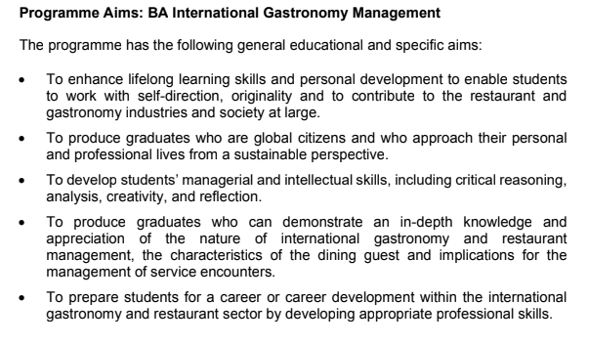

Programme Learning Outcomes
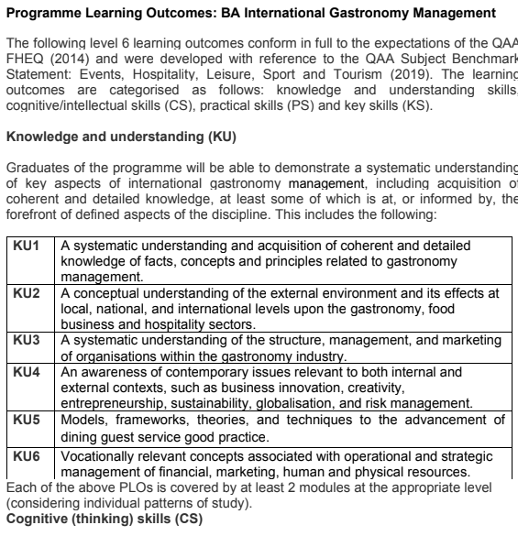
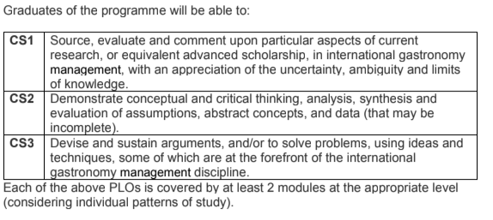
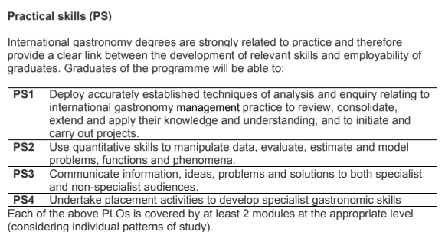
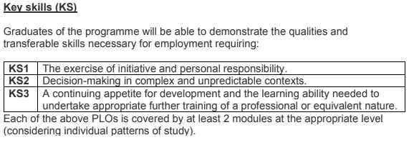

Module Learning Outcomes
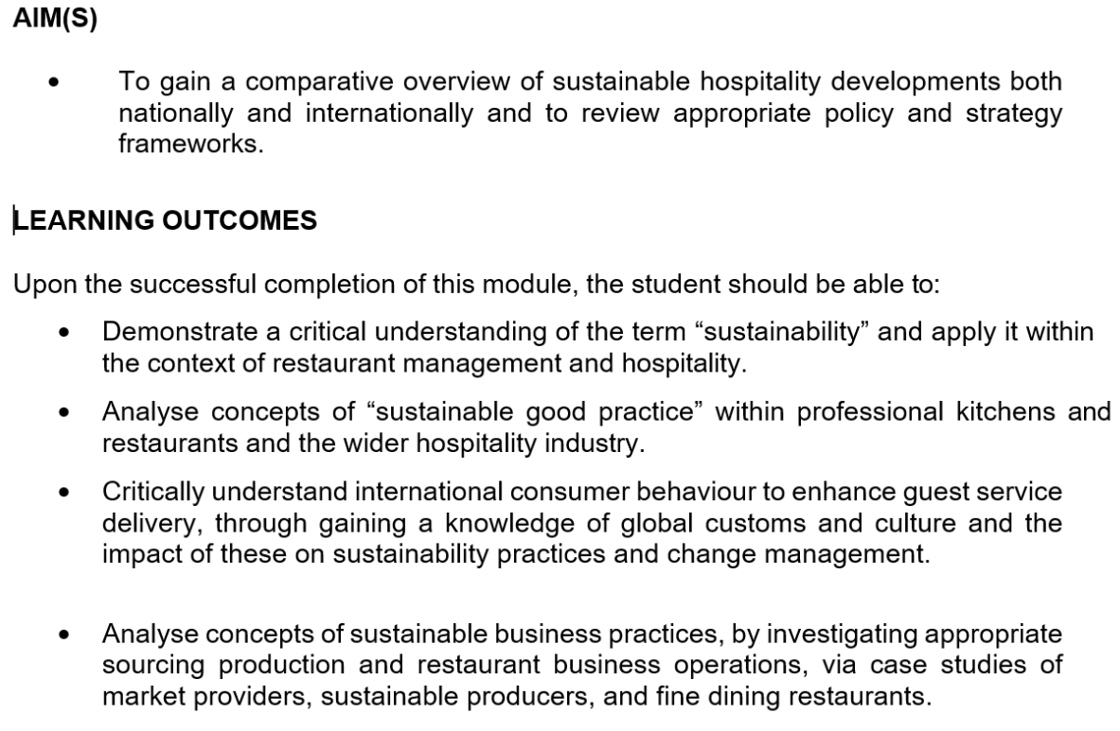

Module Indicative Content
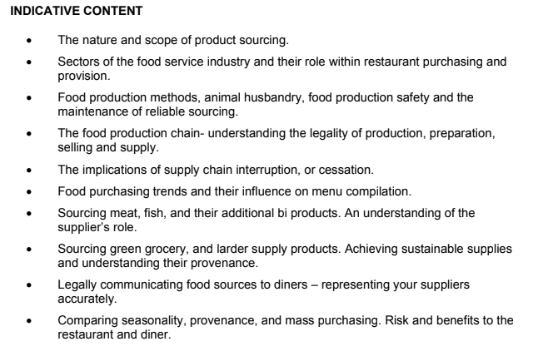

Scheme of Work

Week | Time | Lecture content – main themes to be covered | Teaching Methods & Supporting material | Assessment hand out date | Assessment submission date
Week 1 | 9AM-1PM | Learning objectives (from Programme Document):  Demonstrate a critical understanding of the term “sustainability” and apply it within the context of restaurant management and hospitality.  Introduction Week  Class rules  Student code of conduct  What is sustainability?  Definitions – why is sustainability important? | Ice-breaker activity  PowerPoint  Socratic questioning  Video  Guided online research  Group Activities  Group Discussions | Assignment 1  Assignment 2 | Time:  Date:  Time:  Date:
Week 2 | 9am-1pm | Recap  Learning objectives (from Programme Document):  Demonstrate a critical understanding of the term “sustainability” and apply it within the context of restaurant management and hospitality.  Analyse concepts of “sustainable good practice” within professional kitchens and restaurants and the wider hospitality industry.  Sustainable Hospitality  Pillars Of Sustainability  History  Sustainable Development Goals  Tourism and hospitality:  - Economic benefits and dis-benefits  - Social benefits/dis-benefits  - Environmental benefits/ dis-benefits  - Over tourism  - Sustainable Tourism  Gastronomy and the 3 pillars of sustainability  - Food miles  - Food waste  Assignment 1 briefing | PowerPoint  Video  Socratic questioning  Group Activities  Guided online research  Discussion  Guardians of grub toolkit  WRAP Action Plan  Case study: Burnt Chef  Individual activity – create a 2 minute presentation
Week 3 | 9am-1pm | Recap  Learning objectives (from Programme Document)  Demonstrate a critical understanding of the term “sustainability” and apply it within the context of restaurant management and hospitality.  Corporate Responsibility and Ethical Business Practice  - Corporate Social Responsibility  - Responsible Leadership  - Caroll’s Pyramid  - Importance of CSR  - Driver’s for change  - Exemplar businesses  - Green-washing | PowerPoint  Socratic questioning  Chat function  Video  Group Activities  Guided online research – analysing information and feeding back to the group  Discussion  Case studies – Starbucks, Marriott, Melia
Week 4 | 9am–1pm | Recap  Learning objectives (from Programme Document):  Demonstrate a critical understanding of the term “sustainability” and apply it within the context of restaurant management and hospitality.  Analyse concepts of sustainable business practices, by investigating appropriate sourcing production and restaurant business operations, via case studies of speciality market providers, sustainable producers, and fine dining restaurants.  Us as consumers  - Energy usage  - Waste creation food 7 & e-waste  - Greener living  Sustainable Hospitality –  - Regulations  - Greening Your Business  - The Linear economy  - The Circular Economy  - Using technology to help become more sustainable in restaurants  Assignment 1 briefing | PowerPoint  Statistical web site search/  Energy dashboard  Infographics  Video  Group Activities  Socratic questioning  Guided online research – analysing information and feeding back to the group  Case study: Circular hotel model, Majorca
Week 5 | 9am-1pm | Recap  Learning objectives (from Programme Document):  Demonstrate a critical understanding of the term “sustainability” and apply it within the context of restaurant management and hospitality.  Critically understand international consumer behaviour to enhance guest service delivery, through gaining a knowledge of global customs and culture and the impact of these on sustainability practices and change management.  Sustainable Hospitality: consumer behavior  - Market trends  - Understanding consumers  - Consumer psychology  - International consumers  - Consumer trends  - Inter relationship between gastronomy, hospitality & tourism  - Host populations  - Tourism /product Lifecycles  - Destination management | PowerPoint  Video  Group Activities  Discussions  Mintel statistics  Group workshop: developing a customer profile  Doxey’s irridex  Butler’s Model |  | Assignment 1 due in  Time:  Date:
Week 6 | 9:00am-1pm | Recap  Learning objectives (from Programme Document):  Analyse concepts of “sustainable good practice” within professional kitchens and restaurants and the wider hospitality industry.  Analyse concepts of sustainable business practices, by investigating appropriate sourcing production and restaurant business operations, via case studies of speciality market providers, sustainable producers, and fine dining restaurants.  Sustainable Gastronomy:  - Farm to fork  - EU/UK farming strategies  - Farm diversification – examples  - Food Provenance  - Seasonality  - Gastronomy/food Tourism  - Key Markets  - Value  Assignment 2 briefing | - PowerPoint  - Video  - Socratic questioning  - Case study – UK farm to Fork Summit  - Case study: Llaeth Beynon Farm  - Guided online research/ case studies: Pasture restaurant/Heckfield Place  - Group Activities – create a 3 course menu based on seasonal produce
Week 7 | 9am-1pm | Recap  Learning objectives (from Programme Document):  Demonstrate a critical understanding of the term “sustainability” and apply it within the context of restaurant management and hospitality.  Analyse concepts of “sustainable good practice” within professional kitchens and restaurants and the wider hospitality industry.  Analyse concepts of sustainable business practices, by investigating appropriate sourcing production and restaurant business operations, via case studies of speciality market providers, sustainable producers, and fine dining restaurants.  Sustainable Gastronomy Development. What makes a good sustainable restaurant?  - Certification  - Green key awards  - The Sustainable Restaurant Association  - National Restaurant awards – the Bull Inn  - Michelin Green Star  Assignment 2 briefing | - PowerPoint  - Online activity  - Group activities - Socratic questioning  - Individual activities – Report on case studies for presentation/ discussion: Hotel Soll Cress; Gric restaurant, El Khornat Hotel Amber; The Restaurant Group; (guided online research);  - Individual activity – write a press briefing about the Michelin Green Star award
Week 8 | 9am-1pm | Recap  Learning objectives (from Programme Document):  Demonstrate a critical understanding of the term “sustainability” and apply it within the context of restaurant management and hospitality.  Analyse concepts of “sustainable good practice” within professional kitchens and restaurants and the wider hospitality industry.  Analyse concepts of sustainable business practices, by investigating appropriate sourcing production and restaurant business operations, via case studies of speciality market providers, sustainable producers, and fine dining restaurants.  Reminder of:  - three pillars of sustainability  - Sustainability in gastronomy  Current issues in Sustainability.  - Sustainable gastronomy day  - Regenerative agriculture  - World’s Most sustainable Restaurant  Assignment workshop  Module Conclusion/ Evaluation | PowerPoint  Video  Guided online research  Individual activity – create slides relating to the criteria related to sustainable restaurants  Case study – Azurmendi Restaurant  Quiz  Socratic questioning/Discussion  Sustainable gastronomy day toolkit |  | Assignment 2 due  Time:  Date:

Lesson Plan - Example
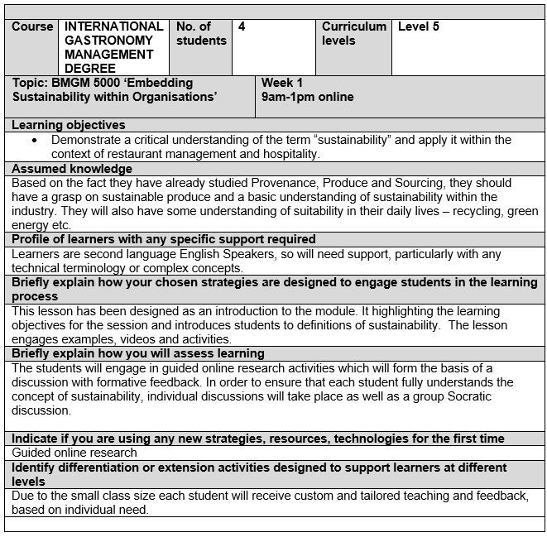
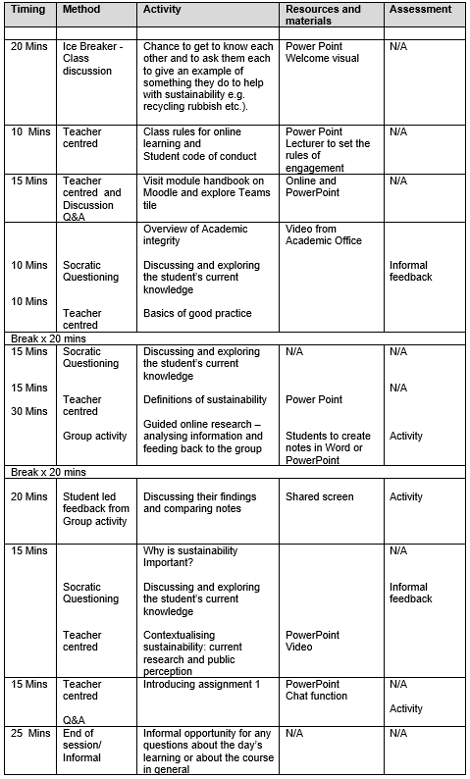

Food and Drink Wales Infographic
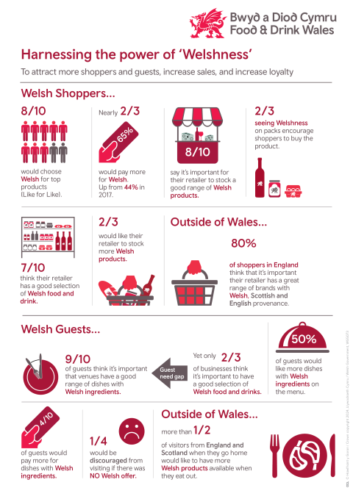

Teaching Observation Form 5/2/2025
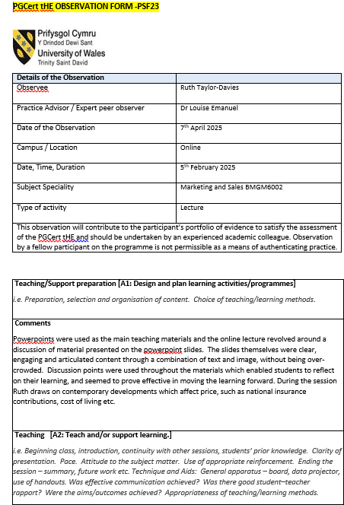

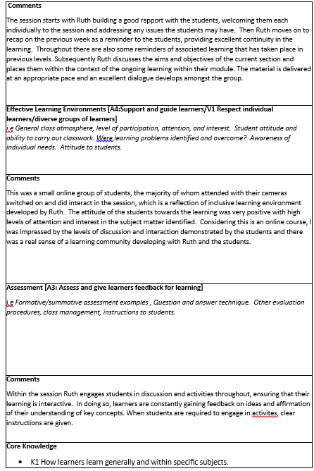
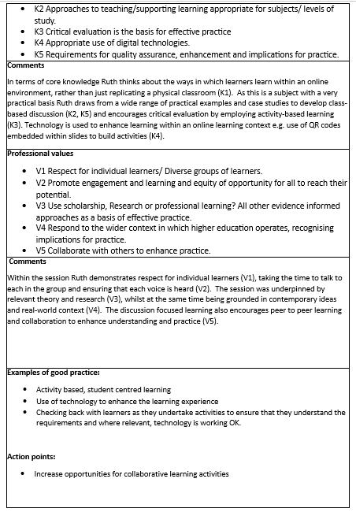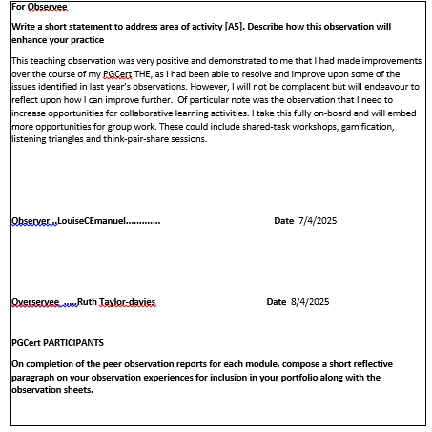

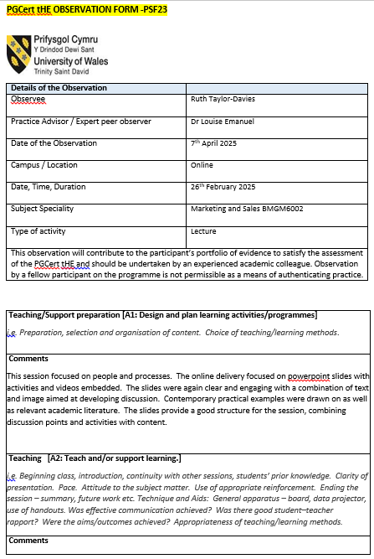
Teaching Observation Form 26/2/202
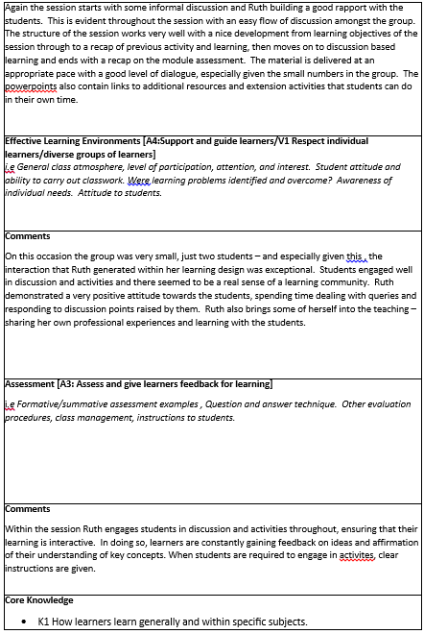

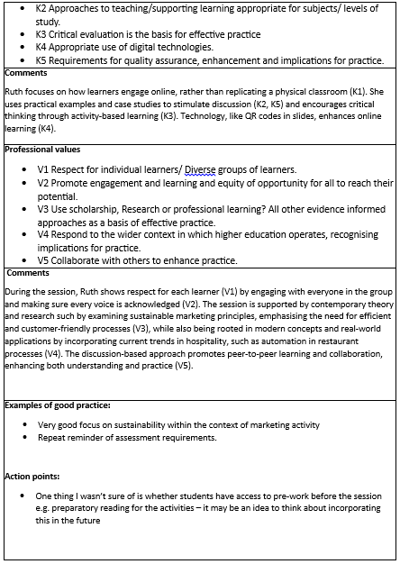

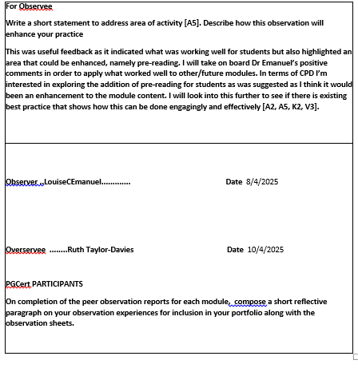

Teaching Observation Form 5/3/2025


