University of Wales Trinity Saint David

School of Engineering

Assignment 1

Materials and Introduction to Manufacturing

M4X01163

Hussain Khan

1701219

Date

23/03/2020

Table of Contents
1 Introduction 1
1.1 Aims 1
1.2 Objectives 1
2 What is Casting 2
2.1 Injection Moulding 5
3 Methodology 7
4 Discussion 8
5 Conclusion 11
6 Reference 12

Introduction

Aims
The aim for this assignment is to write a Lab report based on the skills gained on the course so far and to design and manufacture a pattern to make a badge or figurehead. It is not required to make the badge or figurehead itself, only the pattern. The software package, Solidworks, will be used to manufacture the pattern. The design of the pattern is to be manufactured with sand casting in mind and the research of the factors that should be considered when designing for this method, will be included in this report.
After this, consideration will be given as to the changes required if the manufacturing method was changed to polymer injection moulding and these changes will be included in the report.

Objectives
The objective of this task will be to design and manufacture a pattern of a figurehead or badge using Solidworks, if the pattern were to be manufactured using sand casting. As a result of this work, it is expected that an understanding of the knowledge of the applications advantages, limitations and different manufacturing processes, will be gained. The last objective is to gain an understanding of the engineering materials and the manufacturing processes involved.

What is Casting
Casting is the fabrication process, where a molten metal is poured into a mould cavity of a desired frame (William, 1994). The metal will adapt to the shape of the mould and the molten metal will experience shrinkage. According to William, “Casting techniques are employed (1) when the finished shape is so large or complicated than any other method would be impractical” (William, 1994, p.350).

Sand Casting
Sand casting is the most common method of casting used, as ordinary sand is used to mould the pattern. Two pieces of mould are formed by packing sand around the pattern and it has the shape of the intended casting (William, 1994, p.350- p.351). Sand Casting involves a gating system which is incorporated into the mould and which allows the flow of the molten metal into the cavity and to minimise internal casting defects. Examples of , “Sand-cast parts include automotive cylinder blocks, fire hydrants and large pipe fittings” (William, 1994,p.351).
There are different types of sand casting methods. One method of sand casting is called Foundry Sand casting and which uses a sand which is blended with Silica Gains (SiO₂) and 5-20% of clay or bentonite of water 2-8% (OpenLearn, 2017).
(See Figure 1)

Another method of sand casting is whereby the sand is moulded by hand or a machine around the pattern. A wooden or metal pattern can be withdrawn from the sand to leave the cavity of the required shape. Moulds are usually split into two or more parts of the pattern, which is tapered by 5mm. ‘Yields are 40-50%, cast weights range from 100g to 100 tonnes’ (OpenLearn, 2017).

Die Casting
Die casting uses molten liquid metal which is forced into a mould under pressure and at a relatively high velocity. The liquid metal is allowed to harden and the pressure is maintained during this stage of the process. Two pieces of permanent steel mould, or die, are employed when the pattern is clamped together for the desired shape (William, 1994, p.351).
When the solid faction has been completed and achieved, the die pieces are opened and the cast piece is ejected. The technique of Die Casting lends itself to using only small pieces of alloys of Zinc, Aluminium and Magnesium, which all have low melting temperatures (William, 1994, p.351).

Investment Casting
Investment Casting is sometimes called Low Wax Casting, where the pattern is made from wax or plastic. The wax or plastic both have a low melting temperature and a fluid called Slurry is poured around the pattern which sets the form of a solid mould or investment (William, 1994, p.351). Then a mould is heated which allows the pattern to melt and it is burned out. This leaves behind the
Mould cavity and it has a desired shape. The technique is employed with high dimensional accuracy and reproduction of the final pattern detail shape (William, 1994, p.351).

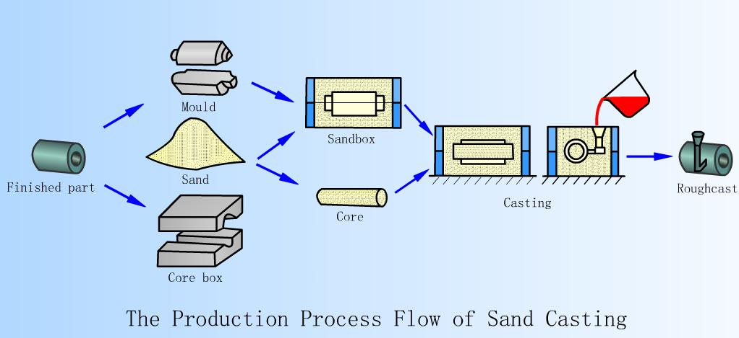
Figure 1 Sand Casting (DHF, 2015)

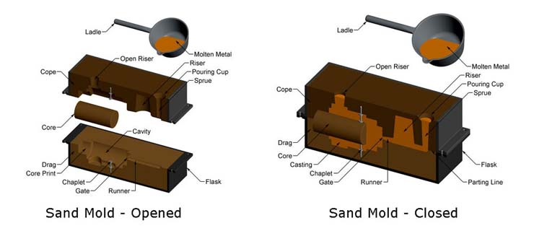
Figure 2 Sand Moulds (DHF, 2015)

Injection Moulding
The Injection Moulding Process involves heating and injecting plastic materials under the closed metal mould tool. This allows thousands or even millions of identical parts to be manufactured cheaply (Toolcraft, n.d). Molten plastic is cooled and hardened into a shape inside the mould tool, which is then opened to allow the moulding to be ejected and removed for inspection. This is followed by the secondary operation (Toolcraft, n.d).
Injection Moulding Process he first stage of the Injection Moulding Process is the melting process, in which a plastic material is fed from the hopper feed into a heated barrel and rotating screw. The material is melted by heat, friction and shear force and is then forced through a check valve to the front of the tool (Toolcraft, n.d.)
The second stage of the process is the injection phase. The screw is moved backwards by a shot of material in the front and then the screw is forced forward by a hydraulic ram. “This action injects material into the mould cavity on the closed mould tool” (Toolcraft, n.d).
The third stage of the process is the Cooling stage. This is where a tool is held closed under pressure until the plastic material cools and sets hard in the mould cavity. This is often one of the longest parts in the injection Moulding Process (Toolcraft, n.d.).
The final stage is the Ejection stage in which the screw starts to move back for the next moulding. This allows the tool to open and the finished plastic part is ejected. “The tool is closed and the injection moulding process starts again at stage 1” (Toolcraft, n.d.)
The Injection Moulding is the polymer analogue of die casting of metals and it is most widely used technique of fabricating thermoplastic materials. Thermosetting polymers are also being injection moulded when curing takes place when the material is under pressure and is heated mould. This will result in a longer cycle times than thermoplastic. (William et al. 2020, p.88)

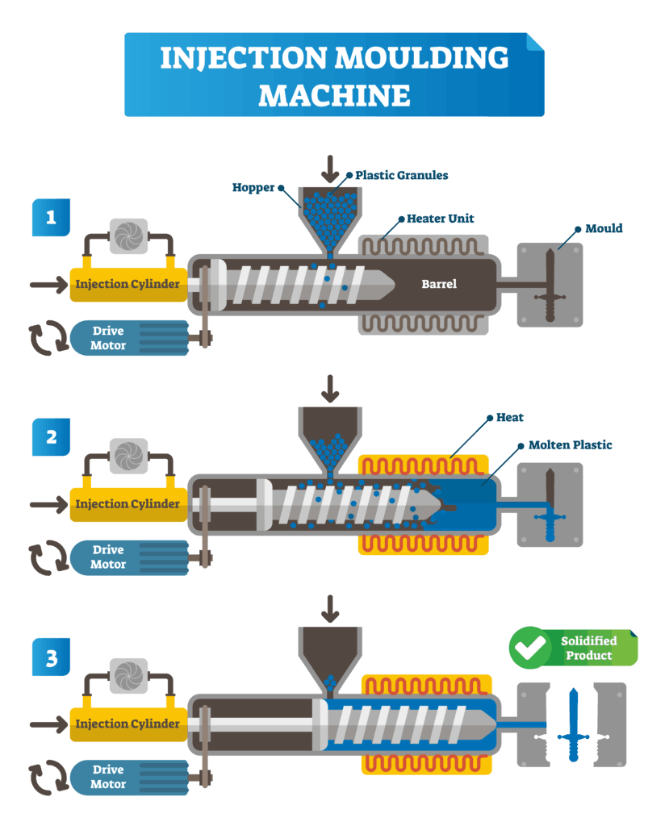
Figure 3 Injection Moulding (GEOmiq, 2019)

Methodology
The aim of this section is to explain the methodology in the Design and Manufacturing process of the Nike pattern, which is shown in Figure 4. The aim has been to design the pattern on Solidworks and to make sure that it is a suitable design and not too complicated for when it comes to Sand Casting the pattern. Using Sand Casting for the pattern will be suitable, whereby sand will be placed around the pattern mould, in order to make the pattern.
The next part of the task is to consider the changes required if the Nike pattern were to be designed and manufactured using Injection Moulding.
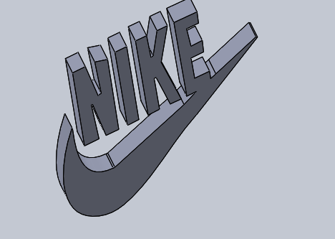
Figure 4 Nike Pattern Khan (2020)

Discussion
The assignment requires designing a 3D pattern using a Software Package, called Solidworks. The software will allow the designer to choose a pattern for their design and it will provide the necessary features to support the manufacture of the pattern using the sand casting method. The chosen design has been the Nike Logo as (Seen in Figure 3). The designer discovered the image from Google and started tracing the pattern via Solidworks. The main purpose for using Solid works is that it is the only software available which can be used to design patterns in 3D and it will also allow the software user to print the Nike pattern in 3D.
The reason for using the Nike pattern is because the designer found it easy to design via Solidworks as it was not too complicated to trace, whereas other patterns of choice were considered to be too difficult to trace e.g. the Trophy and Mercedes Benz Logo.
After designing the Nike Logo pattern, the design will be printed using a 3D printer. Once the design is finished printing in 3D, the Nike Logo pattern will be Sand Casted.
The purpose of Sand Casting the Nike pattern using Solidworks is to see how the pattern will be Sand Casted. This is achieved by observing the animation via Solidworks in order to see how the process can be most effectively manufactured whilst using the Sand Casting Method. The design of the Nike Logo pattern will involve the manufacture of two parts of a mould and will include a gating system on Solidworks, to see how the Sand Casting method will operate (see Figure 5 and Figure 6).

Using Polymer Injection Moulding in place of Sand Casting
The assignment has been set to include the consideration of creating the 3D pattern using the Polymer Injection Moulding method in place of Sand Casting. In considering using Polymer Injection Moulding (P. I. M), it is worth noting that it is a very different method to Sand Casting. P.I.M. involves heat, friction and shear to make the mould. The difference between Sand Casting and Injection Moulding is that Sand Casting involves a Gating system and the moulding can be undertaken by hand. However, Injection Moulding is mostly carried out via the use of machines and it incorporates four process stages to create a pattern, as the pattern would be melted by heat, and subjected to friction and shear force.
Having considered using the Polymer Injection moulding method, the designer has decided that the Sand Casting method is more suitable for their Nike pattern design as the designer will be able to clearly see the pattern when it is moulded and when applying sand around the mould. Whereas with the Polymer Injection Moulding method would require a lot of friction in order to make the pattern and it would also require a machine, rather than making the mould by hand.

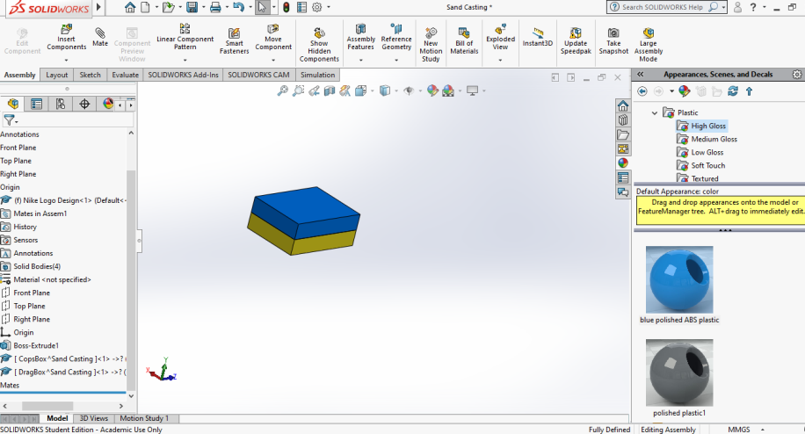
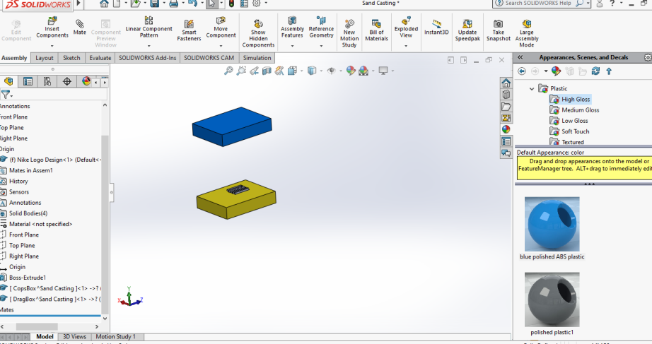
Figure 6 Drag Box Khan (2020)
Figure 5 Cope Box Khan (2020)

Conclusion
The aims of this assignment and Lab Report have been achieved, which has been to design and manufacture a 3D pattern using Solidworks design software. The author of this report researched and listed types of information about Sand Casting, Die moulding and Investment Casting and how they are used to make patterns and the process of Sanding Casting moulds. Further information about Injection Moulding has been included and a description added as to the difference between Injection Moulding and Sand Casting. The author of this report has decided to use the Sand Casing method rather than Polymer Injection Moulding to design the Nike Logo pattern.

Reference
DHF (2015) 25th November Process of Sand Casting
Available at: http://www.dhf-china.com/news/the-process-flow-of-sand-casting.html
(Accessed 26th March 2020)

Geomiq (2019) October, 2019 Why Choose injection moulding
Available at: https://geomiq.com/why-choose-injection-moulding/
(Accessed 26th March 2020)

H Khan (2020) March Nike Design Logo
OpenLearn (2017) October, Sand Casting
Available at: https://www.open.edu/openlearn/science-maths-technology/engineering-technology/manupedia/sand-casting
(Accessed 26th March 2020)
http://www.dhf-china.com/news/the-process-flow-of-sand-casting.html

Toolcraft (n.d) Injection Moulding Process
Available at: https://www.toolcraft.co.uk/plastic-injection-moulding/advice/help-injection-moulding-process.htm
(Accessed 26th March 2020)

D, William and Jr. Callister (1994) Materials Science And Engineering An Introduction. 3rd edn. United States of America: The University of Utah

D, William et al. (February, 2020)Callister’s Material Science and Engineering 10th edn. United States of America: The university of Utah
Available at: https://books.google.co.uk/books?id=IUjODwAAQBAJ&pg=PA588&lpg=PA588&dq=injection+moulding+callister+Jr+materials&source=bl&ots=GxdQ0T2oil&sig=ACfU3U2h6ftNfr7-nkl32mAfSSodBzDpKw&hl=en&sa=X&ved=2ahUKEwiu9Kye-7voAhX4VBUIHV7mAYEQ6AEwAHoECAkQAQ#v=onepage&q=injection%20moulding%20callister%20Jr%20materials&f=false
(Accessed, 28th March 2020)

