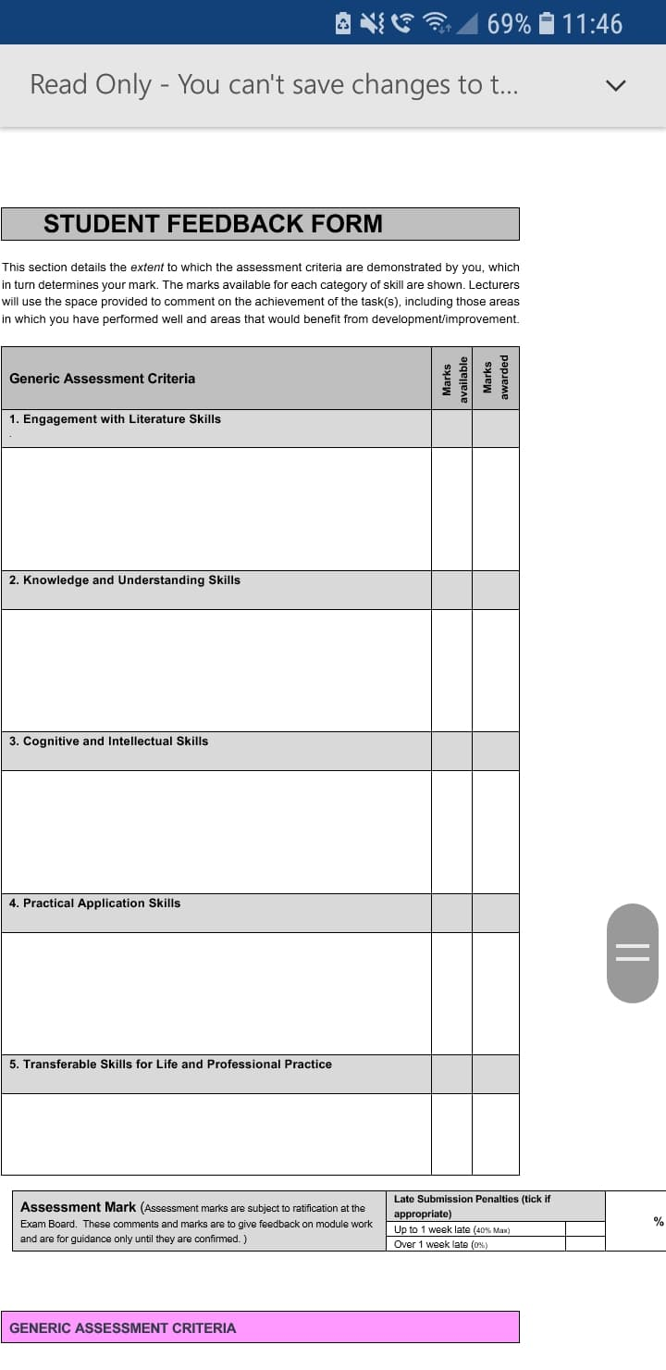
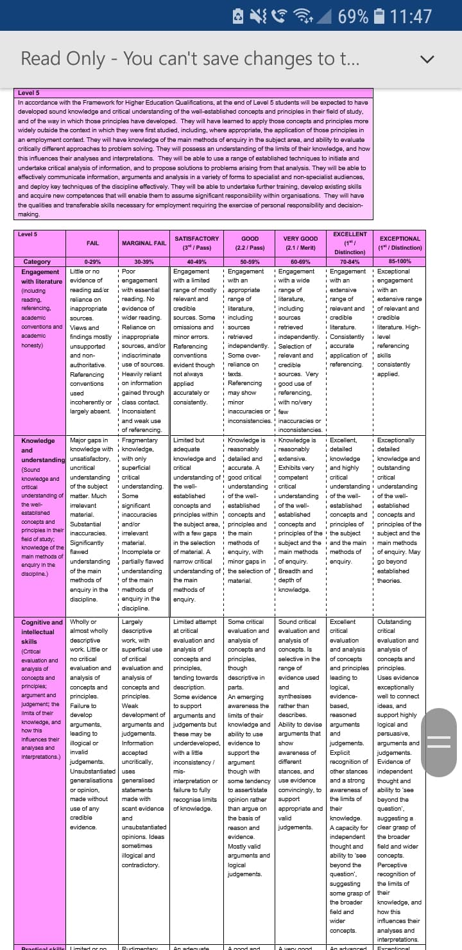
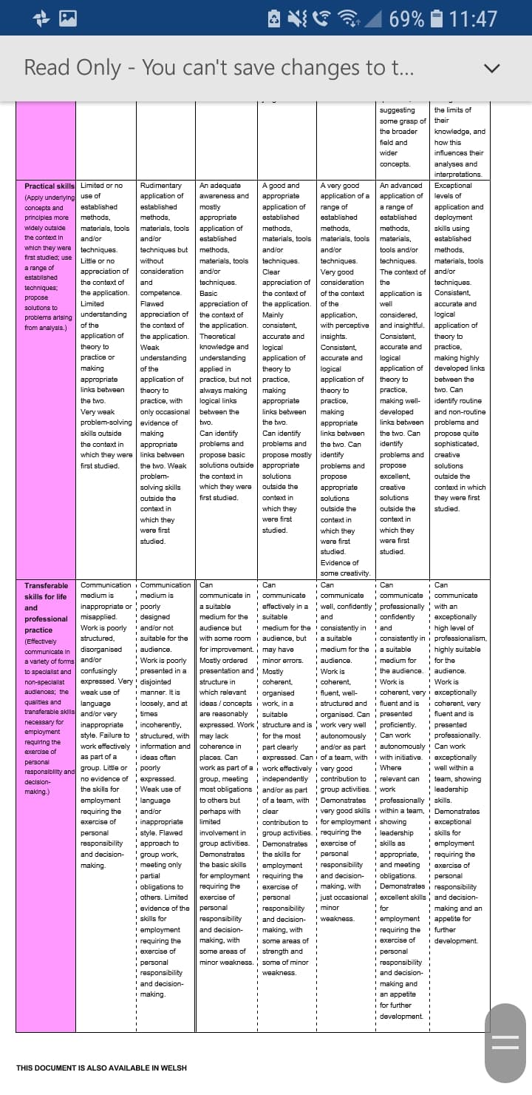

Discuss the importance and effectiveness of developing Assessment for Learning throughout the primary school, including critical analysis of personal implementation of ONE AfL strategy from Professional Teaching Experience.

Assessment for learning (AfL) is an approach to teaching and learning which continually assesses children’s learning and creates feedback. Dylan William (cited in Welsh Assembly Government, 2010) supports AfL as he suggests that feedback should be a continual process, rather than an end-loaded process. Cambridge International Education Teaching and Learning Team (no date) also suggest that AfL is essential. Furthermore, they indicate that the principles of AfL include using feedback to allow both the teacher and the child to understand where they are in their learning, where they need to go next and then how they are going to get there. AfL is a process that involves assessment within the learning environment so that feedback is immediate; this allows learners to understand what is needed to improve and it gives them time to make any changes. AfL is effective because it puts the learner at the heart of the assessment process so that the learner becomes the primary benefactor (Dr Jones, 2005). By allowing the learners to be at the heart of the assessment process, children will be able to form their own judgements about where they are in their learning, in comparison to where they need to be in their learning. Including students in the assessment process also improves their confidence and self-esteem; Dr Jones (2005) states that this reflects positively in learners’ work and their motivation will therefore improve.
Developing AfL throughout the primary school is important as it is a way of improving children’s understanding of their learning and improving their results. There is firm evidence to suggest that formative assessment is an essential part of the classroom and that developing strategies that work for students can raise their standards of achievement (Black and William, 1998). AfL involves feedback continually between the teacher and the learner but, it is imperative that feedback is correctly given. Merry et al (2013) suggested that feedback has been largely about telling a child something, however there is only so much a person can typically learn from being told. This implies that feedback must be a two-way process between a child and a teacher and that the child must understand what their learning objective is to be able to set targets for improvement. AfL is also important as it is a form of assessment and assessment is a major contributor to raising standards in schools (Cohen, Manion and Morrison, 2004, p. 323). Although, assessment is of significant importance to raise standards in schools; Cohen Manion and Morrison (2004) suggest that it can also have a damaging effect on a child’s self-esteem and outlook on learning. In order to avoid such damaging effects, Black and William (1998) proposed that feedback to a pupil should be about particular qualities of his or her work, with advice on what he or she can do to improve; it should avoid comparisons with other pupils.
William and Black (1998) suggested that there are four areas within formative assessment. The four suggested areas are questioning, self and peer-assessment, feedback and sharing criteria. During the professional teaching experience, the AfL strategy implemented was comment only marking. This strategy is within the use and quality of feedback strand of formative assessment, as the quality of the feedback given will determine how the child will understand and use those comments to move forward in their learning. Comment only marking is a very influential strategy for children if they are to close the gap between where they are in their learning and how they’re going to get to the next step. I chose this strategy because I could see purpose behind writing meaningful comments that would specifically highlight what the learners have done well during the task and what the learners could specifically improve on. As Briggs (2008, cited in Grigg, 2015) suggested, a teacher writing comments such as ‘good work’ and drawing smiley faces may show approval but, it does not help children to bridge the gap in their learning. Gadsby (2012, p.115) also supports comment marking as she states that there is an overwhelming body of evidence to support the fact that comment-only marking is the most effective method of feedback and that grading does not work with regards to improving a student’s learning.
Comment only marking links to the constructivist approach to teaching and learning because the comments left in the book are based on the child’s understanding of a learning intention. Gadsby (2012) suggests that comment marking may not be read or acted upon in a meaningful way by the students. Therefore, teachers writing comments in books could be a waste of time. However, the comments could include questions that reinforce the learner’s understanding and bridge the gap between where pupils are in their learning and where they’re required to be. Shepard (2005) suggests that questioning is a form of scaffolding that teachers could use to move learning forward within the zone of proximal development. Nevertheless, Merry et al (2013) suggest that if the feedback provided is outside of Vygotsky’s zone of proximal development then the feedback becomes less useful. Although, by using Blooms taxonomy, the questions can be differentiated to get the desired outcome for specific learners. If a question is used within comment marking, the student would be expected to answer that question to show their understanding. As Vygotsky, Piaget Dewey and Bruner (cited in David, 2015) stated, learning is an active process of constructing knowledge rather than acquiring it. Therefore, by writing a question in a student’s book they can construct their own knowledge based upon previous understanding; this is how a child could bridge the gap in their learning. By using questioning within comment marking, it also allows a child time to think and develop an answer. As the Welsh Assembly Government (2010) state that if the time allowed for a child to answer a question is increased, then there is an increase in the depth of an answer and an increase in the range of language used. Even though allowing time for children to read back through their work and understand the comments left could mean less teaching time, Cohen, Manion and Morrison (2004) state that reading feedback and reflecting is still learning time for the children. Furthermore, unless time is allowed for specific improvements on the work, marking becomes little more than a token exercise.
Comment marking isn’t restricted to just teacher assessment as it can also be used by peers (Welsh Assembly Government, 2010). This means the strategy also falls under the peer and self-assessment strand of formative assessment because children can mark each-others work leaving appropriate specific comments related to the learning intention. However, for this to be successful children must know what the learning intention is and be able to gauge where someone’s learning is in relation to that intention (Cohen, Manion and Morrison, 2004). As Black and William (1998) suggest, feedback to a pupil should be about the particular qualities of his or her work, also including advice on what the pupil can do to improve. Weedon (cited in Cohen, Manion and Morrison, 2004) suggested feedback guidelines that teachers could provide pupils with if they’re peer-assessing work. Weedon suggested that feedback should be realistic, specific and sensitive to the goals of the individual being assessed. For children to provide such comments may seem unrealistic. However, a study by Black and William (1998) showed that if children are involved in self and peer-assessment it enables them to understand both the learning objectives and assessment criteria, which gives them scope to assess where they or their peer is in relation to learning outcomes. James (1998, cited in Faultley and Savage, 2008) also suggested that if students are to learn from their own performance and improve, then they need to be able to assess actual performance against standards. This would help them to identify gaps between actual performance and desired outcomes.
A whole school approach to comment marking is possible although, there are differences to consider throughout the different ages and ability groups. Reading comments may be an issue for some children but, the teacher could use oral feedback with pupils to overcome this. The teacher can record their comment marking and leave it on an interactive program for the child to look at; this ensures that AfL is also being evidenced throughout the school. Oral feedback allows for a child with a low reading ability to have rich and task specific feedback related to their work. Within the foundation phase children’s work isn’t always recorded in a written method but, teachers can implement a ‘practical book’ for their students. This would require the teacher to write down learning intentions and evidence the work completed, either by using written comments or photographic evidence. After the activity the teacher can involve the children in the assessment process by asking them how they feel about their learning in relation to the objective. The teacher could then use comment marking within this book as a means of recording how the child has progressed in relation to the learning intention. This incorporates elements of self-assessment and as Shirley (1998) states, self-assessment within the earlier years is generally oral. Estyn (cited in Welsh Government, 2017) also state that the accuracy of the feedback provided and how the teacher then uses that information to support learners is important.
Cohen, Manion and Morrison (2004) suggest that comment only marking encourages pupils to engage with the quality of work they’re completing as opposed to grade marking, which encourages pupils to look for the best ways to get marks. When children are looking for the best way to get marks, they no longer look at how to improve their learning, which results in a lack of quality work and inhibits a growth mindset. Viering (2016) and Dweck (cited in David, 2015) suggest that the use of formative assessment strategies like comment marking, will help children to develop a growth mindset as they try and improve their work.
Comment only marking features three of Black and Williams (1998) four key recommendations. As a strategy it allows children more time to think when answering questions because the question can be asked as part of the comment. It also encompasses providing constructive comments rather than marks, which encourages children to adjust their work accordingly (Faultley and Savage, 2008). Encouraging children to peer-assess is also included within comment only marking. As pupils peer-assess work they become more aware of the learning intentions and can gauge where they are in relation to the where they need to be. The next task would then be for that child to try and identify how they are going to achieve that intention, perhaps with the guidance of a teacher. The teacher may need to incorporate the next steps into their planning for the next lesson.
To conclude, AfL is an essential component of teaching that improves children’s learning. Black and William (1998) support this as their research concluded that formative assessment can raise standards of achievement for all children and has a greater effect on lower attaining children, thus reducing the gap in attainment. Therefore, the importance of AfL is evident and is something that should continue to develop and improve within schools. Donaldson’s (2015) report supports this as he suggests that formative assessment should be an essential and natural part of the teaching process. Using comment marking throughout the school gives children the chance to self and peer-assess work. This strategy can be implemented throughout a primary school because as noted previously, lower abilities and younger children can use and receive oral and recorded feedback whilst higher ability and older children can leave comments in books. Using self and peer-assessment is supported by Donaldson (2015) as it links to one of his four purposes, developing ambitious and capable learners who are ready to learn throughout their lives. Donaldson (2015) supports children being involved in the assessment process because if children and young people are to develop as lifelong learners, they will need to be able to reflect on their own progress to develop further in their learning. Palmerston Primary School use comment marking throughout their school and when Estyn (2017) reviewed the school, they concluded that the use of comment marking coupled with time for children to review and act upon the comments given, showed clear progress in the children’s learning. Comment marking is a free strategy for schools to use and a staff meeting would enlighten teachers with the methods available to use in their different year and ability groups. Regular staff meetings would allow for clear continuity and progression throughout the school. Comment marking clearly provides the principles of AfL, as the feedback provided helps children regardless of their age or ability to understand their next step in learning and how they are going get there. Comment marking provides schools with methods of delivering feedback in many different ways and as Hattie (2009) states, feedback is among the most powerful influences on achievement; whilst Wiliam (2014) also suggests that feedback is one of public educations best-kept secrets.
(Word Count: 2172)

Reference List
Black, P. and Wiliam, D. (1998) Inside the Black Box: Raising Standards Through Classroom Assessment. London: GL Assessment.
Cambridge International Education Teaching and Learning Team. (no date) Getting started with Assessment for Learning. Available at: https://cambridge-community.org.uk/professional-development/gswafl/index.html (Accessed: 8th December 2018).
Cohen, L., Manion, L. and Morrison, K. (2004). A Guide to Teaching Practice. 5th ed. London: RoutledgeFalmer.
David, L. (2015) Constructivism in Learning Theories. Available at: https://www.learning-theories.com/constructivism.html (Accessed 12th December 2018).
David, L. (2015) Mindset Theory – Fixed Vs. Growth Mindset (Dweck). Available at: https://www.learning-theories.com/mindset-theory-fixed-vs-growth-mindset-dweck.html (Accessed 13th December 2018).
Donaldson, G. (2014) Successful Futures. Crown Copyright. Available at: https://gov.wales/docs/dcells/publications/150225-successful-futures-en.pdf (Accessed: 13th December 2018).
Dr Jones, C. A. (2005) Assessment for Learning. London: Learning and Skills Development Agency.
Estyn. (2017) Effective feedback to support independent learners. Available at: https://www.estyn.gov.wales/effective-practice/effective-feedback-support-independent-learners (Accessed: 13th December 2018)
Faultley, M. and Savage, J. (2008) Assessment for Learning and Teaching. Exeter: Learning Matters.
Gadsby, C. (2012) Perfect Assessment for Learning. Carmarthen: Independent Thinking Press.
Grigg, R. (2015) Becoming an Outstanding Primary School Teacher. 2nd Ed. Abingdon: Routledge.
Hattie, J. (2009) Visible Learning. Abingdon: Routledge.
Merry, S. et al. (2013) Reconceptualising Feedback in Higher Education Developing Dialogue with Students. Oxon: Routledge.
Shepard, L.A. (2005) Educational Leadership. Boulder: ASCD.
Shirley, C. (1998) Targeting Assessment in the Primary Classroom. London: Hodder & Stoughton.
Viering, M. (2016) An argument for formative assessment: Motivation and Persistence. Available at: https://www.pearsoned.com/formative-assessment-motivation-persistence/ (Accessed 10th March 2018).
Welsh Assembly Government. (2010) How to develop thinking and assessment for learning in the classroom. Cardiff: WAG.
Welsh Government. (2017) Foundation Phase Profile Handbook. Cardiff: Crown Copyright
Wiliam, D. (2014) Is the Feedback You’re Giving Students Helping or Hindering? Available at: https://www.dylanwiliamcenter.com/is-the-feedback-you-are-giving-students-helping-or-hindering/ (Accessed: 13th December 2018).

