

Understanding the Importance of recruitment and its impact for organisational performance: A case study of Clipper Logistics now part of GXO



Student name: Ioana Cocea
Student id: 1920428
Programme: BA (Hons) Business Management Level 6
Module name: Dissertation
Module Code: LCBB6000
Name of University: University of Wales Trinity Saint David (London Campus)
Module supervisor: Dudley Ofori

Declaration

I declare that this research was conducted by me and under the supervision of my lecturer and that this research has never been submitted for another degree either in part for a previous degree or research.

Signature: Ioana Cocea

Abstract

The essential significance of recruitment in an organization in modern world is decided by the firm obtaining qualified workforce for the aims and objectives of the company. This study is focused to understand the importance of recruitment and its impact on organisational performance at Clipper Logistics, now part of GXO and it looks on how hiring affects the success of the organisation. As part of the hiring process, organizational effects such as productivity, staff happiness and retention were also be looked at.
To content the assessed targets, a quantitative technique has been used to congregate data from specific candidates divided into three target groups: recruiters, managers, and HR professionals. The questionnaire outcome come up with different aspects which are important and contributes for a successful recruitment using qualified candidates, recruitment channels and recruitment methods in concordance with Clipper Logistics goals. The result shows that recruitment techniques and procedure during hiring influence business and worker quality. As well the research found that a skilled person has as positive effect on business result in matter of productivity and profitability.
Therefore, it may be necessary to conduct further research to establish strategies and implementations to improve the process of recruitment (hiring) at Clipper Logistics, now part of GXO.

Acknowledgement

I would like to express my deepest appreciation to my supervisor who has authorized the work on Understanding the Importance of recruitment and its impact on organizational performance: A case study of Clipper Logistics, now part of GXO. His suggestions and advice have helped me achieve my writing goals and helped me overcome my challenges.
As well, I am extremely grateful to my family both my husband and my son for their constant motivation, understanding and support as I pursued my investigation and write my study.
I wish to extend my special thanks to all my respondents for contributing so honestly to this study, which increased the validity and reliability of the study.

Table of Contents
Declaration 1
Abstract 2
Acknowledgement 3
Chapter 1: Introduction 6
1.1. Introduction 6
1.2. Background of the study 6
1.3. Problem Statement 6
1.4. Aims, Objectives, Research Questions 7
1.5. Importance of the research 7
4.6. Methodology 7
1.7 Structure of the dissertation 8
1.8 Summary 8
Chapter 2: Literature review 9
2.1. Introduction 9
2.2. The recruitment process and practices in staff hiring 9
2.3. Impact of a skilled workforce on business performance and outcomes 11
2.4. Scope of recruiting skilled workforce and its benefit on the hiring process 12
2.5. Previous studies and lessons learned 12
2.6. Gaps identified 13
2.7. Summary 14
Chapter 3: Research Methods and Methodologies 15
3.1. Introduction 15
3.2. Research Philosophy 15
3.3. Research Approach and Paradigm 15
3.4. Research Strategy 16
3.5. Research Method 16
3.6. Study Sampling and Population 16
3.7. Data collection and Analysis 17
3.8. Ethical considerations 17
3.9. Summary 17
Chapter 4: Data presentation, Analysis and Discussion 18
4.1. Introduction 18
4.2. Presentation of responses to the questionnaire 18
4.3. Findings, Analysis and Discussions regarding recruitment practices and process during hiring 25
4.4. Findings, Analysis and Discussions on the impact of skilled workforce on business performance and outcome 26
4.5. Findings, Analysis and Discussions regarding the solutions to resolve the problem of recruitment process 27
4.6. Summary 28
Chapter 5: Conclusion and Recommendation 29
5.1. Conclusion 29
5.2. Recommendations 29
References and Bibliography 32
Appendices 36
Appendix 1. Questionnaire used for primary data collection 36
Appendix 2. Participant Information Sheet 39
Appendix 3. Application for ethical Approval 41
Appendix 4. Participation Consent Form 53

Chapter 1: Introduction

Introduction
Recruitment is the process which describes the way of attracting candidates, hiring, interviewing and on boarding employees for the future. Recruitment indicates the hiring of the new talents and experienced ones as per the position-based vacancies. Hence for the performance of any business organization, the most crucial point is attracting those candidates who are eligible for the business (Hamza et al., 2021).

Background of the study
Clipper Logistics, now part of GXO is a retail and e-commerce service provider which has multiple systems for supporting a wide range of clients. Furthermore, this organization has faced crucial challenges which need to be mitigated. It is challenging for the organization to implement solutions for supporting business growth and managing solutions internally. Another challenge of this organization is to provide flexible solutions that are suitable for small, large and medium business. The topic is going to focus on the recruitment procedure of Clipper Logistics, now part of GXO and how the process is associated with the enhancement of its organizational performance.
In this contemporary world the key importance of recruitment within an organisation is determined by helping the firm in acquiring skilled and qualified labourers to work as a team (Hamza et al., 2021). The reason behind the consideration of this topic is to gather in-depth ideation on how the recruitment process is playing an essential role in organizational productivity enhancement up on competitive business market.

Problem Statement
As Clipper Logistics now part of GXO has faced during the pandemic the problem of fulfilling both online and offline the demand of retail disruption of the staff has been caused for self-isolation and sickness and social distancing (Clipper, 2022). Business organizations are looking for reducing costs and time to get more customers. The topic intends to gather information on the procedure of recruitment and selection that is done by Clipper Logistics, now part of GXO and the way in which this process is connected to the effectiveness of its organisational performance (Usmani,2020). A productive and effective procedure of recruitment, selection and hiring allows Clipper Logistics to attract, source, recognise and retain the best available candidates from the marketplace of labour for their designated roles and responsibilities. These best practices of recruitment, selection, hiring and retention also assist Clipper Logistics to lessen attrition, enhance productivity and improve the profit margins of the organisation.

Aims, Objectives, Research Questions
Aims
The aim of this research is to investigate the process of recruitment (hiring) in order to obtain the required skilled from potential employee advertisements.
Research objectives
● To identify the recruitment practices and process during hiring.
● To analyse the impact of a skilled workforce on business performance and outcome.
● To evaluate the scope of recruiting a skilled workforce and its benefits to the organisation or hiring process.
Research questions
Q.1 What are the recruitment practices and processes which are followed in hiring?
Q.2 How does the skilled workforce impact business performance and outcome?
Q.3 What is the scope of recruiting skilled workforce and what are its benefits to the organisation or hiring process?

1.5. Importance of the research
The purpose of this research is to examine the procedure of recruitment and the process of hiring done by Clipper Logistics system. In many cases it has been observed that unskilled workers could not help the organization and is not effective in the growth of business productivity. Thus, any organization that does not have a good workforce their service could be very expensive and because of that business organizations can pay more for their production methods.

4.6. Methodology
The information in this research was collected from online resources, websites and journals gathered with the help of secondary research method. Moreover, primary data method as quantitative collection is used to congregate data from a specific candidate such as recruiters, managers, and HR professionals. The outcome of this questionnaires provides the actual issues in recruitment hiring process and the recommendations to improve the process of recruitment.

1.7 Structure of the dissertation
The case study is structured in five chapters. The first chapter is focused on introduction and background of the study, problem statement followed by aims, research objectives and research questions, importance of the research, methodology and structure of the case study. The second chapter is about literature review with the concepts linked to the research questions, previous studies and lessons learnt and existing gaps. The third chapter contour the research methods and methodologies, philosophical position, paradigm, research sample and population, data collection and data analysis and ethical consideration of the research. Chapter four is analyzing and discussing the quantitative method chosen, using questionnaires outcome. The last chapter, chapter five concludes each research objectives followed by limitations and recommendations for importance of recruitment and hiring skilled people.

1.8 Summary
This chapter describes the HR recruitment process and the investigation of the process of hiring and to find out the actual skills required for the job. Aims and objectives have been describing the whole concept of this research. Hence Clipper Logistics, now part of GXO is chosen for this discussion of the practices of the recruitment process and selection. The above part has mentioned that the selection process is a crucial topic for every organization and before choosing any candidate it is very important to follow all the requirements.

Chapter 2: Literature review

2.1. Introduction
Due to increase of the global and sophisticated marketplace, recruitment has become an integral part of organizational activities (Buil et al., 2020). This section is talking about the recruitment process and practices which are strictly followed in the hiring process of an organization. Besides the section would also gather a concrete impact of skilled workforce on business outcomes and performance. Another important point which is debated in this section is the scope of recruiting skilled workforce and what are its benefits to the organization or hiring process.

2.2. The recruitment process and practices in staff hiring
The recruitment process and practices in staff hiring is referring to the procedure of finding, selecting, and hiring the new employees for an organization and make sure that recruiters have provide them a proper training and assure to obtain successful competitors and to determine their skills. As opined by Yong et al., (2020), most business enterprises are recently using the “Multi-phased Recruitment Process” because of hiring the right talents through the consideration of multiple hiring processes. This kind of recruitment process at present days has been beneficial for maximizing the talent retention score within the organization, resulting in the generation of high-performing work culture and acceleration of business profit. In addition, retail logistic companies are using the “Value-based Recruitment Method” to hire candidates who have a high degree of capability in achieving the strategic objectives of the business (Bider and Perjons, 2019). Through this recruitment process, a high-performing staff density appears, resulting in the configuration of innovations in business model & strategy and overall growth of the business in the market competitiveness. At Clipper Logistics, now part of GXO, an anti-discrimination-free recruitment process is one of the key indicators in accelerating the company`s organizational growth. This kind of recruitment process influences the concepts of diversity and inclusion scenarios, resulting in a wider scope of hiring talents with a more innovative mindset and logical thinking power.

Theories associated with organisational performance and recruitment practices
The application of theories associated with organisational performance can be effective through recruitment and staff selection. Some of the most effective theories can be identified as Systems theory, Scientific management theory and Contingency theory. These theories are designed to examine the overall organisational performance and reciprocate in a manner that helps an organisation to excel and increase the overall performance level.
Systems Theory
As observed by Tumasjan, et al., (2020), the system theory of management emphasises the point that business organisations are open systems constituted of interrelated as well as interdependent parts which interact as subsystems of the organisation. In addition to that, this theory emphasises the point that the organisation can be viewed as the whole which is affected by the working of its various parts. The system theory assesses the overall organisational effectiveness rather than focusing on a particular area of the company. One of the crucial inputs in the context of system theory is Human resources besides technology and capital which initiates the organisational outputs in the form of products and services as the human results. In this context, the recruitment and selection procedure become a significant component of the whole organisational improvements. A skilled workforce as a part of the company initiates the whole improved performance for the organisation. As per the application of system theory, it can be said that every part and department of the organisation is connected in terms of managing and sourcing staff. Therefore, in terms of recruitment, the HRM department of Clipper Logistics (now part of GXO) must carefully analyse the needs of every department of the company and contribute to the business to recruit quality employees which would help in enhancing organisational performance.
Scientific Management
As observed by Cheng, and Hackett, (2021), scientific management theory focuses on the point that individual efficiency and productivity is the key to organisational success. In order to initiate employee productivity, scientific management theory attempts to divide the overall task into parts and prepares a plan for the proper execution of the task. This theory separates the planning process into the form of actual activity. This creates an outline regarding the process, time, and equipment for the task. In this context, the workers at Clipper Logistics (now part of GXO) needs to be selected properly for each task. This point emphasises the factor that the scope of recruitment needs to be aligned with the principles and outcomes of a skilled workforce. Scientific management critically focuses on improving the quality of work in the workplace. In other words, HRM can apply this theory in order to increase and enhance training opportunities and establish a proper and effective understanding of the scope an employee could have in the organisation.
Contingency Management
As discussed by Farndale, et al., (2020), contingency management leads to the preparedness of businesses in the context of an emergency disaster and system failure. This point is related to the risk management ability of a particular business which identifies the vulnerabilities, weaknesses, and threats of a particular business. Preparing contingency plans are key to maintaining the operational continuity of the business activities as well as disaster recovery. A contingency management plan supports the business objectives in terms of creating plans as well as taking technical measures to execute them. Contingency plans attempt to locate the key areas of business in order to respond to the business threats and deal with the business disruption risks. The human resources of Clipper Logistics (now part of GXO) are the key components that can support contingency planning for a business. This point makes the business owners recruit efficiently as it is going to significantly impact the business performance.

2.3. Impact of a skilled workforce on business performance and outcomes
According to Kurdi and Alshurideh, (2020), skilled workers have a positive endowment in accelerating the profit chain and sustainability index of the business in the dynamic business world. The skilled workforce is directly interconnected with the development of high-performing work culture and betterment in the business performance level. As opined by Bhende et al., (2020), the skilled workforce indicates that the existing manpower has already possessed significant communication and teamwork capabilities to connect with their peers, superiors, and customers to improve the operational flow of the business. Moreover, the skilled workforce also possesses employees with an excellent level of problem-solving mindset, situational decision-making capability, and think big attitude (Leitão et al., 2019). As a result, the impact of skilled workforce appears when employees with a high degree of self-motivation tackle the existing or upcoming business problem flawlessly, improve the operational flow, and increase the operating profit of the business.

2.4. Scope of recruiting skilled workforce and its benefit on the hiring process
As per the statement of Liwani, (2022), a skilled workforce can be developed by recruiting the right talents and hiring potential candidates based on the value-based recruitment style. The prime benefit of configuring a skilled workforce in the competitive business market is to improve the organisational operating profit and sustainability index. The theories of Human resources emphasise those techniques of selection and recruitment that outline the importance of assessments, and interviews and are also related to the selection process. Currently, most of the business enterprise is paying attention to investigate in modern technologies and AI-powered ATS (Application-Tracking-System). Based on this recruitment scope, the inappropriate jobseekers` resumes would automatically discard and the right one would get an interview call. As commented by Rahman et al., (2022), the prime impact of an AI-powered recruitment process is the acquisition of only talented and self-motivated individuals. As a result, the employee productivity rate is heightened which influences the development of a string of financial snapshots of the businesses in the highly saturated market end. As narrated by Elrehail et al., (2019), the skilled workforce always pays attention to hiring potential talents rather than paying attention to the candidates` gender status, cultural beliefs, ethical beliefs, skin colour, socio-economic standards, and race. As a result, the skilled workforce automatically remarked themselves as a zone of diverse and inclusive labour force. It indicates the solving of any kind of existing or upcoming business hurdles with their highly innovative ideologies, situational decision-making abilities, and great problem-solving power.

2.5. Previous studies and lessons learned
The literature review on the importance of recruitment (hiring) and its impact on business performance for obtaining skilled workforce has been concentrated on recruitment process and practice on in staff hiring, impact on skilled workforce and explaining the scope of recruiting skilled workforce and its benefit on the hiring process.
Hence, in the previous studies Yong et al., (2020) explained the recently used recruitment process used by most businesses enterprises as a beneficial process both for the work culture and for the business profit. It has been learned that recruitment of skilled employees is important as it contributes to a significant output of the process of the workplace. Apart from the chosen research theme, the business enterprise recently paid more focus on the “Value-based Recruitment process” to hire the staff that will be responsible for not only fulfilling the vacant position`s responsibility but also meeting the overall strategic objectives of the business.
Also, Cheng, and Hackett, (2021) observed that the scientific management theory is anchored on the point that each person capability and creativity leads to the secret of success. Furthermore, it can be said that scientific management and its application also help an organisation to review individual employee needs and respond accordingly with it to ensure a strategic outcome and serve the needs of the organisation.
Additionally essential lessons have been stated by Kurdi and Alshurideh, (2020) studies, who explain that skilled employees are helping business with their positive aptitudes to accelerate the business world. It has been noticed that with the help of high-degree and self-motivated workforce the operating profit and operational flow of the business can be improved.
Furthermore, it can be acclaimed that the employer community in the modern world are gradually paying attention to making a skilled workforce through an effective and advanced recruitment technique for betterment in the business profit score in the market competitiveness.

2.6. Gaps identified
The research mainly focused on the secondary research method and as well on the primary research method. This section shows the existing gaps in the recruitment hiring process. Finding personnel with the ideal mix of knowledge, training, and experience to carry out the job well is part of the scope of hiring a skilled staff. One of the key benefits of having a qualified crew is that the company outcome will improve. Because skilled people are more likely to succeed in their employment, the output and productivity of the organization may increase. The gaps identified, as noted by Rahman, et.al., (2022) study the effects of social media on corporate efficiency, cost effectiveness, expanding of search, lower staff turnover, and competitive advantage mediated by adopting e-recruitment methods. As mentioned by Yong et. al., (2020), based on the aforementioned findings, human resource managers should give preference to applicants with environmental understanding the procedure of hiring and providing to the employees training in environmental matter including waste management, recycling, and energy management. This section explains the gaps that still need to be filled in the recruitment hiring process, with qualitative data being one of the most significant gaps that Clipper Logistics needs to fill in order to comprehend why it doesn`t have any recruitment tactics. Therefore, more investigations need to be done on primary data method to outline the existing gaps using qualitative data on employees or administrators as well.

2.7. Summary
This chapter summaries literature reviewed above based on aims, objectives and questions to understand the needs of the overall business recruitment process and existing gaps in literature. Finally, it has been learned that every organization has its own personnel planning and among them, Human resource planning is really significant. Commonly Human resource planning sectors conducted recruitment, training and career planning, risk management and also include performance appraisal. Performance appraisal is fundamental point mainly used to motivate employees.

Chapter 3: Research Methods and Methodologies

3.1. Introduction
In this chapter have been presented all parts of the research methods and methodology. The use of the research onion was helpful for this study. Therefore, the various components of the research onion such as: research philosophy, research approach and paradigm, research strategy, research data and the research ethics together with study sampling and population and data collection and analysis have been used here to gather the information needed.

3.2. Research Philosophy
A positivism research philosophy is utilized for this investigation into the significance of recruitment and its effect on the organizational performance at Clipper Logistics now part of GXO. This philosophy holds that objective truth exists and can be discovered through empirical observation and scientific methods. Positivist research enables the researcher to collect quantitative data through surveys and statistical analysis, yielding objective and quantifiable insights into the research question. The purpose of the study is to determine the effect of recruitment (hiring) on organizational performance and positivism will allow the researcher to test hypotheses, draw conclusions, and establish causal relationships among variables. In addition, the study employs a case study approach, which will help provide rich and detailed data on the recruitment process at Clipper Logistics, and the positivist philosophy will enable the researcher to objectively analyse and interpret this data.

3.3. Research Approach and Paradigm
This study uses a deductive research methodology. A deductive approach is a research method that begins with a theory or hypothesis and then tests it by collecting and analysing empirical data. This methodology has allowed to confirm or refute the hypothesis and provide evidence-based recommendations for enhancing organizational performance through improved recruitment practices at Clipper Logistics now part of GXO. Overall, a deductive approach was suitable for this study because it is a quantitative research method that is objective, rigorous, and replicable, which is essential when generating empirical evidence.

3.4. Research Strategy
A case study strategy is a research method that entails an in-depth examination of a particular phenomenon in its real-world context. Case studies using questionnaires allows to gain an extensively understanding of the recruitment (hiring) process at Clipper Logistics and its influence on organizational performance. This methodology has allowed to collect quantitative detailed data on the recruitment practices, obstacles, and outcomes at Clipper Logistics, which has helped answer the research question. The data was collected from employees from Clipper Logistics now part of GXO, who are recruiters, managers, and HR professionals.

3.5. Research Method
Quantitative techniques were employed to collect quantitative data on recruitment (hiring) practices and process and organizational performance. This involves administering a survey to a subset of Clipper Logistics’ employees, a survey which has contained closed-ended questions, enabling the collection of numerical data that can be statistically analysed. Thereupon, numerical data such as recruitment metrics, employee turnover rate and productivity levels were collected and analysed to determine the relationship between recruitment and organisational performance. Regression analysis and other statistical tools can help determine how much job-related factors, recruitment channels, and candidate selection criteria influence an organization's bottom line. The sample size of twenty people was also manageable for quantitative research methods like statistical analysis. It was easier to spot statistically significant correlations between recruitment factors and organizational performance when working with a smaller sample size (Snyder, 2019).

3.6. Study Sampling and Population
In this study, twenty employees were chosen at random to participate. Probability sampling was chosen over other sampling methods.
Thus, to ensure that every member of the population has an equal chance of being included in the sample, a simple random sampling method was ideal for this research. This method guarantees that the sample is statistically representative of the entire population by removing any room for error during the selection process. Data collected using this method is more likely to be accurate and comprehensive because it is drawn at random from a statistically valid representation of the population.

3.7. Data collection and Analysis
The data was collected from twenty employees (using Google forms). These are recruiters, managers, and HR professionals. Quantitative data are analysed using questionnaires via Google Forms. The reason for this was to get data that can be stored in an electronic form that can be referred to at any time and securely kept. Additionally, this has been measured statistically, and the results were displayed in pie, tables, and bar charts in Microsoft Excel.

3.8. Ethical considerations
All research must consider ethical concerns that safeguards participants' rights. Throughout this study, precautions to protect the privacy and confidentiality of the participants by obtaining their informed consent, maintaining their anonymity, and using appropriate data storage and management techniques will be taken. The questions are not lead or biased and will protect the participants from any harm or distress that could come from participating in the study.

3.9. Summary
This study uses a quantitative method to investigate the role recruitment plays in boosting productivity at Clipper Logistics. To do this effectively, data was collected from twenty respondents through questionnaire using Google Forms from recruiters, managers, and HR processionals for analysis purpose. In this study, interpretivism serves as the guiding research philosophy, deductive reasoning serves as the methodological strategy and case studies were used as the research method. Surveys are used to collect data, and descriptive and inferential statistics are employed in its analysis. Along with scientific factors, ethical considerations are considered. In consequence, this approach offers a solid foundation for conducting in-depth investigation of the research question.

Chapter 4: Data presentation, Analysis and Discussion

4.1. Introduction
In this chapter findings, analysis, and results of the research on the significance of recruitments and its effect on organisational success have been presented. Here, the research objectives were fulfilled through questionnaire responses and analysed to obtain outcomes. The study overarching goals were to identify recruitment practices and process during hiring; examine the impact of a skilled workforce on business performance and outcome; assess the breadth of recruiting a skilled workforce and its benefits to the organisation or hiring process and to assess potential solutions to problems encountered during the recruitment process. In this research detailed data on recruitment methods and processes at Clipper Logistics, now part of GXO were acquired, which provided significant insights into industry trends and norms.

4.2. Presentation of responses to the questionnaire
Quantitative data has been collected from a sample of twenty respondents including recruiters, managers and HR professionals using the random sampling technique and utilising Google forms questionnaires (Please see the questionnaire in Appendix 1). Here, responses are presented using pie, tables, and bar charts. The following section includes the presentation and analysis of the data based on the responses to the questionnaire.
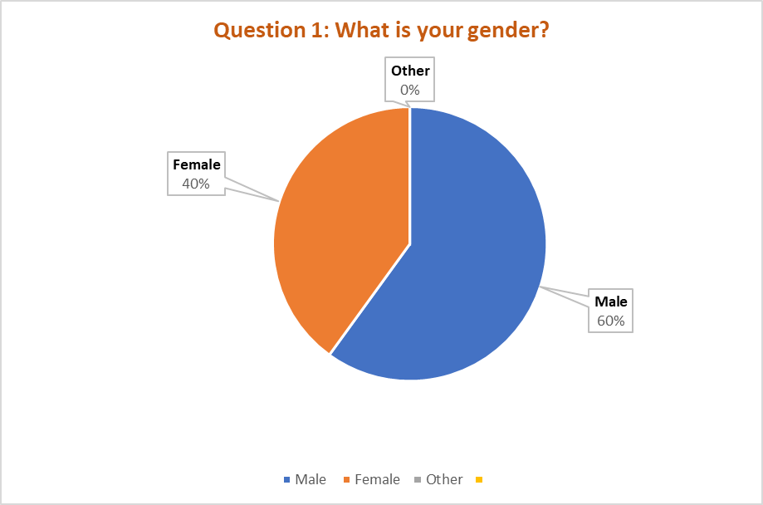
The result shows that more than 60% of employees hired at Clipper Logistics (now part of GXO) answered with male in comparison with 40% respondents what answer with female, and nobody answer with other. Moreover, this research show that any kind of people can be employed at Clipper Logistics.
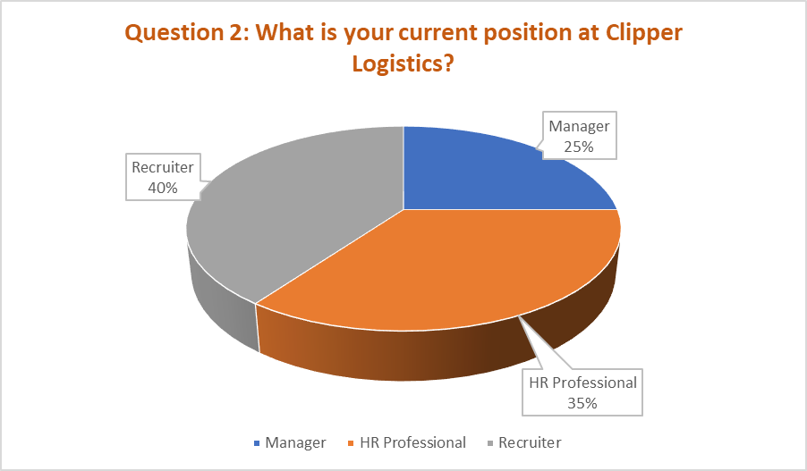
On the base of this research, the study show that 40% responses are from recruiters ,35% answered with HR professionals’ position and 25% with manager positions. This study describes that recruiter have an important role on the recruitment process of Clipper Logistics.
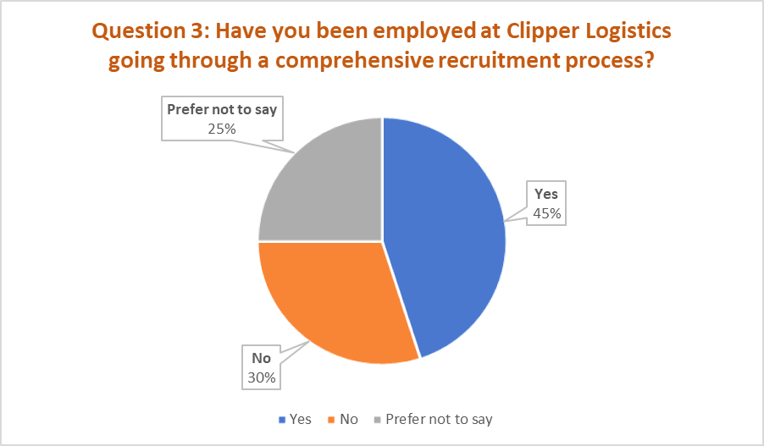
The result reveals that 45% of respondents answer with yes going through a comprehensive recruitment process when they were hired to Clipper Logistics, another 30% of employees answer with no and 25% of people prefer not to answer on this faze. Moreover, this research represents that the recruitment process of the organisation is good enough.
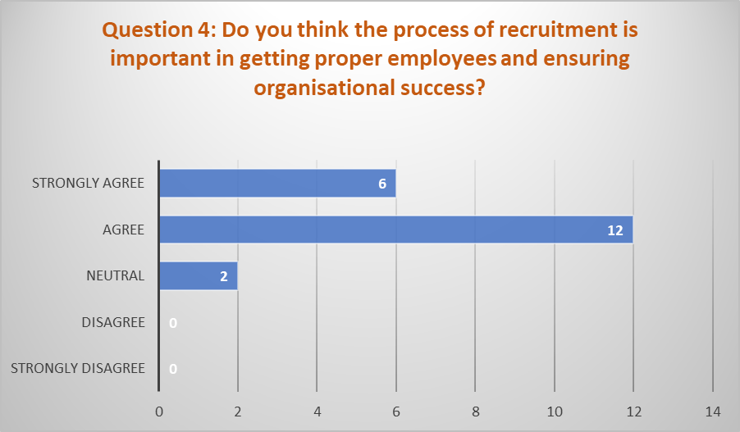

This result presents that recruitment process is important for Clipper Logistics to successfully achieve business growth and show on data collected this conclusion from response of respondents which 12 employees answered with agreed, 6 answered strongly agreed and 2 remained neutral. However, it suggests that recruitment process needs to be streamlined in a way that focuses on selecting and employing proper employees to fulfil job criteria.
Question 5: During the recruitment process, you were hired based on previous job experience of candidate?
Here the outcome is that 50% of managers answered with yes on this study and consider the job experience is a key point to obtain a new job and be hired with success. The 35 % of responses was from recruiters and answer with no and 15% responses was from hr professionals and answer with maybe. This study shows the gender of employees was male and female and indicates, in some instances, previous job experience can be a measure for identification of qualified and skilled candidates.

Question 6: Do you believe that employee retention is more important than hiring skilled workforce?
Managers believe that employee retention is very important in comparison with skilled workforce showing a 40% of the study, as well recruiters show the same opinion, and their response was 40% and answer with important. The HR professionals believe is not important and only 20% of this study have this opinion. All this research indicates there is no substitute of qualified employees.
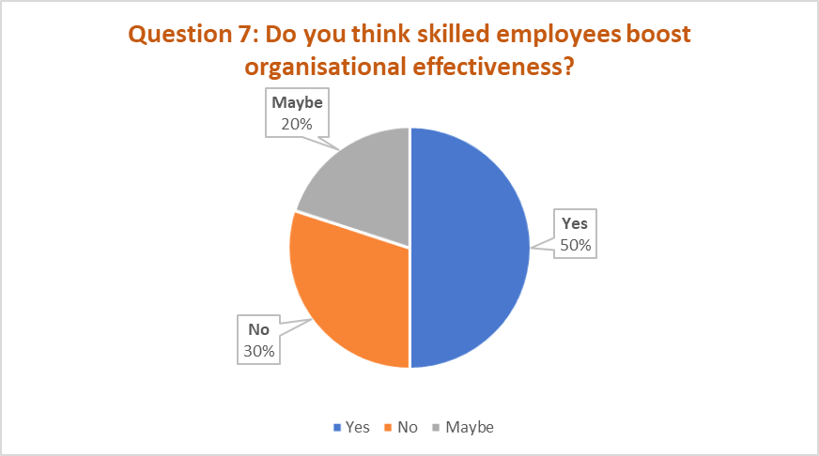
Ten employees (50%) answer with yes and think skilled employees boost organisational effectiveness in contrast with another 6 employees (30%) answer with no and 4 respondents (20%) remained neutral and answer with maybe. These results show to Clipper Logistics they need to be more focused and pay more attention on the selection of skilled worker to complete objectives of company.
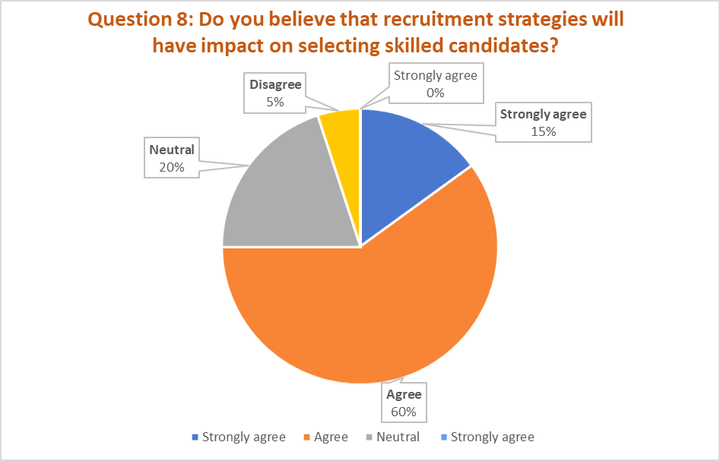
From this process appear that recruitment strategies have impact on chosen candidates for specific job description. The 3 respondents answered with strongly agreed, 12 agreed and 4 remained neutral. Only 1 employee disagreed with this, however, none strongly disagreed. Additionally, the recruitment strategies of Clipper Logistics need to be streamlined in a way that supports identification and employment of skilled workforce.
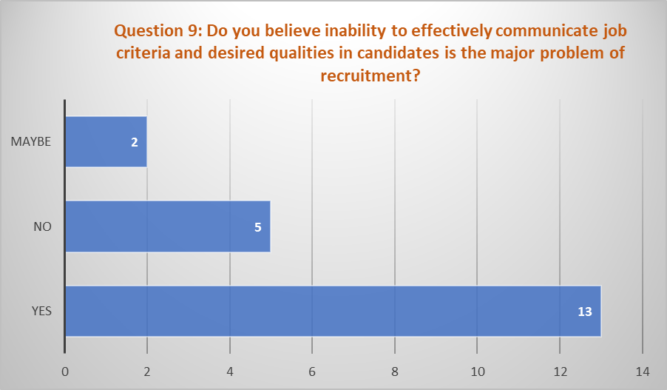
This research show that 13 employees answer with yes and believe this is the major problem of recruitment process. Another 5 employees answer with no considering this is not a big problem and 2 employees respond with maybe. Therefore, Clipper Logistics need to give more attention on this criterion and improve expected attributes for a post need to be communicated properly.
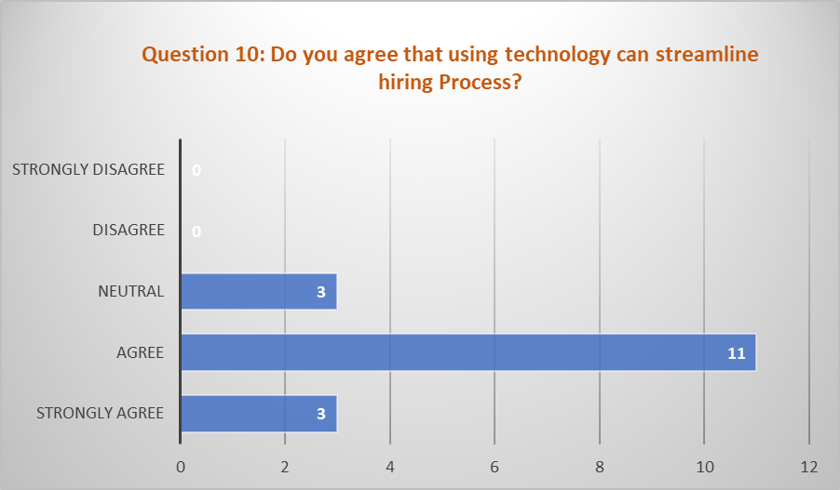
This process communicates from response of 3 employees that they answer with strongly agreed, another 11 employees answer with agreed and 3 remained neutral. The last 3 employees respond with disagreed and think this can’t streamline the hiring process. However, on the base of this study the respondents suggests that usage of modern technologies can mitigate issues of recruitment and selection of the company.
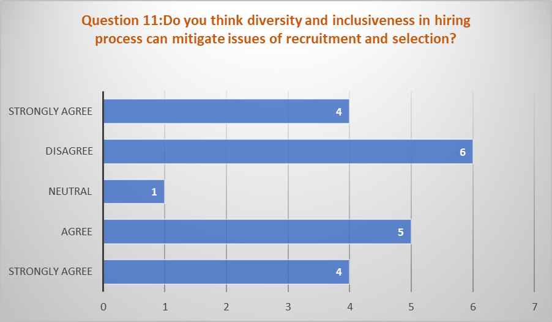
The result show that 4 employees strongly agreed, 5 agreed and 1 remained neutral. Another 6-employee answer with disagreed and 4 strongly disagreed. Thus, there different types of opinions remain regarding diversity and inclusiveness and their impacts on mitigating issues of recruitment and selection, though it indicates that diversity and inclusiveness can't help to mitigate issues of recruitment and selection.
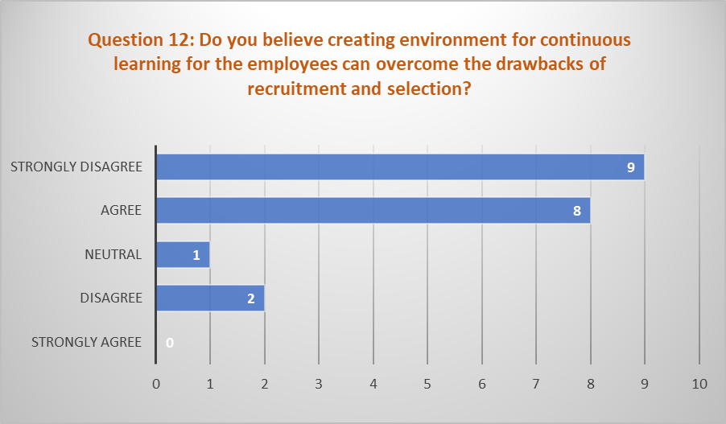
The result reveal that more employees believe creating environment for continuous learning for the employees can overcome the drawbacks of recruitment and selection. Nine employees respond strongly agreed, 8 agreed and 1 remained neutral. Only 2 employees do not agree with the last respondent and answer with disagreed, however, none strongly disagreed. Thus, it indicates that environment of continuous learning is important for the organisation.

4.3. Findings, Analysis and Discussions regarding recruitment practices and process during hiring
The study`s overarching was to examine how different recruitment strategies and procedures affect the effectiveness of organisations. The study`s results suggest that hiring procedures and practices matter greatly for an organization`s success. Most respondents on question 3 believed that high-quality recruitment techniques boost business results. Most respondents from question 7 consider that is necessarily too higher-quality hiring to improve the efficiency and effectiveness of the business.
The survey also found that recruiting managers should place a high value on candidates' prior work experience. Similarly, with (Yu,2018) and from result displayed on question 8 respondents believed that better quality hiring and enhanced organizational performance can be achieved from delivering a great candidate experience, including clear communication, timely feedback, and a streamlined process.
The data collected from question 11 conclude that an organization's performance can be greatly improved by making a commitment to diversity and inclusion initiatives to attract and retain high quality employees. Most employees answering on question 11 and from suggestion of (Rodney et al.2019), consider that different staff like managers, recruiters and hr professionals makes smarter choices, more creative solutions, and a deeper appreciation of customers' perspectives and experiences.

4.4. Findings, Analysis and Discussions on the impact of skilled workforce on business performance and outcome
The third line of enquiry was to learn more about the advantages skilled labour recruitment may bring to businesses or to hiring process. This research shows that hiring competent workers has significant positive effects on business operations and outcomes.
In addition, the results from question 6 shows retaining employees are easier when hiring qualified candidates. When workers are well-trained, is less likely to look elsewhere for employment opportunities. The study result from question 6 communicate to Clipper Logistics that employee retention is beneficial because it allows experienced workers to pass on their knowledge and expertise to new hires, which in turn boosts output and efficiency.
Because of their knowledge, skilled individuals are more likely to be productive and efficient, and they can generate fresh ideas for fixing long-standing issues. This result from. study related on question 6 has the potential to boost product quality, customer satisfaction, and the company's standing in the market.
Again, the research showed that increasing morale and contentment on the workplace was possible by hiring more qualified personnel. Consequently, the research shows on question 8 that hiring a talented staff is crucial to an organization's success. These results provide a useful tool for businesses who want to boost their recruitment strategies and general effectiveness.

4.5. Findings, Analysis and Discussions regarding the solutions to resolve the problem of recruitment process
Some major problems with the recruitment process have been identified after evaluating data from the research on the importance of recruitment and its impact on organisational performance for the case study on Clipper Logistics, now part of GXO. These challenges show an immediate effect regarding organisation`s functioning and outcomes (Chaudhari et al., 2020). Improving recruitment procedures and overall organisational effectiveness requires attending to these concerns.
One of the issues identified on question 9 was the inability of the recruiters and hiring managers to effectively communicate job criteria and desired qualities of the candidates. This issue leads to uncertainty and misunderstanding during the employment process. The company runs the risk of either hiring the unskilled person of failing to get the best person for the job. To solve this difficulty, it is vital to establish a clear line of communication between recruiters and hiring supervisors. Having regular meetings between the two groups cand assist ensure that the recruitment process is tailored to the needs of the company. The data from question 12 shows that existing staff members also complained about a lack of learning and advancement possibilities. This can cause high rates of employee turnover, which is expensive for any business. Giving workers a chance to learn new things is crucial since it boost both their happiness on the job and the company`s success in the long run. Providing training and development programmes can also assist recruit top talent to the company, as it shows a commitment to investing in personnel.
The result obtained from question 10 also showed that technology could be better used streamline the hiring process. Lack of technology acceptance causes delayed and ineffective recruitment practices, which waste time and money. Therefore, it is crucial to use technology, such as automated resume screening tools or video interviewing software, to enhance the recruitment process. This has the potential to shorten the recruitment cycle and boost its efficiency.
Ultimately, the research indicated that a lack of diversity and inclusivity in the recruitment process contributed to a lack of diversity in the organisation`s workforce (Orrick, 2018). Diversity and inclusion are essential to the success of the organisation because they encourage new viewpoints and ideas and including this into the hiring process is crucial to solve this problem. To this end, it is helpful to establish diversity quota for hiring and to use wording in job advertisements that is welcoming to all applicants.

4.6. Summary
The summary of this chapter was focused on the presentation, findings, analysis, and discussions of the data collected from the participants. The findings imply that recruitment procedures and process during hiring have a major impact on the quality of the workforce and ultimately on business performance. The study revealed various aspects that contribute to successful recruiting, including the utilisation of recruitment channels, the selection of qualified individuals, and the alignment of recruitment methods with organisational goals.
Altogether, the findings suggests that Clipper Logistics now part of GXO could enhance their performance and improve the business outcome by enhancing their recruitment practices and establishing successful recruitment strategies and investing in a talented and diverse staff.

Chapter 5: Conclusion and Recommendation

5.1. Conclusion
From the findings of this research, it has been explored the recruitment strategy of Clipper Logistic and its performance. The results imply that recruitment techniques and procedures during hiring significantly affect worker quality and, by extension, business results. Successful recruiting was shown to depend on several factors like recruitment channels, advertisement, the selection of qualified persons through various examination, and finally training and development. Moreover, it has been found that when the company wants to hire skilled employees, it is easy for them because there a several candidates apply for the post. The research has found that a skilled has a positive effect on business outcomes such as productivity, profitability, and customer satisfaction. The benefit of hiring a diverse workforce leads to problem-solving, creativity, and innovation. However, the research also revealed that there are certain challenges in the recruitment process. These include a lack of qualified candidates, high recruitment costs, and insufficient recruitment strategies. To attract and retain top talent, the research found that prioritising investments in employee development and training, developing an employer brand, and using technology to streamline the recruitment process can ensure the skilled workforce. The study's findings emphasise the significance of recruitment and its bearing on the effectiveness of organisations. Businesses may boost Clipper Logistic (now part of GXO) and gain an edge in the market if they take the time to develop effective recruitment strategies and invest in a bright and diverse workforce. Most of the respondents believes that organizational performance depends on the effective hiring process. Communication between HR and recruiting managers can create the chances for employee growth. As well, the use of technology can ensure a speedy hiring process.

5.2. Recommendations
Clipper Logistics now part of GXO may be benefited from these below mentioned recommendations is they can successfully apply to their company:
- Develop a precise job description: Provide a detailed explanation of the tasks and responsibilities of the available position, as well as the required qualifications for the job. This will aid in attracting qualified applicants for the position and ensuring that they have the relevant expertise and skills. The company should present the opportunities of career development.
- Utilise a variety of recruitment channels: To fill open positions, the company can advertise them utilising for example differently recruitment canals, like social media, job boards, and recommendations from other employees. This has the potential to assist in increasing the number of competent candidates and ensuring that the organisation is recruiting individuals from a diverse range of backgrounds. Clipper Logistics now part of GXO has a strong IT network and capacity. They can retain the employees globally.
- Create a positive candidate experience: Develop a candidate experience that is favourable by ensuring that the hiring procedure is time-effective, open to scrutiny, and conveys the core beliefs and practises that define the organisation. This can help to build a favourable impression of the organisation and encourage high-performing individuals to accept job offers that have been extended to them.
- Conduct in-depth interviews: Conduct in-depth interviews using a structured format to evaluate the candidate's abilities, experience, and cultural compatibility. To better anticipate future performance, behaviour-based questions should be asked.
- Use assessments: When determining whether a candidate is qualified for a position, it is important to use evaluations such as mental tests, personality tests, and skill tests. This can be useful in determining which candidates have the necessary abilities and are a good fit for the role.
- Provide compensation and benefits that are competitive in the market provide compensation and benefit packages that are competitive in the market to recruit and keep top employees. This can help the company in remaining competitive up on labour market. Moreover, this guarantee that workers are content with the salary they receive.
- Develop employee training and development programs: Create training and development programmes for employees that help them improve their skills, knowledge, and career progression. This can help high-performing people stay in their jobs longer and improve their performance in the roles they now hold.
The company needs to put resources into their recruitment efforts if they want to find and hire people who will fit in with their culture and values. Individuals with the knowledge, expertise, and motivation to stimulate the company forward can be found through a methodical hiring procedure. In addition, businesses should put money into training and development programmes to boost employee retention, contentment in the workplace, and productivity. This way, Clipper Logistics now part of GXO can make sure they're retaining top employees and enhancing their recruitment strategies to meet their long-term goals.

References and Bibliography

Bhende, P., Mekoth, N., Ingalhalli, V. and Reddy, Y.V., (2020). Quality of work life and work-life balance. Journal of Human Values, 26(3), pp.256-265.Available at: https://aipublications.com/uploads/issue_files/1IJEBM-MAY20213-Recruitment.pdf Accessed:(05 March 2023)
Bider, I. and Perjons, E., (2019). Value-Based Organizational Design. Available at: https://www.researchgate.net/profile/Ilia-Bider/publication/344726217_Value-Based_Organizational_Design/links/5f8c99ada6fdccfd7b6bed6e/Value-Based-Organizational-Design.pdf Accessed on: ( 20 February 2023)
Buil, I., Catalán, S. and Martinez., E., (2020). Understanding applicants` reactions to gamified recruitment. Journal of Business Research, 110, pp.41-50 Available at: https://www.sciencedirect.com/science/article/abs/pii/S0148296319308082 Accessed:(20 February 2023)
Chaudhari, N., Ravi, R., Gogtay, N.J. and Thatte, U.M., (2020). Recruitment and retention of the participants in clinical trials: challenges ad solutions. Perspectives in clinical research, 11(2), p.64.
Cheng, M.M. and Hackett, R.D., (2021). A critical review of algorithms in HRM: Definition, theory, and practice. Human Resource Management Review, 31(1), Available at:https://text2fa.ir/wp-content/uploads/Text2fa.ir-A-critical-review-of-algorithms-in-HRM_compressed.pdf Accessed: (05 March 2023)
Clipper Logistics (2022). About us. Available at: https://www.clippergroup.co.uk/ Accessed: (25 November 2022)
Elrehail, Harazneh, I., Abuhjeelah, M., Alzghoul, a., Alnajdawi, S. ad Ibrahim, H.M.H., (2019). Employee satisfaction, human resource management practices and competitive advantage: The case of Northern Cyprus. European Journal of Management and business Economics, 29(2), pp.125-149. Available at: https://www.emerald.com/insight/content/doi/10.1108/EJMBE-01-2019-0001/full/pdf Accessed: (05 March 2023)
Farndale, E., McDonnell, A., Scholarios, D. and Wilkinson, A., (2020). Human Resource Management journal: A look to the past, present, and future of the journal and HRM scholarship Human Resource Management Journal, 30(1), pp.1-12 Available at:https://onlinelibrary.wiley.com/doi/pdf/10.1111/1748-8583.12275 Accessed: ( 05 March 2023)
Hamza, P.A., Othman, B.J., Gardi, B., Sorguli, S., Mahmood Aziz, H., Ali Ahmed, S., Sabir, B.Y., Burhan Ismael, N., Ali, B.J. and Anwar, G., (2021). Recruitment and selection: The relationship between recruitment and selection with organizational performance. International Journal of Engineering Business and Management Available at:https://aipublications.com/uploads/issue_files/1IJEBM-MAY20213-Recruitment.pdf Accessed:(25 November 2022)
Kurdi, B. and Alshurideh, M., (2020) Employee retention and organizational performance: Evidence from banking industry. Management Science Letters, 10(16), pp.3981-3990 Available at: https://growingscience.com/msl/Vol10/msl_2020_235.pdf Accessed: (05 March 2023)
Leitão, J., Pereira, D. and Gonçalves, Ȃ., (2019). Quality of work life and organizational performance: Workers` feelings of contributing, or not, to the organization`s productivity. International journal of environmental research and public health, 16(20), p,3803. Available at: https://www.mdpi.com/1660-4601/16/20/3803/pdf Accessed: (05 March 2023)
Liwani, U., (2022). Promoting a skilled workforce. Agriprobe, 19(2), pp.18-20. Available at: https://journals.co.za/doi/abs/10.10520/ejc-agriprob-v19-n2-a5 Accessed: (05 March 2023)
Orrick, D.W., (2018). Recruitment, retention, and turnover of police personnel: Reliable, practical and effective solutions. Charles C Thomas publisher.
Rahman, M., Aydin, E., Haffar, M. and Nwagbara, U., (2022). The role of social media in e-recruitment process: Empirical evidence from developing countries in social network theory. Journal of enterprise information Management, 35(6), pp. 1697-1718. Available at: https://www.emerald.com/insight/content/doi/10.1108/JEIM-12-2019-0382/full/html Accessed: (05 March 2023)
Rodney, H., Valaskova, K. and Durana, P., (2019). The artificial intelligence recruitment process: How technological advancements have reshaped job application and selection practices. Psychosociological Issues in Human Resource Management, 7(1), pp.42-47.
Snyder, H., (2019). Literature review as a research methodology: An overview and guidelines. Journal of business research, 104, pp 333-339.
Tumasjan, A., Kunze, F., Bruch, H. and Welpe, I.M., (2020). Linking employer branding orientation and firm performance: Testing a dual mediation route of recruitment efficiency and positive affective climate. Human Resource Management, 59(1), pp.83-99 Available at: https://kops.uni-konstanz.de/server/api/core/bitstreams/00b532bc-44b6-4896-81da-6928ddc6eb65/content Accessed: ( 20 February 2023)
Usmani, s., (2020). Recruitment and selection process at the workplace: a qualitative, quantitative, and experimental perspective of physical attractiveness and social desirability. Review of integrative business and economics research, 9(2), pp.107-112 Available at:https://www.researchgate.net/profile/Sania-Usmani-2/publication/354312981_Recruitment_and_Selection_Process_at_Workplace_A_Qualitative_Quantitative_and_Experimental_Perspective_of_Physical_Attractiveness_and_Social_Desirability/links/6130a4f8c69a4e4879737035/Recruitment-and-Selection-Process-at-Workplace-A-Qualitative-Quantitative-and-Experimental-Perspective-of-Physical-Attractiveness-and-Social-Desirability.pdf Accessed: (25 November 2022)
Yong, J.Y., Yusliza, M.Y., Ramayah, T., Chiappetta Jabbour, C.J., Sehnem, S. and Mani, v., (2020). Pathways towards sustainability in manufacturing organizations: Empirical evidence on the role of green human resource management. Business Strategy and the Environment, 29(1), pp.212-228. Available at:https://www.researchgate.net/profile/Venkatesh-Mani/publication/334572211_Pathways_towards_sustainability_in_manufacturing_organizations_Empirical_evidence_on_the_role_of_green_human_resource_management/links/5d31f5d2299bf1995b39513f/Pathways-towards-sustainability-in-manufacturing-organizations-Empirical-evidence-on-the-role-of-green-human-resource-management.pdf Accessed: ( 20 February 2023)
Yu, H.H., (2018). Gender and public agency hiring: An exploratory analysis of recruitment practices in federal law enforcement. Public Personnel Management, 47(3), pp.247-264.

Appendices

Appendix 1. Questionnaire used for primary data collection
Question 1. What is your gender?
- Male
- Female
- Other
Question 2. What is your current position at Clipper Logistics?
- Manager
- Recruiter
- HR professional
Question 3. Have you been employed at Clipper Logistics going through a comprehensive recruitment process?
- Yes
- No
- Prefer not to say
Question 4. Do you think the process of recruitment is important in getting proper employees and ensuring organisational success?
- Strongly agree
- Agree
- Neutral
- Disagree
- Strongly disagree
Question 5. During the recruitment process you were hired based on previous job experience of candidate?
- Yes
- No
- Maybe
Question 6. Do you believe employee retention is more important than skilled workforce?
- Yes
- No
- Maybe
Question 7. Do you think skilled employees boost organisational effectiveness?
- Yes
- No
- Maybe
Question 8. Do you believe that recruitment strategies will have impacts on selecting skilled candidates?
- Strongly agree
- Agree
- Neutral
- Disagree
- Strongly disagree
Question 9. Do you believe inability to effectively communicate job criteria and desired qualities in candidates is the major problem of recruitment?
- Yes
- No
- Maybe
Question 10. Do you agree that using technology can streamline hiring process?
- Strongly agree
- Agree
- Neutral
- Disagree
- Strongly disagree
Question 11. Do you think diversity and inclusiveness in hiring process can mitigate issues of recruitment and selection?
- Strongly agree
- Agree
- Neutral
- Disagree
- Strongly disagree
Question 12. Do you believe creating environment for continuous learning for the employees can overcome the drawbacks of recruitment and selection?
- Strongly agree
- Agree
- Neutral
- Disagree
- Strongly disagree

Appendix 2. Participant Information Sheet

Appendix 3. Application for ethical Approval

Appendix 4. Participation Consent Form

