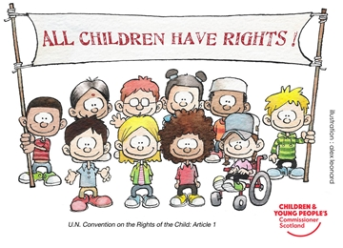  transistion  From Nursery To Reception | Kathryn Protheroe (1707346)  Early Years Education and Care Practitioner

Contents
Introduction 2
The role of an adult 3
The needs of a child 5
Partnerships 8
The importance of play 9
Interventions 11
Proposed outcomes 12
Reference list 13

Introduction
What is a Transition?
Transition is defined in the oxford dictionary as,
noun
the process or a period of changing from one state or condition to another.
"students in transition from one programme to another"

verb
undergo or cause to undergo a process or period of transition.
"he transitioned into filmmaking easily"

The aim of this handbook it to facilitate early years practitioners in supporting children in their transition from nursey to reception. The focus is on understanding the importance of building and supporting ongoing relationships between parents / care giver, children and the school / teacher. Understanding the attachments that children have and those that they will develop. The importance of encouraging and facilitating learning through play.

Role of an adult

It is important to remember that Children develop strong attachments to their parent or primary caregiver from an early age. ‘All theorists share the assumption that the first attachment is the most influential ingredient in the creation or a child’s working model.’ (Bee, h. Boyd, D. the developing child; 291). These attachments can vary considerably depending on what type of attachment;
Secure attachment- A child who knows that they can rely on parent or primary caregiver to be there and can be easily consoled after stress or separation.
Insecure attachment- when a child does not rely on the parent or primary caregiver for comfort after a stressful/upsetting experience. (Bee and Boyd 2010).
The ecological system
The theorist Bronfenbrenner developed an ecological system that can be described as a world where a child is placed at the centre. The microsystem which is the innermost section closest to the child will have the greatest effect on them because of direct frequent contact, these include family, siblings, school and peers. The mesosystem describes how the microsystem system works together. The exostystem will not have a direct effect on the individual child but will have an effect the components of the mesosystem. The macrosystem is the furthest ring from the child and defined by where the child lives, culture and laws. The child will not have direct contact but they will have an influence on how he or she lives. Each layer has an influence on the next so although the parents job (exosystem) does not directly affect the individual child. If they were to work long hours in a stressful job it would most likely affect the family (mesosystem). (Olswart no date)

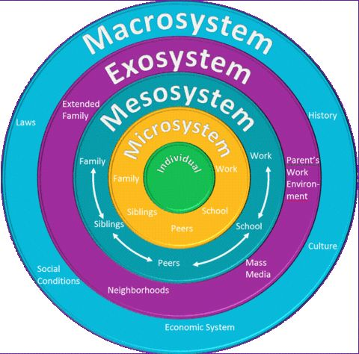

(source: www.google.co.uk 2017)

Early years practitioners have many opportunities to provide children with care and should respect them and remember they are individuals. Your role is to encourage positive behaviour when children are together. Remind them to be aware and considerate of their peers needs, to be kind, helpful and respectful of each other and their belongings. (Nutbrown and Clough 2013)

The needs of a child
Early childhood is an important period of human growth and development and a child should be recognised as an individual with their own thoughts and feelings. This was taken into account when convention outlining the rights of children were formed in 1991 by the UN committee. The guidance explains the international law that requires children to be respected and implemented in all child care settings. The UNCRC has fifty-four sections called articles. Four of these articles have been selected as general principles and are key to the implementation of all the other articles. Mukherji and Dryden (2014).
Article 2 – you should not be treated badly because you are different.

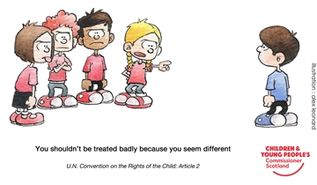
(Source: www.cypcs.org.uk 2017)
Article 4 – the government should make sure your rights are respected.
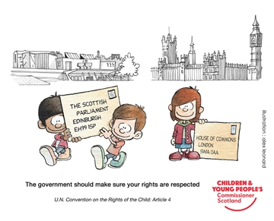
(Source: www.cypcs.org.uk 2017)

Article 6 - everyone should let you live and grow.

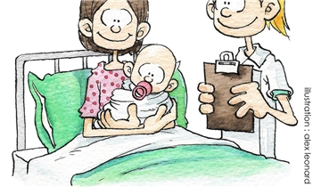
(Source: www.cypcs.org.uk 2017)

Article 12- you should have a say in a decision that affects you.
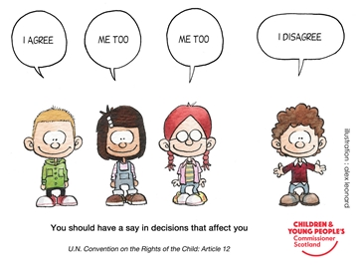
(Source: www.cypcs.org.uk 2017)

According to Dewey (Novak, 2005) every child should be treated as an individual. That education should give every child the opportunity to spontaneously grow and develop. He recommends that lessons should be planned and based on what interests the child and their needs. He believes that a child learns from direct personal experience and they absorb knowledge and are more likely to retain it if what they are actively participating in an activity that interests them. Teachers are in the position to inspire children with the desire to learn they should want more knowledge. Seeing and doing will create an individual personal experience which a child will learn from. Children should have the opportunity to go outdoors daily this will provide them with the opportunity to be free and creative to learn from their experiences and allow their bodies to physically develop.

Partnerships
In New Zealand they take the Te whariki approach to the curriculum the importance of relationships between the child, childcare services, family and teachers. The curriculum is taught through four key principles.
- Empowerment
- Holistic development
- Family and community
- Relationships
There are also five learning strands, theses strands are intended to highlight to practitioners the type of experience they should provide for a young child. Each intended outcome can be identified in each strand.
- Well-being
- Belonging
- Communication
- Exploration
- Contribution
Te whariki translated is a woven mat. Using this approach and facilitating all partnerships to interlink will provide a child a solid foundation to grow and develop. (Terreni, 2016)
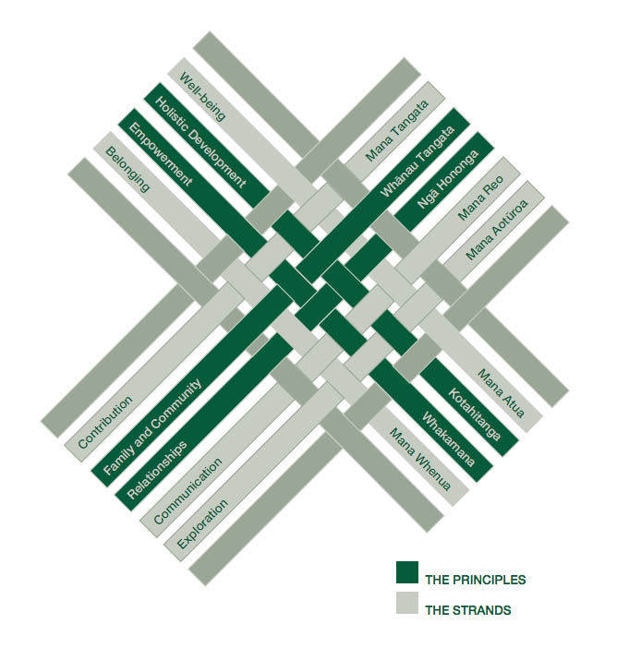
(Source: taukau collage, no date)

The importance of play
Bruce (2012) states that children learn through play. This is not a new concept and the importance of play and the ability to learn from the experiences encountered. Play is enjoyable but also intellectually and emotionally stimulating. Babies use their senses touch, smell, hearing and taste to facilitate play. They need people to encourage play, playing peek a boo and entertaining them with facial expressions. As they physically develop (helped by play) so does their coordination and the ability to grasp an item. They hold an object and instinctively brought to their mouths. As a baby continues to grow and develop into a toddler it is at this critical stage they learn to walk. It is at this stage a child develops their ability to pretend their imagination grows and they learn to create play. They are very social as they try to discover who they are. They notice the difference between themselves and others. They take on the role of others usually by imitating others.eg. when the observe mum hovering, and want to do the same so try and copy. Children aged between three and seven years and beyond need people to help them facilitate play. They need to be provided with a place to play and materials and props to interact with. The role of an adult is crucial in helping children develop their play. Different games can be taught by older children so that younger children learn then and can continue the cycle. As a practitioner you should use observation of play to understand children’s level of learning. Use this information to support and extend play by planning and resourcing an appropriate challenging environment to suit the ability of the children using it. Engage in play to encourage development of communication but know when to take a step back to let children engage with each other and build their own interactions and relationships with their peers without adult invasion.
Learning through play
Play is an active creative enjoyable experience that can facilitate children by making connections in their learning. Children are naturally inquisitive and will instinctively explore their surroundings and situation they will automatically question it. One question leads to another and if a child is interested in something then retaining the knowledge learnt will be easier as it is actively learnt. The importance of play should not be underestimated as children can develop physically, mentally and emotionally. Children also learn without realising they are. It is imperative that a practitioner facilitating play does encourage forward learning creating the opportunity for the child to become more creative and to enable flexible thinking. This does require sophisticated teaching strategies. An extended childhood full of play will maintain flexible thinking and permit intelligence to grow.

Interventions
For an effective transition from nursery to reception you should,
- Encourage children to visit the reception class.
- Visit children in their current class.
- Provide many opportunities for parents and children to visit the classroom.
- Talk about eating lunch in school.
- Ask previous nursery teacher/ care provider for information about individual children.
- Find out about children’s current routines.
- Provide parents with clear information about the settling in policy.
Early finish after lunch for a few days.

when the child starts reception class.
- Be approachable.
- Inform parents what their child ate for lunch.
- Inform the parents of how their child’s day was.
- Share a picture / photograph.
- Build enthusiasm for an upcoming activity.
- Share information with after school clubs.

Proposed outcome
Transition is and important part of growing and developing.
Maslow’s theory hierarchy of needs

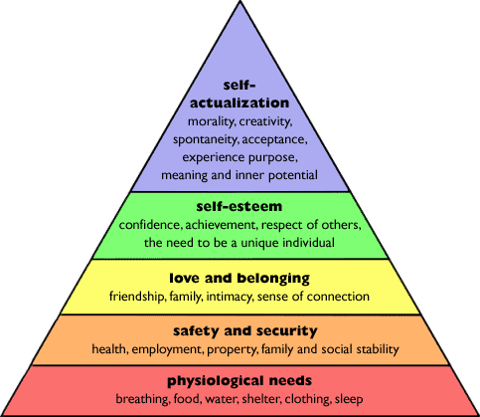
(source: www.researchhistory.org 21017)

each layer must be achieved to move up the pyramid

Noltemeyer et al., 2012. The relationship among deficiency needs and growth needs: An empirical investigation of Maslow's theory. Children and Youth Services Review, 34(9), pp.1862–1867.

