
Student name: Dumitrita Munteanu
Programmes: BA International Hotel Management
Module: Global Tourism and Destination Management
Assignment title: Industry Destination Review
Module Code: M6X01932
Lecturer: Dr. Olu Adegbite

Content

Introduction…………………………………………………………….
Mexico…………………………………………………………………….
SWOT Analysis………………………………………………………..
Infrastructure………………………………………………………….
Economy………………………………………………………………….
Attractions……………………………………………………………….
Water………………………………………………………………………
Challenges……………………………………………………………….
Politics…………………………………………………………………….
Tourism…………………………………………………………………..
Government……………………………………………………………
References………………………………………………………………

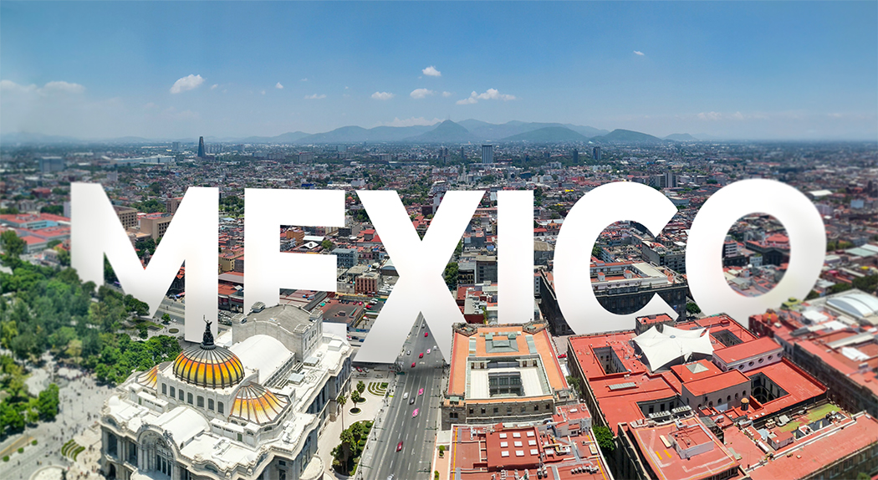
Introduction
This report is to evaluate the state of Mexico as of 2020 and the economic opportunities it represents primarily focused in the tourism sector. The report is gathered from various different topics including the economic and political challenges that the country is facing, how and why Mexico is such an important investment for the hospitality industry, what is the government of Mexico doing in terms of improvement of the economic activities and building up Mexico’s infrastructure.

Mexico
Mexico is playing an important part in the international scene. Its proximity to the great economy of the United States and amazing geopolitical location, connecting the north American countries with the South American countries, it has a border with the North Pacific Ocean on west and the North Atlantic Ocean on east, makes Mexico one of the important countries for international affairs. This important geological position provides the country with great economic opportunities. Within its borders the country is full with beautiful natural spots and landscapes, clean beaches with incredible views, it provides a great attraction for tourists and with the fact that everything in Mexico is much cheaper than other developed economies, makes it a big target for any tourist planning on a vacation on a never ending sunshine and beauty. The natural resources and the fruits and vegetable productions also contributes to the sustainability of the country and gives more security to its economy. It currently enjoys exports of products freely among North America with the NAFTA (North American Free Trade Agreement) playing a major role in the economic development of Mexico. The country faces challenges in stabilizing its tourism sector for over 5 decades, due to the increasing violent crimes and the war of drugs. Nevertheless, the sector still sees growth each year and it shows a great sign of opportunity for more growth. The current pandemic crisis Covid-19 has impacted the tourism sector with a very negative effect in 2020, recovering from this might be a greater challenge than any of Mexico’s challenges so far.

SWOT Analysis
Strengths include:
The country’s external debt is considered to be record low for the past 5 years.
Great climate for vacation, The Pacific Ocean and the Caribbean Sea.
The country’s exports impact the economic growth positively each year.
Beautiful beaches and breath-taking landscapes.
Economic growth and GDP increase.
The geopolitical influence of Mexico.
Big investments in the infrastructure, powered by the private sector.

Weaknesses:
Record high in violent crimes in recent years.
Covid19.
Cartels still occupy and control much of the country’s territories.
The tourism sector is heavily dependant on the United States’ and Canada’s economic growth and stability.
The recent political changes in United States has made it harder for the country to export on the US markets.

Opportunities:
Mexico is situated in a key region, bordering with the great economy of the United States, it is considered of extreme importance, geographically, due to the United States being one of the biggest importers in the world.
The country’s great climate makes it a great investment opportunity for the hospitality sector as it attracts tourists from all over the world.
Threats:
The United States’ hostile policy against the migration and trade with Mexico.
The increasing power and influence of the cartels taking root into the country’s government and policy making.
The reputation of being a major exporter of drugs puts Mexico in a bad position to negotiate with other countries in terms of trade and relations, also many tourists are scared to visit because of the reputation of the violent crimes and links to organized crime.

Infrastructure
Mexico is built up with the necessary infrastructure, having water supply and energy supply across the whole country with very few places with shortage. The huge $44 billion dollar infrastructural update project has started to shape up in 2019. The government has released the statement on the first phase of the ambitious infrastructural plan in November lasts year. The plan includes a big range of transportation and other projects in the public sector that will take place over a 5 years period. The private sector is funding the whole plan, with commitments of value over 859 billion pesos ($44.3 billion) across 147 different projects. The tourism sector will take a major cut from this investment and the other top sectors will be the transportation and telecommunications. The transportation project includes, new highways, rail, ports and airports, and it is valued to cost almost 284 billion pesos, which is 14.7 billion dollars. It will be stretched out until 2024 the deadline for this part of the project. Carlos Slim, the richest man in Mexico, CEO of Telmex and America Movil, is also heavily involved in the plan, said in an interview “There are healthy public finances with a lot of discipline on the part of the public sector...and I think that gives great confidence for private investment, which is what’s available” – Carlos Slim
There is also the energy sector that will take a great boost from this project, starting at 2020, although delays have been made due to the recent Covid-19 pandemic crisis. It is considered that the pandemic will delay much of the infrastructural plan and might end up costing more than the initial $44 billion dollar investment and with few more years delay. As of today, nothing is sure about it.

Economy
Mexico economy is still considered to be a developing market economy. It is the ninth-largest economy in the world and the main industries include food and beverages, petroleum, tobacco, chemicals, iron and steel. Mexico is also a big exporter of fruits and vegetables, cotton and coffee, oil and oil products. It ranks 4th with the biggest number of poor people among richest economies. Has a freedom score of 66.0, considered the 67th freest in the 2020 index. The United States president, Donald Trump, has threaten to impose a 5% tariff on all Mexican imports, if the government of Mexico doesn’t act to stop the illegal flow of drugs and immigration into the US. This threats from United States has shed light on Mexico’s economy and many started to analyse it closer in the last 2 to 3 years. The GDP of Mexico ranks 15th on the global scale, and it is largely achieved with the help of the country’s manufacturing and petroleum exports. But the biggest questions among analysers are about the state of its citizens and how poorly the Mexican economic power covers the standard of living of many of its citizens. Half of the Mexican population lives in poverty, despite the country’s increase in economic value and exports, GDPS, etc. 2017 GDP of Mexico was 1.15 trillion dollars, 2018 it was 1.22 trillion dollars, and 2019 it was 1.2 trillion dollars. A significant portion of the automotive industry from the United States had started building plantations in Mexico after the NAFTA agreement was signed. Because of the cheap labour and the Mexican people being hard workers, for the automotive industry of US makes much more sense to make their car parts in Mexico, pay less for the production costs, increase production volumes and then still be able to sell their cars in the US market for the same price. This in return is a great economic addition to Mexico as it created a lot of jobs and it boosted up the GDP tremendously.
Attractions
Even though it will be challenging for the government to attract visitors due to the crime rate in the country, the massive number of attractions in Mexico is still making a huge positive impact for its tourism. It is considered a favourite vacation destination for North Americans and it becomes increasingly more popular among tourists from Europe who are seeking to enjoy the endless sunshine and beautiful sandy beaches that are not so easily seen in Europe. Guanajuato, Chichen Itza and spots like Cancun, Puerto Vallarta, Playa De Carmen are among the most popular and traditional beach vacation spots.

Water
You will often see warnings not to drink the water from the tap in Mexico. The suggestion is to drink bottled water as it is easily available everywhere to buy and according to tourists it is not that expensive. Even Mexicans don’t drink the water from the tap, they usually buy five-gallon jugs called “garrafones” which you can order and will be delivered to your home. It is recommended to brush your teeth with bottled water, as accidentally swallowing the water from the tap can upset your stomach and digestive system. Drink stands are not very well perceived by tourists as you’re not sure what kind of water they’re using. Hotels and restaurants are much safer in terms of drinks, and the quality and service of these hotels and restaurants won’t allow risking to put tap water in any drink.

Challenges
The biggest challenge remains the Covid-19, as no surprise the pandemic has taken on economies all over the world. Mexico’s current problem with the virus has been considered to be one of the worst, as the country’s death tolls remain to be high. It represents an enormous challenge not only in the tourism sector, but much of the rest of the economy of Mexico. Apart from this recent challenge, the country has suffered tremendously from the cartel wars and the increasing violence due to the massive drug trade. In response to this the people of Mexico has been uprising against the violent crimes forming paramilitary groups and boosting government officials who claim to have a solution to this problem. The current president Manuel Obrador has promised to drastically decrease the cartel’s activities in Mexico and restore piece and prosperity in the country. The plan in 2020 so far seen some form of success, with the Sinaloa Cartel Leader El Chapo being extradited to the United States, Obrador’s current policy and his promises seem to work. On the other hand the government is facing a huge challenge to attract visitors for its tourism sector and to make its streets safe for tourists. This remains to be of a great challenge as 2019 events of the Mexico- Americans killed has made a big news on the international media. Tourists have always been scared to go at places where crime rate is big, and this is the number one challenge for Mexico. If the government wants to strengthen its tourism sector, this is the biggest challenge it faces.

Politics
On international level, Mexico plays a big role in the world of politics. United States’ remarks about Mexico’s exports and illegal migration has taken Mexico in the front page of international news in the last years, creating serious international debate about Mexico. On the immigration talks, even though United States’ president Donald Trump’s remarks about the Mexican illegal immigration, it turns out that a lot of the immigration happens in the other way around, with increasingly more Mexicans leaving the US to go back to Mexico, than Mexicans going into US. With the actual numbers of illegal immigrants to United States still unclear, and somehow covered. Ever since the NAFTA (North America’s Free Trade Agreement) was signed, the country was subject to a lot of controversy, with United States often blaming Mexico for not trading fairly with US. Mexico export far more products into United States than imports from US. This created a trade war in the last decade between the two nations, with more major events taking place recently after Donald Trump became president of the US and threatening to impose tariffs on goods coming from Mexico, building a wall and overall strengthening the border control with strict rules of entering. This presents a major problem for Mexico’s future exports to United States and the automotive industry might go back to US if the tariffs and threats keep occurring.

Tourism
Mexico enjoys a big tourism sector, with contributions to its GDP exceeding 8.5% (both domestic and international visitors). It has contributed greatly to its employment as well as its economic growth and international investments over the past three decades. It is one of the most important tourist destinations in Latin America. 30% of the Mexico’s income is considered to come from the tourism sector. The tourism in Mexico is largely dependent on United States and Canada, (North American neighbours) which makes it vulnerable to the United States and Canada’s economic conditions. It is considered that more than 95% of international visitors come from North America. The economic events in the United States primarily impact Mexico’s tourism sector. It took many years to recover from the shocking events of September the 11th, 2001 terrorist attacks, and also the United States’ 2008 economic crisis made a huge impact on Mexico’s economy, due to its dependence on the US tourists. Apart from North American tourist visits, Mexico has failed to attract visitors from other parts of the world, with European tourists accounting for only 3% of visits in Mexico. Other Latin American Countries’ visits are less than 2%. However, the great climate, location, the beautiful seas and the Pacific Ocean makes it a promising country that can always attract visitors, if the tourism sector implements the right strategy. Currently there are many international investments into the tourism and many more to come.

Government
The policy making of Mexico and its current government has allowed the private sector to contribute and take great portions of the Mexican industries. The government is considered to be a federal republic with Andres Manuel Lopez Obrador being the president and leader of the government. It is composed in total of 31 states, with the power divided between the juridical branches. The original constitution of Mexico, which was written in 1917, has been amended a few times since then. The current government is considered to be much less corrupted as its previous cabinets. In recent years many Mexicans has blamed the government for covering up the organized crime and being heavily involved in the drug trade. President Andres Obrador has promised to end the corruption and establish new rules in the police department. Corruption is to be investigated heavily and drug trafficking has been a primary focus of the government’s promise to the people of Mexico.

References
- Whitmore, G., 2020. Can I Travel To Mexico Right Now During The Covid-19 Pandemic?. [online] Forbes. Available at: https://www.forbes.com/sites/geoffwhitmore/2020/05/31/can-i-travel-to-mexico-right-now-during-covid/.
- Tripadvisor. 2020. Mexico 2020: Best Of Mexico Tourism - Tripadvisor. [online] Available at: https://www.tripadvisor.com/Tourism-g150768-Mexico-Vacations.html
- The Economist. 2020. Mexico’S Emigrants In America Are Ageing. [online] Available at: https://www.economist.com/the-americas/2020/07/23/mexicos-emigrants-in-america-are-ageing
- Marriott.com. 2020. Top Hotels In Mexico | Marriott Mexico Hotels. [online] Available at: https://www.marriott.com/hotel-search/mexico.hotels/
- Human Rights Watch. 2020. World Report 2020: Rights Trends In Mexico. [online] Available at: https://www.hrw.org/world-report/2020/country-chapters/mexico
- GmbH, f., 2020. 11 Unbelievable Facts About Mexico's Economy | Markets Insider. [online] markets.businessinsider.com. Available at: https://markets.businessinsider.com/news/stocks/mexico-economy-facts-disproportionate-poverty-2019-6-1028281403
- Mexico News Daily. 2020. Is Mexico Safe? As The Shooting Continues More People Are Asking. [online] Available at: https://mexiconewsdaily.com/news/is-mexico-safe/
- En.wikipedia.org. 2020. Economy Of Mexico. [online] Available at: https://en.wikipedia.org/wiki/Economy_of_Mexico

