[Date]
A B M Masum (1714934)

Sustainable Business Strategy.
Groupon, Inc

BA Leadership and Management Skills for the Workplace.
Strategic Management for SMEs
Module Code: BMSW6104.
Lecturer: DR Paul Bocij.
Student: A B M Masum (1714934).

Contents

- Introduction----------------------------------------------------------------------------------5
- Organisation’s current strategic Directions------------------------------------------5
  - Mission, Vision, and objective--------------------------------------------------5
  - Porter’s generic competitive strategies---------------------------------------6
  - Business model--------------------------------------------------------------------6
  - Virtual value chain----------------------------------------------------------------7
  - VMOST------------------------------------------------------------------------------9
- Environmental analysis------------------------------------------------------------------9
  - PESTEL analysis-----------------------------------------------------------------10
  - Five Force analysis---------------------------------------------------------------12
    - Threats of New Entrants---------------------------------------------------- 12
    - Bargain power of Suppliers-------------------------------------------------12
    - Bargain power of Buyers----------------------------------------------------13
    - Threats of substitution-------------------------------------------------------13
    - The competitive rivalry among existing competitors-----------------13
  - SWOT--------------------------------------------------------------------------------14
  - VIRO----------------------------------------------------------------------------------15
    - Value-----------------------------------------------------------------------------15
    - Imitable--------------------------------------------------------------------------15
    - Rare------------------------------------------------------------------------------16
    - Organization--------------------------------------------------------------------16
- Stakeholders’ expectations and power in the organization--------------------17
- Grouping’s strategies choice for long-term sustainability in the business--20
  - Balance scorecard-----------------------------------------------------------------20
  - SAFe----------------------------------------------------------------------------------24
    - Suitability------------------------------------------------------------------------24
    - Acceptability--------------------------------------------------------------------24
    - Feasibility------------------------------------------------------------------------25
    - Evaluation-----------------------------------------------------------------------25
- Implementations and Recommendations---------------------------------------------25
- Conclusion------------------------------------------------------------------------------------28
- References----------------------------------------------------------------------------------- 29
- Appendix 1------------------------------------------------------------------------------------31
- Appendix 2-----------------------------------------------------------------------------------32

List of Figure
Figure 1: Three Generic Strategies-----------------------------------------------------------------6
Figure 2. Groupon’s Business model --------------------------------------------------------------7
Figure 3.1: Porter’s value chain model ------------------------------------------------------------7
Figure 3.2. Groupon Virtual Value chain ----------------------------------------------------------8
Figure 4, VMOST analysis ---------------------------------------------------------------------------9
Figure 5, Porter’s Five Forces ----------------------------------------------------------------------12
Figure 6, Deal from Amazon ----------------------------------------------------------------------- 13
Figure 7.1 Stakeholder mapping ------------------------------------------------------------------18
Figure 7.2 Groupon’s Stakeholder mapping ---------------------------------------------------19
Figure 8, Balance scorecard -----------------------------------------------------------------------20
Figure 9, Groupon’s main financial chart -------------------------------------------------------21
Figure 10, Strategic management phases -----------------------------------------------------26
Figure 11, Customer journey map, Groupon’s Food delivery service ------------------27
Figure 12, Three steps change model ----------------------------------------------------------27.

List of Table

Table 1, Groupon’s PESTEL analysis -----------------------------------------------------11
Table 2, Porter’s Five Force Analysis ------------------------------------------------------14
Table 3, Groupon’s advanced SWOT analysis ------------------------------------------15
Table 4, Groupon VIRO framework ---------------------------------------------------------16
Table 5, Groupon’s stakeholders assess and prioritise --------------------------------17
Table 6, Groupon’s Balance scorecard ----------------------------------------------------23
Table 7, SFA matrix for Groupon ------------------------------------------------------------25

- Introduction:
2020 will be remembered through generations to come because of the epidemic (Covid-19). Although the epidemic has had a devastating effect on, people's lives and businesses, some businesses have made significant improvements such as e-business/e-commerce. E-commerce/e-business has been started, almost 3 decades ago since the first website created in 1991 and new doors of business have opened by offering many opportunities for innovative businesses to transform their services, for example, Amazon, eBay, Alibaba etc. It is clear from Amazon's economic report for the three quarters of 2020 that cash transactions have grown by 56% which is $ 55 billion, however, in the same period in 2019 was 35.3 billion (Wire, 2021).
Groupon Inc is one of the e-commerce platforms that has been following the group buying business model since they establish in 2008. Groupon creates a bridge for SMEs (Small and medium-size Enterprises) to the consumer via an e-commerce website, where the business sells the deal of discount (30 to 70%) product or service to the customer. As in 21st-century e-business/e-commerce’s are the key avenue for SMEs to reach millions of people, connect with the global supply chain, cost-effectively track customers, and enhance internal operation (Mazzarol, 2015), and overall Groupon is trying to help SMEs when they were dying for lack of customers, overall losing competition with corporate houses.
The main aim of this report identifies the strategy for not only get a compitive advantage but also long-term sustainability for Groupon because the recent annual reports are not sustainable while other e-commerce doing well. The whole process will be discussing Groupon's current strategic direction, environmental analysis e.g., value chain, SWOT, PASTLEv, stakeholder expectations, and power analysis, and based on all analyses there will be recommendations for a possible strategy and the implimention in the organization. In terms of managing stragic change, Lynch, (2018) has suggested, there should be prescriptive approaches and emergent approaches (Lynch, 2018). However, the limitations of this report are that it has described only prescriptive approaches and does not describe emergent approaches.

- Organisation’s current strategic Directions
‘Everyone loves deal’ one of the key concepts of Groupon Inc. Everyday Groupon reach their subscribers with the discount offers goods and services both from local SMEs and corporate houses via internet website, e-mail, or mobile app to target customer based on location and personal choices. In this section, the writer will discuss Groupon current business strategies.
  - Mission, Vision, and objective:
In the strategy, an organization must identify the fundamental goal which is mainly come out from the company’s mission, vision, and objective. The purpose of strategies is an organizational mission, vision, value, and objective.
According to David (2011), Vision is an agreed short statement among the managers and executive in any organization which is the business strives in the long terms and usually, organization publish their vision and mission in the front of annual reports (David, 2011). It has been claimed by Groupon in their annual proxy statement 2020 that, organization’s vision is to make it easy for customer around the world to discover and purchase local experience from quality vendors with higher expectation (GROUPON 2020 PROXY STATEMENT, 2020).
A mission statement clarifies the current organizational activities to employees and other stakeholders (Johnson, 2020). Therefore, Groupon mission statement is:
“Groupon is a place where customer can discover new experience every day and local business thrive”. (Groupon, Inc. - Home, 2021). Groupon objectives are not only local customers satisfaction but also to generate revenue by directing the customers to SME’s.
However, compared to other organization, Groupon’s vision & mission statement does not specify the organization’s long-term direction. e.g., taxi firm Uber’s vision statement is “We ignite opportunity by setting the world in motion”.
  - Porter’s generic competitive strategies
Porter (1998) always argued that business is all about competitions and to get a competitive advantage, an organization must decide one of the strategies from three generic strategies (Porter, 1998).

Figure 1: Three Generic Strategies (Porter, 1998)
Groupon’s organizational activities are quite different from traditional e-commerce business, so the firm is trying to get competitive advantage differentiation or even further focus on differentiation by the target customer.
  - Business model
Normally, e-commerce uploads the product/service on the website or online marketplace and consumer visit the site and purchase via the internet. However, Groupon doing business slightly different way, such as firms gather the deal from local business and forward to the target customer. Customers pay Groupon for the deal and collect the coupon from the website, later they redeem the coupon in the business e.g., Hotel, restaurant. When customers redeem the coupon, Groupon transfer the money to the business after deducting their fees which is Groupon terms and conditions. If the customer cannot redeem the coupon for some reason, they could refer to friends and families. Figure 2 has briefly described the Groupon business model.

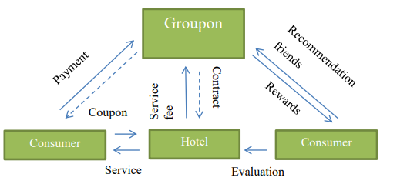
Figure 2. Groupon’s Business model (Johnson, 2020).
  - Virtual value chain
According to Porter (1978), the value chain is a framework where the model describes how an organisation increase margin/profit by adding value in each segment (Porter, 1998). (see description in appendix 3). A brief idea of Porter’s (1978), value chain in figure 3.

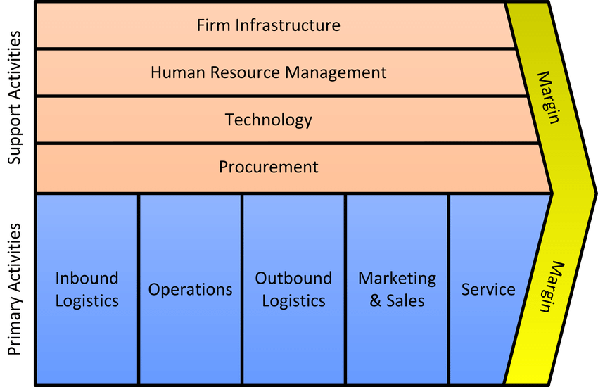
Figure 3.1: Porter’s value chain model (Porter, 1998)
However, John Sviokla and Jeffrey Rayport had argued that organizations can create and extract value with information alongside the physical value chain which is the virtual value chain(Sviokla and Rayport, 1995).
.

Figure 3.2. Groupon Virtual Value chain ((Sviokla and Rayport, 1995).
Groupon creates and adding value to the organization by gathering as much information from the local business deal and forward the deal to the targeted customer. Beyond that, the firms also gather customer information when they purchase the deal or redeem the deal to offer in future similar kind of deal. For example, if a customer purchases a deal from any vegan restaurant that is mean they can offer a similar kind of deal from other restaurants to the same customer rather than a stake or meat curry deal. Figure 3 has a brief description of Groupon’s virtual value chain.

  - VMOST
Chaffey (2015) states that a VMOST analysis is the simple model that can outline the current strategies including business purpose and activities (Chaffey, 2015)
Figure 4, VMOST analysis (Chaffey, 2015),
Groupon’s VMOST analysis revealed the current strategies directions. Although, the vision and mission statement are not very clear as mentioned in section 2.2, that the exact position of the firm will be in the future, but the objectives are the local business deal and target customers. So, Groupon current strategies are collected as much as deals from local business and send to customers. Firms’ tactics are mobile apps, website, and online communications e.g., email, app notification.

- Environmental analysis
In the organizational strategy’s context, interpretations of the environment are everything and everyone outside the organization (Lynch, 2018). In terms of strategic management, the analysis of the environment is so very important because it creates the awareness of competitor, alludes to the opportunity, prescribes substantial threats and so on.
To identify the wider view of Groupon’s environmental outline, the following discussion will be PESTEL, Porters five force, SWOT and VIRO analysis.

  - PESTEL analysis
The PESTEL frameworks differentiate six main types of macro-environmental influences e.g., Political, Economic, Social, Technological, Environmental and Legal (Johnson, 2020).
Groupon Inc.’s long term profitability has a significant impact from the many political factors in different countries e.g., trade regulation tariffs to-commerce. Also, there will be short term effect such as for the pandemic UK Government has short-term intervention tax return and Vat deferred. Also, Brexit has an impact on firms, because there will be different strategies in the UK and EU nations. In terms of economic factors, local currency and inflation rates have an impact on business, also the financial market and local people spending have an impact on the firm.
As mentions before Groupon is growing globally, therefore it is understandable demographical culture, people social behaviour, education, lifestyles have an impact on Groupon from different nations. Technology is another huge factor that has impacts on the firm because long-term sustainability organization needs continual development and the price of the service that the company is taking e.g., Cloud, Server.
Although, Groupon is an environmentally friendly organization because all services online, but some environmental factors have an impact on the firms. For example, weather, climate change, and law regulation of environmental pollutions relate to local businesses, customer choices and Groupon deal offers.
In terms of business legitimacy, different kind of local government laws have an impact on the firm and the organization must bear in mind those laws for long-term success.
The summary of Groupon’s PESTEL discussion has been listed in Table 1. The table has classified all the factors that have different types of impacts and importance with the time frame in the organization.

Factors | Potential  Impact  (High/Low/  Medium  /Unwon) | Time  Frame  (0-6 mths.  6-12 mths.  12-24 mths.  24+ mths) | Type  (+positive  -negative  Unknown) | Impact  (>Increasing  =Unchanged  <Decreasing  Unknown) | Importance  (Critical  Important  Unimportant  Unknown)
Political
- Trade regulation & tariffs to e-commerce | High | 24+ | -Negative | >Increase | Important
- Corporation tax frozen | Low | 0-6 | Unknown | Unknown | Unknown
- Brexit | Low | 12-24 | -Negative | <Decreasing | Important
Economical
- Currency exchange rate | High | +24 | Unknown | Unknown | Critical
- Inflation rate | Medium | 24+ | Unknown | Unknown | Critical
- Financial market. | High | 12-24 | -Negative | Decreasing | Important
Social
- Culture | High | 12-24 | Unknown | Increasing | Important
- Population  (Education, Standard lifestyle) | High | 24+ | Positive | Increasing | Important
- Pandemic. | High | 12-24 | Negative | Decreasing | Unknown
Technological
- Development | High | 12-24 | Positive | Increasing | Important
- Rate technology diffusion. | High | 6-12 | Negative | Increasing | Important
Environmental
- Weather | Low | 24+ | Negative | Decreasing | Unknown
- Recycle policy | Low | 0-6 | Positive | Increasing | Unimportant
Legal
- Copyright, patent/Intellectual property law. | High | +24 | Negative | Decreasing | Critical
- Employment law | Medium | 0-6 | Negative | Decreasing | Important
- Customer protection & e-commerce | High | 12-24 | Positive | Increasing | Important.

Table 1, Groupon’s PESTEL analysis (Johnson, 2020).
  - Five Force analysis
Lynch (2018) argued that it is essential to identify the competitive advantage of rival companies to an organizational environmental analysis (Lynch, 2018). However, Porter’s five force model, lead to a better understanding of competitor and profitability for any e-commerce. Figure 5 has shown Porter’s five competitive models.

Figure 5, Porter’s Five Forces (Porter, 2008)

    - Threats of New Entrants
The nature of Groupon business there is hardly any barrier for new Entrants, because of the on average cost of building a website like Groupon $100 only.
    - Bargain power of Suppliers
Groupon’s main suppliers are the local merchants' and the bargaining power of established merchants higher than other merchants. The well-known business may not interest to publish their product/services daily deals in Groupon because of the higher commission.
    - Bargain power of Buyers
As mentioned before, Groupon presents the deal to the customers rather than the customer asked for a deal, so the buyer got the most power.
    - Threats of substitution
Although there are lots of way of promoting the deal, local business may prefer Groupon because of the cost-effective and high chance to sell the deal to the right buyer.
    - The competitive rivalry among existing competitors.
E-commerce is a rapidly growing market and Groupon has got a huge compilation among the existing competitors. Even some e-commerce has got different strategies from Groupon, they are doing the same approach towards the buyer. Figure 6 has shown Amazon’s deal to a customer.
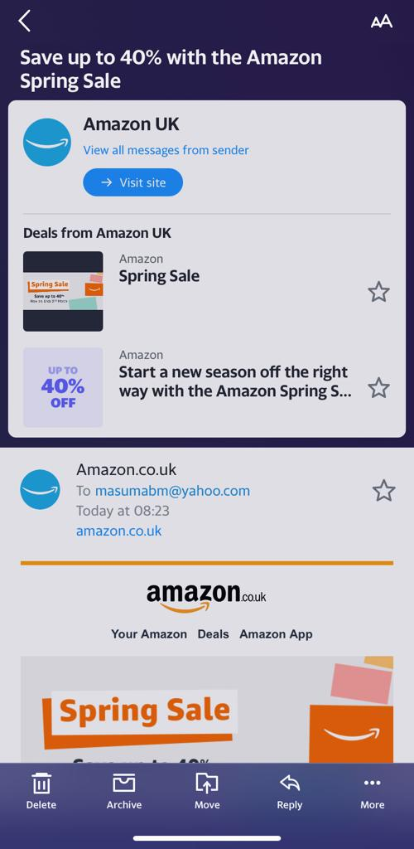
Figure 6, Deal from Amazon

The finding of Porter’s Five force discussions and some key point has listed in the table.

Forces | Level  (High/Low/Medium) | Key point
The threat of the New Entrance | High | - No entry barrier.  - Low-cost entry
Bargain power of  Supplier | Medium | - The number of small/medium local business.
Bargain power of Buyers | High | - Choice of selection.  - Not a necessity.
Threat of Substitution | Low | - Options of promotions
Rivalry Among Existing  Competitors | High | - Multiple entrants  - Coping idea.

Table 2. Porter’s Five Force Analysis (Porter, 2008)

  - SWOT
According to Lynch (2018), to exploring strategic option organization must summarize the environment/situation with the SWOT analysis and the SWOT often stand for strength, weakness, opportunities, and threats (Lynch, 2018).
Groupon is one of the leading groups buying e-business where the firm has got 1+ million merchants and 30 million worldwide customers (see appendix 1).
Groupon’s few weaknesses are the technology cost because customers’ data mining, storing, and managing are costly, also higher employee’s salary and need continually investing in R&D to stay ahead in the market and the product is only deal.
With the attraction of using the mobile internet and online shopping of the world population, Groupon has a huge opportunity to expand in more countries. There is a prediction of economic growth after a pandemic (Casselman, 2021) and that will be a great opportunity for Groupon.
The tax could be a rise in coming years for economic recovery, competitor’s advanced technologies, the local laws and the epidemic hit the local businesses which are the main threats for Groupon in different countries.
Table 3 has an advanced SWOT analysis for Groupon in terms of prioritization of factors and the process of this analysis has been used in three categories e.g., Importance (0.01>1.0), Rating/ Probabilities (1>3) and the score is the multiplication of Importance and rating.

Strengths | Importance | Rating | Score
Strong market position | 0.5 | 2 | 1.0
Established deal distribution network. | 0.6 | 1 | 0.6
Strong supply chain | 0.5 | 2 | 1.0
Large number of active customers | 0.8 | 2 | 1.6
Weakness | Importance | Rating | Score
Cost of Technologies | 0.5 | 2 | 1.0
Investment in R&D | 0.6 | 2 | 1.2
Product only deals | 1.0 | 3 | 3.0
Opportunities | Importance | Probabilities | Score
Extensive use of mobile internet in buying and selling | 0.8 | 3 | 2.4
Future economic growth | 0.7 | 2 | 1.4
Using of new technologies | 0.4 | 1 | 0.4
Threats | Importance | Probabilities | Score
Tax and VAT rise | 0.8 | 2 | 1.6
Epidemic hit in local business | 0.9 | 3 | 2.7
New laws for e-commerce | 0.5 | 2 | 1

Table 3, Groupon’s advanced SWOT analysis ((Jurevicius, 2021)

  - VIRO
The VIRO framework stand for Value, Rare, Imitable and organizations and the tools are used for analysing the firm’s resources and a possible competitive advantage (Barney and Hesterly, 2018).

    - Value
Groupon’s current activities are adding value by generating review to firms from the commission of deals which come from a local business. Beyond that, commonly customers appreciate their wanted deal via Groupon and the local business also benefited from the firm by getting more customer.
    - Imitable
Groupon technic and technologies are not very hard to copy or create a similar website to compete with the firm. One of Groupon’s main competitor is Wowcher and the activities are the same.

    - Rare
Groupon main resource is internet service and nowadays these are available to everyone and everyone can get the advantage at the same time.
    - Organization
Because of the nature of service and resource firm utilising, it is quite difficult to create a barrier for competitors and have a disadvantage from the system.
Valuable | Imitable | Rare | Organization | Competitive  Implication | Comparative performance expectation.
Yes | - | - | Yes | Competitive disadvantage | Above Normal
Yes | Yes | - | Yes/No | Competitive  Parity | Normal
Yes | No | No | Yes/No | Temporary competitive advantage | Below  Normal
Yes | No | No | No | Sustainable competitive advantage | Below  Normal.

Table 4, Groupon VIRO framework (Barney and Hesterly, 2018).

- Stakeholders’ expectations and power in the organization:
A stakeholder can be defined as any person or group that is influences or influenced by an organization (Durham, 2014) and a stakeholder theory is unifying the legitimacy of stakeholder’s ambitions and power (Bonnafous-Boucher, 2016).
From the concept of stakeholder and stakeholder theory, Groupon’s stakeholders have been shown in table 4.
Stakeholder (SH) | Contact/  Position | Roles and  interests | Level of engagement | Importance
SH1. Employees | Directly work for the organizations | Board of directors/  Managers/  Technician/  Customer service | Directly involved | High
SH2. Customers | Groupon’s subscriber,  Deal buyers | Purchase  Local deal | Directly involved | High
SH3. Suppliers | Local business,  Corporate houses. | Provide deal | Directly involved | High
SH4. Shareholders | Share market | Individual shareholder | Informed | Medium
SH5. Communities | Local population and business | Consultant | Consulted | Low
SH6. Government | Central Government,  Local Government, | Roles and law provider | Informed | Medium
SH7. Competitors | Similar or same kind of e-commerce provider | Share the markets | Informed | Medium
SH8. Media | Social media,  Print media | Consultant | Informed | Medium
SH9. Technologies provider | Internet provider,  Service provider, | Internet company, Cloud, Server provider. | Involved | High

Table 4, Groupon’s stakeholders assess and prioritise (Durham, 2014)

Groupon’s board directors and all employees (SH1) and the subscribers, deal purchaser (SH2) have high interest because of direct involvement in the organization to generate revenue. On the other hand, local businesses (SH3) e.g., restaurants, hotels, retailers have also a high influence on the organization because they frequently supply their deal to the organization. Similarly, the technologies providers (SH9) also have a high interest in the organisation because the entire business dwells on technologies.
To quote from Durham (2014), among the many ways of stakeholder analysis or mapping for most the involvement and power or interests categorise, commonly used as figure 7.1 has shown. The figure has 4 squadrons which are Involve, Inform, Collaborate and Consult. The plotting has shown stakeholders influence against interest.
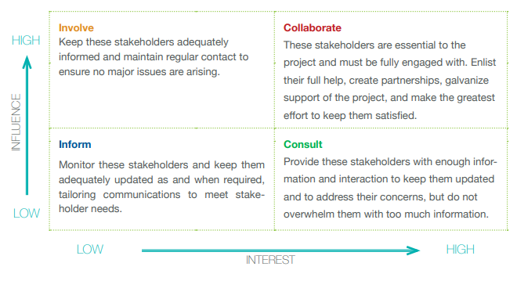
Figure 7.1 Stakeholder mapping (Durham, 2014)

However, figure 7.2 has shown Groupon’s stakeholders mapping in terms of their interest and influences.
Involve | Collaborate
SH 9 Technologies provider  SH6 Government | SH2 Customers  SH3 Suppliers  SH1 Employees
Inform | Consult
SH 4 Shareholders  SH5 Communities | SH8  Media  SH7 Competitors
High

Influence

Low

Low High
Interest

Figure 7.2 Groupon’s Stakeholder mapping (Durham, 2014)

- Grouping’s strategies choice for long-term sustainability in the business
As a daily deal trafficker obviously, Groupon has to retention both parties e.g., a local merchant and the buyers with the same strength for the firm’s long-term sustainability. However, firms need to select smart objectives followed by vision and mission statement to increase the retentions, adding value and create a competitive advantage. A balanced scorecard (BSL) is one of the tools to specify and measure the objectives of both internal and external factors for the organization.

  - Balance scorecard

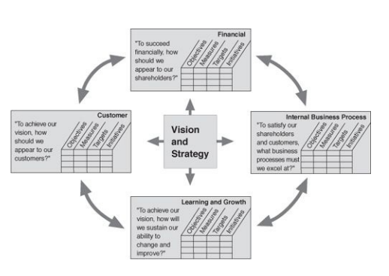
Figure 8, Balance scorecard (Kaplan and Noeton, 1996)
BSL has not only to specify Groupon objectives also created a path for a plan, set a target and align the strategic initiative. Although the BSL concept has an intrinsic appeal, the following discussion has been done in four squadrons of Groupon’s BSL.
Analysis from last few years financial reports, it has been identified that Groupon’s financial positions are not stable, as figure 9 has shown.
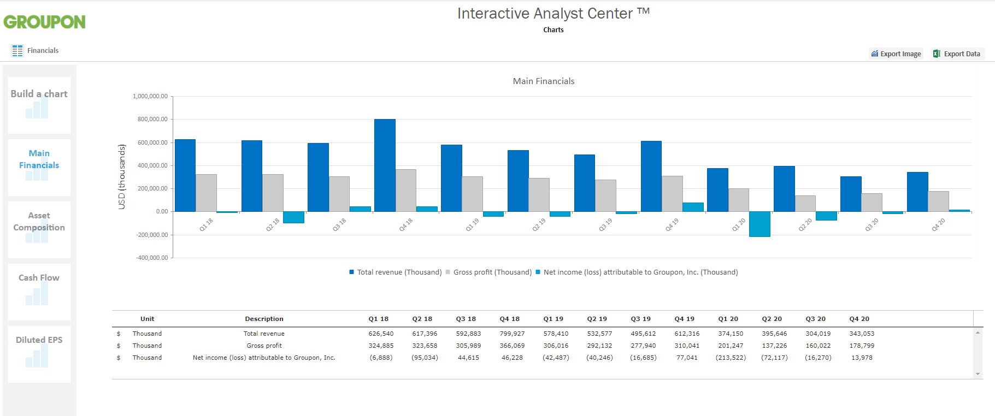
Figure 9, Groupon’s main financial chart (Interactive Analyst Centre ™, 2021)
The financial chart has shown in 2018 Groupon’s total revenue was $799,927.00(Thousand) and in 2019 net income was $77,041.00(Thousand) which are the highest in recent years. On the other hand, in 2020 total revenue was $343,053(Thousand) and net income $13.978.00(Thousand) which are below expectations. As mentioned before in the epidemic, e-commerce has earned above the expectation, Groupon might have not been able to apply the emergent strategies in the epidemic. To meet the stakeholder expectations business might need to increase both revenues and net income by increasing business capacity, generating more deal from businesses, frequently reach customers with the deal and add Groupon’s promotions in print media, social media.
Customer satisfaction and customer trust in e-commerce have been huge issue for a long time. Groupon’s might need to handle customer complaints professionally and effectively. For example, on Groupon’s Facebook page customer complain (see appendix 2), need to tackle carefully because nowadays social media complain spread quickly in the community, beyond that firms might need to take appropriate initiative not to raise any issues for customer complain. Not only focused on end customers also Groupon need to focus on the local business that the deals they are selling, because of main service providers are the local business to end customers. As Groupon current customers 30m worldwide, within 5 years’ time firms target should be 50m worldwide and minimize complain by market research, invest in customer care, monitor, and update customer care continually and so on.
In the internal business process data mining might be necessary for the business, mainly two reasons, firstly gathering large data both from business and customers, secondly analyse and make it usable for adding value to the business (Witten, Frank, Hall, and Pal, 2017). As mentioned in section 2.5 in Groupon’s value chain the information is the main factor in adding value to the firm and the information comes from the data analysis. In the data mining process, Groupon may need to wider market research, improve communication both the customer and business with the skilled worker to reach the target 50m customer and 2m business within 5years.

Groupon has mainly one service, selling deal (section 3.3) and has already got a huge number of subscribers where the company could add another innovative service for business sustainability. Quoting from Cooper (2017), innovate service or product necessary to stay in life (Cooper, 2017). Groupon could extend their service by food delivery like Uber where the firm started internet cab service via mobile app and later add service for food delivery. Groupon could bring up stakeholder satisfaction by adding an innovative service and the firm may need to invest in R&D, hire a more skilled worker and market research.
Although Groupon believes, their employees have been made delighted customers, helping merchants grow and uplifting the community (Groupon Careers, 2021), but firms might need extraordinary effort to get a competitive advantage because the competitor’s employees are similar efficient e.g., Wowcher. In learning and growth company might need more skilled employees to fulfil stakeholders’ expectations such as adding more customer and business with deals. To make an attractive organization for skilled employee Groupon might need to take some initiative, e.g., bonus for achieving targets, improve workplace culture.
In terms of learning and growth, Groupon could cooperate with competitors rather than conflict because the businesses are doing simultaneously war and peace (Brandenburger and Nalebuff, 1996) where companies are in the paper are competitors, but they co-operate each other in the specific task for the mutual benefit even though they have different targets. Although, the company using social media platform e.g., Facebook, Instagram, Twitter for their promotion, firms might co-operate with other e-commerce such as Amazon, Wish, Airbnb etc. Table 5 has shown Groupon’s objectives with the measure, target, and initiatives.

 | Objectives | Measure | Target | Initiatives
Finance
1 | Increase revenue | 5% per year  25% at 5 years | 500,000(Thousand)  1B | -Increase capacity  -Increase Deal  -Contact customers  -Add promotion.
2 | Additional income  Form innovation | 5% per year  20% at 5year | 100K (Thousand)  500K (Thousand) | -Increase R&D  -Market research
Customer
3 | Customer satisfaction | Number  Of complaint | Reduce by 3% per year | -Invest in customer care  -Update customer care  -Update Vendors T&C
4 | Improve Customer  network | New customer  Market share | 50m customer  at 5 years  Increase by 5% per year | -Invest in customer care.  -Update customer care  -Update Vendors T&C  -Market research
Internal business process
5 | Adding Value by Data mining | New customer  New Vendors | 50m customers by 5 years.  2m Vendors by 5years | -Improve communication  -Employee more skilled worker.  -Market research  - Add promotion
6 | Add an extra service (Food delivery) | Stakeholder satisfaction by financial return | Increase 5% revenue per year. | -Add fund in R&D  -Improve communication  -Employee more skilled worker.  -Market research  - Add promotion
Learning and growth
7 | Add skills employee | Job performance on demand. | 90% by 3years  98% by 5 years. | -Financial reward  -Reward for achieving the target.  -Improve workplace culture.
8 | Cooperation | Number of partners | Adding 1000k business per years. | -Add some professional Negotiators.  -Effective communication with rival businesses

Table 6, Groupon’s Balance scorecard (Kaplan and Noeton, 1996)
The BSC analysis has been identified 8 objectives for Groupon’s and each objective could be set in the strategies plan for long-term sustainability. After a closer look at the objective, there could be three strategic options that are Groupon could set out, such as:
- Option 1- Adding extra service e.g., food delivery and increase revenue by setup a specific target and the firm could take some initiative, for example, develop and invest in R&D for market research, improve communication, hire more skilled employees.
- Option 2- Data mining- gather more data about customers and business in terms of demographical needs and this could be done by worldwide effective communication which can be done by skilled workers.
- Option 3- Co-operation with customers, deal provider and even with competitors by the professional negotiator and with effective communication to stakeholder’s satisfaction.
To identify the possible shortlist objectives following discussion will be the SAFe model.
  - SAFe
This section will justify all the objective has identified in section 5.1 by suitability, acceptability, feasibility and evaluation, and the model from Johnson (2020) called SAFe.
    - Suitability
Option 1, adding services like delivery foods increase the strength of business by full filling another one exception of customers and businesses. Also, this will reduce the weakness of the firm, such as their service only offering deals to customers (section 3.3). Also, it reduces the threats of new entrants and exiting rivalry as those are high. Therefore, option 1 can get 9/10 in terms of suitability.
Similarly, option 2 & 3 also suitable for the organization because adding data of customers and business (deal provider) add value to the business (section 2.5, value chain) that create opportunities to strengthening the business. Also, cooperation creates strength and reduce weakness by effective negotiate with stakeholders. So, both option 2 & 3 could get a point of 8 out of 10.

    - Acceptability
To add delivery service, Groupon might need to extend the organizational activities and need extra fund. However, internal stakeholder might accept the change because of external stakeholder demands or needs (section 4). Therefore option 1 could get a point of 8/10.
Data mining and cooperation will improve the relationship with external and internal stakeholders. Beyond that, these activities might reduce the conflict between stakeholders and bought up positive reaction towards the business. However, data mining and co-operation have some limitation such as copyright law/intellectual property law (section 3.1 PESTEL analysis) can be hinder data mining and Groupon already co-operate with external stakeholders. Therefore, a point might get 7/10 both strategy options.
.

    - Feasibility

Delivery services already adopted in some online business, such as Uber eats, even some company doing only food delivery for example Just eat, therefore, Groupon may add this service with the existing one, while the firm already has got large amount customers worldwide, so the point should be 9/10 in terms of feasibility option 1.
Also, data mining and co-operation can be feasible for Groupon, because the organization already doing those activities, they may need to do them in a larger way for option 2 could be 8/10 and options 3 could be 7 out of 10.

SFA  Matrix | Strategic Option
SFA  Matrix | Option 1 | Option 2 | Option 3
Suitability | 9 | 8 | 8
Acceptability | 8 | 7 | 7
Feasibility | 9 | 8 | 7
Total | 26 | 23 | 22

Table 6, SFA matrix for Groupon (Johnson, 2020).
    - Evaluation
Evaluation is the last stage of the model where the strategy options pass or get the point of all the hurdles of suitability, acceptability, and feasibility. In the SFA matrix table at the different criteria, option 1 has sown more points than the other two. Therefore, adding a delivery service could be the strategies for Groupon’s long terms sustainability.
However, the strategy needs an extra budget and time for planning and execution. So, there may have some dispute between the stakeholders that may need to overcome for successful implementations of the strategies.
- Implementations and Recommendations
To quote from Wheelen and Hunger, (2011), there are four phases in the strategic management process e.g., environmental scanning, strategy formulation, strategy implementation and the last one control or monitoring performance, in very brief has been shown all the phases in figure 10 (Wheelen and Hunger, 2011).
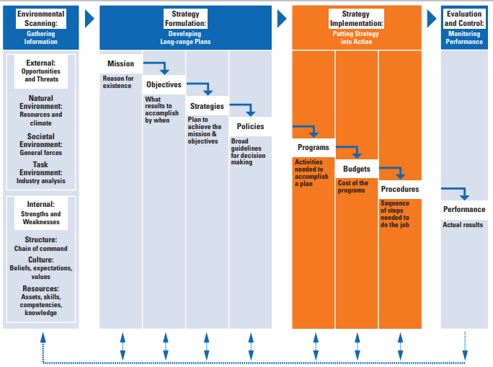
Figure 10, Strategic management phases (Wheelen and Hunger, 2011).

However, this report has done the environmental scanning and formulate the possible strategies, which is adding a delivery service for extra revenue in the organization. Selecting the best strategies are not enough, because poor implementation brings the miscarriage of strategies (Hitt et al., 2021). Strategy implementation and monitoring performance, the organization needs to ensure the strategies are correctly implemented and the organization is benefiting from the strategies, such as activities plan, budgets, suitable steps of implementation, monitoring process and so on.
In the business plan for food delivery service, Groupon needs to focus on every step of the customer journey map as shown in figure 11. For example, the customer needs to open the app, allow the location service, look for options, decide, proceed with the order and payment, order confirmation and track order, delivered to the customer and submit feedback.
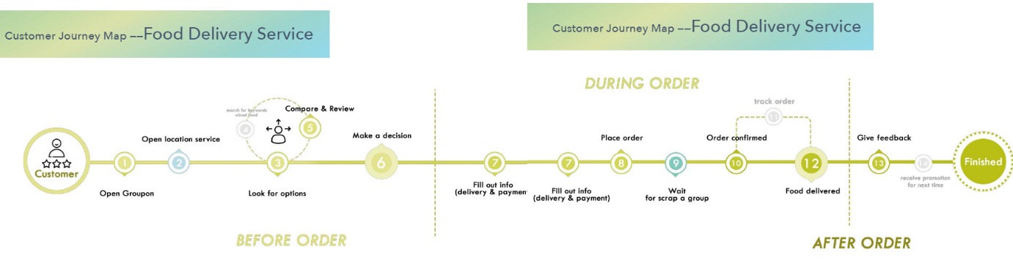
Figure 11, Customer journey map, Groupon’s Food delivery service (Liu, 2021)

A successful change project and to minimize or eliminate the conflict between stakeholders, Groupon might apply Lewin (1947), three-step model as figure 12 has shown (Burnes, 2004).
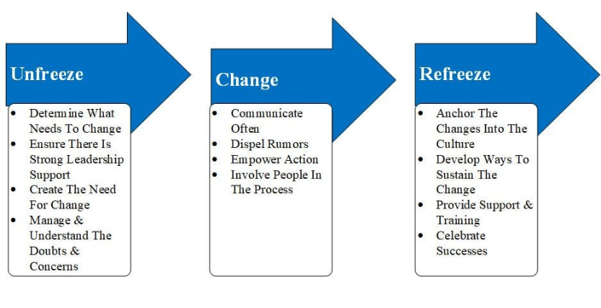
Figure 12, three steps change model (Burnes, 2004)
In the changing process when the firm unfreezes, there will be at least three things recognized e.g., recognition of the legitimacy of the status quo, internal stakeholders’ discomfort or survival anxiety and creating psychological safety. The next step is the implementation of the change where the firm must explain the benefit of change both for the organization and employees that will bring the motivation and eliminate the fear or anxiety. When the change has been done the firm refreeze again and before refreezing, the firm must be confirmed that the change has been adopted properly among the stakeholders (Burnes, 2004).
To implement the strategy and make the effective change, this report recommends five phases for Groupon’s internal stakeholders.
- Step by step planning and controlling the whole process.
- Promoting achievement for the next step of success.
- Co-operate with each other in the difficult stage.
- Have a contingency plan.
- Learning from the mistake and take it positive way (Maund, 2021).
It has been claimed by Bocij, Greasley and Hickie, (2019), an effective strategy formulation process must hold adaption, organizational learning, and incremental progress (Bocij, Greasley and Hickie, 2019) and the new strategy will reflect on Groupon’s constantly changing environment.
- Conclusion
This report has identified the strategy for Groupon, that’s to add an extra service for the customers. In the selecting process of the strategy, firstly the report has discussed the organizational current situation identify the vision and mission, most importantly organization are adding value from information. Secondary, it has done environmental analysis where the report has identified the technological and social factors are more important in the PESTEL analysis and Groupon should consider those in the strategy. The five-force analysis has been identified the threats of new entry and the existing competitor are high because of easy to copy the business and share the market. In the SWOT analysis have found the main weakness of the organization is overall only one kind of services they provide which is deal. The main resources are information and the internet which has got competitive disadvantage and it has identified from VIRO analysis. Thirdly, stakeholders’ expectations and power analysis help to choose the strategy. Fourthly the balanced scorecard has identified the smart objectives and create some options for strategies. Later, the SAFe model clarifies the best option from the point table and evaluate the strategy. Finally, the report has the recommendation for the strategy and the implementation process.
However, new the strategy will be beyond Groupon’s normal routine activities, so the organization should have an emergent approach policy alongside the prescribed approach to successful strategy implementation.

Reference
- Apps.indigotools.com. 2021. Interactive Analyst Center ™. [online] Available at: <https://apps.indigotools.com/IR/IAC/?Ticker=GRPN&Exchange=NASDAQGS> [Accessed 20 March 2021].
- Barney, J. and Hesterly, W., 2018. Strategic management and competitive advantage. 1st ed. Harlow: Pearson, pp.89-94.
- Bocij, P., Greasley, A. and Hickie, S., 2019. Business Information System: Technogy, development for the mordern business. 6th ed. Harlow: Pearson, pp.456-457.
- Bonnafous-Boucher, M. and Rendtorff, J., 2016. Stakeholder Theory: A Model for Strategic Management. 1st ed. Cham: Springer International Publishing, pp.11-38.
- Brandenburger, A. and Nalebuff, B., 1996. Co-Opetition. 1st ed. London: Currency Doubleday, pp.26-40.
- Burnes, B., 2004. Kurt Lewin and the Planned Approach to Change: A Re-appraisal. Journal of Management Studies, [online] 41(6), pp.977-1002. Available at: <https://onlinelibrary-wiley-com.ezproxy.uwtsd.ac.uk/doi/full/10.1111/j.1467-6486.2004.00463.x> [Accessed 27 March 2021].
- Casselman, B., 2021. On the Post-Pandemic Horizon, Could That Be … a Boom?. The New York Time, [online] Available at: <https://www.nytimes.com/2021/02/21/business/economy/pandemic-economic-boom.html> [Accessed 22 February 2021].
- Chaffey, D., 2015. Digital Business and E-commerce Management. 6th ed. Harlow: Pearson, pp.179-240.
- Cooper, Robert G., 2017. WINNING AT NEW PRODUCTS, Creating Value Through Innovation. 1st ed. Ney York: Basic Books, pp.63-65.
- David, F., 2011. Strategic Management. 13th ed. New Jersey: Pearson Education UK, pp.40-50.
- Durham E., Baker H., Smith M., Moore E. & Morgan V. (2014). The BiodivERsA Stakeholder Engagement Handbook. BiodivERsA, Paris (108 pp).
- Groupon Careers. 2021. Groupon Careers. [online] Available at: <https://www.grouponcareers.com/> [Accessed 20 March 2021].
- Hitt, M., Jackson, S., Carmona, S., Bierman, L., Shalley, C. and Wright, D., 2021. The Imperative for Strategy Implementation. The Oxford Handbook of Strategy Implementation, [online] Available at: <https://www-oxfordhandbooks-com.ezproxy.uwtsd.ac.uk/view/10.1093/> [Accessed 25 March 2021].
- Investor.groupon.com. 2021. Groupon, Inc. - Home. [online] Available at: <https://investor.groupon.com/home/default.aspx> [Accessed 4 March 2021].
- Investor.groupon.com. 2021. Groupon, Inc. - Home. [online] Available at:0 <htps://investor.groupon.com/home/default.aspx> [Accessed 5 March 2021].
- Johnson, G., Whittington, R. and Scholes, K., 2020. Exploring strategy. 12th ed. Harlow: Pearson Education, pp.5-10.
- Jurevicius, O., 2021. The Structure of a Good SWOT - How to do it Right. [online] Strategic Management Insight. Available at: <https://strategicmanagementinsight.com/tools/swot-analysis-how-to-do-it.html> [Accessed 10 March 2021].
- Kaplan, R. and Noeton, D., 1996. The Balanced Scorecard. 1st ed. Harvard Business Review Press, pp.23-24.
- Liu, A., 2021. 【 Service Design 】Groupon Case Study × Food Delivery Service. [online] Issuu. Available at: <https://issuu.com/alanyulinliu/docs/sav_201910_serv_kunliu_xinyuwu_alan> [Accessed 25 March 2021].
- Lynch, R., 2018. Strategic Management. 8th ed. Harlow: Pearson, pp.70-80.
- Maund, A., 2021. BA Leadership and Management: Skill for the Workplace, student yearbook, Final Year.. 1st ed. London: SAGE, pp.229-230.
- Mazzarol, T., 2015. SMEs engagement with e-commerce, e-business and e-marketing. Small Enterprise Research, [online] 22(1), pp.79-90. Available at: <http://ttps://search-proquest-com.ezproxy.uwtsd.ac.uk/docview/1698380438?pq-origsite=primo&accountid=130472> [Accessed 27 February 2021].
- Porter, M., 1998. COMPETITIVE ADVANTAGE: Creating and Sustaining Superior Performance. 1st ed. New York: THE FREE PRESS, pp.33-58.
- Porter, M., 2008. The Five Competitive Forces That Shape Strategy. Harvard business review, [online] p.4. Available at: <https://aggie-horticulture.tamu.edu/faculty/hall/EAGL/Strategy_readings/Five_Forces_Update.pdf> [Accessed 10 March 2021].
- S22.q4cdn.com. 2020. GROUPON 2020 PROXY STATEMENT. [online] Available at: <https://s22.q4cdn.com/731250486/files/doc_financials/2020/ar/2020-Proxy-Statement_Final.pdf> [Accessed 5 March 2021].
- Sviokla, J. and Rayport, J., 1995. Exploiting the Virtual Value Chain. Business Source Complete, [online] 73(6), pp.1-12. Available at: <https://web-a-ebscohost-com.ezproxy.uwtsd.ac.uk/ehost/detail/detail?vid=2&sid=aa7c0d1c-d2b9-44e9-acda-63ccd6056bde%40sessionmgr4008&bdata=JnNpdGU9ZWhvc3QtbGl2ZQ%3d%3d#AN=9512052732&db=bth> [Accessed 5 March 2021].
- Wheelen, T. and Hunger, J., 2011. Strategic management and business policy. 13th ed. London: PEARSON, pp.271-280.
- WIRE, B., 2021. Amazon.com Announces Third Quarter Results. [online] Ir.aboutamazon.com. Available at: <https://ir.aboutamazon.com/news-release/news-release-details/2020/Amazon.com-Announces-Third-Quarter-Results/default.aspx> [Accessed 21 February 2021].
- Witten, I., Frank, E., Hall, M. and Pal, C., 2017. Data Mining Practical Machine Learning Tools and Techniques. 4th ed. LONDON: ELSEVIER, pp.9-10.

Appendix

- Groupon public fact Sheet.
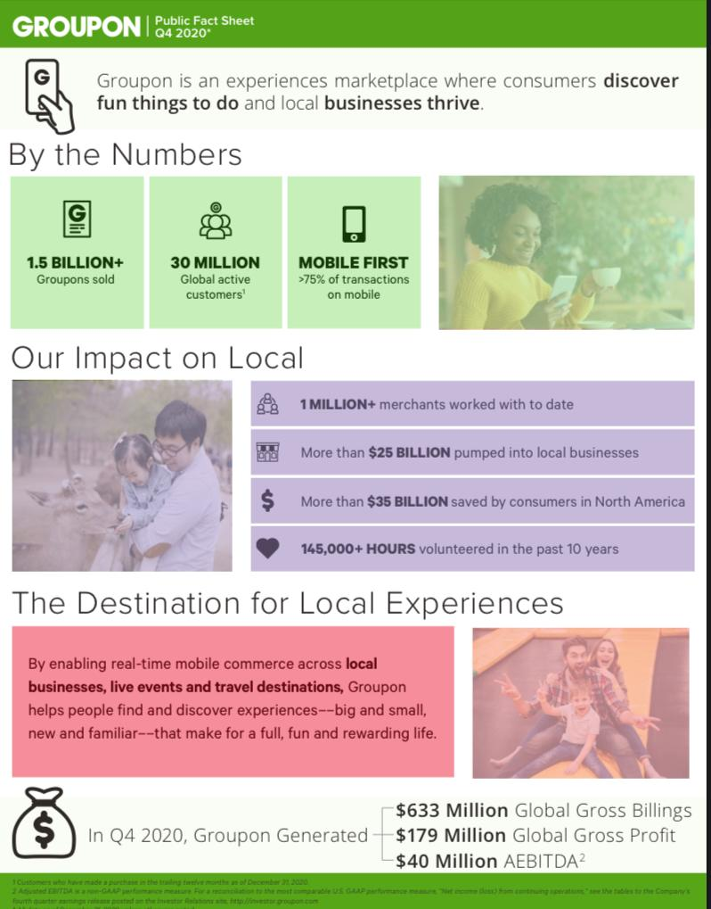

- Groupon’s customers complain on Facebook.
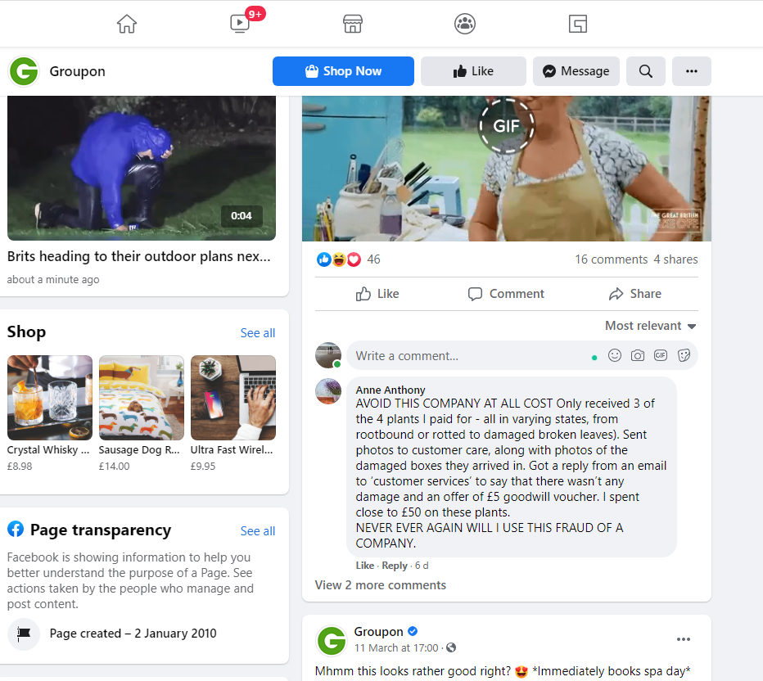
25/03/2021

