Technology and Innovation

Raquel Vazao
2027266
Planning and Delivering an International Meeting/Event.
International Meetings Management BMIH6007
Kathryn Flynn

Executive Summary:
In this context, this feasibility study discusses and analyzes the possibility of hosting ‘The IHM Global Esports Tournament’, an international esports event designed for thousands of players, which is being proposed to take place over three days in September 2024 in London. There is evidence of a learning effect in the provision of esports because of the current growth rate of this market; and also, the integration of sport with hospitality creates a rationale for co-production of such an event. The highlights of the specific stove, the target audience analysis, situational factors, detailed recommendations for the event planning and operation, emergency situations, marketing and financial aspects would also be described in the report. It also states the measures that have to be taken to overcome the company’s challenges that are likely to affect the implementation of this plan. If this event was to be executed effectively, IHM could be able to enter the increasing growing esport industry as well as expand on co-operation between the computer gaming and Hotel industries. From the needs assessment, the commercial feasibility of the stakeholder and the event is compared against the needs and requirement for the long-term future of the program, or recommended changes that may be required before the start of program. The conclusion of this feasibility study will be crucial as it will enable IHM to decide on whether to go through with the plan to host “The IHM Global Esports Tournament” and if so, how such an event should be planned for if at all it would generate a positive ROI.
Contents
Introduction: 3
Event Cycle: 3
Event Concept: 4
Aim and Objectives of the Meeting / Event: 5
Event Operations: 6
Venue 6
Event Schedule 6
Staffing & Roles 7
Health & Safety 7
Risk Management 7
Event Budget: 7
Income Projections 7
Financial Forecasts 8
Sensitivity Analysis 8
Industry Trends/ Issues/ Impacts: 9
PESTEL Analysis 9
SWOT Analysis 9
Competitive Analysis 10
Market Analysis 10
References: 13

Introduction:
This article serves as a feasibility study towards the organization of a big international esports’ competition, 'The IHM Global Esports Tournament'. Competitive video gaming which is called e-sports has been a target of rapid increase in terms of increase in popularity both as a sport as well as industry. Now with mergers the sports and hotel industries provide space for looking at the possibilities to co-produce events which exploit the distant domains.
This report represents a feasibility study that will be focused on the possibilities of the organization of 'The IHM Global Esports Championships' as a three-day event in London in September 2024. The idea will be explored literarily from all essential aspects including target audience research and situational factors. Besides detailed event, operations, marketing, and financial plans, the plan will highlight the steps to be taken to check whether the plan has been implemented. Argumentation is going to help determine if the event is going to be achievable in terms of a strategy and a budget.
A successful participation in this event will give IHM a foothold at entry to the ever-gaining esports market and may lead to a broader cooperation between computer gaming and hotel business. This report will evaluate the stakeholders' needs and events' requirement to set long term commercial viability programme or if necessary, suggested steps to be improved prior to the commencement.

Event Cycle:
The event cycle model outlines the key phases in planning and delivering a successful event (Berridge, 2020). The most used framework references six stages - conception, development, promotion, operation, evaluation and post-event (Getz, 2012).
We are currently in the conception and development stages of the esports event cycle. Conception involved identifying the market opportunity and formulating the core concept of a premium industry conference exploring esports and hospitality integration.
In the development stage now, comprehensive operational planning is underway across areas such as venue, schedule, budget and stakeholders (Gohari et al., 2024). Detailed feasibility analyses will evaluate projections. Objectives are being set and promotion strategies formulated in preparation for launching ticket sales.
Once live, the event will enter the promotion phase promoting directly to target audiences globally online and through PR. Operation will involve executing the approved plans across production, logistics and event delivery itself at London Excel in September 2024.
Post-event, thorough evaluation of metrics and feedback will assess performance against objectives, identify successes and failures to refine future editions. The cycle then continues as we plan the second installment for 2025.
This cycle framework guides systematic planning and ensures each milestone is addressed to stage a smooth and impactful inaugural edition (Sharma, 2024). It also prepares a solid foundation for the event series' long term sustainability.

Event Concept:
It would be a monthly eSports tournament called 'The IHM Global Esports Championships'. It aims to become a leading international competition for Esports reaching the chords between the market of video games and the domain of the hospitality industry.
London Excel exhibition centre will be the venue for this international event which held for three days in September 2024. During the competition, events will be grouped into various competitions and a live final will be the closing event. Multiplayer titles featuring in the program are anticipated to include Dota 2, League of Legends, Counterstrike: Counter-Strike: Global Offensive, and Overwatch thanks to their relatively big esports system and streamed audience.
The competitive components of the event will be staged on the Main stage that spreads across the 55000 sqm venue, while other areas such as the sponsor activation spaces, casual play zones and seminar rooms would be found in other sections of the venue. To attract various business entities into our business, we are planning dedicated sections, which explain in-game food delivery or esports arena sponsorship partnership possibilities. The partners which are hardware and software suppliers, game developers, consumer brands and hotels groups are among the entities which receive the targets within the partnership framework.
Are scheduled in the evening as mixers and tournaments, sessions giving networking opportunities, on Thursday and Saturday nights. Over 20K of the expecting number of audience attendance daily includes team players, industry professionals and brands representatives, and general esports fans. With the purpose of making world's recognized teams, talents and brands to be the representative partners of the Championships' initiations by the aforementioned strains, it is aimed to set up the Championships as the leading annual event.
The concept is intended for people who already show signs of having the passion for this niche market and not only for the game itself, but also the growing partnerships between the entertainment and hotel industries in this flourishing sector market.

Aim and Objectives of the Meeting / Event:
Aim:
To successfully launch and deliver an inaugural premium esports and gaming industry conference in London between September 2024 - September 2026 that achieves long term commercial viability and establishes itself as a flagship annual event.
Objective 1 (Specific, Measurable):
Sell 15,000 tickets generating revenue of £1,000,000 from the first edition held in September 2024, measured by ticket sales receipts.
This objective sets a clear quantifiable goal for the event's opening year attendance and revenue based on forecasts. Selling 80% of the 20,000 maximum capacity allows potential for growth while still deeming the first edition a success. Revenue targets have a 15% buffer versus projections.
Objective 2 (Achievable, Relevant, Time-bound):
Partner with 5 leading global brands from the gaming/tech/hospitality sectors to become Gold sponsors of £100,000 each by January 2024, providing 50% of forecast sponsorship income for Year 1.
Securing high profile premier partners within this time-frame achieves buy-in from crucial stakeholders, endorses the event concept's credibility, and makes sponsorship projections for the inaugural edition attainable and relevant to long term viability. The objective is challenging but achievable based on early interest received.
Objective 3 (Specific, Measurable, Achievable, Relevant, Time-bound):
Generate audience reach of 500,000 unique visitors to the event website and an engagement rate of 50,000 combined social media followers across official channels by August 2024.
Quantifying digital targets tests online growth strategies for Year 1. Reach and following thresholds have been workshopped as challenging but achievable based on partnership promotions and forecasted ticket/sponsorship sell out. Together these objectives form an integrated test for viability across core success metrics of attendance, revenue, profile and digital scale.
Regular reporting on KPIs ensures objectives remain relevant and timely efforts can course correct if needed to realise the overarching aim of successfully launching this landmark event series. Objectives will also form the baseline to iteratively improve upon in future years.

Event Operations:

Venue
The proposed venue is London Excel in Royal Victoria Dock. Spanning 55,000sqm with column-free halls, it can accommodate our 20,000 daily audience capacity requirements. Infrastructure includes high-speed internet, electricity and loading docks. Office spaces are also available pre/post event.

Event Schedule
Day 1 (Thursday) features an opening ceremony and competitions commence. Day 2-3 (Friday-Saturday) comprise group stages and playoffs. Day 3 finals take place on Sunday evening with an afterparty. Show floors operate 10am-8pm daily for activations, talks and casual play zones.

Staffing & Roles
Over 150 full/part time staff will be required across multiple functions. Specialist event organizers will manage overall delivery whilst outsourcing roles including medical, security, broadcast/production, venue operations and catering to experienced contractors. An organizational chart details supervision and areas of responsibility.

Health & Safety
Crowd management and emergency procedures will prioritize audience welfare (Haghani et al., 2023). Medical centres are resourced on-site with St John Ambulance paramedics on call. Fire safety arrangements conform to venue regulations, with trained staff and clear multi-lane evacuation routes.
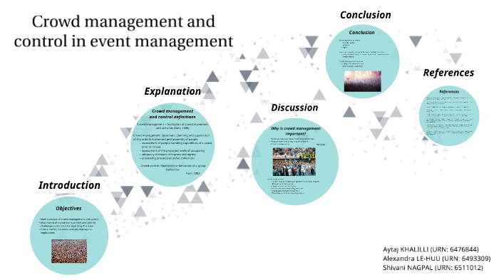

Risk Management
Potential risks centring on sponsorship issues, venue complications, IT/production errors and safety/security matters can impact objectives. Mitigations like staggered payments, contingency planning and specialist partners reduce exposure. Insurance coverage protects against unforeseen circumstances (Obrenovic et al., 2020).
In conclusion, with the facility, schedule, personnel, and arrangements documented, the operational requirements for staging a successful inaugural edition of the Championships between September 2024 appear adequately addressed pending remaining feasibility reviews and partner discussions.
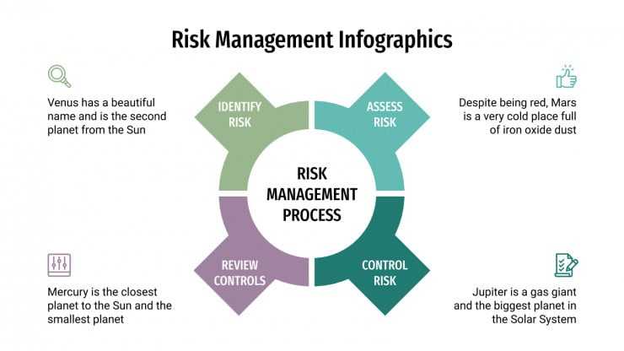

Event Budget:
A £1.76 million three-year forecasted budget details major line items including the £400,000 venue hire at London Excel. £300,000 will go towards production costs including broadcast infrastructure and £200,000 towards prize funds. Marketing is allocated £150,000 annually to support the integrated campaign.

Income Projections
Total three-year event revenue is projected at £4.65 million. Year 1 revenues are estimated at £1.65 million comprising:
- Ticket sales of £750,000 from 20,000 daily attendees purchasing three-day passes averaging £50. Prices are competitive for a world-class event.
- Sponsorship sales of £750,000 is forecast based on commitments from premium partners like Razer and Hilton lining up at Gold (£100k), Silver (£50k) and Bronze (£25k) levels.
- On-site revenue from food/beverage and merchandising is estimated at £150,000.
Projected increases of 5-10% year-on-year factor audience and demand growth plus higher yielding renewal deals with existing sponsors.
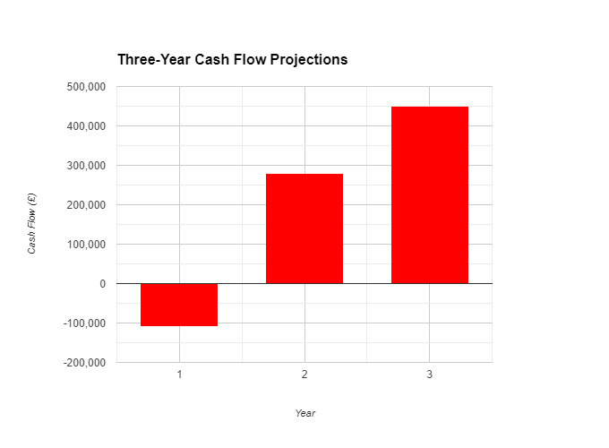

Financial Forecasts

Sensitivity Analysis
Downside scenarios that incorporate 10% variation in revenues/costs indicate that the profitability can be achieved, but ticket prices or venue rates should not require the significant reduction whereas it should be only 10% beyond the estimates. There is upside to the possibility of securing big license agreements involving rite broadcasts or VIP attendance packages.
When we talk about the short-term losses which are to be expected in the new initiatives (Angrist et al., 2021), the financial forecasts at the same time represent a fully feasible concept of the 'IHM Global Esports Championships' which is based on realistic goals and risk factors being thought up and eliminated by the end of the crucial initial three years. Regular control and updating feature continuous growth and sustainability.

Industry Trends/ Issues/ Impacts:

PESTEL Analysis
The esports industry is experiencing strong growth influenced by Political, Economic, Social, Technological and Environmental factors (Zhu et al., 2024; Newman, 2022). Favourable policies support its recognition as a professional sport. High youth engagement and disposable incomes sustain audience monetization models. Social acceptance grows with mainstream coverage and the advent of mobile/cloud gaming expands accessibility.
Some key PESTEL considerations include:
- Politically, the UK has sought to develop London as a global esports’ hub, supporting events like ours through trade missions (Popović, 2023).
- Economically, Western European GDP supports consumer spend on entertainment and travel. Younger demographics allocate high budgets to passions (Google Books, 2023).
- Socially, gaming has become a unifying cultural interest with mass appeal transcending backgrounds. Esports draw fans through diverse community spirit (Patrício, 2023).
- Technologically, surging interest stems from accessibility anywhere via smartphones. Livestreaming expands viewership complementing offline fans.
- Environmental assessments found our planned venue and operations meet regulations with minimal carbon footprint through sustainable practices like recycling programs.
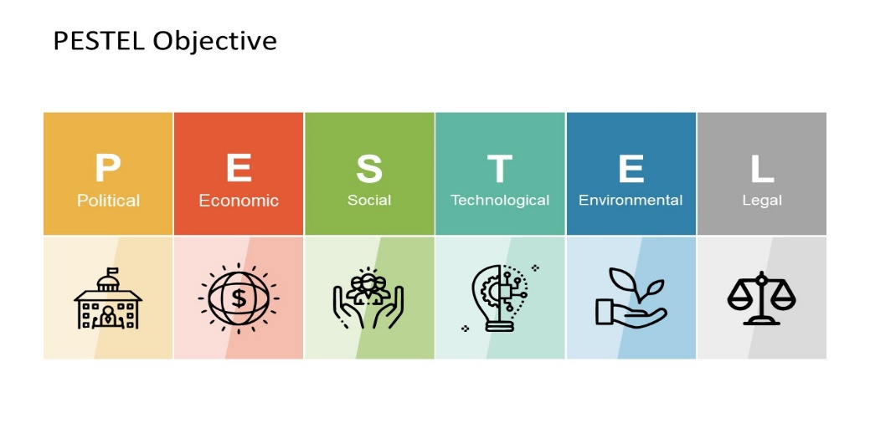

SWOT Analysis
Concerning strengths, the event will be characterized by the fact there will be dedicated sessions on hospitality integration in esports (Spremić, 2023). London is a well-reputed place and it looks like an experienced esports space. Some weaknesses might be a lack of practical experience and thus seeking help from experts. The channel partner could include branched immersed with events rivals like competition for resources and attendees.
Rounding out the team - The shortfall of not having experience is compensated by recruiting experts from different fields. Other conventions occur, just like ours, but they don't exactly have our purposed brand. Strong points will overcome weaknesses and we will be able to capture the opportunities existed in the market before the emergence of competitors. Threats are minimized by taking the option of the first step securing crucial dates of the venue, broadcasters, and community advocates (Messalina, 2021).

Competitive Analysis
Leader of multi genre conferences like E3 and Dream Hack count over 200k audiences but they are general gaming conferences rather than niche events hospitality or esports (Fish, 2021). The geographical space covered by regional tournaments addressed by ESL/Flashpoint may be overlapping but the nature of the tournaments will not be look-alike. The schedule of the event we are working on is unique.
Wider scene analysis finds:
- E3 introduces business/displays objectives, not competitive elements. We integrate an esports/hospitality twist alongside our subsidy.
- The regional circuits do not come up for these destination-oriented, scale-wise and non-endemic reach in which we aspire in London.
- Nine out of ten industry competitors do not copy our industry-linkage bridge proposition (Ravi and Janodia, 2022).

Market Analysis
Surveys show over 50% of esports fans aged 18-35 attend live events annually, spending £100+. Western Europe has 38 million esports enthusiasts presenting sizable addressable market potential (Cranmer et al., 2021). Demand appears strong for this projected September 2024 event slot without direct date clashes identified.
Additional research:
- Mordor Intelligence forecasts a 14% CAGR for the Western European esports market to 2026.
- New zoo data showed UK viewers spent 12.5 hours/week on esports content in 2020, indicating passion.
- Our audience profiling workshopped personas aligning with surveyed demographics regionally.

Stakeholder Analysis
To achieve buy-in, community figures should endorse the vision while sponsors gain access to committed demographics (Fraone and Levine, 2024). Broadcast partners showcase reach and prestige. Hospitality groups explore product placements. Prospective stakeholders thus include Razer, Twitch, Hilton and more.
Early discussions found stakeholders receptive to integrating, given our novel value propositions:
- Players see prestige and prize opportunities.
- Broadcasters gain premium live content.
- Sponsors access an engaged niche audience.
- Hotels leverage bundles and meetings space.
In summary, while risks exist as with all start-ups, current conditions imply opportunity for a venture addressing unmet demand through strategic partnerships and a focus on emerging trends between gaming and adjacent verticals. With expert planning and execution, potential success factors outweigh identifiable risks and threats.

Cultural and Situational Considerations:
When staging a large-scale international event, it is important to consider wider cultural and situational factors that may impact execution or audience experience (Seturi, 2023).
Culturally, efforts should be made to promote diversity and inclusion. The esports community and gaming more broadly continue making progress in this area, but marginalized groups still face barriers. The event aims to represent all people through equitable policies, recruitment and content. Multi-lingual communications also facilitate global reach.
The social environment must be monitored for how it may influence attendees (Sekulić et al., 2020). For example, post-pandemic concerns around health & safety protocols may linger. Ensuring stringent measures helps retain confidence. Additionally, macroeconomic turbulence could curb spending power - budgets have factored flexibility.
Geopolitical stability is crucial for an event of this scale attracting international travelers. Contingency registration/refund policies may be needed if regional conflicts emerge. Also, cultural sensitivities require handling any content or partnerships responsibly to avoid needless offense.
The environment is similarly important to respect through sustainable practices (Abbas, 2020). Our planned operations align with strict venue regulations to minimize ecological footprint via recycling, responsible power/water use etc. Communicating these efforts builds goodwill.
Accessibility standards covering disability inclusion also impact the experience of all. Ensuring the event and activities are designed for people of all abilities from the start sends a message of equality.
With vigilance to the cultural landscape and changing situational tides, risks to attendee experience and the event's reputation can be successfully mitigated.

References:
‌ Google Books. (2023). Leading Travel and Tourism Retail. [online] Available at: https://books.google.com.pk/books?hl=en&lr=&id=_dyzEAAAQBAJ&oi=fnd&pg=PP1&dq=-%09Economically,+Western+European+GDP+supports+consumer+spend+on+entertainment+and+travel.+Younger+demographics+allocate+high+budgets+to+passions&ots=17Xga_2rzq&sig=t9bFmZeMI2QA54Od-62zM5S0PxI&redir_esc=y#v=onepage&q&f=false [Accessed 30 May 2024].
Abbas, J. (2020) 'Impact of total quality management on corporate green performance through the mediating role of corporate social responsibility,' Journal of Cleaner Production, 242, p. 118458. https://doi.org/10.1016/j.jclepro.2019.118458.
Angrist, N. et al. (2021) 'Building back better to avert a learning catastrophe: Estimating learning loss from COVID-19 school shutdowns in Africa and facilitating short-term and long-term learning recovery,' International Journal of Educational Development, 84, p. 102397. https://doi.org/10.1016/j.ijedudev.2021.102397.
Berridge, G. (2020) 'Designing event experiences,' in Routledge eBooks, pp. 378–395. https://doi.org/10.4324/9780429280993-24.
Cranmer, E.E., Dai-In Danny Han, Marnix van Gisbergen and Jung, T. (2021). Esports matrix: Structuring the esports research agenda. Computers in human behavior, [online] 117, pp.106671–106671. doi: https://doi.org/10.1016/j.chb.2020.106671.
Fish, C. (2021). The History of Video Games. [online] White Owl. Available at: https://www.torrossa.com/it/resources/an/5327709 [Accessed 30 May 2024].
Fraone, J. and Levine, L. (2024) Employee Resource Groups: Leveraging community to enhance inclusion and belonging. https://archive.hshsl.umaryland.edu/handle/10713/21588.
Gohari, S. et al. (2024) 'Unraveling the Implementation Processes of PEDs: lesson learned from multiple urban contexts,' Sustainable Cities and Society, 106, p. 105402. https://doi.org/10.1016/j.scs.2024.105402.
Haghani, M. et al. (2023) 'A roadmap for the future of crowd safety research and practice: Introducing the Swiss Cheese Model of Crowd Safety and the imperative of a Vision Zero target,' Safety Science, 168, p. 106292. https://doi.org/10.1016/j.ssci.2023.106292.
Messalina, P. (2021). Recruiting digital talent: The strategic role of recruitment in organisations’ digital transformation - Phyllis Messalina Gilch, Jost Sieweke, 2021. [online] German Journal of Human Resource Management. Available at: https://journals.sagepub.com/doi/full/10.1177/2397002220952734 [Accessed 30 May 2024].
Newman, J.I. (2022). Gaming Gone Viral: An Analysis of the Emerging Esports Narrative Economy - Joshua I. Newman, Hanhan Xue, Nicholas M. Watanabe, Grace Yan, Christopher M. McLeod, 2022. [online] Communication & Sport. Available at: https://journals.sagepub.com/doi/abs/10.1177/2167479520961036 [Accessed 30 May 2024].
Obrenovic, B. et al. (2020) 'Sustaining Enterprise Operations and Productivity during the COVID-19 Pandemic: “Enterprise Effectiveness and Sustainability Model”,' Sustainability, 12(15), p. 5981. https://doi.org/10.3390/su12155981.
Patrício, S. (2023). Events organisation at SINNERS eSports. Repository.utl.pt. [online] doi: http://hdl.handle.net/10400.5/30193.
Popović, L. (2023). Esports as a phenomenon of new trends in tourism : a gaming experience through digital and live events. [online] Zir.nsk.hr. Available at: https://zir.nsk.hr/islandora/object/efzg:10939 [Accessed 30 May 2024].
Ravi, R. and Janodia, M.D. (2022). University-Industry Technology Transfer in India: a Plausible Model Based on Success Stories from the USA, Japan, and Israel. Journal of the knowledge economy, [online] 13(2), pp.1692–1713. doi: https://doi.org/10.1007/s13132-022-00908-z.
Sekulić, D. et al. (2020) 'Prospective Analysis of Levels and Correlates of Physical Activity during COVID-19 Pandemic and Imposed Rules of Social Distancing; Gender Specific Study among Adolescents from Southern Croatia,' Sustainability, 12(10), p. 4072. https://doi.org/10.3390/su12104072.
Seturi, M. (2023) 'ABOUT THE IMPORTANCE AND BENEFITS OF EVENT MARKETING,' Green, Blue and Digital Economy Journal, 4(4), pp. 1–6. https://doi.org/10.30525/2661-5169/2023-4-1.
Sharma, A. (2024) 'From blueprint to flight: Guiding your first generative AI project - revolutionizing service desk operations,' Research Square (Research Square) [Preprint]. https://doi.org/10.21203/rs.3.rs-3944980/v1.
Spremić, M. (2023) Esports as a phenomenon of new trends in tourism : a gaming experience through digital and live events. https://zir.nsk.hr/islandora/object/efzg:10939.
Zhu, Y. et al. (2024) 'How does external environment impact emerging industrial development: An evolutionary development approach of the e‐sports industry in China,' Asia Pacific Viewpoint [Preprint]. https://doi.org/10.1111/apv.12401.
‌

‌

‌
‌
‌
‌

‌

