Organisation Structure, Functional Area and Business Growth
Introduction (138 words)
An organisation can be defined as a group of individuals who come together to achieve common goals (Cambridge Dictionary, n.d.). Understanding the legal features, functional areas, growth strategies, and organisational structures of a business is crucial for effective management, compliance with laws, and achieving objectives. Legal frameworks governing private and public limited companies, or not-for-profits, set out rules regarding liability, governance, and reporting requirements, which protect stakeholders and ensure transparency (Jangid, 2025; UK Government, n.d.). Functional areas, including human resources, finance, marketing, operations, and IT, are the core components that drive day-to-day business activities. Their collaboration is essential for operational efficiency (Trigg, 2024). This essay examines the legal features and formation of organisations, the roles and interlinkages of functional areas, the methods and impacts of business growth, and the types of organisational structures, including factors influencing their choice.

Legal Features and Formation of Organisations (665 words)
Private limited companies (Ltd) are for-profit organisations owned by shareholders who acquire shares privately (Jangid, 2025). Shares represent a part of the business, and shareholders receive a proportionate amount of company profits to the shares they own. The remaining profit is reinvested into the business to support operations, including research or expansion. Limited liability is a key feature of a limited company, protecting shareholders and directors from being personally responsible for debts beyond their investment (Jangid, 2025). Day-to-day operations, decision-making, and fulfilling legal duties are managed by the company directors. Private limited companies are legally required to have at least one director (Jangid, 2025). Dyson Ltd is an example of a private limited company; it is family-owned yet operates internationally, demonstrating how Ltds can maintain private control while growing globally (Jangid, 2025).
By contrast, public limited companies (PLCs) can sell shares publicly on the stock market, allowing them to raise significant capital (BBC Bitesize, n.d.). PLCs also have limited liability but are required to have at least two directors and two shareholders for improved accountability whereas Ltds only need one of each (Tutor2u, 2021). Moreover, a PLC must have a qualified Company Secretary to make sure accounts are completed correctly and submitted on time, and the company operates fairly and legally (Institute of Directors, 2017). For a PLC, the minimum share capital (funds raised from shares) is £50,000, with at least 25% paid upfront whereas Ltds don’t have a minimum (Your Company Foundations, 2024). Like Ltds, profits from a PLC are distributed to shareholders or reinvested to support further growth. Tesco PLC exemplifies how public investment can be useful for large-scale operations, and expansion.
Not-for-profit organisations (NFPs) differ from limited companies as they aim to support social, charitable, or environmental improvement through funding rather than making profits for private owners (Tutor2U, 2024b). Surplus income is reinvested to support their mission, such as funding medical research, community services, or environmental conservation. NFPs can take several forms including charities, and social enterprises like community interest companies (CICs) (a legal form of a social enterprise). On one hand, charities like the British Heart Foundation are registered with and regulated by the Charity Commission, ensuring fair and legal governance, transparent financial reporting, and use of funds for public benefit (UK Government, n.d. a). Whereas CICs, such as Belu Water, work similarly to for-profit limited businesses, also limited by shares or guarantees, but their surplus profit goes to social causes (Belu, n.d.).
The formation of limited companies involves registering with Companies House, the UK government body responsible for incorporation and dissolution, maintaining public records, ensuring compliance with the Companies Act 2006, and issuing financial penalties for non-compliance (Mollie, 2022). As part of registering, limited companies must submit Articles of Association, a document that explains how the company is run, including directors’ powers, shareholder rights, decision-making processes, and profit distribution (Iod, 2023). Limited companies must also file annual accounts, confirm director and shareholder details, and maintain accurate financial records to meet statutory obligations (UK Government, n.d. c).
Not-for-profits must register with the appropriate regulator, such as the Charity Commission for charities or the CIC Regulator for CICs. In the UK, a charity must register if it makes a minimum annual income of £5000 or is a Charitable Incorporated Organisation (CIO) (UK Government, n.d. d). To register, supporting documents must prove this annual minimum if it is not a CIO, explain the charitable purpose and how it will benefit a community, among other details like trustee names and addresses, and bank details (UK Government, n.d. d.). Meanwhile, CICs require a Community Interest Statement and Articles of Association, including an asset lock to ensure profits are used for their intended purpose (UK Government, 2025). Once set up charities and CICs must submit annual returns and keep details updated. Charities with an income under £10,000 need to report income and spending. If earning more than £25,000 annually, the charity must submit several other details including a report by an independent examiner (UK Government, 2023).
Key Functional Areas of a Business and Their Interlinkages (634 words)
A business is divided into functional areas that take care of activities necessary for its smooth-running. Core functional areas include Human Resources (HR), Finance, Marketing, Operations, and IT (Trigg, 2024).
Firstly, Human Resources (HR) is responsible for key areas including recruitment, training, performance evaluation, employee welfare, and organisation development (Trigg, 2024). An effective HR department ensures the organisation attracts and retains skilled staff, maintains high morale, and complies with relevant laws (BBC Bitesize, n.d. a; Indeed Editorial Team, 2025). The experience of staff is very important to the success of a business. For example, studies show that a positive staff experience leads to increased successful innovations, customer satisfaction, and employee retention (Kimonyo, T., 2024). A HR department can improve employee experience and welfare in various ways including surveys to learn about the current employee experience, creating pay and benefits plans that support employees’ money, health, and personal life needs, resolving conflicts, listening to employee complaints, and ensuring rules are applied fairly to create a trusting and safe work environment (BMC, 2024).
The finance department manages all financial activities of the business, such as budgeting, forecasting, reporting, and payroll (Trigg, 2024). A key role of the finance department includes maintaining financial records, covering areas such as costs, revenue, cash flow, break-even points, profit and loss, and overall business performance (BBC Bitesize, n.d. b). This is vital to a business’ success (particularly large ones) as inaccurate or outdated information can lead managers to make ineffective business decisions (BBC Bitesize, n.d. b). Moreover, the finance department protects the company’s financial health by enforcing internal controls to prevent errors or fraud, and ensures compliance with laws, which maintains credibility, and stakeholder trust (AccountingInsights Team, 2025).
The marketing department is responsible for attracting and retaining customers by promoting the business, its products, and its overall brand identity. It develops marketing and advertising strategies by creating promotional materials aimed at the target audience, which is identified by conducting research and surveys that identify specific needs and wants of potential customers. Additionally, the department oversees brand management, social media presence, website content, and communication with the media (Trigg, 2024). Well-planned marketing strategies that follow these activities are essential for shaping consumer behaviour, enhancing brand loyalty, and gaining a competitive advantage, particularly in today’s digitally driven market (Kumar & Surya, 2024).
Lastly, the operations department manages all activities involved in the daily functioning of a business. These include overseeing supply chain management, procurement, logistics, production methods, stock control, and the overall sales process, while managing costs and profitability in each activity (BBC Bitesize, n.d. c). Supply chain management involves coordinating the sourcing, production, and delivery of products. Efficient supply chain management reduces delays, ensuring that materials and products are available when needed, and minimises costs, improving profitability and customer satisfaction (Coursera, 2025). Overall, the operations department is vital for the smooth functioning of a business, as it oversees and optimises all internal processes, and manages resources, supporting efficiency and profitability.
The interlinkages between these functional areas are very important. For instance, HR recruits and trains staff for finance, marketing, and operations. Finance allocates budgets for the operations department for goods and their transport, and marketing campaigns as well as evaluating profitability of such ventures. Marketing informs operations about demand trends, allowing production adjustments, and informs HR of staffing needs. These functional areas also collaborate with others including Information Technology (IT). For example, IT provides technical support to all departments and maintains the function and security of the company computer system.
A real-world example of interdepartmental collaboration is Coca Cola’s ‘Share a Coke’ campaign (Marketing Week, 2025). Marketing developed the idea and promotional strategy, operations managed production and distribution, IT maintained the online ordering platform and data systems, finance controlled the budget and analysed sales, and HR coordinated staff training and internal communications.
Business Growth and Its Impact (899 words)
Business growth is when a company expands in areas such as scale, revenue and profits, or position within the market (Revision World, n.d). Businesses can grow internally and externally with advantages and disadvantages (Revision World, n.d.). Both approaches impact functional areas such as HR, finance, marketing, and operations (Eades, 2025).
Internal (organic) growth happens when a business increases its operations by relying on its own resources. One method of internal growth is entering new markets like opening a branch in a new location or reaching new customers from different demographics. A business can also achieve internal growth by developing new products and adapting its marketing mix, like adjusting product features, pricing, or promotional strategies. This attracts new markets as well as meeting evolving needs of customers. Advantages of internal growth include lower risk, greater control over operations, and a more sustainable pace of expansion. That said, organic growth can be slower than mergers or takeovers, as limited resources and market saturation may restrict how quickly the business can expand (Revision World, n.d.).
External (inorganic) growth happens when a business expands rapidly by merging with or taking over another business, or franchising (BBC Bitesize, n.d. e.; Revision World, n.d.). A merger occurs when two businesses voluntarily combine to form a new entity, while a takeover happens when one company gains control of another, usually by purchasing more than half of its shares (Revision World, n.d.). On the other hand, franchising occurs when a business grants another person or company a licence to sell its products or services (BBC Bitesize, n.d. f.). The advantages of mergers and takeovers include rapid expansion, and access to new resources like markets or skilled staff. However, the processes can be financially costly, complex, and can come with challenges in integrating cultures and systems (Revision World, n.d.). For the franchisee, franchising offers lower risk because they can operate under an established brand and business model with access to training and marketing support. The risks, however, include the cost of setup, ongoing royalties paid to the franchisor, and limited independent decision-making. On the other hand, the franchisor benefits from the opportunity to expand the business while sharing financial risks and setup costs with the franchisee. That said, risks for the franchisor include a loss of control, the risk that negative publicity from one outlet could damage the entire brand, and the requirement to share profits with franchisees (BBC Bitesize, n.d. f.).
As a business expands through these internal or external means, its overall size, organisational structure, and resource requirements evolve, creating advantages and challenges for its functional departments.
For instance, HR can create more specialised roles, opportunities for promotion, and comprehensive training programs that make joining the company and staying more attractive to potential and current employees. However, large-scale recruitment also brings challenges as gaps in communication may widen and employees can feel less recognised, reducing motivation. Moreover, external growth areas like mergers or rapid hiring may lead to cultural clashes within the organisation (Eades, 2025). Therefore, attention to employee welfare and communication are important in keeping staff turnover low during growth.
In the finance department, business growth increases retained profits and assets such as resources and property, which in turn improve the company’s credit rating and reduce borrowing costs. On the downside, rapid growth often ties up more cash in areas such as inventory and new facilities, raising the risk of overtrading (Eades, 2025). Especially common in fast-growing small businesses, overtrading can cause cash flow gaps, making it difficult to pay bills or staff wages, and even result in legal claims from customers over unfulfilled orders (British Business Bank, n.d.).
An improved financial position allows marketing to expand its campaigns and product promotion efforts, and funding national or international initiatives. The expansion of the product range also facilitates cross-promoting items, increasing overall brand exposure. However, growth can also make marketing efforts less focused, as managing a wider range of products can dilute the core brand message. Furthermore, if marketing activities are directed mainly from head office, knowledge of local customer bases may also be less focussed, reducing the company’s ability to tailor messages to specific markets (Eades, 2025).
The increased demand generated by marketing places additional pressure on operations, requiring production systems, supply chains, and quality controls to scale. An advantage for the operations department is that growth leads to benefits from economies of scale, such as larger production reducing cost per item. Moreover, expansion makes investment in advanced technologies more likely, improving efficiency and productivity. However, operating on a larger scale can introduce coordination challenges, as longer and more complex supply chains become harder to manage. (Eades, 2025).
An example of a business that experienced internal and external growth is Greggs. This was achieved through franchising into service and petrol stations, partnering with companies such as Moto and the EG Group. Operationally, the franchise model required Greggs to establish standardised procedures to ensure consistent quality and service across all locations. In finance, the company reduced its capital risk by transferring setup and staffing costs to franchise partners, while generating revenue through royalty fees. The HR department played a key role in designing training programmes and compliance systems to maintain brand standards, while recruitment and day-to-day management were handled by franchisees. Meanwhile, marketing benefited from increased brand visibility, as Greggs’ presence in high-traffic motorway and petrol station sites boosted customer awareness without needing large advertising campaigns.
Types of Organisational Structures (512 words)
An organisational structure defines how tasks, responsibilities, and authority are distributed within a business (Lucidchart, n.d.). A clear structure ensures efficient communication, accountability, and decision-making, which are critical for business performance, growth, and adaptability (Stanmore UK, 2024). Common structures include hierarchical, flat, matrix, functional, and divisional. Hybrid structures are also becoming popular (OfficeRnD, 2024).
Firstly, in a hierarchical structure, people are arranged in levels according to their authority and responsibility. It resembles a pyramid, with the highest level of power—such as the CEO—at the top, followed by senior and middle managers, and finally the wider workforce at the base. Each level reports to the one above. Overall goals and strategies, information, and policies are made at the top by senior leaders or executives and then passed down through the different management levels to employees who carry them out (BoardMix, n.d.).
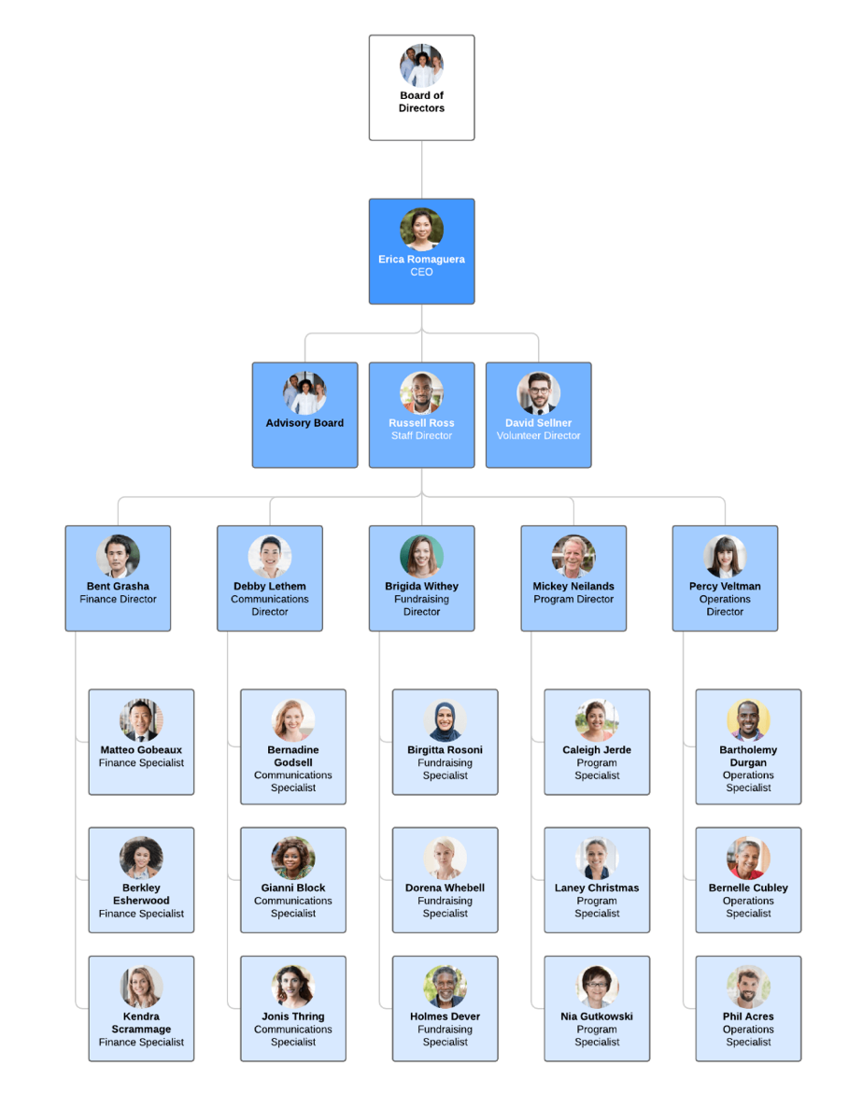
By contrast, a flat structure has very few management layers separating senior leaders from employees. This structure is common in smaller or start-up businesses, where teams are closely connected, and everyone contributes directly to decisions and operations (Lucidchart, 2024).
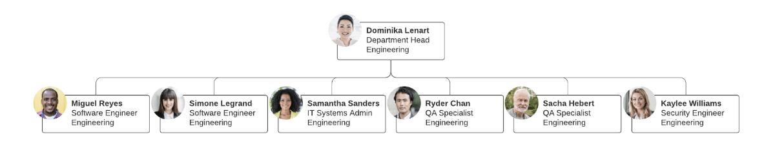
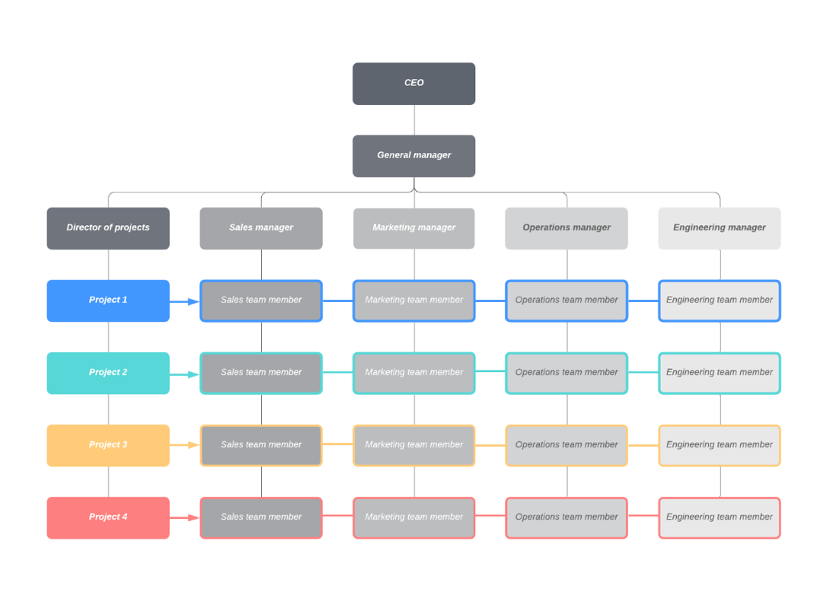
A matrix is a more complex structure in comparison. It is arranged like a grid, where employees report to both their functional department and project managers for specific initiatives. For example, an engineer might belong to the engineering department under the direction of the engineering lead while simultaneously contributing to a temporary project managed by a project manager. The matrix setup reflects both roles as well as each reporting line and allows managers to assign staff based on project requirements (Lucidchart, 2024).

Similarly, a functional organisational structure also has separate departments with their own managers. However, unlike in a matrix structure, employees remain in their specific departments which operate independently with very limited collaboration (Lucidchart, 2024).
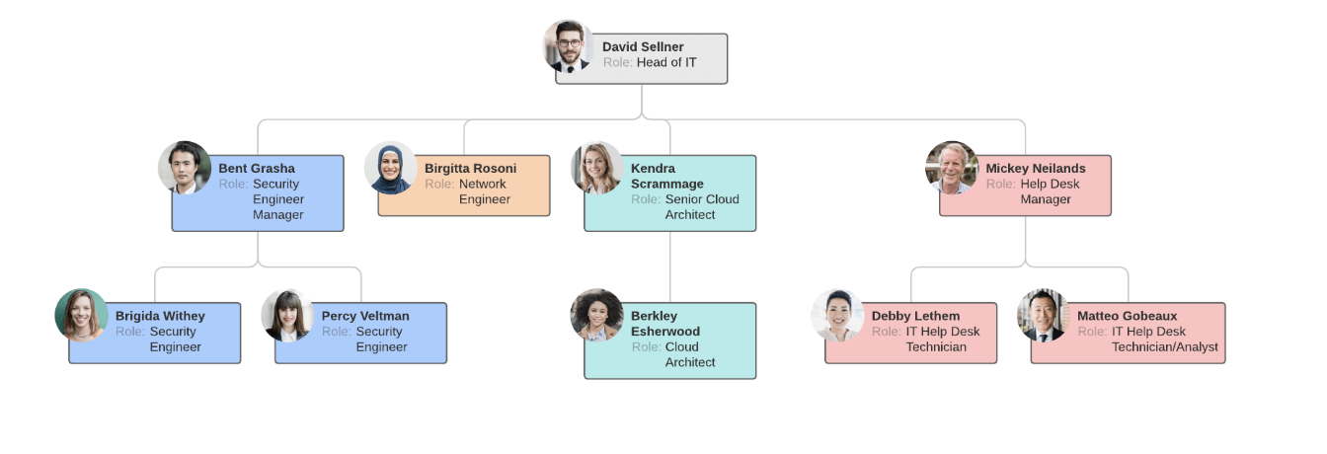
A divisional structure is like a functional structure in that both organise employees by specific functions. However, in a divisional structure, each division is semi-autonomous, managing its own resources and functions like a smaller company within the larger organisation. For instance, each division may have its own marketing, sales, IT, and other teams. Divisions can be organised in several ways including market divisions, product divisions, or geographic divisions. An example of an organisation with market divisions could be a retailer that has distinct divisions for clothing and electronics, and groceries. Furthermore, organisations with product-based divisions could include a tech company having one division for cloud services and another for software products like Adobe Illustrator, Photoshop, or InDesign. Lastly, geographic divisions organise teams by region or territory, which enables better localisation and customer service (Lucidchart, 2024).
Below is an example of a market-based divisional structure, followed by product-based, and geographic:
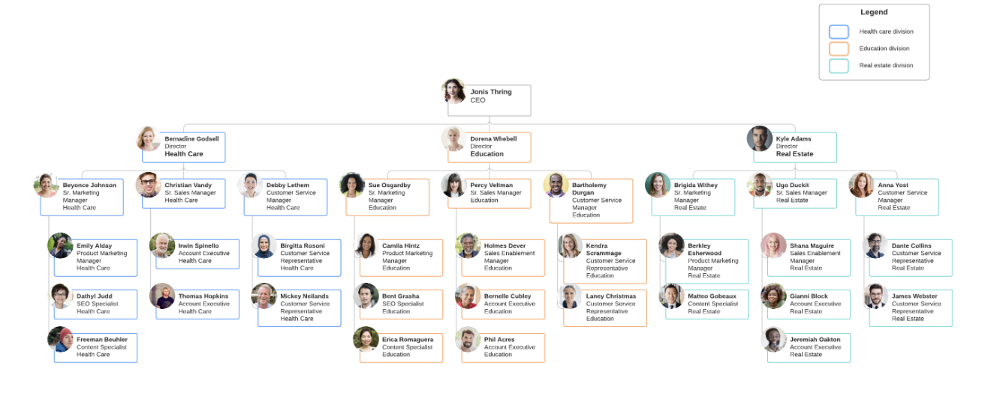
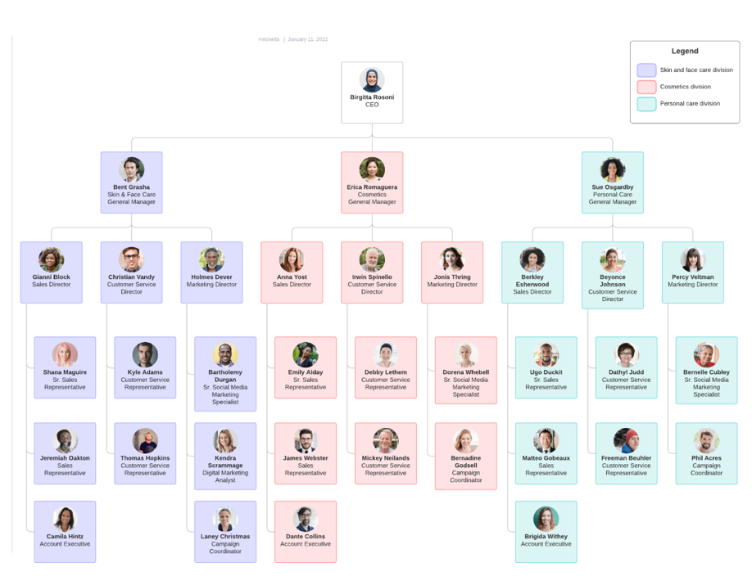
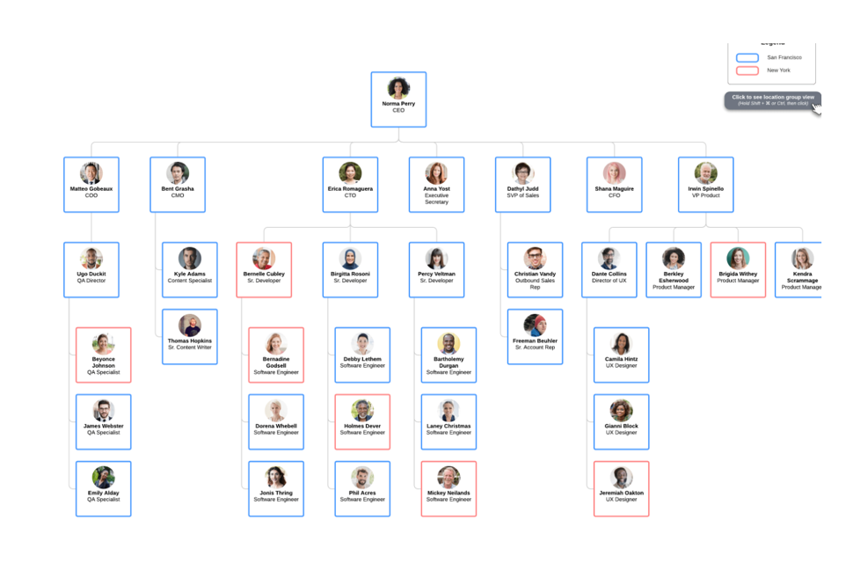
All images sourced from Lucidchart (2024).
Finally, a hybrid structure blends aspects of both traditional hierarchical and modern flat systems, incorporating functional, divisional, and matrix elements. Many businesses organise their workforce into departmental teams, such as finance, sales, marketing, or HR. Whereas some establish cross-departmental teams that collaborate to achieve specific business objectives, such as launching a new product (OfficeRnD, 2024).
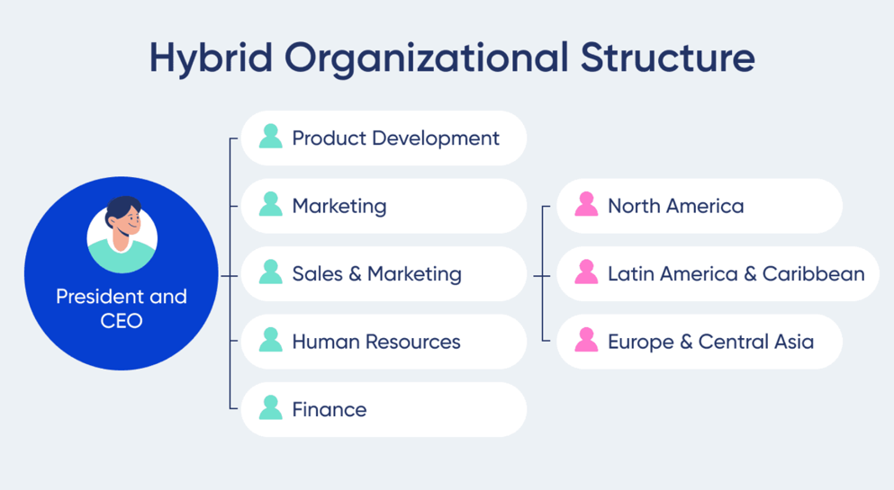
Image sourced from OfficeRnD (2024)
Merits of Different Organisational Structures (559 words)
Each organisational structure offers their own advantages and disadvantages. The best structure for a business depends on its size, strategy, environment, technology, and culture.
Firstly, the hierarchical structure clearly defines levels of authority, roles, and responsibilities, helping employees understand reporting lines. Moreover, it offers clear opportunities for career progression and encourages specialisation and teamwork within departments. That said, it can sometimes lead to slower decision-making due to bureaucracy and may discourage innovation and collaboration if communication between levels and departments is limited (Lucidchart, 2024).
By contrast, a flat structure fosters collaboration, faster decision-making, and a sense of ownership among employees because communication flows more freely due to minimal management layers. As a result, employees can contribute ideas and make operational decisions, improving innovation. However, disadvantages include potential role ambiguity leading to broader, less specialised skills in employees. Moreover, there may be confusion about authority, coordination challenges, and difficulties in scaling as the business grows (Lucidchart, 2024).
The features of a matrix structure enable managers to assign staff to projects based on their specific skills and expertise, making the organisation more flexible. It also gives employees opportunities to apply their abilities in different roles, promoting professional growth and collaboration. However, this structure can sometimes create confusion or conflict between project and departmental managers over authority and priorities, and it may require frequent adjustments as projects begin and end (Lucidchart, 2024).
A functional organisational structure allows individuals to concentrate on their specialised duties, improving efficiency and skill development within each department. It also helps teams feel independent and can be easily scaled as a business grows. However, it may lead to departments working in isolation, which can limit communication and collaboration across the organisation. Additionally, this separation can make it harder to coordinate strategies or processes between different functions, especially in companies operating across multiple markets or product lines (Lucidchart, 2024).
The set-up of a divisional structure helps large businesses adapt to changes in the market or customer demands, while allowing each division to operate with some independence and tailor its approach to its specific area. However, this structure can also lead to inefficiencies, such as duplicated resources or overlapping roles across divisions. Communication between the central headquarters and individual divisions may become unclear, and in some cases, divisions might even compete against one another rather than working together. (Lucidchart, 2024).
Finally, a hybrid structure promotes flexibility, improves resource management, and facilitates communication across departments and projects. However, it can increase administrative demands on HR and other departments and may create confusion for employees in matrix teams who have multiple managers rather than a single reporting line (OfficeRnD, 2024).
A business’ organisational structure depends on many factors. One factor is size; for instance, a small innovative company may benefit from a flat structure to encourage creativity, whereas a large organisation may require a hierarchical structure to manage its scale (Indeed Editorial Team, 2025a). Strategy also shapes structure, with innovative businesses favouring decentralised, flexible set-ups, and cost-focused firms preferring centralised ones (SLM.MBA., 2024). The environment also plays a role; for example, dynamic markets require dynamic structures like flat, whereas stable markets suit hierarchical structures. Elsewhere, technology affects how work is coordinated, as modern communication tools support decentralisation and collaboration Finally, culture influences authority and communication, with open, creative cultures encouraging flatter structures, and traditional, control-oriented cultures aligning with hierarchical models (SLM.MBA., 2024a).
Conclusion (93 words)
Overall, understanding legal features, functional areas, business growth methods, and organisational structures of businesses is essential for effective management and strategic decision-making. Limited and public companies have distinct legal and regulatory requirements, influencing ownership, liability, and governance. Meanwhile, not-for-profits operate under frameworks that prioritise social or charitable objectives. Functional departments such as HR, finance, marketing, operations, and IT must collaborate to achieve efficiency and support growth. Finally, choosing an appropriate organisational structure—considering factors like size, strategy, environment, technology, and culture—ensures the business is operated effectively, can adapt, and sustain long-term success.

Bibliography
AccountingInsights Team, 2025. How Does the Finance Function Contribute to the Business? Accounting Insights. Available at: https://accountinginsights.org/how-does-the-finance-function-contribute-to-the-business/ [Accessed 19 October 2025].
BBC Bitesize, n.d. Business ownership: public limited companies. Available at: https://www.bbc.co.uk/bitesize/articles/zfxrmbk [Accessed: 17 October 2025].
BBC Bitesize, n.d. a. The purpose of human resources in business. Available at: https://www.bbc.co.uk/bitesize/guides/zbfphbk/revision/1 [Accessed 19 October 2025].
BBC Bitesize, n.d. b. The role of the finance function. Available at: https://www.bbc.co.uk/bitesize/guides/zk94cqt/revision/1 [Accessed 19 October 2025].
BBC Bitesize. n.d. c. Business operations. Available at: https://www.bbc.co.uk/bitesize/guides/zdskkmn/revision/1 [Accessed 20 October 2025].
BBC Bitesize, n.d. d. Reasons for and against business growth; and factors limiting growth. Available at: https://www.bbc.co.uk/bitesize/articles/zstyjfr [Accessed 21 October 2025].
BBC Bitesize, n.d. e. Business growth; external/inorganic Available at: https://www.bbc.co.uk/bitesize/articles/zwtyjfr#zy9qvj6 [Accessed 22 October 2025].
BBC Bitesize, n.d. f. Business ownership: franchise. Available at: https://www.bbc.co.uk/bitesize/articles/zywnkhv [Accessed 22 October 2025]
Belu, n.d. About Belu. Available at: https://belu.org/about-belu/ [Accessed: 17 October 2025].
BMC, 2024. HR employee satisfaction: key to workplace success. Available at: https://www.bmc.net/blog/general-blog-posts/employee-satisfaction-in-hrm [Accessed 19 October 2025].
BoardMix, n.d. Hierarchical Structure: Definition, How it Works, and Examples. Available at: https://boardmix.com/knowledge/hierarchical-structure/ [Accessed: 25 October 2025].
British Business Bank, n.d. ‘What are the dangers of overtrading?. Available at: https://www.british-business-bank.co.uk/business-guidance/guidance-articles/business-essentials/what-are-the-dangers-of-overtrading [Accessed: 2 November 2025].
Cambridge Dictionary, n.d., Organization. Available at: https://dictionary.cambridge.org/dictionary/english/organization [Accessed: 27 October 2025].
Chartered Institute of Personnel and Development (CIPD), 2024. Transforming the HR operating model: Tesco. Available at: https://www.cipd.org/uk/knowledge/case-studies/operating-model-tesco/ [Accessed 19 October 2025].
Coursera, 2025. What is Supply Chain Management? Roles, Salaries, and Career Insights. Available at: https://www.coursera.org/articles/supply-chain-management [Accessed 20 October 2025].
Eades, L., 2025. The impact of changes to size on the functional areas. Save My Exams. Available at: https://www.savemyexams.com/a-level/business/aqa/23/revision-notes/9-strategic-methods-how-to-pursue-strategies/9-1-changes-in-scale/the-impact-of-changes-to-size-on-the-functional-areas/ [Accessed 21 October 2025].
Indeed Editorial Team, 2025. 13 Key Functions of a Human Resources Department. Available at: https://www.indeed.com/career-advice/career-development/human-resource-function [Accessed 19 October 2025].
Indeed Editorial Team, 2025a. How to choose an organizational structure in 5 steps. Indeed. Available at: https://www.indeed.com/career-advice/career-development/how-to-choose-organization-structure [Accessed 27 October 2025].
Institute of Directors, 2017. The role of the company secretary. Available at: https://www.iod.com/resources/company-structure/the-role-of-the-company-secretary/ [Accessed 17 October 2025].
Institute of Directors (IoD), 2023. What are Articles of Association? Factsheet. Available at: https://www.iod.com/resources/governance/what-are-articles-of-association/ [Accessed 19 October 2025].
Jangid, D., 2025. Private limited company examples in the UK. Debitam. Available at: https://www.debitam.com/private-limited-company-examples/ [Accessed 17 October 2025].
Kimonyo, T., 2024. The Impact of Employee Experience on Organizational Performance: Driving Innovation, Engagement, and Customer Satisfaction. Kabarak Journal of Research & Innovation, 14(2), pp.220-229. doi:10.58216/kjri.v14i02.417.
Kumar, R.G. & Surya, G., 2024. A Study on the Role of Marketing Strategy in Determining Consumer Purchasing Behaviour. International Journal for Novel Research in Economics, Finance and Management, 3(3), pp.1-4. Available at: https://ijnrefm.com/wp-content/uploads/IJNREFM_V3_issue3_129.pdf [Accessed 20 October 2025].
Lucidchart, n.d. Types of organisational structures. Available at: https://www.lucidchart.com/blog/types-of-organizational-structures [Accessed: 24 October 2025].
Marketing Week, 2025. ‘“Share a Coke” relaunch is driving growth, claims Coca-Cola’. Available at: https://www.marketingweek.com/share-a-coke-growth-coca-cola/ [Accessed: 2 November 2025].
Mollie, 2022. What is Companies House? Available at: https://www.mollie.com/gb/growth/what-is-companies-house [Accessed: 17 October 2025].
OfficeRnD, 2024. ‘The Hybrid Organisational Structure Explained’. Available at: https://www.officernd.com/blog/hybrid-organizational-structure/ [Accessed: 2 November 2025].
Organimi, 2024. What Is a Flat Organizational Structure? Available at: https://www.organimi.com/what-is-a-flat-organizational-structure/ [Accessed: 26 October 2025].
Revision World, n.d. Business Growth. Available at: https://revisionworld.com/gcse-revision/business-gcse-revision/growing-business/business-growth [Accessed 21 October 2025].
SLM.MBA., 2024. How strategy influences organizational structure and control systems. Available at: https://slm.mba/mmpf-003/strategy-influences-organizational-structure-control-systems/ [Accessed: 27 October 2025].
SLM.MBA., 2024a. Factors influencing organisational structure: environment, technology, and psychological characteristics. Available at: https://slm.mba/mmpc-001/factors-influencing-organisational-structure/ [Accessed: 27 October 2025].
Stanmore UK, 2024. The importance of organizational structure in business success. Available at: https://blog.stanmoreuk.org/the-importance-of-organizational-structure-in-business-success-2/ [Accessed: 25 October 2025].
Trigg, D., 2024. Functional areas of business: business departments explained. Available at: http://www.biznas.co.uk/business/functional-areas-of-business-explained/ [Accessed: 17 October 2025].
Tutor2u, 2021. Public limited companies. Available at: https://www.tutor2u.net/business/reference/public-limited-companies [Accessed 17 October 2025].
Tutor2U, 2024. Not-for-profit organisations. Available at: https://www.tutor2u.net/economics/topics/not-for-profit-organisation [Accessed: 17 October 2025].
UK Government, n.d. Community Interest Companies Guidance. Available at: https://www.gov.uk/government/publications/community-interest-companies-how-to-form-a-cic/community-interest-companies-guidance-chapters [Accessed 18 October 2025].
UK Government, n.d. b. About us – The Charity Commission for England and Wales. Available at: https://www.gov.uk/government/organisations/charity-commission/about#responsibilities [Accessed 18 October 2025].
UK Government, n.d. c. Company and accounting records – your responsibilities: Running a limited company. Available at: https://www.gov.uk/running-a-limited-company/company-and-accounting-records [Accessed 18 October 2025].
UK Government, n.d. d. Register your charity. Available at: https://www.gov.uk/setting-up-charity/register-your-charity [Accessed 18 October 2025].
UK Government, 2023. Prepare a charity annual return. Available at: https://www.gov.uk/guidance/prepare-a-charity-annual-return [Accessed 18 October 2025].
UK Government, 2025. Community Interest Companies Guidance [online]. Available at: https://www.gov.uk/government/publications/community-interest-companies-how-to-form-a-cic/community-interest-companies-guidance-chapters [Accessed: 31 October 2025].
Your Company Formations, 2024. Guide to Public Limited Companies (PLC). Available at: https://www.yourcompanyformations.co.uk/learning-centre/public-limited-companies-plc/ [Accessed 17 October 2025].

